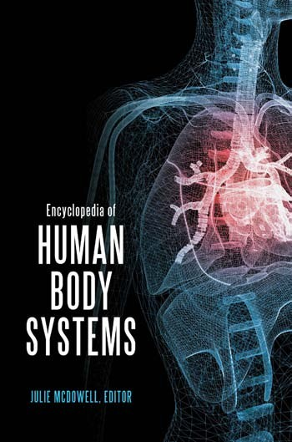

How to go to your page

This eBook set contains two volumes. The main content pages are contiguously numbered: use the Table of Contents to find those page numbers.

The front matter pages and indices are labeled with the Volume number and page separated by a colon. For example, to go to page vi of Volume 1, type Vol1:vi in the “page #” box at the top of the screen and click “Go”. To go to page vi of Volume 2, type Vol2:vi in the "page #" box… and so forth.

Encyclopedia of Human Body Systems

*This page intentionally left blank*

Encyclopedia of

Human Body Systems

VOLUME 1

Julie McDowell, Editor



Copyright 2010 by ABC-CLIO, LLC

All rights reserved. No part of this publication may be reproduced, stored in a retrieval system, or transmitted, in any form or by any means, electronic, mechanical, photocopying, recording, or otherwise, except for the inclusion of brief quotations in a review, without prior permission in writing from the publisher.

Library of Congress Cataloging-in-Publication Data

McDowell, Julie.

Encyclopedia of human body systems / Julie McDowell.

p. cm.

Includes bibliographical references and index. ISBN 978–0–313–39175–0 (hard copy : alk. paper)

1. Human physiology—Encyclopedias. I. Title. QP11.M33 2011

612.003—dc22 2010021682

ISBN: 978–0–313–39175–0

EISBN: 978–0–313–39176–7

14 13 12 11 10 1 2 3 4 5

This book is also available on the World Wide Web as an eBook. Visit [www.abc-clio.com](http://www.abc-clio.com/) for details.

Greenwood

An Imprint of ABC-CLIO, LLC

ABC-CLIO, LLC

130 Cremona Drive, P.O. Box 1911 Santa Barbara, California 93116-1911

This book is printed on acid-free paper  Manufactured in the United States of America

## Contents

VOLUME ONE

*About the Editor and Contributors, vii**Introduction, ix*

CHAPTER 1

The Building Blocks of the Human Body, 1

*Julie McDowell*

CHAPTER 2

The Circulatory System, 23

*Leslie Mertz*

CHAPTER 3

The Digestive System, 85

*Michael Windelspecht*

CHAPTER 4

The Endocrine System, 151

*Stephanie Watson and Kelli Miller Stacy*

CHAPTER 5

The Integumentary System, 207

*Julie McDowell*

CHAPTER 6

The Lymphatic System, 223

*Julie McDowell and Michael Windelspecht*

v

vi Contents

*Glossary, 273*

*Select Bibliography, 317**Index, I-1–I-30*

VOLUME TWO CHAPTER 7

The Muscular System, 323

*Amy Adams*

CHAPTER 8

The Nervous System, 379

*Julie McDowell*

CHAPTER 9

The Reproductive System, 453

*Kathryn H. Hollen*

CHAPTER 10

The Respiratory System, 497

*David Petechuk*

CHAPTER 11

The Skeletal System, 547

*Evelyn Kelly*

CHAPTER 12

The Urinary System, 599

*Stephanie Watson**Glossary, 619*

*Select Bibliography, 663**Index, I-1–I-30*

## About the Editor and Contributors

#### About the Editor

Julie McDowell is a science and health care journalist based in Washington, D.C. She is the author or coauthor of several books in the sciences, including *The Nervous System and Sense Organs*, *The Lymphatic System*, and *Metals*. She holds an MA in nonﬁction writing from Johns Hopkins University in Baltimore, Maryland.

#### About the Contributors

Amy Adams has written science news and features for publications including *The Scientist*, *Discovery Channel Online*, *CBS HealthWatch*, and *Science*, among others. She holds an MS in developmental genetics from Cornell University and is a graduate of the Science Communication Program at the University of California, Santa Cruz.

Kathryn H. Hollen is a science writer who has worked extensively with the National Institutes of Health, especially the National Cancer Institute, as well as many other organizations devoted to the life sciences.

Evelyn Kelly is an independent scholar and adjunct professor at Saint Leo University, Florida Southern College, and Nova University. She has writ- ten more than 10 books and over 400 journal articles. She is a member of the National Association of Science Writers and past president of American Medical Writer’s Association, Florida chapter.

vii

viii About the Editor and Contributors

Leslie Mertz is a biologist at Wayne State University. She is the author of *Recent Advances and Issues in Biology* (2000), and former editor of the research magazine *New Science*.

David Petechuk is an independent scholar. He has written on numerous topics including genetics and cloning and has worked with scientists and faculty in areas such as transplantation and psychiatry.

Kelli Miller Stacy is a board-certiﬁed life sciences editor and the founder of NEWScience Inc. where she is a feature writer on health and medicine for clients such as *The Scientist* and *Popular Science*. She is the winner of the American Medical Writers Association’s Eric Martin Award for excellence in medical reporting.

Stephanie Watson is a professional medical writer and editor. She is the author of *Medical Tourism: A Reference Guide* (2011).

Michael Windelspecht is Associate Professor of Biology at Appalachian State University. He is the author of two books in Greenwood’s *Ground- breaking Scientiﬁc Experiments, Inventions, and Discoveries through the Ages* series and editor of Greenwood’s *Human Body Systems* series.

## Introduction

The *Encyclopedia of the Human Body Systems* provides an overview of the physiology of the major organ systems of the body. For the purposes of this book, a system is deﬁned as an organ group that works to perform a function for the body.

This book looks at 11 systems, with each chapter dedicated to explor- ing a speciﬁc system. The ﬁrst chapter of the book provides an overview of the human body, including a look at its cellular foundation, chemical composition, and how the body is organized as well as an explanation of anatomical terms used to describe different areas of the human body. The subsequent chapters then focus on each of the systems. The purpose of this organization is so that readers can understand the basics of the human body and then go on to learn about each system.

The primary organs and functions of each system that are covered in this book’s chapters are outlined below, as well in Table A. It’s important to note that while each system does have its own distinct function, the sys- tems interact with each other and rely on the organs of other systems to function properly.

* The Circulatory System: The major organ is the heart, which functions with the help of blood vessels. The circulatory system’s major responsibility is to ensure that the blood transports vital substances like oxygen throughout the body to the heart and other systems’ organs, including the liver, stomach, and brain.
* The Digestive System: The major organs of this system are the mouth, esophagus, stomach, and small and large intestine, while the secondary organs are the liver, pancreas, salivary glands, and the gall

ix

x Introduction

bladder. The digestive system’s primary role is to turn substances coming into the body—such as through food and water—into fuel for its cells. This process is called metabolism, and is part of the larger, more comprehensive digestive process.

* The Endocrine System: The primary organs of this system (more commonly called glands in the case of the endocrine system) are the hypothalamus, pituitary, thyroid, parathyroids, adrenal, pancreas, and sex glands. The endocrine system is one of the body’s two communication hubs, the other being the nervous system. In this system, the communication is carried out through hormones, which are chemicals that travel through the bloodstream that prompt stimulation and inhibition of nerve impulses.
* The Integumentary System: Major organs are the skin and accessory organs, including hair and nail follicles. The primary job of this system is to protect the body, as well as detect changes that affect the body using its sensory receptors.
* The Lymphatic System: The primary organs of this system are the bone marrow and thymus, while the secondary organs are the spleen, tonsils, adenoid, Peyer’s patches, and appendix. The lymphatic system’s job is to protect the body against toxins and other potentially harmful substances that can cause illness and disease. While not an organ, one of this system’s most important components are lymphocytes. These specialized cells detect organisms that might be harmful to the body and then prompt an immune response to drive them out of the body.
* The Muscular System: Three types of muscles make up this system: the skeletal muscle, which helps the body to move; the smooth muscle, which is associated with the internal muscles; and cardiac, which works to help the heart to function. The movement of each of these muscles is determined by direction they receive from different areas of the body. Speciﬁcally, the autonomic nervous system controls the smooth and cardiac muscles and the central nervous system controls the central nervous system.
* The Nervous System: The primary organs of the nervous system are the brain and spinal cord. Through the nervous system’s two divisions, the central nervous system (CNS) and the peripheral nervous system (PNS), stimuli and other information is processed into the form of reaction and activity. In addition to the endocrine system, the nervous system is known as one of the body’s key communication centers. This communication is done through nerve impulses that travel through the body’s nerve ﬁber system.
* The Reproductive System: The role of this system is to carry out the process of sexual reproduction, which is necessary to continue the human species that contains genetic information that determines a person’s physical characteristics, but also their resistance to certain mutations also ensures the future of the species. This system is unique because there are distinct sets of organs for females and males. In addition, there are internal and external organs in the male and female, with the internal organs located inside the body and external organs located outside the body. Some examples of the internal female reproductive system include the cervix, vagina, and fallopian tubes; external organs include the mammary glands or breasts. For males, internal organs include the ejaculatory ducts and urethra; external organs include the penis and testicles.
* The Respiratory System: The primary organs are located in two areas: the upper and lower respiratory tracts. The upper tract contains the nose and nasal cavity (also known as the nasal passage), the pharynx (or throat), and the larynx (or voice box). The lower respiratory tract contains the trachea (windpipe), the bronchi, the alveoli, and the lungs. This system’s major responsibility is to control and regulate the breathing process, which involves moving air into and out of the lungs.
* The Skeletal System: The main components of the skeletal system are the body’s 206 bones, as well as the tendons, ligaments, and joints that connect the bones to the muscles, controlling their movement. The skeletal system is similar to the integumentary system in that it plays a protective role. Like the skin, skeletal bones

xii Introduction

TABLE A

Human Body Systems

*System Some examples of organs*

Circulatory Heart

Digestive Stomach, small intestine

Endocrine Thyroid

Lymphatic Spleen

Muscular Cardiac muscle, skeletal muscle

Nervous Brain, spinal cord

Reproductive Testes, ovaries

Respiratory Lungs

Skeletal Bones, ligaments

Urinary Bladder, kidneys

Integumentary Skin, hair

*Note:* This organ list just provides some examples and is not meant to be complete.

protect tissues and organs, as well as the other important internal organs from the body’s other systems.

* The Urinary System: This system’s primary organs are the kidneys, ureters, bladder, and urethra. The urinary system’s primary job is to rid the body of waste, through producing urine and other elimination processes. In addition, this system ensures that the body’s ﬂuid system is balanced in terms of acidity.

Each chapter in this volume opens with a listing of interesting facts pertaining to each system, as well as the topics or highlights that will be covered in each chapter. Do not feel the need to memorize these high- lights; it is just a way of alerting the reader to the focus of the chapter. Each chapter also contains a “Words to Watch For” section. This listing is an overview of the important terms that the reader can expect to learn about in each chapter. Many of these terms are also highlighted in bold in the chapter and then deﬁned in the glossary, which is located at the back of both volumes for the reader’s convenience. Throughout the book, tables and appropriate graphics will be used to help illustrate some concepts in a visual manner.

This book will be useful for students with various backgrounds in understanding human biology. Presented in a clear and concise manner, this book explains basic concepts of the human body—such as cell and blood composition—and then builds on this foundation to explore more complex concepts, such as nerve impulse transmission and respiratory processes. Whether readers open this book with no grasp of or a ﬁrm comprehension about the workings of the human body, they will broaden and deepen their understanding about a subject that has confounded some of the greatest minds in history, including Hippocrates, Aristotle, and Michelangelo. The mysteries of the human body continue to perplex scien- tists, medical experts, and the general public. However, these minds—from the past and present—found learning about the human body exhilarating and vital in order to improve the quality of life and ﬁnd cures and treat- ments for diseases and disorders. But the one thing necessary to explore these mysteries is learning and studying not only the complexities of each of the human body systems, but also the basics—what are they composed of, and how do they function? The *Encyclopedia of the Human Body Systems* is a key resource for this information, and therefore, an important tool in gaining a comprehensive understanding of the human body.

Julie McDowell Washington, D.C.

*This page intentionally left blank*

1

The Building Blocks of the Human Body

*Julie McDowell*

Interesting Facts

* It’s estimated that over a lifetime, humans produce a total of 10,000 gallons of saliva. While saliva is necessary for us to taste our food, we cannot taste it before some food dissolves in it.
* There are approximately 100 trillion cells in the adult human body.
* There are approximately 31 billion base pairs in the human genome.
* In a single cell, there are six billion “steps” of the DNA or body’s genetic code. If stretched out, it would measure six feet, but it is twisted up in a coil in the nucleus of the cell, where its diameter measures only 1/2500 of an inch.
* A mammal’s lifespan is typically determined by its size. But because humans have developed ways to protect themselves, their lifespan is longer. More speciﬁcally, a man’s lifespan should be 10 to 30 years— somewhere between a goat and a horse—but it’s actually an average of 74.7 years in the United States.
* Thanks to the body’s complex and extensive circulatory network, between 40 and 50 percent of body heat is lost through the head. This is why hats keep the body warm in winter—they keep the heat in the body.

1

* Compared to other cells in the body, brain cells live the longest, with some living an entire lifetime.
* Every second, the human body destroys—as well as produces—15 blood cells.
* Approximately 90 percent of the body is made up of four elements: oxygen, carbon, nitrogen, and hydrogen.
* The brain is especially reliant on oxygen to function. In fact, it uses more than 25 percent of the body’s oxygen supply.

Chapter Highlights

* Levels of the human body
* Chemical elements of the body
* Cells and tissues
* Organs and organ groups
* Body cavities
* How is the body organized?
* Key anatomy terms

#### Words to Watch For

Adiopose tissues Cells

Cell membrane Cell organelles Cell respiration Cranial cavity Cytoplasm Dorsal cavity Enzymes Frontal plane

Homeostasis Hormones Inorganic chemicals

Median sagittal plane Meninges

Mesentery Nucleus

Organic chemicals Organs

Organ systems

Pelvic cavity Peritoneum Plane

Serous membranes Solvent

Spinal cavity Tissues Transverse plane Ventral cavity

#### Introduction

The human body is a composed of a complicated organizational structure that becomes increasingly complex. As the complexity increases through the various levels of the human body, the behavior of each level is by the function and operation of the previous—or simpler—level of the body. But just because the human body is complicated and complex does not mean that many aspects cannot be studied and understood. While many mysteries still surround the human body, there is much that we know and understand. The key to this understanding is starting at the most basic level, and that is the chemicals of the human body. This chapter will begin with a brief overview of the levels—from the chemical to the organ system level—and then go into more details about certain aspects of each of the levels, such as cells, tissues, and membranes (see Table 1.1). Of course, more details on all of these levels are incorporated throughout *The Encyclo- pedia of Human Body Systems*.

#### Chemical Components of the Body

The human body is often described as a large vessel containing chemicals that are constantly reacting with one another. There are two kinds of chemicals that make up the human body: inorganic and organic chemicals. Although there are some exceptions, inorganic chemicals are primarily molecules that are made up of one or two elements that are not carbon. Water (H2O) and oxygen (O2) are examples that are important for the human body to function, as are iron (Fe), calcium (Ca), and sodium (Na). One exception is carbon dioxide (CO2)—even though this contains

TABLE 1.1

The Structural Organization of the Human Body

Level 1 Chemical

Level 2 Cellular

Level 3 Tissue

Level 4 Organ

Level 5 Organ system

Level 6 Organism

SIDEBAR 1.1

#### Atoms: Chemical Foundation of the Body

The simplest chemical, in living as well as nonliving matter, is the element, and the simplest element is the atom. In fact, the atom is the smallest unit in the body’s chemical system, which is its simplest level. Therefore, the atom really is the most basic element of the human body. The four most common elements in the human body are carbon (C), oxygen (O), hydrogen (H), and nitrogen (N).

Each atom is made up of a center or nucleus. The nucleus also contains protons and neutrons. Floating around the nucleus at rapid speeds are electrons. While each proton is positively charged, the neutrons are neutral. The electrons, however, are negatively charged. In a regular atom, the number of protons and neutrons are equivalent, therefore the electrical charge is neutral. One example is the carbon atom, which has six protons and six neutrons in its nucleus, while six electrons are in orbit around the nucleus on paths known as energy levels.

Electrons are also the way that atoms bond to one another to form molecules. A molecule is made up of tightly bound atoms that behave as a unit. However, the number of electrons in the body will determine how the atoms will bond. The bonding also depends on the arrangement of the electrons.

carbon, it is inorganic. Information about the body’s chemical components is also covered in detail throughout this book, but below is a brief intro- duction. (See Sidebar 1.1 for a brief explanation of the importance of atoms in the chemistry of the body.)

The other category of chemicals important to the body is organic chemicals, which contain the two elements hydrogen and carbon. These chemicals include fats, proteins, carbohydrates, and nucleic acids.

##### Key Inorganic Compounds

As noted earlier, water, oxygen, and carbon dioxide are among the body’s most important chemical compounds.

Water

Water, which scientists estimate comprises approximately 60 to 75 percent of the human body, is important for three primary reasons: it acts as a solvent, it acts as a lubricant, and because it changes temperature slowly, it is vital in regulating the body’s temperature. The ﬁrst reason—because it is a solvent—means that many substances can dissolve in it, which allows nutrients and other vital components to be transported throughout the body. This is because the body’s main transportation systems, blood, are largely composed of water. Therefore, substances like glucose (which comes from food) that are needed for energy in the body can be dissolved in the blood and then delivered to the heart and cells. Another important function is the elimination of waste. Materials that the body does not need, called waste products, are dissolved in the water component of urine and then ﬂushed out of the body through the urinary system.

In addition to acting as a solvent, water is a lubricant, which means it prevents friction between the various surfaces inside the body, such as bones and blood vessels. One example of water acting as a lubricant is in the diges- tive system. One of the ﬂuids present in this system is the ﬂuid mucus, which, like blood, is primarily made up of water. Mucus enables food to move through the intestines and be digested, providing the body with fuel.

The third function of water in the body is that of a temperature regulator. The temperature of water does not change quickly—it has to absorb a lot of heat or lose a lot of heat before the temperature increases or drops. This prop- erty enables the body to stay at a fairly constant temperature. In addition, water does an important cooling job for the body in the form of perspiration. When the body is absorbing an excess amount of heat, sweat forms on the skin, which allows the heat to escape the body without damaging any cells. While water is always moving throughout the body, it is categorized into two types, depending on its location. The two types are intracellular ﬂuid (ICF) and extracellular ﬂuid (ECF). ICF is the water located within the cells. This water makes up approximately 65 percent of the body’s total water supply. ECF is the remaining 35 percent of the body’s water and is the water outside of the cells. There are three types of ECF— plasma, lymph, tissue ﬂuid (also known as interstitial ﬂuid), and special- ized ﬂuid. Plasma is water found within the blood vessels; lymph is water found in lymphatic vessels; and tissue ﬂuid is water found in the small

spaces that exist between cells. Specialized ﬂuids include water that per- forms a speciﬁc function, depending on the system in which they are located; examples include cerebrospinal ﬂuid around the spinal cord in the nervous system, and aqueous humor in the eye.

Oxygen and Carbon Dioxide

We are continuously inhaling the gas known as oxygen—without it, we would die. Oxygen plays a vital role in breaking down nutrients such as glucose that need to be transported to various locations to provide the body with energy. This process is known as cell respiration. The energy produced through cell respiration is contained in a molecule that is called ATP, which stands for adenosine triphosphate. ATP can be thought of as the fuel required for various cellular processes to occur throughout the body. In addition to producing ATP, cell respiration also produces carbon dioxide. So while oxygen is inhaled, carbon dioxide is exhaled, and is con- sidered a waste product. It is exhaled because it is a waste product of cell respiration. Like other waste products that are covered throughout this book, carbon dioxide must leave the body. If carbon dioxide builds up in the body, it can disrupt the chemical balance in the body. This can cause acidosis, when ﬂuid becomes too acidic, which can result in calcium deposits in the body’s soft tissue. Carbon dioxide buildup in the body is

toxic to the heart (see Sidebar 1.2).

##### Key Organic Compounds

As indicated earlier in this chapter, some of the most important organic compounds in the body include carbohydrates, lipids, proteins, and nucleic acids. These compounds are explained in detail in Chapter 3, which covers the digestive system, but below is a brief introduction.

Carbohydrates

These compounds are made up of carbon, hydrogen, and oxygen, and its main function is to be the body’s energy source. There are four types of carbohydrates, all of which are forms of saccharide, which means sugar. The four types are monosaccharides, disaccharides, oligosaccharides, and polysaccharides. The preﬁxes refer to how many sugars are in the compound.

SIDEBAR 1.2

#### Cell Respiration: How the Body Produces Energy

The body relies on the chemical reaction known as cell respiration to pro- duce energy, and involves both oxygen and carbon dioxide. The chemical reaction is spelled out in the following equation:

Glucose (C6H12O6) + 6O2 ! 6CO2 + 6H2O + ATP + heat

Glucose comes from food, which is broken down with the help of oxygen. This reaction results in carbon dioxide, which, because it is a waste product, is exhaled. Water, energy (ATP), and heat are also pro- duced. In addition to carbon dioxide, these other substances perform key functions in the body. Water becomes part of the body’s ﬂuid system, acting like a solvent and lubricant, while the heat helps to maintain the body’s temperature. ATP is energy used for processes vital for the body to function, including digestion and muscle contraction.

Monosaccharides are the simplest sugar compounds, because they only contain one sugar. Disaccharides are composed of two monosaccha- ride compounds, while oligosaccharides are made up of anywhere between 3 and 20 monosaccharides. Finally, polysaccharides are composed of thou- sands of monosaccharide compounds.

Lipids

Like carbohydrates, lipids are also composed of carbon, hydrogen, and oxygen. Some lipids also contain phosphorus. Three types of lipids include true fats (or just fat), phospholipids, and steroids.

True fats are made up of a molecule called glycerol, and between one and three fatty acid molecules. These fats are where the body stores excess energy produced by food in the form of calories. If a body does not use all of the calories, it is then converted to fat and stored in the body’s adipose tissues. These tissues are located between the skin and muscles.

Triglyceride is one type of true fat. It is when one glycerol is bound to three fatty acid molecules. This is the type of fat often found in highly processed foods, and often found in two forms—saturated and unsaturated

SIDEBAR 1.3

#### Saturated versus Unsaturated Fat

There are two types of true fats—saturated and unsaturated fats, with a diet high in saturated fats, as well as cholesterol, getting a lot of blame for con- tributing to heart disease. Heart disease, or atherosclerosis, occurs when there are deposits of cholesterol on the walls of the coronary arteries that supply blood to the heart muscle. These deposits cause the arterial walls to narrow, which then inhibits blood ﬂow through the arteries. If the deposits become too great and blood is blocked from the heart, a clot forms and can result in a heart attack.

Saturated fats are typically in a solid form, and are found in food derived from animals such as beef and pork, chicken, eggs, and cheese, as well as some oils, including coconut and palm oils. Unsaturated fats are also found in oils, but those that are plant-based, including corn, sun- ﬂower, safﬂower, and certain ﬁsh oils.

When saturated fats are broken down by the liver, they are used to synthesize cholesterol, which cause the blood cholesterol level to increase. But unsaturated fats behave differently; when they are broken down by the liver, they do not increase the body’s cholesterol. In fact, there is evidence that some unsaturated fats may actually help lower cholesterol and prevent atherosclerosis in the body by inhibiting cholesterol from being produced by the liver. This is why a diet that is high in unsaturated fats and low in saturated fats is believed by scientists and medical experts to help prevent heart disease. However, there are other contributing factors to atherosclerosis, including heredity and risk factors such as smoking, as well as being overweight. Therefore, eliminating these contributing factors, through quitting smoking, and exercising to lose weight, help to reduce the risk of heart disease. It cer- tainly helps to eat a healthy diet—to help us maintain a reasonable weight.

fats—on nutrition labels. (See Sidebar 1.3 for more information about saturated and unsaturated fats).

Another type of lipids is phospholipids, which are diglycerides that are bonded to a phosphate molecule. Unlike fats, phospholipids do not store energy. They are a part of a cell’s structure; they form part of the cell mem- brane known as lecithin. They also are an integral part of the body’s nervous system, in that they help to form the cell’s myelin sheath that protects neurons. Like phospholipids, steroids form part of the cell membranes. But they also have other functions. One of their primary functions is that they are processed by the liver into bile salts, which are used during the digestion to process fats. In addition, steroids are also involved in hormones related to male and female reproductive organs—testes (men) and ovaries (women).

Proteins

Comprised of building blocks known as amino acids, proteins contain car- bon, hydrogen, oxygen, nitrogen, and sometimes sulfur. One of the most important functions of proteins is their role as enzymes or catalysts. Enzymes accelerate chemical reactions in the body without additional energy, such as heat.

There are speciﬁc enzymes for speciﬁc reactions. The digestive system provides some excellent examples. The enzymes that react to digest starches are different from those that digest lipids in food. Because there are many thousands of different chemical reactions going on in the body at one time, there are many thousands of different enzymes.

Nucleic Acids

There are two types of nucleic acid—DNA, which stands for deoxyribonu- cleic acid, and RNA, which stands for ribonucleic acid. Nucleic acids are large molecules that are made up of nucleotides. Each nucleotide has four components: sugar, phosphate group, and a nitrogenous base. Here is more detail on each of these molecules (see Figure 1.1):

*DNA*

Sugar: deoxyribose

Bases: adenine, guanine, cytosine, or thymine

*RNA*

Sugar: ribose

Bases: adenine, guanine, cytosine, or uracil

As evident in the illustration, DNA looks similar to two ladders twisted together. These strands are the nucleotides, and their twisted form

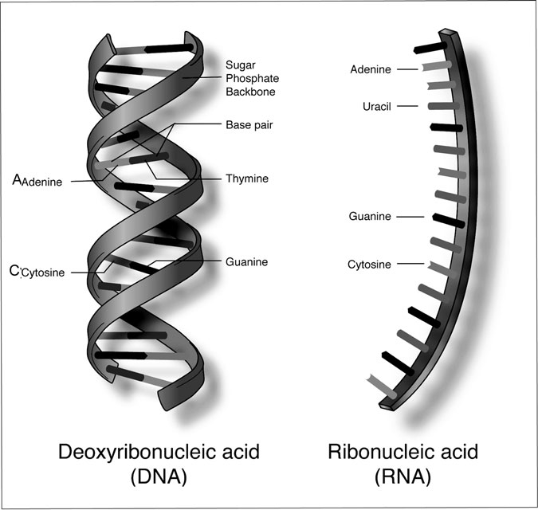

Figure 1.1 DNA and RNA Structure. A small portion of the RNA and DNA molecules, with some of the different nucleotides identiﬁed, including cytosine, adenine, and uracil. The synthesizing of RNA produces a complementary copy of half of the DNA strand. (National Human Genome Research Institute)

is called a double helix. Phosphate and sugar molecules alternate to form each nucleotide, or the upright length of the ladder. The rings that connect the strands are formed by the nitrogenous base pairs. It’s important to note that in terms of the nitrogenous pairs, adenine is always with thymine, while guanine is always with cytosine.

DNA contains information on hereditary characteristics, and therefore is the body’s genetic code. The code is determined in how the bases are arranged, and determines the various kinds of proteins produced by the body. While these bases make up the protein, the sequence of these bases is called a gene.

While DNA is a double strand of nucleotides, RNA is just a single strand. Uracil is in place of thymine in the nucleous bases. It is produced through synthesis from DNA in a cell’s nucleus. RNA’s primary function is to carry out protein synthesis, and it performs this duty in the cytoplasm.

#### Cells

The next level of complexity in the human body is cells, which are the smallest units in the body. There are numerous types of cells in the body, and different cells perform speciﬁc functions depending on their chemical reaction. However, in order for the body to be stable and func- tion normally—also known as a state of homeostasis—cells must work together. While the speciﬁc functions of cells will be discussed through- out *The Encyclopedia of Human Body Systems*, it’s important to have a basic understanding of the structure of a cell and some of their basic functions.

In addition to varying by function, cells also come in all shapes and sizes, although most are very small and can only be viewed under a micro- scope. They are measured in units called microns, and each micron is approximately 1/25,000 of an inch. Some exceptions to this are nerve cells, which can be very long, although very narrow in diameter. Some nerve cells are at least two feet long.

Despite their different shapes and measurements, most cells have four common structural features: a cell membrane, a nucleus, and cytoplasm and cell organelles (see Figure 1.2). The one exception is mature red blood cells—they have no nuclei (the plural form of nucleus).

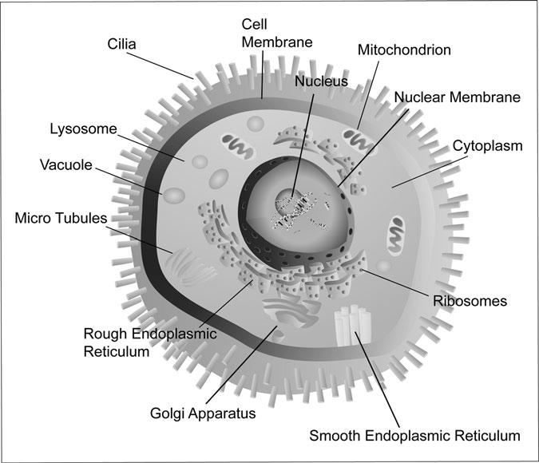

Figure 1.2 Human Cell. Some important elements of a cell, including the nucleus, cytoplasm, mitochondrian, lysosome, and ribosomes. (Mark Rasmussen/Dreamstime.com)

##### Cell Membrane

The cell membrane is the outermost part of the cell, and is composed of phospholipids, cholesterol, and proteins. This membrane is permeable, which means that certain substances and ﬂuids are allowed to enter and exit. In fact, the phospholipids allow other lipids or substances that are soluble in lipids to leave and enter the cell membrane through a process called diffusion. But the ﬂuid movement into and out of the membrane is controlled by cholesterol in the cell, making the cell stable. It’s important to note that while certain substances are allowed into the cell through its membrane, the membrane is selectively permeable. Part of the job of the

membrane is to keep out dangerous substances that will harm the cell, and therefore the body.

Proteins are also involved in allowing substances to ﬂow in and out of the membrane. Some cell proteins form openings known as pores that allow the stream of materials in both directions. Other proteins act as enzymes that enable substances to go in and out of the membrane. Finally, some proteins act as receptor sites for hormones. Once these hormones come into contact with these receptor sites, certain chemical reactions begin.

##### Nucleus

Located within the cytoplasm is the nucleus, which is protected by the two- layered nuclear membrane. Each nucleus has at least one nucleoli, as well as the cell’s chromosomes. The nucleolus is made up of three substances: DNA, RNA, and protein. Chromosomes are made up of DNA and protein. There are 46 chromosomes in a nucleus, and they are in the form of long threads called chromatin. As discussed earlier in this chapter, DNA is the body’s genetic code. While the DNA in a nucleus does contain all of the body’s genetic traits, there are only a few genes that are active. It is these active genes that code the proteins that determine the speciﬁc type

of the cell.

##### Cytoplasm and Cell Organelles

Cellular chemical reactions take place in the cytoplasm, which is the watery liquid between the cell membrane and nucleus. Cytoplasm is a concoction of minerals, gases, and other organic molecules as well as cell organelles.

Each of these organelles has a speciﬁc job to do in order to enable cells to function. One type of cell organelle is the ribosomes, made up of protein and ribosomal RNA, that is the location of protein synthesis. Also present in the cytoplasm is the Golgi apparatus. These are ﬂat, circular membranes arranged in a stack. Inside these sacs, materials such as carbo- hydrates are synthesized, and leave the cell by secretion. This secretion occurs when a single sac breaks from the Golgi membrane, becomes part of the cell membrane, and ultimately leaves the cell.

In addition to the ribosomes and the Golgi apparatus, another cell organelle is the mitochondria, which are oval in shape. The mitochondria

have a double membrane, with the inner membrane containing folds known as cristae. Mitochondria are where cell respiration takes place, and the loca- tion of ATP, or energy, production.

Another type of organelle is lysosomes, which contain digestive enzymes and help white blood cells to destroy bacteria. These lysosomes also digest dead cells and damaged cellular parts, which has to occur before a cell can be repaired.

The last three types of organelles are centrioles, cilia, and ﬂagella. Centrioles are located immediately outside the nucleus, and play an impor- tant role in organizing spindle ﬁbers during the division of a cell. Cilia and ﬂagella can be thought of as sweepers; they are responsible for sweeping certain materials along the surface of the cell.

#### Tissues

Following the cellular level, the next level is tissues, which is a cell group with a similar structure that performs a function. There are four types of tissue groups:

* Epithelial tissues: These cover or serve as lining on certain body surfaces, including the outer layer of the skin; some of these cells produce secretions that have a speciﬁc function.
* Connective tissues: These connect as well as support certain parts of the body. Some connective tissues transport and/or store materials. Examples include blood, bone, and adipose tissue.
* Muscle tissues: These are responsible for contraction, which enables movement. Examples include skeletal muscles as well as the heart.
* Nerve tissues: These are responsible for regulating body functions through generating and transmitting electrochemical impulses. Examples include the brain and optic nerves.

#### Organs

Groups of tissues arranged to perform specialized functions are called organs. Some examples include the stomach, kidneys, and lungs. The organs all work in concert with other each other. For example, the

epithelial tissue in the stomach secretes juices that allow food to digest. The wall of the stomach contains muscle tissue that contracts, allowing food to mix with gastric juice. This digesting concoction then moves into the small intestine. Along the way, nerve tissue is transmitting an impulse that controls the contracting of the stomach.

#### Organ System

Just like organs are a group of tissues that perform a speciﬁc function, an organ system is a group of organs that together perform a speciﬁc function. Just like the organs work together, so do the organ systems to ensure the proper function of the human body. There are 11 organ systems, and each with their own chapter in this book. The body’s organ systems are integu- mentary, skeletal, muscular, nervous, endocrine, circulatory, lymphatic, respiratory, digestive, urinary, and reproductive (see Table 1.2) for a more

TABLE 1.2

Organ Systems of the Human Body

*Organ system General function Some examples*

Circulatory Movement of chemicals through the body Heart

Digestive Supply of nutrients to the body Stomach, small intestine

Endocrine Maintenance of internal environmental

conditions

Integumentary Protection against pathogens and

chemicals, as well as excessive loss of water

Lymphatic Immune system, transport, return

of ﬂuids

Thyroid Skin, hair

Spleen

Muscular Movement Cardiac muscle, skeletal muscle

Nervous Processing of incoming stimuli and coordination of activity

Brain, spinal cord

Reproductive Production of offspring Testes, ovaries

Respiratory Gas exchange Lungs

Skeletal Support, storage of nutrients Bones, ligaments Urinary Removal of waste products Bladder, kidneys

detailed description of the functions of each organ system. It’s important to understand that the organ systems work together in order for the body to function properly.

#### The Body’s Cavities

Another important method to describe the human body is according to cavities. There are two major cavities in the body: the dorsal cavity and ventral cavity (see Figure 1.3). It’s important to note that when describing

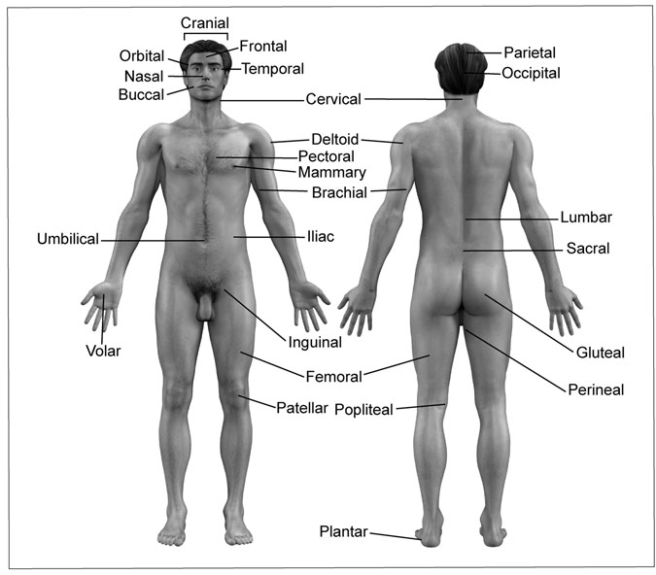

Figure 1.3 Body Parts and Areas. The anterior (left) and posterior (right) views of the human body, including body parts and areas. (Linda Bucklin/Dreamstime.com)

these and related locations, it’s assumed that the body is in an anatomical position, which means that the body is standing up and facing forward. The arms are at the side and facing up.

Based on this anatomic position, the dorsal cavity is the posterior view. This cavity includes the cranial cavity, which is comprised of the skull and the brain. The dorsal cavity also includes the spinal cavity, which includes the spine and spinal cord. Both the cranial and spinal cavities contain all of the nervous system organs. Membranes known as meninges line the dorsal cavity systems.

The ventral cavity includes organs and organ system in the anterior view. The thoracic and abdominal cavities are part of the ventral cavity system. Located in the abdominal cavity is the pelvic cavity. The abdomi- nal and thoracic cavities are divided by the diaphragm.

The thoracic cavity’s organs include the heart and the lungs, which are covered by pleural membranes. The pleural membranes include the pari- etal, which cover the walls of the chest and visceral, which cover the lungs. Pericardial membranes cover the heart. Within the heart, there are parietal and visceral pericardium membranes that cover various areas of the heart. These membranes are known as serous, which means they cover organs.

In the abdominal cavity are located the liver, stomach, and intestines. There are two types of serous membranes in the abdominal cavity—the peritoneum and mesentery. The abdominal wall is lined by the perito- neum, while the outer surfaces of the organs located in the abdominal cavity are covered by the mesentery membranes.

The third cavity, the pelvic cavity, is below the abdominal cavity. The peritoneum is also present in this cavity, because it covers some of the sur- faces of the pelvic organs, which include the body’s reproductive organs, as well as the urinary organs such as the bladder.

#### Planes, Sections, and Areas

In addition to cavities, there are other important ways to describe how the body is organized. These include learning certain terms that refer to certain areas of the body (Table 1.3), as well as terms that refer to speciﬁc locations

TABLE 1.3

Key Anatomy Terms: Body Parts

*Name of body part/area Refers to*

Axillary Armpit

Brachial Upper arm

Buccal Mouth

Cardiac Heart

Cervical Neck

Cranial Head

Cutaneous Skin

Deltoid Shoulder

Femoral Thigh

Frontal Forehead

Gastric Stomach

Gluteal Buttocks

Hepatic Liver

Iliac Hip

Lumbar Small area of the lower back

Mammary Breast

Nasal Nose

Occipital Back of the head

Orbital Eye

Parietal Crown of head

Patellar Kneecap

Pectoral Chest

Plantar Sole of the foot

Pulmonary Lungs

Renal Kidney

Sacral Spine base

Temporal Side of head

Umbilical Navel

in the body (Table 1.4). You might recognize some of these terms, such as visceral, which have already been mentioned in reference to cavities and membranes.

TABLE 1.4

Key Anatomy Terms: Location

*Location/position*

*in the body Refers to*

Superior Above, higher

Inferior Lower, below

Anterior Towards the front of the body (chest)

Posterior Towards the back of the body (lumbar)

Ventral Towards the front of the body (breasts, mammary glands) Dorsal Towards the back of the body (buttocks)

Medial Towards the body’s midline (lungs)

Lateral Facing away from the midline (shoulders, in comparison to neck) Internal Within (brain in the skull)

External Outside (ribs are located outside of the lungs) Superﬁcial Towards the body’s surface (skin)

Deep Within (various vein systems)

Central Primary portion of the body (brain in relation to the nervous system)

Peripheral Rooted in the main part of the body and extending outward (nerves in the arms, legs, and face)

Proximal Near the origin (knee, in relation to foot)

Distal Removed from the origin (bicep in relation to hand)

Parietal Related to the cavity walls (membranes that line the chest cavity)

Visceral Related to the organs within a cavity (membranes that cover the lungs)

One way the body is described—particularly the internal anatomy—is by separating different parts of the body into sections, planes, and areas (Planes are also discussed in Chapter 11, “The Skeletal System”).

There are three primary planes in body: the median sagittal plane, the transverse plane, and the frontal plane (see Figure 1.4). The plane is an imaginary ﬂat surface intersecting the body that separates the body into two separate sections of the body or of an organ, such as the brain or the spinal cord. It’s important to note that the right and left refer to that of the person being described, not how it looks on the printed page. The median sagittal plane is longitudinal and divides the left and right parts along the

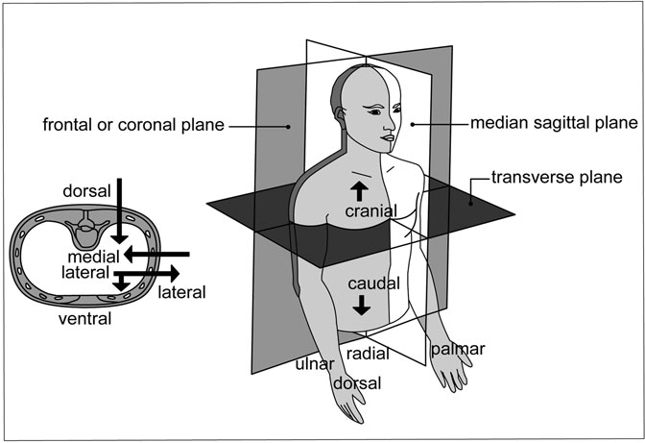

Figure 1.4 Planes of the Body. The left graphic represents a cross section of the spinal cord. The terms indicating directions of the body are indicated. The right graphic identiﬁes the terms for the different planes of the body. (Sandy Windelspecht/Ricochet Productions)

midline of the body. The transverse plane divides a person into upper and lower sections, while the frontal plane divides the body in dorsal (posterior or lumbar side) and the ventral (anterior or abdominal side) portions.

Two other sections/planes are the cross section and the longitudinal sections. The cross section is a plane that runs perpendicular to the long portion of an organ. Examples include the cross section of the spinal cord or even a small intestine. A longitudinal section runs along the long axis of the organ.

#### Abdomen Areas

The abdomen—what is known as the lower trunk of the body—is divided into four quadrants, as well as nine areas that are based on the planes and sections that were just described (see Figure 1.5). These quadrants are

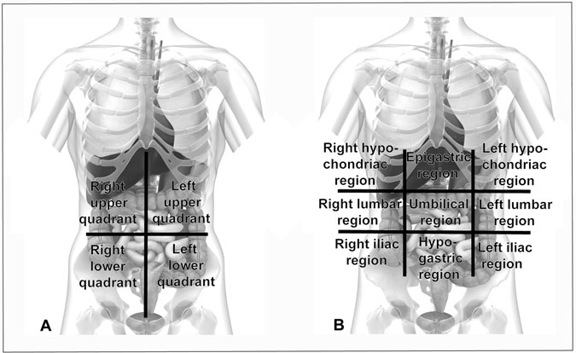

Figure 1.5 Areas of the Abdomen. The “A” graphic represents the four quadrants of the body. The “B” graphic depicts the abdomen’s nine quadrants. (Sebastian Kaulitzki/Dreamstime.com)

evident when a transverse plane and a midsagittal plan intersect around the umbilical area. The four quadrants of the abdomen are the right upper quadrant, left upper quadrant, right lower quadrant, and left lower quadrant.

But to describe the different abdominal areas in more detail, the abdo- men call be further divided into nine areas if two transverse planes and two sagittal plans divide the body. The nine regions can actually be organ- ized according to three groups: the upper areas, middle areas, and lower areas. The upper areas include the hypochondriac and epigastric regions, while the middle areas include the lumbar and umbilical regions. The lower areas encompass the iliac and hypogastric regions.

#### Summary

Before understanding each of the body’s complex organ systems, it’s important to have an understanding of how the body is organized, as well

as to get an overview of how the body’s key building blocks function. This includes understanding that the body is divided into levels—beginning with the simplest structures like the chemical, cellular, and tissue levels, and moving up to more complex levels, including the organ, organ system, and organism levels. The body is made up of organic and inorganic chem- icals, but its smallest unit is the cell. In addition to levels, the body is also organized according to cavities, as well as planes, sections, and areas.

# 2

### The Circulatory System

*Leslie Mertz*

Interesting Facts

* At any given time, the veins and venules typically hold about two- thirds of the blood ﬂowing through the body.
* As the heart contracts and blood rushes into the aorta, it is traveling at a speed of about 8 inches (20 centimeters) per second.
* Even in a person who is resting, blood issuing from the heart can travel down to the person’s toes and back to the heart in just a minute. When a person is exercising heavily, that trip can take just 10 seconds. On average, every red blood cell completes the heart-to-body-to-lungs circuit 40–50 times an hour.
* If all of the blood vessels in an average adult were strung together end to end, they would reach at least 60,000 miles long, more than twice the distance around the Earth’s equator. The capillaries alone make up 60 percent of that total.
* Every second, 10 million red blood cells die in the normal adult. The body replaces them just as quickly, however, so the total number remains constant.
* In the average adult, the heart weighs less than three quarters of a pound—about 11 ounces (310 grams). In any given person, it’s about the size of his or her ﬁst.

23

* The heart beats an average of 72 times a minute with a typical at- rest volume of 75 ml of blood pumped with each beat. Using those ﬁgures, a 75-year-old’s heart has contracted more than 2.8 billion times and pumped more than 212 million liters of blood in his or her lifetime.
* When a person is resting, the left ventricle pumps about 4–7 liters of blood every minute. In a well-trained athlete who is doing strenuous exercise, that amount can rise to almost 30 liters per minute.
* Heart rate changes greatly during child development. The typical heart rate in a newborn is 130 beats per minute (bpm). It drops to 100 bpm by the time the child reaches 3 years old, 90 at 8 years old, and 85 at 12 years old.
* In an increasingly common practice, people are donating blood for use in their own upcoming surgeries. Called autologous blood donation, it helps patients ensure safe transfusions.

Chapter Highlights

* Blood: red blood cells, white blood cells, plasma
* Blood vessels: systemic and pulmonary circulation, arterial and venous systems
* Capillary system
* The heart: muscle, blood ﬂow, electrical function
* Organs that depend on the circulatory system: digestion, liver and hepatic circulation, kidneys and renal circulation, spleen, cerebral circulation and the blood-brain barrier

#### Words to Watch For

Agglutination Albumins Amino acids

Anions

Annulus fibrosus Antigens

Aortic arch

Arterial baroreceptor reflex

Arterial system Arteriovenous

anastomoses

Atrioventricular node

Atrium

B lymphocytes (B cells)

Baroreceptor Basophils

Bayliss myogenic response

Blood

Blood pressure Blood sugar level Blood type Blood vessels

Bowman’s capsule Brachiocephalic

artery

Bundle of His Capillaries Cations

Chordae tendineae Circle of Willis Circulatory

system

Colic artery Common carotid

arteries

Complement

Concentration gradient

Coronary arteries Coronary circulation Diastole

Diffusion End-diastolic

volume

Endocardium Endothelium Eosinophils Epitope Femoral artery Femoral vein Fibrinogen Fibular vein Gastric Gastroepiploic Globulins Glomerulus Granulocytes Heart

Heme group Hemoglobin Hemolysis Hypertension Immunoglobulins In-series blood

circulation

Intestinal villi Involuntary muscle

Lymph Lymphocytes Macrophages Microvilli Monocytes Nephrons Neutrophils Osmosis Pacemaker Partial pressure Pericardium pH level Phagocytosis Plasma Plasminogen Platelets

Portal circulation Prothrombin Protozoa Purkinje fibers Red blood cells Septum Sinoatrial node Solutes

Stroke

Systemic circulation Systole

T lymphocytes (T cells)

Terminal arterioles

Thrombocytes Thromboplastin Tunica adventitia Tunica intima Tunica media

Type A, B, AB, and O blood

Ureter Vasoconstrictor

nerves

Vena cava Ventricle Voluntary muscle White blood cells

#### Introduction

Animals possess an array of internal circulatory systems for transporting materials through the blood and to every part of the body. Depending on the type of animal, the system may be quite simple or very complex. Earthworms, for example, have a series of “hearts” that are little more than pulsating blood vessels to assist the transit of blood through other vessels and to body organs. Insects and some other invertebrate animals have what is known as an open circulatory system that forgoes the net- work of vessels and instead usually delivers blood through one long, dor- sal vessel that empties into a large cavity, or sinus. In that ﬂooded cavity, the body organs are actually bathed in blood. As organisms become more complex and larger, a closed circulatory system is the norm. In a closed system, the blood makes its route through the body and to the tissues in vessels. Earthworms have a closed circulatory system, and so do all verte- brates, including humans.

The purpose of this chapter is to examine the structure and function of the human circulatory system, which is also known as the cardiovascular system because it includes the heart, or cardium from the Greek word for heart, and the blood vessels, or vasculature. The blood and all of its cells are also part of this system. The circulatory system serves as the body’s delivery method, picking up oxygen from the lungs and dropping it off at tissue and organ cells around the body, then gathering carbon dioxide from the tissues and organs, and shipping it off to the lungs. It also distributes nutrients from the digestive system, transports chemical mes- sages from the brain and other organs to various sites in the body, and pro- vides the route and means for the body to mount a defense against bacterial infection. It even maintains the internal temperature by shuttling excess heat from the core of the body to the outside.

#### A Living River: Foundations of the Human Circulatory System

An amazing river system ﬂows through the human body. After a person takes a breath of air, the oxygen is swept into the current and rushes to muscles, the brain, or another part of the body. Shortly after a Sunday dinner, nutrients begin to make their way into this same system for dispersal throughout the body. Alongside them, bacteria-ﬁghting cells race to the site of an infection.

This remarkable river is the circulatory system: the heart, blood vessels, and blood. In a river system, water ﬂows with a current between banks. A typical river system comprises tiny creeks, usually with a very slow current; larger, faster-moving river branches; and the main river with its strong ﬂow. Likewise, the circulatory system has a liquid that ﬂows with a current within a conﬁned space. Blood replaces water. Instead of a river- bed, the blood ﬂows inside of tubes, the blood vessels. Here and there, smaller branches separate from or connect into the main bloodstream. Blood from these branches eventually ﬂows into or collects from even tinier vessels, which have a much slower current than the main bloodstream. This chapter will provide an introduction to the various components of the circu- latory system, primarily the heart, the blood vessels, and the blood.

#### The Blood

Blood is more than just a simple, red liquid. It is actually a clear, somewhat gold-colored, protein-rich ﬂuid crowded with red and white cells. The pre- ponderance of red cells gives it the scarlet cast. When separated from the rest of the blood, the clear ﬂuid, called plasma, has a more watery consistency. The reason that blood is more like syrup than water is the addition of red and white cells, and platelets, which combine to make up 40 to 45 percent of blood volume. Just as a glass of mud is more difﬁcult to pour than a glass of water, because mud is actually a mixture of water plus dirt particles, blood is thicker because its plasma is laden with red and white blood cells. From this standpoint, blood truly is thicker than water. The “thickness” of a liquid is known as its viscosity. The slower something ﬂows, the more viscous it is. Blood, for example, is three to four times more viscous than water.

All of the various components of blood have vital functions. As an example, the plasma serves as the liquid that suspends the red and white blood cells, along with all of the other chemical compounds and various materials that use the bloodstream to travel throughout the body. It also regulates the movement of heat from the body’s core to the skin, the head, and the extremities. The red blood cells have a primary role of trans- porting oxygen from lungs to cells, while the white blood cells help defend against infection from invading organisms and foreign proteins. Table 2.1 describes some of these components in greater detail.

Red Blood Cells Of the 5.5 quarts (5.2 liters) of blood in an average person, the red blood cells are, by far, the most prominent cellular component. Red blood cells, or

erythrocytes, number about 28.6 trillion in the average male and 24.8 tril-

lion in the average female. It follows, then, that red blood cells are micro- scopic. Ranging in size from 2.6 to 3.5 × 10−4 inches (6.5–8.8 m), red blood cells are disk-shaped cells with concave depressions in the centers of both sides. Red blood cells must be ﬂexible, too. The ﬂexibility is critical, because they have to bend, twist, and otherwise deform to squeeze through the tiny capillaries that serve as gateways to the tissue. Another identifying

TABLE 2.1

Components of the Blood

|  |  |  |  |
| --- | --- | --- | --- |
|  | *Size* | *Lifespan* | *Number* |
| Red blood cellsa (Erythrocytes) | 6.5–8.8 µm | 120–180 days | 5.5 × 1012/L in  males 4.8 × 1012/L |
|  |  |  | in females |
| White blood cells | 7–18 µ | Variable | 4–11 × 109/L |
| (Leukocytes) |  |  |  |
| Platelets | about 3 µ | 4–10 days | 150–400 × 109/L |

aThe number of red blood cells increases among persons living at high altitudes. In extreme altitudes, individuals may have 50 percent more red blood cells than the amounts shown here.

feature of red blood cells is the lack of nuclei, a characteristic that sets them apart from other blood cells.

The primary duty of red blood cells is to transport oxygen and carbon dioxide. After a human breathes in oxygen, the red blood cells deliver it to the tissues. As tissue cells use the oxygen, carbon dioxide begins to accu- mulate. The red blood cells then pick up the carbon dioxide waste product and transport it back to the lungs, where it is discharged during exhalation. The jobs of picking up and delivering oxygen and carbon dioxide are accomplished through a large chemical compound known as hemoglobin (Figure 2.1). Located within red blood cells, hemoglobin also gives red blood cells their red color. The

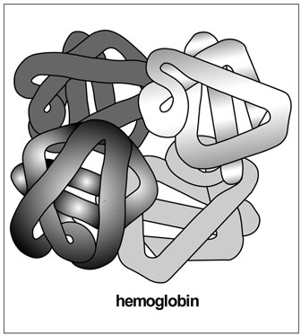more oxygen the hemoglobin is carrying, the brighter red the blood. When the blood is carrying carbon dioxide rather than oxygen— when deoxygenated blood is returning from the tissues back to the lungs—blood takes on a dark maroon hue. The change in color is actually a result of a slight change in the three-dimensional conﬁguration of hemoglobin when it is carrying oxygen.

Hemoglobin itself is a combi- nation of a simple protein and an

organic structure that contains

iron ions. The protein, called a globin protein, contains four poly- peptide chains, which are short strings of amino acids, the build- ing blocks of proteins. In adults, the four chains normally come in two varieties: a pair of alpha chains and a pair of beta chains.

Figure 2.1 A Hemoglobin

Molecule. Hemoglobin is made up of four globin chains: two beta and two alpha chains. Within each globin chain sits one iron-containing heme group. The heme group binds oxygen for transport from the lungs to the body tissues. (Sandy Windelspecht/ Ricochet Productions)

Such hemoglobin is designated hemoglobin A. Each polypeptide chain is coupled with a separate iron ion, which is bound in a ringlike chemi- cal structure known as a heme group. This heme group is the part of hemoglobin that actually binds oxygen for transport through the bloodstream.

Each red blood cell contains approximately 300 million molecules of hemoglobin, and every one of those units can bind with a total of four oxygen molecules—one oxygen for each of the four heme groups. Hemoglobin does not always bind oxygen, however. It has a differential ability to bind oxygen, which means that it picks up oxygen when the oxygen content in surrounding tissues is high, as it is in the lungs, and drops off oxygen when the oxygen content in the surrounding tissues is low, as it is in the tissues. This relative oxygen concentration is known as partial pressure. This property makes hemoglobin an ideal oxygen transportation vehicle. The high partial pressure existing in the lungs stimulates hemoglobin to load up with oxygen, and the low partial pressure in tissues triggers hemo- globin to release it. Sometimes, particularly under conditions of high acid- ity in the blood or elevated temperature, the red blood cells’ afﬁnity for oxygen can drop. This can cause oxygen delivery to tissues to similarly drop. (The relationship between pH and oxygen is discussed further in the section on plasma.)

The blood is also an excellent carrier for carbon dioxide, a by-product of cell metabolism. As carbon dioxide enters the red blood cells at a tissue site, it lowers the hemoglobin’s afﬁnity for oxygen, which further facili- tates the discharge of oxygen into the tissues. Once in the blood, the car- bon dioxide mostly travels either bound to hemoglobin or as bicarbonate ions (HCO3−) that form when carbon dioxide is hydrated (combined with water). The majority of CO2 takes the latter form. Once the blood arrives at the lung, the bicarbonate ions revert to their original CO2 state and depart through the lungs. The hemoglobin drops off its carbon dioxide for a similar exit, and the hemoglobin is ready to accept oxygen once again.

Besides oxygen, hemoglobin can lock onto dangerous gases like car- bon monoxide (CO), a molecule that contains only one oxygen molecule, monoxide (carbon dioxide has two). Carbon monoxide is hazardous to human health because hemoglobin binds with carbon monoxide

molecules 200 times more readily than it does with oxygen molecules. Therefore, it preferentially binds carbon monoxide instead of oxygen, which can severely reduce oxygen ﬂow to tissues and can quickly become fatal. Cigarette smoke, as well as emissions from automobiles and many home heating systems, contains carbon monoxide. The potential for car- bon monoxide poisoning from this gas, which is colorless and odorless, has prompted health professionals to warn people against running a car in a closed garage and to recommend the use of carbon monoxide detec- tors to check for a buildup of the gas in a heated home.

##### White Blood Cells

White blood cells have a completely different function than red blood cells. White blood cells, or leukocytes, are part of the body’s defense team and can actually move out of the bloodstream to do their work in the tissues (Figure 2.2). Adults may have anywhere from 20 to 60 billion white cells

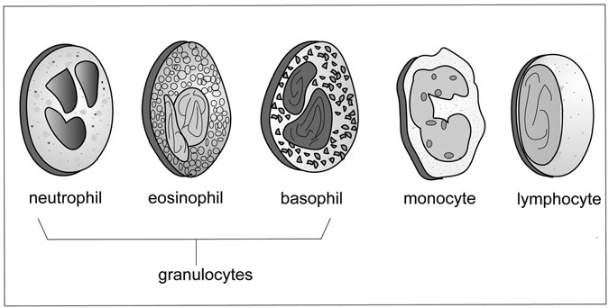

Figure 2.2 White Blood Cells. White blood cells come in three main types: granulocytes, monocytes, and lymphocytes. The granulocytes, so called because of their grainy appearance, include the neutrophils, eosinophils, and basophils. White blood cells are part of the body’s defense system against foreign materials and invading microorganisms. (Sandy Windelspecht/Ricochet Productions)

in the bloodstream, far fewer than the 25 trillion red blood cells in the human body. White blood cells come in three main types:

* Granulocytes, including neutrophils, eosinophils, and basophils
* Monocytes
* Lymphocytes

Granulocytes are the most abundant type of white blood cell, comprising 7 out of every 10 leukocytes. They are named granulocytes based on the grainy appearance of the cytoplasm, the part of the cell outside the nucleus but inside the membrane. All granulocytes also have distinctive lobed nuclei. Depending on which type of biochemical dye best stains them, granulocytes are further subdivided into neutrophils, eosinophils, or basophils. Neutrophils stain with neutral dyes, basophils stain with basic dyes, and eosinophils readily stain with the acid dye called eosin.

In addition to their different staining properties, the three types of granulocytes have separate functions. Neutrophils, the most common granulocyte with up to about 5.2 billion cells per quart (5 billion cells per liter) of blood, engulf and destroy small invading organisms and materials, which are collectively known as antigens. Averaging about twice the size of red blood cells, neutrophils are a main bodily defense mechanism against infection and are particularly suited to consuming bacteria. This process of engulﬁng and destroying bacteria and other antigens is called phagocytosis (Figure 2.3). The sequence of events begins with the human body recognizing that a foreign material has invaded. Antigens are different from the body’s own cells and trigger the body to enter its defense mode. If the infected site is within the bloodstream, the neutrophils remain there, but if the site is in the tissues, the neutrophils will ﬂow out through the capillaries to ﬂood the area of infection directly. Each neutrophil at the infected site stretches a bit of its tissue, called a pseudopod, toward and then around the invader. Once the invader is contained inside the neutrophil, an organelle called a lyso- some ﬁnishes the job by using its internal battery of enzymes and hydro- gen peroxide to digest the material. Usually, the neutrophils are able to kill the bacteria quickly, but sometimes the toxins in the bacteria are

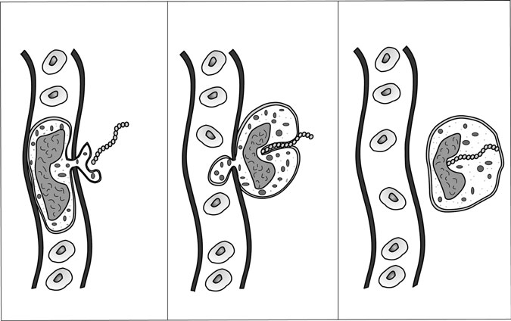

Figure 2.3 Phagocytosis. Leukocytes are primary players in the body’s defense mechanism. Here, a leukocyte protrudes from a blood vessel and surrounds an invading bacterium. Once the bacterium is engulfed, it is destroyed. This process of engulﬁng and destroying materials is called phagocytosis. (Sandy Windelspecht/Ricochet Productions)

fatal to the neutrophil. The result is pus, a mixture of mostly dead bacte- ria and leukocytes that perished during the battle.

Basophils, which are the smallest and least common type of white blood cells, appear to be active in the inﬂammatory process. While baso- philic activity is not fully understood, scientists do know that basophils release substances like histamine and serotonin. Histamine helps maintain a free ﬂow of blood to inﬂamed tissues, particularly by dilating blood ves- sels. Serotonin is similarly vasoactive. Basophil granules also contain hep- arin, which helps prevent blood from clotting.

The third group of granulocytes, the eosinophils, likewise demands additional study. Evidence indicates that they engage in minimal phagocy- tosis. Their primary tasks are to moderate allergic responses and to help destroy parasites. They accomplish the latter by using unique proteins that are toxic to speciﬁc invading organisms. Although they are not quite as

motile as the basophils and neutrophils, eosinophils do slowly travel through the body.

The second major type of white blood cell is the monocyte, the largest cell in the bloodstream. Monocytes are much larger than red blood cells, and have diameters of 3.9–11.8 × 10−4 inches (10–30 m). They are, how- ever, only temporary residents in the bloodstream, remaining in the blood for about three days before moving into tissues where they become macro- phages, large cells that engage in phagocytosis. Just as the neutrophils do, the highly motile monocytes latch onto invading organisms, then literally devour them with a mixture of highly reactive molecules. The neutrophils typically target smaller organisms, like bacteria, while the macrophages take on larger invaders, even protozoa, and also remove old cells and other detritus from the bloodstream.

Lymphocytes, the third major type of leukocyte, are the second most common white blood cell, but they frequently are not in the bloodstream, either. They usually reside in the lymph, a clear, yellowish ﬂuid that exists around and between cells in the body tissues. This ﬂuid, which is about 95 percent water, enters the bloodstream mainly through one of two ducts, and carries lymphocytes into the blood with it. Lymphocytes come in two main varieties: B lymphocytes, or B cells, and T lymphocytes, or T cells. Both B and T cells have antigen receptors on their cell surfaces. These receptors are highly speciﬁc. In other words, one particular form of lymphocyte can only bind to one type of foreign material, much as differ- ent keys ﬁt different locks. The speciﬁc area of an antigen to which the B cell receptor binds is called an epitope. (For more information on the functions of B cells and T cells, see Chapter 6 on the lymphatic system.)

##### Plasma

The circulatory system reaches just about everywhere in the human body, so the volume of plasma is fairly high. In fact, plasma makes up about 5 percent of a normal human’s body weight. Plasma itself is a solution of about 90 percent water, 7–9 percent proteins, and roughly 1 percent ions, which are either positively or negatively, charged molecules of such chemicals as sodium, calcium, and potassium. The remainder includes dissolved organic nutrients, gases, and waste products. Some textbooks

refer to the plasma as the extracellular matrix of blood. In other words, it is the portion of blood that lies outside the red and white blood cells, and that provides the blood’s liquid “structure.”

Plasma is mostly water, but it is the smaller ion and protein compo- nents that draw biologists’ interest. Their roles include regulating the blood’s volume and viscosity; maintaining the steady pH level required by the muscular, nervous, and other major physiological systems; facilitat- ing the transport of various materials; and assisting in bodily defense mechanisms, including the immune response and blood clotting.

Plasma proteins consist of albumins (the most abundant plasma pro- tein), globulins, and ﬁbrinogen, most of which are synthesized in the liver. The ions in plasma include both positively and negatively charged varieties. Sodium (Na+), calcium (Ca2+), potassium (K+), and magnesium (Mg2+) carry positive charges and are called cations (pronounced “cat-ions”). Anions (“ann-ions”) are negatively charged, and in the plasma include

chloride (Cl−), bicarbonate (HCO −), phosphate (HPO 2− and H PO −), and

3 4 2 4

sulfate (SO 2−). Most of the ions in the plasma of humans and other mammals are sodium and chloride. The general public is familiar with the two ions in their combined form of NaCl, or normal table salt.

4

Because blood vessels are permeable to water, water can move freely into and out of the blood. The more water in the blood, the greater the overall blood volume. A change in the concentration of different ions or proteins can play havoc with the amount of water in the blood, and too much or too little water can have damaging effects on a person’s health. The body’s ion and protein concentrations keep the blood volume from plummeting too low or rising too high. Plasma proteins and ions make up 10 percent or less of the plasma volume, but they are critical in regulating how watery the plasma, and thus the blood, is. Sodium chloride (NaCl) and sodium bicarbonate (NaHCO3) are the key ion regulators of the amount of water in the plasma, while the albumins are the primary proteins involved in the water content of the plasma. This system is based on a balance between the liquid inside the blood vessels and the liquid outside.

Osmosis is a process that seeks to equalize the water-to-solute ratio on each side of a water permeable membrane. In other words, if the water on one side of the membrane has twice as many dissolved materials, called solutes, additional water will move by osmosis across the membrane and

into the side with the higher solute concentration. This action adjusts the solute concentration so that the ratio of water to solutes on each side of the membrane is the same. In blood vessels, water likewise moves in and out based on the relative solute concentrations within and beyond the ves- sels. As it turns out, the water content in the circulatory system sometimes falls too low, because the sheer force of blood rushing away from the heart literally pushes water out of the smallest blood vessels, the capillaries. The system remains stable because plasma proteins and the albumin proteins, in particular, diffuse very poorly through capillary walls and therefore allow the osmotic pressure gradient to draw water back into the capillaries. Osmosis alone is not enough to maintain the proper solute concentra- tion in blood. Blood carries all kinds of solutes, including organic mole- cules like food, cholesterol and other fats, waste products, and hormones, yet the blood is not continually ﬂooded with water. The reason is that ions, speciﬁcally sodium, use pumps that reside in the membranes of the cells within the blood vessel to actively drive sodium molecules out of the ves- sels, leaving behind a lower concentration of solutes and, in turn, requiring less water to enter by osmosis. This balance between osmosis and ion

pumps is vital to regulating blood volume.

While the total amount of ions and proteins is important, the levels of individual ions and proteins are also signiﬁcant. For example, muscles and nerves respond to even slight changes in potassium and calcium ion concen- trations. Likewise, cell membranes rely on the right combination of cal- cium, magnesium, potassium, and sodium in their immediate environments. As mentioned, plasma proteins include albumins, globulins, and ﬁbrino- gen. Fibrinogen makes up only 0.2 percent of plasma proteins, with the remaining 99.8 percent split as 55 percent albumins and 44.8 percent globu- lins. As previously described, the albumins are involved in maintaining blood volume and water concentration, and some of the globulins serve as transpor- tation vehicles for a variety of molecules. Other important activities for glob- ulins include blood clotting and immune responses. The immune response of plasma proteins will be discussed here, and blood clotting in the next section.

(More details are available in Chapter 6 on the lymphatic system.)

Globulins come in three types: alpha, beta, and gamma globulins. The transferrin used in iron transport is a beta globulin. A variety of other beta globulins is collectively termed complement, and assist in the immune

system by binding to passing potential antigens. Beta globulins identify invaders by telltale structures on the cell surface that are different than those of the body’s own cells. Beta globulins are designed to grab onto these unusual structures, and they basically put a plug in the antigen’s active site that renders it harmless. Similarly, beta globulins can ferret out cells that have antibodies already attached. In this case, another part of the body’s immune response has already begun to mount a defense to the invading organism or foreign protein by creating the antibody. The beta globulins recognize the antibodies and attach to them. The captured cell then proceeds to the white blood cells for destruction.

Some plasma proteins, called immunoglobulins (Ig), go a step further and act as antibodies themselves. The ﬁve main types of these immuno- globulin antibodies are:

* IgA, which is found in bodily secretions, like saliva, tears, milk, and mucosal secretions
* IgE, which causes the snifﬁng and sneezing associated with hay fever and asthma, and also defends against parasites
* IgG, which helps battle infections and also confers mother-to-fetus immunity
* IgM, common to almost every early immune response
* IgD, which has an unknown function

Proteins within each type of immunoglobulin are similar in basic structure, but have a variable region speciﬁc to a particular antigen. (Details are available in Chapter 6 on the lymphatic system.) Another of the body’s lines of defense depends in part on plasma proteins. Blood clotting requires ﬁbrinogen, a soluble plasma protein; the beta globulins called prothrombin and plasminogen; platelets; and a slew of other molecules. The process is discussed in the next section.

##### Platelets and Blood Coagulation

Platelets, plasma proteins, vitamin K, and calcium all take their place in a quick-acting series of chemical reactions that result in blood coagulation,

or clotting. Clotting begins almost immediately after the wound occurs as platelets congregate at the site of the injury. Platelets, also known as thrombocytes, are not cells. Rather, they are sticky, disk-shaped frag- ments of large blood cells called megakaryocytes that reside solely in the bone marrow. These small cell fragments exist throughout the circula- tory system, with tens of millions in every droplet of blood. Their primary role is blood-clot formation. Because so many exist in the blood, a good supply of platelets usually is not far from the wound site.

The ﬁrst step in blood clotting is the release by the damaged tissue of a substance known as thromboplastin. As platelets arrive at the wound site, they disintegrate and release additional thromboplastin. Thrombo- plastin and calcium are both required to trigger the beta globulin called prothrombin to produce the enzyme thrombin. For the next step, the thrombin, platelets, and ﬁbrinogen, a soluble plasma protein, work together to help make a tight web of insoluble ﬁbrin threads that stick together and to the blood vessel wall. When blood cells encounter the web, they become trapped and form a blood clot. A scab is a dry, external clot. A bruise is a blood clot, too, but an internal one.

Although the coagulation process may seem complex, it happens very quickly. Small cuts are usually sealed within a couple of minutes, with an external scab hardening in place not long afterward. The yellowish ﬂuid sometimes remaining at the injury site is called serum. Although the term serum is sometimes used interchangeably with plasma, serum actually refers to plasma that no longer contains ﬁbrinogen or other clotting factors. Nor- mally, blood clots promote injury recovery by stopping blood loss, but that is not always the case. Clots that form within the blood vessels can be dan- gerous, because they can block blood ﬂow and oxygen transport. A stroke, for example, is the result of a blood clot in the brain. Fortunately, platelets normally do not stick to the smooth walls of healthy, undamaged vessels. Other fail-safes are heparin, which is found in basophils, and substances called antithrombins that turn off thrombin activity, effectively shutting down the coagulation machinery and preventing unnecessary blood clotting.

##### Blood Type

The preceding introduction to blood cells may give the impression that blood in all individuals is alike. It is not. The most obvious differences are

blood type and Rh factor: Human blood types, or groups, are type A, type B,

type AB, or type O, and Rh factors are deﬁned as either positive or negative.

Blood type refers to the presence or absence of chemical molecules on red blood cells. These molecules can instigate antibody reactions and are therefore antigens. Red blood cells can have one, both, or neither of the two antigens named “A” and “B.” Blood with only A antigens or only B antigens is called type A or type B, respectively. Blood with both A and B antigens is called type AB, and blood with neither is type O. People with type A blood are also born with beta (or anti-B) antibodies, which are designed to detect and eliminate B antigens. Likewise, people with type B blood have alpha (or anti-A) antibodies that assail A antigens. Type AB blood has both antigens but neither antibody, and type O blood has neither antigen but both antibodies.

This confusion of letters means that type A blood donors can safely give their blood to any person who does not have antibodies to the anti- gens in their blood, namely A. As noted in Table 2.2, the type A donor’s blood is compatible with the blood of recipients with type A or type AB. On the other hand, a person who has type A blood can receive blood don- ations from any person whose blood does not trigger a response from their own antibody contingent, beta. The table shows that type A persons can receive blood donations of type A and type O, because neither adversely reacts with the beta antibody in type A blood.

|  |  |  |  |  |
| --- | --- | --- | --- | --- |
| TABLE 2.2 |  | | | |
| Blood Types |
| *Blood type* | *Antigens present* | *Antibodies present* | *Can be donated to* | *Can accept donations from* |
| A | A | Beta | Type A, type AB | Type A, type O |
| B | B | Alpha | Type B, type AB | Type B, type O |
| AB | A, B | None | Type AB | Type AB, type A, Type B, type O |
| O | Neither | Alpha, beta | Type O, type A, Type B, type AB | Type O |

Blood type refers to the presence or absence of chemical molecules on red blood cells. These mole- cules, called antigens, can instigate antibody reactions. For this reason, medical professionals check blood compatibility before performing transfusions.

Reactions between mismatched blood can be severe. If type A blood from one person is given to another person with type B blood, the blood will clump due to a process called agglutination, as the alpha antibodies battle the B antigen. After clumping, the red blood cells will rupture in a process called hemolysis, which can lead to serious consequences, such as kidney dysfunction, chills, fever, and even death. For this reason, medical professionals compare blood type and Rh factor from a patient and a donor before proceeding with a transfusion.

Type AB-positive blood is frequently called the “universal recipient.” Type AB blood has neither alpha nor beta antibodies, which means that any blood can be introduced without the chance of an antibody attack by the recipient’s blood. The recipient does not have to worry about antibodies from the donor blood, because the amount of donated blood is small, becomes diluted in the recipient’s blood, and presents no threat.

At the opposite end of the spectrum, type O blood is known as the “universal donor.” It has neither the A nor B antigens, and therefore can be administered with little fear of agglutination. Nonetheless, medical professionals still take precautions to ensure blood-transfusion compati- bility by mixing donor and recipient blood and watching it closely for adverse reactions. The reason for the wariness is that A and B are not the only antigens. Sometimes, blood contains less common antigens that can bring about agglutination and cause problems for the patient.

#### Blood Vessels: The Transportation System Within

As previously described, the blood is not just red liquid. It is ﬁlled with millions of cells, each with a speciﬁc job to do. Likewise, blood vessels are much more than a simple series of pipes to contain and route blood. Blood vessels are living, dynamic tissues with complexities all their own. The circulatory system in a single adult human being comprises some 60,000 miles of blood vessels. Most people can see at least a few of them just under the skin of the wrist. The vast majority is much smaller than those visible vessels, and has diameters of less than one three-thousandths of an inch (about 10 microns). Blood vessels are associated with one of three major groups: the arterial system, the venous system, or the capillary system.

Whenever blood is moving away from the heart, either to the body tissues (systemic circulation) or to the lungs (pulmonary circulation), the arterial system is involved. The capillaries take over when the blood reaches its des- tination, and serve as the exchange vessels between the blood and the lungs, or between the blood and the body tissues. When the exchange is complete, the blood moves from the capillaries into the vessels of the venous system, which directs the blood back to the heart to begin another route either to and from the lungs, or to and from the body tissues.

All three types of vessels, then, participate in the circuitous path of the blood from the heart to the lungs and back to the heart, and from the heart to the other body tissues and back. The heart-to-lungs-to-heart path is called the pulmonary circulation and serves to allow the blood to pick up oxygen. The heart-to-body tissues-to-heart circuit is called the systemic circulation and allows tissues to take up oxygen and other materials trans- ported in the blood. Overall, the blood travels more or less in two loops, one from the heart to the lungs and back, and a second from the heart to the body tissues and back to the heart.

#### Arterial System

The main function of the arterial system is to carry blood away from the heart and either to the lungs to pick up oxygen, or to other body tissues to drop off nutrients, oxygen, hormones, or other needed substances. Like a river system that has main branches from which diverge many smaller side creeks, the arterial system has main branches called arteries and many diverging, smaller vessels called arterioles (Figure 2.4). The major arteries provide quick, direct routes to major body areas, and smaller arteries divert blood to more speciﬁc sites. Separating from the arteries, the arteri- oles bring blood to speciﬁc target tissues. The arterial system works much as a road system does: travelers use superhighways to get quickly to a gen- eral region, then take smaller freeways and ﬁnally side roads to reach a speciﬁc destination. In the case of the arterial system, the blood moves along main arteries, then into smaller arteries and even smaller arterioles. The speciﬁc destination of the blood cells is a set of capillaries in the lungs or in some other body tissue. For more information on a dangerous condi- tion associated with the arteries, please read Sidebar 2.1.

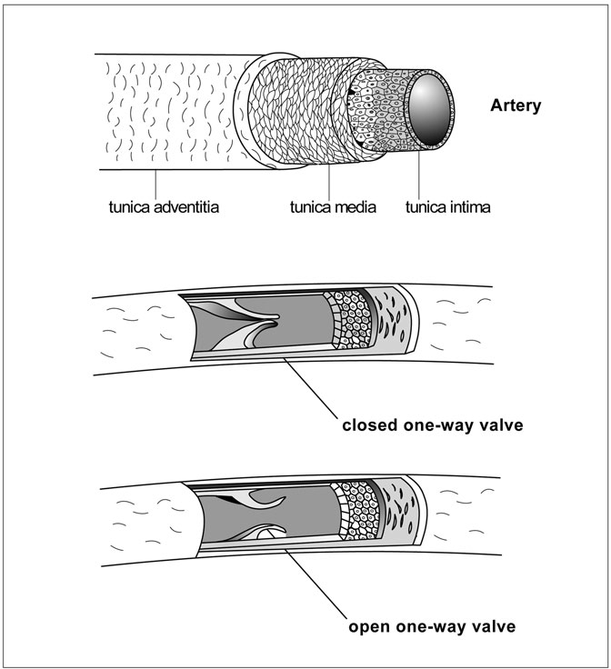

Figure 2.4 Arteries and Arterioles. Arteries and arterioles have three layers. The outer layer, called the tunica adventitia, is made of ﬁbrous connective tissue and loosely holds the vessel in place. The middle, or tunica media, is a thick, muscular, elastic layer. The inner layer, or tunica intima, is a one-cell-thick layer of endothelial cells. Many of the larger blood vessels contain valves that open when blood is pulsing forward and close against any back ﬂow. This ensures a unidirectional blood ﬂow. (Sandy Windelspecht/Ricochet Productions)

SIDEBAR 2.1

#### Reducing the Risk Factors for Coronary Artery Disease

The leading cause of death in the United States is coronary artery disease (CAD), according to the National Heart, Lung, and Blood Institute. It is estimated that every year, over 500,000 Americans die from this disease.

CAD, also known as coronary heart disease, occurs when plaque builds up inside the arteries that supply the muscles of the heart with blood. This plaque buildup makes it harder for blood to get to the right areas of the heart. Plaque is composed of substances found in the blood, like fat and cholesterol. Plaque buildup results in a condition called atherosclerosis.

Certain factors increase the risk of developing CAD:

Overweight or obesity: Extra body weight from bone, fat, and/or water (overweight), or a high amount of extra body fat (obesity).

Unhealthy cholesterol levels: High LDL cholesterol (also known as bad cholesterol) and/or low HDL cholesterol (good cholesterol).

High blood pressure: Blood pressure that stays at or above 140/ 90 mmHg over a period of time is considered too high.

Smoking: Smoking can cause numerous risk factors. It can damage and tighten blood vessels, increase cholesterol levels, and inhibit oxygen from reaching certain tissues in the body.

Diabetes: In people with diabetes, the body’s high blood sugar level means that it cannot use the hormone insulin properly or produce enough insulin.

A sedentary lifestyle: Lack of physical activity can exacerbate these and other risk factors, such as obesity and overweight.

Age: The risk of CAD increases with age. For men, this risk increases after age 45, and for women, the risk increases after age 55. During middle age, signs or symptoms of CAD can begin to present, particularly if there are genetic and lifestyle risk factors.

Genetic risk factors: Having a family history of CAD increases the risk of CAD.

##### Vessel Composition

Arteries and arterioles are more complicated than they might seem at ﬁrst, and that complexity begins with the structure of the vessels themselves. Arteries and arterioles are made of three concentric layers: the tunica adventitia, the tunica media, and the tunica intima. The tunica adventitia coats the outside of an arterial vessel and is made of ﬁbrous connective tissue that loosely holds the vessel in place. In the larger arteries, the adventitia also holds a number of small blood vessels of its own. These small vessels, called vaso vasorum, provide nourishment to the thick vessel walls.

The thickest of the three layers is the tunica media, which is the muscu- lar and elastic middle layer of vessel walls. This layer allows the large arteries to expand and contract in tune with the waves of blood accompany- ing each beat of the heart. Widening slows the blood ﬂow and narrowing quickens it, so the combined action helps to moderate the blood’s speed. Elastin, a protein that has six times the spring of rubber, provides the vessels’ elasticity and allows the vessels to stretch wide as a pulse of blood arrives. A much stiffer protein, called collagen, prevents the vessels from expanding too much. Stretching is essential for arteries lying close to the heart, where the force of the heart’s pumping on blood ﬂow is most strongly felt. Here, arteries distend to take the brunt of each blood rush, then recoil to create a more even blood ﬂow to subsequent areas of the circulatory system. As might be imagined, these arteries contain a higher percentage of elastin than other vessels further down the line in the systemic circulation.

For the contraction of arteries, the spindle-shaped, smooth muscle cells of the tunica media take over. Overall, the body has three types of muscle: smooth, striated, and cardiac. Striated muscles are those that a person can consciously control. Leg muscles are an example. A jogger or walker can control the muscles to speed the pace or to slow down. Smooth muscle, on the other hand, is controlled mainly by the autonomic nervous system, which means that these muscles work involuntarily or outside of a person’s will. Unlike striated muscle that tires rather quickly (as any jogger will attest), smooth muscle can continue working for long periods of time. The tunica media, or middle layer of the vessels, has smooth muscle, which wraps around the vessel rather than running its length and is responsible for contracting arteries.

When the smooth muscle tightens and decreases a vessel’s diameter, blood pressure rises because the blood is forced through a narrower open- ing. The effect is similar to that achieved by holding the thumb partially over the water ﬂow at the end of a garden hose. The decreased diameter of the hose at the point of constriction (the thumb) increases the water pressure. As stated earlier, the arteries closest to the heart have the most elastin to slow the strong pulses of blood leaving the heart. They also have the least smooth muscle. In contrast, vessels farther away from the heart have a higher proportion of smooth muscle to control vessel diameter and help keep the blood moving. The innermost layer of the blood vessel is the tunica intima, which is also known as the endothelium. This layer has direct contact with the blood that runs through the artery or arteriole. Although it is only one cell thick, the tunica intima’s ﬂat and smooth cells are important in imposing a barrier of sorts and preventing the passage of plasma proteins out of the blood. In arteries that connect with the heart, the tunica intima has a thin, ﬁbrous layer that blends seamlessly with the heart’s inner lining, known as the endocardium.

##### Systemic Circulation

The blood entering the aorta from the heart has just been to the lungs, so it is fully oxygenated and bright red. As just described, the aorta is highly elastic and can distend greatly to accept the powerful rush of blood pumped from the heart. As the aorta returns to its original size, the blood moves out in a more even ﬂow. Although the blood eventually ﬂows very smoothly, the pulse can be felt by pressing on some areas of the body where main arteries run close to the skin surface. For example, nurses typically determine a patient’s heart rate by feeling the wrist, or the radial pulse site, and counting the number of pulses over a set period of time. A normal resting adult’s heart rate is about 70 beats per minute. The rate is typically lower in adult athletes and higher in children. Other major arterial pulse sites include:

* Temporal, in front and slightly above the ear
* Facial, along the lower jaw
* Carotid, beside the windpipe in the neck
* Brachial, on the inside of the elbow
* Femoral, on the upper thigh beside the groin
* Popliteal, on the back of the knee
* Posterial tibial, on the inner ankle
* Dorsal pedal, just above the toes on the upper foot

The aorta is a large, arched artery that originates at the heart, where it connects to the lower left heart chamber, called the ventricle. From there, it continues down the trunk of the body. All of the major arteries in the human body branch off of the aorta. Using the analogy of a road system, the aorta would be the main superhighway through which all outgoing (systemic) trafﬁc has to pass. The highways that divert from it would represent the major arteries. These major arteries supply blood to all of the main body regions, including the limbs, head, and body organs. The arterioles are the side roads that bring the blood to speciﬁc locations throughout the body.

Two major arteries parting from the aortic arch are the right and left coronary arteries, which provide blood to an important body organ, the heart. These two arteries further subdivide. The left coronary artery splits into a circumﬂex branch that runs behind the heart and an anterior descending branch that curves forward over the heart. These two branches mainly supply the left ventricle and left atrium, which is the heart’s left, upper chamber. The right coronary artery and its posterior descending branch deliver blood mainly to the right side of the heart, which has its own ventricle and atrium. In addition, both the left and right coronary arteries supply blood to the septum. The septum is the interior wall between the right and left ventricles.

All of the blood pumped from the heart into the aorta in one contrac- tion is called the total cardiac output or stroke volume. Because the heart is such a hard-working organ, it receives a rather large portion, about 5 percent, of the total cardiac output even when a person is resting. As will be discussed later, that proportion can change if a person is active or under some form of psychological or physical stress.

Blood travels to the head via two major vessels called the left and right common carotid arteries. The left carotid splits directly from the aortic arch between the bases of the two coronary arteries. The right carotid indirectly branches from the aorta via a short vessel, called the brachiocephalic (or innominate) artery. The brachiocephalic artery also feeds the right subcla- vian artery, which is discussed below. Each of the two carotids splits into internal and external carotid arteries, which are the principal arterial vessels of the head and neck.

Other arteries that branch from the aorta soon after it leaves the heart include the right and left subclavian arteries. Like the right carotid artery, the right subclavian artery divides off of the brachiocephalic artery. Each subclavian artery supplies an arm. They earned the name subclavian because their paths to the arms run beneath the collarbone, or clavicle. Blood ﬂow continues down the length of the arm through the brachial artery and into the ulnar arteries and radial arteries of the forearm.

As the aorta travels down the spine, it is called the thoracic aorta in the chest, or thorax, and then becomes the abdominal aorta. Along the way, it supplies blood to various internal organs, such as the kidneys, spleen, and intestines. Each of the two kidneys, for example, gets its arterial blood sup- ply from a renal artery that separates from the aorta. The renal artery splits into smaller and smaller vessels, eventually leading to a round cluster of capillaries, which is called the glomerulus. Fully 25 percent of the total cardiac output goes through the renal arteries to the pair of kidneys. These two organs not only excrete waste products through the urine but also have important roles in regulating the amount of water in the blood, as well as its pH level (a measure of acidity/alkalinity) and electrolyte content.

Some of the other major organs and systems receiving blood from the aorta—in this case, the abdominal artery—are the spleen, which is fed by the splenic artery; the liver, which gets its blood via the hepatic artery; and the digestive system, which is supplied by a number of arteries, includ- ing the gastric, gastroepiploic, superior and inferior mesenteric, sigmoidal, and colic arteries.

Many of the arteries’ names come from the medical names of their destination. The renal artery is named for the renal, or kidney, system; the ulnar and radial arteries ship blood to the area surrounding the ulna and radius, which are bones in the forearm; and the superior mesenteric

artery supplies the region around the intestinal membrane, which is known as the mesentery.

The abdominal artery ends when it bifurcates into the left and right common iliac arteries, each of which soon divides again into internal and external iliac arteries (sometimes called hypogastric arteries). From each of the internal iliac arteries come various arteries that supply blood to the pelvic area, including the reproductive organs. The external iliac artery becomes the femoral artery when it enters the thigh.

Continuing with the leg, the femoral artery of the thigh becomes the popliteal artery at the knee (popliteal is a medical term for the back of the knee), then divides into the posterior and anterior tibial arteries (the tibia is a bone in the lower leg).

As described previously, the arterioles-to-capillaries-to-venules route is the most common pathway for blood. However, the arterioles in a few tissues never connect with capillaries, instead attaching to venules by way of wide vessels called arteriovenous anastomoses. These muscular vessels, which range from 7.9 × 10−4 to 5.3 × 10−3 inches (20–135 µm) in diameter, are common in the skin and in the nasal mucosa (in the nostrils), and regulate body temperature. Heat from the body’s core is transported via the blood to these areas for release to the outside.

##### Pulmonary Circulation

Pulmonary circulation is less complex than systemic circulation because the only target organ for the arterial system is the lungs. There, the blood picks up the oxygen that it will eventually deliver to the body through the systemic circulation, which was just discussed.

Unlike the systemic arterial circulation, which heralds from the heart’s left ventricle at the aorta, the pulmonary arterial circulation begins with the right side of the heart and the pulmonary artery. The pulmonary artery connects to the right ventricle, which is the smaller of the heart’s two ventricles. As the right ventricle contracts, it pushes blood into the pulmonary artery. The artery soon splits, and its two branches lead to either the right or left lung.

Just as blood in the systemic circulation moves from major to smaller arteries, and then to arterioles and capillaries, the blood in the pulmonary

system diverts into smaller and smaller vessels, ultimately ending at the capillaries. Once the blood enters these tiny vessels, it picks up the mole- cules of oxygen that are so important for cellular function. That process will be described in the section on the capillary system.

#### Venous System

On many levels, the venous system is the opposite of the arterial system. On the systemic side, the arterial system delivers blood away from the heart and to the tissues, and the venous system goes the other way, bringing the blood back to the heart. On the pulmonary side, the arterial system sends blood from the heart to the lungs for oxygenation, and the venous system sends the now-oxygen-rich blood back to the heart. Revisiting the road analogy, a traveler might leave a major city (the heart) via a superhighway (the aorta), then take a smaller highway (the arteries) and ﬁnally side roads (the arterioles) to get to a small town (the tissues) or other destination. To return to the city, the traveler would go in the opposite direction, beginning by taking the side roads, which are analogous to the venules; then the high- ways, or the veins; and ﬁnally the superhighway that leads into the city, or the heart. The venous system has two superhighways, which are two large veins called the superior vena cava and the inferior vena cava, which will be described later. (The plural of vena cava is venae cavae.)

Besides its role in returning blood to the heart, the venous system is a blood reservoir. Typically, about two-thirds of the body’s circulating blood supply is in the venous system. The veins and venules temporarily store blood that can be immediately transported to the other areas of the body as necessary. Exercise, for example, initiates a series of responses within the body that affect the circulatory system. One occurs when vasocon- strictor nerves send messages primarily to the veins that tell them to constrict. As they do, blood moves from the venous system to the heart, which in turn sends added oxygenated blood to the arterial system and facilitates the increasing need for oxygen in the working muscles. Simi- larly, when a person loses a large volume of blood through a serious wound, nerves signal a reorganization of the blood from tissues that are less important to immediate survival to those tissues that are vital in main- taining life. The venous vessels constrict in some areas, such as the skin or

the digestive tract. This forces blood to vessels in vital organs, such as the heart. The action not only preserves oxygenation to critical tissues, but also helps maintain the body’s overall blood ﬂow and helps ensure that the blood reaches its destination without delay.

Another important difference between the venous and arterial systems is the movement of the blood. Blood efﬁciently ﬂows through veins and venules even though the driving blood pressure is lower than it is in the arterial system. Blood pressure is measured in a unit abbreviated as mmHg. It refers to millimeters (mm) of mercury (Hg), the standard method of measuring pressures. Scientists measure pressure by watching its effect on mercury—the silver liquid in old-fashioned thermometers. If mercury is placed in a tube, an increase in pressure will cause the mercury to expand and rise. A pressure decrease results in a drop of the mercury level. A reading of 120 mmHg means that the pressure in the aorta is enough to raise a column of mercury by 120 mm above the zero point, which is normal atmospheric pressure.

In the venous system, just 10–15 mmHg pressure is enough to force blood all the way from the venules back to the heart. This is about half of the average pressure of 30 mmHg seen even in the small arteries. The venous system can function on the lower pressure, which nears 0 mmHg (atmospheric pressure) by the time it gets to the heart, in part because the branching of the venous system is going in a direction opposite to that of the arterial system. Instead of an aorta that branches into smaller arteries and then miniscule arterioles—and slows as it goes—the venous “river” does the opposite. Blood from perhaps dozens of tiny venules merges into a slightly larger venule. When it does, the blood rate increases because the overall lumen (interior diameter) of the larger venule is still less than the combined lumens of all the smaller venules feeding into it. In other words, blood from a bigger space is squeezing into a tighter space. The same thing happens when venules merge into one small vein, or when numerous veins merge into the vena cava. The ﬂow accelerates along the way much as a river’s current hastens as new creeks join it.

The elasticity of the large and small venous vessels is also opposite to that of the arterial vessels. Whereas the largest arteries are the most elastic to tame the pulses of blood from the heart, the largest veins are the most rigid to help maintain or boost the blood ﬂow. Conversely, the most

distensible vessels on the venous side are the venules, which readily expand to serve as blood reservoirs.

The venous and arterial systems have other similarities and dissimi- larities, too, and these will be discussed in the next sections.

##### Vessel Composition

Veins and venules have a three-layered structure much like that of arteries and arterioles (Figure 2.5). Each of these vessels has the same three layers: the tunica adventitia on the outside, the tunica media in the middle, and the tunica intima lining the inside. Just as in the arterial vessels, the mus- cular and elastic tunica media is the thickest layer in veins and venules and includes both elastin and muscle tissue to allow the vessel openings to expand and constrict. The elastin protein gives the vessels their stretch and slows the blood moving through them, while the smooth muscle cells contract and narrow the vessels’ openings to urge the blood’s pace.

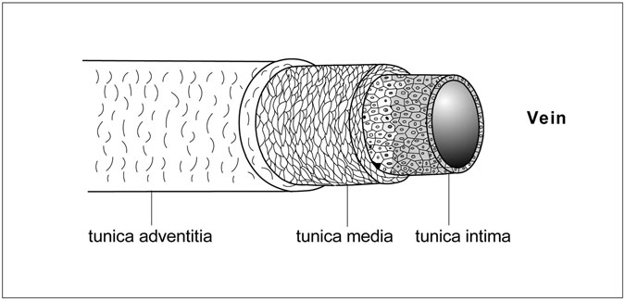

Figure 2.5 Veins. Veins and venules have a three-layered structure: the tunica adventitia on the outside, the tunica media in the middle, and the tunica intima lining the inside. The main difference between these vessels and those of the arterial system is in the middle layer. The veins and venules have a thinner tunica media with a higher collagen content and with fewer muscle cells that are commonly in a less-ordered arrangement. (Sandy Windelspecht/Ricochet Productions)

Collagen in this middle layer helps to rein in the vessels’ elasticity and yields structural strength.

The tunica adventitia, or outer layer, of veins and venules is a covering of connective tissue. Its job is to hold the vessel in place. The innermost of the three layers, or the tunica intima, is a one-cell-thick sheet of endo- thelial tissue.

So far, this description of the composition of veins and venules is the same as that for arteries and arterioles, but differences do exist. In the arterial system, the delineations between the three layers are much more dis- tinct than they are in the venous system. The transition in venules and veins is rather gradual. In the arteries and arterioles, the smooth muscle cells of the tunica media wrap around the vessels in a very regularly arranged fashion. The veins and venules have a thinner middle layer with fewer muscle cells that are commonly in a less-ordered arrangement. This would result in a severe lessening of their mechanical strength were it not for their high collagen content. The additional collagen typically seen in veins and venules also limits the vessels’ elasticity somewhat. As seen in the arterial system section, arterial vessels, especially the larger arteries, must distend to even out the strong blood pulses from the heartbeat and regulate the blood ﬂow. There is no similar demand on veins and venules, but they do need to stretch out enough to accommodate the temporarily stored blood they are holding. In effect, veins and venules are striking a balance between stretch- ing to hold up to 70 percent of the body’s blood and remaining inelastic enough so that they can maintain a sufﬁcient ﬂow to transport the blood back to the heart.

Venous blood faces other challenges on its way back to the heart. The force of gravity discourages blood ﬂow. In a standing individual, the blood in the feet has to overcome the gravitational pull to ﬂow up the leg and back to the heart, and it does it without the heart’s pumping action to help it along. While ﬁghting gravity, the blood also must ﬂow into increasingly bigger vessels, which would seemingly have the effect of slowing blood ﬂow. In large part, blood can overcome these obstacles for the same reason that venules develop a ﬂow with the inﬂux of capillaries: Blood is still moving from a larger space to a smaller space. Because so many smaller vessels feed a larger vessel, the combined cross-sectional area of the

smaller vessels is greater than that of the larger vessel, and blood ﬂow actually speeds up as it approaches the heart. In addition, venous vessels become stiffer as they get closer to the heart, because their collagen con- tent is greater. This ensures that the vessels will not distend and therefore will not create a larger space for blood or slow the blood rate.

##### Systemic Circulation

The systemic side of the venous system begins at the capillaries and ends at the heart. The capillaries are the site of blood-to-tissue transfer of nutrients and other materials, including oxygen. Once that oxygen and nutrient transfer has occurred at the tissues, the venous system takes over to collect the blood from the capillaries and convey it back to the heart. Oxygenated blood in the arterial system is bright red, because oxygen causes a change in the three-dimensional conﬁguration of the large com- pound called hemoglobin that is found in red blood cells. Without the oxy- gen, the blood appears dark maroon. For this reason, blood leaving the capillaries—after the oxygen drop-off—is more blue than red. The ven- ules are the ﬁrst vessels in the return of blood from the capillaries to the heart. A typical venule has a lumen of about 7.9 × 10−4 inches (20 µm) with a vessel wall that is about 7.9 × 10−5 inches (2 µm) thick. This com- pares to the average arteriole, which has a like-sized lumen but a wall thickness of 5.9 × 10−4 inches (15 µm). Many capillaries, which are about a quarter of the size of a venule, may empty into a venule, and, as already described, this onslaught helps to generate an increased ﬂow. From there, smaller venules merge into larger and larger venules, and eventually into small veins. Although the size varies considerably, a typical vein has a lumen of around 0.197 inches (5 mm or 5,000 µm). Its wall thickness averages about 0.02 inches (0.5 mm or 500 µm). When looking at the cir- culatory system as a whole, the venous vessels often have arterial counter- parts, with blood ﬂowing out to the tissue in an artery and back to the heart in a nearby, sometimes adjacent, vein.

This chapter will now provide a closer view of some of the major veins in different body areas, beginning with the leg. Blood from the foot may ascend into the anterior tibial vein, which is named for the tibia (one of the lower leg

bones). Veins in the ankle and numerous capillaries in the leg empty ﬁrst into peroneal veins, which are also known as ﬁbular veins because of their loca- tion in the region of the ﬁbula (the other lower leg bone), and then into the posterior tibial vein, which eventually unites with the anterior tibial vein. Both the anterior and posterior tibial veins, which also accept blood from numerous other capillaries in the lower leg, ﬂow into the popliteal vein at the back of the knee. The popliteal vein, in turn, empties into the femoral vein, a large vessel in the thigh (alongside the large upper leg bone, or femur). Blood from the foot can also take a more direct route to the femoral vein by way of the great saphenous vein, the longest vein in the human body.

Regardless of how it reaches the femoral vein, all of this blood ﬂows into the external iliac vein. Now in the abdomen, blood from the external iliac vein joins with the internal iliac vein, which carries blood from the pelvis to form the common iliac vein. This vein joins the large inferior vena cava, one of the two “superhighways” in our road system bringing blood back to the heart.

Many other major veins in the abdominal cavity empty directly or indirectly into the inferior vena cava. Within the blood supply for the reproductive system, for example, the female body has a pair of ovarian veins, and the male body has a pair of spermatic veins. Both the right ovar- ian vein and the right spermatic vein connect directly to the inferior vena cava, but the left ovarian and spermatic veins ﬁrst merge with the left renal (kidney) vein, which then unites with the inferior vena cava. The female’s uterine veins take a more convoluted route to the inferior vena cava, ﬁrst merging with the internal iliac vein that unites with the common iliac vein, and ﬁnally joining the inferior vena cava.

Other major body areas that use the inferior vena cava include the kidneys, liver, spleen, digestive system, and pancreas. The renal veins of the kidneys and the hepatic veins of the liver empty directly into the inferior vena cava. The liver performs a vital function because it absorbs products that the blood has gained from the digestive system. For example, the liver absorbs glucose (a sugar that results mainly from starch digestion) and uses much of it to make glycogen, which is basically a storable form of glucose. When the body needs extra energy, the glycogen transforms back into glucose.

Blood from the spleen takes a less direct route to the inferior vena cava. It drains from the spleen via the splenic vein, which joins the

superior mesenteric vein to create the portal vein. The portal vein empties into the liver. Venous blood leaves the liver through the hepatic veins, as previously described, and discharges into the inferior vena cava.

The digestive system has many veins emptying the intestines, rectum, stomach, and other speciﬁc areas. These veins include the rectal, pudendal, lumbar, superior and inferior mesenteric, gastric, gastroepiploic, and epigastric veins. Each has its own path to the inferior vena cava. As an example, the rectal veins number three: the inferior, middle, and superior rectal veins. The inferior rectal vein joins the internal pudendal vein, which ﬂows into the internal iliac vein, while the middle rectal vein connects directly to the internal iliac vein. The internal iliac vein then continues to the common iliac vein, which ﬁnally unites with the inferior vena cava. The superior rectal vein avoids the internal iliac vein altogether and instead drains into the inferior mesenteric vein, which ﬂows into the splenic vein, then to the superior mesenteric vein and portal vein, through the liver, into the hepatic vein, and to the inferior vena cava. As the inferior vena cava returns blood from the lower body to the heart, another superhighway is doing the same for the upper body. This large vein is the superior vena cava, which gathers blood from the arm, chest, head, and neck regions.

The arm’s arrangement is somewhat similar to that of the leg. The veins, of course, are named differently to reﬂect the speciﬁc body area in which they are found. Veins in the hand ﬂow into the radial vein, the ulnar vein, or the basilic vein. The radial vein eventually merges into the ulnar vein, which then continues into the brachial vein in the upper arm. The basilic and brachial veins ﬂow into the axillary vein that carries blood into the chest. Just as some blood from the foot can patch nearly directly into the femoral vein via the long saphenous vessel, some of the blood from the hand can drain through a long cephalic vein right to the axillary vein of the upper arm. The axillary vein ﬂows into the subclavian vein and then the brachiocephalic vein (also called the innominate vein) of the upper chest.

The head and neck region have several major veins, but the most well known are the jugular veins, which accept blood from the brain, face, and neck. These veins ﬂow into either the subclavian or brachiocephalic veins. One of the three jugular veins, the internal jugular vein, is the largest venous vessel in the head and neck. This vessel actually merges with the subclavian vein to form the brachiocephalic vein of the upper chest. Blood

from tissues of the chest muscles, from the thyroid gland, and from the diaphragm also either directly or indirectly release into the brachioce- phalic vein. The brachiocephalic vein drains into the superior vena cava. The ultimate destination of both superhighways—the inferior vena cava and the superior vena cava—is the heart. Speciﬁcally, they deliver blood to the right atrium of the heart.

##### Pulmonary Circulation

Like the arterial system, the pulmonary side of the venous system is much simpler than the systemic side. Just two major veins are involved: the bronchial vein and the pulmonary vein. Most veins are single or paired, but the pulmonary veins are actually four vessels that ﬂow directly from the lungs to the left atrium. These veins return newly oxygenated blood from the lungs to the heart. The bronchial veins, on the other hand, drain blood of the bronchi and a portion of the lungs, then travel through one or more smaller veins to reach the superior vena cava, which brings blood into the heart’s right atrium.

#### Capillary System

Although the capillaries are the smallest vessels in the circulatory system, they represent the main exchange site between the blood and the tissues (Figure 2.6). They can be viewed as both the ultimate destination of the arterial system and the starting point of the venous system. From the heart, blood travels through the arteries to the arterioles, and then to the capilla- ries, where exchange occurs. Nutrients, oxygen, and other materials carried by the blood are traded for waste products from tissue cells. Blood contin- ues down the capillaries, soon entering the venules and then the veins on its return trip to the heart.

##### Vessel Composition

Capillaries have a composition that is somewhat different from that of other circulatory vessels. As already described, arteries, arterioles, veins, and venules have a three-layered construction, including elastic tissue

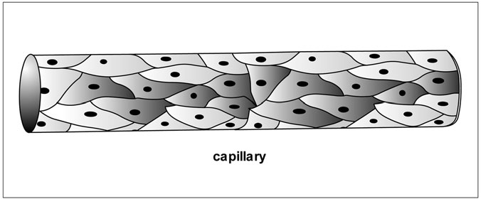

Figure 2.6 Capillaries. Capillaries have an important function in exchanging gases and materials between blood and tissues, but their composition is quite simple. A capillary is basically a tube comprised of a single layer of epithelial cells. (Sandy Windelspecht/Ricochet Productions)

and smooth muscle. Capillaries, in contrast, are composed of just a single layer of endothelial cells, which gives them a wall thickness of just 2.0 × 10−5 to 3.9 × 10−5 inches (0.5–1 µm). Their internal diameter, or lumen, is about 1.6 × 10−4 to 3.9 × 10−4 inches (4–10 µm). That is a tight ﬁt for red blood cells, which range from 2.6 × 10−4 to 3.5 × 10−4 inches (6.5–

8.8 µm) in diameter. To squeeze their way through these tiny vessels, red blood cells travel in single ﬁle (a so-called bolus pattern), and when that is not enough, they bend, twist, partially fold, and otherwise deform. At the same time, the capillaries distend to allow the blood cells to pass through them. It is a tortuous pathway, but it is a short one: Capillaries are typically just 0.02–0.039 inches (about 0.5–1 mm) long.

Capillaries come in three types:

* Continuous
* Fenestrated
* Discontinuous or sinusoidal

Continuous capillaries are constructed of epithelial cells that overlap tightly, leaving no gaps between them. They are present in the skin, muscles, and

lungs as well as the central nervous system (the brain and spinal cord), and are the least permeable type of capillary. Only those substances with molecular weights of less than 10,000 can easily cross them. They are par- ticularly important in what is known as the blood-brain barrier. This barrier prevents damaging substances from being transmitted from the circulating blood to brain tissue and to the watery cerebrospinal ﬂuid that cushions and protects the brain and spinal cord. Although continuous capillaries gen- erally permit only small molecules to traverse them, even large molecules with molecular weights of up to 70,000 can make their way across, given enough time. Scientists believe this is accomplished through temporary openings that may occasionally form between epithelial cells.

Unlike continuous capillaries, fenestrated capillaries are always full of holes. The endothelial cells overlap much less tightly, creating gaps. In addition, they have numerous pores, or fenestra (literally, “little windows”), of 2.0 × 10−6 to 3.9 × 10−6 inches (50–100 nm) in diameter. These openings greatly increase the capillaries’ permeability, making them particularly useful in tissues that exchange a great deal of ﬂuid and metabolites with the blood. Fenestrated capillaries are common in such tissues as the kidney and the intestinal villi, which are tiny projections that serve as the nutrient exchange point for the intestines.

Discontinuous or sinusoidal capillaries are large capillaries with aper- tures so wide that bulky proteins and even red blood cells can pass through them. Of the three types of capillaries, they are the most permeable to water and solutes. They are found in such tissues as the liver, spleen, and bone marrow.

##### Exchange Function

The exchange of water, oxygen, nutrients, hormones, drugs, waste prod- ucts, and other chemicals occurs primarily at the capillaries. Oxygen and carbon dioxide, which are gases, move by passive molecular ﬂow, a process called diffusion, right through the wall. An individual endothelial cell, like other cells in the human body, is surrounded by a thin membrane made of two fatty layers, the lipid bilayer. Substances that can pass through this layer are termed lipophilic (fat-soluble). Besides oxygen and carbon dioxide, other substances that can readily cross the membrane include some

drugs, like the general anesthetic a person receives before surgery. Actually, oxygen and other materials do not move directly from capillary to cell or vice versa. Instead, they ﬁrst enter a region just outside the cell. This ﬂuid-ﬁlled extracellular area is called the interstitial space.

The direction of diffusion is determined by the concentration gra- dient, which means that molecules travel from an area of high concentra- tion to one of low concentration. Transport from high to low concentration is described as moving down the concentration gradient. Therefore, if an arteriole delivers oxygen-laden blood to a capillary near oxygen-poor tis- sue, the oxygen (O2) will pass from the blood to the tissue, or from an area of high concentration to an area of low concentration. The same thing hap- pens with the waste product carbon dioxide (CO2), which accumulates in tissue. The carbon dioxide moves from the cell to the blood, or from an area of high concentration to an area of low concentration. The reverse likewise occurs in the lungs, when oxygen-poor blood arrives to pick up oxygen from and drop off carbon dioxide to the alveoli, the tiny air sacs in the lungs. In this case, the alveoli gather oxygen with every breath a person takes, then deliver it to the blood in the pulmonary circulation. Oxygen in the blood is carried by the large hemoglobin molecule, also known as a respiratory pigment. Each hemoglobin molecule can carry four oxygen molecules. Because red blood cells in the average adult num- ber from 24.8 to 28.6 trillion, and each red blood cell contains about 300 million molecules of hemoglobin, the potential for oxygen transport by the blood is immense. (See Chapter 10 on the respiratory system for more information about this process.)

The oxygen exchange between the capillaries and the alveoli, as well as other tissue cells, is possible because of their proximity to one another. The time it takes for a molecule to move is proportional to the square of the distance moved. The time quickly escalates as oxygen has farther to go. For this arrangement to work in the human body, an enormous number of capillaries is required—enough to place capillaries within 3.9 × 10−4 to 7.9 × 10−4 inches (10–20 m) of just about every cell—just one, two, or three cells’ diameter away. Some organs even have special networks or clusters of capillaries. In the kidney, the cluster is known as the glomerulus and facilitates the considerable volume of blood that ﬂows to and from this organ. The capillaries in the glomerulus are typically fenestrated.

(See Chapter 12 on the urinary system for more details.) Other tissues and organs that have a higher density of capillaries include the heart and skel- etal muscles, which are both very metabolically active and demand a highly proﬁcient transfer of gases and nutrients. In organs and tissues, such as joint cartilage, that are less active and less oxygen-demanding, fewer capillaries are necessary.

Of course, the body cannot rely solely on diffusion to get oxygen all the way from the lungs to every tissue cell. The pumping of the heart does much of the transportation, forcing the blood along the arteries, then more slowly into the arterioles, and, slower yet, into the capillaries. Blood is progressing so slowly in the capillaries that each red blood cell commonly takes 1–2 seconds to traverse it, ample time for diffusion to occur.

#### The Blood Circuit

Now that the basic components and functions of the arterial, venous, and capillary systems have been described, this section will take a closer look at how the blood makes the transit through those vessels.

##### One-Way Valves

Blood valves are located throughout the circulatory system. Just as a door marked “push” or “pull” only opens in one direction, these valves swing strictly one way. In the arterial system, blood rushes from the left side of the heart through a valve and into the aorta. As the heart beats, the valve swings wide to let the blood pass into the aorta. The blood ﬂow naturally slows when the contraction ends, and the valve swings shut. This prevents the blood from streaming back into the heart chamber.

Other large blood vessels have similar valves that open in just one direction. In the legs, for example, a pair of semilunar valves swing out- ward to the vessel walls, allowing blood to move past. Any reverse ﬂow causes the valves to close. Just as wind from outdoors may cause a door to swing open, but a breeze from indoors can quickly slam it shut, the valves allow blood to move one way, but not the other. This simple system ensures that deoxygenated and waste-ﬁlled venous blood doesn’t ﬂow backward and mix with the oxygenated, nutrient-ﬁlled arterial blood.

##### Blood Pressure

Systemic Circulation

Blood pressure is a key force driving the blood through the arterial system. Blood leaves the heart in the systemic circulation under a very high pressure caused by the heart’s contraction. On average, the blood pressure in the aorta reaches 120 mmHg following a heartbeat, then falls back down to 80 mmHg before the next heartbeat. This is often written as 120/80 mmHg. The 120 mmHg reading in the aorta immediately following a heart- beat is the highest pressure that blood reaches in the circulatory system. As the heart’s contraction ends, the blood pressure quickly drops. As seen earlier, the aorta and other large arteries have a high percentage of elastin, the protein that permits stretching. When the pulse of blood enters the aorta, that large vessel quickly distends, then slowly returns to its normal size. By doing so, it eases the blood pressure. Subsequent arteries do the same thing, although they become less and less elastic as blood moves farther from the heart. Every time a vessel widens, the pressure drops a bit. By the time the blood reaches the junction between the small arteries and arterioles, it has diminished to about 60–70 mmHg. At the arteriole-

capillary border, the blood pressure is just 35 mmHg.

Pulmonary Circulation

The pulmonary circulation begins with the beat of the right side of the heart, which is smaller and less powerful than the left side that drives the systemic circulation. Here, the pressure of the blood leaving the heart and entering the pulmonary artery is just 25 mmHg, which is still sufﬁ- cient to force the blood the small distance from the heart to the lungs. Between heartbeats, the pressure drops to about 10 mmHg. As in the sys- temic circulation, the pressure continues to decline as the blood travels from arteries to arterioles to capillaries.

The Return Trip

If the arterial system requires the force of the heartbeat to drive blood to the lungs and body tissues, what does the venous system use to propel the blood back to the heart? The answer has several parts.

As shown in the section on the venous system, the veins and venules greatly outnumber the arteries and arterioles. They are also oriented in

the opposite direction with blood ﬂowing from the smallest and most plentiful vessels into ever-larger but fewer vessels. In the arterial system, the total cross-section of the vessels (the sum of their lumens) increases as they get farther from the heart, which results in a slower blood velocity. This reliance of the ﬂow rate on cross-sectional area is illustrated in the mathematical equation:

velocity of the blood (mm/sec) = blood flow (mm3/second)/ cross-sectional area (mm2)

The velocity is the overall speed of the blood through a vessel, the blood ﬂow is the volume of blood that moves through a vessel, and the cross-sectional area is the size of the vessel’s lumen. The mathematical for- mula shows that velocity is inversely proportional to the cross-sectional area, so as cross-sectional area increases, the velocity decreases.

In the venous system, the vessels increase in size closer to the heart, but their number decreases dramatically, until the two large venae cavae are accepting blood from thousands of vessels throughout the entire venous system. The sum total of cross-sectional areas of smaller vessels greatly surpasses the area of larger vessels, which results in an increase in blood velocity. In summary, both the vessels of the arterial and venous systems are largest and least numerous near the heart, and smaller and more numerous away from the heart. The difference is in the direction of ﬂow. On the arterial side, blood is moving away from the heart and slows as it goes. On the venous side, blood is returning to the heart and speeds up as it approaches the heart. In addition, venous blood gets a little help in its return trip from the structure of the vessels, from muscles, and even from arteries. By the time blood makes its way through the arterial system and the capillaries, its pressure in the venules is just 15 mmHg and is nearly nonexistent by the time it reaches the venae cavae. With such little impetus to return to the heart, gravity would inﬂuence the blood to pool wherever the body is clos- est to the ground. This usually does not present a debilitating problem because venous vessels have the ability to deﬂate and reinﬂate with very little pressure applied to them, so even the small 15 mmHg gradient from venules to heart is sufﬁcient to urge the blood along. The arteries also help. Because arteries and veins are usually in close proximity, the strong pulses of blood that move from the heart and down the arteries put some

pressure on the adjacent veins and help circulate the blood. In addition, the venous blood near the heart gets an added incentive from the heart itself. As the heart’s valves open to allow in venous blood, suction results and actually draws the approaching blood into the waiting chamber.

The body’s skeletal muscles also help by contracting and relaxing, and pressing on venous vessels. This action squeezes the blood back to the heart through the re-inﬂated veins. This type of muscle action produces obvious results in an exercising person, but even when a person is quietly standing, these muscles are continually contracting and relaxing, and push- ing blood into veins. Valves in the larger veins assist as well. Once the blood makes its way partially up the leg, the valves prevent it from rushing back down. In the large leg veins, valves occur about every half inch (1.25 cm) along the vessel.

The legs are not the only parts of the body that have to contend with the effects of gravity. When a person stands up, about 16.9 ounces (500 ml) of blood shifts to the lower legs, so some pooling does occur. The volume of liquid lowers as plasma from the blood ﬁlters out of the vessels and into adjacent tissues. This causes an overall drop in blood volume, and the body responds by lowering cardiac output. As a result, less blood reaches other parts of the body, including the brain. Usually the body responds by quickening the heart rate, constricting the venous vessels in the legs, or using nervous control to decrease the amount of blood reaching the legs. When these steps are not enough, a person begins to feel light-headed. By putting the head between the knees—or, in extreme examples, by fainting—the head is lowered, making it much eas- ier for the blood to ﬁght gravity and reach the head.

##### Effect of Velocity on Capillaries

The blood’s ﬂow rate is also an important consideration in the blood-to- tissue exchange that occurs in the capillaries. Because of capillaries’ distance from the heart and the distance of the arterial vessels, as well as the large cross-sectional area of the capillaries, the blood’s velocity is so slow that blood cells barely creep through the capillaries. In fact, the blood’s velocity in the capillaries is less than 1/200th its speed in the aorta. The sluggishness provides ample time and optimal conditions for

diffusion of oxygen and other materials to occur. In most cases, blood cells take 1–2 seconds to traverse a capillary, a considerable time for a vessel that is just 0.02–0.039 inches (about 0.5–1 mm) long.

##### Control of Blood Flow

Although the circulatory system is similar to a road system in some regards with the vessels analogous to the highways and streets, the cardiovascular system is hardly passive. The blood vessels are alive and dynamic struc- tures that can change diameter and alter the ﬂow of the blood within them. As previously shown, the blood vessels contain smooth muscle. When contracted, these muscle cells can narrow blood vessels. When the contrac- tion ends, the blood vessel returns to its larger diameter, which is driven by the pressure of the passing blood. Even when the smooth muscle cells are

not contracting, however, they are imparting muscle tone to the vessels.

The mechanism for the control of this tone is called the Bayliss myo- genic response. Without this response to counteract the force of the blood pressure, the vessels would continue to stretch wider and wider, which would affect ﬂow.

Besides those in the peripheral venous system, other blood vessels change diameter to meet the needs of the body. These types of adjustments occur continually. For example, the brain requires a constant, sufﬁcient blood ﬂow. Oversight and maintenance of this ﬂow is the job of the arterial baroreceptor reﬂex, which responds to slight changes in blood pressure. In this case, the baroreceptors, which are pressure detectors located in the major arteries, sense a dip or spike in blood pressure. When pressure increases, the baroreceptors reﬂexively send a message that shuts down the vasoconstrictor center in the brain’s medulla, which is respon- sible for constricting blood vessels. With the vasoconstrictor center off- line, the blood vessels dilate and pressure drops. At the same time, cardiac output changes to meet demands and venous vessels likewise dilate. These actions collectively return blood pressure to normal. If, however, the blood pressure remains elevated, as occurs in a person with hypertension (high blood pressure), the baroreceptors become accustomed to the new, higher average pressure and stop sending messages to the vasoconstrictor center. As a result, the body no longer tries to rectify the higher blood pressure.

The arterioles play a vital role in controlling blood ﬂow. These vessels are often called resistance vessels because they offer resistance to and therefore regulate the ﬂow of blood from the heart. Due to the consider- able smooth muscle in the walls of these vessels, the lumen can change diameter to allow more or less blood to reach the tissues. In addition, the arterioles that feed capillaries, called terminal arterioles, take their cues from local metabolic factors rather than nerves. Each terminal arteriole serves as a door to its own little network of capillaries. Based on metabolic needs, the arteriole can close tight or open wide to regulate blood ﬂow.

Venous muscle tone is also important in peripheral venous vessels, which regulate blood volume by adjusting the amount of liquid in the plasma and in such tissues as the skin, muscles, and kidneys. These periph- eral vessels can thus act as blood reservoirs that can temporarily hold unneeded blood, which has a regulating effect on the overall blood supply. Hormones regulate blood ﬂow, too. Adrenaline is perhaps the most well- known hormone in this regard. When a person is under physical or mental stress, the body boosts adrenaline production. This hormone, as well as angiotensin II and vasopressin, helps to maintain a healthy blood pressure even under the most dangerous conditions, like severe blood loss. (Hormones

are discussed further in the endocrine system chapter in this encyclopedia.)

In addition to controlling blood ﬂow through muscles, hormones, and nerves, the body has fail-safes in certain organs, including the brain. Here, arteries and arterioles merge to create what are called arterial anastomoses. These are alternative sites where the organ can obtain blood if a supplying artery becomes blocked. The anastomoses essentially serve as backup blood sources for use in emergencies. (The arterial anastomoses are not to be confused with arteriovenous anastomoses, which are wide vessels found especially in the skin and nasal mucosa. These vessels bypass capillaries and attach arterioles and venules directly.)

#### The Heart: A Living Pump

Although it is only as big as a ﬁst, the heart drives the circulatory system. This organ works constantly over the course of a lifetime, pumping blood to the lungs in the pulmonary circulation and to all other body tissues in the systemic circulation. Even a short pause in its functioning can result

in death. This section will take a closer look at this amazing organ and how it carries out its job.

##### Anatomy and Blood Flow

The heart is truly a pump made of muscle tissue. Blood moves in and out of this pump through four chambers inside (see Figure 2.7). The two, smaller, top chambers are called atria (atrium is the singular form) and two bottom

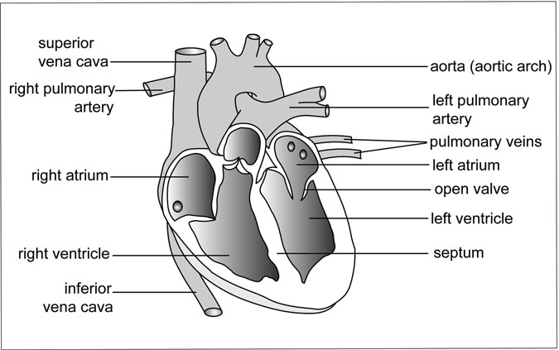

Figure 2.7 The Heart. The heart has two upper chambers, called the atria, and two lower chambers, or ventricles. The right and left sides of the heart are separated by a thick wall, known as the septum, and the atrium and ventricle on each side are divided by valves that open to allow the passage of blood. The superior and inferior venae cavae are the main blood vessels that return deoxygenated blood from the upper and lower body, respectively, to the heart’s right atrium. The right and left pulmonary arteries deliver blood from the right ventricle to the lungs for oxygenation, and the newly oxygenated blood returns to the left atrium through pulmonary veins. Newly oxygenated blood leaves the heart by way of the aorta, the largest artery in the body. Near the heart’s right ventricle, the aorta bends. This is known as the aortic arch. (Sandy Windelspecht/ Ricochet Productions)

chambers are called ventricles. It actually works like a double pump, with the right half taking in blood returning to the heart from the body tissues, and then sending it over to the lungs to drop off carbon dioxide and pick up oxygen. The newly oxygenated blood then heads back to the other side of the heart, where it gets the added boost it needs to propel it to the body tissues again. This double pump springs into action an average of 70–80 times every minute, all day and all night, for a person’s entire lifespan.

##### Cardiac Muscle

The heart is made out of cardiac muscle (also known as myocardium), a tissue that is unlike the smooth or striated muscle seen elsewhere in the human body. Striated muscle is the tissue that a person uses to move his or her legs or ﬁngers. Because the individual can control it, it is also known as voluntary muscle.

This tissue has light and dark bands, called striations, which give skel- etal muscle yet another name: striated muscle. Smooth muscle, like that in blood vessels, is known as involuntary muscle, because a person cannot direct its movements like he or she can control skeletal muscle. Instead, the autonomic nervous system controls its action. Falling somewhere in the middle of these two types of tissue is cardiac muscle. Cardiac muscle has the striations seen in skeletal muscle, but it takes its direction from the autonomic nervous system like the smooth muscle does. Unlike either stri- ated (also known as skeletal) or smooth muscle, cardiac muscle cells are very closely linked to one another and have ﬁbers that interconnect one cell to the next. As will be shown in the section on electrical activity later in this chapter, this is vital in making the heart beat as a unit. In addition, cardiac muscle does not tire out like skeletal muscle does, and it requires a shorter resting time between contractions. It is easy to assume that skeletal muscle can contract for a very long time, especially when considering how a body maintains muscle tone. A closer look reveals that different groups of skeletal muscle alternately shorten to give the appearance of constant contraction, even when the muscle cells are individually contracting and relaxing. In the heart, conversely, all of the cardiac cells contract at the same time. (For an in-depth discussion of cardiac muscle, see Chapter 11 on the musculoskeletal system.)

This muscle tissue of the heart surrounds all four of its chambers, completely enclosing them. The muscular walls of the atria do not require the kind of force that the ventricles do, and they are considerably thinner. All of the chambers are lined with endocardium, a thin membrane that provides a smooth, slick surface for the blood to slide along. This mem- brane is similar to the endothelium that coats the inside of blood vessels. The entire heart is enclosed in a ﬂuid-ﬁlled ﬁbrous sac, called the pericar- dium, that attaches to the diaphragm. Actually a double sac with ﬂuid between the two layers, the pericardium supports, lubricates, and cushions the heart. The diaphragm, which is a large muscle that separates the chest and abdominal regions, pulls downward during inhalation and conse- quently tugs the heart into a more upright position.

As mentioned, the atria sit at the top of the heart and the ventricles at the bottom. The word atrium means “entrance hall” in Latin. These cham- bers got their name because the blood enters the heart through the atria. At one time, atria were known as auricles because they somewhat resemble ears, and auris is Latin for ear. Ventricle is Latin for “little belly,” and one might say they look like ministomachs. If the atria are considered the entrances to the heart, the ventricles are the exits, and blood drains from them via the pulmonary artery and aorta. The right and left sides of the heart are completely separated by a thick muscular wall called the sep- tum. This ensures that deoxygenated and oxygenated blood do not mix.

In addition, the heart has a ring of ﬁbrous connective tissue, called the annulus ﬁbrosus, that serves as an anchor for the heart muscle and as an almost continuous electrical barrier between the atria and ventricles. Elec- trical charge plays a key part in proper heart functioning and will be dis- cussed later in this chapter.

The right atrium is separated from the right ventricle by a valve. The same holds true for the left atrium and left ventricle. This arrangement allows blood to move from one to the other, but only when the valve is open. Like the valves in the blood vessels, the heart valves permit blood ﬂow in only one direction. Between the two right chambers, the valve has three ﬂaps, or cusps, and is known as a tricuspid atrioventricular valve. It is com- monly called the AV valve. A bicuspid (two-cusped) mitral valve (also known as the mitral valve) divides the two left chambers. The ventricles have additional valves to seal off ﬂow between them and the arteries. The

valve between the right ventricle and pulmonary artery is called the pulmo- nary semilunar valve, and the valve between the left ventricle and aorta is called the aortic semilunar valve. Both have three cusps.

The AV, mitral, and semilunar valves all work the same way. When blood is rushing through a valve, each of which is about 0.004 inches (0.1 mm) thick and made of ﬁbrous connective tissue lined with membra- nous tissue, its cusps open with the ﬂow. As the blood tapers off, the cusps fall back to their original closed positions. Tiny tendinous cords, appropri- ately called chordae tendineae, attach to adjacent muscles (papillary muscles) and prevent the valve’s cusps from falling back too far and letting blood seep through.

##### Blood Flow and the Heart

The valves, chambers, and muscle tissue are all involved in blood ﬂow through the heart. Venous blood returning from the body tissues enters the heart through the two large venae cavae. The anterior vena cava carries blood from the head, neck, and arms, and the posterior vena cava conveys the blood from the rest of the body tissues (except the lungs). The right atrium ﬁlls with blood from the venae cavae, as well as the coronary sinus, which is the main vein carrying blood from the heart (details of the coro- nary circulation are included in the next section). When it contracts, the pressure of the blood builds, forcing open the tricuspid AV valve and allowing the blood to ﬂood the right ventricle. When the atrium relaxes, the blood’s pressure drops, and the AV valve falls back to its original posi- tion. The now-ﬁlled ventricle contracts. The only way out for the blood is through the pulmonary semilunar valve, which opens outward into the pulmonary artery.

Blood rushes out of the heart and into the pulmonary artery, where it branches and eventually reaches the lungs and alveoli to pick up oxygen. Following the ventricle’s contraction, the blood pressure in the pulmonary artery is 35 mmHg. The newly oxygenated blood returns to the left side of the heart and enters the atrium. It contracts, forcing blood through the bicuspid mitral valve in the left ventricle. Now that the blood is in the left ventricle, the mitral valve closes, the ventricle contracts, and blood ﬂows through the aortic semilunar valve and into the aorta. The force of the

contraction boosts the blood pressure in the aorta to 120 mmHg, more than three times the pressure of a similar volume of blood in the pulmonary artery. To accomplish this feat, the muscular wall of the left ventricle is about three to four times as thick as the right ventricle’s wall. The increased thickness gives the left ventricle the power it needs to drive blood throughout the body. Normally, the amount of blood in a completely ﬁlled adult ventricle is about 0.12 quarts (120 ml). This amount is called the end-diastolic volume. The heart typically only ejects about two-thirds of this blood, retaining 0.04–0.05 quarts (40–50 ml). That yields a total stroke volume—the amount of blood that exits the heart—of 0.07–0.08 quarts (70–80 ml). When the body needs to increase stroke volume, such as during periods of heavy exercise, it calls on the heart to begin pumping the residual 0.034 quarts (40–50 ml).

As it turns out, both atria ﬁll simultaneously, so the right side of the heart is taking in deoxygenated blood from the systemic circulation at the same time that the left side is admitting newly oxygenated blood from the pulmonary circulation. The ventricles likewise ﬁll at the same time. When either the ventricles or the atria contract, the chambers get smaller. When the atria relax following a contraction, they go back to their normal, larger size. The ventricles have an effect on the size of the atria, because they contract when the atria are resting. As the ventricles contract or shorten, they actually pull down on the bottom of the atria to further expand these upper chambers. This enlargement creates suction in the atria and serves to draw in blood from the venae cavae and begin prepar- ing the way for the next heartbeat. Cigarette smoking can have a damaging effect on the circulatory system, as detailed in Sidebar 2.2.

The heart spends about as much time resting as it does contracting, with each contractile and resting period lasting less than half of a second. The contractile period is known as systole, and the resting period is known as diastole. Although each contraction lasts only about 0.4 seconds, that is enough time for the atria and the ventricles to contract. Careful observa- tion reveals that the atria contract slightly before the ventricles during sys- tole, so that blood travels from the atrium to the ventricle and to the aorta or pulmonary artery with every contraction.

The heartbeat’s familiar “lubb-dupp” sound is actually the valves vibrating when they ﬂap shut rather than the heart muscles expanding

SIDEBAR 2.2

#### The Damaging Impact That Smoking Has on the Circulatory System

It is estimated that cigarette smoking leads to one out of every ﬁve deaths every year in the United States. It damages nearly every organ of the body, particularly the organs and components of the circulatory system, such as the heart and blood vessels.

Cigarettes contain tobacco, and there are chemicals in tobacco that shrink the blood vessels, leading to a condition know as atherosclerosis, which can lead to coronary artery disease (CAD). CAD occurs when plaque builds up in the blood vessels, making it difﬁcult for blood to get to the heart. Smoking is also a risk factor for peripheral arterial disease (PAD), which occurs when plaque builds in the vessels and prevents blood from traveling to the head, limbs, and other organs in the body.

It is not only heavy smokers who are doing damage to their bodies. Research has shown that even occasional smoking can cause signiﬁcant dam- age to the circulatory system, as well as the rest of the body. Female smokers who take oral contraceptives are at greater risk for developing CAD, as are patients who have certain chronic conditions such as diabetes. Secondhand smoke—inhaling smoke from nearby cigarettes, cigars, or pipes—can also be harmful to the heart and blood vessels. In fact, it is estimated that second- hand smoke can lead to approximately 50,000 deaths every year in the United States. Most of these deaths are due to heart disease.

How to reduce this risk? Avoid tobacco smoke. Because tobacco has addictive properties, medical experts recommend that people never start smoking or quit immediately. In addition, secondhand smoke should be avoided, given the damage that this exposure can do to the body. While quitting smoking can be hard, there are numerous strategies, programs, and medicines that can help with the quitting process.

and contracting as many people think. These vibrations (about 100 cycles per second, or 100 hertz) result when the heart’s contraction ends and the blood starts to slosh back toward the valves. As the liquid hits the valves, they shudder slightly. That shudder is the vibration that is audible to a

doctor with a stethoscope pressed to a patient’s chest. The “lubb” half of the heartbeat is the closing of the tricuspid AV and mitral valves that sep- arate the atria and ventricles. The “dupp” is the sound made by the semi- lunar valves located between the ventricles and either the aorta or pulmonary artery.

##### Coronary Circulation

The heart is a hardworking muscle that demands its own arteries and veins to maintain its operation. In fact, some textbooks and medical articles even describe the human body as having three circulatory systems: the systemic, the pulmonary, and the coronary circulations.

The two major arteries feeding the entire heart muscle are the right and left coronary arteries that stem from the base of the aorta. The right coronary artery primarily delivers oxygen-rich blood to the two right chambers: the right atrium and the right ventricle. The left coronary artery mostly feeds the left side. Unlike the right artery that remains as a single, large vessel, the left almost immediately splits into two vessels, known as the transverse and descending branches. Each artery also ships a little blood to the opposite side, but the right artery mainly concentrates on the right side, and the left artery on the left side. Strangely, the amount of blood delivered by the two sides differs in individuals. About half of all people have a dominant right artery, 3 in 10 have equal delivery in the two arteries, and about one out of ﬁve have a dominant left artery.

As mentioned, the heart demands a strong blood ﬂow to supply the oxygen it requires. The body will even respond to a blockage in a coronary artery by rerouting blood through nearby collateral arteries and around the compromised area. Heart patients frequently refer to this phenomenon as “growing new arteries.” In addition, the heart has more than 2,000 capillaries per 0.00006 inch (mm3) that help ensure an ample oxygen supply to this active muscle.

##### Electrical Activity

How does the heart keep pumping? What triggers a heart to beat? Electri- cal activity is the answer. In the human body, the nervous system controls

the overall electrical activity, including that in the heart, and is thus its pri- mary regulator.

In skeletal muscle, nerves outside the muscle direct its contraction. In the heart, small and weakly contractile modiﬁed muscle cells serve as the initiation point for the heart’s electrical system. These cells, located in a

0.8 × 0.08 inch (2 cm × 2 mm) area in the atrial wall near the entrance of the superior vena cava, are collectively known as the sinoatrial node (SA node), or the pacemaker. These cells are electrically connected, so when one “ﬁres”—delivers an electrical impulse—they all do. The pace- maker ﬁres spontaneously and needs no nervous system input to continue to deliver regular electrical impulses. In fact, the heart will continue to beat for a while even if it is completely removed from the body. On the other hand, the nervous system is important in that it can override the pacemaker’s regular ﬁring rate and either slow it down or quicken it. The heart also has backup regions that can take over if the pacemaker is compromised. These regions, called ectopic pacemakers, are capable of initiating the heartbeat when necessary.

When the pacemaker ﬁres, the electrical impulse spreads at a rate of about 3.29 feet (1 m) per second to the left and right atria and causes them to contract. As noted earlier, the ﬁbers in each cardiac muscle cell are connected to ﬁbers in adjoining cells. This connection allows the cells to contract nearly in unison. As the atria contract, the blood ﬂows past the respective valves and into the left or right ventricle. At the bottom of the septum dividing the atria is a small group of cells and connective tissue known as the atrioventricular node, or AV node. The AV node is the only conducting path through the annulus ﬁbrosus that divides the atria and ventricles. This node gets the electrical impulse from the pacemaker at about the same time as the atria do, but forwards it much more slowly to the ventricle, resulting in a delay of about a tenth of a second. This allows time for the atria to contract and squeeze the blood into the ven- tricles. The AV node then relays the impulse not directly to the ventricle, but to two structures. The ﬁrst of the two is the bundle of His (pronounced “hiss”), a thick conductive tract that transmits the signal to a mesh of modiﬁed muscle ﬁbers, called the Purkinje ﬁbers (pronounced “purr- kin-gee”), in the base of the ventricle wall. It is these ﬁbers that pass the impulse to the ventricle (at a speed of 5.5 feet [1.6 meters] per second!).

The ventricle contracts beginning at the bottom. As the wave of contraction progresses upward, it efﬁciently forces the blood upward to the exit valves.

##### Normal Heart Function Variations

Although the heart beats about 70–80 times per minute in a resting adult, that rate can vary considerably depending on whether the person is sitting down or standing up, walking or running, relaxed or under stress—activity of nearly any sort, as well as various medical conditions and medications, can cause the heart to speed up or slow down. In addition, stroke volume (the amount ejected from the left ventricle to the aorta with each beat) can also change to meet demands.

This formula is used to obtain the cardiac output, which is the volume of blood pumped over a certain period of time (typically the amount of blood ejected by one ventricle in one minute):

(stroke volume) × (heart rate) = cardiac output

On average, the stroke volume of an adult at rest is about 0.08 quarts (75 ml). When multiplied by the average male’s heart rate of 70 beats per minute (a female’s is about 78 beats per minute), the cardiac output comes to 5.5 quarts (5.2 liters) per minute. Cardiac output varies greatly among individuals, and while 5.5 quarts per minute is the approximate overall average, a healthy individual can fall within the range of about 4.2–7.4 quarts (4–7 liters) per minute. Generally, an individual’s cardiac output at rest is 3.2 quarts (3 liters) per minute for every 3.3 square feet (or 1 square meter) of body surface area. Using that calculation, an adult weighing 150 pounds (68 kg) and having a body surface area of about 5.9 square feet (1.8 square meters) would have a cardiac output of 5.4 quarts (5.1 liters) a minute.

That cardiac output is distributed to the body more or less on the fol- lowing principle: the higher the metabolic rate of the tissue, the higher the percentage of the cardiac output it receives. Muscles use about a ﬁfth of the oxygen a person breathes, so they receive about a ﬁfth of the blood. Two of the most notable exceptions to the rule are the kidneys and the heart. The kidneys receive as much blood as the muscles, even though the kidneys use less than a third of the oxygen. High blood ﬂow to the kidneys

is necessary because these organs are the body’s blood ﬁlters, removing waste products and excess water. The heart, on the other hand, receives proportionately less blood than it should, if ﬁgured according to the rule. It compensates, however, by drawing more oxygen from its limited supply than other organs do, thanks to its particularly dense capillary network.

For the most part, the autonomic nervous system rules the variations of the heart rate, which in turn affects cardiac output. The autonomic system, which controls involuntary activities, has two major divisions: the sympathetic nervous system and the parasympathetic nervous system. (See Chapter 8 on the nervous system for more information.) The former stimulates the pacemaker and boosts the heart rate, while the latter inhibits the pacemaker and lowers the heart rate. The sympathetic and parasympa- thetic systems also have opposite effects on the arteries, with the former causing them to contract and the latter causing them to dilate. In effect, the sympathetic side prepares a person to respond to stressful situations by heightening blood ﬂow, and the parasympathetic (also known as vagal) side brings a person back to normal.

Besides the autonomic nervous system, other factors can inﬂuence cardiac output, including various hormones, baro- and chemoreceptors, and the ﬁtness level of the individual.

##### Receptors

Every time the heart beats, the blood pressure increases in the aorta and in the carotid sinuses, which are swellings or expansions at the base of the internal carotid arteries. When the heart’s contraction ends, the pres- sure decreases. Detectors in the walls of major arteries perceive those pressure changes by sensing the tension in the vessel walls. The detec- tors, neurons called baroreceptors, pass this information to the parasym- pathetic nervous system, which responds as necessary by lowering the heart rate and decreasing its contractility, which together cause a dip in blood pressure. The sympathetic nervous system also heeds the call by reducing arterial tone and making arteries more elastic, which also serves to decrease blood pressure. The major baroreceptors are the aortic baroreceptors that keep track of blood pressure in the ascending aorta, and the carotid sinus baroreceptors in the neck that track blood

ﬂow to the brain. In addition, atrial baroreceptors at the venae cavae and right atrium check blood pressure as blood enters the heart from the venous system. When more blood is entering the heart than is being pumped out, the body rectiﬁes the imbalance by heightening cardiac output until the incoming and outgoing blood are equalized again. In summary, the baroreceptor system is an effective means for evening out the short-term spikes and dips in blood pressure.

Besides pressure detectors, the body has chemoreceptors to monitor the levels of oxygen and carbon dioxide in the blood. These receptors, located near the carotid sinus and the aortic arch, also detect acidity, or pH, levels. The amount of carbon dioxide in the blood can alter its acidity level, because carbon dioxide dissolves in the water of the blood plasma and makes carbonic acid. The more acidic the blood, the lower the pH. When chemoreceptors sense a rise in carbon dioxide levels, a fall in oxygen levels, or a drop in pH, they trigger a hike in cardiac output, which leads to higher arterial blood pressure. Other chemoreceptors in the medulla oblongata (lower brain stem) keep track of blood composition going to the brain and respond to reduced oxygen by initiating the dilation of cerebral vessels while constricting vessels to other parts of the body. The body, then, works to maintain blood ﬂow to the brain at the expense of other organs and systems.

#### Blood-Demanding Organs and Circulation-Related Systems

Blood is almost everywhere in the human body. It ﬂows to all of the tissues, moves in and out of organs, and participates in all sorts of bodily functions. This section will introduce some of the organs that put a high demand on blood ﬂow, as well as the lymphatic system that has a close bond with circulation.

##### Digestion

The main arteries feeding the stomach include the celiac, gastric, gastroduo- denal, and gastroepiploic arteries. The celiac artery, or celiac trunk, stems from the abdominal aorta, which is the portion of the aorta that lies in the

abdomen (as opposed to the thoracic aorta that runs through the chest cavity). The celiac artery branches into the left gastric, common hepatic, and splenic arteries. For the digestive system, the left gastric artery supplies blood to the stomach and the lower part of the esophagus, which is the feed- ing tube extending from the pharynx at the back of the mouth to the stomach. The gastroduodenal artery separates from the common hepatic artery, which itself continues on to the liver as the hepatic artery. The gastroduode- nal artery, the right gastroepiploic artery that branches from it, and the left gastroepiploic artery that arises from the splenic artery all provide blood to the stomach and duodenum (the ﬁrst part of the small intestine). The right gastric artery arises not directly from the celiac artery like the left gastric artery does, but from the hepatic artery proper. It eventually connects with the left gastric artery and supplies blood to the stomach.

Blood to the colon comes from the left, middle, and right colic arteries, all of which branch from either the inferior or superior mesenteric arteries. Both mesenteric arteries separate from the abdominal aorta. The mesen- teric arteries also supply blood to the rest of the intestinal system through the intestinal, ileocolic, and other arteries.

How does the food a person eats wind up in the blood? The answer lies in tiny outgrowths, called villi (the singular is villus), that line the inside of the wall of the small intestine (Figure 2.8). These villi are, in turn, coated with even smaller outgrowths, called microvilli. By the time digested food reaches the small intestine, it has already been broken down into molecules small enough to cross the capillary walls. Each of the villi has a set of capillaries, thus providing ample opportunity for the uptake of food from inside the small intestine into the blood system. Although the work of the villi might seem inconsequential, they are so numerous throughout the small intestine and are covered by such a large number of microvilli that they actually increase the surface area of the interior small intestine by about 600 times. This puts the blood into close contact with much of the digested material, or chyme, before it makes the approxi- mately two-hour journey through the small intestine.

The mesenteric veins and other feeder arteries serve as the exit route for blood from the intestines and colon. Gastric and gastroepiploic veins drain the stomach into a number of other veins that ultimately unite—along with the mesenteric veins—at the large portal vein. Thus, nutrient-laden

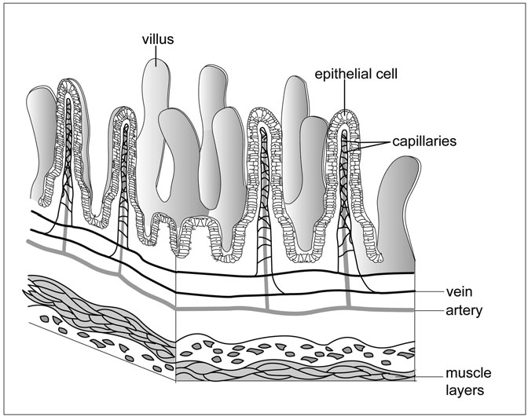

Figure 2.8 Villi. A multitude of tiny outgrowths, called villi, line the inside of the wall of the small intestine. These villi are, in turn, coated with even smaller outgrowths, known as microvilli (not shown). Each villus has its own set of capillaries, thus providing ample opportunity for the uptake of food from inside the small intestine into the blood system. (Sandy Windelspecht/Ricochet Productions)

blood leaves the digestive system through the portal vein, but before it begins its return trip to the heart, it heads to the liver.

##### Liver and Hepatic Circulation

The liver is a large, broad organ (sometimes referred to as a gland) that sits below the lungs and diaphragm, but above the stomach. Measuring about 8–9 inches (20–23 centimeters) long and 6–7 inches (15–18 centimeters) high, this two-lobed, wedge-shaped organ plays an important part in the use and storage of food energy.

About a quarter of the entire cardiac output passes through the liver, but unlike many organs, the liver gets only 25–28 percent of this blood directly from the aorta or its primary branches. That amount, however, is enough to support the organ and its functions. Most of the remaining 72–75 percent of the blood arriving at the liver has already been through the digestive system, where it picked up nutrients from food. This indirect type of blood distribution is termed in-series blood circulation because the blood goes from one organ to another in a series. It is also called portal circulation.

As soon as the blood arrives in the liver from the portal vein, the liver gets to work removing the food molecules, including fats, the amino acids from proteins, and sugars, and converts them into a carbohydrate called glycogen for storage as a reserve energy supply for the body to use later as the need arises. The sugars, called glucose, switch readily to glycogen, but the fats and amino acids must ﬁrst be converted to glucose before they make the change to glycogen. Because the liver is capable of converting glycogen back into glucose, it serves as a regulator of the blood-sugar level.

The liver is also one of the body’s lines of defense against drugs, alco- hol, poisons, pollutants, and other chemical threats. Just as it ﬁlters out sugar, the liver selectively removes these substances via the urine or the bile. In addition to its responsibilities in metabolism and detoxiﬁcation, the liver makes other compounds, including cholesterol.

Blood exits the liver through the hepatic vein that joins the inferior vena cava for the return trip to the heart.

##### Kidneys and Renal Circulation

As described previously, the kidneys are the body’s blood ﬁlters and the site where urine is produced. The two kidneys, shaped appropriately like kidney beans, are each about 4 inches (10 centimeters) long and 2 inches (5 centimeters) wide, and are located in about the middle of the back, with one on either side of the backbone.

Blood is approximately 80 percent water, so the body requires a com- petent system to maintain a proper water balance. The kidneys provide that service, removing excess water and also ﬁltering out waste products. The water and waste products, including soluble materials like salts, are

all eliminated via the formation of urine, which exits each kidney through a long tube, called a ureter, that ﬂows into the bladder.

The ﬁltering process begins when blood—about a ﬁfth of the total car- diac output—arrives at each kidney from a separate renal artery. Interlobar arteries branch from the renal artery to disperse the blood throughout the kidney and to networks of capillaries, called glomeruli (glomerulus is the singular). The glomeruli come into contact with the kidney’s ﬁltering units, called nephrons, which are each composed of a twisting epithelial tube. On one end, the epithelial tube eventually empties into the ureter, and on the other end, terminates in a bulb. The bulb, known as a Bowman’s capsule, surrounds the glomeruli and provides an efﬁcient transfer site for water and waste products to move from the blood to the urinary system. Blood leaves the Bowman’s capsule in one vessel, but that vessel quickly branches into a second set of capillaries. This time, the capillaries form a web that weaves around the nephron tubules, which participate in returning much of the water and many of the solutes to the blood through the capillaries. Excess water and solutes continue through the nephron to the ureter. Blood exits each kidney through a renal vein.

In a single day, a single person’s kidneys can ﬁlter out some 40 gallons (151 liters) of water. Reabsorption returns about 39.6 gallons (150 liters). The difference, 33.8 ounces (1 liter), is about the same as the amount of water ingested by that person in a 24-hour period. Thus, the body neither adds nor loses water in a typical day.

Right and left renal veins drain the kidneys. These veins also transport blood from the adrenal glands that sit atop the kidneys. (See Chapter 12 for more information on the kidneys.)

##### Spleen

The spleen is a mainly red, heart-sized organ that sits to the left and below the stomach. As noted in the section on the digestive system, one of the branches from the celiac artery is the splenic artery. This artery supplies blood not only to the stomach, but also to the spleen.

This organ has two primary functions: assisting in the removal of foreign materials and aging red blood cells from circulation, and storing red blood cells and platelets.

To spot and eliminate the threat from invading organisms, the spleen relies on the immune system. The organ contains many branching blood vessels that are enveloped with B lymphocytes and T lymphocytes (B cells and T cells). The T cells have a mission of surveillance and scan the slowly ﬂowing blood for the foreigners, like bacteria. They report invaders to the B cells. Any B cell that has previously encountered the bacterium rapidly multiplies and then begins producing antibodies to weaken or destroy the invader. The spleen is also armed with many macrophages, the white blood cells that ingest and digest bacteria, other foreign organ- isms, platelets, and old or deformed red blood cells.

In addition, the spleen can swell to hold blood in storage. This ability provides a reserve supply that can be tapped when necessary. Besides the ﬁltration and storage functions, the spleen has another job in the human embryo: It makes red blood cells, a function that shifts to the bone marrow after birth.

##### Cerebral Circulation and the Blood-Brain Barrier

As discussed previously, the maintenance of blood ﬂow to the brain is one of the circulatory system’s highest priorities. This is because the brain is key to so many vital physiological processes. The main arteries to the head include the left common carotid that branches directly off of the aortic arch, and the right common carotid that branches indirectly from the aortic arch by way of a short brachiocephalic (also called innominate) artery. The two carotid arteries traverse almost straight up, branching again at about chin level into internal and external carotids. Other arteries feeding the head include the vertebral arteries. These two arteries, one on each side of the neck, arise from the right and left subclavian arteries that divert from the aorta. The vertebral arteries unite at the basilar artery, and this artery joins with other cerebral arteries to form what is known as the circle of Willis.

Blood supply to the brain comes from numerous major arteries, as well as smaller, branching arteries and arterioles. For example, the internal carotid artery supplies blood to the anterior brain, and one of its branches, called the anterior cerebral artery, feeds the cerebrum. The cerebrum com- prises the two large hemispheres of the brain. In some cases, several

arteries may supply the same area of the brain. The cerebrum also receives blood from the posterior cerebral artery, which derives from the basilar artery that arises from the vertebral artery. Blood ﬂow to the brain, then, emanates from numerous arteries and arterioles.

Similarly, blood drains from the brain via a large number of venules and veins that empty into several large veins. These include the vertebral vein, and the internal and external jugular veins. The internal jugular is by far the largest of the three, and runs almost down the middle of the neck. It serves as the primary collector for deoxygenated blood, which it delivers to the subclavian vein and eventually to the superior vena cava for its return to the heart.

Although the brain accounts for only 2 percent of an average person’s weight, it demands approximately one-ﬁfth to one-sixth of the cardiac output, or a ﬂow of about 0.74 quarts (700 ml) per minute in an adult. The kidney and liver both require a high percentage of the cardiac output for such maintenance functions as water ﬁltration or waste removal. The brain, on the other hand, needs the large quantity of blood for the oxygen. This heightened demand stems from the extreme rate of oxidative meta- bolism seen in the nerve cells, or neurons, of the brain. These neurons, collectively called gray matter, account for about 40 percent of the brain and use almost 20 percent of the oxygen that a resting person breathes. Just 1 square millimeter of gray matter can have up to 4,000 capillaries. In addition, the gray matter is damaged very quickly if the oxygen supply drops off. Fainting is one of the body’s responses to this condition of hypoxia (low oxygen levels). This brings the head closer to the ground, which serves to take advantage of gravity and allow blood to ﬂow more readily to the brain. Continued hypoxia lasting more than a couple of minutes can cause permanent brain damage.

##### Blood-Brain Barrier

The blood-brain barrier is actually a collection of tightly enmeshed cells and other obstacles that effectively serve as a boundary, allowing only oxygen, certain nutrients, and a few other items to pass into brain tissues via the blood (Figure 2.9). Researchers Paul Ehrlich and Edwin Goldman saw in the late 1800s to early 1900s that dyes injected into the brain and

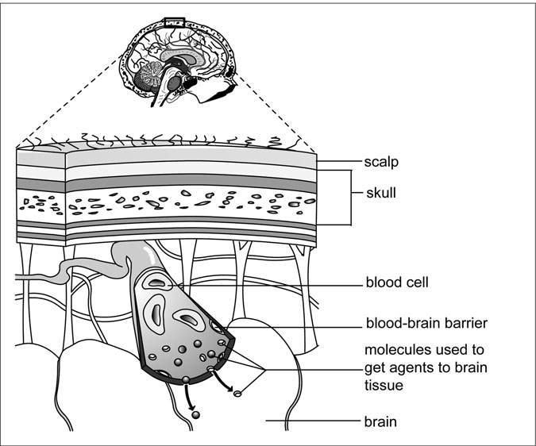

Figure 2.9 Blood-Brain Barrier. The blood-brain barrier is a protec- tive boundary that allows only certain gases, nutrients, and other materials to pass from the blood into the brain tissues. In some cases, special molecules help to transport materials across the barrier. Scientists are now learning more about these transportation avenues and other ways to circumvent the barrier to allow beneﬁcial materials, like drugs, to enter the brain. They are also studying why such dangerous entities as bacterial meningitis are able to circumvent the barrier. (Sandy Windelspecht/ Ricochet Productions)

cerebrospinal system would only color blood there, and dyes injected else- where would color all the blood except that in the brain and cerebrospinal system. A barrier existed that selectively prohibited various toxins and other substances from entering the brain. This is now known to protect the brain and its myriad nerve cells from diseases and chemicals that might impair its function. It also, however, prevents many helpful

medications from penetrating into the brain, and researchers have been studying how to circumvent the barrier for several decades.

#### Summary

This chapter provides a brief overview of the very complex circulatory system. The system’s primary organ is the heart, which continuously forces blood into and out of the body’s blood vessels. The blood is another vital component of this system, and is responsible for transporting impor- tant materials throughout the body, including oxygen to the lungs and the heart. The blood is made up of red and white cells, as well as plasma and platelets, all of which have important roles in ensuring the blood performs its duties. Another important component of the circulatory system consists of the blood vessels, which are tissues that transport the blood to where it is needed. While the vessels allow the blood to travel throughout the body, the capillary system facilitates the exchange between the blood and various tissues, including the vessels. Since all of the body’s systems are interconnected and depend on one another, it is not surprising that organs from other systems rely on the blood and circular system to function. These include the liver, stomach, and other organs of the digestive system; the kidneys and renal organs; as well as the brain—the primary organ of the nervous system.

# 3

### The Digestive System

*Michael Windelspecht*

Interesting Facts

* The salivary glands can produce up to 1.5 quarts (1,500 milliliters) of saliva daily.
* Food remains in the esophagus for as little as ﬁve seconds before entering the stomach.
* The human stomach can hold as much as 2.1 quarts (2 liters) of food.
* The stomach produces 2.12 quarts (2 liters) of gastric juice daily.
* Gastric juice is 100,000 times more acidic than water and has about the same acidity as battery acid.
* The small intestine in an adult can reach 3.28 yards (3 meters) in length, while the large intestine is only about 1.64 yards (1.5 meters) long.
* Every square millimeter of the small intestine can contain 40 villi and 200 million microvilli.
* Food remains in the small intestine for three to ﬁve hours on average, during which most nutrients are removed.
* The intestines receive over 10 quarts (9 liters) of water daily, of which almost 95 percent is recycled back into the body.

85

* As little as 10–15 percent of the iron we eat in food is absorbed into the human body.

Chapter Highlights

* The mechanics of digestion
* Different types of energy nutrients
* Vitamins, minerals, and water
* Upper gastrointestinal tract (oral cavity, esophagus, and stomach)
* Lower gastrointestinal tract (small intestine and colon)
* Large intestine
* Accessory organs (salivary glands, liver, gall bladder, pancreas)

#### Words to Watch For

Alkaline Amphipathic

molecules

Antioxidants Autocatalytic process Bilirubin

Binucleate cells Bioavailability Bolus

Buccal cavity Cholesterol Deglutition Dehydration

synthesis

Dentin

Diaphragm Diploid cells Electrolytes Epithelial cells Exocrine gland

Facilitated diffusion Hemoglobin

Hepatic portal system High-density lipopro-

teins (HDL)

Hormones Hydrolysis Hydrophilic Hydrophobic

Ions Kilocalorie Lacteals Lipoproteins

Low-density lipopro- teins (LDL)

Lumen Mesentery Metabolism

Organic molecules Peristaltic action Pharynx Phospholipids Polyploid cells

#### Introduction

One of the unifying characteristics of all living organisms is their ability to process nutrients from the environment into the chemical compounds found within the cells. This processing of nutrients is commonly called metabolism. Plants, animals, fungi, and bacteria have all evolved different strategies for supplying the energy and chemical needs of the organism. Simply stated, digestion is the breakdown of food particles into their fundamental building blocks. As heterotrophic organisms, or those that rely on others as a source of energy, animals have evolved a wide range of digestive systems to accom- modate their environmental needs. The internal body plan of an animal species is frequently deﬁned by its digestive system. The purpose of this chapter is to examine the structure and function of the digestive systems in the species Homo sapiens, or humans.

The digestive system is not a stand-alone system. The primary digestive organs—the mouth, esophagus, stomach, and small and large intestine— not only interact to some degree with each other, but also receive signals from other organs of the body. The accessory organs—the liver, pancreas, salivary glands, and gall bladder—supply chemicals necessary for the nutrient processing. The liver and pancreas are active with other systems of the body as well, such as the endocrine and circulatory systems. The digestive system is partially under the control of the nervous system, but also is inﬂuenced by the hormones secreted by the endocrine system. Because nutrients absorbed by the digestive system must be transported throughout the body, the gastrointestinal tract interacts with the circulatory and lymphatic system for the transport of water-soluble and fat-soluble nutrients, respectively. Finally, the urinary system removes some of the waste products of nutrient metabolism by the liver.

The purpose of digestion is to process food by breaking the chemical bonds that hold the nutrients together. This is necessary so that the body has an adequate source of energy for daily activity, as well as materials for the construction of new cells and tissues. Since these nutrients arrive in the digestive system as the tissues of previously living organisms, they are rarely in the precise molecular structure needed by a human body. For example, the blood of cows and chickens has evolved over time to meet the precise metabolic needs of the organism. When the tissues of these

animals are consumed, our bodies must chemically alter the proteins and other nutrients found in the animal’s blood to form human blood proteins such as hemoglobin. As is the case with almost all the nutrients (with the exception of water, minerals, and some vitamins), the body breaks down the nutrient into its fundamental building blocks, transports the digested nutrient into circulatory and lymphatic systems, and eventually uses these nutrients in the cells of the body for either energy or metabolic processes. Before proceeding into how these reactions occur, it is ﬁrst necessary to provide an overview of the digestion process, as well as to discuss the basic nutrient classes.

#### Digestion at the Cellular and Molecular Level

When the term digestion is mentioned, it is natural to think about the actions of the mouth, stomach, and small intestine in the processing of food for energy. While these actions are no doubt important in the breakdown of food, they actually are the result of complex processing mechanisms at the cellular level. This chapter will examine the physiology of the digestive system at the organ level. However, to effectively understand the structure and function of the digestive system, we must ﬁrst understand the cellular and molecular basis of nutrient processing.

The purpose of digestion is to process food by breaking the chemical bonds that hold the nutrients together. This is necessary so that the body has an adequate source of energy for daily activity, as well as materials for the construction of new cells and tissues. Since these nutrients arrive in the digestive system as the tissues of previously living organisms, they are rarely in the precise molecular structure needed by a human body. For example, the blood of cows and chickens has evolved over time to meet the precise metabolic needs of the organism. When the tissues of these animals are consumed, our bodies must chemically alter the proteins and other nutrients found in the animal’s blood to form human blood proteins such as hemoglobin. As is the case with almost all the nutrients (with the exception of water, minerals, and some vitamins), the body breaks down the nutrient into its fundamental building blocks, transports the digested nutrient into circulatory and lymphatic systems, and eventually uses these nutrients in the cells of the body for either energy or metabolic processes.

#### Classes of Nutrients

There are six general classes of nutrients: carbohydrates, fats, proteins, water, vitamins, and minerals. Carbohydrates, fats, and proteins are char- acterized as energy nutrients. These organic (or carbon-containing) molecules are responsible for providing our bodies with the majority of the energy needed for daily metabolic reactions. This does not mean that the remaining nutrient classes are not important in energy reactions within the body. In fact, many of these, such as some of the B vitamins and water, are crucial to the efﬁcient operation of the energy pathways. However, our bodies do not get energy from these nutrients directly.

Carbohydrates, proteins, and fats all contain energy in the carbon- carbon bonds of their molecules. The energy of these bonds is measured in a unit of heat measurement called the calorie. A calorie is the amount of energy required to raise 1 gram of pure water by 1 degree Celsius at sea level. However, this is a relatively small unit of measurement, and thus for nutritional analysis the term kilocalorie (1,000 calories) is frequently used. When one examines the ingredient label of a prepared food, such as a soft drink, the listed calorie value is actually in kilocalories, also called kcals. Organic molecules contain a large number of carbon-carbon bonds, and are therefore an excellent source of metabolic energy.

##### Energy from Energy Nutrients

Cells have a variety of mechanisms for releasing the energy contained within the carbon-carbon bonds of organic molecules. Some cells are anaerobic and can obtain small amounts of energy without the assistance of oxygen. However, the majority of the cells of the body utilize a complex metabolic pathway called aerobic respiration. Aerobic respiration consists of three main series of reactions: glycolysis, the Krebs cycle, and the elec- tron transport chain (ETC). The Krebs cycle and ETC occur in the mito- chondria of the cell and use oxygen to regenerate a cellular energy molecule called adenosine triphosphate (ATP). In the Krebs cycle, the carbon-carbon bonds are broken and a small amount of ATP is generated. The remaining carbon is combined with oxygen to form carbon dioxide, a waste product. The details of aerobic respiration will be covered in greater detail in Chapter 10 on the respiratory system.

TABLE 3.1

The Energy Nutrients

*Energy nutrient Monomer Polymer*

*General enzyme*

*Energy per gram*

Carbohydrates Monosaccharides Polysaccharides Amylases 4 kcal Proteins Amino acids Proteins Proteases 4 kcal Fats and lipids N/A N/A Lipases 9 kcal

This table lists some important facts regarding the energy nutrients. The “N/A” under fats and lipids reﬂects the fact that these molecules do not form complex structures in the same manner as carbohydrates and proteins. The energy per gram is an approximation and varies depending on the metabolic properties of the cell and individual.

The aerobic respiration pathways are capable of utilizing most organic molecules as an energy source. However, in order for the nutrients to enter the pathway, they must ﬁrst be broken down into their fundamen- tal building blocks. Proteins and carbohydrates are actually long repetitive chains of individual building blocks called monomers. These monomers are linked by chemical bonds into long polymers (see Table 3.1), which ﬁrst must be broken down. Water is used to break the bonds linking the monomers in a process called hydrolysis. Cells use the reverse of this pro- cess, called dehydration synthesis or condensation reactions, to form more complex molecules from the monomers.

##### Carbohydrates

In the study of nutrition, carbohydrates are frequently abbreviated as CHO, which reﬂects the fact that this nutrient class contains the elements carbon, hydrogen, and oxygen. All carbohydrates possess carbon, hydrogen, and oxygen in a 1:2:1 ratio, respectively. For example, the molecular formula for glucose is C6H12O6. Carbohydrates are the short-term energy molecules of the human body and are the preferred fuel of the aerobic respiration pathways.

All carbohydrates are made up of one of three building blocks, or monosaccharides. The most common of these is glucose, with the other two being fructose (the monosaccharide associated with the sweet taste) and galactose (sometimes called a milk sugar). Glucose is the preferred

energy molecule for aerobic respiration, and the human digestive system is well adapted to extracting this nutrient from foods and delivering it to the cells. All of the monosaccharides are water-soluble and easily trans- ported by the circulatory system.

Monosaccharides are linked together in pairs by chemical bonds to form the disaccharides. All disaccharides contain at least one glucose unit in their structure. There are three different disaccharides: maltose (glucose-glucose), sucrose (glucose-fructose), and lactose (glucose-galactose). Together, the monosaccharides and disaccharides all are commonly called the simple sugars. Complex carbohydrates, or the polysaccharides, are composed of long chains of glucose units. The different classes of polysaccharides vary in the physical structure of the chemical bonds that link the glucose units. In some cases, such as starch, the chemical bonds are easily digested by the human digestive system and thus provide a useful source of glucose for energy. However, a slight change in the conﬁguration of the chemical bonds between the glucose units makes the bonds inaccessible by human digestive enzymes. These molecules are called ﬁbers, and even though they are not digest- ible by human enzymes, they play an increasingly important role in human digestion. Since they are basically indigestible, ﬁbers provide bulk to food. This bulk helps move materials through the system and provides resistance to muscles of the gastrointestinal tract. This resistance acts as a form of workout for the muscles, which keeps them strong, allowing for the efﬁcient movement of food in the system. Fibers exist in one of two general catego- ries: soluble and insoluble. The soluble ﬁbers, which are readily dissolved in water, are found primarily in fruits. These ﬁbers slow down the movement of food through the gastrointestinal tract as well as the absorption of glucose. In contrast, the insoluble ﬁbers, which are found in bran material and whole grains, increase the rate at which material is moved through the

gastrointestinal tract, as well as provide bulk to the fecal material.

##### Fats and Lipids

While the carbohydrates are regarded as short-term energy sources for the human body, the fats and lipids are involved with more long-term energy processes within the body. There are exceptions to this, but in general the fats and lipids take more time to process by the digestive system and are

associated with developing the long-term energy stores of the body. Techni- cally, the term lipid is used to represent the entire class of these molecules, with the term fat primarily being reserved for a group of lipids called the triglycerides. However, frequently in nutritional analysis and on consumer products, the terms are used interchangeably. In this volume, the term fat will be reserved for the triglycerides, with lipids indicating the entire class of molecules. Two major classes of lipids are of interest in understanding the physiology of the digestive system of humans: the triglycerides and the sterols. A third class, the phospholipids, plays an important role in the structure of cell membranes.

For the most part, the lipids are hydrophobic molecules, meaning that they do not dissolve readily in water. Because the digestive system is a water environment, as is the circulatory system, this physical characteristic of the lipids means that the digestive system will have to handle the lipids differ- ently than most other nutrients. Chemical secretions such as bile, and specialized proteins called the lipoproteins, will assist the processing and transport of these important energy nutrients.

The triglycerides make up the majority (95 percent) of the lipids in food. The structure of these molecules, with its high number of carbon-carbon bonds, makes them an excellent source of energy for aerobic respiration. The long chains, called fatty acids, can vary in length and their degree of saturation. It is these chains that make the triglycerides hydrophobic. The level of saturation of the fatty acid chains has also been associated with human health. Saturated fats, found typically in animal products, are known to increase the risk of heart disease, while the unsaturated fats of plant products produce less of a risk. While the words triglyceride and fat have a negative connotation in today’s society, in fact they are necessary and useful molecules in human metabolism when they are consumed in correct quan- tities. Some fats, called the omega-3 and omega-6 fatty acids due to their structure, actually help regulate the lipid biochemistry of the blood. Fats and lipids also provide insulation for the body. Because the fats give texture to food, release a pleasing aroma when cooked, and provide a fullness to the meal, they can be easily over-consumed during eating.

A second major class of lipids is the sterols, of which the most common is called cholesterol. As is the case with the triglycerides, the word choles- terol does not have a positive image in today’s society. However, just like

the triglycerides, cholesterol is an important molecule for our bodies. It serves as the starting material for the manufacture of important hormones such as testosterone and estrogen, is a component of the membranes of our cells, used by the liver to manufacture bile, and is the starting material for the synthesis of vitamin D in our bodies. In fact, cholesterol is such an important molecule to our bodies that our liver has the capability of manu- facturing all of the body’s daily requirements of cholesterol.

Like the triglycerides, cholesterol is a hydrophobic molecule, and thus the body can have some problems moving it around. To remedy this, choles- terol as well as triglycerides are packaged into a group of special transport molecules called lipoproteins. Think of these lipoproteins as balloons. When the balloons are empty of cholesterol, they are compact and small and are called high-density lipoproteins (HDL). When there is an abun- dance of cholesterol in the system, the balloons are full, and they are called low-density lipoproteins (LDL). Unfortunately, these lipoproteins have been given the names “good” (HDL) and “bad” (LDL) cholesterol, but that really is not correct. Because the body has the ability to manufacture all of its cholesterol, an overabundance in foods, called dietary cholesterol, will ﬁll the balloons creating LDLs. A diet low in fat and cholesterol will leave the balloons empty, which are the HDLs. Scientists and nutritionists are still debating the effects of dietary cholesterol on the body. The amount of cholesterol does not directly inﬂuence the operation of the digestive system (although the foods that cholesterol is associated with do), but it does affect the health of the circulatory system.

There are additional classes of lipids, such as the waxes and phospholi- pids. Although important to the overall operation of the human body, they have little inﬂuence on the physiology of the digestive system and are processed in the same manner as the triglycerides and sterols.

##### Proteins

While the body primarily uses lipids and carbohydrates for energy, proteins are involved in a wide variety of functions other than supplying energy. To put it simply, proteins are the working molecules of the cell and, as such, are involved in the majority of all cellular functions. Proteins may have structural functions, such as those found in muscles; others work as

signaling molecules in the nervous system or as hormones for the endocrine system. This list of protein functions in the human body is almost too numerous to mention, but a specialized group of proteins, called the enzymes, are an important component of the digestive system and are covered in the next section.

The building blocks of proteins are the amino acids. Twenty different amino acids are needed to construct the proteins of the human body. Each of these amino acids has a slightly different molecular structure, which gives each of them a unique chemical characteristic. Within each cell, using instructions from the genetic material (deoxyribonucleic acid, or DNA), amino acids are linked together by the process of dehydration synthesis to form proteins. Like other molecules, these bonds are broken by the process of hydrolysis. However, unlike the carbohydrates, when the amino acid chains are formed, they fold into complex three-dimensional structures that inhibit digestion in the body. Furthermore, the peptide bonds that hold the amino acids together are exceptionally strong, thus requiring the assistance of enzymes to break them down.

Because the proteins in food are the product of the original organism’s body, and were constructed by the organism for a speciﬁc purpose, few proteins that are brought into the human digestive system are usable in their current form. Instead of absorbing whole proteins into the body, the role of the digestive system is to break down the protein bonds into their amino acid building blocks. The individual amino acids are then absorbed into the body and used as raw materials for the building of human-speciﬁc proteins. The digestion and absorption of proteins will be covered in more detail later in this chapter.

##### Enzymes

For the most part, the metabolic reactions of the body, including the dehydra- tion synthesis and hydrolytic reactions mentioned previously, do not occur spontaneously. Instead, they require a catalyst to accelerate the rate of the reaction to a point that is efﬁcient for the cells of the body. These catalysts are called enzymes. While the human body has a wide array of enzymes, which control everything from the operation of the nervous system to the process of cell division, they all share some common characteristics.

First, the vast majority of all enzymes are proteins. The three-dimensional shape of enzymatic proteins enables them to interact with other molecules. Second, enzymes are very speciﬁc to the molecules, or substrates, with which they interact. Third, enzymes all serve to increase the efﬁciency of metabolic reactions by lowering the amount of energy needed to initiate the reaction. Finally, enzymes themselves are not consumed or destroyed during the course of an enzymatic reaction, allowing them to be reused over and over again for the same process.

The activity of an enzyme may be regulated by a variety of mecha- nisms. First, enzymes all have a speciﬁc environment in which they are the most efﬁcient. The temperature and pH (or acid/base level) of the enzyme’s environment act as a switch to regulate its activity. Since within the digestive system of humans, the temperature remains a relatively con- stant 98.6°F (37°C), digestive enzymes are primarily regulated by the pH of their environment. The level of compartmentalization in the human digestive system helps to establish zones of enzyme activity. Throughout this chapter, we will examine how the stomach and small intestine regulate the pH of their environments to control enzyme activity.

The digestive system utilizes a large number of enzymes to break down the nutrients within food into units small enough to be transported by the circulatory or lymphatic system. In this volume, we will usually refer to the enzymes by their general function. For example, enzymes that assist in the processing of lipids are called lipases, and those that process proteins are called proteases. The preﬁx “amyl-” means sugar. Other enzymes and their mechanism of regulation will be discussed in the next several chapters.

#### Vitamins, Minerals, and Water

The action of the digestive system is not conﬁned solely to the processing of the energy nutrients. The human body requires a daily input of other nutrients to meet its metabolic requirements. The processing of vitamins, minerals, and water differs from that of the energy nutrients in that these nutrients are usually not broken down by the digestive system, but rather are absorbed intact and then transported by the circulatory system to the other systems of the body. While is it beyond the scope of this ency- clopedia to describe all of the vitamins and minerals, some basic

characteristics of these nutrients are described in the following paragraphs so as to provide an overview of how these nutrients interact with the diges- tive system. The bibliography of this encyclopedia provides a list of useful sources for additional information on speciﬁc nutrients.

##### Vitamins

Vitamins are similar to the energy nutrients in that they are organic mole- cules, but differ in the fact that the body does not get energy directly from these molecules. Instead, vitamins serve as enzyme assistants, or coen- zymes. Some vitamins, speciﬁcally the B-complex vitamins, are directly involved in the processing of energy nutrients, speciﬁcally lipids and carbohydrates. Certain vitamins serve as protectors of the delicate cellular machinery. These are called the antioxidants and are best represented by vitamins C and E. Others aid in the vision pathways (vitamin A), or in the building of healthy bones (vitamins D and A). Nutritionists divide the vitamins into two groups based upon how they interact with the body. The ﬁrst are the water-soluble vitamins, a group that consists of vitamin C and the B vitamins. These vitamins are readily absorbed by the digestive system and, with a few exceptions, do not require special processing. The other class, known as the fat-soluble vitamins (vitamins A, D, E, and K), are frequently treated in the same manner as the triglycerides, meaning that they are packaged into specialized lipoproteins and transported by the lymphatic system. In general, both classes are required in relatively small quantities (micrograms or less) daily by the body.

There are two vitamins that we will focus on in some detail. The ﬁrst is vitamin D, which is produced by the body using the cholesterol in the skin as a starting material. When the skin is exposed to sunlight, speciﬁcally ultra- violet radiation, the chemical structure of the cholesterol is modiﬁed to create a precursor of vitamin D. This chemical is then transported to the liver and adrenal glands for additional processing. Vitamin D acts like a hormone, in that it regulates the calcium absorption properties of calcium in the small intestine.

The second vitamin of interest in the study of the digestive system’s physiology is vitamin K. Vitamin K is a vitamin that is involved in a wide variety of body functions, most notably the clotting response of the blood.

Some vitamin K is produced by the naturally existing bacteria of the large intestine, or colon. As with many of the nutrients, there is a signiﬁcant amount of misinformation in the popular media regarding the ability of some vitamins to prevent disease, enhance performance, increase memory, and so on.

##### Minerals

Minerals are inorganic nutrients that play an important role in the regulation of many of the body’s metabolic functions. Like the vitamins, many miner- als function as assistants to metabolic pathways. Still others help regulate body ﬂuid levels, and some serve as structural components of bones.

Minerals are also the major electrolytes in the circulatory system. Nutritionists divide minerals into two broad classes: the trace minerals and the major minerals. It is important to note that the terms trace and major do not reﬂect the importance of the mineral in the body, but rather the abundance of the mineral in the human body. For example, iron is considered to be a trace mineral, but it is crucial to the development of hemoglobin in the blood. The digestive system handles minerals in a variety of ways. Some miner- als, such as sodium and potassium, are quickly absorbed from food and transported by the circulatory system. However, some minerals, such as calcium, are poorly absorbed by the gastrointestinal (GI) tract. This level of potential availability of minerals is frequently called bioavailability and reﬂects not only the physical interaction of the digestive system with the mineral, but also the presence of certain chemicals in foods that may bind the mineral and make it unavailable to the digestive system. In addition, the ability of the GI tract to extract minerals from food is dependent on the over- all health of the system, the age of the person, their sex, and other factors, such as pregnancy. The role of some of the more important minerals, such as iron, calcium, sodium, and potassium, will be discussed throughout this volume of the encyclopedia. By examining these minerals in detail, one can gain an appreciation of how the GI tract processes minerals in general.

##### Water

While the average person may not consider water to be a nutrient, in fact it is probably one of the most important nutrients for the digestive system. Like the circulatory, respiratory, and urinary systems, the digestive system is a

water-based system that uses water to move nutrients, deliver digestive enzymes, lubricate the length of the gastrointestinal tract, and facilitate the absorption of nutrients into the circulatory and lymphatic systems. The average human requires about 2.65 quarts (approximately 2.5 liters) of water per day to meet the metabolic requirements of the body. The majority of this comes from liquids and foods that are consumed throughout the day. A smaller amount is derived from chemical reactions within the body, such as dehydration synthesis reactions.

The movement of water between the digestive system and the tissues of the body, most commonly the circulatory system, is highly regulated. The digestive system must simultaneously retain enough water for its own operation and supply the body with the water it needs to function. This is a complex task and frequently involves the use of minerals such as potassium and sodium to establish concentration gradients to efﬁciently move water. The large intestine, or colon, is the major digestive organ responsible for this process.

#### The Upper Gastrointestinal Tract: Oral Cavity, Esophagus, and Stomach

The human digestive system is actually a series of organs that form a long, enclosed tube. This organ system of the human body is specialized for break- ing down incoming food into the needed nutrients for the body’s vast array of metabolic functions. The majority of the organs in the human body are either directly or indirectly associated with the process of digestion. The organs of the GI tract are those that physically comprise the tube, also called the alimentary canal, which the food physically passes through. These include the oral cavity, esophagus, stomach, small intestine, and large intestine (also called the colon). Figure 3.1 gives the location of these organs in the human body. Associated with the organs of the gastrointestinal tract are the acces- sory organs. The accessory organs, which will be covered in detail later in this chapter, contribute needed materials for the breakdown and processing of the food entering the system. In many cases, the accessory organs have multiple functions that are highlighted in other volumes of this series.

For convenience, the GI tract is frequently divided into two major sec- tions for study. The upper GI tract consists of the oral cavity, esophagus,

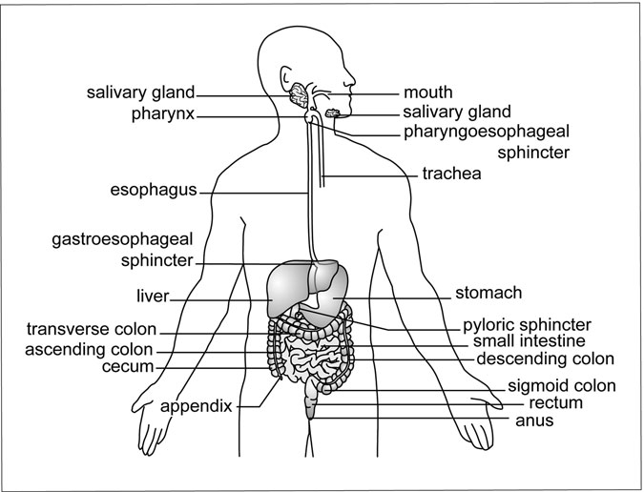

Figure 3.1 Gastrointestinal Tract. This diagram gives the general arrangement of the digestive and accessory organs. (Sandy Windelspecht/ Ricochet Productions)

and stomach, as well as associated valves and accessory organs. The lower GI tract consists primarily of the small intestine and colon. This division, while practical from the standpoint of a reference book, also has some basis in physiological function. As this chapter will explore, the role of the upper GI tract is primarily in the processing of food material. The majority of the digestion and nutrient processing, as well as the preparation of waste material, occurs in the lower GI tract.

##### The Oral Cavity

The human mouth, also called the oral cavity or buccal cavity, is the entry point into the human digestive system. The oral cavity represents an area of intense activity for the body. Not only are nutrients initially processed

in this location, but is also serves as the connecting point between the respiratory system and the outside environment, as well as the location of a signiﬁcant amount of sensory input from chemical receptors, most notably taste (Figure 3.2). The human mouth is the site of both mechanical and enzymatic digestive processes.

##### Salivary Glands

Vital to the digestive functions of the oral cavity are the secretions of three pairs of accessory glands collectively called the salivary glands. These

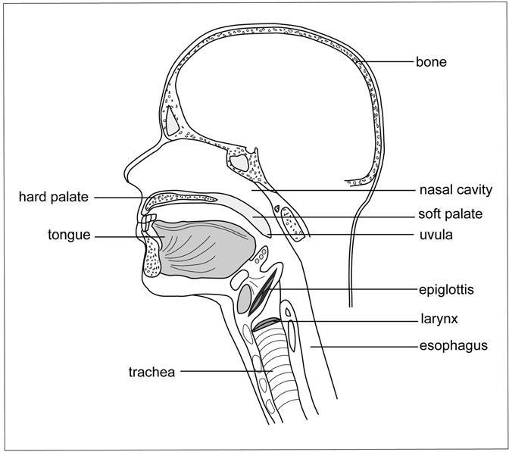

Figure 3.2 Oral Cavity. The structures of the oral cavity, including the relationship to the nasal cavity and respiratory passages. (Sandy Windelspecht/Ricochet Productions)

glands are identiﬁed by their location in the oral cavity. Two pairs are located along the bottom of the oral cavity. The sublingular glands are located just below the tongue, and the submandibular glands are positioned just beneath these, near the mandibula (jawbone). A third set, called the parotid glands, are located just in front of, and slightly below, the ears. The childhood disease called mumps frequently infects the parotid glands, although the other pairs may become infected as well. A duct carries the secretions of each salivary gland into the oral cavity.

Saliva, the chemical secretion of the salivary glands, is actually a com- plex mixture that performs a variety of functions for the digestive system. Saliva is primarily water (99.5 percent), which serves to lubricate and mois- ten the digestive system. However, it is the remaining 0.5 percent of the volume that contains some of saliva’s most important functions. This small fraction contains important ions, such as potassium, chloride, sodium, and phosphates, which serve as pH buffers and activators of enzymatic activity. Since salivary glands are similar in structure to sweat glands found within the skin, they also secrete urea and uric acid as waste products. Saliva also contains a small amount of an enzyme called lysozyme, which inhibits, but does not eliminate, the formation of bacterial colonies in the oral cavity. Mucus, a watery mixture of complex polysaccharides, helps lubricate and protect the oral cavity. Also found in saliva is another enzyme, called salivary amylase, which initiates the process of carbohydrate diges-

tion (discussed at length in the following section).

The composition of the saliva varies slightly depending on the salivary gland in which it originates. The salivary glands of an adult can secrete a combined volume of 1.58 quarts (1,500 milliliters) of saliva daily. The amount of saliva secreted at a speciﬁc time is dependent on a number of fac- tors. For example, when the body is dehydrated, the production of saliva is decreased, which in turn contributes to a thirst response by the body. An increase in saliva production is under direct control of the brain and is usu- ally the result of a response to a chemical stimulus. The sight or smell of food typically serves to increase saliva production. Memories can also result in an increase of saliva production, such as the memory of a favorite food or food-related event. Increased saliva production can continue for some time after eating to cleanse the mouth of food, eliminate harmful bacteria, and restore the normal pH of the oral cavity.

##### Mechanical Digestion

In the oral cavity, the process of mechanical digestion serves several func- tions. First, the action of the teeth and tongue break the food into small portions so that it may be sent to the stomach via the esophagus. Second, the process of mechanical digestion increases the surface area of the food, allowing the secretions of the salivary glands to mix freely with the food and stimulating the action of the taste buds.

The action of chewing, or mastication, is the ﬁrst stage of mechanical digestion. Chewing involves the action of both the teeth and the tongue. While there are three major types of teeth in a human adult mouth (molars and premolars are frequently classiﬁed as one type), all teeth have the same fundamental structure (Figure 3.3). It is the shape of the tooth that deter- mines its function in mechanical digestion (Table 3.2). The combination of different types of teeth in the mouth allows for the processing of a large variety of foods, from protein-rich meats to nutritious vegetables and fruits. The shape and structure of the human jaw is designed to provide a large physical force to the teeth, which can be used to grind both plant tissue and bones to release nutrients.

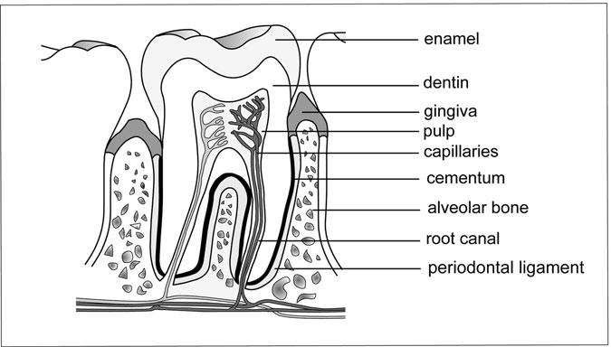

Figure 3.3 The Teeth. The internal structure of a typical human tooth. (Sandy Windelspecht/Ricochet Productions)

TABLE 3.2

The Teeth of an Adult Human

|  |  |  |
| --- | --- | --- |
| *Class* | *Function* | *Number* |
| Incisors | Cutting food | 8 |
| Cuspids (canines) | Tearing and shredding | 4 |
| Premolars | Crushing and grinding food | 8 |
| Molars | Crushing and grinding food | 12 |

The teeth absorb the brunt of this force. To prevent damage, each tooth is located in a socket of the jawbone. Connecting each tooth to the socket is the periodontal ligament, which also acts as a shock absorber. The socket and lower portions of the tooth are covered by the gums, or gingivae. (A common inﬂammation of this tissue is called gingivitis.) Teeth are made from a calciﬁed form of connective tissue called dentin, which is covered with a combination of calcium phosphate and calcium carbonate commonly called enamel. (Dental caries typically erode this area of the tooth.) Within the center of each tooth is an area called the pulp cavity, which contains nerves, blood vessels, and ducts of the lymphatic system. Without teeth, humans would be required to swallow food whole in much the same manner as snakes. As organisms with a high metabolic rate, we require a relatively rapid processing of incoming nutrients. The importance of the teeth in increasing the surface area of the food for later enzymatic digestion should not be underestimated.

The second stage in the mechanical processing of the food involves the action of the tongue. The tongue is comprised of skeletal muscle, which is under the voluntary (but not always conscious) control of the body. The movement of the tongue is controlled by two separate sets of muscles. The extrinsic muscles enable the movement of the tongue that is important for digesting food. These muscles move the food from the area of the teeth to the back of the mouth, where it is formed into a small round mass of material called a bolus. This area at the rear of the oral cavity is commonly called the pharynx. The pharynx serves as the junction between the respira- tory system and digestive system, and thus all activity in this area must be highly coordinated by the body. By the action of the tongue, the food is lubricated with saliva to facilitate swallowing and to mix in the enzymes

of the salivary glands. The tongue also participates in the swallow reﬂex (see the “Swallowing Reﬂex” section) through the action of the intrinsic muscles. This muscle group also controls the size and shape of the tongue and is involved with speech.

Located on the tongue are a series of papillae, which are small projec- tions of the tissue. It is the papillae that give the tongue its rough texture. The papillae are sometimes mistakenly referred to as the taste buds, but the taste buds are actually specialized receptors located at the base of certain types of papillae. There are three different forms of papillae, which differ in their appearance and location on the tongue. The circumvallate papillae are the largest and are located in a V-shaped region at the rear of the tongue (Figure 3.4). All of the circumvallate papillae contain taste buds. The fungiform papillae are knoblike in appearance and are dispersed across the entire tongue. Depending on their location, some fungiform papillae contain taste buds. The last group is the ﬁliform papillae. These have a

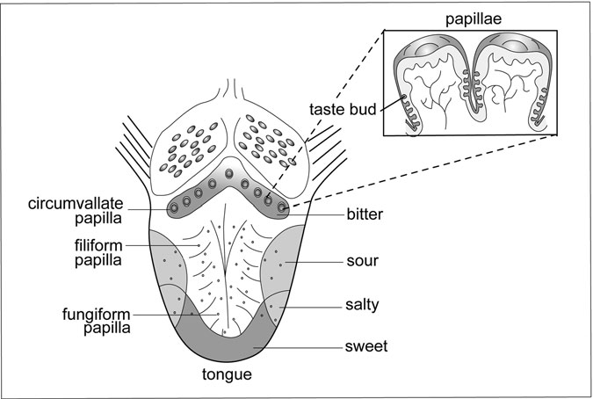

Figure 3.4 The Tongue. The external structure of the tongue showing the relationship between papillae types and taste zones. (Sandy Windelspecht/Ricochet Productions)

ﬁlament-like appearance and are also uniformly distributed across the surface of the tongue. However, unlike fungiform papillae, ﬁliform papillae rarely contain taste buds.

The tongue is divided into four different taste zones—sour, bitter, sweet, and salty. The taste buds in each area are sensitive to a unique chemi- cal signature. Depending on the origin of the signal, the brain interprets the different tastes. The number of receptors that ﬁre and the duration of the signal determine the intensity of the taste.

##### Enzymatic Digestion

Enzymatic digestion is responsible for breaking organic material into smaller subunits that can be absorbed into the circulatory system. The amount of enzymatic digestion within the oral cavity is small in comparison to the activity of the lower GI tract. However, there is some initial digestion of both carbohydrates and lipids in the oral cavity. The salivary glands, pri- marily the submandibular and sublingual glands, secrete an enzyme called salivary amylase. Recall that the nutrients are primarily absorbed from the digestive system in their simplest structure, or monomers. Salivary amylase belongs to a class of enzymes that digest complex carbohydrates, such as starch, into monosaccharides. The monosaccharides are easily absorbed into the circulatory system, although little absorption occurs in the oral cavity. The salivary amylase is mixed into the food by the action of the tongue and cheeks and continues to break down the starches in the food for about an hour until deactivated by the acidic pH of the stomach. A second enzyme of the oral cavity is lingual lipase. Lingual lipase is secreted from glands on the surface of the tongue. This enzyme acts on triglycerides in the food, breaking them down into monoglycerides and fatty acids. How- ever, the action of this enzyme is relatively minor and it does not make a major contribution to overall lipid digestion.

##### Swallowing Reﬂex

As the bolus forms in the rear of the oral cavity, or pharynx, the swallowing reﬂex begins. Swallowing, or deglutition, is a staged process that is partly under voluntary control and partly a reﬂex action. While most people do not consciously think of swallowing, in fact it represents a complex, highly

coordinated activity. The tongue, through the action of the intrinsic muscles, forces the food to the back of the mouth. The pressure of the bolus on the pharynx activates a series of receptors that send a signal to the swallowing center of the medulla oblongata and pons in the brain. The swallowing center then temporarily deactivates the respiratory centers of the brain to ensure that the bolus will be directed into the digestive, and not the respira- tory, system.

As the bolus prepares to enter the esophagus, a series of events is initi- ated to direct the food into the digestive system. Once the swallowing reﬂex has begun, the following four events occur in rapid succession:

1. The tongue moves upward against the roof (hard palate) of the mouth to prevent the food from reentering the oral cavity.
2. The uvula, an inverted-Y-shaped ﬂap of skin at the rear of the mouth, moves upward to block the nasal passages.
3. The vocal cords in the larynx tightly close over the opening of the windpipe, or glottis.
4. As the bolus passes into the esophagus, it forces a ﬂap of cartilaginous tissue called the epiglottis downward over the glottis as an added pre- caution to protect against the food entering the respiratory system.

##### Layers of the Digestive System

Before following the bolus on its brief journey through the esophagus, it is necessary to discuss the tissue structure of the digestive tract. From the esophagus to the anus, the walls of the digestive tract have the same general structure, with minor variations in each organ to enable speciﬁc functions. Within the wall of the digestive tract are four major tissue layers. From outermost to innermost, they are the serosa, muscularis externa, submucosa, and muscosa.

The serosa is the outermost layer of the digestive tract and is comprised of connective tissue. The serosa is important in that it forms a connection between the digestive tract and the mesentery that suspends the organs of the digestive tract within the abdominal cavity. To prevent friction between the organs of the system, the serosa secretes a water-based mixture that

lubricates the exteriors of the organs. Directly under the serosa is a double layer of smooth muscle, the muscularis externa. These two muscle layers are the inner circular muscle and the outer longitudinal muscle. Since these layers are composed of smooth muscle, they are not under voluntary control of the brain. However, a nerve network called the myenteric plexus allows for regulation of activity from the involuntary control centers of the brain. The muscles contract in different directions, with the circular layer control- ling the diameter of the digestive tract and the longitudinal layer controlling the length. The human digestive system does not rely on gravity to move nutrients through it; instead, the action of these two muscle layers rhythmi- cally moves food through the system by a series of coordinated contractions called peristaltic action.

The next layer inward is a dense section of connective tissue called the submucosa. Located within the submucosa are the major blood and lymphatic vessels, as well as another series of nerves called the submucous plexus that provides involuntary regulation of the layer. The innermost layer is the mucosa. This layer lines the interior of the digestive tract and thus is in direct contact with the nutrients passing through the system. The epithelial cells of the mucosa serve several functions, depending on the region of the gastrointestinal tract. In some cases, these cells secrete a mucus layer that serves to lubricate the passage and protect the cells. Other cells may secrete digestive juices, while still others may release hormones that regu- late the activity of the region. Epithelial cells are arranged into folds to increase the surface area. The amount of folding is dependent on the region of the gastrointestinal tract. Also within the mucosa, usually just underneath the epithelial cells, is a thin layer of smooth muscle, as well as blood vessels, lymphatic vessels, nerves, and cells of the immune system.

##### Esophagus

Once the bolus leaves the oral cavity, it enters into a muscular tube called the esophagus. The esophagus is not a major digestive organ, because the only enzymes that are active here are the salivary amylase and lingual lipase from the oral cavity. Furthermore, since the bolus spends only a brief amount of time in the esophagus (between ﬁve and nine seconds), and since the mucosa tissue layer does not contain a large number of folds, there is almost

no absorption of nutrients through the walls of the esophagus. Instead, the esophagus serves as a conduit from the oral cavity, through the thoracic region of the body and to the stomach. The thoracic region houses the heart and lungs and is bordered on the bottom by a muscular barrier called the diaphragm. The esophagus passes through the diaphragm and connects to the upper portion of the stomach.

The bolus moves through the esophagus by peristaltic action. To aid the movement of the bolus, the cells of the mucosa tissue layer secrete mucus to lubricate the tube. To ensure the one-way movement of food, the esophagus is regulated by two sphincters, or valves. At the upper end of the esophagus is the pharyngoesophageal sphincter, which also serves to limit the ﬂow of air into the gastrointestinal tract during breathing. At the lower end of the esophagus is the gastroesophageal sphincter, sometimes called the cardiac sphincter, which connects the esophagus to the stomach. The gastroesopha- geal sphincter also inhibits the reﬂux, or backup, of gastric juices from the stomach into the esophagus. Without this valve, the highly acidic gastric juices would damage the delicate mucosa layer of the esophagus.

##### Stomach

The stomach is commonly recognized as a muscular sac that functions as a holding site for food before it enters into the small intestine, as well as the location where the food is mixed and partially digested by mechanical processes. However, while the stomach does perform these functions, in actuality, its physiology and role in the digestive process is much more complex.

The stomach is an elastic, J-shaped organ whose boundaries are deﬁned at the upper end by the gastroesophageal sphincter, and at the lower end by the pyloric sphincter (Figure 3.5). When empty, a human stomach may have a volume as little as 0.05 quarts (50 millimeters). In comparison, when full, the stomach may contain almost 1.06–2.11 quarts (1–2 liters) of food, depending on the individual. The stomach contains the same tissue layers as are found in the esophagus, small intestine, and colon, with some impor- tant variations in the secretions and structure of the mucosa layer. The J-shaped interior of the stomach is divided into regions based on slight differ- ences in the secretions of the mucosa layer, thickness of the muscle layers,

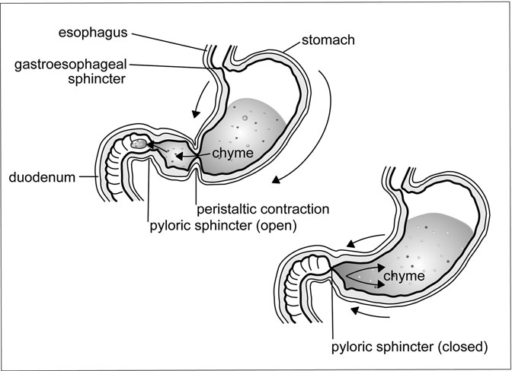

Figure 3.5 The Stomach. This diagram not only shows the location of the sphincters that deﬁne the boundaries of the stomach, but also the peristaltic contractions that are responsible for moving forward toward the duodenum. (Sandy Windelspecht/Ricochet Productions)

and overall function in digestion. The uppermost part, located above the level of the gastroesophageal sphincter, is the fundus. Below this is the main region of the stomach, called the body. The lower portion of the stomach, which connects to the small intestine, is called the antrum. A fourth region, called the cardia, is located around the area of the gastroesophageal opening and plays only a limited role in digestion. The physiological differences of the fundus, body, and antrum will be covered within the following sections.

##### Composition of Gastric Juice

The stomach produces about 2.12 quarts (2 liters) of gastric juice per day. Recall that in the general structure of the digestive tract, the mucosa tissue layer may contain folds. In the stomach, these folds are called gastric pits (Figure 3.6). Located in each of these pits are specialized cells that are

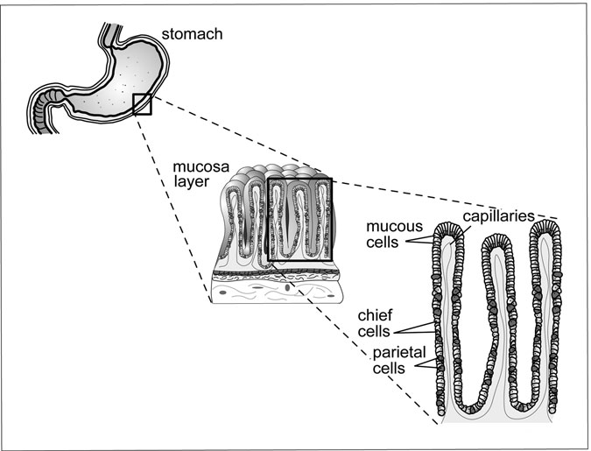

Figure 3.6 The Gastric Pits. The gastric pits of the stomach showing the location of chief and parietal cells. (Sandy Windelspecht/Ricochet Productions)

responsible for generating the secretions of the stomach. At the top of the gastric pit are the mucous neck cells. Together with the surface epithelial cells, they are responsible for secreting the mucus coating that protects not only the cells within the gastric pit, but also the mucosa layer of the stomach. The mucus has an alkaline, or basic, pH, and thus serves to neutralize any stomach acid before it comes in contact with the stomach mucosa. The mucus also serves to lubricate the interior of the stomach for mechanical digestion. Located within the gastric pits are the chief cells and parietal cells. The chief cells secrete an inactive enzyme called pepsinogen, which is involved in the chemical digestion of proteins (as described in the next section).

The parietal cells are responsible for manufacturing hydrochloric acid. The manufacture of hydrochloric acid is an energy-intense process, and thus the parietal cells have an exceptionally high concentration of

mitochondria to generate the needed energy. Hydrochloric acid has a pH of 2.0, making it 100,000 times more acidic than water. The hydrochloric acid serves a number of functions in the stomach. First, it distorts, or dena- tures, the structure of proteins, making them easier to digest. Second, the low pH of the hydrochloric acid activates the pepsinogen enzyme secreted by the chief cells. Finally, the low pH of the hydrochloric acid acts as a deterrent against bacterial contaminants in the food. In this regard, the gastric juice of the stomach acts as a physical barrier of the immune sys- tem. In addition to hydrochloric acid, the parietal cells secrete an intrinsic factor that aids in the absorption of vitamin B12 in the small intestine.

While the gastric pits of the fundus, body, and antrum may look funda- mentally the same, there are some important variations in the secretions from these areas. Gastric juice, containing hydrochloric acid, pepsinogen, some mucous, and intrinsic factors, is secreted primarily by the cells of the fundus and body. In comparison, the cells of the antrum are responsible for secreting a large amount of mucus. Specialized cells in this area, called G cells, release a hormone called gastrin. Gastrin is released directly into the bloodstream and regulates the activity of the parietal and chief cells in the body and the stomach.

##### Enzymatic Digestion

The food was mixed in the oral cavity with saliva, which contains salivary amylase. The chemical digestion of complex carbohydrates in the bolus continues down the esophagus. After the bolus passes through the gastroe- sophageal sphincter and enters the stomach, it comes in contact with the highly acidic hydrochloric acid. While hydrochloric acid deactivates salivary amylase, the lack of a signiﬁcant amount of mechanical digestion in the fundus and upper regions of the body of the stomach allows the salivary amylase to continue carbohydrate digestion within the bolus. How- ever, once mechanical digestion begins lower in the stomach, the salivary amylase is quickly inactivated. The thick mucus coating of the stomach prohibits the absorption of digested carbohydrates into the bloodstream.

In the oral cavity, the enzyme lingual lipase initiated a limited digestion of triglycerides in the food. In the stomach, the chief cells also release a gastric lipase, which serves much the same function in breaking down triglycerides.

As was the case with the carbohydrates in the oral cavity and stomach, this is not a major contribution to the overall digestion of these nutrients, and there is no appreciable absorption of triglycerides through the stomach lining.

The prime nutrient target of enzymatic digestion in the stomach is pro- tein. Recall from earlier in this chapter that proteins may be large molecules, and all contain multiple levels of complex organization. This three- dimensional structure of proteins, and the presence of peptide bonds holding the amino acids together, makes proteins a difﬁcult class of nutrients to digest. The purpose of protein digestion in the stomach is to initialize the process by destabilizing the structure of the protein. Thus, the mechanisms of protein digestion in the stomach are very general, and not directed at one speciﬁc type of protein. As was the case with carbohydrates, there is no absorption of peptides or amino acids through the lining of the stomach. Enzymes that are involved in protein digestion belong to the general class called proteases. The pepsinogen secreted by the chief cells in the gastric pits is initially inactive, so as to protect the cells of the gastric pit from unintentional digestion. After being secreted, the pepsinogen makes its way through the protective mucus coat and into the main cavity, or lumen, of the stomach (Figure 3.7). The hydrochloric acid in the lumen activates the pepsinogen by cleaving off a small fragment from one end of the molecule. This active form of the enzyme is called pepsin. Pepsin also has the ability to activate pepsinogen in what is frequently called an auto- catalytic process. Once activated, pepsin breaks down some proteins into

smaller peptide fragments for further digestion later in the small intestine.

##### Mechanical Digestion

The stomach is primarily an organ of mechanical digestion, whose purpose is to thoroughly mix the incoming food material with gastric juice, forming a semi-solid mixture called chyme. This process occurs in three distinct stages:

(1) the ﬁlling of the stomach with food and the temporary storage of food, (2) the mixing of the food with gastric juice, and (3) the emptying of the stom- ach. The purpose of these processes is to manipulate the chyme to the correct consistency, so that it can pass through the pyloric sphincter into the upper region of the small intestine, also called the duodenum, for digestion. A series of complex signals between the stomach and small intestine controls

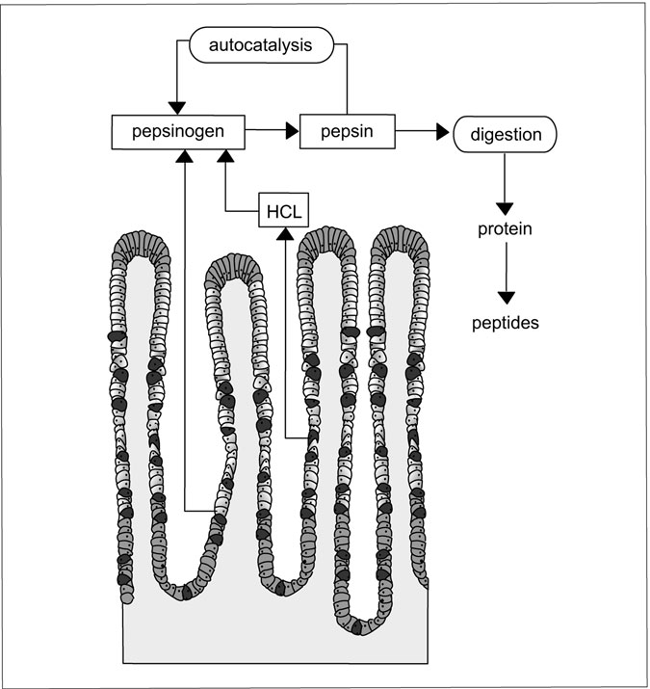

Figure 3.7 Digestive Enzymes. The autocatalytic activation of digestive enzymes in the stomach. (Sandy Windelspecht/Ricochet Productions)

the ﬁnal movement of materials into the duodenum. As was the case with enzymatic digestion, each of the three regions of the stomach has slightly different roles in mechanical digestion. Certain surgical procedures can also alter a body’s digestion patterns and are used as a means to treat severe obesity (Sidebar 3.1).

After passing through the gastroesophageal sphincter, the bolus enters into the body of the stomach. With a normal volume of about 1.5 ﬂuid

SIDEBAR 3.1

#### Treating Severe Obesity through Surgery

Diet and exercise are important approaches to treating overweight and obesity. However, in the case of severe obesity, diet and exercise are not possible and are not enough. Another treatment option is bariatric surgery, which assists weight loss and has been shown to reduce chronic health condi- tions associated with obesity—such as type 2 diabetes—through restricting food intake and blocking the digestive system’s absorption of calories and nutrients. Of course, healthy eating and exercise must follow the bariatric surgery for optimum results.

There are three primary bariatric surgeries commonly offered in the United States. Below are some details on each of these procedures:

*Adjustable Gastric Band*: Also known as AGB, this surgery works primarily by reducing food intake by placing a small band around the top of the stomach. This produces a small pouch that is about the size of a thumb. The size of the pouch is controlled by a balloon located inside the band. It can be inflated or deflated with saline solution, based on the needs of the patient.

*Roux-en-Y Gastric Bypass*: This surgery—RYGB—works by decreasing food intake, in addition to decreasing food absorption. Similar to the AGB surgery, a pouch is created about the same size to the one using the adjustable band. Absorption of food is reduced by directing food directly from the pouch to the small intestine, bypassing the stomach and upper intestine.

*Biliopancreatic Diversion with a Duodenal Switch*: Also known as BPD-DS or the duodenal switch, this surgery has three parts. The procedure removes a large part of the stomach to reduce portion sizes, routes food away from the small intestine to diminish absorption, and re-routes bile and other digestive juices, which impair digestion. When a large portion of the stomach is removed, a gastric sleeve in a tubular shape is created. This is known as a vertical sleeve gastrectomy, or VSG. This sleeve is connected to a short segment of a part of the digestive system known as the duodenum,

which is directly connected to a lower part of the small intestine. The smaller portion of the duodenum remains available for food intake, as well as vitamin and mineral absorption. But in fact, the majority of food bypasses duodenum. The surgery reduces the distance between the stomach and colon, which encourages malaborption. The result can be significant weight loss, although there are risks of long-term complications due to the reduced absorption of vitamins and minerals.

ounces (50 milliliters), this region of the stomach would quickly ﬁll with food if it were not for the elastic nature of the stomach lining. Located along the inside of the stomach are deep folds of tissue called rugae. The purpose of the rugae is to allow the gradual expansion of the stomach, eventually allowing a liter or more of food to enter into the cavity. This process is called receptive relaxation, since it involves the gradual relaxation of the rugae to accommodate the incoming food. This allows the stomach to easily expand its volume to about 1.06 quarts (1 liter), after which the tension of the stom- ach may cause discomfort. The volume at which this occurs varies with the individual, dietary habits, emotional state, and a number of other factors.

The peristaltic contraction of the smooth muscle that is responsible for mixing the food with gastric juice to produce chyme is initiated in the fun- dus. However, the areas of the stomach differ in the strength of the smooth muscle and thus the intensity of the peristaltic action. The contraction in the fundus is relatively weak, but becomes progressively stronger as it moves through the body and antrum. In the body of the stomach the contrac- tions are not sufﬁciently powerful enough to provide a signiﬁcant amount of mixing, allowing the continued digestion of carbohydrates in the bolus by salivary amylase. Thus in many regards the body of the stomach acts primarily as a storage site for incoming food.

As the contractions continue, the gastric juice mixes with the food to form chyme. This chyme is propelled downward into the narrower regions of the antrum, where the force of the peristaltic actions increases signiﬁcantly. At the terminal end of the antrum is the pyloric sphincter, which serves to isolate the stomach from the small intestine. The pyloric sphincter is never com- pletely closed, allowing for an almost continuous passage of water and other ﬂuids into the duodenum. As the peristaltic contraction of the antrum

approaches the phyloric sphincter, a small amount of chyme is moved through the opening and into the duodenum. However, the majority of the chyme is blocked from passing and is forced backed into the antrum for further mixing.

##### Regulating Stomach Motility

The emptying of the stomach contents, also called motility, usually takes between two to four hours following completion of a meal and is dependent on a large number of factors. These factors either inhibit or stimulate the movement of the chyme and are summarized in Table 3.3. For the most part, actions of the stomach increase motility into the duodenum, while feedback from the duodenum inhibits movement of chyme through the pyloric sphincter. There are three distinct phases to stomach motility: the cephalic phase, gastric phase, and intestinal phase.

The preﬁx ceph- means “head,” and the cephalic phase refers to the interaction of the brain with the stomach. If chemical receptors detect the smell or taste of food, a signal is sent to the medulla oblongata in the brainstem, which relays a signal along the vagus nerves to the submucosal plexus in the stomach. The submucosal plexus then stimulates the activity of chief and parietal cells, thus preparing the stomach for incoming food. A similar event occurs when a person thinks about food, especially those foods that that the individual enjoys. The emotional state of the individual, such as anger or anxiety, may inhibit these stimuli by activating the sympathetic nervous system. The sympathetic nervous system is involved with the

TABLE 3.3

Factors Inﬂuencing the Movement of Chyme into the Duodenum

*Stimulation Inhibition*

Distention of the stomach Distention of the duodenum

Presence of partially digested proteins in stomach

Presence of fatty acids and carbohydrates in the duodenum

Gastrin Cholecystokinin (CCK)

Gastric inhibitory peptide (GIP)

Fluid chyme Viscous chyme

Presence of alcohol or caffeine in stomach

ﬁght-or-ﬂight response, one aspect of which is to reduce activity in the gastrointestinal system so that blood may be redirected to muscles.

As its name implies, the gastric phase involves the activity of the stom- ach. Two factors inﬂuence its activity. First, the amount of distention, or stretching of the stomach lining, acts as an indicator of the fullness of the stomach. As the stomach ﬁlls, and the rugae relax, stretch receptors in the lining stimulate the release of gastrin by G cells in the mucosal lining of the antrum. Gastrin is released into the blood stream, where it returns to the stomach to stimulate the generation of gastric juice by the parietal and chief cells. The gastric juice has a normal pH of around 2.0; if this becomes more basic (or alkaline), then the secretion of gastrin is increased. (A reverse reaction occurs if the pH level of the stomach increases above 2.0.) The stretch receptors also stimulate the peristaltic contractions of the stomach.

As noted in the section on mechanical digestion, these contractions are responsible for mixing the incoming food with gastric juice. As the con- tractions increase in strength, more of the chyme passes through the pyloric sphincter. The amount varies with the consistency, or ﬂuidity, of the chyme. Under the ideal conditions, around 0.01–0.02 quarts (10–15 milliliters) of material may pass through the pyloric sphincter with each wave of contractions.

The duodenum of the small intestine may also regulate the activity of the stomach during the intestinal phase. Since the small intestine represents the major organ of digestion and absorption in the body, the duodenum must be ready to receive the incoming chyme for processing. The duodenum primarily has an inhibitory effect on stomach motility (see Table 3.3). Distention of the duodenum, due to the presence of a large volume of chyme, initiates a neural response called the enterogastric reﬂex, which through the action of the medulla oblongata decreases the strength of peri- staltic contractions in the stomach, thus reducing the amount of chyme entering the duodenum.

The presence of partially digested carbohydrates and fats in the duo- denum also activates an inhibitory pathway, but this pathway is based on the action of hormones. The action of salivary amylase, lingual lipase, and gastric lipase had previously started digestion of both carbohydrates and fats in the stomach. When these breakdown products reach the duodenum, they signal the release of gastric inhibitory peptide (GIP), secretin, and cholecystokinin

(CCK) by the mucosa layer of the duodenum. These hormones are released directly into the bloodstream and inﬂuence the activity of a number of organs of the digestive tract, including the stomach. The secretions of the stomach are inhibited by secretin and GIP, while CCK and GIP reduce gastric motility. When this occurs, fewer breakdown products are generated, less chyme enters the duodenum, and thus fewer hormones are produced. When the gastric and intestinal regulatory mechanisms are combined, it allows a ﬁne-tuning of the gastrointestinal system to ensure that the optimal amount of material is being processed by the small intestine at all times.

##### Absorption of Nutrients

As mentioned previously, very few nutrients are absorbed through the lin- ing of the stomach, primarily due to the presence of the mucus layer, which isolates the mucosa tissue from the hydrochloric acid. However, water and some ions are able to be absorbed directly into the circulatory system. In addition, both ethyl alcohol (the form found in alcoholic bever- ages) and acetylsalicylic acid (commonly known as aspirin) are able to penetrate the mucus layer and enter into the circulatory system.

#### The Lower Gastrointestinal Tract: Small Intestine and Large Intestine (Colon)

The previous section described how the upper gastrointestinal (GI) tract, consisting of the stomach, esophagus, and oral cavity, was involved with the processing of food for digestion. While there were some examples of enzymatic digestion in the upper gastrointestinal tract, the majority of the activity was associated with mechanical processing. The primary purpose of this mechanical digestion was to increase the surface area of the food so that the enzymes of the lower gastrointestinal tract can efﬁciently break down the nutrients into chemical forms that are able to be rapidly absorbed by the small intestine.

The lower gastrointestinal tract consists of two digestive organs called the small intestine and large intestine. Assisting with the operation of the small intestine are three accessory organs, the liver, gall bladder, and pancreas (Figure 3.8). The lower gastrointestinal tract serves two primary functions. First, the small intestine functions as the main organ of digestion

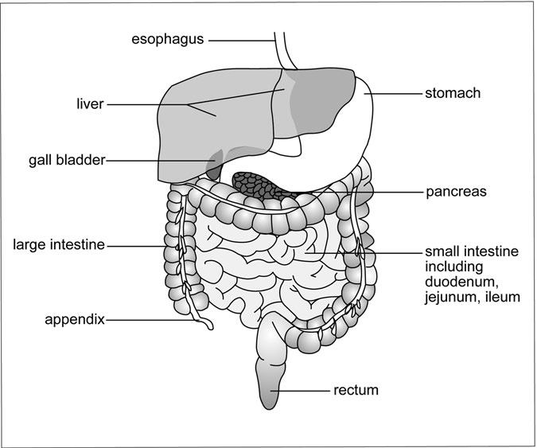

Figure 3.8 The Lower Gastrointestinal Tract. The lower gastrointestinal tract, giving the locations of the digestive organs and accessory glands. The large intestine is frequently called the colon. (Sandy Windelspecht/Ricochet Productions)

and absorption in the human body. It is here that the bulk of nutrient processing is performed. The large intestine, or colon as it is commonly called, is primarily involved in the reabsorption of water and salts back into the body, and the preparation of the fecal material for excretion. This section covers the physiology of the small and large intestine and their interaction with the accessory organs of the digestive system.

##### Small Intestine

The name of the small intestine is derived from its diameter, and not its overall size. The small intestine averages only approximately 1 inch (2.5 centimeters)

in diameter, but in an adult can be over 10 feet (3 meters) in length. Although it may be of a small diameter, the small intestine represents the major site of digestion and absorption in the human body and is thus one of the more important organs of the digestive system.

The small intestine connects to the stomach at the pyloric sphincter and empties into the colon through the ileocecal valve, also called the ileocecal sphincter. For the purpose of study the small intestine is divided into three segments, although there is little difference in the physical appearance or struc- ture of the regions. The ﬁrst 7.8–9.8 inches (20–25 centimeters) of the small intestine, starting at the pyloric sphincter, is the duodenum. The next 2.7 yards (2.5 meters) of the small intestine is called the jejunum, and the last section, about 2 yards (2 meters) in length and ending at the ileocecal valve, is the ileum.

This chapter previously examined the structure of the tissue layers in the gastrointestinal tract. As was the case with the stomach, the physical characteristics of these tissue layers vary in the lower gastrointestinal tract. The most signiﬁcant of these differences occur in the mucosa and submucosa layers, the two innermost tissue layers. These layers interact directly with the interior cavity, or lumen, of the small intestine.

The most notable difference in the structure of the mucosa layer is the presence of numerous ﬁngerlike projections called villi. Unlike the folds in the mucosa layer of the stomach, which enable it to expand in response to an incoming volume of food, the villi of the small intestine are involved in increasing the surface area to facilitate the absorption of nutrients. There may be as many as 40 villi per square millimeter of mucosa, effectively increasing the surface area of the small intestine by a factor of 10. Within each villi are capillaries and portions of the lymphatic section called lacteals (Figure 3.9). As nutrients are absorbed into the villi (see the following section), they pass into either the capillaries or lacteals and are transported away from the small intestine. Along each of the villi are located four types of specialized cells. At the base of each villi, in pits called the intestinal glands (also known as the crypt of Lieberku¨ hn), are the Paneth cells. These cells release lysozyme, an enzyme that protects the small intestine from bacteria. They also may move larger nutrient particles out of the lumen by the process of phagocytosis. Also located within the intestinal glands are enteroendocrine cells. As their name implies, these cells are actually part of the endocrine system and are

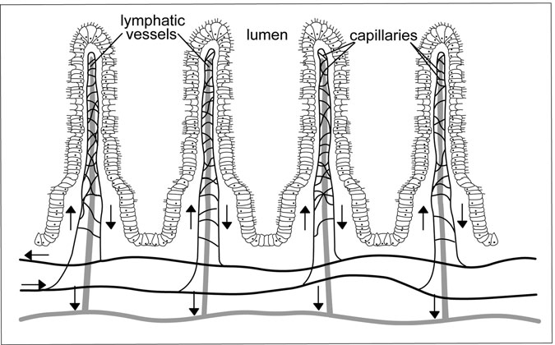

Figure 3.9 Villi of Small Intestine. Notice that each villi contains both capillaries and lymphatic vessels. (Sandy Windelspecht/Ricochet Productions)

responsible for releasing hormones such as gastric inhibitory peptide (GIP), secretin, and cholecystokin (CCK).

Further up the villi are located the goblet cells, which are responsible for secreting the protective mucus coating of the small intestine. While this mucus coating is not as thick as that found in the stomach, it serves to lubri- cate and protect the mucosa of the small intestine. Located along the length of the villi, but primarily above the region of the intestinal glands, is a layer of epithelial cells. These cells, also called absorptive cells, are the major site of nutrient absorption in the small intestine. These cells are unique in that the plasma membrane on the lumen side of the cell contains a large number of small projections called microvilli. Each of these projections is about 1 micrometer (µm) long and a typical absorptive cell may have as many as 6,000 microvilli on its surface. A square millimeter of small intestine may contain up to 200 million microvilli. This increases the surface area of the small intestine by an additional factor of 20. When combined, the villi and microvilli of the small intestine increase the overall surface area in this organ by 600 times, further disproving the idea that this is a “small” intestine.

Under a microscope, the microvilli appear as a thin, fuzzy barrier on the lumen side of the absorptive cells. This is sometimes called the brush border, and it represents a region that is not only involved in nutrient absorption, but also in nutrient digestion by a group of enzymes called the brush border enzymes (see the following sections on the individual nutrient classes).

In the submucosa, a group of specialized cells called the duodenal glands, also known as the Brunner’s glands, release additional mucus into the lumen. This mucus is alkaline in pH, which helps to neutralize any hydrochloric acid from the stomach remaining in the food as it moves through the small intestine.

##### Movement of Nutrients

It takes approximately three to ﬁve hours for nutrients to transit the small intestine from the pyloric sphincter to the ileocecal valve. In the stomach, the incoming food was mixed with gastric juice to form chyme. This chyme is moved along the length of the small intestine by two different types of contractions, peristalsis and segmentation. The peristaltic con- tractions in the small intestine are similar to those found in the stomach and esophagus. However, the contractions in the small intestine are much lower in intensity than those in the upper gastrointestinal organs.

The primary mechanism by which the chyme is moved through the small intestine is by segmentation. Unlike peristalsis, which is the rhythmic, sequential contraction of the smooth muscle layers of the gastrointestinal tract, the process of segmentation involves the localized contraction of small segments of the small intestine. These circular contractions squeeze the chyme against the mucosa layer of intestine, bringing the nutrients into direct contact with the microvilli of the absorptive cells. These contractions also serve to further mix the chyme with the secretions of the small intestine, gall bladder, and pancreas (see the following section on the role of the accessory glands). As the chyme is mixed by segmentation, it is slowly propelled along the length of the small intestine toward the ileocecal valve. Since the contractions of segmentation are not directional, as is the case with peristaltic contractions, some of the material will actually back up into the previous segment of the intestine. To ensure that the chyme has an over- all movement toward the large intestine, the duodenum contracts more

frequently (around 12 per minute) than either the jejunum or ileum (approx- imately nine per minute).

After the processing of a meal is complete, the small intestine enters into a “housekeeping” mode to remove the remnants of the chyme from the lumen. This consists of a series of weak peristaltic contractions that begin in the duodenum and contract for a short length of the intestine before ending weakly. The next contraction begins a little further down the intestine, and so on. The process is analogous to a sweeping action and is called the migrating motility complex. The entire process can take several hours to complete.

Although the small and large intestine are linked by similarities in their names, in reality the internal environments and physiology of these organs are vastly different. As will be described later in this chapter, the large intestine possesses a natural population of bacteria. If allowed into the small intestine, these bacteria could wreak havoc with the delicate tissues present there. The ileocecal valve is well designed to prevent the movement of materials into the small intestine from the large intestine. The folds of the valve are arranged to open easily as the chyme moving through the ileum of the small intestine exerts pressure against the valve. However, if material in the large intestine presses against the valve, the pressure forces the folds tightly closed, preventing contamination of the small intestine. The valve is also under hormonal control. As food enters the stomach, special cells release a hormone called gastrin. Gastrin serves to relax the ileocecal valve, allowing for the emptying of the small intestine in response to an incoming meal.

##### Role of Accessory Glands

The digestive functions of the small intestine are assisted by the secretions of three accessory glands—the liver, gall bladder, and pancreas. This sec- tion will introduce the digestive roles of these glands.

One of the most important organs in the human body is the liver. The larg- est organ by weight, the liver coordinates activity between a number of body systems. The liver not only provides chemicals to assist in the digestive pro- cess, but it also ﬁlters and stores nutrients coming from the digestive system. As an accessory organ to the small intestine, the liver provides a compound called bile, which assists in the process of lipid digestion. Bile is synthesized in the small intestine from a number of chemicals, including cholesterol,

phospholipids, bile acids, and water. Another ingredient is bilirubin,a waste product from the breakdown of worn-out red blood cells in the liver. Bilirubin does not play a role in digestion, but does give bile and the fecal material their color. Bile is continuously excreted into the bile duct, which connects the liver to the duodenum via the hepatopancreatic ampulla.

The gall bladder is a small sac, roughly pear-shaped, that is located just beneath the liver. The sole purpose of the gall bladder is the storage of the bile salts from the liver between meals. Before entering the duodenum, the bile duct links up with the pancreatic duct to form the hepatopancreatic ampulla. At the duodenum end of this structure is a small valve called the Sphincter of Oddi. This sphincter is normally open when chyme is present in the duodenum, but closes between meals. Since bile production by the liver is a continuous event, the bile leaving the liver backs up and enters the gall bladder to be stored. As food enters the duodenum, CCK is released from the enteroendocrine cells in the mucosa of the small intestine. This hormone signals the gall bladder to contract, releasing its contents, as well as acting as a signal for the Sphincter of Oddi to relax.

The third major accessory organ is the pancreas. It is located just below the stomach, adjacent to the small intestine. Like the liver, the pancreas performs a variety of functions in the human body. As an accessory organ for the digestive system, the pancreas is responsible for providing the majority of the digestive enzymes needed for nutrient processing in the small intestine. The cells of the pancreas produce a colorless liquid called pancreatic juice. This colorless, watery mixture is collected into the pancreatic duct, which later joins the bile duct to form the hepatopancreatic ampulla, which empties into the duodenum. The major enzymes present in the pancreatic juice are listed in Table 3.4. In addition to these enzymes, pancreatic juice contains a compound called sodium biocarbonate. This compound is slightly alkaline and serves to neutralize the acid in the chyme from the stomach. This establishes the correct pH for optimal enzyme activity in the small intestine (Sidebar 3.2).

##### Overview of Nutrient Processing

As mentioned previously, the small intestine is the primary organ of diges- tion and absorption in the human body. In general, the small intestine has

TABLE 3.4

The Sources of the Digestive Compounds of the Small Intestine

|  |  |  |
| --- | --- | --- |
| *Target nutrient* | *Compound* | *Source* |
| Carbohydrates | Pancreatic amylase | Pancreas |
| Lipids | Bile | Liver |
|  | Pancreatic lipase | Pancreas |
| Proteins | Chymotrypsin | Pancreas |
|  | Trypsin | Pancreas |
|  | Carboxypeptidase | Pancreas |
|  | Elastase | Pancreas |
| Nucleic acids | Deoxyribonuclease | Pancreas |
|  | Ribonuclease | Pancreas |

to process two very broad classes of nutrients. The hydrophilic (“water- loving”) molecules, which include the monosaccharides and many of the amino acids, are easily transported, digested, and absorbed by the small intestine. The second class is the hydrophobic (“water-fearing”) molecules, of which fats and cholesterol are the major examples. Due to their chemical properties, hydrophobic molecules will require more elaborate processing and transportation systems.

For each of the four major classes of organic nutrients, the carbohy- drates, lipids, proteins, and nucleic acids, the job of the small intestine is to ﬁrst break down the large complex structures of these nutrients into units that are small enough to be transported into the villi. The following sections will detail the digestion and absorption of each of the major classes of nutrients. It is important to remember that, for the most part, the processing of nutrients occurs simultaneously throughout the length of the small intestine.

Carbohydrate Digestion and Absorption

Carbohydrate digestion began in the oral cavity with the activity of the sali- vary amylase enzyme. While this enzyme only acts on the incoming food for a brief period of time before becoming inactivated by the hydrochloric acid of the stomach, it does initiate the breakdown of starches and other polysaccharides into disaccharides and monosaccharides. The majority of

SIDEBAR 3.2

#### Alcohol’s Negative Impact on the Liver

The disease of alcohol has many negative health impacts, but it is especially harsh on the liver. One of the digestive system’s secondary organs, the liver breaks down alcohol so it can be eliminated from the body. When the body consumes excessive amounts of alcohol, the liver has a hard time processing it fast enough. This leads to an imbalance—too much alcohol in the liver—which interferes with how the organ breaks down protein, fat, and carbohydrates. This can lead to alcohol-induced liver disease.

There are three primary types of alcohol-induced liver disease:

*Fatty Liver Disease*: This condition occurs when there is an accumulation of fat cells in the liver. The liver may be enlarged, and discomfort may be felt by patients in the upper abdomen.

*Alcoholic Hepatitis*: This occurs in up to 35 percent of heavy drinkers, and is characterized by inflammation of the liver. Patients may experience nausea, vomiting, fever, and jaundice. While this disease can cause progressive liver damage over a period of years, it can be reversed if drinking is stopped. Severe forms of alcoholic hepatitis can lead to life-threatening complications.

*Alcoholic Cirrhosis*: This is the most serious type of alcohol-induced liver disease, and occurs when normal liver tissue is replaced with scar tissue. It is the most serious type of alcohol-induced liver disease. An estimated 10–20 percent of heavy drinkers develop this condition, typically after drinking for more than 10 years. Symptoms are similar to alcoholic hepatitis. Cirrhosis is a life-threatening disease, and cannot be reversed, although damage can be minimized upon abstaining from alcohol.

Complications of these and other alcohol-induced liver diseases include a buildup of abdominal ﬂuid, an enlarged spleen, bleeding from esophageal veins, high blood pressure in the liver, kidney failure, and liver cancer.

the polysaccharide digestion is conducted in the small intestine by a secretion of the pancreas called pancreatic amylase. Pancreatic amylase is active in the lumen of the small intestine. Like salivary amylase, this enzyme can break down starch and glycogen, but not plant polysaccharides such as cellulose, commonly called ﬁber. These remain undigested and unprocessed until they reach the large intestine and provide much of the bulk of the food.

To be absorbed into the villi, carbohydrates must be in their simplest form, as monosaccharides. In most cases, the action of the salivary and pancreatic amylases generates a compound called dextrin, a short chain of glucose molecules. The ﬁnal breakdown of the carbohydrates into mono- saccharides is performed by a group of enzymes physically embedded in the brush border of the small intestine. These enzymes are named by the speciﬁc carbohydrate substrate that they recognize. For example, the dextri- nase enzyme breaks down the short-chains of glucose (dextrins) into single glucose units. The maltase enzyme digests the disaccharide sugar maltose into two glucose units. Sucrose, another of the disaccharides that consists of glucose and fructose, is digested by the sucrase enzyme, and lactose, a sugar commonly found in milk, is broken into the monosaccharides galac- tose and glucose by the action of the lactase enzyme.

Once the carbohydrates in the chyme have been digested into one of the three monosaccharides (fructose, glucose, or galactose), they are ready for absorption into the villi of the small intestine (Figure 3.10). The molecules themselves are too large to pass directly through the membranes of the intes- tinal cells. Fructose is absorbed by a process called facilitated diffusion, in which a protein channel in the membrane of the epithelial cells aids in the movement of the fructose into the villi. The movement of glucose and galac- tose is slightly different. To move these molecules into the epithelial cell, the cell couples their movement with the transport of sodium ions (Na+) into the cell. This is a form of active transport, and as such requires energy.

Once these monosaccharides are in the cytoplasm of the epithelial cell, they are rapidly moved into the capillaries of the villi by the process of facilitated diffusion. There they enter the circulatory system and proceed to the liver for additional processing. The rapid movement of these mole- cules out of the epithelial cells ensures that the interior of the cell has a low concentration of the monosaccharides, thus aiding in the absorption of sugars from the lumen.

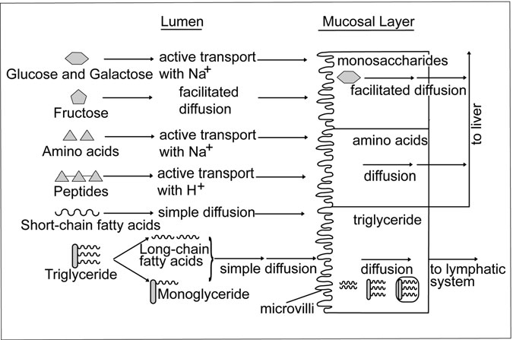

Figure 3.10 Small Intestine Nutrient Absorption. Nutrient absorption in the small intestine. Note how monosaccharides and most amino acids proceed directly to the liver, while the triglycerides enter in the lymphatic system. Triglycerides are ﬁrst disassembled in the lumen and then reassembled into chylomicrons for transport in the lymphatic system. (Sandy Windelspecht/Ricochet Productions)

Proteins

The digestion of proteins was initiated in the stomach with the activity of the enzyme pepsin. Recall that pepsin is a general enzyme, which serves to dis- rupt the complex three-dimensional structure of the proteins in the chyme. Thus, when the proteins reach the small intestine, they are primarily in the form of small chains called peptides. In general, protease enzymes are powerful catalysts and thus are secreted in an inactive form until needed by the body. This prevents the unwanted digestion of the mucosal lining. For example, in the stomach, the pepsin enzyme was generated from a molecule called pepsinogen under the correct pH conditions. A similar event occurs in the small intestine. The pancreas releases a protoenzyme called trypsinogen into the lumen of the duodenum via the pancreatic duct. Trypsinogen is

inactive and cannot begin the breakdown of proteins until it is ﬁrst activated by enterokinase, an enzyme that is present in the brush border region of the villi. The enterokinase cleaves off a small portion of the trypsinogen molecule, forming the enzyme trypsin. In turn, trypsin activates three reactions with chymotrypsinogen, proelastase, and procarboxypeptidase to produce chymo- trypsin, elastase, and caboxypeptidase, respectively. These molecules are all proteases that are active in the lumen of the small intestine. While each targets a different structural part of the protein, their overall function is to digest the proteins into smaller peptides, at times releasing individual amino acids.

Present in the brush border region are two other enzymes. The ﬁrst are the aminopeptidases, which are responsible for removing the terminal amino acid from the end of the peptide chain. The second is an enzyme called dipeptidase, which breaks the remaining peptide bond holding two amino acids together. The end result of this activity is free amino acids, which may now be absorbed into the villi.

The absorption of the individual amino acids is very similar to the pro- cess outlined previously for carbohydrates. In most cases, the movement of amino acids across the membrane is an active process that is coupled to the movement of sodium ions (Na+), although in some cases the process is coupled to the transport of hydrogen ions (H+). Once in the epithelial cells, the amino acids diffuse into the capillaries of the villi, to be trans- ported by the hepatic portal system to the liver for processing.

There are two additional aspects of protein digestion to be mentioned. While we previously noted that the three regions of the small intestine are fundamentally the same, there are some minor differences with regards to protein digestion and absorption. The majority of protein digestion occurs in the duodenum and jejunum, with only minimal activity in the ileum. Also, any protein that enters the small intestine is subject to the digestive process outlined above. This includes not only proteins from food sources, but also the proteins found in worn-out mucosal cells, enzymes such as pepsin and salivary amylase, bacterial proteins, and miscellaneous pro- teins such as bilirubin that are excreted from the liver and pancreas.

Lipids

The processing of lipids by the small intestine differs signiﬁcantly than that described previously for carbohydrates and proteins. This is primarily due to

the fact that lipids are hydrophobic molecules, and as such are not easy to work within the hydrophilic environment of the lumen of the small intestine. Prior to the entry of lipids into the small intestine, there was a small amount of processing performed by the lingual lipase in the oral cavity. This enzyme primarily serves to initiate triglyceride digestion, but is active only for a relatively short period of time before entering the stomach. In the stomach, gastric lipase may act on short-chain fatty acids, such as those found in milk products. However, this enzyme does not make a signiﬁcant contribution to lipid processing. Thus, the real ﬁrst level of lipid digestion

and absorption occurs in the small intestine.

As the chyme passes the pyloric sphincter, it is mixed with secretions of the liver, gall bladder, and pancreas. Recall from the previous section that the liver produces bile salts, which may be temporarily stored and con- centrated within the gall bladder. Bile emulsiﬁes, or breaks down, droplets of fats in the chyme into smaller particles. This is not enzymatic digestion, since the individual lipid molecules are not the target, but rather the interac- tion between the fat molecules. The result is small droplets of lipids with a diameter of about 0.039 inches (1 millimeter). This drastically increases the surface area for digestion, speeding the overall processing of the lipids. The enzyme responsible for the digestion of lipids is pancreatic lipase. Pancreatic lipase enters the small intestine through the duct called the hepatopancreatic ampulla, along with bile from the gall bladder and liver. This lipase breaks down triglycerides into small fatty acid chains and monoglycerides, which consist of a single fatty acid chain connected to the glycerol backbone. In these forms, the molecules can then be absorbed directly into the epithelial cells of the villi by the process of diffusion.

However, most of the triglycerides that enter into the small intestine contain long-chain fatty acids, which due to their size cannot diffuse into the villi. For the long-chain fatty acids, and similar hydrophobic molecules such as cholesterol, a different process exists to move the nutrients out of the lumen and into the body. When combined with the bile salts released from the liver, the lipids and cholesterol form spheres called micelles. Each micelle consists of an outer shell of approximately 30 to 50 bile salt mole- cules. Micelles are amphipathic molecules, meaning that they have both polar and nonpolar regions, enabling them to interact with both hydrophobic and hydrophilic molecules. The hydrophobic lipids are carried within the

center of the micelle. When the micelle reaches the cell membrane of the epithelial cells in the villi, the lipids and other hydrophobic molecules in the core of the micelle are able to diffuse across the membrane. The sphere of bile salts is then able to return to the lumen to pick up more hydrophobic lipids. In other words, the micelle acts as a shuttle by providing a hospitable environment for the movement of large hydrophobic molecules.

Since bile salts represent a reusable resource for the digestive system, they are recycled in the small intestine. The bile salts that were initially released in the duodenum are reabsorbed in the ileum of the small intestine. There they enter into the portal circulatory system and are returned to the liver. This circu- lar recycling of bile salts is sometimes called the enterohepatic circulation.

One more important aspect of lipid processing occurs in the small intestine. With hydrophobic nutrients, such as sugars, the nutrients that are absorbed by the small intestine quickly diffuse into the capillaries of the villi, where they then enter the circulatory system. However, lipids by nature do not interact well with an aqueous environment, and their large size would quickly clog the narrow capillaries contained within the villi. Instead, lipids are packaged into a special form of lipoprotein called a chylomicron. Chylomicrons are protein-covered balls of lipids, choles- terol, and phospholipids. The role of the chylomicron is to move the lipids into the lacteal of the villi, where it then enters into the lymphatic system.

Nucleic Acids

Recall that nucleic acids represent the genetic material of living organisms, and thus are present in most of the material being processed by the small intestine. Since DNA and RNA (ribonucleic acid) both consist of long chains of nucleotides, they are digested in a similar manner by the small intestine. The fact that the DNA is double-stranded, and typically a longer polymer, has little inﬂuence on the properties of nucleic acid digestion.

Along with its previously mentioned enzymes, the pancreas secretes pancreatic ribonuclease and deoxyribonuclease, which act on RNA and DNA, respectively. The purpose of these enzymes is to cleave individual nucleotides from the polymer. In many ways these enzymes function simi- larly to the pancreatic proteases mentioned earlier. Once a nucleotide is removed from the polymer, it is further digested by brush border enzymes called nucleosidases and phosphatases. These enzymes break the nucleotide

down into its constituent sugars, phosphates, and nitrogenous bases for absorption into the villi by active transport. Once there, they move into the capillaries by diffusion and enter the portal circulatory system.

Water

While water is an integral part of the digestive tract, and one of the more important nutrients in the human body, it is not “digested” in the same manner as the organic nutrients just mentioned. Instead, it is absorbed by the villi of the small intestine into the circulatory system, and to a lesser extent the lymphatic system. Most physiologists believe that water moves from the lumen of the intestine into the epithelial cells by the process of osmosis, or the diffusion of water. This passive process is dependent on the concentration of solutes and has long been recognized as the prime mechanism of water movement by biological systems.

However, researchers have begun to discover that many organisms pos- sess specialized channel proteins, called aquaporins, that allow for the rapid movement of water across a plasma membrane. The small intestine processes a tremendous volume of water daily. Almost 10 quarts (close to 9.3 liters) of water enter the small intestine daily, most of it (7.4 quarts, or approximately

7.0 liters) comes from the secretions of the accessory glands (4.2 quarts, or about 4 liters), stomach (2.1 quarts; 2 liters), and small intestine (1.06 quarts; 1 liter). The remainder (2.4 quarts; an average of 2.3 liters) is obtained from the ingested food and liquids. The small intestine reabsorbs almost 90 percent of this volume, with the remainder passing into the large intestine.

Vitamins

Vitamins are frequently assigned to two general classes, those that are water soluble (vitamin C and the B-complex vitamins) and those that are fat-soluble (vitamins A, D, E, and K). These general classes also apply to the approach that the small intestine takes in absorbing these important compounds. The water-soluble vitamins are treated in much the same manner as monosaccharides and amino acids, meaning that they are actively transported into the epithelial cells and then move by diffusion into the capillary of the villi.

Fat-soluble vitamins may either move into the epithelial cells by diffu- sion, or through the action of the micelles. They are typically then loaded

into chylomicrons for transport into the lymphatic system. Some vitamins have special processing in the small intestine. Vitamin B12, sometimes also called cobalamin, is typically found in protein-rich foods. The pH of the stomach releases the vitamin, which then binds with an intrinsic factor before entering the small intestine. In the small intestine, vitamin B12 is absorbed into the epithelial cells, where it then returns to the liver via the enterohepatic circulation. The liver continuously secretes both vitamin B12 and folate into the bile. Since folate is associated with the health of rapidly dividing cells, and vitamin B12 is needed to activate folate, this mechanism ensures that the rapidly dividing epithelial cells of the small intestine are provided with a source of these important vitamins.

Minerals

Minerals, like water, are not organic nutrients and thus are not digested by the small intestine. However, the small intestine does represent an impor- tant location of absorption for many of the minerals in a human diet.

Unlike the other nutrient classes, mineral absorption in the small intestine is not guaranteed. Many foods contain chemicals that actively bind nutrients, reducing their ability to be absorbed. Thus, for minerals, it is often more correct to refer to their bioavailability, and not necessarily the total quantity in the food. Examples of these binders are oxalic acid, found in leafy vegetables such as spinach, and phylic acid, a compound frequently found in grains and beans (legumes).

There are many different minerals, each with its own unique absorption properties. For nutritional purposes, minerals are classiﬁed as being either trace or major, depending on the quantity that is required in the diet. How- ever, since minerals are not digested enzymatically, as was the case with the organic nutrients, the activity of the small intestine is conﬁned to absorption only. Most of the minerals behave as hydrophilic molecules (such as potassium and sodium), but a few display hydrophobic characteris- tics. In most cases, minerals are absorbed by active transport into the villi.

Two minerals of special interest in examining the physiology of the small intestine are calcium and iron. Calcium is an important nutrient for muscle contraction, and has the secondary function of providing strength to bone (see Chapters 7 and 11 of this encyclopedia for more information). Calcium is usually brought into the digestive system in the form of a salt,

and is kept in a soluble form by the acidic nature of the stomach. The efﬁ- ciency of the small intestine in absorbing calcium is based upon a number of factors. In general, an adult human is able to absorb about 30 percent of the calcium found in food, although this value may vary depending on age, sex, gastrointestinal tract health, and emotional state. For example, young children frequently absorb up to 60 percent of ingested calcium, and the value in pregnant women can reach 50 percent. (Other factors that inﬂuence calcium absorption are listed in Table 3.5.) However, the greatest factor that inﬂuences the absorption of calcium is the presence of vitamin D. Vitamin D, a fat-soluble vitamin, actually functions as a hormone, in that it is manu- factured by one organ of the body to inﬂuence the activity of a second organ. Vitamin D may also be found in some foods, such as milk products, where it is frequently added to enhance calcium absorption. Once activated, vitamin D stimulates the small intestine to produce a calcium-binding protein, which in turn facilitates the movement of calcium into the villi.

The absorption of iron is slightly more complex. As was the case with calcium, all of the iron that is ingested is not absorbed. In fact, as little as 10 percent of the available iron is absorbed in an adult male, and only 15 per- cent in an adult female (Table 3.6). Iron may exist in one of two ion forms: ferrous iron (Fe2+) or ferric iron (Fe3+). Of these, ferrous iron is more easily absorbed. The source of the iron also plays a role in iron absorption. Iron that is present in animal ﬂesh, called heme iron, is more easily absorbed that iron that originates in plant material (non-heme iron). As was the case with calcium, several environmental factors contribute to the absorption of iron from the chyme. Recently it has been discovered that vitamin C, a water- soluble antioxidant vitamin, has the ability to keep iron in its ferrous form,

TABLE 3.5

Factors Inﬂuencing Calcium Absorption in the Small Intestine

*Inhibitory factors Enhancing factors*

Presence of oxalates and phylates Presence of growth hormones High ﬁber diets Presence of lactose in the chyme

High phosphorus intake Equal concentrations of phosphorus vitamin D

TABLE 3.6

Factors Inﬂuencing Iron Absorption in the Small Intestine

*Inhibitory factors Enhancing factors*

Presence of phylates Citric acid and lactic acid

High ﬁber diets Some sugars

Presence of phosphorus and calcium Vitamin C

Food additives such as EDTA (ethylenediamene tetra acetate)

MFP factor

thus increasing its bioavailability. In addition, many meat products contain a substance called MFP factor that increases iron absorption. However, the iron processing by the small intestine can also be inhibited by the presence of a number of compounds. One additional interesting feature of iron physi- ology is the ability of the small intestine to act as a temporary storage site. Unlike most nutrients, which quickly move through the absorptive cells of the villi into the circulatory or lymphatic systems, the mucosal layer may actually store iron using a special protein called mucosal ferratin. This pro- tein binds iron and releases it to mucosal transferrin when needed by the body. Transferrins are iron-transport proteins. Mucosal transferrin then transfers the iron to blood transferrin (sometimes just called transferrin) for movement into the body.

##### Large Intestine

The name large intestine is derived from its diameter (2.5 inches; 6.5 cen- timeters), not its length (1.37 yards; 1.5 meters). The large intestine begins at the ileocecal valve, which serves as the boundary between the small and large intestines. The terminal portion of the large intestine, and the entire gastrointestinal tract, is the anus. The large intestine is vastly shorter than the small intestine and differs signiﬁcantly both in anatomy and function. The large intestine is often mistakenly considered the location in the body where waste material is generated. In reality, this organ is more of a recy- cling center and temporary storage location than a waste disposal site. The large intestine is comprised of three distinct regions: the cecum, the colon, and the rectum (see Figure 3.11). The colon is subdivided into four zones,

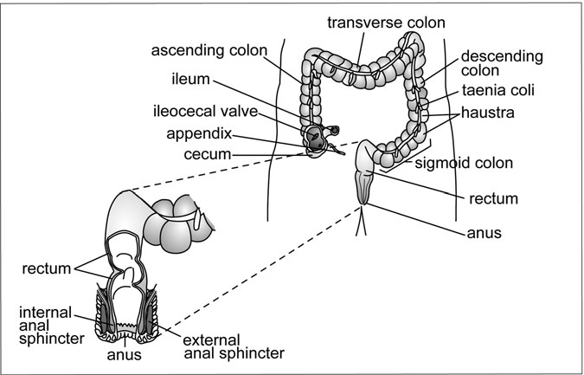

Figure 3.11 The Large Intestine. Commonly called the colon, the large intestine consists of three major sections, named for their orientation in the abdominal cavity. The large intestine terminates in the rectum. (Sandy Windelspecht/Ricochet Productions)

called the ascending colon, transverse colon, descending colon, and sig- moid colon, based on their orientation and position in the body cavity. The physiology of these zones is fundamentally the same, and the names are used for descriptive purposes only. Because the majority of the large intestine is comprised of the colon, the term colon is frequently used as a common name for the large intestine.

While the appendix has historically been considered a part of the large intestine, and often thought of as a vestigial organ, it is actually made from the same type of tissue as the lymph nodes and thus is now considered to be part of the lymphatic and immune systems. Lymphocytes housed in this area help protect the digestive system from pathogenic microorganisms, and thus the appendix serves as an important ﬁrst line of defense for the lower GI tract. However, ailments of the appendix are frequently caused by problems with the digestive system.

##### Movement of Material

The large intestine receives approximately 15 ﬂuid ounces (500 milliliters) of material daily from the small intestine. Under normal conditions, the majority of this material is the undigested remnants from the small intestine (see the following section on digestion and absorption). The colon regions of the large intestine are structured differently from the small intestine. Whereas the small intestine utilized circular and longitudinal patterns of smooth muscle to power the contractions necessary to move the food, the colon instead possesses three bands of smooth muscle. Rather than surrounding the GI tract, these muscles are arranged to run the length of the intestine, called the taeniae coli. The arrangement of the taeniae coli causes the exterior surface of the large intestine to resemble a series of small pouches, called haustra. The haustra are not permanent structures, but actually change position slightly based upon the contractions of the taeniae coli.

The movement of the material through the large intestine is a much slower process than in the small intestine. This gives ample time for the sections of the colon to reabsorb important nutrients such as water. In the small intestine, the contractions of the smooth muscle (segmentation) occurred at a rate upwards of 12 times a minute. In the large intestine, the contractions may occur several times an hour. These contractions are called haustral contractions, and the entire process is called haustration.

Also, unlike the small intestine, in which the contractions were controlled to move the chyme through the length of the intestine, in the colon, the haustral contractions are more regional. This causes the material to move back and forth between haustra, further increasing the time that the material is in the system. Several conditions may cause a synchronization of these haustral con- tractions, resulting in a uniform movement of material toward the rectum and anus. The ﬁrst of these is called a mass movement. Mass movements occur several times daily, usually following meals, and are characterized as synchronous contractions of the ﬁrst two sections of the colon (ascending and traverse). This contraction propels the food into the descending colon, moving the material there into the sigmoid colon and rectum. Although a mass movement can occur without food entering the stomach, the body does possess a mechanism to clear the intestines to prepare for incoming

food. As food enters the stomach, it triggers the gastrocolonic reﬂex. This reﬂex action causes contractions along the entire length of the intestines, moving food from the small intestine into the colon, and driving the undi- gested material in the colon into the rectum. The gastrocolonic reﬂex is often accompanied by an urge to defecate.

The ﬁnal movement of material out of the gastrointestinal tract is called defecation and the factors that cause it to occur are called the defecation reﬂex. Defecation is actually a complex process since it involves both voluntary and involuntary actions of the anus. The anus, the terminal sphincter of the gastrointestinal tract, consists of both smooth and skeletal muscle. The internal anal sphincter is comprised of smooth muscle and thus is under involuntary control. During the defecation reﬂex, the smooth muscle of this sphincter relaxes. At the same time, the rectum and sigmoid colon contract, moving the contents toward the external anal sphincter. This sphincter is made of skeletal muscle, and thus is under voluntary control. If the external anal sphincter is relaxed, defecation occurs. If not, then the urge can be controlled, although this may result in excess water being absorbed from the feces, causing constipation. Although the external anal sphincter may be closed, it is still possible to force intestinal gas (ﬂatus) out through a narrow opening in the anus, thus partially relieving pressure in the rectum.

##### Digestion and Absorption

Of the quarts of material that enter the digestive tract each day, only about

0.53 quarts (0.5 liters) actually ends up in the large intestine. The small intestine is highly effective as an organ of digestion and absorption; thus, the material reaching the large intestine usually contains only undigested material, such as cellulose, some water, salts, and bilirubin from the liver. Since the amount of usable nutrients is severely limited by the time the food material reaches the large intestine, there is no enzymatic digestion conducted by the cells of the large intestine. While no digestive enzymes are secreted by the large intestine, the mucosal cells along the length of the organ secrete an alkaline mucus, which serves to lubricate the internal lining of the large intestine and protect it from any acids produced by fermenting bacteria in this region. There is some minor breakdown of

the bilirubin from the liver, and this accounts for the characteristic color of the fecal material.

The large intestine also lacks the complex internal structure found in the small intestine. Instead of a network of villi and microvilli, the interior surface of the large intestine is for the most part smooth. This reduced surface area limits the ability of the large intestine to be a major organ of absorption. However, the decreased surface area is slightly compensated for by slowing the movement of material through the organ. The relative lack of segmentation and peristaltic contractions in the large intestine means that the material is present in the intestine for a longer period of time, allowing for more (although slower) absorption of selected nutrients. The action of the haustral contractions also serves to move the material back and forth within the colon, further slowing the movement of material. Dietary factors, namely the amount and types of ﬁber, also inﬂuence the rate of movement. In addition, health factors such as age, stress, and disease all contribute to the speed at which the material transits the large intestine. Of the 15 ﬂuid ounces (500 milliliters) of the material that enters the large intestine, about 10.5 ﬂuid ounces (350 milliliters) is reabsorbed, with the remaining volume exiting through

the anus as feces.

The colon primarily absorbs water and salts, although it may also take in other nutrients, such as glucose and vitamins, that may be present (see the following section). Salts in the colon normally consist of both sodium and chloride ions, both of which are essential nutrients, and are reabsorbed. In addition, water is reabsorbed by osmosis, but a signiﬁcant amount remains in the feces to lubricate it. The ﬁnal daily fecal volume of 4.5 ﬂuid ounces (150 milliliters) usually is two-thirds water and one-third solid material. Most of the solid material is actually bacterial mass, with bilirubin from the liver and cellulose accounting for the remainder.

The slower movement of material also gives microorganisms, such as bacteria, the opportunity to establish populations. However, unlike the remainder of the gastrointestinal tract, where the presence of bacteria causes problems, the colon actually contains a natural ﬂora of bacteria that make a positive contribution to human physiology. The bacteria of the large intestine are in a symbiotic relationship with their human host.

#### The Accessory Organs

The previous two sections have examined the movement of food through the gastrointestinal system. As noted previously, there are two types of organs in the digestive system. Digestive organs, such as the stomach and small intestine, form the conduit through which food is moved and proc- essed in the body. Associated with the operation of these organs are the accessory organs. In general, the accessory glands contribute important lubricants, enzymes, and chemicals that are required for the operation of the digestive organs. There are four accessory organs: the salivary glands, liver, gall bladder, and pancreas (see Table 3.7).

##### Salivary Glands

The salivary glands consist of three major pairs of glands that are located within the oral cavity. As previously mentioned, these are called the parotid, sublingual, and mandibular glands. There are also minor salivary glands, called the buccal glands, located in the linings of the cheek. Located under the tongue, along the base of the mouth, are the sublingual glands. Excretions from these glands are moved into the oral cavity by a short duct called the lesser sublingual duct. Located just below the sublingual glands, along the jawbone (mandibula), is the submandibular gland, which is connected to the oral cavity by the submandibular duct. Just in front of each

TABLE 3.7

Summary of Accessory Gland Contributions to Digestion

*Organ Role in digestion*

Salivary glands Provides salivary amylase for CHO digestion

Provides mucus to lubricate oral cavity and esophagus

Liver Manufactures bile for lipid digestion

Central role in carbohydrate, fat, and protein metabolism

Gall bladder Stores bile

Pancreas Manufactures sodium bicarbonate Manufactures pancreatic digestive enzymes

ear are the parotid glands. These are connected to the oral cavity via the parotid duct, which enters close to the molars in the rear of the mouth.

The salivary glands play several important roles in the overall physiol- ogy of the oral cavity. First, they actively moisten the oral cavity, which greatly aids not only in the swallowing of food, but also in the process of speech. The mucus content of saliva serves to protect the tissues of the tongue and cheeks from the action of the teeth. In addition, saliva contains an antimicrobial compound called lysozyme, which serves to reduce, but not completely eliminate, bacterial growth in the mouth. Saliva is slightly alkaline in pH, and thus helps to buffer the oral cavity to the correct pH. The salivary glands also release an enzyme called salivary amylase, which initiates carbohydrate digestion. Each of the salivary glands varies slightly in the content of the saliva, although the saliva from each contains ions, mucus, water, and salivary amylase.

Combined, the salivary glands secrete an average of 1.06 quarts (1,000 milliliters) of saliva daily. The level of saliva production is dependent on a number of factors. In response to dehydration, the body limits saliva production, producing the thirst response. However, it is important to note that the feeling of a dry mouth lags the actual need for water, meaning that a dry mouth signals an advanced stage of dehydration. Most people are aware of increased saliva production in response to the sight or smell of food. This is due to the action of the nervous system, which has the ability to stimulate saliva production based on chemical signals from taste buds or olfactory (smell) glands, or by the touch of food on the tongue. It is also possible to invoke salivation by the memory of food, especially when hungry. The body may also increase or decrease saliva production during illness. In the case of fever or other illnesses, the body may reduce saliva production to conserve water (Sidebar 3.3). During times of nausea, saliva production may be increased.

##### Gall Bladder

The gall bladder is a small sac-like organ, 3.1–3.9 inches (8–10 centimeters) in length, located just under the liver (Figure 3.12). It is connected to the duodenum of the small intestine by the common bile duct. The gall bladder represents the simplest of the accessory glands in the fact that it primarily

SIDEBAR 3.3

#### Not to Be Underestimated: The Importance of Clean Water

Access to clean, safe water can not be undervalued when it comes to the maintaining the health of the digestive system on a global level. Proper san- itation and hygiene is vital to the health of societies everywhere in the world. According to the Centers for Disease Control and Prevention (CDC), eating contaminated food and drinking contaminated water can lead to developing certain infectious diseases related to certain germs, such as Cryptosporidium, Giardia, Shigella, and norovirus. Below are some important facts from the CDC about the importance of global access to safe water, adequate sanitation, and proper hygiene:

* Clean water as well as proper sanitation and hygiene have the potential to prevent at least 9.1 percent of the world’s disease burden and 6.3 percent of all global deaths.
* Improved sanitation could save the lives of 1.5 million children every year who otherwise succumb to diarrhea-related diseases, according to the World Health Organization (WHO) and UNICEF.
* Over 800 million people around the world do not have access to an improved water source.
* An estimated 2.5 billion people—more than 30 percent of the world’s population—do not have access to adequate sanitation.
* By improving water sources, deaths from diarrhea can be reduced by 21 percent worldwide. Improved sanitation can reduce deaths related to diarrhea by 37.5 percent; and simple hand washing at certain critical times can reduce the incidence of diarrhea by 35 percent. Improvement of drinking-water quality, including disinfec- tion efforts, would lead to a 45 percent reduction of diarrhea cases.
* Millions of people around the world are infected with neglected tropical diseases (NTDs). NTDs are related hygiene-related, and are often found in locations with unsafe drinking water and poor

sanitation. Examples of these diseases include Guinea Worm Disease (GWD), buruli ulcer, trachoma, and schistosomiasis. GWD, for exam- ple, is a rare but extremely painful parasitic infection spread through contaminated drinking water. Symptoms of GWD include thread-like worms slowly emerging from the human body through blisters.

* According to the United Nations and UNICEF, one in ﬁve girls worldwide who are of primary-school age are not in school, compared to one in six boys. One reason cited for this is lack of sanitation facilities for girls reaching puberty, or who are already going through menstrua- tion. In addition, girls are also often responsible for collecting water for their family, making it difﬁcult for them to attend school during school hours. For these reasons, installation of toilets and latrines may enable more schoolchildren, especially menstruating girls, to remain commit- ted to getting an education.

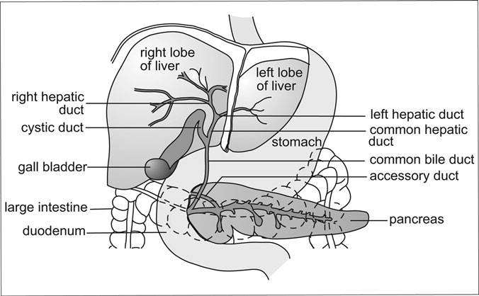

Figure 3.12 The Accessory Glands of the Lower GI Tract. The relationship of the accessory glands of the lower gastrointestinal tract

to the stomach, small intestine, and large intestine (colon). (Sandy Windelspecht/Ricochet Productions)

serves as a storage location for secretions of the liver (see the next section). Unlike the pancreas, liver, and salivary glands, the gall bladder does not pro- duce any chemicals necessary for digestion. Its sole purpose is the storage of bile between meals. Bile is produced by the liver and aids the small intes- tine in the digestion of hydrophobic molecules such as triglycerides.

The common bile duct is actually a conduit from the liver to the duode num. At the junction of the small intestine is the sphincter of Oddi. When chyme is present in the duodenum, the sphincter of Oddi is open and the bile produced by the liver proceeds directly into the lumen of the small intestine. However, when chyme is absent, the sphincter is closed and the bile being continuously produced by the liver backs up in the bile duct and enters the gall bladder via a small duct called the cystic duct. Once stored in the gall bladder, the bile is concentrated and readied for the next meal. When the next meal enters the duodenum, the hormone CCK stimulates the gall bladder to contract, releasing the concentrated bile into the bile duct and into the duodenum.

##### Liver

The liver represents one of the most important and unique organs of the human body. From a genetic perspective, the cells of the liver are interesting in that some are polyploid and binucleate. Normally, cells of the body have a single nucleus and are diploid, meaning that they contain two copies of each chromosome. However, about 50 percent of the hepatocytes in the liver are polyploid cells, meaning that they contain additional copies of each chromosome, while others contain an extra nucleus. There are examples of hepatocytes that have eight or more copies of each chromosome. This arrangement most likely explains the large numbers of organelles found in these cells. Hepatocytes have some of the most abundant endoplasmic reticu- lum and Golgi bodies of any human cells, which enable them to manufacture large quantities of many biologically important molecules for export. The chromosomal and nuclear state of these cells may also explain regenerative properties of the liver.

With the exception of the skin, the liver is the largest organ in the human body. In an adult, the liver may weigh up to approximately 3 pounds (1.4 kilograms). The liver consists of two primary lobes, called the right and

left lobes. The right lobe, the larger of the two, is sometimes subdivided for study into two additional lobes, called the quadrate and caudate lobes. The lobes are separated by a ligament called the falciform ligament. The falci- form ligament not only deﬁnes the two major lobes, but together with other minor ligaments, it helps suspend the liver from the diaphragm. Despite the large size and fairly complex shape of the liver, its tissue is relatively homogenous, which plays an important role in liver physiology.

The liver is also a special organ in that it has the ability to regenerate itself in case of injury or disease. This is primarily due to the redundant structure of liver tissue. Each lobe of the liver consists of self-sufﬁcient sub- units called lobules (Figure 3.13). Within each lobule are liver cells called hepatocytes and phagocytic cells called Kupffer’s cells. The purpose of the Kupffer’s cells is to engulf worn-out blood cells and invading pathogens, such as bacteria and viruses, arriving from the digestive tract. Thus, these cells technically belong to the immune, and not the digestive, system.

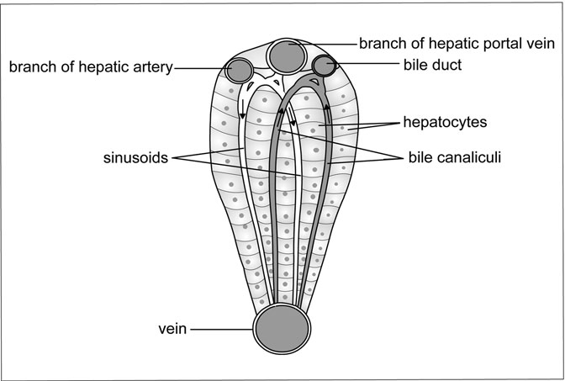

Figure 3.13 Lobule of the Liver. The liver is a redundant structure, meaning that each lobe of the liver contains numerous identical lobules. (Sandy Windelspecht/Ricochet Productions)

The hepatocytes are the cells where the work of the liver is conducted. On one side of each hepatocyte is a sinusoid. Blood from the digestive sys- tem, arriving via the portal circulatory system, enters into the sinusoid cavities. Sinusoids are not the same thing as capillaries, but rather represent open spaces from which the hepatocytes can extract nutrients from the diges- tive system. The phagocytic Kupffer’s cells are located along the lining of the sinusoids to protect the liver from pathogens arriving from the digestive tract. On the other side of the hepatocyte are small vessels called the bile canaliculi (bile canals). The hepatocytes continuously produce bile from cholesterol, lecithin (a phospholipid), and bile salts and secrete it into the bile canaliculi. Within each lobe, these vessels merge into larger structures called the left and right hepatic ducts, which in turn combine to form the common hepatic duct. The common hepatic duct carries bile to the gall bladder, where it then becomes the common bile duct. The common bile duct connects with

the duodenum of the small intestine through the sphincter of Oddi.

Due to the liver’s central role in digestive system physiology, there is a minor deviation in normal blood ﬂow with regard to digestion. Typically, blood leaves the heart via arteries and proceeds to an organ of the body where it enters a capillary bed. The blood then returns to the heart by way of veins. However, in the processing of nutrients, there is a minor deviation in this path. Blood leaving the stomach, small intestine, and colon proceeds directly to the liver via the hepatic vein (Figure 3.14). This minor detour, sometimes called the portal, or hepatic, circulatory system, ensures that nutrient-rich blood from the digestive tract is ﬁrst processed and screened by the liver, thus establishing the status of the liver as the master control organ for human digestion. Since the blood from the diges- tive system is low in oxygen, the oxygen needed for the metabolic func- tions of the liver cells is delivered by the hepatic artery.

The liver plays many important roles in human physiology. Since all of the blood leaving the digestive tract ﬁrst passes through the sinusoids of the liver, the hepatocytes have the ability to screen and ﬁlter nutrients and other materials from the blood before it is delivered to the remainder of the body tissues.

In addition to screening, the liver secretes several important com- pounds. As previously noted, the hepatocytes manufacture bile salts from

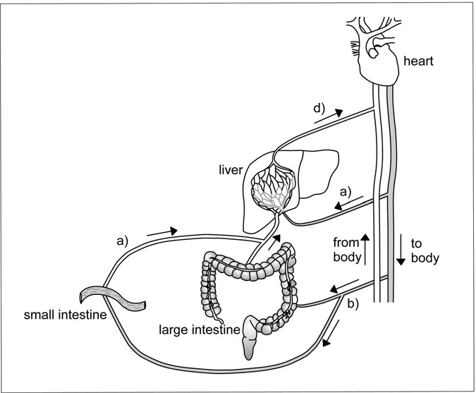

Figure 3.14 Hepatic Circulatory System. Blood leaving the heart may proceed directly to the liver (a) or to the intestines (b) by way of arteries. However, nutrient-rich blood from the intestines ﬁrst returns to the liver (c) where nutrients are ﬁltered before the blood returns to the heart (d). (Sandy Windelspecht/Ricochet Productions)

cholesterol. This bile is either secreted into the duodenum, or stored in the gall bladder. In addition, the liver excretes a compound called bilirubin, which is derived from the destruction of worn-out red blood cells. It is bilirubin that gives bile its characteristic yellow color. In the small intes- tine, bacteria break down bilirubin into stercobilin, giving the fecal material its brown color. However, a small amount is reabsorbed by the blood system and eventually excreted by the kidneys. This small amount of bilirubin is responsible for urine’s yellow color.

##### Pancreas

The pancreas is an irregular-shaped gland that is located just below the stomach and adjacent to the duodenum of the small intestine. It averages between 4.7 and 5.8 inches (12 and 15 centimeters) in length, and a little over 0.8 inches (2 centimeters) in thickness. For descriptive purposes, it is divided into three major sections, although there is little difference in the physiology of the sections. The head is located closest to the duodenum and is connected to the digestive tract by two ducts. The hepatopancreatic duct is a common duct formed by the linking of the bile duct and pancreatic ducts. A second duct, called the duct of Santorini, directly connects the pancreas to the duodenum. Moving away from the duodenum and the head of the pancreas are the regions called the body and tail.

The pancreas actually represents two separate organs, both of which contribute to digestion, which are integrated into a single structure. A por- tion of the pancreas is an exocrine gland, meaning that it secretes com- pounds into a cavity. The second major area of the pancreas is the endocrine tissue, which secretes chemicals into the bloodstream. In general, the exocrine functions of the pancreas can be described as those directly involved with the processing of nutrients in the duodenum, while the endo- crine is best described as those functions that involve hormones and the regulation of glucose homeostasis in the body. Both types of tissue exist throughout the pancreas.

Two types of cells make up the endocrine portions of the pancreas (Figure 3.15). Duct cells secrete what is formally called the aqueous alka- line solution. This solution is primarily sodium bicarbonate (NaHCO3), and its purpose is to neutralize hydrochloric acid coming through the pyloric sphincter along with the chyme. These cells are named due to their close proximity to the pancreatic ducts. Deeper within the pancreas are groups of cells called acinar cells. These cells are responsible for generating the enzymatic secretions of the pancreas and together may excrete 1.6–2.12 quarts (1–2 liters) of ﬂuid per day into the duodenum. The enzymatic secre- tions produced by the acinar cells of the pancreas contain three basic classes of enzymes. These are the proteolytic enzymes (proteins), pancreatic lipase (lipids), and pancreatic amylase (carbohydrates). It is these enzymes that enable the small intestine to conduct its physiological function as the major

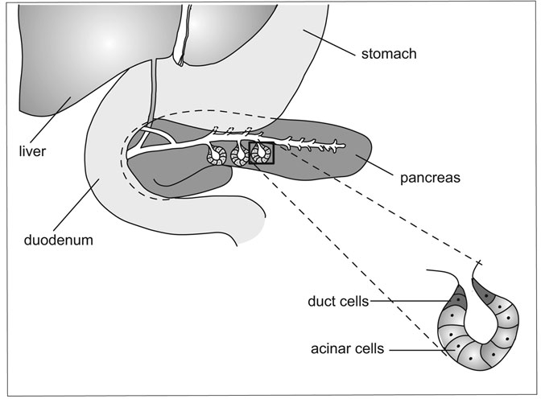

Figure 3.15 The Pancreas. Diagram of the internal exocrine structure of the pancreas showing the relationship between acinar and duct cells. (Sandy Windelspecht/Ricochet Productions)

organ of digestion and absorption. The pancreatic amylase and lipase enzymes hydrolyze carbohydrates and fats, respectively, into their mono- mers, which are then absorbed by the small intestine. However, the actions of the proteolytic secretions are a little more complex.

The proteolytic enzymes released by the pancreas are initially inactive. This protects the pancreatic cells from being damaged. The proteolytic excretions of the pancreas contain a mixture of enzymes: trypsinogen, chymotrypsinogen, proelastase, and procarboxypeptidase. Once released by the acinar cells, these inactive enzymes proceed through the pancreatic duct into the duodenum. Once in the lumen of the small intestine, rypsino- gen is activated by an enterokinase enzyme located in the mucosal layer of the duodenum. The active form of trypsinogen is trypsin. Activated

trypsin is an autocatalytic enzyme, meaning that it has the ability to react with additional trypsinogen to produce trypsin. Trypsin also activates chymotrypsinogen, proelastase and procarboxypeptidase to produce chymotrypsin, elastase, and carboxypeptidase, respectively. Together, these enzymes are responsible for digesting proteins in the food into individual amino acids or short chain peptides for absorption by the small intestine.

#### Summary

All living organisms, including human beings, take nutrients from the environment and process them into chemical compounds to fuel their cells. This is called metabolism, and is part of the larger process of diges- tion, which is when food is broken down into its essential elements and components. Although some compounds behave differently (such as water, minerals, and some vitamins), the body transports most of the digested food particles throughout the body. The digestive system is made up of primary and secondary organs. The primary organs are the mouth, esophagus, stom- ach, small intestine, and large intestine. The secondary or accessory organs are the liver, pancreas, salivary glands, and gall bladder. The primary organs communicate with other organs of the body, while the accessory organs enable the chemical interactions necessary for digestion.

Digestion is a vital function of the body, because it ensures there is an adequate source of energy available at all times. In addition, digestion pro- vides the necessary materials to create and repair cells and tissues.

# 4

### The Endocrine System

*Stephanie Watson and Kelli Miller Stacy*

Interesting Facts

* Ancient peoples called the pineal gland the “third eye” because they believed it held mystical powers. French philosopher Rene´ Descartes (1596–1650) thought that the pineal gland was the point at which the human soul met the physical body.
* The endocrine pancreas contains about one million small endocrine glands called the islets of Langerhans.
* Special ﬂuid sensors in the brain, called osmoreceptors, are so sensitive that they can detect a 1 percent ﬂuctuation in the body’s water concentration.
* The adrenal cortex produces more than 60 different steroid hormones, but only a handful of these hormones are important to body function.
* Aldosterone, a steroid hormone produced in the adrenal cortex, acts upon the sweat glands to reduce the amount of sodium lost in the sweat. After a few days in a hot climate, sweat becomes virtually salt-free.
* During times of stress, the adrenal cortex can produce up to 10 times the normal amount of cortisol.

151

* The fetal adrenal gland is larger than the adult gland in relation to body mass.
* In recent years, scientists have discovered that many industrial chemicals, pesticides, and heavy metals interfere with the endocrine systems of humans and wildlife by mimicking natural hormones.
* Endocrine disruptors have even been found in the breast milk of Inuit women in the remote Arctic, where known endocrine-disrupting chemicals are neither used nor produced.
* Scientists say that some deli wrap, food can linings, teething rings, vinyl toys, medical IV bags, and plastic bottles may seep small amounts of potential endocrine disruptors.

Chapter Highlights

* Hormones and how they behave
* Target cells and receptors
* Second messenger systems
* Hormone regulation and secretion
* Feedback loops
* Glands of the endocrine system: hypothalamus; pituitary gland; anterior pituitary, posterior pituitary, pineal gland, thyroid, and parathyroid glands; adrenal glands; pancreas; ovaries; and testes

#### Words to Watch For

Adrenocorticotropic hormone

Agonists Androgens Antagonists Anterior pituitary

Antidiuretic hormone Autocrine

Calcitonin Catecholamines Chondrocytes Corpus luteum

Corticotroph Cortisol Cytokines Dopamine Eicosanoids Electrolytes

Epinephrine Erythropoietin Estrogen Exocrine glands Extracellular fluid

Follicle-stimulating hormone

Gastric inhibitory peptide

Gastrin

Gene transcription Glycogenolysis Glycoprotein Gonadotroph Gonadotropins Growth factors Growth hormones High-density

lipoproteins

Homeostasis Hypocalcemia Hypophsis Hypothalamic-

hypophyseal

portal system Hypothalamic-

pituitary-

target organ axis

Hypothalamus Inhibin

Insulin

Insulin-like growth factor

Intermediate pituitary

Intracellular fluid Islets of Langerhans Ketone bodies Lactrotroph

Leptin

Low-density lipoproteins

Luteinizing hormone

Luteolysis Mineralocorticoids Motilin Neurohormones Neurosecretory

cells

Norepinephrine Oogenesis Osmoreceptors Pancreatic

polypeptide

Paracrine Parathyroid

hormone

Polyunsaturated fatty acids

Posterior pituitary

Pregnenolone Preprohormone Progesterone Progestins Proglucagon Proinsulin Prolactin Prostaglandins Receptor Seminiferous

tubules

Sertoli cells Somatostatin Somatotroph Substance P Target cells Testosterone

Thyroid-stimulating hormone

Thyrotroph Thyrotropin-

releasing

hormone Thyroxine Triiodothyronine Tyrosine Vasopressin Zona fasciculate

Zona glomerulosa Zona reticularis

#### Introduction

For all of the various cells and tissues in the human body to work in har- mony, they must communicate and coordinate with one another. Com- munication is essential in the human body. Without a network to integrate functions of the organs, muscles, nerves, and all other tissues, the body would virtually shut down. Ingested food would not be prop- erly absorbed and utilized for energy, ﬂuids and electrolytes would swing wildly up and down, and disease would easily set in, all with dev- astating effects.

To avoid these scenarios, the body has not one, but two integrated command centers. These centers—the nervous system (which is covered in Chapter 8 of this encyclopedia) and the endocrine system—act as the body’s control towers, sending out messages that coordinate the function of every cell. The nervous system sends out its messages via electrical impulses, which travel within nerve cells (neurons); and chemical signals (called neurotransmitters), which transmit those impulses across small gaps (called synapses) between the neurons. The endocrine system sends out its messages via chemical messengers called hormones, which travel through the bloodstream to act on cells in other parts of the body. Together, the two systems regulate every essential function, from metabo- lism to growth and development.

The parts and functions of the endocrine and nervous systems are closely connected and synchronized. Nerves oversee the release and inhibition of endocrine system hormones, as well as blood ﬂow to and from endocrine glands. Hormones, in turn, direct the nervous system by stimulating or inhibiting the release of neural impulses.

To comprehend the role of the endocrine system and the pathways by which hormones affect biologic processes, it is ﬁrst necessary to under- stand the chemical makeup of hormones, to learn how they are secreted and by what mechanisms they reach and interact with their target tissues, and to discern the complex relationship between the endocrine and nervous systems. In this chapter, the anatomy of the glands will be discussed. These glands are the hypothalamus, pituitary, thyroid, parathyroids, adrenal, sex glands (testes and ovaries), and the endocrine pancreas. It is important to note that there are also tissues throughout the body that are not considered

classic endocrine organs but that secrete hormones or hormone-like sub- stances.

#### Fundamentals of the Endocrine System: Hormones and Their Actions

The process by which the endocrine system coordinates bodily functions is complex, consisting of many interrelated parts and systems that oversee hormone production, secretion, and delivery. At the core of the system are the hormones—the messengers that transport endocrine commands throughout the body.

Hormones are the chemical signals by which the endocrine system coordinates and regulates functions such as growth, development, metabo- lism, and reproduction. The word “hormone” comes from the Greek word meaning “to set in motion.” When a hormone is released into the blood- stream, it does just that: It sets in motion a chain of events that ultimately results in a desired reaction within cells that are receptive to its inﬂuence. The reaction is generally designed to either trigger or inhibit a physiologi- cal activity.

Hormones are produced by various tissues and secreted into the blood or extracellular ﬂuid. According to the traditional deﬁnition, hormones travel through the bloodstream to work on tissues in distant parts of the body. But some hormones act locally without ever entering the blood- stream. They may exert their effects on cells close to where they were pro- duced (called paracrine action), or they may act on the same cells that produced them (autocrine action).

Some hormones act upon just one type of cell; others inﬂuence many different cells. Similarly, some cells are receptive to only one hormone, while others respond to several hormones. Hormones are not the only sub- stances in the body that exert physiologic control on cells. A number of other chemical messengers act much like hormones. These include:

* *Neurotransmitters*: The nervous system, like the endocrine system, transmits messages to target tissues. But nervous system mes- sages are made up of chemical signals called neurotransmitters.

Unlike endocrine cells, which release their hormones into circulation, neurotransmitters are released into the gap where two neurons (cells in the brain that receive and transmit nerve impulses) meet (called a synapse). At the synapse, they bind to receptors on the receiving neuron. Some substances (such as epinephrine, norepinephrine, dopamine, gastrin, and somatostatin) serve double duty, acting as both hormones and neurotransmitters.

* *Growth factors*: Not to be confused with growth hormones produced by the endocrine system, growth factors are proteins that bind to receptors on the cell surface and stimulate or inhibit cellular division and proliferation. Some growth factors act on many different kinds of cells; others target one speciﬁc cell type. Examples include platelet- derived growth factor (PGDF), epidermal growth factor (EGF), trans- forming growth factors (TGFs), and erythropoietin.
* *Cytokines*: Cytokines are signaling peptides secreted by immune cells (as well as by other types of cells) in response to stress, allergic reaction, infection, or other potentially harmful stimuli. Much like endocrine hormones, cytokines either travel through the bloodstream or act locally on target cells. Once cytokines bind to their receptors, they trigger a biological effect within cells. Cytokines may inﬂuence cell growth, cell activation, or cell death (i.e., in the case of cancer cells). They also act directly upon the hypothalamic-pituitary- target organ axis of the endocrine system by increasing or decreasing hormone synthesis as part of the body’s stress response. There are four major categories of cytokines: interleukins, interferons, colony stimu- lating factors, and tumor necrosis factors (TNF).
* *Eicosanoids* (fatty acid derivatives): These compounds are produced from polyunsaturated fatty acids, most commonly from the precursor arachidonic acid. Depending upon which enzymes act on arachidonic acid, it may be converted into one of several classes of hormone-like substances, including prostaglandins, prostacyclines, and thrombox- anes. Although they are not technically hormones, eicosanoids act in much the same way to inﬂuence a variety of physiological processes, including smooth muscle contraction; kidney, immune system, and

reproductive function; and calcium mobilization. Eicosanoids primarily exert a paracrine inﬂuence on nearby cells or an autocrine inﬂuence on the cells that produced them.

Just as a hormone does not always have to ﬁt the classic deﬁnition, a hormone-producing tissue does not always need to reside within the endocrine system. Although hormones are primarily associated with the endocrine glands, tissues in other parts of the body (kidneys, liver, and heart, for example) can also produce and release them.

##### Hormone Modes of Action

Hormones are grouped according to their chemical structure (see Table 4.1). The structure of a hormone (i.e., whether it is water soluble or fat soluble) determines how it will travel through the bloodstream (alone or attached to a protein) and how it will bind to its receptor (fat-soluble hormones can travel through the membrane to receptors on the inside of the cell, while water-soluble hormones cannot pass through the membrane and must bind to receptors on the outside of the cell).

##### Steroid Hormones

Steroid hormones (including estrogen, testosterone, and cortisol) are fat-soluble molecules produced from cholesterol. Because they generally repel water, steroid hormones travel through the blood attached to carrier proteins. Once they reach their target cell, steroid hormones pass through the cell membrane and bind to receptors in the cytoplasm and genes in the nucleus to regulate protein production.

TABLE 4.1

Examples of Hormones within Each Class

Protein and peptide hormones

Antidiuretic hormone (ADH), follicle-stimulating hormone (FSH), glucagon, growth hormone (GH), insulin, luteinizing hormone (LH), oxytocin, prolactin (PRL), thyroid stimulating hormone (TSH), thyrotropin releasing hormone (TRH)

Steroid hormones Aldosterone, cortisol, estrogen, testosterone

Amino acid derivatives Epinephrine, norepinephrine, thyroxine, triiodothyronine

##### Amino Acid Derivatives

Amino acid derivatives (such as epinephrine and norepinephrine) are water-soluble molecules derived from amino acids (compounds that form proteins). These hormones travel freely in the blood, but they cannot pass through the cell membrane, so they bind to receptors on the surface. Bind- ing activates second messengers inside the cell that trigger enzymes or in- ﬂuence gene expression.

##### Protein and Peptide Hormones

Protein and peptide hormones (including insulin, prolactin, and growth hormone) are water-soluble hormones made up of amino acid chains. Like amino acid derivatives, peptide hormones circulate alone and bind to recep- tors on the cell surface. Protein and peptide hormones consist of chains of amino acids. These chains may number only a few amino acids in length, as is the case with many peptide hormones (thyrotropin-releasing hor- mone [TRH] contains only three amino acids); or they may contain more than 200 amino acids, as do many protein hormones (follicle-stimulating hormone [FSH] contains 204 amino acids).

A glycoprotein is a special type of protein hormone consisting of a protein connected to a glucose (sugar) molecule. Examples include luteinizing hormone (LH), follicle-stimulating hormone, and thyroid- stimulating hormone (TSH).

Peptide and protein hormones are produced in the endocrine cell under the direction of mRNA (messenger ribonucleic acid). The mRNA contains information that dictates the amino acid sequence of the protein. mRNA originates in the cell nucleus, then moves out into the cytoplasm, where it serves as a template for the amino acids to form an inactive mol- ecule called a preprohormone (or prohormone). The prohormone is packaged into a secretory granule, which carries it to the cell surface. When the granule meets the cell membrane, an enzyme processes the pro- hormone to release the active hormone from the cell into circulation.

Steroid hormones are synthesized from cholesterol, about 80 percent of which comes from food and is transported through the blood plasma as high- density lipoprotein (HDL) particles. Included among the steroid hormones are the sex steroids (estrogen, androgens [testosterone], and progesterone)

produced by the ovaries and testes, and the glucocorticoids (cortisol),

mineralocorticoids, and androgens produced by the adrenal cortex.

To produce steroid hormones, enzymes convert cholesterol into a pre- cursor molecule, called pregnenolone, in the cell mitochondria. Pregne- nolone is then transported out of the mitochondria to the endoplasmic reticulum, where enzymes break it down further to produce either another precursor(s) or the active steroid hormone. Unlike protein hormones, which require granules to transfer them to the cell surface, steroid hor- mones can make the trip on their own and exit the cell via diffusion across the membrane.

Unlike protein and peptide hormones, which consist of several linked amino acids, amino acid derivatives contain just one or two amino acids. Two major groups of hormones, both derived from the amino acid tyrosine, fall within this category: thyroid hormones (thyroxine [T4] and triiodothy- ronine [T3]) and catecholamines (epinephrine and norepinephrine, which are both hormones and neurotransmitters). Tyrosine reaches the endocrine cell via the bloodstream. Once inside the cell, enzymes transform the tyro- sine into the active hormone. In the case of thyroid hormones, iodine is added to the modiﬁed tyrosine molecules. Amino acid hormones, like ste- roid hormones, can travel on their own across the cell membrane.

##### Hormone Transport

Once a hormone is released from the cell, it travels through the blood- stream to the cell upon which it will act. To get there, a hormone may either circulate alone (free) or bound to a carrier protein in the blood. As mentioned above, amino acid, peptide, and protein hormones typically cir- culate free because they are water soluble; steroid and thyroid hormones, which are fat soluble, circulate bound to proteins. The advantage to bind- ing is that the carrier protein helps the hormone navigate through all of the cellular trafﬁc in the body to reach its target tissue. A bound hormone also stays longer in the blood than a free hormone, because its carrier protein holds it back from crossing a cell membrane. The level of bound and free proteins in the blood usually remains stable, because the proteins are in a concentration equilibrium, so each time a newly produced hormone is released into circulation, a hormone that is bound to a protein is freed.

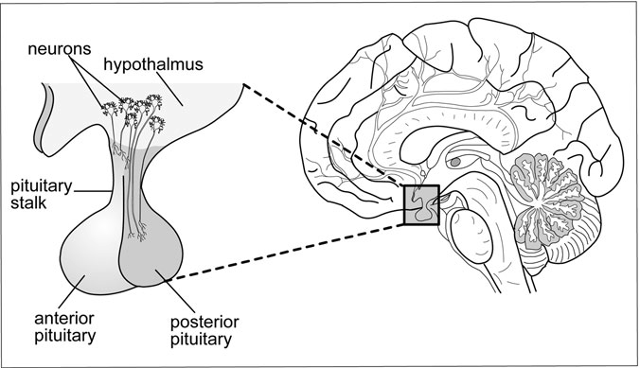

Figure 4.1 The Hypothalamus. Hormones released from the hypothalamus travel through blood vessels in the pituitary stalk to the anterior pituitary. (Sandy Windelspecht/Ricochet Productions)

Although most hormones travel through the bloodstream to reach their target cells, there are exceptions. One example is the hypothalamichypo- physeal portal system (Figure 4.1), through which releasing hormones secreted by nerve cells in the hypothalamus travel (via capillaries in the hypothalamus and veins in the pituitary stalk) directly to the anterior pituitary without ever entering the general circulation.

##### Target Cells and Receptors

A hormone cannot trigger a physiological reaction in just any cell—it is speciﬁcally designed to act upon only those cells that are receptive to it, which are called target cells. How does a hormone ﬁnd its target cell? Each target cell comes complete with receptors—proteins that lie either on the surface of the cell or within the nucleus. The receptors exhibit speciﬁcity and bind only to the right hormone—or hormones—from a sea of other molecules. A cell’s response depends upon the concentra- tion of the hormone and the number of receptors to that hormone that it contains.

When the hormone binds to its receptor, it initiates a chain of events that ultimately alters the cell’s function. The activated hormone-receptor com- plex can have one of three main effects: It can instruct cells to either make or stop making RNA from DNA (by the process of gene transcription), thus starting or stopping protein production; it can turn enzymes in the cell on or off, thus altering the cell’s metabolism; or it can change the permeability of the cell membrane to allow in or shut out certain chemicals. If an individual lacks receptors for a particular hormone (or hormones), that hormone will not be able to do its job, and disease will often result. Hormones not only trigger production of certain proteins within a cell; they may also block protein production or even block other hormones from binding to the cell receptor. Based on their effect, hormones are assigned to one of four classiﬁcations:

* *Agonists*: Agonists are hormones that bind to their receptor and elicit a speciﬁc biological response. For example, a glucocorticoid is an agonist for the receptor that binds cortisol.
* *Antagonists*: Antagonists are hormones that bind to the receptor but do not trigger a biological response. By occupying the receptor, the antagonist blocks an agonist from binding and thus prevents the triggering of the desired effect within the cell. For example, an antiandrogen is used to block the function of androgens in hormone therapy.
* *Partial agonist–partial antagonist*: A hormone that, when bound to the receptor, initiates a lesser biological response within the cell. By occupying the receptor, the partial agonist–partial antagonist blocks the potential action of an agonist, which could have generated a more signiﬁcant biological response within the cell.
* *Mixed agonist–antagonist*: A hormone that exerts a different action on the receptor, acting as either an agonist or antagonist, depending upon the situation.

There are two types of receptors. Water-soluble hormones are unable to cross the membrane on their own because they are repelled by the fatty membrane that surrounds each cell, so they bind to receptors on the cell

surface. Hormones that are fat soluble (such as steroids) are able to cross the membrane, so they bind to receptors inside the cell.

Cell Surface Receptors and Second-Messenger Systems Glucagon, catecholamines, parathyroid hormone (PTH), adrenocorti- cotropic hormone (ACTH), thyroid-stimulating hormone (TSH), and

luteinizing hormone (LH) are water soluble and therefore cannot cross

into the cell. Instead, they bind to receptors on the surface of the cell mem- brane and trigger a cascade of events that leads to the desired biological response within the cell. For the message to pass from the hormone into the cell requires the efforts of second messengers (Figure 4.2), which acti- vate enzymes or other molecules inside the cell.

The hormone’s actions are similar to those of a witness to a car acci- dent. The witness acts as a ﬁrst messenger, calling 911 and alerting the

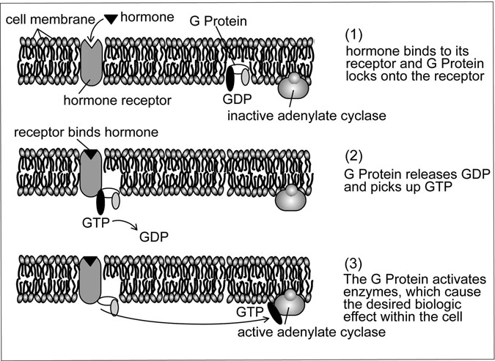

Figure 4.2 Second messenger system. (Sandy Windelspecht/Ricochet Productions)

operator to the problem. The 911 operator is the receptor, taking the mes- sage and passing it along to the emergency crew, which acts as the second messenger, coming to the aid of the accident victims.

One of the primary second-messenger systems involves G proteins. G proteins are like chemical “switches” that have to be triggered before the hormonal message can be passed into the cell. When a hormone binds to its receptor, the receptor changes shape and activates a G protein inside the cell. The G protein releases a guanine nucleotide it had been holding called guanine diphosphate (GDP), then grabs another, similar nucleotide called guanine triphosphate (GTP). Then the G protein goes to work, acti- vating enzymes such as adenylyl cyclase. These enzymes produce a second messenger called cyclic adenosine monophosphate (cAMP). cAMP relays messages to effectors (molecules that regulate a series of chemical reac- tions) inside the cell, which lead to the desired biological reaction (for example, releasing glucose from cells when the body needs it for energy).

##### Intracellular Receptors

Receptors for steroid and thyroid hormones, as well as for vitamin D (a vitamin with hormone properties), are located inside the cell nucleus or cytoplasm. These hormones are fat soluble and can therefore cross the cell membrane on their own via simple diffusion. When they enter the cell, they meet up with and bind to their receptors, forming a hormone-receptor complex. The complex binds to parts of DNA in the cell nucleus called hormone response elements. Binding alters the DNA, resulting in the syn- thesis of a new protein.

##### Hormone Regulation and Secretion

Hormones are so potent that just a tiny amount can exert powerful inﬂuen- ces throughout the body. If too much or too little of a hormone is in circu- lation, the body can fall prey to serious disease. The effects of a particular hormone are related to its concentration in the bloodstream. Concentration is affected by the rate of production, the speed of distribution to target cells, and the speed at which the hormone is degraded after it is released from its receptor. All of these elements are strictly controlled by feedback loops or mechanisms, which measure and respond to changes within the

body. Feedback loops ensure that enough hormones are produced to com- plete necessary tasks and keep the endocrine system tightly integrated with the nervous and immune systems.

Some endocrine cells secrete their hormones at set times every day, every month, or even every year. Other cells secrete hormones following stimulation by other hormones, or in response to internal or external stimuli. Some hormones are released in regular patterns that follow a 24-hour cycle (called circadian rhythms). Cortisol release, for example, rises in the early morning, gradually drops during the day, and stays very low during sleep. Other hormones follow a monthly, or even a seasonal, pattern. The pituitary gland, for example, releases luteinizing hormone and follicle- stimulating hormone in response to variations in a woman’s monthly men-

strual cycle.

##### Hormonal Inﬂuences

The majority of hormones are regulated by other hormones (called tropic hormones), which either stimulate or inhibit their release based on the body’s needs. The hypothalamus-pituitary control system is an example of tropic inﬂuence. The hypothalamus secretes several neurohormones, which signal the pituitary to release its own hormones. Pituitary hormones, in turn, direct the functions of several target organs.

##### Internal and External Inﬂuences

Many endocrine glands have their own mechanisms for sensing whether they need to release hormones. The endocrine-producing islet cells of the pancreas detect glucose levels in the blood, and release or inhibit insulin production as necessary. Sometimes, external factors are involved in hor- mone secretion. When a baby nurses from its mother’s breast, the suckling action stimulates secretion of the hormones prolactin and oxytocin. Prolac- tin causes milk production in the mammary glands and maintains lactation. Oxytocin stimulates the release, or let-down, of milk into the nipple.

##### Feedback Mechanisms

Hormones regulate one another through feedback loops. The most basic feedback systems involve only one closed loop. More complex systems

consist of a series of interrelated loops. Two main types of feedback sys- tems exist.

Negative Feedback

The most common type of feedback works much like a home air condi- tioning unit. When the temperature in the home rises to a preset level, a sensing mechanism turns on the air conditioner. After the air conditioning has run long enough to drop the temperature to a comfortable level, the shut-off mechanism is activated. Thanks to the feedback mechanism, the home is never allowed to get too cold or too warm.

In the body’s negative feedback loop, a physiological change triggers the release of a particular hormone. Once the level of this hormone rises in the blood, it signals the endocrine cells that secreted it to stop producing it. Negative feedback prevents the overproduction of hormones, which could lead to disease.

An example of a simple negative feedback loop occurs after a person eats a piece of cake. After the cake is ingested, glucose (sugar) levels in the blood rise. In response to rising glucose levels, the endocrine cells of the pancreas release insulin. Insulin helps the cells take in and use glucose, lowering the amount of the sugar in the bloodstream. When blood glucose levels fall back to a normal level, insulin release is inhibited.

Positive Feedback

As the name implies, a positive feedback loop stimulates, rather than inhib- its, the production of a particular hormone. One example involves the release of oxytocin from the pituitary gland during childbirth. Oxytocin stimulates uterine contractions, which help push the baby out of the uterus. As levels of oxytocin in the blood rise, they trigger the pituitary to secrete even more of the hormone. Uterine contractions continue to increase until the child is ﬁnally born. Positive feedback is far less common than negative feedback, because it has the potential to contribute to dangerously high hormone levels.

More complex feedback systems involve several interrelated loops. One example is the hypothalamic-pituitary-target organ axis, a multi-loop system that coordinates the efforts of the hypothalamus in the brain, the pituitary gland, and the target gland.

The hypothalamus, in response to reduced hormone levels in the bloodstream, stimulates pituitary hormone secretion. The pituitary hor- mone travels through the bloodstream to act on its target tissue(s). As the level of pituitary hormone in the blood rises, the hypothalamus stops secreting its releasing hormone. Consequently, the pituitary stops produc- ing its own hormone, and blood levels of the hormone return to normal.

The hypothalamus has the ability to override the system, increasing or reducing hormone levels to adjust to physical and emotional stresses. Hormones from the target gland bind to nerve cells in the hypothalamus, which inhibit or trigger production of releasing hormones that inﬂuence pituitary hormone secretion. Without this mechanism, hormone levels would remain constant, even when they were needed in greater amounts to mediate a stress response.

##### Hormone Elimination

After hormones interact with their target cells and produce the desired result, they are no longer needed by the body. Most hormones are either converted to less active molecules or degraded by enzymes into an inac- tive form before being excreted in the urine or feces. Very few hormones are eliminated intact. Peptide hormones, catecholamines, and eicosanoids are all degraded by enzymes in the cell. Steroid hormones are metabolized into inactive forms and eliminated by the kidneys.

#### Endocrine Glands: Anatomy and Function

The endocrine system is made up of a complex network of glands (Figure 4.3), each of which secretes hormones that coordinate and regulate functions throughout the body. The pituitary, thyroid, parathyroids, adrenals, gonads (testes and ovaries), and endocrine pancreas are considered tradi- tional endocrine glands with the primary purpose of secreting hormones into the bloodstream. But other, nonendocrine organs—including the heart, brain, kidneys, liver, skin, and gastrointestinal tract—can also secrete hormones.

By deﬁnition, endocrine glands release their hormones into the blood- stream to act upon target tissues elsewhere in the body. Endocrine glands should not be confused with exocrine glands, which secrete their substan- ces to the outside of the body, to internal cavities such as the lumen of the

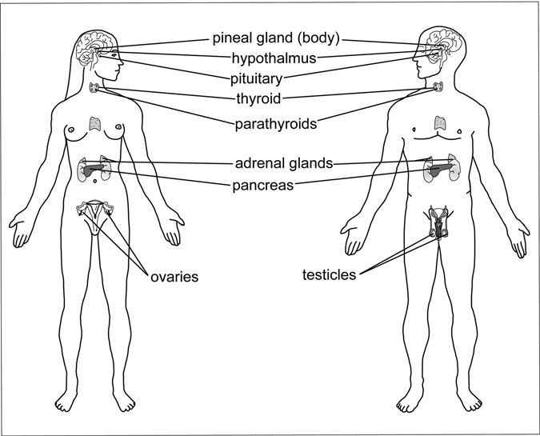

Figure 4.3 The endocrine system: female and male. (Sandy Windelspecht/ Ricochet Productions)

intestines, or to other tissues through ducts (for example, the salivary and sweat glands).

The endocrine system is assigned several critical responsibilities, the most important of which are to maintain a constant internal environment (homeostasis); aid in growth, development, reproduction, and metabo- lism; and coordinate with the central nervous and immune systems.

##### Water and Electrolyte Balance

For the body to function properly, it needs to maintain an internal balance of ﬂuids and electrolytes (electrically charged chemical ions such as sodium, potassium, chloride, calcium, magnesium, and phosphate). More than 40 quarts (37 liters) of water circulate throughout the body. About two-thirds

is intracellular ﬂuid, located within the cells. About 75 percent of the remaining extracellular ﬂuid is found in the tissue outside of the cells, and the other 25 percent is contained within the ﬂuid portion of blood (plasma). A rise in blood ﬂuid volume (overhydration) can force the heart to work harder and dilute essential chemicals in the system. Too little water, or dehydration, can lead to low blood pressure, shock, and even death. The kidneys help to balance the ﬂuid in the body by reabsorbing liquid into the bloodstream when levels get too low, or by eliminating excess ﬂuids when levels rise too high. These processes occur under the direction of the endo-

crine system.

If the concentration of water drops too low (because not enough liquid was ingested or because ﬂuid was lost through sweating, vomiting, or diarrhea), neurons called osmoreceptors send a message to the hypothala- mus in the brain, which in turn tells the pituitary gland to secrete antidiuretic hormone (ADH) (also known as vasopressin) into the bloodstream. This hormone increases the permeability of the distal convoluted tubules and the collecting ducts in the nephrons of the kidneys, thus returning more ﬂuid to the bloodstream. When more water is reabsorbed, the urine becomes more highly concentrated and is excreted in smaller volume. When the ﬂuid con- centration in the body is too high, ADH is not released. The distal convoluted tubules and collecting ducts are less permeable to water, and the kidneys ﬁlter out excess ﬂuid, producing a larger volume of more dilute urine.

The kidneys must also maintain a balance of sodium, potassium, and other electrolytes in body ﬂuids. To do this, they separate ions from the blood during ﬁltration, returning what is needed to the bloodstream and sending any excess to the urine for excretion. Electrolyte levels are also directed by the endocrine system.

Sodium and potassium are two of the most important electrolytes, because without them, ﬂuids would not be able to properly move between the intracellular and extracellular spaces. Sodium is the most abundant electrolyte in the extracellular ﬂuid, and it also plays an important role in nerve and muscle function. The presence of too much sodium (a condi- tion called hypernatremia) will send water from inside the cells into the extracellular region to restore balance, causing the cells to shrink. If nerve cells are affected, the result can be seizures and, in rare cases, coma. Too little sodium (called hyponatremia)—lost from excessive diarrhea,

vomiting, or sweating—can send water into the cells, causing them to swell. Hyponatremia can lead to weakness, abdominal cramps, nausea, vomiting, or diarrhea. The swelling is even more dangerous if it occurs in the brain, where it can cause disorientation, convulsions, or coma.

Potassium assists in protein synthesis and is crucial for nerve and muscle function. Too little potassium can lead to a buildup of toxic substances in the cells that would normally pass into the extracellular ﬂuid. To prevent a sodium-potassium imbalance, the cells use a mechanism called the sodium-potassium pump. This pump is a form of active transport (as opposed to the passive transport used in osmosis), which means that ﬂuid can pass from one side of a semipermeable membrane to another, even if the concentration is already high on that side. But active transport requires energy to push molecules across the membrane. That energy is derived from adenosine triphosphate (ATP), a by-product of cellular respiration.

Once activated by ATP, the sodium-potassium pump pushes potas- sium ions into the cell while pumping sodium ions out of the cell until a balance is reached. Endocrine hormones regulate the amount of sodium and potassium in the bloodstream. In the case of a sodium imbalance, an enzyme secreted by the kidneys, called renin, stimulates the production of the hormone aldosterone by the adrenal glands, which are located just above the kidneys. Aldosterone forces the distal convoluted tubules and collecting ducts in the kidneys to reabsorb more sodium into the blood. It also maintains potassium homeostasis by stimulating the secretion of potassium by the distal convoluted tubule and collecting ducts when levels in the bloodstream get too high.

Parathyroid hormone (PTH), produced by the parathyroid glands, regulates levels of bone-building calcium and phosphate. When calcium concentrations in the body drop, PTH pulls calcium from the bones, triggers the renal tubules to release more calcium into the bloodstream, and increases the absorption of dietary calcium from the small intestine. When too much calcium circulates in the blood, the thyroid gland produ- ces another hormone, calcitonin, which causes bone cells to pull more calcium from the blood, and increases calcium excretion by the kidneys. PTH decreases phosphate levels in the blood by inhibiting reabsorption in the kidney tubules, and calcitonin stimulates the bones to absorb more phosphate.

The following sections will provide a closer look at the function of each of the endocrine glands.

#### The Hypothalamus and Pituitary Gland

The hypothalamus and pituitary gland together serve as the command center of the endocrine system, and the core of the relationship between the endocrine and nervous systems. Together, they regulate virtually every physiological activity in the body. As mentioned earlier, the nervous and endocrine systems also regulate each other: neurohormones from the hypothalamus direct the release of endocrine hormones, and hormones from the endocrine system regulate nervous system activity.

##### The Hypothalamus

The tiny, cone-shaped region at the base of the brain (Figure 4.4) called the hypothalamus coordinates the neuroendocrine system, helps regulate metabolism, and controls the part of the nervous system that oversees a number of involuntary bodily functions (sleep, appetite, body tempera- ture, hunger, and thirst). It also serves as the link between the nervous and endocrine systems.

The hypothalamus projects downward, ending at the pituitary stalk, which connects it to the pituitary gland. Together, the hypothalamus and pituitary (known collectively as the hypothalamic-pituitary axis [HPA]) direct the functions of the endocrine system. Although the pituitary has been termed the “master gland,” the hypothalamus is the real control center behind the operation. The hypothalamus sends out messages (releasing or inhibiting hormones), which signal the pituitary to release— or stop releasing—its hormones. Pituitary hormones control the functions of virtually every endocrine gland in the body.

The hypothalamus is made up of clusters of neurosecretory cells, which both transmit electrical messages (impulses) and secrete hormones. Electrical impulses are transmitted from one nerve cell to another via chemical messengers called neurotransmitters. The impulses travel across junctions called synapses and bind to receptors on the receiving neuron. Neurotransmitters are chemical compounds that are made up of simple or more complex amino acid sequences or peptides. Examples of

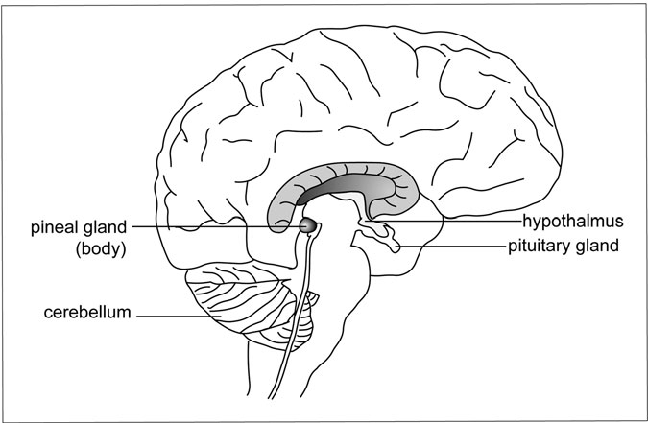

Figure 4.4 The Pineal Glands. The hypothalamus, pituitary, and pineal body. (Sandy Windelspecht/Ricochet Productions)

neurotransmitters include epinephrine, norepinephrine, serotonin, acetyl- choline, dopamine, and histamine.

The hypothalamus also secretes a number of hormones that are referred to as neurohormones, which either travel through the body via the general circulation or go directly to the anterior pituitary gland through a portal network of blood vessels (called the hypothalamic-hypophyseal portal system) and signal it to release or stop releasing its hormones. Hypo- thalamic hormones are called releasing or inhibiting hormones, depending upon how they inﬂuence the pituitary gland. As their names suggest, releasing hormones trigger hormone secretion, and inhibiting hormones halt hormone secretion.

One of the neurohormones is the growth hormone-releasing hormone (GHRH), which is a large peptide hormone that stimulates the secretion of growth hormone from the anterior pituitary gland. Release of GHRH is triggered by stress (such as exercise) and is inhibited by somatostatin, which is also released by the hypothalamus. Negative feedback is largely

controlled by compounds known as somatomedins, growth-promoting hormones made when tissues are exposed to growth hormone.

##### The Pituitary Gland

The pea-shaped pituitary gland (also known as the hypophsis) sits nestled in a cradle of bone at the base of the skull called the sella turcica (“Turkish saddle”). It is attached to the hypothalamus by the pituitary (hypophyseal) stalk, through which run the blood vessels and nerves (axons) that deliver hypothalamic hormones to the anterior pituitary.

As previously noted, the pituitary (Figures 4.5 and 4.6) is often referred to as the “master gland” because it directs the functions of most other endocrine glands (including the adrenals, thyroid, and gonads [ova- ries and testes]). In addition to stimulating other endocrine glands to release their hormones, the pituitary secretes several of its own hormones: growth hormone (GH), prolactin, and oxytocin.

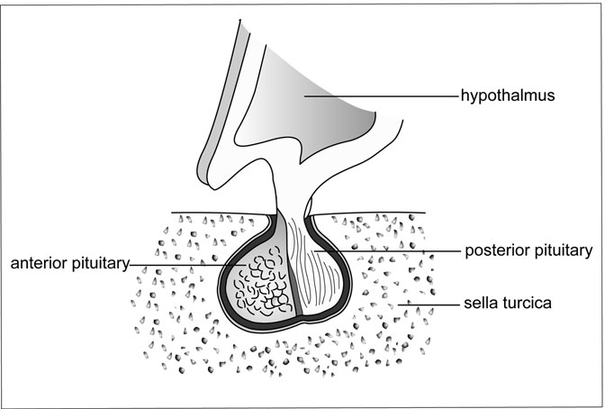

Figure 4.5 The anterior and posterior pituitary gland. (Sandy Windelspecht/ Ricochet Productions)

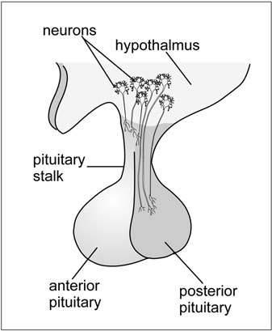

Figure 4.6 The pituitary gland. (Sandy Windelspecht/Ricochet Productions)

The pituitary gland is made up of three lobes: the anterior, inter- mediate, and posterior.

* *Anterior pituitary*: The anterior pituitary is composed of endocrine cells, which secrete hormones in response to stimulation by hypotha- lamic hormones. Anterior pituitary hormones, in turn, stimulate the adrenal glands (adrenocorticotropic hormone [ACTH]), thyroid gland (thyroid-stimulating hormone [TSH]), and ovaries and testes (follicle-stimulating hormone [FSH] and luteinizing hormone [LH]). The anterior

pituitary also produces growth hormone (which stimulates growth of bone and muscle) and prolactin (which initiates milk production following childbirth).

* *Intermediate pituitary*: The intermediate pituitary exists as a separate entity in animals, but only vestiges of this lobe remain in humans. Cells within the intermediate pituitary produce melanocyte- stimulating hormone, which controls skin pigmentation.
* *Posterior pituitary*: Although the posterior pituitary is situated next to the anterior pituitary, it has very different functions. The posterior pituitary is an extension of the nervous system, made up primarily of axons and nerve endings that reach down from the hypothalamus. The posterior pituitary stores and releases hormones that are actually produced within the hypothalamus: antidiuretic hormone (ADH), which helps the body conserve water by increasing reabsorption in the kidney tubules; and oxytocin, which stimulates uterine contractions during childbirth and triggers the letdown of milk from the mother’s breast when her infant nurses.

The pituitary gland is divided into two separate units: the anterior pituitary and posterior pituitary, each of which functions independently and secretes its own set of hormones.

##### The Anterior Pituitary

The anterior pituitary is made up of ﬁve different types of cells, each of which secretes one or more different hormones:

* *Thyrotroph*: Thyroid-stimulating hormone (TSH)
* *Gonadotroph*: Luteinizing hormone (LH) and follicle-stimulating hormone (FSH)
* *Corticotroph*: Corticotropin (ACTH)
* *Somatotroph*: Growth hormone
* *Lactotroph*: Prolactin

Hormones are synthesized in the cytoplasm of the cell as larger, inactive molecules called prohormones. Neurohormones from the hypothalamus travel to the anterior pituitary via a closed system of veins (the hypothalamic- hypophyseal portal system) and signal the anterior pituitary to either release or stop releasing its hormones. When the signal is to release hormones, the hormone is activated from the prohormone as it is sent out from the cell into circulation. If the hypothalamus were destroyed, the anterior pituitary would be unable to secrete any of its hormones, with the exception of prolactin, which the hypothalamus primarily inhibits.

The anterior pituitary affects growth and metabolism in most other endocrine glands, as well as in other areas of the body. It also stimulates other endocrine glands to produce and secrete their hormones:

Thyroid-stimulating Hormone (TSH)

TSH, also called thyrotropin, is a large glycoprotein that affects cell growth and metabolism in the thyroid gland, and signals the gland to pro- duce and release its hormones thyroxine (T4) and triiodothyronine (T3). Thyrotroph cells in the anterior pituitary release TSH after being

stimulated by TRH from the hypothalamus. TSH release is inhibited by negative feedback involving thyroid hormones. When blood levels of thy- roid hormones are high, somatostatin inhibits the production of TRH from the hypothalamus, which then inhibits TSH release. Glucocorticoids and estrogens also serve an inhibitory function by making the pituitary less responsive to TRH.

Gonadotropins

Luteinizing hormone (LH) and follicle-stimulating hormone (FSH) are gonadotropins secreted by cells called gonadotrophs in the anterior pitui- tary. These hormones promote egg and sperm development and control gonadocorticoid hormone (androgens and estrogen) release by the ovaries and testes. The secretion of both hormones remains very low from shortly after birth until puberty, when levels rise dramatically. In females, the rate of secretion varies at different times during the menstrual cycle. Secretion of both LH and FSH is controlled by gonadotropin-releasing hormone (GnRH) from the hypothalamus.

*Luteinizing hormone*: This hormone was given its name because it stimulates the conversion of the ovarian follicle to the corpus luteum following egg release. In the middle of a woman’s menstrual cycle, estrogen levels rise, causing the release of GnRH from the hypo- thalamus. GnRH causes LH levels to surge, triggering ovulation. That surge allows the egg to rupture from its follicle and travel down the fallopian tube toward the uterus. Once the egg has been released, LH stimulates the conversion of the ovarian follicle to the corpus luteum, which produces progesterone, a hormone necessary to maintain pregnancy. LH also stimulates estrogen and progesterone production. In men, the hormone stimulates the growth of—and testosterone production in—the Leydig cells of the testes.

*Follicle-stimulating hormone*: In women, FSH stimulates the maturation of the ovarian follicles, in which the eggs develop. With the help of LH, FSH also increases estrogen secretion by the ovaries. In men, FSH acts upon the Sertoli cells (cells that line the seminiferous tubules, which nourish the germ cells from which

sperm develop) of the testes, facilitating sperm maturation and development. Like LH, the release of FSH is stimulated by GnRH from the hypothalamus. FSH is inhibited by the hormone inhibin, which is secreted by the ovaries and testes.

Adrenocorticotropic Hormone (ACTH)

ACTH, also called corticotropin, is a small peptide hormone that stimu- lates cell development and hormone synthesis in the adrenal cortex (glu- cocorticoids, mineralocorticoids, and gonadocorticoids). In the fetus, ACTH also stimulates secretion of an estrogen precursor called dehydroe- piandrosterone sulfate (DHEA-S), which prepares the mother for labor. Stress stimulates the release of CRH from the hypothalamus. CRH then activates the secretion of ACTH. ADH (vasopressin) also plays a role in ACTH release. High circulating levels of cortisol in the blood inhibit ACTH in two ways: by directly suppressing ACTH synthesis and secre- tion in the pituitary gland, and by acting on the hypothalamus to decrease CRH release. ACTH may also inhibit its own secretion.

Growth Hormone

Growth hormone, also called somatotropin, is a large polypeptide hormone produced by somatotroph cells in the anterior pituitary that plays a signiﬁ- cant role in growth and metabolism. It primarily affects bone, muscle, and tissue growth. Without sufﬁcient growth hormone, an individual would suffer from short stature. Too much growth hormone would result in gigan- tism. For normal growth to occur, the body requires energy, which growth hormone provides through protein synthesis and the breakdown of fats. Growth hormone has two types of effects: direct and indirect.

*Direct effects*: Growth hormone acts directly upon protein metabolism, fat metabolism, and carbohydrate metabolism to help the body more efficiently use and conserve energy. It moves amino acids from the blood into cells and stimulates protein synthesis within the cells; it moves fats out of storage (in adipose tissue) for use in energy production to conserve proteins; and it decreases carbohydrate use and impairs glucose uptake into cells, thus sparing glucose for the brain.

*Indirect effects*: Growth hormone stimulates bone, muscle, and cartilage growth indirectly, by triggering the production of insulin-like growth factor 1 (IGF-1, or somatomedin). Insulin-like growth factors are synthesized in the liver and other tissues and act much like insulin, stimulating glucose uptake by cells. They also influence protein and DNA synthesis. IGF-1 stimulates proliferation of cartilage cells (called chondrocytes), causes muscle cell differentiation and proliferation, and initiates protein synthesis in muscle tissues.

##### Regulation of Anterior Pituitary Hormones

Hormones from the anterior pituitary can be regulated in one of three ways:

1. Hormones such as LH and FSH are released in pulses that follow a regular cycle. The strength and frequency of these pulses is set, in part, by the hypothalamus. Pulsatile release may follow a daily rhythm (circadian), or it may occur more frequently (ultradian) or less frequently (infradian) than once a day.
2. Most hormones are regulated by feedback loops, in which circulating hormone levels act upon the hormones that triggered their release. Three types of feedback loops exist:
   * *Long-loop system*: After being stimulated by a releasing hormone from the hypothalamus (CRH), the anterior pituitary signals its target organ (for example, the adrenal cortex) to produce its hor- mone (cortisol). When that hormone reaches a certain level in the system, it acts upon the hypothalamus via negative feedback, inhibiting its releasing hormone (CRH). When the hypothalamus stops or decreases production of the releasing hormone, the ante- rior pituitary subsequently stops releasing its hormone (ACTH).
   * *Short-loop system*: Some hormones (for example, LH and FSH) can suppress their own release without entering the bloodstream.
   * *Ultrashort-loop system*: A releasing hormone (for example, LHRH or GHRH) can act directly on the hypothalamus to regu- late its own secretion.
3. Finally, hormone release can be inﬂuenced by external factors, such as stress (for example, the ﬁght-or-ﬂight release of corticotropin from the adrenal cortex), diet, and illness.

##### The Posterior Pituitary

The posterior pituitary is not a classic endocrine organ because it is com- posed primarily of extensions of axons and nerve endings from the hypo- thalamus. Its two hormones, antidiuretic hormone (ADH, or vasopressin) and oxytocin, are actually produced in the neurons of nuclei in the hypo- thalamus. These hormones travel down nerve ﬁbers to the posterior pitui- tary, which merely stores and releases them.

Antidiuretic Hormone

Antidiuretic hormone (ADH, or vasopressin) is a small peptide hormone whose primary role is to conserve water in the body by signaling the kid- neys to excrete less ﬂuid. The hormone is synthesized as a preprohormone in the hypothalamic neurons. The preprohormone is converted into a pro- hormone, which contains an attached protein called neurophysin that is removed as the hormone is secreted.

The human body contains about 60 percent water. Signiﬁcant ﬂuctua- tions in water balance (i.e., dehydration or overhydration) can be extremely dangerous to the system. When the concentration of liquid in the blood drops, special sensors (called osmoreceptors) in the hypothalamus alert the neurons that produce ADH. Osmoreceptors are extremely sensitive and can respond to tiny changes (as small as 1 percent) in water concentration. Whereas a diuretic increases urine output, an antidiuretic conserves ﬂuid in the body by reducing urine output. When ADH is released, it binds to receptors in the distal or collecting tubules of the kidneys and increases their permeability, thus stimulating the reabsorption of liquid back into the blood (normally, these tubules are virtually impermeable to water). When more water is absorbed into the bloodstream, blood volume and pressure increase. Conversely, when the ﬂuid level in the body gets too high, ADH release is suppressed, and the kidneys excrete more liquid into the urine. ADH also constricts blood vessels (vasoconstriction), the role for

which it was given its alternate name, vasopressin.

Thirst, the body’s physical indicator that ﬂuid levels are low, is also regulated by osmoreceptors in the hypothalamus, although not the same ones that trigger ADH release. The body ﬁrst sends in ADH to try to regu- late water balance; then, if that measure fails to increase ﬂuid volume, it invokes thirst. Changes in blood pressure also stimulate ADH release. Two pressure sensors—one in the carotid artery in the neck, and the other in specialized cells in the atrium of the heart—discern changes in blood pressure and volume. They send a message, via nerves, to the hypothala- mus. When these sensors are stretched by expanding blood volume, they shut off ADH secretion so that more water is excreted by the kidneys. When they sense reduced blood volume (for example, when a person is hemorrhaging from a severe injury), they trigger ADH production.

Oxytocin

Oxytocin is similar in structure to ADH, and it is also synthesized from preprohormones in the hypothalamus and transported to the posterior pituitary for secretion into the blood. In addition to being secreted by the pituitary, oxytocin is also released by tissues in the ovaries and testes. The primary function of oxytocin is to stimulate the mammary glands in a mother’s breast during lactation—to let down the milk so that her baby can nurse. Oxytocin (which is derived from the Greek word meaning “swift birth”) also stimulates uterine contractions during labor. The release of oxytocin into a new mother’s brain also helps forge a bond between her and her new baby. The hormone normally circulates in low levels in both men and women, but it rises in women during ovulation, birth, and lactation, as well as in times of stress.

##### Pineal Gland

The small, cone-shaped pineal gland was once called the “third eye” and ascribed supernatural powers. It extends downward from the third ven- tricle of the brain, above and behind the pituitary gland. The pineal gland is composed of parts of neurons, but otherwise has no direct neural con- nection with the brain.

Scientists know very little about the gland and what it does, but they do know that it secretes the hormone melatonin, which responds to light

and dark, and communicates that information to the rest of the body. Melatonin inﬂuences circadian rhythms (the body’s daily biological clock) and thus plays a role in functions regulated by night/day cycles, including reproduction and sleep/wake patterns.

Melatonin synthesis begins with the amino acid tryptophan, which is then converted into serotonin and ﬁnally into melatonin. Melatonin release is regulated by the sympathetic nervous system and is stimulated primarily by darkness, but it can also be triggered by hypoglycemia (low blood sugar). Melatonin concentration is highest at night and falls to almost undetectable levels during the day.

Although its function is still not completely clear, melatonin is believed to act upon suprachiasmatic nuclei (tightly packed groups of small cells) in the hypothalamus (which have receptors to it) to inﬂuence the body’s daily biological rhythms. Synthetic versions of the hormone have been used to treat everything from jet lag to insomnia.

#### The Thyroid and Parathyroid Glands

The thyroid and parathyroid glands in the neck have several life-sustaining functions: The thyroid gland produces hormones that affect growth, devel- opment, metabolism, calcium homeostasis, and cell differentiation; and the parathyroid glands regulate calcium and phosphorous levels.

The Thyroid Gland The largest endocrine gland in the body sits just below the larynx (voice box) and wraps around the trachea (windpipe). The thyroid gland (Figure 4.7)

resembles a butterﬂy, with its two lobes reaching out like wings on either

side of a narrow strip of tissue called the isthmus. In a healthy adult, the thy- roid weighs about 20 grams, but it can grow to several times this size.

The thyroid gland is the largest endocrine organ and is crucial to nearly all of the body’s physiological processes. It produces thyroid hormones, which are needed for growth, development, and a variety of metabolic activities. The thyroid is composed of two types of cells: follicular and parafollicular.

Follicles are sacs ﬁlled with the prohormone thyroglobulin. Thyroglo- bulin breaks apart to produce the two thyroid hormones, thyroxine (T4)

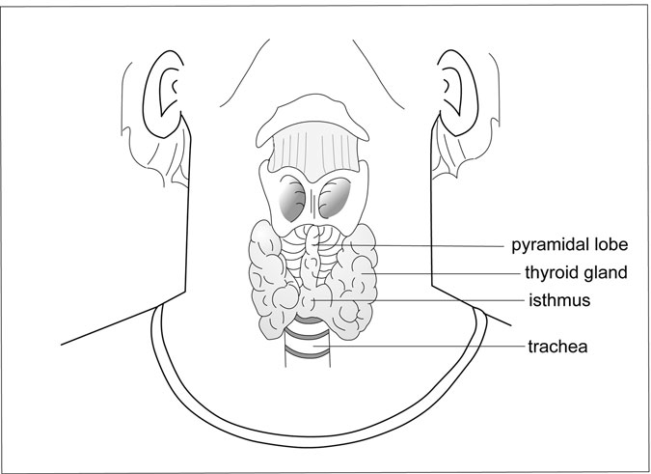

Figure 4.7 The thyroid gland. (Sandy Windelspecht/Ricochet Productions)

and triiodothyronine (T3). Lining the sacs are follicular cells, which syn- thesize and then either secrete or store these hormones. Parafollicular (or

C) cells ﬁll the spaces in between follicles. They secrete the hormone cal- citonin. Inside the follicles is a substance called colloid, which consists primarily of the glycoprotein thyroglobulin.

##### Thyroid Hormone Synthesis

What makes the thyroid gland unusual among endocrine organs is that it requires iodine to produce its hormones. Iodine enters the body through food (i.e., iodized salt and bread) and water in the form of iodide or iodate ion.

The thyroid gland captures this iodide, and the enzyme thyroid peroxi- dase activates it. The follicular cells produce thyroglobulin, which is depos- ited in the colloid. Tyrosine is bound to the thyroglobulin molecule. Iodine diffuses into the colloid and is added to the thyroglobulin. Enzymes break down the thyroglobulin, releasing thyroid hormones into the bloodstream.

Without sufﬁcient iodine, the thyroid reduces its hormone output. Decreased levels of thyroid hormones in the blood stimulate the anterior pituitary to secrete more thyroid-stimulating hormone (TSH) to make up for the deﬁcit. The thyroid gland swells in size as it tries to increase its output, a condition called goiter.

Unlike most other endocrine organs, which produce and immediately secrete their hormones, the thyroid can store its hormones for several weeks. It releases its hormones when acted upon by TSH from the pituitary gland. TSH stimulation leads to the activation of thyroxine (T4). It splits from the thyroglobulin molecule as it leaves the cell and enters the bloodstream. T4 is the more plentiful of the two hormones, making up about 90 percent of the total thyroid hormones. Triiodothyronine (T3) is secreted in much smaller concentrations than thyroxine, but it is the more active of the two hormones. T3 is produced (usually in the peripheral tissues, especially the liver and kidney) when thyroxine loses one of its iodine molecules.

Because thyroid hormones are not water soluble, they generally travel through the bloodstream attached to carrier proteins (most often thyroxine-binding globulin, but also to a lesser extent to thyroxine-binding prealbumin and albumin). Virtually every cell in the body contains thyroid hormone receptors. Once the thyroid hormone reaches its target cells, it travels through the membrane via diffusion or with the help of carriers, and it binds to receptors in the nucleus. Thyroid hormones affect gene tran- scription, which either stimulates or inhibits protein synthesis.

##### Regulation of Thyroid Hormone Secretion

The hypothalamic-pituitary axis is the primary regulator of thyroid hormone production and secretion (Figure 4.8). Thyrotropin-releasing hormone (TRH) from the hypothalamus travels to the anterior pituitary and stimulates it to release thyroid-stimulating hormone (TSH). TSH inﬂuences every step of the thyroid production process, from thyroid cell growth to iodide uptake and metabolism. Finally, TSH triggers hormone secretion.

TSH release is stimulated and inhibited by positive and negative feed- back, based on circulating levels of T4 and T3. When these hormones are in short supply, the pituitary and hypothalamus act on the thyroid to increase its production. Conversely, when too much of these hormones circulate in

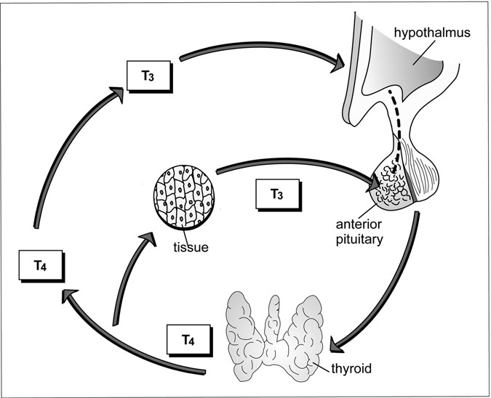

Figure 4.8 Thyroid Hormone Regulation. (1) TRH from the hypothalamus triggers TSH secretion from the pituitary, (2) TSH stimulates thyroid hormone release, and (3) circulating levels of T4 and T3 inﬂuence the hypothalamus and pituitary to regulate thyroid production. (Sandy Windelspecht/Ricochet Productions)

the blood, the pituitary and hypothalamus slow or stop thyroid production. Feedback ensures that hormone levels remain at an appropriate level.

Also controlling thyroid hormone secretion is the conversion of T4 into T3. As more T4 is converted into T3, rising T3 levels make the pitui- tary less responsive to TRH. But as more T4 is lost because of this conver- sion, the pituitary once again becomes more sensitive to TRH stimulation.

##### The Parathyroid Glands

Most healthy adults have two pairs of oval-shaped parathyroid glands, which lie next to the thyroid gland in the neck (the word “parathyroid”

means “beside the thyroid”). In some instances, individuals may have fewer than or more than four parathyroid glands. Inside the glands are clusters of epithelial cells that produce and secrete parathyroid hormone, which is the most signiﬁcant regulator of calcium levels in the blood. Calcium is essential for cell function as well as for bone formation.

The parathyroid glands produce only one major hormone: parathy- roid hormone (PTH). PTH (also called parathormone), a polypeptide, opposes the actions of calcitonin by increasing blood calcium levels. Without this hormone, calcium concentrations in the blood would drop to life-threatening levels (hypocalcemia). Another effect of PTH is to reduce blood levels of phosphorous.

The parathyroids synthesize PTH from a larger, inactive prohormone in the parenchymal parathyroid cell. As PTH is released from the cell, it is split from the prohormone. PTH increases blood calcium by acting upon the bones, the kidneys, and (indirectly) the small intestine:

* *Bone*: PTH releases calcium from bone by stimulating the formation and activity of bone-dissolving cells called osteoclasts.
* *Kidneys*: PTH increases calcium reabsorption in the kidney tubules, reducing the amount of calcium that is lost in the urine. Because the kidneys ﬁlter a large volume of calcium each day, even a slight adjust- ment in excreted calcium can have a big effect on body chemistry. PTH also decreases phosphorous reabsorption, so the kidneys excrete a greater amount.
* *Small Intestine*: The effects of PTH on the small intestine are indirect. PTH increases production of vitamin D metabolites (the active form of vitamin D) in the kidneys (more on vitamin D later in this chapter). These metabolites increase the rate at which ingested calcium is absorbed in the small intestine, providing more calcium to circulate in the bloodstream.

##### PTH Regulation

Because blood calcium levels are so crucial to normal body function, cells of the parathyroid contain special receptors that can sense minute changes in calcium concentration. When calcium binds to these receptors, it results

in reduced PTH secretion, which lowers calcium concentration in the blood. Without the inﬂuence of bound calcium, the receptors continue to stimulate PTH secretion. In the event that blood calcium levels remain depressed, PTH secretion can increase to 50 times its normal levels.

##### Parathyroid Hormone-related Protein (PTHrP)

PTHrP is similar in structure and function to parathyroid hormone (it too affects calcium and phosphorous balance), but it is produced in many tis- sues throughout the body. PTHrP binds to PTH receptors and has several of its own receptors as well. PTHrP can either act upon cells in other parts of the body or inﬂuence the nucleus of the cell(s) in which it was produced (called intracrine action). Like PTH, it releases calcium from bone into the blood and increases reabsorption in the kidneys.

#### The Adrenal Glands and Endocrine Pancreas

The adrenal glands are often referred to as the ﬁght-or-ﬂight glands because they secrete hormones involved in the body’s stress response (Figure 4.9). The small, triangular glands sit on top of each kidney, sur- rounded by a capsule of connective tissue. When the body is confronted with stress—a serious car accident or a career-ending confrontation with one’s boss, for example—the two adrenal glands kick into gear. The sub- stances they produce (the catecholamines from the adrenal medulla and the steroid hormones from the adrenal cortex) orchestrate the stress response, making the body more alert, more energy efﬁcient, and ready to face the daunting task at hand. Adrenal hormones are also involved in a number of other functions: regulating electrolyte balance, blood sugar levels, and metabolism; and inﬂuencing sexual characteristics.

Like the pituitary gland, the adrenals are essentially two glands in one: an outer cortex and an inner medulla. Each region originates from a separate embryological source, functions separately, and produces its own distinct hormones.

##### Adrenal Medulla

Hormones produced in the central, medullary region of the adrenal gland are referred to as the catecholamines. They are both hormones and

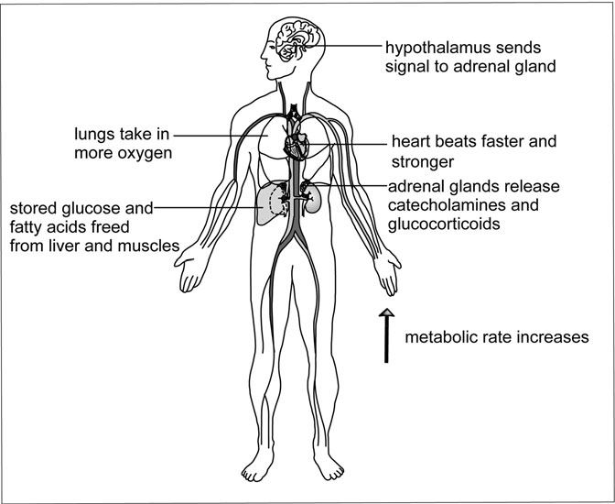

Figure 4.9 The ﬁght-or-ﬂight response. (Sandy Windelspecht/Ricochet Productions)

neurotransmitters, because they are produced and secreted by sympathetic nerves (including neurons in the brain). The primary catecholamines are epinephrine (adrenaline), norepinephrine (noradrenaline), and dopamine. Catecholamines are produced in a multistep process that begins with the amino acid tyrosine. First, an enzyme converts tyrosine into the chemical L-dopa. A second enzyme converts L-dopa to dopamine. Dopamine is then converted to norepinephrine by yet another enzyme. Finally, epinephrine is synthesized from norepinephrine before being released into the blood.

Epinephrine makes up the bulk (80 percent) of catecholamines released from the adrenal medulla; the remaining 20 percent is norepinephrine.

Catecholamine release is part of what Harvard physiologist Walter Cannon (1871–1945) termed the body’s ﬁght-or-ﬂight response. When confronted with stress, the body shifts into overdrive. It becomes more

alert and refocuses energy as it prepares to either stay and ﬁght the danger or run away as quickly as possible.

As soon as the physical or emotional trauma occurs, the hypothalamus sounds the alarm. It sends out nerve impulses, which race to the adrenal medulla and signal it to release epinephrine and norepinephrine. These substances course through the blood attached to carrier proteins such as albu- min, and they bind to adrenergic receptors on the surface of their target cells. Two types of adrenergic receptors exist: alpha-adrenergic and beta- adrenergic. The response elicited depends on the type of receptor stimulated. Alpha receptors are involved in smooth muscle contractions, pupil dilation, and blood vessel contraction. Beta receptors stimulate the heart and lungs, and relax the uterus.

Once the hormones are bound to their receptors, the body undergoes a rapid and dramatic transformation. The heart beats faster and stronger, the pupils dilate, the skin breaks out in a sweat, and the breathing becomes more intense as the body reaches a new level of alertness. Under the surface, a number of important physiological changes occur, directed by the adrenal catecholamines:

* The heart beats faster and more forcefully (primarily as a result of epinephrine), rushing additional blood throughout the body (especially to the brain and muscles). At the same time, the arteries constrict (primarily as a result of norepinephrine), increasing blood pressure.
* Stored glucose and fatty acids are freed to be used for energy. Catechol- amines release glucose from the liver and muscles by stimulating the breakdown (glycogenolysis) of glycogen—the stored form of glucose. They also release fatty acids from adipose tissue by breaking down fatty compounds called triglycerides. The catecholamines oppose the action of insulin by preventing glucose movement into muscle and adipose tissue. Glucose is therefore preserved for use by the brain, which needs it most.
* The metabolic rate increases. Oxygen consumption and body heat rise.
* In the lungs, small tubules called bronchioles dilate, increasing the ﬂow of air.
* Smooth muscles in the gastrointestinal tract and sphincters contract, while muscles in the uterus and trachea relax.
* Motor activity, gastrointestinal secretion, and other nonessential activities slow to conserve energy for other, more crucial functions.

Dopamine, a neurotransmitter, is similar to epinephrine. It inﬂuences the brain processes controlling emotion, movement, and the sensations of pleasure and pain. When dopamine is not produced in large enough quan- tities (for example, in patients with Parkinson’s disease), the body grows rigid, and movement becomes difﬁcult.

##### Adrenal Cortex

The large outer region of the adrenal gland, the cortex is made up of three layers or zones, each of which produces its own group of steroid hormones:

* Zona glomerulosa, the outermost layer, is where the mineralocor- ticoids (aldosterone) are produced.
* Zona fasciculata, the middle layer, is where the glucocorticoids (cortisol) are produced.
* Zona reticularis, the innermost layer, is where the gonadocorticoids (sex hormones androgens and estrogens) are produced.

The adrenal cortex is separated into two functional regions, each regulated by a separate entity. The fasciculata and reticularis layers depend upon adrenocorticotropic hormone (ACTH) stimulation from the anterior pitui- tary. Without ACTH, these two regions would atrophy. The zona glomer- ulosa is under the control of the renin-angiotensin system, which regulates blood pressure.

Mineralocorticoids, glucocorticoids, and gonadocorticods are all ste- roid hormones derived from cholesterol. Most of the cholesterol that enters the adrenal gland comes from low-density lipoproteins (LDLs) circulating in the blood. Upon stimulation of the adrenal cortex, choles- terol that splits off from the LDL is converted into pregnenolone, the pre- cursor molecule for steroid hormones. The adrenal gland can also synthesize a small amount of its own cholesterol.

##### Mineralocorticoids

The principal mineralocorticoid, aldosterone, is produced and secreted by the zona glomerulosa. Aldosterone acts upon the kidneys to regulate sodium, potassium, and water reabsorption. It stimulates the distal tubules to reabsorb more sodium and excrete more potassium (as well as hydro- gen) in the urine. As sodium is reabsorbed, more water is also reabsorbed, increasing blood ﬂuid volume. Aldosterone also acts upon the salivary glands, sweat glands, and colon to reduce the amount of sodium lost in saliva, sweat, and feces.

Sodium and potassium balance is crucial, because these ﬂuids regu- late ﬂuid movement between the cells and the extracellular ﬂuid. Without aldosterone, a deadly ﬂuid imbalance could result. When too much sodium is present, water from inside the cells crosses over into the extrac- ellular region to restore balance, causing the cells to shrink—a situation that could lead to shock and death. Too little sodium can send water into the cells, causing them to swell and potentially leading to nausea, vomit- ing, diarrhea, convulsions, or coma.

Aldosterone release is primarily under the control of the renin- angiotensin system, which helps regulate blood volume and blood pres- sure. Inside the blood vessels of the kidneys are tiny receptors that can detect changes in blood pressure and extracellular ﬂuid volume. When these sensors notice a drop in pressure and volume, they release the enzyme renin into the blood. Renin travels to the liver, where it converts the protein angiotensinogen into another protein, called angiotensin I. Once angiotensin I reaches the lungs, it is converted by angiotensin- converting enzyme (ACE) into the much more potent hormone, angioten- sin II, which constricts the blood vessels and stimulates the zona glomer- ulosa to synthesize aldosterone, raising blood pressure.

##### Glucocorticoids (Corticosteroids): Cortisol (Hydrocortisone)

The principal glucocorticoid, cortisol, is produced in the zona fasciculata and is sometimes referred to as the “stress hormone.” Like the catecholamines from the adrenal medulla, it helps the body respond during times of stress (for example, injury or emotional trauma). Cortisol is essential because of

its effects on metabolism: It maintains the body’s energy (glucose) supply and regulates ﬂuid balance. Without it, the body could overreact to stress and disrupt the fragile homeostatic balance that it needs to stay alive.

The testes, erythrocytes, kidney medulla, and especially the brain rely on glucose as their sole energy source. Without it, they cannot function prop- erly. After a meal, blood levels of glucose are typically high and the body is able to store whatever it does not immediately use. But glucose stores are not everlasting. Glycogen, the form of glucose stored in the liver, can run out within 24 hours after a meal. During periods of fasting, cortisol maintains blood glucose levels by affecting a number of metabolic processes.

##### Glucose, Fat, and Protein Metabolism

In the muscles and other tissues, cortisol increases the breakdown of pro- tein into amino acids. Those amino acids are used to produce additional glucose (via a metabolic pathway called gluconeogenesis) in the liver. Cortisol also conserves glucose for the brain and spinal cord by blocking the actions of insulin (which will be discussed later in this chapter)— inhibiting glucose absorption into other tissues.

Cortisol also stimulates the release of fatty acids and glycerol from adipose tissue. Glycerol is used in gluconeogenesis, while fatty acids are made available for energy to other tissues to preserve glucose for the brain. Cortisol reduces protein reserves everywhere except in the liver. As proteins continue to be broken down in muscles and in other tissues, blood levels of amino acids rise. The additional amino acids are used for gluco-

neogenesis, glycogen formation, and protein synthesis in the liver.

##### The Pancreas

The pancreas has two roles: It functions both as an endocrine and as an exo- crine organ. As an exocrine organ, the pancreas releases digestive enzymes via a small duct into the small intestine. These enzymes break down carbo- hydrates, fats, and proteins from food that has been partially digested by the stomach. The exocrine pancreas also releases a bicarbonate to neutralize stomach acid in the duodenum (ﬁrst portion) of the small intestine.

In its role as an endocrine organ, the pancreas secretes the hormones insulin and glucagon, which help the body use and store its primary source

of energy—glucose (sugar). The endocrine pancreas also secretes somato- statin, which is a primary regulator of insulin and glucagon release.

The pancreas is long and soft, and stretches from the duodenum of the small intestine almost to the spleen. It is divided into a head (its widest point), neck, body, and tail. The endocrine pancreas is made up of clusters of cells called the islets of Langerhans, in which the hormones insulin and glucagon are produced. There are about one million islets, but they make up only about 1 percent of the endocrine pancreas’ total volume. The islets also contain parasympathetic and sympathetic neurons, which inﬂuence insulin and glucagon secretion. The islets also produce the hor- mones somatostatin and pancreatic polypeptide.

##### Energy Metabolism

Why are insulin and glucagon so crucial? Because the body needs energy to survive, and these two hormones regulate the distribution of energy to tissues. Energy enters the body in the form of food. As food passes through the mouth, esophagus, and stomach, enzymes break it down into tiny pieces. Once the partially digested food reaches the intestines, more enzymes go to work, breaking it down into molecules small enough to enter the blood- stream and be transported to cells. Starches are broken down into glucose (sugar), proteins are broken down into amino acids, and fats are broken down into fatty acids and glycerol.

Food metabolism occurs in two distinct phases: During the anabolic phase, which occurs after a meal, enzymes convert nutrients from food into substances the body can use. Blood levels of glucose, fatty acids, and amino acids rise. Because the body has more energy than it needs at the moment, it stores the excess for later. Glucose is stored as glycogen in the liver and muscles, fat is stored in adipose tissue, and amino acids are stored in muscle.

About four to six hours after a meal, the catabolic phase begins. Stored energy from the liver, muscles, and adipose tissue is mobilized to sustain the body until its next meal. The liver produces glucose from stored glycogen and by converting amino acids via gluconeogenesis. When the body has gone for some time without food, the liver converts free fatty acids into ketone bodies. The brain normally uses only glucose

for energy, but it can use ketone bodies as a backup energy source when glucose supplies are low. Without this alternative energy source, the brain and nervous system would starve and suffer permanent damage.

The hormones insulin and glucagon from the endocrine pancreas regulate these stages of energy metabolism. Insulin primarily regulates the anabolic phase, while glucagon inﬂuences the catabolic stage.

##### Insulin

After a meal, the body converts carbohydrates from foods into simple sug- ars in the intestine. Glucose is carried to the tissues through the blood- stream. When blood glucose levels rise, the beta cells in the endocrine pancreas produce and release insulin. Insulin is formed from a larger, inactive molecule, called proinsulin. Before insulin is released into the bloodstream, the inactive molecule splits off. For a look at diabetes, a chronic condition involving insulin production, see Sidebar 4.1.

Insulin levels rise 8–10 minutes after a meal, reaching their peak con- centration 30–45 minutes after the meal. Nearly every cell in the body has insulin receptors. When insulin binds to its receptors on the cell surface, it triggers other receptors that help the cells take in glucose. The body uses and stores glucose in the liver, muscles, and adipose tissues. Without insu- lin, an individual could eat three meals a day and still starve to death because the cells would be unable to use the energy.

In the liver, insulin promotes glucose storage in the form of glycogen. It also inhibits the breakdown of glycogen and the production of glucose from other, noncarbohydrate sources (gluconeogenesis), and it decreases overall glucose release by the liver.

Insulin helps transport glucose to muscle cells and stimulates the incorporation of amino acids into protein, which is used to sustain and repair muscles. It promotes glycogen synthesis to replace glucose the muscles have used. Insulin also promotes glucose uptake in adipose tissue, promotes its conversion to fatty acids, and inhibits the release of stored fatty acids.

As insulin moves glucose into the tissues for energy use and storage, blood glucose levels fall. Between 90 and 120 minutes after a meal, blood glucose concentration returns to its original, pre-meal levels. To help the

SIDEBAR 4.1

#### Understanding Diabetes: The Key to Staying Healthy

Diabetes is a serious, chronic condition involving the endocrine system. It is deﬁned as a disease where patients have elevated levels of blood glucose or sugar that results from defects in either or both insulin production and action. According to the most recent estimates from the National Institute of Diabetes and Digestive and Kidney Diseases (NIDDK), 23.6 million people—over 7 percent of the population—have diabetes. Of particular concern is that of these over 20 million people with diabetes, almost 6 million are undiagnosed. This is especially dangerous because diabetes can lead to serious complication—even premature death—if patients do not control the disease and lower the risk of complications.

There are three primary types of diabetes, and below is a brief explan- ation of each of these types:

* *Type 1 Diabetes*: Formerly known as insulin-dependent diabetes melli- tus or juvenile-onset diabetes, type 1 diabetes occurs when the body’s immune system destroys the cells in the body—called pancreatic beta cells—that produce insulin that regulates blood glucose levels. Patients with this type of diabetes use either a pump or injection device to deliver insulin into their body. While type 1 diabetes typi- cally develops in children and young adults, it can develop in people of any age. In fact, type 1 diabetes accounts for 5–10 percent of all diagnosed cases of diabetes. There is currently no known way to pre- vent this type the diabetes. Some risk factors are believed to be linked to autoimmune, genetic, or environmental factors.
* *Type 2 Diabetes*: Formerly known as non-insulin-dependent diabetes mellitus, this type of the disease is estimated to comprise 90–95 percent of all diagnosed cases of diabetes in adults. Diagnosis is typically preceded by an inability of the cells to properly produce insulin—a con- dition known as insulin resistance. The need for insulin steadily increases while the pancreas generally loses the ability to produce it.

This type of diabetes has several known risk factors: older age, obesity, family history of the disease, and lack of physical activity. In

addition, experts believe that race/ethnicity can be a risk factor. Medical experts believe that African Americans, Hispanic/Latino Americans, Native Americans, and some Asian Americans and Native Hawaiians or other Paciﬁc Islanders have an increased risk for type 2 diabetes.

* *Gestational Diabetes*: This type of diabetes is related to glucose intolerance and is diagnosed in pregnant women—occuring more frequently among African American, Hispanic/Latino American, and Native American women. Obesity and family history are also risk factors for diabetes. During pregnancy, treatment is focused on normalizing glucose levels to protect the infant. After pregnancy, however, an estimated 5–10 percent of women with gestational diabetes are diagnosed with type 2 diabetes. In addition, women with gestational diabetes are at an increased chance—40–60 percent—of developing type 2 diabetes over the next 5–10 years.

If not treated and controlled properly, diabetes can lead to serious complications, including blindness, kidney damage, cardiovascular disease, and amputations of lower limbs. The risk of these complications can be lowered by controlling blood glucose, blood pressure, and blood lipid levels. As mentioned earlier, many type 1 and 2 diabetes patients need insulin delivered by injection or a pump. Some patients also have to take other medications to control related conditions, such as high blood pressure. However, some patients take little or no medications—even insulin—by following a healthy meal and exercise plan. According to the NIDDK, among adults with type 1 or 2 diabetes, an estimated 14 percent take only insulin, 13 percent take both insulin and oral medi- cation, 57 percent take oral medication only, and 16 percent do not take either insulin or oral medication. The treatment regimen for each indi- vidual will often change over the course of the disease. Among diag- nosed diabetics—type 1 or type 2—14 percent take insulin only, 13 percent take both insulin and oral medication, 57 percent take oral medication only, and 16 percent do not take either insulin or oral medi- cation. Medications for each individual with diabetes will often change over the course of the disease.

body maintain a constant blood glucose level, insulin and glucagon release are synchronized on an alternate schedule. When glucose concen- trations in the blood rise during the anabolic phase, insulin is released. As insulin pulls glucose from the blood for tissue use and storage, blood glu- cose concentrations drop, stimulating glucagon release.

Insulin release may also be triggered by signals from the nervous system in response to external stimulation; for example, the sight and/or smell of food. The gastrointestinal hormones cholecystokinin (CCK), secretin, gas- trin, gastric inhibitory peptide (GIP), and acetylcholine are thought to play a role in this response, preparing the pancreas to release insulin. Insulin release is inhibited not only by low glucose levels, but also by low levels of amino acids and fatty acids in the blood, as well as by the hormones somato- statin, epinephrine, and leptin.

##### Glucagon

Following a meal, insulin pulls glucose from the blood to be used and stored by cells. When several hours have passed without additional food being ingested, blood sugar is eventually depleted (a condition called hypoglycemia). The body still needs energy, much of which it gets from fatty acids until the next meal is available. But the brain, which cannot directly use fatty acids and other alternative energy sources, still relies on glucose. In response to dropping blood glucose levels, the alpha (α) cells of the endocrine pancreas begin to secrete the hormone glucagon from the large precursor molecule proglucagon. The same prohormone is found in cells of the gastrointestinal system, although it produces different secreted products.

Glucagon has the opposite effect of insulin. Whereas insulin lowers blood glucose levels by promoting glucose usage and storage, glucagon raises blood glucose levels. It acts primarily upon the liver to increase glu- cose output. When it binds to receptors on liver cells, glucagon activates the enzymes that break down stored glycogen (glycogenolysis) to release glucose and increases production of glucose from amino acid precursors (a process called gluconeogenesis). In adipose tissue, glucagon promotes the breakdown and release of fatty acids (lipolysis) into the blood, which are used by the cells for energy in the absence of glucose. By raising the

level of fatty acids in the blood, glucagon indirectly prevents glucose uptake by the muscles and adipose tissue.

The main trigger for glucagon release is low blood sugar, but it may also be stimulated by other hormones, namely the catecholamines (in stressful situations); cholecystokinin, gastrin, and gastric inhibitory peptide (GIP) from the gastrointestinal system; and the glucocorticoids. Sympathetic nerve stimulation can also lead to glucagon release. Rising blood glucose levels, high circulating levels of fatty acids, as well as the hormones insulin and somatostatin inhibit glucagon secretion.

##### Somatostatin

The hormone somatostatin is produced in the delta (6) cells of the pancre- atic islets as well as in the gastrointestinal tract and hypothalamus. Soma- tostatin is primarily an inhibitory agent. In the pancreas, it acts in a paracrine manner, suppressing production of insulin and glucagon. It also acts upon the gastrointestinal tract, inhibiting secretion of the hormones gastrin, secretin, and cholecystokinin; prolonging gastric emptying time; decreasing gastric acid and gastrin production; and slowing intestinal motility. Together, these actions reduce the rate of nutrient absorption. When secreted from the hypothalamus, somatostatin acts upon the pitui- tary to inhibit growth hormone secretion.

Somatostatin release is triggered by rising levels of glucose, fatty acids, and amino acids in the blood. Gastrointestinal hormones like secre- tin and cholecystokinin can also stimulate its release. Insulin inhibits somatostatin secretion.

##### Gastrointestinal Hormones

The intestinal tract not only digests food and absorbs nutrients; it also pro- duces and secretes a number of hormones that aid in the digestive process. Gastrointestinal hormones, which are primarily peptides, are produced in specialized endocrine cells in the stomach and small intestine, as well as in neurons scattered throughout the gastrointestinal tract. Most gastroin- testinal hormones either act upon nearby cells (paracrine delivery) or act as neurotransmitters within neurons (neurocrine delivery). Endocrine and

neural cells in the intestinal tract are referred to collectively as the enteric endocrine system.

The central nervous system and gastrointestinal tract are linked by pathways known as the brain-gut axis. Neurotransmitters located in both the brain and the gut regulate and coordinate such functions as satiety, nutrient absorption, gut motility, and intestinal blood ﬂow. Any disruption of this system is believed to result in gastrointestinal disorders such as irri- table bowel syndrome (IBS).

##### Gastrin

This hormone, produced by specialized cells in the stomach, regulates stomach acid secretion. When partially digested proteins, peptides, and amino acids are present in the stomach, gastrin stimulates the release of gastric acid and the digestive enzyme, pepsin, into the stomach cavity to aid digestion. Beer, wine, and coffee can also stimulate gastrin release. As the stomach becomes more acidic, gastrin production declines.

##### Cholecrystokinin (CCK)

Food entering the small intestine must be broken down into smaller mole- cules (such as amino acids and fatty acids) in order to be absorbed. When partially digested proteins and fats enter the duodenum (ﬁrst portion) of the intestine, cells in that region secrete the peptide hormone CCK. This hormone triggers the release of pancreatic enzymes and stimulates gall- bladder contractions to release stored bile. Pancreatic enzymes and bile are sent to the intestines, where they aid in digestion. As proteins and fats are digested and absorbed, a drop in their levels shuts off CCK release. CCK is also released as a neurotransmitter by the central nervous system. Scientists believe that it may help regulate food intake by signaling the feeling of satiety.

##### Secretin

The stomach regularly secretes acid, which could potentially burn and damage the small intestine. When acid enters the duodenum, cells lining the region release secretin. This hormone stimulates the pancreas to

release acid-neutralizing bicarbonate and water. As acid in the intestine is neutralized, the rising pH level shuts off secretin release. Somatostatin also inhibits secretin production.

##### Gastric Inhibitory Peptide (GIP)

Gastric inhibitory peptide (GIP), also called glucose-dependent insulino- tropic peptide, is part of the secretin family of hormones, and like secretin, it is released by cells in the duodenum. It blocks gastrin and gastric acid secretion into the stomach and inhibits gut motility. Following a meal, GIP responds to increased glucose levels, enhancing the insulin response to glucose.

##### Vasoactive Intestinal Polypeptide

This peptide is found throughout the body but is secreted in greatest concentration by cells in the intestinal tract and nervous system. VIP increases secretion of water and electrolytes by the intestine, increases blood ﬂow within the gut, and inhibits gastric acid secretion.

##### Ghrelin

This peptide hormone, secreted by epithelial cells in the stomach, stimu- lates growth hormone secretion from the pituitary gland. In the gastrointes- tinal system, ghrelin stimulates the sensation of hunger by communicating the body’s energy needs to the brain. Ghrelin levels in the blood are highest during the fasting state several hours after a meal, and lowest just after food consumption. Scientists are investigating ghrelin’s role in obesity, in the hope of one day discovering more effective weight control methods.

##### Motilin

As its name suggests, motilin controls movement (smooth muscle contrac- tions) in the gut. In between meals, cells in the duodenum secrete small bursts of motilin into the blood at regular intervals. Motilin contracts and releases smooth muscles in the intestine wall to clean undigested materials from the intestine.

##### Substance P

The neuropeptide substance P, found in both the brain and gastrointestinal system, stimulates smooth muscle contractions and epithelial cell growth. It may also be involved in inﬂammatory conditions of the gut. In the brain, substance P has been linked to both the pain and pleasure responses. It is released from enteric neurons in response to central nervous system stimu- lation, serotonin, and CCK, and it is inhibited by somatostatin.

#### Endocrine Functions of the Sex Glands

##### Sex Glands

The sex glands (ovaries in the female and testes in the male) serve as both reproductive and endocrine organs. They produce the eggs and sperm that form the basis of human life. They also synthesize and secrete the sex steroids—testosterone, estrogen, and progesterone. These hormones give males and females their individual sexual characteristics, and play a key role in reproduction.

The two bean-shaped ovaries (Figure 4.10) sit on either side of the female uterus, just below the openings to the fallopian tubes. Like the adrenal glands, the ovaries contain an outer cortex and an inner medulla. The medulla consists primarily of connective tissue containing blood vessels, smooth muscle, and nerves. The real activity occurs in the larger outer cortex, which holds the follicles in which the eggs develop. Eggs are stored inside these follicles until they are ready to be released on their journey through the fallopian tubes, where they may ultimately be fertilized by sperm.

Also inside the cortex are specialized cells that produce and secrete the steroid hormones estrogen and progesterone, as well as less potent male hormones (androgens). Ovarian sex hormones are produced and released in response to follicle-stimulating hormone (FSH) and luteinizing hormone (LH) from the anterior pituitary. Once released, estrogens and progestins inﬂuence the development of the female reproductive organs and sexual characteristics. On the side of each ovary is a small notch, called the hilum, through which blood vessels and nerves enter and exit.

The ovaries and testes are necessary for reproduction: Without them, the human species could no longer reproduce. Along with their central

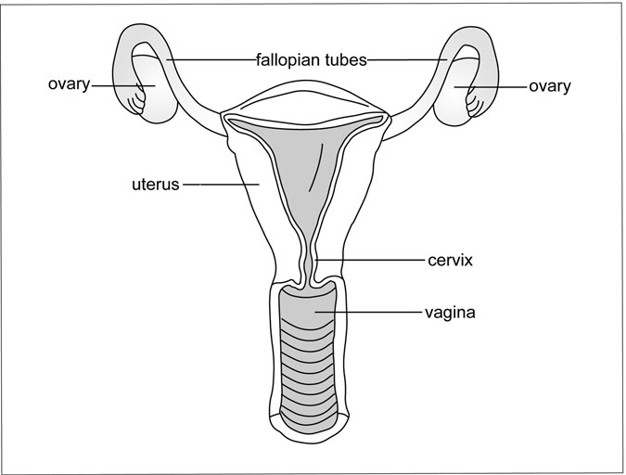

Figure 4.10 The ovaries. (Sandy Windelspecht/Ricochet Productions)

functions—producing and sustaining the eggs and sperm—the sex glands have a number of other crucial tasks. As part of the endocrine system, they produce and secrete the sex hormones, which are involved in sexual maturation, differentiation, and function, as well as metabolism and bone growth.

##### The Ovaries

The ovaries are the female reproductive organs. Inside the ovaries, the eggs, or ova, develop and are nourished until they are ready to be released into the fallopian tubes. The eggs form and develop by a process known as oogenesis. In the developing female embryo are primordial germ cells, from which the fundamental egg cells develop. These cells remain dormant until a girl reaches puberty, then develop into the mature eggs,

which are released one at a time in a process known as ovulation. Like the adrenal gland, each ovary is constructed of an outer cortex and an inner medulla. The cortex contains tiny sacs called follicles. Ovarian follicles consist of two types of cells: theca and granulosa. Nestled inside each follicle is an immature egg, surrounded by a layer of granulosa cells. A woman is born with every egg (about a million of them) that she will ever possess. Once these eggs are used up, she will no longer be able to conceive.

The ovarian follicles normally remain in an inactive state. These so- called primordial follicles lie in wait for hormonal stimulation that will help them mature and prepare them for possible fertilization. During each menstrual cycle, follicle-stimulating hormone (FSH) from the pituitary stimulates a few of these eggs. Typically, only one egg completes the ovu- lation process.

##### Follicular Phase

During this phase, which lasts 10–16 days, gonadotropin-releasing hor- mone (GnRH) from the hypothalamus triggers the release of follicle- stimulating hormone (FSH) and luteinizing hormone (LH) from the ante- rior pituitary. FSH and estrogen stimulate the development of between 6 and 12 primary follicles. LH causes the follicles to produce estrogen. Between days 5 and 7 of the cycle, one of the follicles ripens (in the case of a multiple pregnancy, more than one follicle has ripened) and becomes ready for ovulation. As the dominant follicle develops, estrogen levels rise, inhibiting FSH secretion. Without FSH stimulation, the other follicles begin to wither away.

##### Ovulatory Phase

At the end of the follicular cycle, estrogen levels peak. Estrogen normally suppresses gonadotropin production, but in this case, rising estrogen lev- els trigger a surge in LH and FSH (usually around day 13 of the cycle). The hormonal surge lasts between 24 and 36 hours, at the end of which the dominant follicle ruptures and releases its egg from the ovary. This is called ovulation.

##### Luteal Phase

Following ovulation, the erupted follicle transforms into a body called the corpus luteum. The corpus luteum begins to secrete estrogen and proges- terone under the inﬂuence of luteinizing hormone from the pituitary. Estrogen and progesterone prepare the uterus for implantation and are necessary to maintain a pregnancy. If the egg is fertilized, the corpus luteum remains intact and continues to secrete estrogen and progesterone throughout the ﬁrst trimester of pregnancy. The luteal phase lasts for about 14 days.

##### Menstrual Phase

If the egg is not fertilized, production of progesterone and estrogen in the corpus luteum diminishes. The uterine lining, which has become rich with blood vessels to nourish the growing embryo, is no longer needed. Small arteries in the lining constrict, cutting off oxygen and nutrients. The cells die and slough off (known as menstruation). The corpus luteum undergoes a process known as luteolysis. It degenerates, becomes unable to produce hormones, and is ﬁnally replaced by scar tissue. As steroid production by the corpus luteum decreases, FSH secretion increases, stimulating the development of new follicles and initiating a new menstrual cycle. Men- struation lasts for four to ﬁve days.

In addition to providing a site for egg development, the ovaries pro- duce several steroid and peptide hormones. Steroid hormones (estrogens, progesterone, and androgens) are produced in the follicular cells. Like all steroid hormones, they are produced from cholesterol, which is both present in the ovaries and transported to the ovaries in the form of low- density lipoproteins (LDLs). Peptide hormones (relaxin, inhibin, oxyto- cin, and vasopressin) are produced in the follicular cells and within the corpus luteum.

##### Estrogen

The primary female sex hormones produced in the ovaries, estrogens play a role in the development of sexual characteristics and help regulate the reproductive cycle. The three estrogens—estradiol, estriol, and estrone— are produced in the thecal and granulosa cells in the developing follicles.

Estradiol is the most powerful—and most plentiful—of the three estro- gens. It is made from the androgens testosterone and androstenedione, which are produced in the thecal cells under the inﬂuence of luteinizing hormone. In the granulosa cells, follicle-stimulating hormone helps con- vert these androgens into estradiol (and estrone). At the onset of puberty, estradiol inﬂuences maturation of the reproductive organs (uterus, fallo- pian tubes, cervix, and vagina) and redistributes fat to the hips, buttocks, thighs, and breasts to produce a more feminine, curvy shape.

Estradiol also inﬂuences the menstrual cycle by stimulating and inhib- iting the release of LH and FSH. Normally, estradiol acts upon the hypo- thalamus to inhibit GnRH secretion, which prevents the release of LH from the anterior pituitary. But at the end of the follicular phase of the menstrual cycle, rising estradiol concentrations trigger the surge of LH that initiates ovulation.

Most of the estriol in a woman’s body is produced not in her ovaries but in her liver, where it is converted from estrone and (by a more indirect route) estradiol. This relatively weak hormone may actually act as a par- tial agonist–partial antagonist by blocking receptors that would otherwise be occupied by the stronger estrogen, estradiol. During pregnancy, estriol is secreted in large quantities by the placenta. Doctors test a mother’s urine for this hormone to assess the viability of her pregnancy.

Estrone, the weakest of the three estrogens, is primarily converted from estradiol or androstenedione (from the adrenal cortex). It is similar in func- tion, although not as potent, as estradiol. Following menopause, estrone pro- duction increases due to increased conversion of androstenedione.

When the estrogens are secreted into the bloodstream, they travel bound to proteins—mainly albumin and sex hormone-binding globulin (SHBG). Once they arrive at their target cells, estrogens bind to an intra- cellular protein, which carries them to the nucleus. There, they inﬂuence protein synthesis.

##### Progestins

Progestins are primarily designed to maintain and support a pregnancy. Synthetic versions can also prevent a pregnancy. The most signiﬁcant pro- gestin is progesterone. It is produced by the corpus luteum after the egg

has been released from the follicle. If the egg is fertilized, the corpus luteum continues to produce progesterone for the ﬁrst trimester of preg- nancy until the placenta takes over production. Progesterone prepares the mother’s body for pregnancy by thickening the uterine lining to nourish the growing embryo. It then maintains the viability of the pregnancy by stopping additional follicles from becoming mature and by preventing uterine contractions.

Progesterone travels through the blood bound to corticosteroid- binding globulin (CBG) and albumin. Its other actions are to stimulate breast growth and development (along with estrogen); inﬂuence carbohy- drate, protein, and fat metabolism; and decrease the body’s responsiveness to insulin (as sometimes occurs during pregnancy).

##### The Testes

The testes, like the female ovaries, serve both reproductive and endocrine functions (Figure 4.11). They are made up of a network of tubules

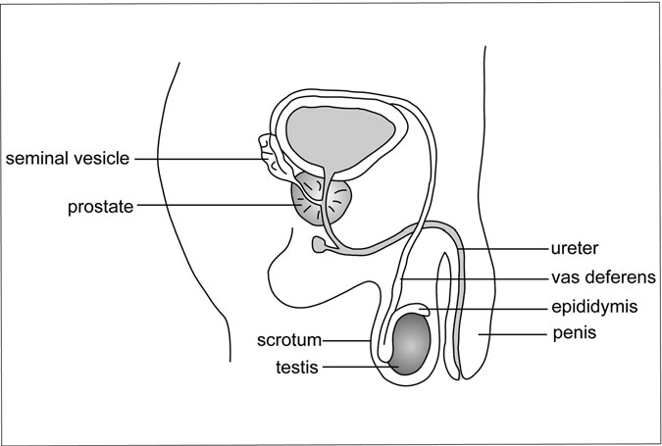

Figure 4.11 The testes. (Sandy Windelspecht/Ricochet Productions)

(seminiferous tubules) that produce and carry sperm, interspersed with cells in which androgens (male hormones) are produced. The testes con- tain two types of cells:

*Sertoli cells*: These cells, which line the seminiferous tubules, surround and nourish the germ cells from which sperm develop, and they facilitate the journey of sperm out of the testes. Sertoli cells also produce androgen-binding protein, which maintains high levels of androgens in the testes and seminal fluids, as well as many peptides (inhibin, activin, and follistatin) that regulate testicular function.

*Leydig cells*: In between the seminiferous tubules are the cells in which testosterone, the primary androgen, is produced.

*Sperm Production*

Production of sperm in the Sertoli cells depends upon stimulation by follicle-stimulating hormone (FSH) from the anterior pituitary and by testosterone. When FSH binds to androgen receptors on Sertoli cells, it stimulates the production of androgen-binding protein. This protein keeps levels of testosterone in the seminiferous tubules high. FSH stimulates sperm production and maturation. As androgen levels rise, Sertoli cells begin to secrete inhibin, which inhibits FSH release from the pituitary.

##### Testicular Hormones

The testes produce a number of hormones, including testosterone, dihydrotestosterone, androstenedione, and estradiol. Testosterone is by far the most plentiful, and most important, of these hormones.

Like other steroid hormones, testosterone is synthesized from choles- terol. Its release is initiated by gonadotropin-releasing hormone (GnRH) from the hypothalamus, which stimulates the release of luteinizing hor- mone (LH) from the pituitary. LH stimulates the Leydig cells to produce and secrete testosterone. In a classic negative-feedback loop, elevated tes- tosterone levels in the blood inhibit secretion of LH by acting on the hypo- thalamus and the anterior pituitary, both of which contain androgen receptors.

Testosterone travels through the blood bound to carrier proteins— typically either sex hormone–binding globulin (SHBG) or albumin. When it reaches its target cell, it binds to the androgen receptor.

#### Summary

The human body must have certain communications in place that coordi- nate the function of all of its organs, muscles, nerves, and tissues. There are actually two communication centers in the human body—the nervous system and the endocrine system. While the nervous system communi- cates through electrical impulses traveling throughout the body as part of a nerve network, the endocrine system communicates through chemicals called hormones, which travel through the bloodstream. In fact, hormones actually control how the nervous system behaves through stimulation or inhibition. Hormones are secreted through the glands of the endocrine system. The glands are the hypothalamus, pituitary, thyroid, parathyroids, adrenal, pancreas, and sex glands.

# 5

### The Integumentary System

*Julie McDowell*

Interesting Facts

* The entire body is covered with skin. This surface area is between

1.5 m2 and 2 m2.

* Skin makes up approximately 7 percent of the body’s weight. It weighs approximately 4 kg.
* It’s estimated that approximately 70 percent of household dust is made up of shed human skin.
* Between 30,000 and 40,000 dead skin cells drop off the body every minute.
* Nails grow an average of two centimeters every year, and ﬁngernails grow almost four times as fast as toenails.
* There are approximately 10,000 hairs on a human head, with each hair growing a rate of ﬁve inches a year.
* Human hair is virtually impossible to destroy; it is resistant to extreme cold and heat (except for burning), water, and many types of acids and chemicals.
* Over the course of a lifetime, each human will shed an average of 40 pounds of skin.

207

* On average, each person loses between 80 and 100 hairs every day.
* Each human scalp has an average of 100,000 hairs.

Chapter Highlights

* Skin: epidermis, dermis
* Skin’s accessory organs: hair and hair follicles, nail follicles

#### Words to Watch For

Blister Callus Cerumne

Ceruminous glands Collagen

Elastin Encapsulated nerve

endings

Eponychium

Free nerve endings

Hair Hair root

Hair shaft Hyponchium Keratin Langerhans cells Lunula

Melanin Melanoctyes Papillary layer

Phagocytize Pore Sebaceous duct

Sebaceous glands Skin

Skin grafts Stratum corneum Stratum

germinativum

Sweat glands

#### Introduction

The integumentary system is made up of skin and the subcutaneous tissue, which is located right below the skin’s surface (Figure 5.1). This system also includes the skin’s two accessory structures, the hair and sweat glands, as well as glands and sensory receptors. Because it covers the entire surface of the body, it is an important protector of the body by keeping out substances that could be harmful. In fact, the skin is actually the body’s largest organ, and has many important roles, including helping to regulate the body’s temperature. (For more details on some of the jobs that the skin and subcutaneous tissue performs for the body, see Sidebar 5.1. Some of the jobs will be discussed in more detail throughout this chapter, as well as this encyclopedia.)

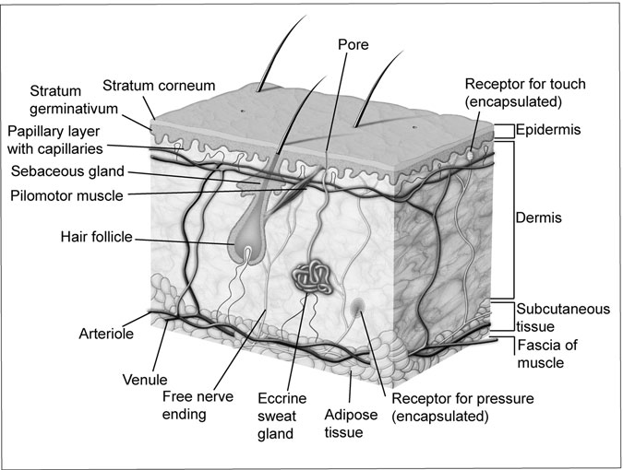

Figure 5.1 The Body’s Skin Structure. The body’s subcutaneous tissue. (Andreus/Dreamstime.com)

#### Skin

##### Epidermis

The skin has two primary layers: the epidermis (outer) and the dermis (inner). The epidermis has two important sublayers—the stratum germi- nativum and the stratum corneum. The epidermis is made up of cells called keratinocytes; these cells make up the epithelial tissue.

It is in the epidermis layer where blisters and calluses can form. Blisters occur when friction—such as what might develop between the skin and the inside of a shoe—causes layers to separate within the epidermis or between the epidermis and the dermis. As these layers separate, tissue ﬂuid may build up, leading to a blister. While blisters often result because of fric- tion, calluses result from pressure. When exposed to increased amount of pressure, mitosis will occur at a rapid rate, causing the epidermis to thicken.

SIDEBAR 5.1

#### Skin: The Body’s Best Protector, and More

In addition to protecting the body from dangers related to the environ- ment, the skin also has a number of other important jobs:

* *Regulating Body Temperature*: The blood vessels in the dermis layer of the skin widen (vasodilate) and narrow (vasoconstric), allowing the production of sweat that cools the body.
* *Sensing Pain*: There is a thick collection of nerve endings located in the dermis that is sensitive to pain as well as pressure. These nerves communicate with the brain through the nervous system, informing the brain when danger is imminent, such as in the form of a hot surface (heat).
* *Losing Too Much Water*: Within the dermis layer, glands secrete a substance known as sebum. This spreads across the skin, enabling it to become waterproof. The dermis also has collagen ﬁbers that soak up water.
* *UV Protection*: The skin produces a pigment called melanin, which ﬁlters the sun’s dangerous ultraviolet (UV) radiation.
* *Manufacture of Vitamin D*: Produced by the skin as a result of exposure to sunlight, vitamin D plays an important role in regulating how the body metabolizes calcium.

Calluses can occur anywhere on the skin, although they are most often found on the palms of the hands and soles of the feet.

Of the two epidermal sublayers, the innermost layer is the stratum germinativum. This is the surface where mitosis occurs, meaning that new cells are always being produced while older cells are forced to the skin’s surface. These new cells are producing a protein called keratin. As the older cells are pushed farther away from the dermis, they eventually die. These dead skin cells eventually make their way to the outer sublayer, the stratum corneum.

While the cells are dead by the time they get to the outer layer of the skin, they do still contain keratin. This protein is important to the skin— it is waterproof, prevents evaporation of water inside the body, and pre- vents water from entering the body through the skin. If the body did not have a waterproof statum corneum layer, we would not be able to take a bath or shower, or even swim without risking serious damage to our bodies. In addition to its waterprooﬁng functions, the stratum corneum also protects the body from dangerous substances such as pathogens, like bac- teria, and chemicals that could be dangerous. Of course, if skin is broken, then some of these substances can enter the body, which could lead to an infection. The body is even more vulnerable if it is burned, especially if the burn is so bad that the stratum corneum is destroyed (see Sidebar 5.2

for more information on the impact that burns can have on the body).

The epidermis also contains two types of cells that are important pro- tectors: the Langerhans cells and the melanoctyes.

Langerhans cells originate in the bone marrow and are known for their ability to travel fast within the body. They need to be mobile, because they are an important part of the body’s immunity response. When a bacteria or other foreign substance enters the body through broken skin, the Langerhans cells ingest or phagocytize the pathogen, and then deliver it to the lymph nodes. There, a type of white blood cell called a lymphocyte prompts the start of the body’s immune response and antibodies are produced to neutralize any danger presented to the body by the pathogen. (For more detail on the body’s immune response, see Chapter 6 on the lymphatic system.)

The second type of important cell in the epidermis, the melanocytes, produces a kind of protein called melanin (also known as pigment) that plays an important role in skin color. Skin color is genetic or hereditary, and is determined by how fast and how much melanin is produced by the body’s melanocytes. In dark-skinned people, their bodies are con- stantly producing a large amount of melanocytes, while light-skinned peo- ple’s bodies produce much less of this protein. But regardless of one’s skin color, exposure to the sun’s ultraviolet (UV) rays causes melanin produc- tion to ramp up. Change in a skin’s color—sunburn or tanning—is the result of excess melanin making its way from the epidermal cells to the skin’s surface. Another result of prolonged sun exposure is freckles, which

SIDEBAR 5.2

#### Burns

The skin can be burned by sources of heat, such as ﬁre, steam, hot water, or sunlight. But it can also be burned by electricity or certain chemicals that are corrosive. Burn injuries can be minor or fatal. They are classiﬁed in three categories, according to the resulting damage:

* *First-degree Burns*: While a ﬁrst-degree burn can be painful (think of a bad sunburn), it is minor because only the superﬁcial or outermost layer of the epidermis is affected. First-degree burns do not result in blisters on the skin’s surface. The skin will appear red, indicating an inﬂammatory response. The inﬂammation means that vasodilation is occurring, bringing additional blood to the burn site.
* *Second-degree Burns*: Blisters occur as a result of second-degree burns, which affected the deeper layers of the epidermis. In a second-degree burn, the inﬂammation prompts the release of histamine, causing the blood capillaries to release plasma. This plasma then becomes tissue ﬂuid, which form into blisters as it collects on the skin’s surface.
* *Third-degree Burns*: These burns destroy the entire epidermis, including its outermost layer, the stratum corneum, that is a barrier from pathogens and other dangerous chemicals from entering the body. Ironically, because the epidermis is gone, so are the pain receptors, so victims of these burns often do not initially feel much pain. But because the protection of the stratum corneum is lost, the victims are at serious risk of developing infections, as well as dehydration, because the skin is not there to keep the water in the body.

represent concentrated areas of cells that produce melanin. The darkening of the skin actually protects the stratum germinativum from overexposure to UV rays. As a result, dark-skinned people have some natural defense against the sun’s harmful effects, such as skin cancer, as opposed to light-skinned people.

##### Dermis

As mentioned earlier in this chapter, the epidermis is the skin’s outer layer, while the dermis is the inner layer. While the epidermis is an impor- tant protector of the body from dangers of the outside environment, the dermis is notable for its strength and ﬂexibility. The tissue of the dermis is ﬁbrous. It is made of two ﬁbers: collagen and elastin. The collagen ﬁbers are strong, while the elastin ﬁbers are ﬂexible and can return to their original shape after being stretched. But this elasticity does not last for- ever. With age, the elastin ﬁbers break down, meaning that this elasticity undergoes deterioration, which results in wrinkles.

Located between the epidermis and the dermis is a layer called the papillary layer, which contains a large population of capillaries. Since there are no capillaries in the epidermis, the papillary layer is the epider- mis’ only access to oxygen and nutrients from the body’s blood supply. These capillaries also provide oxygen and other nutrients to the dermis.

Before describing the accessory organs of the skin, such as hair follicles and nails, it is important to understand the skin’s ability to repair itself. If the skin is cut—whether from an injury or surgical incision—it will automati- cally grow back together, even without stitches. What is really happening, however, is new skin is formed or regenerated. At the site of the cut, the skin cells located right next to the wound site enlarge, while the cells surrounding the wound multiply at a rapid pace to replace cells that have been destroyed. Healing begins as all of these cells eventually converge and epithelial cells continue production. Eventually, skin will be replaced at its original thickness. This repair process also allows skin grafts—or transplanting of the skin—to be successful. Skin grafts are often necessary when a person has third-degree burns, because the skin is so damaged that it cannot regenerate. The skin to be transplanted is typically taken from a ﬂeshy place on the body, such as the thighs or buttocks. Once this transplanted skin is applied to the wound, the cell regeneration process hopefully will

occur, helping to cover the wound.

##### The Skin’s Accessory Organs

Located in the dermis are the skin’s accessory organs. These include the hair and nail follicles, sensory receptors, and various glands.

Hair and Hair Follicles

Hair follicles are composed of epidermal tissue, but their base is the hair root (Figure 5.2). It is at the hair root where mitosis occurs, and these new cells produce keratin. Melanin is involved because it determines the hair color. But these cells quickly die, and then become part of the hair shaft. The end of the hair follicle is called a bulb. In this bulb is located a supply of capillaries that feed the needs of the growing hair shaft. Hair type is also determined by the shape of this hair shaft. If the cross section of the shaft is round, the hair is curly, and the rounder the shaft, the curlier the hair.

Along with the hair root, the follicle also contains certain glands and nerve endings, as well as muscle. When hair follicles are located on the skin’s surface, such as on the scalp, they are adjacent to oil or sebaceous glands. These glands produce an oily liquid called sebum that travels through the hair shaft to the body’s surface. Sebum is important because it moisturizes the skin to keep it from drying out. It also is composed of bacteria-ﬁghting substances that protect the follicles from infection. Sebum travels to the hair shaft by draining through a sebaceous duct in the hair follicle. The volume of sebum that the sebaceous duct produces depends not only on the actual size of the duct, but also the amount of hormones circulating, particularly the male sex hormones called androgens. The larg- est sebaceous ducts are located on the head, neck, and front and back of the chest. (For information on one of the most common skin disorders of the sebaceous glands, acne, read Sidebar 5.4 at the end of this chapter).

In addition to the sebaceous glands, nerve endings are located around the hair follicle’s bulb. These nerves are affected by any movement near the hair shaft, meaning that if there is any pressure on or around the hair shaft (such as pulling of the hair), then these nerve endings will send signals to the brain. One example is when there is a bee or other insect ﬂying on or around the hair on the top of the head. The nerve endings in the hair shaft will let the brain know that this insect is near, causing the person to swat it away, before it lands on the head and possibly plants its stinger, in the case of a bee.

As noted earlier, there are also muscles in the hair follicle. This muscle is called the arrector pili, which means “raiser of the hair” and is attached to the follicle. The contraction of the arrector pili forces the hair to move

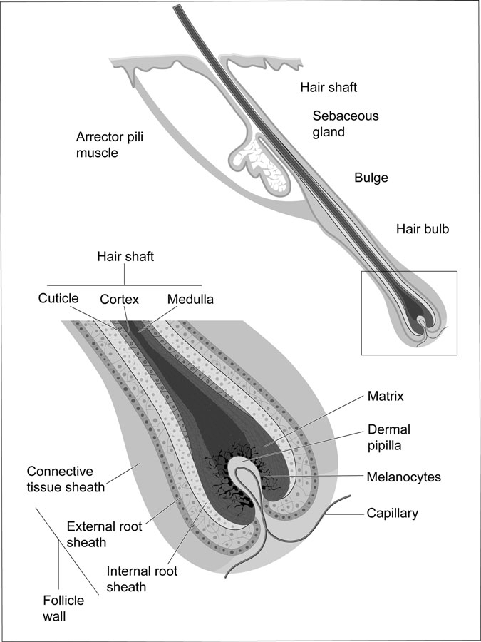

Figure 5.2 The Hair Follicle. Each hair root sits in a follicle, which is located about 4 or 5 mm below the skin surface. The sebaceous glands produce oil that lubricates the hair. (Legger/Dreamstime.com)

from its normal position—which is angled—and become vertically erect. In humans, the contraction of a signiﬁcant number of these muscles occurs during times when the body is chilled or a person is afraid. It is also known as “goose pimples.” This feature is an important source of protection for mammals with a lot of fur, because it allows them to insulate themselves by trapping air within their fur.

While hair is not as important to humans in comparison to other mam- mals, it does serve certain functions. It insulates the head and, as mentioned earlier, has nerves that sense when small objects or insects are close to the head.

There are millions of hair strands covering the body, but the most concentrated amounts of hair are on the head, surrounding the external genitalia, and under the armpits. The hair on our head—as well as our eyelashes and eyebrows—is actually these dead cells. Each strand con- tains the protein keratin, which is produced in the dermis. However, the actual strand is produced by a process called “inpouching,” which occurs in the epidermis.

There are three layers to each hair strand: the medulla, cortex, and cuticle. The medulla is the central core, while the central cortex is the next layer. The cortex is made up of layers of ﬂattened cells containing melanin that determines hair color. The outermost layer is the cuticle, which is made up of one layer of overlapping cells. This layer tends to break away at the end of hair strands, causing what is known as “split ends.” (For infor- mation on hair thinning and loss, please see Sidebar 5.3.)

Nail Follicles

The primary function of nails is to protect the ﬁngers and toes, and make it easier for the ﬁngers to pick up small objects (Figure 5.3). While the nails themselves do not have nerves, they are rooted in the nail bed, which does have nerves.

Nail and hair follicles are similar in that mitosis takes place in both of these areas. For nails, this mitosis takes place in the nail root. These new cells also produce the protein keratin—similar to new hair cells. However, the keratin is stronger in nails. Once these cells produce keratin, they die. These dead cells make up the nail body; however, the nail bed underneath is a living tissue. The nail bed is under the entire nail.

SIDEBAR 5.3

#### Thinning and Baldness: Follicles Slow Down as They Age

Hair follicles slow down their growth around the age of 40; therefore, hair production also slows down. This means that hair is not quickly replaced when it naturally falls out, leading to thinning and some patches of baldness. Baldness, also known as male-pattern baldness, is caused by certain conditions, which include aging. Scientists are not exactly sure what causes baldness, but heredity and androgen (male sex hormone) levels appear to play a role, as well as certain medical conditions. There is evidence that baldness is linked to a gene that begins behaving in a way that changes

how the hair follicle responds to circulating hormones.

In addition to the root and the nail bed, there are six other important parts of the nail anatomy:

* *Body*: the main part of the nail, also known as the nail plate
* *Free edge*: the portion of the nail that extends beyond the ﬁngertip

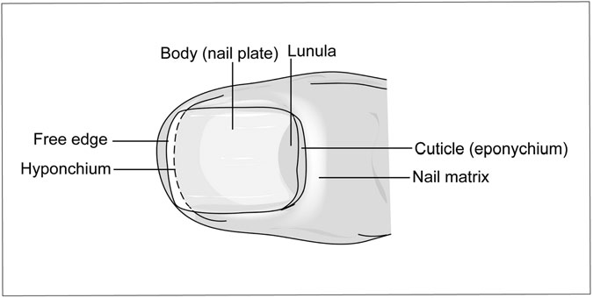

Figure 5.3 Anatomy of a ﬁngernail. (Legger/Dreamstime.com)

* *Eponychium*: Also known as the cuticle, this is a row of dead skin located between the nail plate and the matrix
* *Lunula*: Located right above (and sometimes covered by) the cuticle, this is the crescent shaped, opaque area at the base of the nail plate
* *Hyponchium*: This is the portion of skin located right below the free edge of the nail; this area has an abundant supply of nerve cells, which means it is sensitive to pressure, heat, and other potential sources of pain

Sensory Receptors

This chapter has already included some discussion on the sensory recep- tors in the integumentary system, particularly in the hair root and nail bed, as well as the skin.

It is important to note that in the skin’s dermis layer, there are sensory receptors for the cutaneous senses, including touch, pressure, pain, and temperatures, including cold and heat. Receptors are speciﬁc to the senses that they detect, based on their structure. Sensory receptors for pain are called free nerve endings, while receptors for the other senses are called encapsulated nerve endings. These encapsulated nerve endings are sur- rounded by a sensory nerve ending.

These receptors communicate with the nervous system about any impact or changes that the environment is having on the skin and its sensory organs. Areas with a high concentration of receptors are the most sensitive. For example, ﬁngertips have a large amount of these receptors in a small area, especially compared to the upper portion of the arm, where the receptors are more spread out. This means that the ﬁngertip will be more sensitive.

Because these receptors detect changes and communicate with the brain, they work closely with the nervous system, which is the focus of Chapter 8.

Glands

In addition to sebaceous glands, which were discussed earlier in this chap- ter, there are some other important glands in the integumentary system: ceruminous and sweat glands.

SIDEBAR 5.4

#### Acne

Acne is one of the most common skin disorders, and is related to hor- mone and other substances plugging the skin’s sebaceous glands—also know as oil glands—as well as hair follicles. The plugging of the pores can cause outbreaks of lesions called pimples or “zits.” Typically, lesions develop on the face, neck, back, chest, and shoulder.

Medical experts do not routinely describe acne as a disease related to lesions as pimples or zits, but rather as a disease of the pilosebaceous units (PSUs). These PSUs are made up of a sebaceous gland connected to a follicle. While PSUs are found all over the body, they are most populous on the face, upper back, and chest. These glands produce an oily substance known as sebum. This substance typically makes its way to the skin’s surface through the follicle’s opening, called a pore. Lining the follicle are cells called keratinocytes.

Acne occurs when the sebum, hair, and keratinocytes that occupy the narrow follicle form a plug in the pore, which prevents the sebum from being released to the surface of the skin through the follicle. When the oil from the sebum mixes with the keratinocyte cells, it causes the formation of bacteria known as *Propionibacterium acnes* (*P. acnes*). These bacteria produce various chemicals and also attract white blood cells that cause inﬂammation. Eventually, the wall of the plugged pore will break down. When this happens, the sebum and bacteria spill on to the surface of the skin, which causes pimples to form.

There are a number of different kinds of pimples or lesions. The basic and most common is called the comedo. This lesion is a plugged hair follicle that is often inﬂamed. If it stays beneath the skin, a white bump often appears that is called a whitehead. If the comedo reaches the surface of the skin, it is called a blackhead, referring to its appearance on the skin’s surface. This black appearance is often thought to be because of dirt, but because of changes in the sebum when it is exposed to air.

Some other acne lesions the following:

* *Papules*: These lesions are inﬂamed pink bumps that are tender.
* *Pustules*: Also called pimples, these lesions contain a head of white or yellow pus and an inﬂamed base.
* *Nodules*: These are large and solid lesions rooted deep in the skin and painful to the touch.
* *Cysts*: These lesions are also deep-rotted, and ﬁlled with pus. Cysts can often cause scarring.

Ceruminous glands are type of sebaceous gland found in the dermis layer of the ear canal. These glands produce a secretion called cerumen, more commonly known as ear wax. While cerumen helps to moisturize the eardrum’s outer surface, it can impact the hearing if it builds up and becomes impacted in the ear canal. This impacting can inhibit the ear- drum’s ability to vibrate and function properly.

There are two types of sweat glands in the body: apocrine and eccrine. The apocine glands respond primarily during times of stress and heightened emotion. They are primarily found in the underarm or axillae areas, as well as the genital areas.

The eccrine glands are located all over the body, particularly in the forehead, upper lip, palms, and soles of the feet. These glands secrete through a duct that is in the form of a coiled tube, located in the dermis. This duct connects to a pore on the skin’s surface.

The eccrine gland and the sweat it produces are important in main- taining the body’s temperature. When the body temperature rises, such as during exercise or when in warm temperatures, sweat production is increased, and sweat makes its way to the skin surface. The sweat then evaporates, ridding the body of excess heat. However, this can be dangerous if too much heat is lost. Excess loss of body water through sweat can lead to dehydration, which is a form of heat exhaustion. This is why medical experts recommend that people increase their ﬂuid intake during periods of intense heat and exercise.

#### Summary

This chapter explored the integumentary system, which is composed of the skin and its accessory organs, which include hair and nail follicles as well as glands and sensory receptors. One of the skin’s most important

roles is to protect the body from harmful substances, as well as detect changes in the body through sensory receptors. The two layers of the skin are the epidermis (outer) and the dermis (inner). There are two types of glands, the ceruminous glands, which are related to the skin surrounding the ear, and the sweat glands. Sweat glands play an important role in keep the body at a normal temperature.

*This page intentionally left blank*

6

The Lymphatic System

*Julie McDowell and Michael Windelspecht*

Interesting Facts

* The lymphatic system returns about 3.17 quarts (3 liters) of ﬂuid each day from the tissues to the circulatory system.
* The average macrophage can engulf 100 bacteria a second.
* A plasma cell (B cell) can produce over 2,000 antibodies per second.
* The thymus gland, the site of T cell maturation, reaches its maximum size when a person is age 12, then decreases in size with age.
* A cubic millimeter of blood can contain up to 10,000 leukocytes, of which up to 70 percent are neutrophils and 25 percent lymphocytes.
* In patients with leukemia, the total white blood cell content per 0.03 ounces (1 cubic millimeter) of blood may reach over 500,000.
* Vaccinations against smallpox have been in use since the time of the ancient Chinese civilizations.

#### Chapter Highlights

* Lymphatic system’s cells and chemicals
* Lymphatic ﬂuid

223

* Lymphocytes
* White blood cells
* Cellular signals and markers in the lymphatic system
* Lymph nodes and circulation
* Lymph vessels
* Bone marrow and thymus
* Spleen, tonsils, adenoids, Peyer’s patch, and appendix
* Immune response
* Genetic and acquired immunity
* Vaccines

#### Words to Watch For

ABO group Acquired immunity Afferent vessels Agglutination Alleles

Anemia Appendectomy Appendicitis Autoimmune disease Biomolecules

Bone marrow Chemotaxis Complement fixation Cytokine

Efferent vessels Erythropoietin

Extrinsic factor Genetic immunity Glycoproteins Hemolysis Hydrophilic Hydrophobic Hypoxia Immunity Immunoglobulins Intrinsic factor Lipoproteins Lymph

Lysozyme Malignant Medullary cords Monocytes

Neutrophils Normoblast Opsonization Osmosis Phagocytic cells Plasma

Protease Reticulocyte Rh factor Tonsils Toxoid Triglycerides Vasodilation Virus

#### Introduction

The natural world is an exceptionally hostile place, with pathogenic and parasitic organisms waiting to exploit any weakness in an organism. Fungi, bacteria, parasitic worms, protistans, and viruses abound in the natural world. The concept of survival of the ﬁttest extends from the lowest life forms to the complex environments of primates. In order to survive, all organisms must possess some mechanism of combating invaders. Humans are no exception to this rule. They are in a biological arms race with the microscopic world. Luckily, humankind possesses one of the most elabo- rate defensive systems on the planet—the lymphatic system.

The primary task of defending the approximately 100 trillion cells of the body against this onslaught of invaders rests with the lymphatic sys- tem. While other systems do provide some protection, such as the acids of the stomach and the structure of the skin, it is the job of the lymphatic system to initiate an immune response against invading pathogens. The lymphatic system is the system of the body that is responsible for the immune response. This tiered system of defense utilizes physical barriers, such as the skin, and general defense mechanisms, such as the white blood cells. But perhaps the most signiﬁcant weapon in its arsenal is the speciﬁc defense system. In this aspect of the immune response, specialized cells called lymphocytes detect speciﬁc invaders (such as fungi, bacteria, and viruses) and eliminate them from the body. This response can be directed against both free pathogens in the body or against cells that have become infected. As an added protection, the speciﬁc response has the ability to “remember” an infection, practically ensuring that you will never be infected by the same organism or virus twice.

The lymphatic system does have other roles in the body. First, it acts as a second circulatory system. The lymphatic system is responsible for returning the ﬂuid from the tissues of the body, called interstitial ﬂuid, to the circulatory system. In this regard, the lymphatic system helps regulate water balance, ensuring not only that the tissues have proper ﬂuids, but that excess ﬂuids do not accumulate in the extremities. The second—often overlooked—role is that of a transport system. The lymphatic system moves fat-soluble nutrients from the digestive system to the circulatory system using a special class of molecules called the lipoproteins.

Unlike other body systems, such as the digestive system and endo- crine system, the lymphatic system does not have a large number of organs dedicated to the role of immune response. While there are some, such as the thymus and spleen, the majority of the lymphatic system con- sists of small ducts, minor glands, and specialized cells located in other body systems, which will be discussed in this chapter.

#### The Chemicals and Cells of the Lymphatic System

The lymphatic system is a complex group of cells, tissues, and organs that are widely dispersed throughout the human body (Figure 6.1). The lymphatic system has three primary functions. First, its cells are primarily

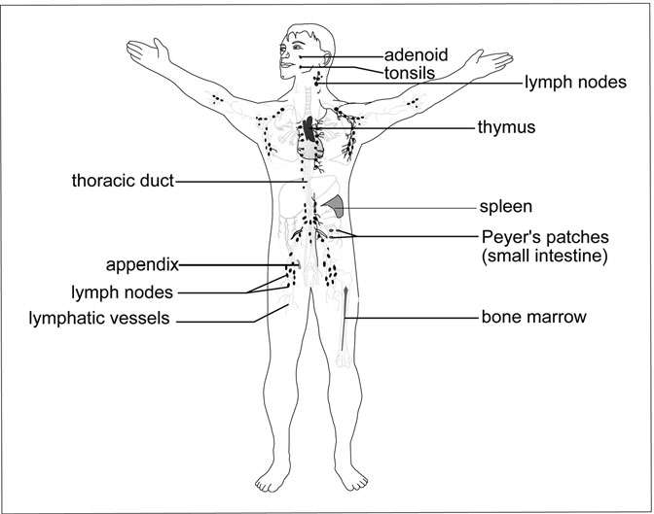

Figure 6.1 Location of the Lymphatic System Organs. In many cases, the organs of the lymphatic system have dual roles in the body. (Sandy Windelspecht/Ricochet Productions)

responsible for the immune response of the body. For this reason, the lym- phatic system is frequently called the immune system. Most people are familiar with the immune system as it provides resistance to disease. Modern diseases such as acquired immunodeﬁciency syndrome (AIDS) and sudden acute respiratory syndrome (SARS) greatly challenge the capa- bilities of our immune system. Second, the vessels of the lymphatic system actually represent a separate circulatory system in the human body. Unlike the cardiovascular circulatory system, the lymphatic system does not directly supply nutrients or oxygen to the tissues of the body, but rather is primarily involved in the return of ﬂuids from the tissues. Finally, the lym- phatic system is involved in the transport of select nutrients from the diges- tive system to the circulatory system.

These initial sections of this chapter provide an overview of the mole- cules, cellular components, and chemical signals of the lymphatic system. It focuses primarily on those aspects that are associated with the immune response, although some transport molecules are also discussed. The inter- action of these cells, signals, and molecules to create an immune response will be covered later in the chapter.

##### Subcellular Components of the Lymphatic System

Complement Proteins

As the name suggests, these proteins complement or assist in the function of the immune response. These are nonspeciﬁc components of the lymphatic system, meaning that they do not recognize speciﬁc types of pathogens entering the body, but instead target any form of invading bacteria or fungus. From an evolutionary perspective, complement proteins probably represent the simplest and oldest form of immune system. Forms of complement proteins are found in all animals. There are approximately 20 different types of complement proteins in humans; collectively, they are called the comple- ment system. Complement proteins move throughout the circulatory system in an inactive form, commonly called a zymogen. The mechanism by which they are activated is dependent upon the class of the complement protein. Although complement proteins are found in the circulatory system, they are considered to be part of the lymphatic system due to their association with the immune response.

The complement proteins may either target invading fungal and bacte- rial cells directly, or they may be recruited by antibodies or other cells of the immune system. The proteins have a variety of functions. Some classes are involved with attacking the membrane of the invading patho- gen causing it to lyse, or break. Other classes interact with the antibodies secreted by the B lymphocytes (see the “Lymphocytes” section later in this chapter). This is often called the classical pathway, because it is the most common mechanism of complement system activation. Once acti- vated by an antibody, the complement proteins form a pore in the mem- brane of the invading cell, causing it to lyse.

Some complement proteins act as molecular ﬂags. This class sticks to the surface of the pathogen, but rather than causing the membrane to rup- ture, these proteins signal macrophages and other phagocytic cells of the immune system to envelop the invading cell and destroy it. Other classes of complement proteins are involved in the inﬂammatory response or in activating enzymes in the blood.

The complement proteins that directly lyse the membrane of the pathogen do so by what is called the alternative pathway. In this case, the inactive proteins are activated by some component of the bacterial or fungal cell wall. Once activated, the proteins congregate on the invading cell and form a pore through the membrane, disrupting the membrane barrier of the cell and causing it to lyse.

While complement proteins may appear to be an effective mechanism of immune response, they lack the ability to target speciﬁc types of cells that are invading the body. The task of targeting speciﬁc invaders falls to the cells of the immune system.

Chylomicrons and Lipoproteins

One aspect of the lymphatic system that is not involved in the immune response is the transport of fat-soluble material from the digestive tract. This includes not only triglycerides, but also the fat-soluble vitamins. These hydrophobic molecules are packaged within the small intestine into spherical structures called lipoproteins.

Lipoproteins are a combination of fats and proteins. Following enzy- matic digestion in the lumen (cavity) of the small intestine, fatty acids are

reassembled into triglycerides in the epithelial cells of the small intestine. They are then packaged into chylomicrons. Chylomicrons represent one form of lipoprotein that is manufactured within the lining of the small intes- tine. Due to their size and hydrophobic characteristics, chylomicrons cannot pass into the capillaries within the villi of the small intestine, and thus are unable to be transported to the liver in the same manner as the majority of nutrients. Instead, they enter into the lacteals of the digestive tract.

Once in the lacteals of the intestines, the chylomicrons utilize the lym- phatic system to bypass the liver and travel to the heart via the thoracic duct, where they enter into the bloodstream. At this point the vitamins and energy-rich nutrients within the chylomicron are removed by the tis- sues, and the chylomicron becomes an empty shell. The other lipopro- teins, such as low-density lipoproteins (LDLs) and high-density lipoproteins (HDLs), are manufactured by liver tissue and do not enter the lymphatic system.

Antimicrobial Proteins

The surface cells of the body, called the epithelia, are most often the ﬁrst to experience an attack by an invading organism. For this reason, many of the body’s surfaces secrete antimicrobial proteins or enzymes. An enzyme is a chemical compound (usually a protein) that accelerates a chemical reaction. Although enzymes are most often thought of in associ- ation with the digestive or nervous systems, in fact they are active in all of the systems of the body.

The surfaces of the eyes and mouth, because they are moist environ- ments and warmer areas of the body, represent an ideal location for a microbial attack. At these locations, the body secretes an enzyme called lysozyme in the saliva and tears. Lysozyme acts by degrading the cell walls of invading bacteria. Because animal cells lack cell walls, they are not disturbed by the presence of the enzyme.

This is not the only example of antimicrobial compounds in the body. Technically, the protease enzymes of the stomach may be considered a part of the immune response, because, in cooperation with the hydro- chloric acid of the stomach, they inhibit the activity of pathogenic organ- isms. In the small intestine, specialized cells called Paneth cells secrete

an antimicrobial compound called cryptidin. Even the bacteria loca- ted within the large intestine assist with patrolling against incoming pathogens. *Escherichia coli* (commonly called just *E. coli*), frequently considered to be a pathogen itself, helps protect the large intestine by secreting a chemical called colicin that prevents growth of pathogenic organisms.

These antimicrobial systems are not designed to completely prevent an attack by a pathogenic organism. Instead, like the complement pro- teins, the antimicrobial substances noted in this section act to slow the growth of an invader and give the speciﬁc defense mechanisms (lympho- cytes) time to prepare. In this regard, antimicrobial systems are very effec- tive in their mode of action.

##### Lymphatic Fluid

The ﬂuid content of the lymphatic system is actually derived from the circulatory system. In the circulatory system, the capillaries represent the location where gas and nutrient exchange is most likely to occur with the surrounding tissue. Capillaries are fragile structures, whose walls are typically only one cell thick. However, these cells, called endothelial cells, do not form a solid structure, like that of a hose. Instead, there are small pores between the cells that form the lining of the capillaries. These pores are too small to allow the cells and plasma proteins of the circulatory sys- tem to pass, but large enough to allow a free exchange of ﬂuid with the surrounding tissues. This ﬂuid represents the medium through which nutrients and gases may be exchanged. The ﬂuid, called interstitial ﬂuid, bathes most tissues of the body. Cells typically deposit waste in the inter- stitial ﬂuid for pickup by the circulatory system, and receive nutrients and gases to conduct their metabolic processes.

The majority of this ﬂuid is reabsorbed back into the capillaries. How- ever, this process is only about 85 percent effective. Each day, about 3.17 quarts (3 liters) of ﬂuid is not reabsorbed back into the capillaries, but instead remains in the tissue. This amount may not sound signiﬁcant, but in an average adult, there is only 5.28 quarts (5 liters) of blood. It would seem that the loss of ﬂuid from the capillaries would represent a severe challenge for the circulatory system, and the organism as a whole.

The lymphatic system makes up the difference by recycling the interstitial ﬂuid and returning it back to the circulatory system. In most people, the lymphatic system returns around 3.17 quarts (3 liters) of ﬂuid daily. In other words, the output of the circulatory system to the tissues is matched by the input of interstitial ﬂuid from the lymphatic system.

Lymphatic ﬂuid does not contain red blood cells, and in general lacks any pigmentation. However, despite its lack of color, there are plenty of ions, molecules, and cells in lymphatic ﬂuid. These include ions such as sodium (Na+) and potassium (K+), chylomicrons, and a host of cells asso- ciated with the immune response (see next section).

##### Cells of the Lymphatic System and Immune Response

The immune system utilizes a number of different cell types to protect the body from infection. The major classes of cells are listed in Table 6.1.

TABLE 6.1

Cells of the Immune System

*Cell class Type*

*Speciﬁc or*

*nonspeciﬁc defense General function*

Lymphocytes Natural killer (NK)

Nonspeciﬁc Targets virus- infected cells

T cells Speciﬁc Attacks antigen- presenting cells

B cells Speciﬁc Produces antibodies to attack free antigens

White blood cells Macrophages Nonspeciﬁc General phagocytic

cells

Neutrophils Nonspeciﬁc One-time-use cells that contain power- ful chemical reactions

Eosinophils Nonspeciﬁc Destroys parasitic organisms

Basophils Nonspeciﬁc Releases histamine

Mast cells Nonspeciﬁc Releases histamine

These cell types may either be generalists (nonspeciﬁc defense mecha- nisms) or specialize in the destruction of certain identiﬁed invaders of the body. Cells of this second class belong to the speciﬁc defense mechanism of the body. The lymphatic cells are derived from the same type of cell in the bone marrow as the cells of the circulatory system. The common name for this type of cell is called a stem cell. While stem cells are commonly thought of as being able to form any type of cell in the body, in reality they vary in this ability. Some stem cells, such as those in early embryonic development, are totipotent, meaning that they have the ability to form virtually any cell type. However, shortly after the embryo starts to develop, stem cells lose their potency, and thus their ability to form certain types of cells. The stem cells in the bone marrow are pluripotent cells, indicating that they are limited in what types of cells they can differentiate into.

The type of stem cell that gives rise to the immune cells, as well as the majority of cells in the circulatory system, is called a hematopoietic stem cell. From this stem cell are derived progenitor cells, which possess an additional layer of specialization. Two different types of progenitor cells are involved with the formation of lymphatic cells. The lymphocytes are derived from the lymphoid progenitor cell, while the leukocytes and macrophages are derived from the myeloid progenitor cell. The cell types also differ in where they mature in the body and their contributions to the function of the lymphatic system and immune response.

Natural Killer Cells

Natural killer (NK) cells are another example of a nonspeciﬁc defense mechanism in the body. While the complement system acts nonspeciﬁcally against invading fungal and bacterial cells, the role of the NK cells is to eliminate cells of the body that have either been invaded by viruses or are cancer cells. It is important to note the difference between NK cells and a form of T cells called the cytotoxic T cells (see the next section). While both attack viral infected cells and cancer cells, cytotoxic T cells are spe- ciﬁc in their targets, meaning that they will destroy only cells that have been infected with a speciﬁc virus. NK cells are generalists and will destroy any viral infected cell that they come in contact with. Natural killer cells are not phagocytic cells, but rather destroy the target cell by lysing the membrane.

Natural killer cells belong to a class of cells called the lymphocytes, of which the T and B cells are the most commonly recognized. NK cells are formed in the same manner as T and B cells (see the next section), but do not mature in the thymus, as is the case with the T cell.

Lymphocytes

The term lymphocyte is most commonly used to describe two groups of lymphatic cells, the B cells and T cells, although, as noted in the preceding section, the NK cells also belong to this class. Lymphocytes start as hematopoietic stem cells in the bone marrow of the long bones of the body. The hematopoietic stem cells form progenitor lymphoid cells, which then divide into the cell lines that will form the B cells, T cells, and NK cells. Unlike B and T cells, NK cells do not require additional processing and instead proceed directly into action as nonspeciﬁc defense mechanisms.

B and T lymphocytes are named for the location in the body in which they complete their maturation process. An immature T cell migrates to the thymus to ﬁnish its development; a B cell completes its maturation in the bone marrow. The “B” does not actually stand for “bone,” but rather a structure called the bursa of Fabricus. This structure is only found in birds, but is where the B cells were ﬁrst discovered. Since the B cells of all other vertebrates mature in the bone marrow, the B is commonly con- sidered to refer to “bone.” Although both B cells and T cells are lympho- cytes and are involved in the defense of the body against speciﬁc pathogens, their modes of action are very different.

T and B cells both respond to speciﬁc antigens in the human body. An antigen is a molecule that invokes an immune response. All cells and viruses have unique antigens present on their surface. What distinguishes the cells of our body from invading viruses and the cells of invading bac- teria, fungi, protistans, and parasitic worms is the presence of self- markers. In other words, if a cell cannot identify itself as a normal part of the human body, it runs the risk of initiating an immune response.

The role of the B cells is to develop antibodies against antigens that present themselves in the tissues and ﬂuids of the body. Antibodies are proteins that target the antigen and either mark it for destruction by

nonspeciﬁc mechanisms or physically destroy the molecule. (The action of antibodies will be covered in greater detail later in this chapter). Because almost anything may be an antigen (proteins, cellular debris, chemicals, etc.), it is possible for a B cell to mistakenly identify a cell of the body as an antigen. Therefore, immature B cells are screened while in the bone marrow before maturing and being sent to secondary lymphoid tissues, such as the appendix and lymph nodes. This process is often called self-tolerance, because the B cell must be able to tolerate the wide range of potentially false antigens that are produced by the cells of the body. However, sometimes this screening is not completely effective, resulting in an autoimmune disease.

Each B cell of the body will recognize—and produce antibodies against— one speciﬁc antigen. Antibodies are proteins, and are manufac- tured in the same manner as other proteins in the body. The instructions for producing the antibody are stored as genes in the deoxyribonucleic acid (DNA). When needed, these genetic instructions are transcribed into a message (called messenger ribonucleic acid, or mRNA), which proceeds to the cytoplasm of the cell to be translated into a functional protein.

All antibodies have a characteristic structure (Figure 6.2). Each anti- body contains two light chains and two heavy chains. They are called the light and heavy chains based upon the number of amino acids in the peptides that make up their structure. The chains are held together by disulﬁde bonds, forming a “Y”-shaped molecule. There is very little variation in the constant regions (or C regions) of the heavy chains in the antibody.

In humans, there are just ﬁve major variations in this area of the heavy chain, which correspond to the ﬁve major classes of antibodies. This com- bination of light and heavy chains is responsible for the tremendous varia- tion in antibody speciﬁcity. At the terminal end of each chain is an area called the hypervariable segment, which is ultimately responsible for targeting a speciﬁc antigen. The mechanism by which these hypervariable regions in the chains are generated is one of the amazing features of the immune system.

The structure of the antibody, and thus its effectiveness in recognizing the correct antigen, is determined by the sequence of genetic information that is used to construct the protein. Even though the human genome

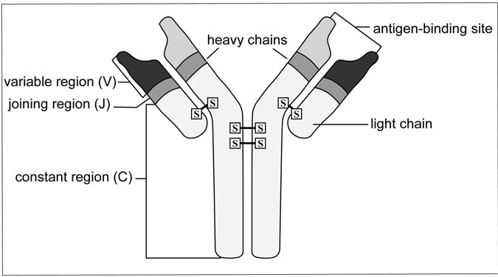

Figure 6.2 Antibody Structure. This diagram illustrates the basic structure of an antibody protein. (Sandy Windelspecht/Ricochet Productions)

contains over three billion pieces of information, organized into over 30,000 genes, there is still not enough information or room to have a sin- gle gene for each antibody that a human being may require over an entire lifetime. It is believed that the immune system has the potential to produce between one million and one billion different types of antibodies. It is simply not possible that each antibody is the result of a single dedicated gene in the DNA.

It is now known that there are only a few hundred genes that are responsible for generating the diverse array of antibodies. These genes are grouped into four major types:

* Genes grouped into the C regions are responsible for generating the protein sequences in the constant regions of the heavy and light chains.
* The J genes are responsible for generating the small peptide segments that link portions of the antibody together.
* The D group of genes encodes for a small diversity region found only in the heavy chain.
* The V genes provide the information for generating the hypervariable segments of the light chains.

It is important to note that the following process of selecting the genes that will form an antibody occurs before the B cell encounters an antigen. In other words, as the B cell matures, it becomes speciﬁc in what type of antigen it will respond to. It is extremely possible that a B cell may never come in contact with its antigen, and thus never be involved in an immune response. However, the large number of B cells in circulation, and the mechanism of the speciﬁc immune response, means that the body needs only one B cell that recognizes the antigen to mount an effective immune response. Because many invading pathogens, such as bacteria and viruses, may present multiple antigens, it is possible that more than one B cell may be producing antibodies for the same pathogen at the same time.

To construct a light chain, it is necessary to have a single V, J, and C gene segment (there are no D segments in the light chain). There are 30 to 40 V segments, four to ﬁve J segments, and a single C segment in the area of DNA responsible (located on human chromosomes 2 and 22) for the formation of the light chain. This alone produces around 200 different combinations. Furthermore, the regions are subject not only to mutation, but also to minor variations in the reading and processing of the genetic information. These mistakes serve to increase the variation in the seg- ments. Thus, it is highly unlikely that two B cells will be identical in the types of antibodies that they produce. Before maturation, the lymphocyte possesses all of the gene segments. By a process called somatic recombi- nation, a single V and J region are selected and then matched up to the one C region. After translation, the result is a protein (also called a pep- tide) that will become the light chain of the antibody.

The synthesis of a heavy chain is slightly different, but follows the same general pattern. There are 65 V segments, 27 D segments, and 5 J segments available on chromosome 14 to construct a single heavy chain, resulting in 10,530 possible combinations. Once again, a single V, D, and J segment are combined, and then linked to a C segment. The same errors that produced variation in the light chains may also play a role in the formation of the heavy chains, resulting once again in an almost end- less source of variation in heavy chain structure. Following processing,

transcription of the information, and translation into a functional protein, the result is the heavy chain of the antibody. The light chains and heavy chains are then linked together, forming an antibody.

Although all B cells undergo a similar maturation process, there are minor variations in their form and function in the immune system. Once activated by a speciﬁc antigen, a B cell rapidly divides, forming a large number of effector B cells, or plasma cells. These cells actively combat the antigen in the body in what is called the primary immune response. As the primary response progresses, some of the activated B cells are retired, forming memory B cells. These cells are responsible for the sec- ondary immune response that occurs when the body is exposed to the same antigen later in time. All B cells are involved in the humoral response, which targets free antigens in the system.

As noted, T cells complete their maturation in the thymus, one of the primary lymphoid organs of the body. The thymus is located just above the heart. In the thymus, the immature T cells undergo a series of modiﬁ- cations. The most important of these changes occurs as speciﬁc genes within the T cells are activated, which enables the production of unique proteins, called glycoproteins, on the surface of these cells. These pro- teins, examples of which are called CD4 and CD8, play an important role in the function of the immune system. As was the case with the B cells, the maturing T cells in the thymus are screened to ensure that they are not rec- ognizing any of the tissues or cells of the body as invading antigens. Those T cells that display an afﬁnity for self are targeted for cell death and usu- ally do not mature.

While T cells are specialized for the targeting of antigen-presenting cells of the body, there are actually several different forms of T cells, each of which has a speciﬁc function in the immune response:

* *Helper T cells*. Helper T cells serve as the liaison between the nonspeciﬁc and speciﬁc defense mechanisms. They are responsible for activating both the humoral and cell-mediated responses in the body, by interacting with both mature T and B lymphocytes.
* *Cytotoxic T cells*. These cells destroy infected body cells under the direction of the helper T cells.
* *Inducer T cells*. Cells located in the thymus that are responsible for T cell maturation.
* *Suppressor T cells*. The task of these cells is to shut down the immune response once the infection is complete. These cells divide much slower than other T cells, producing a natural delay mechanism.
* *Memory T cells*. As was the case with the B cells, some T cells are held in reserve for future exposures to the antigen. These are called memory cells, because they originated with the initial exposure to the antigen.

The activity of T cells is highly dependent on cell-to-cell signaling using proteins embedded in the plasma membrane. T cells not only serve to identify cells of the body, but also to distinguish between infected and healthy cells so as to prevent unnecessary tissue damage. This identiﬁca- tion is made possible by speciﬁc receptors on the surface of the T cell. The antigen identiﬁcation portion of these receptors is highly variable. T cells use a similar method of generating variation, as do the B cells with antibody formation. Within the genome of the T cell are the same variable (V), diversity (D), joining (J), and constant (C) families of genes that are present in the B cells. These genes are rearranged in much the same way as in the B cells to produce a receptor that is speciﬁc for one type of anti- gen recognition. As is the case with the B cell, each T cell is speciﬁc in what it can recognize. The difference is that while the antibodies of the B cell recognize free antigens, such as what might be found in the ﬂuids of the body, the receptors of the T cells are designed to identify cells that are presenting a speciﬁc antigen as the result of being infected by a patho- gen, such as a virus. This is a complex interaction, which involves a num- ber of cellular markers and proteins.

White Blood Cells

The term white blood cell is used as a general description for a wide variety of cells in the immune system, including macrophages, neu- trophils, eosinophils, and basophils (the general function of each is provi- ded in Table 6.1). A white blood cell begins as a hematopoietic stem cell in the bone marrow. This cell then begins to differentiate into a myeloid

progenitor cell, which then becomes basophils, eosinophils, neutrophils, and a precursor of macrophages called monocytes. Typically, the term white blood cell indicates the macrophages.

Macrophages are the general workhorses of the immune system. These are amoeba-like cells that move throughout the body. Unlike many cells of the circulatory and lymphatic system, the macrophages are not conﬁned to capillaries. Instead, they are able to move freely between the circulatory system and the interstitial ﬂuids that bathe the tissues of the body. Macrophage is the collective name for these cells, but they are sometimes called by other names throughout the body (see Table 6.2). Inactive macrophages are monocytes. These may be activated at the site of an infection by a variety of mechanisms.

Macrophages are phagocytic cells, meaning that in order to destroy pathogens, macrophages must ﬁrst ingest them. Phagocytosis involves a bud- ding in of the cell membrane, forming a vesicle inside the cell. Once the pathogen is engulfed, the macrophage can utilize two major mechanisms for destroying the invader. First, the macrophage may merge the pathogen- containing vesicle with another cellular vesicle called a lysosome.

The lysosome contains powerful digestive enzymes that effectively “eat” the pathogen, rendering it harmless. A second mechanism involves making the internal environment of the vesicle containing the pathogen extremely toxic. Macrophages can produce free radicals such as nitric oxide and superoxide anion. These chemicals are highly destructive to organic molecules, and quickly destroy the incoming pathogen.

TABLE 6.2

Nomenclature for Macrophages in the Body

*Tissue Name*

Digestive system (liver) Kupffer’s cells

Urinary system (kidney) Mesangial cells

Connective tissue Histocytes

Respiratory system (lungs) Alveolar macrophages

Nervous system (brain) Microglial cells

Once the pathogen has been destroyed, an interesting change happens in the receptors of the macrophage. The macrophages are nonspeciﬁc gen- eralists, but they play an important role in informing the lymphocytes (speciﬁc defense) of the presence of a pathogen in the body. Small pieces of the pathogen are moved to receptors on the cell membrane. These receptors, part of the self-identiﬁcation process (see the next section, “Identiﬁcation of Self: The Role of Cellular Markers”), act as an activa- tion mechanism for the helper T cells, an important link between the spe- ciﬁc and nonspeciﬁc responses. Once the macrophage alters the surface receptors, it is then called an antigen-presenting cell (APC).

In many ways, the neutrophils are very similar to the macrophages. Both are phagocytic cells that patrol the body looking for pathogenic organisms or viruses. Neutrophils are actually the most abundant type of white blood cell in the body. They are typically found only at the site of an infection, usually because they are attracted by macrophage activity and chemicals released from damaged cells. Unlike the macrophages, which rely almost exclusively on phagocytic activity, the neutrophils have a variety of options available for the destruction of incoming pathogens.

Neutrophils may engulf pathogens in a manner similar to the macro- phages. However, they also possess a more destructive mechanism. Each neutrophil contains a limited number of internal structures, called granules. These granules contain a variety of substances that are highly toxic to micro- organisms. These include oxygen radicals, antimicrobial proteins, peroxyni- trate (a nitric oxide compound), and hydrogen peroxide. When a neutrophil reaches the site of an injury or infection, it releases these chemicals into the surrounding environment, killing not only microorganisms, but often cells of the body as well. Each neutrophil only contains a limited arsenal of chem- icals, and once depleted, the neutrophil dies. Often, the neutrophil may be destroyed by the very chemicals that it releases. The debris from these dead cells is what forms the pus at a site of a wound or infection.

Another form of white blood cell is the eosinophil. The eosinophils are another nonspeciﬁc mechanism, but one that is targeted against para- sitic organisms, such as intestinal worms, ﬂukes, microscopic nematodes, and even ticks and mites. Eosinophils act by orientating themselves along the surface of the parasitic invader and then releasing chemicals to destroy the membrane or surface of the organism.

The last two major types of white blood cells are not directly involved in the destruction of invading organisms, but rather are involved in some of the chemical signaling. These are the basophils and mast cells, which are responsible for the release of a chemical called histamine, an impor- tant chemical in the inﬂammatory response. The role of these cells in his- tamine production is discussed later in this chapter.

##### Identiﬁcation of Self: The Role of Cellular Markers

Before beginning a discussion of cellular markers, it is ﬁrst important to understand the basic structure of a cell membrane. The membrane of a cell is composed primarily of a molecule called the phospholipid. Phospholipids belong to a class of biomolecules called the lipids and are unique in that they contain both hydrophilic and hydrophobic regions. When these molecules are placed in an aqueous environment, the hydrophilic and hydrophobic regions align to form a double layer, called a lipid bilayer. This lipid bilayer forms the basic structure of the cell membrane, the properties of which effectively block the passage of most molecules into the cell.

Located within the phospholipid layer of the cell membrane are a wide variety of proteins. Some of these proteins serve as channels through the membrane, while others act as receptors for chemical signals passing back and forth between the tissues of the body. The proteins of interest in the immune response belong to the glycoproteins, the proteins that have a sugar group attached to their outer surface. Glycoproteins are common on the surface of the cell membrane, but two types of glycoproteins play an important role in the immune response. These are the major histocom- patibility complexes (MHC) markers.

MHC markers should be considered a form of cellular identiﬁcation card. All of the cells of the body have the same identiﬁcation tag, which enables the body to distinguish between “self ” and invading microorgan- isms and viruses. There are two classes of MHC markers in the cell, called MHC-I and MHC-II. MHC-I markers are more general, and are found on every cell of the body. MHC-II markers are slightly more speciﬁc, and are found almost exclusively on cells of the immune system.

There is a tremendous amount of variation between individuals in the structure of the MHC markers. While only three genes are responsible for

forming an MHC-I protein (all on human chromosome 6), there exists a number of variations, or alleles, for each of these genes. This allele effec- tively ensures that the MHC signature of one individual is unique.

##### Chemical Signals in the Lymphatic System

Because the cells of the immune system are not all localized in a single tissue, the system possesses an elaborate series of chemical signals to operate effectively. These signals perform a variety of functions, from the recruitment of nonspeciﬁc defense mechanisms to the activation of cells involved in the identiﬁcation and destruction of speciﬁc pathogens. The cytokines are a special group of chemical signals in the immune sys- tem. These protein, or peptide, signals are secreted primarily by the T cells of the body to inﬂuence the activity of both the speciﬁc and nonspeciﬁc cells of the immune system. There are currently 13 different types of cyto- kines that have been identiﬁed. The majority of these belong to two major groups, the interferons and the interleukins (Figure 6.3).

As their name implies, the interferons are involved in an interference response in the immune system. Several different types of interferons are active in the immune response. Type 1 interferons (also called interferon alpha and interferon beta) are used as a local defense against invading viruses. When a cell is infected with a virus, it secretes interferons into the surrounding interstitial ﬂuids. On neighboring cells, the interferon interacts with a receptor common on the surface of all cells. This causes the cell to activate antiviral protection mechanisms (frequently protease enzymes), which inhibit viral replication in uninfected cells. The type 1 interferons also enhance the devel- opment of APCs, and serve to activate NK cells in the area. It is important to note that the secretion of interferons does not protect the infected cell, only those in close proximity to it. It is also nonspeciﬁc, meaning that neighboring cells are temporarily protected against any viruses in the area.

Another type of interferon is called interferon gamma. This interferon is secreted by selected T cells and is not directly related to the type 1 interfer- ons. The role of this interferon is to activate macrophages near the cytotoxic T cells, thus providing a better coverage in the area of an infection or wound.

Interleukins are the second major form of cytokine. There are a number of interleukins in the immune system, the most common of which are

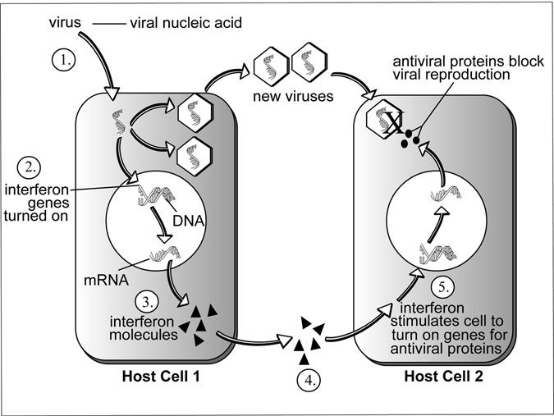

Figure 6.3 Interferon Activity. The cell on the left has been infected by a virus. It then produces interferon, which is detected by a nearby cell (on the right), enabling the production of antiviral proteins. (Sandy Windelspecht/Ricochet Productions)

interleukin-1 (IL-1) and interleukin-2 (IL-2). IL-1 acts as a link between the nonspeciﬁc and speciﬁc defense systems. After a macrophage has engulfed a pathogen and become an APC, it secretes IL-1 to help activate helper T cells in the area. The helper T cells then communicate directly with cyto- toxic T cells and B cells to begin the humoral and cell-mediated responses to the antigen.

The second major form of interleukin, IL-2, is basically an activated signal. Secreted by helper T cells, the signal activates B cells to begin anti- body production, as well as cytotoxic T cells to begin destruction of infected cells of the body. The loss of helper T cells, as is the case with AIDS, means that this signal is not present, and the speciﬁc defense sys- tems are not activated.

There are other chemical signals in the immune system besides the interferons and interleukins. In response to injury, basophils and mast cells release a chemical called histamine. Histamine causes the cells of the capillary beds (circulatory system) to dilate, increasing the amount of ﬂuid (but not the amount of red blood cells) ﬂowing out of them. This increase in interstitial ﬂuid increases the pressure, slowing the spread of bacteria and other pathogens into the wound. In addition, clotting proteins can now move more easily to the site of the wound, allowing for a more rapid healing process. Macrophages and NK cells also beneﬁt by the ease of moving into the interstitial spaces, allowing for a more rapid cleanup to begin. Antihistamine medications, such as those used for the common cold, reverse this process and may actually slow the immune response.

#### An Examination of the Lymph Nodes and Lymphatic Circulation in the Body

One of the primary functions of the lymphatic system is to capture and collect the protein-rich ﬂuid that escapes from the circulatory system’s blood vessels and deposit it back into the tissue network. These proteins cannot be reabsorbed; therefore, the lymphatic circulatory system must fetch them and bring them back. As explained previously, the lymphatic system’s circulatory functions are separate from the cardiovascular system in the human body. However, unlike the cardiovascular system, the lym- phatic system’s circulatory processes are focused on returning ﬂuids from other areas of the body, rather than directly supplying the tissues with the nutrients and oxygen that they need to function.

This section will begin to look at some of the basic components of the lymphatic system—the lymph nodes and the elements involved in lym- phatic circulation, in addition to the system’s primary organs, the bone marrow and the thymus. These aspects of the lymphatic system are important to understand before learning how the more complex functions, such as immunity and autoimmune response, work to protect the body.

##### Lymphatic Vessels

The cardiovascular, circulatory system and the principal parts of the lymphatic system interact primarily through the lymph nodes, lymphatics,

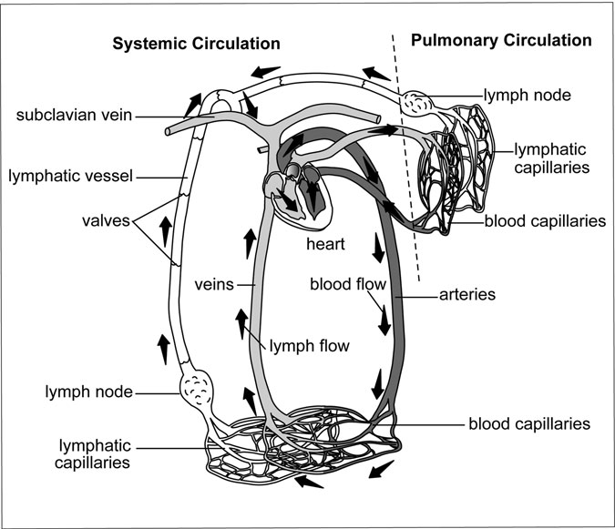

Figure 6.4 The Interaction between the Body’s Lymphatic and Cardiovascular Systems. Tissue ﬂuid is collected by lymph capillaries and is then returned to the blood. The arrows indicate the ﬂow of the lymph and blood. (Sandy Windelspecht/Ricochet Productions)

and lymph capillaries (Figure 6.4). The lymphatic vessels begin as blind- end tubes—called lymph capillaries—that form in the spaces between cells.

Lymph capillaries are slightly larger, in addition to being more per- meable, than the blood capillaries in the circulatory system. These capilla- ries can form in most regions of the body, and converge to form larger lymph vessels called lymphatics. These lymphatic vessels have a vein- like appearance, although their walls are thinner and they contain more valves than blood veins. In addition, at various spots in their structure, lymphatics contain lymph nodes.

Lymph is the name of the ﬂuid that enters the lymph capillaries. As explained previously, tissue ﬂuid comes from the ﬁltration in the capillaries. While the process of osmosis allows much of this ﬂuid to return to the blood, some of the ﬂuid is lodged in interstitial spaces. The lymphatic vessels return this interstitial ﬂuid to the blood to become plasma again. Without this occurring, blood volume and blood pressure would rapidly decrease, eventually leading to serious health threats, such as a heart attack or stroke. Unlike the circulatory system, there is no pump for the lymph. In the circulatory system, the heart serves as the pump to keep blood moving throughout the body. In the lymphatic system, the lymph is kept mobile through the muscles of the lymph vessels (Figure 6.5). As the smooth muscle layer of the larger lymph vessel constricts, the one-way valvular

structure prevents the backﬂow of the lymph.

As the lymph capillaries form lymphatics, the lymphatics eventually merge into two main structures or channels, called the thoracic duct (also called the left lymphatic duct) and the right lymphatic duct. Lymphatic vessels from the left side of the head, neck, and chest, in addition to the left upper extremity and the entire body below the ribs, all converge in front of the lumbar section of the vertebrae to form the cistern chyli vessel, which then continues to creep up the backbone as the thoracic duct. This duct then empties the ﬂuid into the left subclavian vein, where a pair of valves is located to prevent the passage of blood into the thoracic duct. The second channel, the right lymphatic duct, takes the lymph from the right side of the body and then deposits it into the opposite, or left subclavian vein.

When doctors need to take a detailed look at the lymphatic vessels and organs, they rely on a procedure known as a lymphangiography. The lymphatic vessels and organs are ﬁlled with an opaque substance and then ﬁlmed, which produces a lymphangiogram. This image is useful for identifying edemas, carcinomas, and viewing any irregularities of the lymph nodes.

##### Lymph Nodes

The lymphatics contain structures that are oval in shape called lymph nodes. These bean-like organs can range in size from 0.04 to 1 inch (1 to 25 millimeters). Blood ﬂows into lymph nodes on the way to subclavian

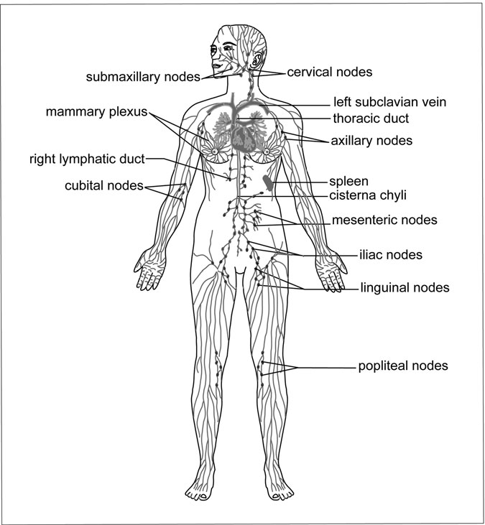

Figure 6.5 Primary Groups of Lymph Nodes and the Lymph Vessel System. The right and left subclavian veins return lymph to the body’s blood supply. (Sandy Windelspecht/Ricochet Productions)

veins. Each lymph node contains a hilum, which is a slight depression on one side where the blood vessels enter and leave the node (Figure 6.6).

Three structural elements form the framework of a lymph node: the capsule, the trabeculae, and the hilum. The capsule is made up of ﬁbrous connective tissue that not only covers the node, but also extends into it.

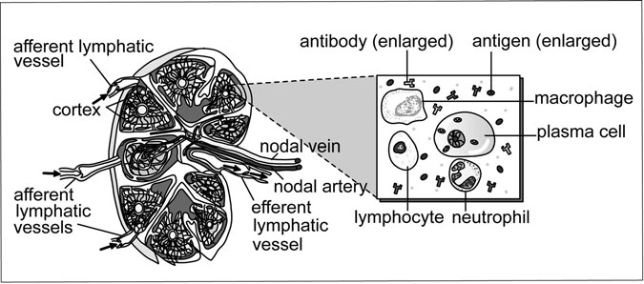

Figure 6.6 The Lymph Node. On the left, a cross-section view of a lymph node, with the arrows indicating the lymph ﬂow. On the right, a detailed view of antigen being destroyed within the lymph node. (Sandy Windelspecht/Ricochet Productions)

These extensions into the node are call trabeculae. Inside the node, the outer cortex is composed of tightly packed lymphocytes organized into lymph nodules. These nodules contain germinal centers, where lympho- cytes are actually produced. Then the inner portion of the lymph node is called the medulla, which contains lymphocytes that are organized into strands called medullary cords.

Lymph nodes contain two kinds of vessels: afferent and efferent. Lymph leaves the node through one or two efferent vessels, while it enters through one or a couple of afferent vessels. Once the lymph is in the node, any bacteria and other foreign materials it is carrying are phagocytized (consumed) by macrophages. The lymphocytes contain plasma cells that produce antibodies to counteract any pathogens that the lymph brings with it. These antibodies, in addition to the lymphocytes, will eventually travel to the blood. (Antibodies will be discussed later in this chapter.)

Once lymph enters the node through the afferent vessels, which are located at various places on the surface of the node, the ﬂuid then enters the node’s sinuses, which are a series of irregular channels. After passing through the afferent vessels, lymph enters the cortical sinuses and then cir- culates through the medullary sinuses located between the medullary

cords. After the lymph passes through these sinuses, it then travels to the efferent vessels, which are located at the node’s hilum structure. While the afferent vessels open only toward the node, the efferent vessels open only outward away from the node, pushing lymph out from the structure. In addition, there are fewer efferent vessels (although the actual vessels are wider) than there are afferent vessels.

Macrophages that contain phagocytic cells are located along the sinuses. Lymph travels through the nodes, and is then processed by these phagocytic cells, which work to separate out the bacteria, dirt, and other contaminants from the ﬂuid. In addition, the nodes are where the lympho- cytes and plasma cells are produced, which then lead to the formation of antibodies. When too many pathogens and microbes enter the node, it can become infected, causing the node to enlarge and become inﬂamed.

Numerous groups, or chains, of lymph nodes are located along the body’s lymph vessel network, but the three primary groups of nodes classiﬁed according to their location in the body—cervical, axillary, and inguinal—are detailed in Table 6.3. Each of these node groups are located at an important junction of the body: the cervical nodes are located near the neck and head junction; the axillary nodes are located near where the arm meets the trunk of the body; and the inguinal nodes are found near where the leg meets the trunk. This is important because the skin is more likely to break in these areas, thus allowing pathogens to enter the body. For example, it is more likely that skin will break in the head, arms, or legs, rather than the

TABLE 6.3

Groupings or Chains of Nodes

*Group Location and function*

Deep cervical lymph nodes Located along the internal jugular veins, these nodes

process lymph from the head and neck.

Axillary lymph nodes Located in the chest and underarm areas of the body,

these nodes process lymph from the skin and chest muscles, which include the breasts.

Inguinal lymph nodes Located in the groin region, these nodes drain lymph

from the lower extremities of the body, including the genitals.

trunk of the body. Therefore, if pathogens enter the body through any of these locations, the lymph will destroy them before they reach the trunk, and also before the lymph is returned to the blood contained in the subclavian veins. As these lymph nodes are processing the pathogens and bacteria, inﬂammation and temporary infection can occur. For instance, swollen glands frequently accompany “strep throat,” which is an infection caused by a bacteria called Streptococcus. The glands that are swollen are actually the cervical nodes, which have temporarily enlarged as the mac-

rophages ﬁght off the bacteria in the throat’s lymph.

There is also a speciﬁc kind of lymphatic tissue found in all mucous membranes, which line those systems of the body that have exterior open- ings to the environment. These include the respiratory, digestive, urinary, and reproductive tracts. All of these systems are lined with mucous mem- branes for protection. Located under the epithelial layer of these membranes are small groupings of lymphatic tissue know as lymph nodules.

This is an important area for lymph nodules because, while these sys- tems are shielded from some contamination through the mucous mem- branes, they are still vulnerable to attack by microbes, bacteria, and various pathogens. If bacteria is inhaled and enters the body through the respiratory system, the lymph nodules located in the trachea will counter- act that bacteria before it even reaches the blood. Two kinds of lymph nod- ules are Peyer’s patches (located in the small intestine) and tonsils (located in the pharynx).

##### Bone Marrow

The three kinds of blood cells—white blood cells (WBCs), red blood cells, (RBCs), and platelets—are produced in two kinds of hemopoietic tissues: red bone marrow (or simply bone marrow), and lymphatic tissue that is found in the spleen, thymus gland (see the “Thymus” section later in this chapter), and lymph nodes. The red bone marrow is spongy tissue found in ﬂat and irregular bones. Basically, the purpose of the RBCs is to carry oxygen throughout the body. Through a protein that they carry called hemoglobin, RBCs are able to bond to oxygen molecules. (The function of the RBCs are covered extensively in Chapter 2 on the circula- tory system, and WBCs are extensively covered earlier in this chapter).

Before RBCs are produced in the bone marrow, they are stem cells that are constantly changing to form all kinds of blood cells. The rate of RBC production is high; approximately a few million are produced every second. This production rate, however, is regulated by the presence of oxygen. If plenty of oxygen is available in the body, then the bone marrow will produce the RBCs at a normal rate. However, if the body is low on oxygen (or in a state of hypoxia), then the kidneys will begin producing a hormone called erythropoietin, which causes the bone marrow to pro- duce more RBCs, which are then able to carry oxygen through the body. Once the oxygen begins making its way through the circulatory system, the body is no longer in a hypoxic state. A person can become hypoxic fol- lowing a hemorrhage or other injury that has caused them to lose a lot of blood, or if they spend a signiﬁcant amount of time in higher altitudes.

As stem cells develop into RBCs, they go through a number of stages. The most important stages are the last two: when the cell is a normoblast and then a reticulocyte. The last stage during which the cell actually has a nucleus is the normoblast stage. After this stage, the nucleus disintegrates and the cell becomes a reticulocyte. While a small number of reticulocytes in the blood’s circulation is normal, too many (in addition to the presence of normoblasts) could indicate that not enough mature RBCs are available to transport oxygen. Once again, this could be due to an injury, such as a hemorrhage, or a disease.

In order for these stem cells to mature into RBCs, they need a signiﬁ- cant amount of nutrients, such as protein and iron. In fact, protein and iron are necessary in order for hemoglobin to synthesize. In addition, vitamins such as folic acid and B12 are needed in order for the stem cells’ genetic material to synthesize in the bone marrow. Two necessary chemical agents, called factors, must be present in order for the stem cells to mature into RBCs: the extrinsic factor and the intrinsic factor. The source for the extrinsic factor, also known as vitamin B12, is, as the name implies, external—food. The intrinsic factor comes from certain cells, called pari- etal cells, of the stomach lining. This factor then combines with food’s vitamin B12 resources in order to prevent the vitamin’s ingestion in the stomach so it can instead be absorbed in the small intestine. If the body is not getting a sufﬁcient supply of the intrinsic or extrinsic factors, then the person might develop anemia.

Once the RBCs are produced, they live for approximately 120 days; past this time, they lose their durability and become fragile. At that point, they are removed from the circulatory system by the tissue macrophage system. Macrophages—which are contained not only in the bone marrow, but also in the liver and the spleen—are the lymphatic system’s consum- ers. These old and failing RBCs are eaten (phagocytized) and digested by the macrophages. However, the iron in the RBCs is extracted and placed in the blood, eventually returning back to the bone marrow to be synthesized into new hemoglobin. This recycling process is done repeat- edly. All excessive amounts of iron are stored in the liver until needed by the bone marrow.

But not every aspect of the RBCs can be recycled. As the macro- phages are processing the RBCs, they take the “heme” portion of the hemoglobin and convert it into bilirubin. The liver then takes the bilirubin and excretes it into bile. The bile leaves the liver, travels to the small intes- tine and colon, and eventually leaves the body as the waste product known as feces. A small amount remains in the bloodstream and is responsible for the coloring of the urine. If bilirubin does not leave the body, it stays in the blood and can be a sign that the person is suffering from hepatitis or some other blood-related illness.

##### Blood Types

There are two kinds of red blood cell types important to the lymphatic sys- tem because they involve antigens and antibodies: the ABO group and the Rh factor (see Table 6.4 and Figure 6.7). The ABO group includes A, B,

TABLE 6.4

Blood Types: The ABO Group

*Blood type What are the antigens on the RBCs?*

*What are the antibodies present in the plasma?*

1. A Anti-B
2. B Anti-B

AB Both A and B Neither anti-A nor anti-B

O Neither A nor B Both anti-A and anti-B

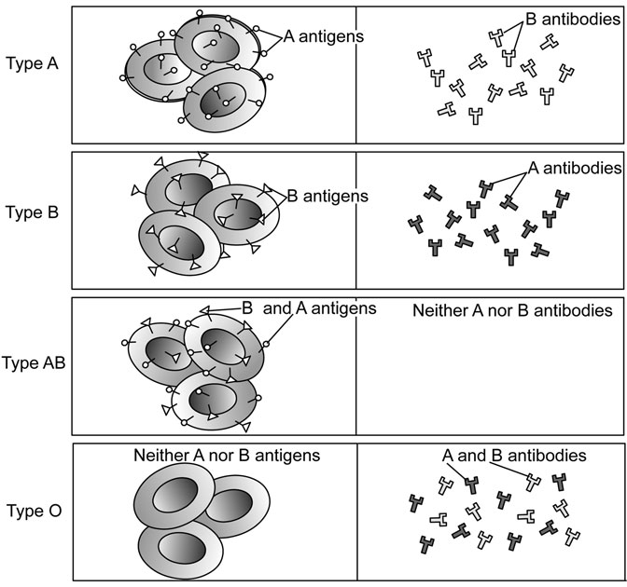

Figure 6.7 Blood Types and Antibodies. The column on the left shows red blood cells, and the right column shows plasma. The ABO blood types on the left include antigens, while the plasma includes the presence of antibodies. (Sandy Windelspecht/Ricochet Productions)

AB, and O blood types. A and B represent the presence of antigens on the RBC membrane. For example, there are A antigens on the RBCs of the patient with type A blood, while there are B antigens on the RBCs of the patient with type B blood. In someone with type AB blood, both anti- gens are present in the blood, while type O indicates that the person’s blood contains neither A nor B blood.

The plasma of each person’s blood contains naturally occurring anti- bodies for those antigens that are not present in the RBCs. This means that

a person with type A blood has anti-B antibodies present in his plasma. In addition, the person with type B blood has anti-A antibodies in his plasma, and a type AB blood classiﬁcation means that the person has neither A nor B antibodies in his plasma. The type O blood patient will have both anti-A and anti-B antibodies.

Blood-typing is extremely important when a blood transfusion is nec- essary for an operation or other medical procedure. Ideally, a patient should receive only a transfusion of their own blood type, or the procedure will not be successful. For example, if a type A patient needs blood and receives type B blood, then the patient’s anti-B antibodies will bind to the donated blood’s type B antigens. After the antibodies and the antigens are bound together, they would clump (agglutination) and then burst (hemolysis), which would defeat the entire purpose of the transfusion. In more serious circumstances, the RBCs that have ruptured would emit free hemoglobin, which would then clog and block the kidney’s capillaries, eventually leading to renal failure or even damage. Because the type O patients have neither the A nor the B antigens, they are often considered “universal donors” who will not cause a reaction in the recipient.

Another important characteristic of RBCs is an antigen known as the Rh factor. While people with the Rh factor are considered Rh positive, those without the factor are called Rh negative, and their bodies do not have natural antibodies to this antigen. Therefore, during a blood transfu- sion, an Rh-negative patient should receive Rh-negative blood, while the Rh-positive patients should receive Rh-positive blood. If for some reason, an Rh-negative patient receives Rh-positive blood, the body will perceive the Rh factor as foreign, and therefore will then begin producing antibod- ies during that initial exposure. While there likely will not be a problem following this initial transfusion, subsequent exposures to Rh-positive blood when the anti-Rh-factor antibodies are already present could lead to hemolysis and potentially damage the kidneys.

##### Thymus

In addition to the bone marrow, the second primary lymphatic organ is the thymus, which is located under the sternum in an adult. In a fetus and an infant, however, the thymus gland is located below the thyroid gland,

which is an endocrine gland below the larynx. As the body develops and grows, the thymus actually shrinks and becomes fat tissue, leaving only a small amount of the thymus in adults. The thymus reaches maximum size during puberty.

The T lymphocytes or T cells that are vital in the body to prepare the immune system to perform its primary duties are produced in the thymus. In fact, the term “T cell” is derived from “thymus-dependent cells.” The hormone released by the thymic gland prepares the T cells to recognize antigens and other foreign invaders in the body and subsequently provide immunity.

During the fetal and infant stages, the immune system is immature, which is why babies are more vulnerable to disease and illness in comparison to children and adults. Early in life, the T cells begin (and the lymphocytes perpetuate) this protection as the immune system develops and matures. When a child is two years old, his or her immune system is typically consid- ered mature and fully functional. While infants are routinely given vaccines to boost their immune systems, some vaccines, such as the measles vaccine, are not recommended for children younger than 18 months, because many medical professionals believe that the child’s immune system would not be strong enough to respond properly, thus putting the child in danger of not getting the full beneﬁt of the vaccine, or even having a reaction.

#### Secondary Lymphatic Organs

In addition to the lymph nodes, thymus, and the bone marrow, the lymphatic system functions with help from ﬁve other important organs: the spleen, tonsils, adenoid, Peyer’s patches, and appendix. This section will describe how these secondary lymphatic organs function and help to protect the body from microbes and other foreign antigens that could lead to illness or cause various kinds of diseases.

##### Spleen

The spleen is protected from harm by the lower rib cage, which encases the organ behind the stomach and is inferior to the diaphragm. While in the fetal stage, the spleen produces RBCs, although this process is taken over by the bone marrow shortly after birth.

There are three primary operations performed by the spleen following birth. One of the spleen’s functions is to produce lymphocytes, which then enter the blood and serve as one of the primary tools for the immune system to ﬁght off antigens. Secondly, the spleen contains plasma cells, which produce antibodies that also ward off foreign antigens and microbes. Finally, the spleen also contains macrophages which have the ability to consume, or phagocytize, foreign materials ﬂoating around in the blood. In addition, the spleen’s supply of macrophages serves to destroy old RBCs and produce bilirubin, which is eventually extracted to the liver and excreted from the body as bile.

Because of its two-part composition, this organ is often described as two organs. One portion of the spleen is composed of lymphatic sheaths and germinal centers called white pulp. The second portion is known as red pulp, and consists of macrophages. The white pulp’s function is considered immune, while the red pulp’s function is considered phagocytic. The white pulp is in charge of producing the antibodies, and this region is also where B and T cells, in addition to plasma cells, are produced and mature. The red pulp is kind of a cleaning machine; it removes unwanted matter, such as bacteria. In addition, the red pulp also acts as a reservoir for other lymphatic elements such as white blood cells and platelets.

Doctors do not consider the spleen a “vital organ,” because it performs the same functions as some other organs. For instance, the liver and bone marrow can remove RBCs from the circulatory system, and the lymph nodes will produce lymphocytes and monocytes, in addition to destroying pathogens. However, doctors and researchers have found that without a spleen, a person is more vulnerable to certain bacterial infections such as pneumonia and meningitis.

##### Tonsils, Adenoid, and the Peyer’s Patches

Tonsils are a type of lymph nodule found in the throat’s pharynx. Tonsils are oval-shaped, pink masses of lymphatic tissue. There are three kinds of tonsils named for their location in the pharynx. Along the lateral walls of the pharynx are the palantine tonsils, while the adenoid, or the pharyngeal tonsil, are located on the posterior wall. The lingual tonsils are located

on the base of the tongue. The tonsils and adenoid are composed of lym- phatic tissue, just like the lymph nodes located in the neck, groin, and armpits.

The adenoid is a single mass of tissue; therefore, it is incorrect to refer to it as “adenoids.” As explained above, it is located in the upper part of the throat, behind the nose and above a part of the throat called the uvula. This area of the throat is called the nasopharynx. While the tonsils can be seen simply by opening the mouth wide, the adenoid can be viewed only through the use of special mirrors and instruments that are passed through the nose by a doctor or other medical professional.

The tonsils form a kind of ring of lymphatic tissue around the pharynx. This is a key location because it is near the entrance to breathing passages, in addition to being where food ﬁrst enters the mouth. Therefore, the tissue can capture germs and pathogens that are coming into the body through food and air, and it can act as a sort of ﬁlter for the lymphatic system. This function is especially important during the initial years of life, but becomes less important as the body and lymphatic system matures. Children who suffer frequent infections of the tonsils (called tonsillitis) may have to have their palatine tonsils and their adenoid removed. Some signs of infected tonsils might be noisy breathing, snoring, difﬁculty swallowing (especially solid foods), and choking or gasping while sleeping. The surgery to remove the tonsils is known as a tonsillectomy. It is important to note that when children have their tonsils removed, they do not suffer immunity loss, because the body has lined up redundant systems, such as the other lymph nodules, that will serve the same function if the tonsils are surgically removed.

In the small intestine, there is an abundance of lymphatic tissue in order to ﬁlter out pathogens that might be brought into the body through eating and drinking. One type of lymph nodule grouping, located in the small intestine, is called Peyer’s patches. In the small intestine, the Peyer’s patches work to remove pathogens that are invading the body through the digestive system. There are also single lymph nodules, known as solitary lymph nodules, located in the lower part of the small intestine (see Chapter 3 on the digestive system for more information on how the body breaks down and processes food and other substances).

##### Appendix

A small, blunt-ended tube, the appendix is considered part of the large intestine, even though its walls are rich with lymphatic tissue. However, it is recognized that the appendix is not actually part of the digestive tract because of differences in its tissues from the tissues of the small and large intestine. In some cases, fecal matter or waste can become impacted in the appendix, which can cause it to become inﬂamed, a condition known as appendicitis. If this occurs, the appendix will be surgically removed, a process known as an appendectomy.

#### The Immune Response: Cell-Mediated and Antibody-Mediated Responses

In order to maintain good health and homeostasis, the human body must continually protect itself against harmful disease-causing substances. This section will explore how the lymphatic system is able to protect the body by providing immunity, the ability to ﬁght off certain infectious substan- ces that can lead to disease and illness. It takes various elements of the lymphatic system, including lymphocytes and antibodies, which provide a strong defense to counter these disease-producing pathogens.

Before each of these lymphatic tools is explained, however, it is important to distinguish between nonspeciﬁc and speciﬁc defenses. Non- speciﬁc defenses are reactions that involve a variety of pathogens and microbes. These defense reactions occur in the skin, mucous membranes (such as nasal passages), the stomach, and the respiratory tract. For in- stance, lysozyme is an enzyme produced in the eyes’ lacrimal glands as well as the glands in the mucous membranes of the nose and mouth; it is able to destroy harmful microbes, and thus it is considered one of the body’s nonspeciﬁc defenses. Also, stomach lining is able to secrete an appropriate amount of hydrochloric acid in order to kill harmful microbes present in food, although some food-borne pathogens can still be harmful. When one breathes, it is natural to inhale dust particles that then settle in the respiratory tract. Microbes attach themselves to these particles, but thread-like structures called cilia move these microbes up through the res- piratory tract to be coughed up or spat out.

While the body’s nonspeciﬁc defense system is effective against microbes and some pathogens, it needs help to ﬁght, especially against cer- tain toxins produced by pathogens. Therefore, the body is equipped with a second line of defense, known as the speciﬁc defenses. The speciﬁc defenses involve the production of antibodies, which serve to inactivate substances called antigens (pathogens and their related toxins). Anti- gens act as chemical markers that identify cells as invasive substances. Human cells have their own antigens, which recognize foreign antigens as dangerous and are subsequently destroyed, thus activating an immune response. Examples of foreign antigens include bacteria, viruses, fungi, protozoa, and malignant cells, which are abnormal cells such as those associated with cancer. The response that results from the antibody-antigen reaction is speciﬁc. Only a speciﬁc antibody can ﬁght off a particular antigen (this relationship will be explored later in this chapter).

Nonspeciﬁc and speciﬁc immune responses are also referred to as innate and adaptive responses, and both systems work together to identify harmful invaders to the body, and then contain and eliminate them. The innate or nonspeciﬁc system is always on alert, and is prepared to react to any and all invaders. While their action is rapid, the innate immune response is also limited, but keeps the harmful pathogens from invading the body to a signiﬁcant degree. However, the adaptive immune system can come in and is equipped with the powerful, speciﬁed tools to com- pletely eliminate the pathogen.

##### Thymus Gland

It is important to emphasize the vital role that the thymus gland plays in immunity. One of the lymphatic system’s primary organs, scientists and doctors noted in the early years of immune research that children born without this organ could not ﬁght off infection. Research has indicated that the thymus gland is instrumental in structuring and organizing the body’s lymphatic system from the fetal years through the initial years after birth. The primary function of the thymus gland is to prepare lymphocytes to participate in the immune response.

##### Lymphocytes

The lymphatic system’s organs—the lymph nodes, thymus gland, spleen, and bone marrow—all contain lymphoid tissue, which is home to two kinds of lymphocytes that each respond to antigens in different ways: T cells and B cells.

In the embryo stage, T cells are produced in the bone marrow and thymus. While passing through the thymus, they mature with the help of the thymic hormones. Scientists believe that the thymus gland alters the lym- phocyte’s DNA so they become T cells. These cells then travel to the spleen, lymph nodes, and lymph nodules, where they then are produced following birth. After the initial production, the T cells circulate through the body’s blood network, and then lodge in the lymph nodes and other lymphoid tissue. T cells are small lymphocytes that attach to antigens. Once attached, the T cells secrete certain enzymes that dissolve the antigen’s membrane and digest its contents, which destroy both the antigen and the T cell. These lymphocytes primarily kill antigens produced by fungus cells, viruses, and bacteria that result from slow-developing infections and diseases. T cells are also responsible for the rejection that can result from an organ transplant. The second kind of lymphocyte, the B cell, is produced in the bone marrow during the embryonic stage, although it soon moves into the spleen and lymph nodes and nodules. When B cells come into contact with a speciﬁc antigen, they become plasma cells, which produce antibod- ies that are released into the blood’s circulation. Once these speciﬁed B cells are produced after coming into contact with a speciﬁc antigen, they can remain in the lymph nodes for years, on alert to attack if the antigen

is once again introduced into the body.

##### Antibodies

As stated earlier, antibodies are proteins that are produced in response to foreign antigens. Also called immunoglobulins or gamma globulins, it is important to note that antibodies in themselves do not destroy foreign antigens. Instead, antibodies attach themselves to foreign antigens, mark- ing these substances so the body knows to destroy them.

Also as stated earlier, there is one speciﬁc antibody for one speciﬁc antigen, which means that if the need occurs, the immune system has the

capacity to respond to millions of antigens by producing millions of dif- ferent antigen-speciﬁc antibodies. These millions of antibodies are sepa- rated into ﬁve classes: IgG, IgA, IgM, IgD, and IgE.

##### The Immune Response

One of the main goals of the lymphatic system’s immune response is to destroy a harmful pathogen, and the ﬁrst step to achieve this goal is for the body to recognize the antigen associated with this pathogen as foreign. While both T cells and B cells can provide this recognition function, the immune response is more effective if the antigen is dealt with by macro- phages and helper T cells, which are a specialized group of T lympho- cytes. This foreign antigen is ﬁrst consumed, or phagocytized, by a macrophage. Parts of this antigen then become attached to the macro- phage’s cell membrane. Also located on this cell membrane are “self” antigens, which are the safe type of antigens found in other cells through- out the individual. When the helper T cells come into contact with this macrophage, it will detect not only the “self” (and harmless) antigens, but also the foreign antigens. This helper T cell is then on alert and sensi- tized to this macrophage that contains parts of the foreign antigen.

Cell-Mediated and Humoral Immunity

There are two types of speciﬁc (or adaptive) immunity: cell-mediated and humoral. T cells are responsible for cellular or cell-mediated immunity, which refers to immune response in which macrophages and T cells par- ticipate, while humoral immunity involves B cells, T cells, and macro- phages. While T cells are associated with cellular immunity, B cells are responsible for humoral immunity, because the B cells are providing pro- tection as they circulate through the blood and tissues of the body. Humoral immunity protects against more acute diseases than are warded off by T cells, such as pneumonia, staphylococcal infection (staph infec- tion), and streptococcal infection, which is also known as strep throat.

Figure 6.8 depicts the cell-mediated immunity process. This process does not produce antibodies, although it is successful against intracellular pathogens, including viruses, fungi, malignant cells, and foreign tissue grafts. The initial step in this process is to activate the T cells, which

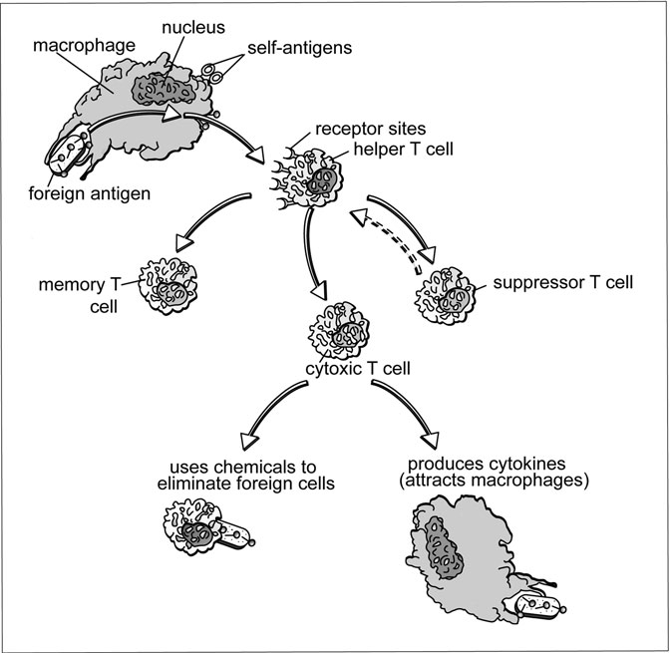

Figure 6.8 Cell-mediated immune response. (Sandy Windelspecht/ Ricochet Productions)

occurs when the helper T cells and macrophages recognize a foreign antigen. Now, recall that these activated T cells are antigen-speciﬁc, meaning individual T cells are successful only against certain antigens. But when these T cells are activated, they divide numerous times into two kinds of cells: memory T cells and cytotoxic (killer) T cells.

While the memory T cells can always recall a speciﬁc antigen and become sensitized upon its presence in the body, the cytotoxic cells are able to eliminate these foreign antigens by destroying their cell membranes. These cells also produce a certain chemical called a cytokine that attracts

macrophages to the area where an antigen is present, and then activates them to consume, or phagocytize, the antigen. The effect of these two types of T cells working together ensures that a harmful antigen, such as a virus, is quickly detected, destroyed, and then prevented from reproducing other virus-infected cells in the body.

Another kind of cell, called the suppressor T cell, is also present in this immune system. Once the memory and cytotoxic cells work to elimi- nate the antigen, the suppressor cells work to stop the immune response once the antigen has been destroyed. However, if the antigen reappears, the memory cells will initiate the immune response.

Unlike the cell-mediated immunity, humoral immunity does result in antibody production (Figure 6.9). Once again, the initial step in this immune response is also the recognition of the foreign antigen; the helper T cells, B cells, and macrophages are all involved. The helper T cells recognize the antigen and then alert the B cells, which activate other B cells that might be specialized or speciﬁc in combating the antigen. These sensitized B cells go through numerous divisions, which results in the production of two types of cells: memory B cells and plasma B cells. The memory B cells will remember the antigen, while the plasma B cells will produce speciﬁc antibodies against this one invading antigen.

After these antibodies are produced, they bond to the antigen, which forms an antigen-antibody complex. This complex is then marked, or undergoes opsonization, which means that macrophages or neutrophils will know that this antigen must be phagocytized. The creation of this antigen-antibody complex also begins the process of complement ﬁxation. A complement is a family of about 20 different plasma proteins. These proteins circulate through the body’s blood network until they are activated, or “ﬁxed,” by the formation of the antigen-antibody complex. This ﬁxation process can be complete and thorough, but it can also be partial. Complete ﬁxation is successful if the antigen is cellular, which is often the case with bacterial antigens. In this instance, the complement proteins will bond to the complex and to each other, surrounding the anti- gen with an enzymatic structure that ultimately inﬂicts damage on the cells to a destructive degree, thus killing the cell.

But only partial complement ﬁxation takes place if the antigen is not cellular, which would occur if the antigen were a virus. In this instance,

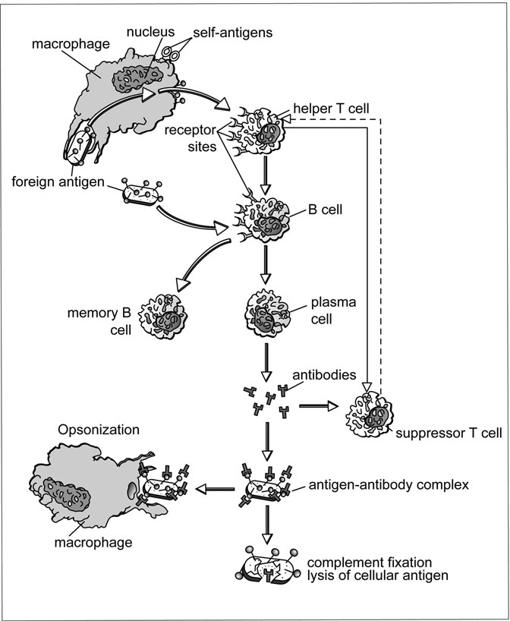

Figure 6.9 Humoral immune response. (Sandy Windelspecht/Ricochet Productions)

only some of the complement proteins bond to the antigen-antibody complex, thus prompting the antigen to go under chemotaxis, which is another labeling mechanism that attracts macrophages to phagocytize the antigen.

As stated earlier, once the antigen has been eliminated, the suppressor T cells step in and work to halt the immune response. This is vital to the health of the lymphatic system so that the body doesn’t overproduce anti- bodies, which could trigger an autoimmune response.

Innate Immunity

Two important types of innate, or nonspeciﬁc, defenses are the inﬂamma- tion response and the release of interferons. The inﬂammation of body tissue is a nonspeciﬁc response to tissue injury or pathogen invasion. The inﬂammatory response has three primary goals: the isolation and elimination of the harmful pathogens, the removal of debris from the injury site, and the preparation of the injury site for healing and repair.

When a pathogen, such as bacteria, enters the skin by breaking through the external skin wall, the macrophages present in that region of the skin promptly descend and go to work phagocytizing the microbes (Figure 6.10). As the initial line of defense, the macrophages ﬁght infec- tion to some extent, although they are not able to shoulder the work on their own. In fact, they are relatively stationary by nature, although they can travel to other sites near that initial region of invasion if necessary. As the macrophages go to work on the microbes, mast cells in the area of tissue damage release histamine, which prompts vasodilation.

As a result of vasodilation, blood vessels expand, delivering an increased amount of blood, phagocytic leukocytes, and plasma proteins to the injury site. In addition, the release of histamine causes capillaries to become more permeable, which causes a capillary’s pores to enlarge. When this occurs, plasma proteins that are normally trapped in the capil- laries are able to escape and travel to the inﬂamed tissue.

The arrival of the leukocytes and plasma proteins, along with the accompanying increased amounts of blood, cause ﬂuid to build up in the injured tissue area. This leads to swelling, one characteristic of inﬂamma- tion, in addition to redness and heat, which are due to the increased ﬂow of warm, arterial blood to the region. These substances also sensitize the affer- ent neurons in the area, which causes the feelings of pain and tenderness.

In addition to inﬂammation, interferons are another nonspeciﬁc immune defense that is important against viral infections. Interferons are

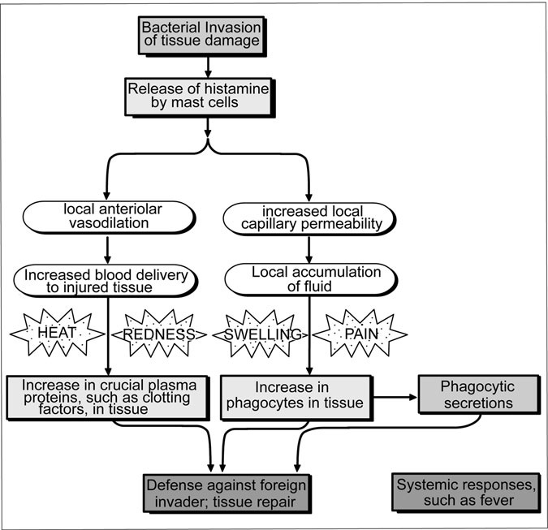

Figure 6.10 Inﬂammation and the Body’s Immune Response. The production of inﬂammation as part of the body’s immune response. (Sandy Windelspecht/Ricochet Productions)

not one single chemical or molecule, but rather a family of proteins that interfere, albeit brieﬂy, with a virus’s ability to reproduce in other cells. These proteins derive their name from the ability to interfere with viral replication. When a virus invades a cell, the cell’s genetic components prompt it to produce an interferon, which is then secreted into the extrac- ellular ﬂuid. In this way, the interferon is able to warn nearby healthy cells of the viral presence, thus helping them to prepare for resistance.

Once the interferon is in the extracellular ﬂuid, it attaches itself to receptors present on the plasma membranes of these neighboring cells, and even distant cells. While it is important to note that interferons them- selves do not have antiviral capabilities, these proteins prompt potential host cells to begin production of virus-blocking enzymes, which can break down the virus’s genetic components (including protein synthesis) that are vital for replication. These antiviral enzymes are dormant unless a virus invades their host cells, in which case the enzymes detect the virus’s genetic material (nucleic acid) and go to work. However, this activation can occur only during a limited amount of time, and therefore, it is only a temporary defense against viral infections. After this time, speciﬁed immune responses are needed, such as those that relate to antibody production.

In addition to their power against viral replication, interferons also help to boost other immune-related mechanisms, including enhancing the phagocytic behavior of macrophages and the production of antibodies. Because they have been shown to slow cell division and tumor growth, interferons also have anticancer beneﬁts, although the extent of these ben- eﬁts is still being researched.

##### Genetic and Acquired Immunity

The human body’s immune system is divided into two categories: genetic immunity and acquired immunity. Genetic immunity is determined by DNA and therefore does not involve antibodies; rather, it is the immune system that we are born with as part of our genetic composition. This is speciﬁc to a species, however, which means that some species have immunity to pathogens that are harmful to other species. For example, while the measles virus is harmful to humans, it does not affect dogs and cats because of their genetic immunity to the pathogens associated with the virus. Certain viruses that are dangerous to plants are harmless to humans because our genetic makeup protects our cells and tissues from these pathogens (see Table 6.5).

Acquired immunity involves antibody production. Within this category, there are two subcategories: passive and active immunity. While active or

TABLE 6.5

Genetic and Acquired Immunity

*Type of immunity Deﬁnition Examples*

Genetic Part of the human body’s genetic makeup (DNA); does not involve antibodies; different from other species

Acquired Involves antibody production

Passive (Natural) Transmission of antibodies through placenta from mother to fetus; antibodies from other resources; antibody transmission through breast milk from mother to baby

Passive (Artiﬁcial) Antibody injection in the form of gamma globulins or immune globulins after prior exposure

Active (Natural) Production of own antibodies; disease recovery through antibody and memory cell production

Active (Artiﬁcial) Antibody and memory cell production as a result of a vaccine

“self-generated” immunity involves the production of antibodies, passive or “borrowed” immunity is when antibodies are acquired through the direct transfer of antibodies produced by another person or animal. An example of this transfer includes the IgG antibody movement from mother to fetus through the womb’s placenta. Another example includes breast-feeding, when a mother’s milk is enriched with IgA antibodies. This is important because even though these acquired antibodies are broken down within a month, they provide that initial protection against infections while the new- born begins to develop his own immune response system, because the pro- duction of antibodies does not happen until at least one month after birth. (See Table 6.6 for a breakdown of passive and active immunity.)

In some cases, passive immunity is used in response to a lethal toxin or dangerous viral-related infectious agent, such as when someone has

TABLE 6.6

Active and Passive Immunity

*Active immunity Passive immunity*

Antigen exposure The immune system is exposed to the antigen either naturally as a result of an infection, or artiﬁcially as a result of a vaccination.

Antibody source Antibodies are produced by the body’s immune system upon exposure to an antigen.

No antigen exposure is required.

Preformed antibodies are borrowed from another source and introduced into the immune system.

Administration of antibodies

Develop time for resistance

Injection or attenuated antigen is needed for artiﬁcial active immunity.

Antibody production can occur in several weeks or days.

For artiﬁcial passive immunity, patient is injected with borrowed antibodies.

Antibody production is immediate.

Resistance time Sometimes lifelong. Only a few weeks.

been bitten by a dog afﬂicted with the rabies virus or a snake with poison- ous venom. When this occurs, the injected antibodies have been harvested from another, often nonhuman source that has produced antibodies fol- lowing exposure to the antigen in an attenuated form, which means a less potent or virulent form of the antigen. Some of the most common animals used for passive immunity procedures are horses and sheep. Because the antibody injection (or serum) is a foreign substance, the body’s immune system might launch an attack in response, which would result in an aller- gic reaction.

##### Vaccines and Immunity

While active immunity is the production of one’s own antibodies, it may be done naturally, or even stimulated through artiﬁcial means. Once a per- son has recovered from a disease, such as chickenpox, his body now has speciﬁc antibodies and memory cells that will activate if that disease’s pathogens enter the body again. This is called naturally acquired active

immunity. Vaccines help bring about artiﬁcially acquired active immunity, because the mechanism stimulates the production of memory cells in addition to antibodies against a disease.

The vaccine mechanism was invented by Edward Jenner, a British physician in 1797, when he found that patients could become immune to the devastating effects of the smallpox disease (which had a mortality rate of 40 percent) through exposing or inoculating patients with small amounts of the cowpox disease, which is a weaker form of the smallpox disease.

The goal of vaccination, which begins soon after birth for infants, is to equip the body with active immunity by creating a memory system that calls on B and T cells to defend the body when recognizable disease- causing agents enter the blood and lymphatic system. Usually injected through a needle, a vaccine contains a weakened, or attenuated, form of a speciﬁc disease-causing germ. In some cases, the vaccine will contain an inactivated form of the germ, which will produce the toxins associated with the disease upon entering the bloodstream.

Once in the body, the immune system produces antibodies against these germs. Because these germs are weakened or dead, they are often not strong enough to make the patient sick, but just strong enough to stimulate the immune system to produce antibodies. It is important to note, however, that just like any medical procedure, there are risks associ- ated with vaccines. Some people have an allergic or other adverse reaction to certain vaccines, although the chances are minimal. Once these antibod- ies are ﬂoating around in the body, memory cells are formed. Both anti- bodies and these memory cells are then on alert in case the disease- related germ or pathogen invades the body at a later date.

Vaccines come in different forms. Some are used in combinations, such as the DTP (diphtheria, tetanus, pertussis) and the MMR (measles, mumps, rubella) vaccines that children receive during their early years to boost their immune systems. Vaccines can be produced from three types of microbe- related materials: inactivated (killed), attenuated (live), and synthetic (pro- duced in a laboratory). In the ﬁrst type, inactivated vaccines are produced by killing the disease-causing microbe through chemical means, making them stable. Most inactivated vaccines stimulate a rather weak immune response in patients; therefore, the vaccines must be given several times. Examples of inactivated vaccines include those for cholera and hepatitis A.

Live and synthetic vaccines are produced in a laboratory setting in order to eliminate its viral and disease-causing characteristics. Unlike inactivated forms, these vaccines produce both cell-mediated and antibody-mediated immunity, and usually require only one dose. Examples of these vaccines include those for yellow fever, measles, rubella, and mumps.

Another kind of vaccine formulation is a toxoid. A toxoid contains an inactivated form of a toxin, which is the harmful substance produced by a microbe. In general, microbes are not dangerous or disease-causing, although some toxins emitted by microbes can cause illness. For example, in a normal environmental setting with plenty of oxygen, the bacterium associated with tetanus is harmless. But when this bacterium is in an envi- ronment without oxygen, the bacterium produces a poisonous toxin. These potent toxins are treated with materials, such as a sterile water and formaldehyde solution called formalin, which inactivates these toxins. Diphtheria and tetanus vaccines use toxoids.

#### Summary

One of the human body systems’ most important—and difﬁcult—jobs is to protect the body against the myriad of organisms that threaten its health and homeostasis. While each of the human body systems has its own defense mechanisms, the duty to protect the body against dangerous invad- ers falls primarily to the lymphatic system. This system contains special- ized cells called lymphocytes that detect threatening organisms and put into motion an immune response that eliminates them from the body. The immune response also protects the rest of the body against free pathogens and cells that might already have been infected. In addition, this response mechanism actually remembers the infection for future defense purposes; if the invading organism enters the body again, protection will be in place. Unlike other systems in the human body, there are only a few primary and secondary organs in the lymphatic system. The bone marrow and thymus are the primary organs, while the secondary organs include the

spleen, tonsils, adenoid, Peyer’s patches, and appendix.

*This page intentionally left blank*

Glossary

Abduction Withdrawal of a part of the body from the body’s axis.

ABO group The name of the genetic system that determines human blood groups. Named for the presence of A and B carbohydrates on the surface of the cell, or the absence of the carbohydrates in the case of the O group. This system uses four possible combinations: A, B, AB, or O.

Acetylcholine (ACh) A neurotransmitter released in the central and peripheral nervous system, speciﬁcally at neuromuscular joints.

Acetyl Coenzyme A (acetyl CoA) A molecule that enters the citric acid cycle to produce energy. The acetyl CoA can come from sugars that have gone through glycolysis, or it can come directly from fats or proteins in the cell.

Acidosis An abnormal increase in the acidity of the body’s ﬂuids.

Acquired Immunity A type of immunity that is not the result of genetic inheritance, but rather due to the exposure to some antigen and the result- ing response by the immune system.

Actin One of the major proteins involved in muscle contraction. Actin proteins form a long ﬁber within the muscle contractile unit. Myosin, the other major protein involved in muscle contraction, attaches to the actin ﬁlaments and pulls the muscle shorter.

Action Potential A change in the electrical charge of a nerve cell follow- ing the transmission of a nerve impulse.

Adaptation The state of sensory acclimation in which the sensory aware- ness diminishes despite the continuation of the stimulus.

Adduction Movement of a limb toward the median line of the body.

273

Adenosine Diphosphate (ADP) A chemical substance produced through digestion and used in cell respiration and energy production.

Adenosine Triphosphate (ATP) A chemical substance produced from aerobic cell respiration that is the muscle’s direct source of energy for movement.

Adipocytes Cells that have large holes ﬁlled with fat.

Adipose Capsule The central layer surrounding the kidney, composed of fatty tissue.

Adrenal Glands The hormone-releasing glands located above the kidneys.

Adrenaline Also known as epinephrine, a hormone produced by the adre- nal glands that helps regulate the sympathetic division of the autonomic nervous system. During times of stress or fear, the body produces addi- tional amounts of adrenaline into the bloodstream, causing an increase in blood pressure and cardiac activity.

Adrenocorticotropic Hormone (ACTH) Hormone produced by the pituitary gland, which stimulates the release of hormones from the adrenal cortex. Also called corticotropin.

Aerobic Anything having to do with acquiring oxygen from the air.

Aerobic Cell Respiration A chemical process that allows the cell to pro- duce energy from glucose and oxygen.

Aerobic Exercise Exercise in which energy is made by processes invol- ving oxygen. Types of aerobic exercise include swimming, biking, and jogging.

Afferent Nerves Fibers coming to the central nervous system from the muscles, joints, skin, or internal organs.

Afferent Vessels A form of vessel that brings ﬂuid towards an organ or lymph node.

After-image An image of a visual nature that exists even after the visual stimulus has ceased.

Agglutination The clumping of blood. This can occur if a patient with a certain blood type is given blood of another type.

Agonists Hormones that bind to their receptor and elicit a speciﬁc biologi- cal response.

Albumin The most abundant plasma protein. It makes up 55 percent of the total protein content of plasma. It is involved in maintaining blood vol- ume and water concentration.

Aldosterone A hormone secreted by the adrenal glands in the kidneys that increases sodium reabsorption.

Alkaline A term used to indicate a pH of 7 or greater. Sometimes also called basic.

Allele A variation of a gene that encodes for a speciﬁc trait. It is usually due to minor variations in the DNA at the molecular level.

Allergies Hypersensitive reaction to a particular substance or allergen; symptoms vary in intensity.

Alveoli Tiny air sacs in the lungs. They exchange oxygen and carbon dioxide between the lungs and the blood.

Amino Acids The building blocks of proteins.

Amphiarthrosis Joint that permits only slight movement.

Amphiphatic Molecules A term given to a molecule that has both hydro- philic and hydrophobic properties.

Anaerobic Exercise Exercise in which energy is made by processes that do not involve oxygen. Types of anaerobic exercise include weight lifting and sprinting.

Androgens Male sex hormones produced by the gonads and adrenal cortex.

Anemia A reduction in the number of red blood cells in the body, result- ing in an insufﬁcient number of hemoglobin molecules to carry oxygen to the tissues of the body. This may result in tissue color changes, weak- ness, and increased susceptibility to disease.

Anions Negatively charged particles.

Annulus Fibrosus A ring of ﬁbrous connective tissue that serves as an anchor for the heart muscle and as an almost continuous electrical barrier between the atria and ventricles.

Antagonistic Muscle Pair Two muscles that have an opposite action, such as the muscle that bends the arm and the muscle that straightens the arm. The antagonistic pair controls and stabilizes the elbow as it bends and straightens.

Antagonists Hormones that bind to the receptor but do not trigger a bio- logical response. By occupying the receptor, an antagonist blocks an ago- nist from binding and thus prevents the triggering of the desired effect within the cell.

Anterior Situated in front; at or toward the head end of a person or animal.

Anterior Pituitary The lobe of the pituitary that secretes hormones that stimulate the adrenal glands, thyroid gland, ovaries, and testes.

Antibody Proteins that attack antigens.

Antidiuretic Hormone (ADH) Hormone produced by the pituitary gland that increases the permeability of the kidney ducts to return more ﬂuid to the bloodstream. Also called vasopressin.

Antigens Invading organisms and materials that enter the human body. The body may mount a defense with antibodies.

Antioxidants Compounds that prevent oxidative damage to organic mole- cules. Vitamins C and E are examples of antioxidant nutrients, as is the min- eral selenium.

Aorta The largest artery in the human body. It supplies oxygenated blood from the left ventricle of the heart to the branching arteries, which in turn supply oxygen to all parts of the body.

Aortic Arch A large, rounded section of the aorta that occurs above the heart, just after the aorta leaves the right ventricle.

Aortic Bodies Chemoreceptors found in the aortic arch, the curved por- tion between the ascending and descending parts of the aorta.

Appendectomy The surgical procedure that is used to remove an inﬂamed,

diseased, or ruptured appendix.

Appendicitis An inﬂammation of the appendix. This is usually caused by an infection of the appendix and results in fever, pain, and loss of appetite.

Appendicular Skeleton The skeletal structures composing and support- ing the appendages; these include the bones of the shoulder and hip girdles as well as those of the arms and legs.

Arterial Baroreceptor Reﬂex The mechanism that provides oversight and maintenance of the blood ﬂow by responding to slight changes in blood pressure.

Arterial System The portion of the circulatory system that delivers oxygen-rich blood to the body tissues.

Arteries Larger blood vessels that deliver oxygen-rich blood to the body tissues.

Arterioles Smaller blood vessels that deliver oxygen-rich blood to the body tissues.

Arteriovenous Anastomoses Blood vessels that directly connect arte- rioles to venules. Commonly, blood travels from arterioles to capillaries to venules. Arteriovenous anastomoses are typically found in only a few tissues.

Arthritis An inﬂammation of the joints.

Asexual Reproduction Reproduction in which genetically identical off- spring are produced from a single parent.

Atherosclerosis Also known as hardening of the arteries. It is a narrowing of arterial walls caused by deposits, collectively called plaque, that create rough, irregular surfaces prone to blood clots.

Atria Plural of atrium.

Atrium In the human heart, it is one of the heart’s two upper chambers. The plural form is atria.

Autocatalytic Process A chemical reaction in which the products of the reaction are responsible for initiating the start of the reaction.

Autocrine The action of a hormone on the cells that produced it.

Autoimmune A term used to describe an immune response to the patient’s own body. An autoimmune disease is therefore one that attacks part of the patient’s body.

Autoimmune Disease This occurs when the immune system incorrectly identiﬁes the tissues of the body as foreign material, and begins an immune response against the cells or tissue. Lupus and forms of diabetes may be caused by an autoimmune response.

Autonomic Nervous System The part of the nervous system that controls involuntary actions and rules the variations of the heart rate.

Axial Skeleton The central supporting portion of the skeleton, composed of the skull, vertebral column, ribs, and breastbone.

Axon A single nerve ﬁber that carries impulses away from the cell body and the dendrites.

B Cells Also known as B lymphocytes. They are one of two main types of lymphocyte, and participate in the body’s immune response.

B Lymphocytes *See* B Cells.

Baroreceptors Pressure detectors located in the major arteries. Part of the arterial baroreceptor reﬂex, they sense a dip or spike in blood pressure.

Basilar Artery A blood vessel that arises from the vertebral arteries and joins with other cerebral arteries to form the circle of Willis.

Basophil A type of granulocyte that appears to be active in the inﬂammatory process.

Bayliss Myogenic Response The mechanism by which smooth muscle cells impart muscle tone to the blood vessels.

Bilirubin A waste product produced by the liver that is the result of the breakdown of red blood cells. It is released into the small intestine, but some is reabsorbed back into the blood and excreted with the urine.

Binucleate Cell A cell that contains two nuclei.

Bioavailability A term of nutritional analysis that indicates how much of a nutrient in a food is actually available to the body for absorption by the gastrointestinal tract.

Biomarker A molecular clue indicating the presence of disease or the genetic predisposition for disease.

Biomolecule A general classiﬁcation for any of the four groups of organic molecules that are used in the building of cells—proteins, carbohydrates, lipids, and nucleic acids.

Bipedal An animal that walks on two feet.

Bladder A hollow, muscular organ that stores urine for elimination.

Blastocyst An embryonic stage following the morula stage characterized by outer trophoblast cells, an inner cell mass, and a central, ﬂuid-ﬁlled cavity.

Blood The ﬂuid that contains the plasma, blood cells, and proteins and carries oxygen, carbon dioxide, nutrients, waste products, and other mole- cules throughout the body.

Blood Cells Cells contained in the plasma of the blood. *See also* Red Blood Cells and White Blood Cells.

Blood Pressure The force of the blood against the walls of the blood vessels.

Blood Sugar Level The amount of glucose in the blood.

Blood Type A form of blood, determined by the presence or absence of chemical molecules on red blood cells. A person may have type A, B, O, or AB blood.

Blood Vessels Also known as the vasculature. These are the tubes of the circulatory system that transport the blood throughout the body.

Bohr Effect High concentrations of carbon dioxide and hydrogen ions in the capillaries in metabolically active tissue that decrease the afﬁnity of hemoglobin for oxygen and leads to a shift to the right in the oxygen dis- sociation curve.

Bolus The name given to the mass of food that accumulates at the rear of the oral cavity for swallowing.

Bone Marrow The site in the body where the cells of the lymphatic system originate.

Bowman’s Capsule The bulb surrounding the glomeruli. It provides an efﬁcient transfer site for water and waste products to move from the blood to the urinary system.

Brachial Artery The blood vessel in the upper arm that accepts blood from the subclavian artery by way of the axillary artery, and travels down the arm to supply the ulnar, radial, and other arteries of the forearm.

Brachial Vein The blood vessel that collects blood from the ulnar vein and empties into the axillary vein.

Brachiocephalic Artery Also known as the innominate artery. This short blood vessel arises from the aortic arch, and branches into the right common carotid artery and the right subclavian artery.

Brachiocephalic Veins Also known as the innominate veins. This pair of veins arises from the convergence of the internal jugular and subclavian veins and ﬂows into the superior vena cava.

Brain Other than the spinal cord, the primary organ in the nervous system.

Brain Stem This area of the brain connects the cerebrum with the spinal cord and is also the general term for the area between the thalamus and the spinal cord, which includes the medulla and pons.

Bronchi The two large air tubes leading from the trachea to the lungs that convey air to and from the lungs.

Bronchial Vein One of two main blood vessels that collect newly oxygen- ated blood from the bronchi and a portion of the lungs, and deliver it through one or more smaller veins to the superior vena cava.

Bronchiole Any of the smallest bronchial tubes that end in alveoli.

Buccal Cavity Another term commonly used to describe the oral cavity. It technically represents the space between the back of the teeth and gums to the rear of the mouth.

Bundle of His A thick, conductive tract located in the heart that transmits the electrical signal from the AV node to the Purkinje ﬁbers in the base of the ventricle wall.

Bursa A sac of ﬂuid within a joint.

Calcitonin Hormone produced by the thyroid gland that inﬂuences cal- cium and phosphorous levels in the blood.

Calcitrol A hormone secreted by the kidneys that increases the levels of calcium and phosphorous in the blood.

Calorie A measure of how much energy food contains.

Cancellous Bone Bone that has a latticework structure, such as the spongy tissue in the trabecular bone.

Capillaries The tiniest blood vessels. They are the sites of exchange: At body tissues, blood in the capillaries delivers oxygen and nutrients, and

picks up carbon dioxide and waste products; and at the lungs, blood in the capillaries drops off carbon dioxide and picks up oxygen.

Carbon Monoxide Poisoning A medical condition arising when a person is exposed to carbon monoxide gas. Prolonged exposure can be fatal.

Cardiac (Heart) Muscle The type of muscle found in the heart.

Catecholamines A class of hormone (including epinephrine and norepi- nephrine) synthesized in the adrenal medulla that is involved in the body’s stress response.

Cation A positively charged particle.

Cell Body Main mass of the neuron that contains the nucleus and organelles.

Central Nervous System Division of the nervous system that contains the brain and the spinal cord.

Cerebellum Located towards the back of the medulla and pons, this por- tion of the brain is in charge of many subconscious aspects of skeletal muscle functioning, such as coordination and muscle tone.

Cerebral Aqueduct The tunnel that runs through the midbrain, allowing cerebrospinal ﬂuid to travel from the third to the fourth ventricle.

Cerebral Cortex This area of the brain is the gray matter located on the surface of the cerebral hemispheres. The cerebral cortex includes the brain’s motor, sensory, auditory, visual, taste, olfactory, speech, and associ- ation areas.

Cerebrospinal Fluid (CSF) The ﬂuid in the spinal cord’s central canal that serves as the ﬂuid for the central nervous system. This tissue ﬂuid cir- culates in and around the brain.

Cerebrum This is the largest portion of the brain and consists of the left and right cerebral hemispheres. The cerebrum controls movement, sensa- tion, learning, and memory.

Chemoreceptors Cells that respond to changes in their chemical environ- ment by creating nerve impulses. Some chemoreceptors in the brain respond to carbon dioxide levels in the blood to help regulate breathing.

Chemotaxis The reaction of mobile cells to a chemical gradient; the cells may move either towards or away from the gradient depending on the nature of the chemical being used.

Chloride Shift Describes the exchange of negatively charged chloride ions for negatively charged bicarbonate ions across an erythrocyte’s cell membrane.

Cholesterol A fatlike substance that occurs naturally in the body. Two types exist: high-density lipoprotein (HDL) and low-density lipoprotein (LDL).

Chondrocytes Cartilage cells.

Chordae Tendineae Tiny tendinous cords located at each of the heart valves. They attach to nearby muscles and prevent blood backﬂow through the valves.

Choroid Plexus This capillary network helps form the cerebrospinal ﬂuid in the brain.

Chromatin A diffuse mixture of DNA and proteins that condenses into chromosomes prior to cell division.

Chromosomes Cellular structures composed of proteins and DNA that carry the body’s hereditary information.

Cilia Hairlike projections from the surface of a cell. In the respiratory sys- tem, cilia help ﬁlter out foreign particles from the air before they reach the lungs.

Circadian Rhythm The body’s 24-hour biological cycle that regulates certain activities, such as sleep, regardless of environmental conditions, including lightness and darkness.

Circle of Willis A vascular structure that supplies blood to the brain. It arises from the basilar, internal carotid, and other arteries.

Circulatory System The heart, blood vessels, and blood.

Circumcision The surgical removal of the foreskin. The term is also sometimes used with reference to females to describe a controversial and excruciating practice of genital mutilation that is common in certain soci- eties around the world.

Citric Acid Cycle A chemical reaction that takes place in the mitochon- dria. The cycle produces some energy for the cell and produces products that can be used to produce large amounts of energy through oxidative phosphorylation.

Colic Arteries Divided into right, left, and middle colic arteries, all of which branch from either the inferior or superior mesenteric arteries, and feed the colon.

Collagen The albumin-like substance in connective tissue, cartilage, and bone.

Collecting Duct Where ﬂuid is carried from the distal convoluted tubule (DCT) in the nephron of the kidneys on its way to the minor calyx.

Colostrum Nutritious ﬂuids secreted by the breasts shortly before and after a woman gives birth; precedes the production of breast milk.

Common Carotid Arteries One of two major blood vessels that supply the head. The left carotid splits directly from the aortic arch between the bases of the two coronary arteries. The right carotid indirectly branches from the aorta via the brachiocephalic artery.

Complement The collective term for a variety of beta globulins. *See also*

Globulins.

Complement Fixation The process by which complement factors bind to either antibodies or cell surfaces during the immune response.

Complementary Base Pair Nucleotide bases (adenine and thymine or guanine and cytosine) that pair up via hydrogen bonds in DNA.

Compression Forces Forces that squeeze items together; blows that press against the body.

Computed Tomography (CT) Scan A commonly used tool for determin- ing the nature of a stroke.

Concentration Gradient The change in solute concentration from one location to another. Unless restricted, solutes will move from a site of higher solute

concentration to one of lower solute concentration, leading to an equi- librium between the two sites.

Concentric Contraction The type of contraction that occurs when a muscle contracts and grows shorter, such as the biceps muscle when bend- ing the elbow.

Conchae Structures or parts that resemble a seashell in shape with three bony ridges or projections—the superior, middle, and inferior conchae— on the surface of the nasal cavity sides.

Contraceptive An agent that prevents ovulation, kills sperm, or blocks sperm from reaching the ovum for fertilization.

Convergence An impulse pathway where a neuron receives impulses from the nerve endings of thousands of other neurons but transmits its message to only a few other neurons.

Coronal Plane Divides the body into front and back portions.

Coronary Arteries Arising from the base of the aorta, these are the two major arteries that feed the heart muscle. The right coronary artery remains a single, large vessel, but the left coronary artery almost immedi- ately splits into transverse and descending branches.

Coronary Circulation The circulatory system of the heart.

Corpus callosum A band of white matter connecting the cerebral hemispheres.

Corpus luteum Progesterone-secreting tissue that forms from a rup- tured Graaﬁan follicle in the mammalian ovary after the egg has been released.

Cortex The tissue layer that covers the brain.

Cortical Bone The hard, dense bone that forms the outer shell of all bones.

Corticotroph Cell in the anterior pituitary gland that secretes corticotropin (ACTH).

Cortisol A steroid hormone produced by the adrenal cortex that inﬂuences the body’s stress response.

Cranial Nerves The brain’s 12 pairs of nerves located in the peripheral nervous system.

Craniosacral Division Another name for the parasympathetic division of the autonomic nervous system. In this division, all the cell bodies of pre- ganglionic neurons are located in the brain stem and sacral segments of the spinal cord.

Cranium The bones of the skull that house the brain.

Creatinine Waste produced by the breakdown of creatine phosphate in muscles.

Creatine Phosphate A molecule stored in the muscle that can quickly replenish ATP during a sudden burst of exercise.

CT Scan *See* Computed Tomography (CT) Scan.

Cuboid Bones Bones in the wrist that are shaped like cubes.

Cutaneous Senses The skin’s sensory mechanisms whose receptors are located in the dermis.

Cytochromes A class of membrane-bound intracellular hemoprotein res- piratory pigments. These enzymes function in electron transport as car- riers of electrons.

Cytokines Signaling peptides secreted by immune cells and other types of cells in response to infection or other stimuli.

Cytoplasm Cellular material located between the nucleus and cell membrane.

Daughter Cells Cells arising from mitotic division that are identical to the parent cell.

Deglutition Another term used for the act of swallowing.

Dehydration Synthesis A form of chemical reaction that involves the removal of water to form a chemical bond. Also called a condensation reaction.

Dentin A tissue that is the majority of the mass of a tooth. It consists pri- marily of minerals (70 percent), with the remainder being water and organic material.

Depolarization When the electrical charges in a nerve cell reverse due to a stimulus. The rapid infusion of sodium ions causes a negative charge outside and a positive charge inside the cell membrane.

Detrusor Muscle Three layers of smooth muscle surrounding the mucosa of the bladder.

Diaphragm A muscle that aids in respiration. It separates the thoracic cavity from the abdominal cavity.

Diaphysis The central shaft of a bone.

Diastole The heart’s resting period.

Diathroses Joints allowing free movement.

Diffusion The passive ﬂow of molecules from one location to another.

Diploid Cells Any organism whose cells contain two copies of each chromosome. The majority of human cells, except sex cells and some liver cells, are diploid.

Dislocation Condition when a bone is moved out of a joint.

Distal Indicates direction away from the torso.

Distal Convoluted Tubule (DCT) Located between the loop of Henle and the collecting duct inside the nephron of the kidney.

Diuretic A substance (i.e., caffeine) that increases urine production.

Divergence An impulse pathway where a neuron receives impulses from a few other neurons and relays these impulses to thousands of other neurons.

DNA A nucleic acid that contains a cell’s genetic or hereditary information.

Dopamine A neurotransmitter found in the motor system, limbic system, and the hypothalamus.

Dorsal Root The sensory root of a spinal nerve that attaches the nerve to the posterior part of the spinal cord.

Dorsal Root Ganglion An enlarged portion of the spinal nerve’s dorsal root that contains the sensory neuron’s cell bodies.

Down Syndrome Mental retardation associated with speciﬁc chromoso- mal abnormalities.

Dura Mater This ﬁbrous connective tissue is the outermost layer of the brain’s meninges.

Eccentric Contraction The type of contraction that occurs when a muscle contracts but the overall muscle grows longer rather than shorter; an eccentric contraction occurs in the biceps which contracts to control the arm as it extends, but the muscle grows longer rather than shorter.

Effector A muscle, gland, or other organ that responds after receiving an impulse.

Efferent Nerves Fibers leaving the central nervous system carrying mes- sages to the muscles, joints, skin, or internal organs.

Efferent Neuron Nerve cells that carry impulses and messages away from the spinal cord and brain to the muscles and glands.

Efferent Vessels A vessel of the lymphatic or circulatory systems that car- ries ﬂuid away from an organ or lymph node.

Eicosanoids Compounds derived from fatty acids that act like hormones to inﬂuence physiologic functions.

Elastin A protein of blood vessels that imparts elasticity.

Electrocardiogram (ECG or EKG) The product of an electrocardio- graph, it is a printout depicting the heart’s electrical activity. An ECG has ﬁve parts, each signiﬁed with the letter P, Q, R, S, or T, that reﬂect dif- ferent phases in the heart activity.

Electrocardiograph (ECG or EKG) A device that records the heart’s electrical activity as a jagged line on a sheet of paper, which is called an electrocardiogram.

Electrolyte A charged particle like calcium (Ca2+) or magnesium (Mg2+) that may have a number of functions in cells.

Electron Transport System A complex sequence found in the mitochon- drial membrane that accepts electrons from electron donors and then passes them across the mitochondrial membrane creating an electrical and chemical gradient.

Embryogenesis The entire process of cell division and differentiation leading to the formation of an embryo.

End-diastolic Volume The amount of blood in a completely ﬁlled ven- tricle. In an adult, this is typically about 0.12 quarts (120 ml).

Endocardium The membrane lining the heart.

Endocrine System The body’s organ system that controls hormone secretion.

Endothelium In blood vessels, it is also known as the tunica intima. The tunica intima forms the innermost layer of blood vessels.

Eosinophil A type of granulocyte that appears to be active in the modera- tion of allergic responses and the destruction of parasites.

Epiblast The outer layer of a blastocyst before differentiation into the ectoderm, mesoderm, or endoderm.

Epidemic A widespread outbreak of an infectious disease that affects a disproportionately large number of people within a given population.

Epinephrine *See* Adrenaline.

Epiphysis The portion of bone attached to another bone by a layer of cartilage.

Epithelial Cell A type of cell that lines organs and tissues of the body. It specializes in the exchange of materials with the external environment, such as the lumen of the gastrointestinal tract.

Epitope The speciﬁc area of an antigen to which the B cell receptor binds. Equilibrium Balance mechanisms that are regulated by inner ear structures. Erythroblast An early stage in red blood cell development.

Erythrocytes Red blood cells.

Erythropoietin A protein hormone produced by the kidneys that stimu- lates red blood cell production.

Estrogen Any of a family of hormones produced by the female ovaries that determine female sexual characteristics and inﬂuence reproductive development.

Excitatory Nerve/Fiber A nerve ﬁber that passes impulses on to other ﬁbers.

Excitatory Synapse The passing of an impulse transmission to other synapses.

Exocrine Glands Glands that utilize ducts to release their secretions to the outside environment.

Extension A stretching out, as in straightening a limb.

External Urethral Sphincter Ring of voluntary muscle surrounding the end of the urethra, which regulates urine ﬂow out of the body.

Extracellular Fluid The water found outside a cell that contains plasma and other tissue ﬂuids.

Extrinsic Factors Another term used for vitamin B12 in the diet.

Facilitated Diffusion A passive process that utilizes a membrane-bound protein to move a compound across a membrane down its concentration gradient.

Fascia The connective tissue surrounding an entire muscle. The fascia becomes part of the tendon at either end of the muscle, connecting the muscle to the bone.

Fascicle A bundle of muscle ﬁbers within the muscle surrounded by a tis- sue called the perimysium. Each muscle is made up of many fascicles.

Fast-twitch Muscle A type of muscle ﬁber that is able to contract very quickly. These ﬁbers are predominantly found in muscles that must con- tract quickly and with great strength but do not need to contract over a long period of time.

Femoral Artery Arising from one of the two external iliac arteries, the femoral artery traverses the thigh to the popliteal artery.

Femoral Vein A large blood vessel in the thigh that collects blood from the popliteal vein and great saphenous vein and delivers it to the external iliac vein.

Fibrinogen A protein in plasma. It functions in blood clotting.

Fibular Vein *See* Peroneal Veins.

Flavoproteins The enzymes that contain ﬂavin bound to a protein. Flavo- proteins play a major role in biological oxidations.

Flexion The bending of a joint or of body parts having joints.

Follicle-stimulating Hormone (FSH) A hormone produced by the ante- rior pituitary gland that triggers sperm production in the testes and stimu- lates the development of follicles in the ovaries.

Fossa A hole or indentation.

Fossae The plural form of fossa.

Gametes Reproductive cells that, before fusing at fertilization, are haploid—they contain 23 instead of 46 chromosomes.

Gas Exchange In the respiratory system, gas exchange refers to the pro- cess of acquiring oxygen from the air and eliminating carbon dioxide from the blood.

Gastric Arteries Blood vessels of the digestive system. The left gastric artery stems from the celiac artery and supplies the stomach and lower part of the esophagus. The right gastric artery stems from the common hepatic artery and eventually connects with the left gastric artery.

Gastric Inhibitory Peptide (GIP) The gastrointestinal hormone whose main action is to block the secretion of gastric acid.

Gastric Veins Blood vessels of the digestive system. Blood from the stom- ach exits into the gastric veins, which then empty into a number of other veins that ultimately enter the portal vein (in the case of the left and right gastric veins) or the splenic vein (in the case of the short gastric vein).

Gastrin Hormone produced by the gastrointestinal system that regulates stomach acid secretion.

Gastroepiploic Arteries Blood vessels of the digestive system. The right gastroepiploic artery branches from the gastroduodenal artery. The left gastroepiploic artery branches from the splenic artery. Both provide blood to the stomach and duodenum.

Gene Expression In genetics, a term describing the results of activating of a gene.

Gene Transcription The process by which a strand of DNA is copied to form a complementary RNA strand.

Genetic Immunity A form of immunity to a pathogen that is inherited.

Genetic Imprinting Refers to differences in the way maternal or paternal genes are expressed in the offspring.

Genetic Sex Gender determination based on an XX or an XY chromo- some conﬁguration.

Glia Support cells in the brain.

Globulins Plasma proteins that function as transportation vehicles for a variety of molecules, in blood clotting and/or in the body’s immune responses. They are

divided into three types alpha, beta, and gamma globulins.

Glomerular Capsule A cup-shaped sac that surrounds glomeruli of the nephrons.

Glomerular Filtrate The product of blood ﬁltration in the nephrons of the kidneys.

Glomeruli Clusters of capillaries in the kidneys.

Glomerulus The singular form of glomeruli.

Glossopharyngeal Nerve The mixed nerve in the throat and salivary glands that contains sensory ﬁbers for the throat and taste from the pos- terior one-third of the tongue.

Glucose A form of sugar that is a necessary component (along with oxy- gen) in cell respiration.

Glucose Tolerance Test A test measuring blood sugar levels that is often used to diagnose diabetes.

Glutamate A neurotransmitter associated with pain-related impulses.

Glycogen A storage form of carbohydrate. The liver converts fats, amino acids, and sugars to glycogen, which functions as a reserve energy supply for the body.

Glycogenolysis The breakdown of glycogen in the liver and in muscle tissue.

Glycolysis The process of breaking down glucose into two molecules of pyruvate. Glycolysis produces some energy for the cell and is the primary way of producing energy during anaerobic exercise.

Glycoprotein An organic compound composed of a joined protein and carbohydrate.

Goblet Cell An epithelial cell that secretes mucus.

Gonadotroph A cell in the anterior pituitary gland that secretes luteiniz- ing hormone and follicle-stimulating hormone.

Gonadotropins Hormones (luteinizing hormone and follicle-stimulating hormone) released by the anterior pituitary gland that stimulate the ovaries and testes.

Graft Rejection The tendency of the immune system to reject trans- planted tissue as foreign.

Granulocyte The most abundant type of white blood cell. *See also*

Basophil, Eosinophil, and Neutrophil.

Gray Matter Nerve tissue located in the central nervous system contain- ing cell bodies of neurons.

Growth Factors Proteins that act on cells to stimulate differentiation and proliferation.

Growth Hormone Hormone secreted by the anterior pituitary gland that promotes bone and muscle growth and metabolism.

Growth Hormone-Releasing Hormone (GHRH) A hormone that stimu- lates the anterior pituitary gland to secrete the growth hormone (GH).

Gyri Folds or ridges in the cerebral cortex.

H Zone The space between the two sets of actin ﬁlaments in the center of the sarcomere. The H zone grows smaller when the sarcomere contracts, and the actin ﬁlaments slide toward each other in the center of the sarcomere.

Haldane Effect A high concentration of oxygen, such as occurs in the alveolar capillaries of the lungs, that promotes the dissociation of carbon dioxide and hydrogen ions from hemoglobin.

HDL *See* High-density Lipoprotein (HDL).

Heart The muscular pump that powers the circulatory system.

Heart Attack Also known as a myocardial infarction, this condition hap- pens when the supply of oxygen to a portion of the heart muscle is cur- tailed to such a degree that the tissue dies or sustains permanent damage.

Heart Failure A condition in which the heart can no longer carry out its pumping function adequately, resulting in slow blood circulation, poorly oxygenated cells, and veins that hold more blood.

Hematopoeisis The formation and maturation of blood cells.

Hematuria Blood in the urine.

Heme Group A ringlike chemical structure that is part of hemoglobin.

Hemes The deep-red organic pigment that contains iron and other atoms to which oxygen binds in blood hemoglobin. Hemes are found in most oxygen-carrying proteins.

Hemoglobin A large chemical compound in red blood cells that imparts their red color and also participates in transporting oxygen and carbon dioxide.

Hemolysis The rupture and destruction of red blood cells.

Hepatic Arteries The blood vessels supplying the liver and other organs. The common hepatic artery arises from the celiac trunk and supplies the right gastric, gastroduodenal, and proper hepatic arte- ries. The proper hepatic artery supplies the liver by way of the cystic artery.

Hepatic Portal System The name given to the portion of the circulatory system that connects the stomach and both intestines to the liver.

Hepatic Vein The blood vessel that collects blood from the liver and delivers it to the inferior vena cava.

High Blood Pressure A medical condition that arises when the pressure of the blood against the blood vessel walls exceeds normal limits. It results from a narrowing of the arterioles.

High-Density Lipoprotein (HDL) Often called the type of chole- sterol curtails the accumulation of low-density lipoprotein in blood vessels.

Hilius The curved notch on the side of each kidney near the center where blood vessels enter and exit the kidney.

Histones Proteins associated with gene expression.

Homeostasis The regulation of the body’s internal environment to main- tain balance.

Homologous In genetics, chromosomes (one from the male parent, one from the female parent) carrying alleles for similar traits, such as eye color, that pair up during meiosis.

Hormone A chemical compound, often called a chemical messenger, that the brain and other organs use to communicate with the cells.

Huntington’s Chorea A progressive and fatal disease affecting the nerv- ous system.

Hydrolysis In chemistry, the breaking of a chemical bond by the addition of water.

Hydrophilic A water-loving compound, meaning that it is soluble in water. An example is glucose.

Hydrophobic A water-fearing compound, meaning that is it generally insoluble in water. Most lipids are hydrophobic, as are some amino acids.

Hypernatremia Too much sodium in the extracellular ﬂuid.

Hypertension *See* High Blood Pressure.

Hypertrophy The process in which muscles grow larger in response to exercise.

Hyperventilation An increased and excessive depth and rate of breathing greater than demanded by the body’s needs; can lead to abnormal loss of carbon dioxide from the blood, dizziness, tingling of the ﬁngers and toes, and chest pain.

Hypoblast The inner layer of tissue in a developing embryo that will eventually become the digestive tract and respiratory tract.

Hypocalcemia A deﬁciency of calcium in the blood. Hyponatremia Too little sodium in the extracellular ﬂuid. Hypophysis The pituitary gland.

Hypothalamic-Hypophyseal Portal System The circulation sys- tem through which neurohormones from the hypothalamus travel directly to the anterior pituitary gland without ever entering the general circulation.

Hypothalamic-Pituitary-Target Organ Axis A multiloop feedback sys- tem that coordinates the efforts of the hypothalamus, the pituitary gland, and the target gland.

Hypothalamus This part of the brain regulates body temperature and pituitary gland secretions. The hypothalamus is located superior to the pituitary gland and inferior to the thalamus.

Hypoxia A sudden decrease in the blood’s oxygen content.

I Band The region between the Z band at the outside of the sarcomere and the end of the myosin chain that spans the center of the sarcomere.

Iliac Arteries These arise at the end of the abdominal artery. The abdomi- nal artery bifurcates into two common iliac arteries, each of which soon divides again into internal and external iliac arteries.

Iliac Veins Blood from the femoral vein collects in the external iliac vein, which joins the internal iliac vein and carries blood from the pelvis to form the common iliac vein.

Immune System A body system that includes the thymus and bone mar- row and lymphoid tissues. The immune system protects the body from for- eign substances and pathogenic organisms in the form of specialized cellular responses.

Immunity The ability of an organism not to be affected by a given disease or pathogen.

Immunoglobulins (Ig) Plasma proteins that act as antibodies. The ﬁve main types are IgA, IgD, IgE, IgG, and IgM.

Inﬂammatory Mediators Soluble, diffusible molecules that act locally at the site of tissue damage and infection.

Inhibin Hormone secreted by the ovaries and testes that inhibits the release of follicle-stimulating hormone (FSH) by the pituitary.

Inhibitory Nerve A type of nerve ﬁber that obstructs impulse transmis- sion to another ﬁber.

Inhibitory Synapse An impulse transmission obstruction due to a chemi- cal inactivator located at the dendrite of the postsynaptic neuron.

In-series Blood Circulation Also known as portal circulation. It is blood ﬂow that travels from one organ to another in series.

Insertion The end of the muscle that is usually farthest from the center of the body and usually the one that moves when the muscle contracts.

Insulin A hormone secreted by the pancreas. It allows the body cells to use energy, speciﬁcally glucose.

Insulin-like Growth Factors Substances produced in the liver and other tissues that act much like growth hormone, stimulating bone, cartilage, and muscle cell growth and differentiation.

Intercalated Disk A disk that separates two muscle ﬁbers in the heart muscle. This disk can conduct the signal to contract from one muscle ﬁber to the next. With this connection, the entire heart muscle can contract in unison.

Intercostal Muscles Found under the ribs, these muscles play a role in res- piration.

Interferons A family of drugs used to regulate the body’s immune sys- tem. They may be used for such diseases as multiple sclerosis or cirrhosis of the liver.

Interlobar Arteries Blood vessels that branch from the renal artery to disperse blood throughout the kidney and to glomeruli.

Intermediate Pituitary A lobe of the pituitary of which only vestiges remain in humans.

Intermediolateral Cell Column Located on the thoracic level of the spi- nal cord, this is an extra cell column where all presynaptic sympathetic nerve cell bodies are located.

Internal Urethral Sphincter Ring of involuntary muscle that surrounds the urethra where it meets the bladder and that controls the ﬂow of urine.

Intestinal Villi Tiny projections that line the inside wall of the small intes- tine and the uptake of nutrients by capillaries.

Intracapsular Ligaments Ligaments within the capsule at the joint.

Intracellular Fluid The water found within a cell.

Intrinsic Factors A protein released by the gastrointestinal tract that aids in the absorption of vitamin B12.

In Vitro Occurring outside the body, often used to refer to laboratory pro- cedures such as fertilization of ova within a laboratory dish.

In Vivo Occurring inside the body.

Involuntary Muscle *See* Smooth Muscle.

Ions Any element or compound that loses or gains electrons and in the process changes its net electric charge.

Islets of Langerhans Endocrine cells located in the pancreas in which the hormones insulin and glucagon are produced.

Isometric Contraction The type of contraction that occurs when a muscle contracts but the joint does not open or close, such as when pushing against a wall or pushing down on a table.

Joint The union between two bones.

Jugular Veins Blood vessels of the head and/or neck. The anterior jug- ular vein collects blood from veins of the lower face, traverses the front of the neck, and delivers the blood to the external jugular vein. The external jugular vein is a large vein that also receives blood from within the face and around the outside of the cranium, and empties into one of several veins, including the internal jugular. The internal jugular vein is the largest vein of the head and neck, and also drains blood from the brain and neck. It joins the subclavian vein to form the brachiocephalic vein.

Ketone Bodies Substances produced from fats when not enough glucose is present, which provide an alternate energy source for the brain and other tissues.

Kidneys The two bean-shaped organs that ﬁlter wastes, regulate electro- lyte balance, and secrete hormones.

Kilocalorie The amount of energy required to raise 1,000 grams of water from 14.5° to 15.5° Celsius at standard atmospheric pressure.

Lacteals The portion of the lymphatic system that is associated with the gastrointestinal system, speciﬁcally the intestines.

Lactotroph A cell in the anterior pituitary gland that secretes prolactin.

Lateral Situated on a side.

LDL *See* Low-density Lipoprotein (LDL).

Leptin A protein hormone that inﬂuences metabolism and regulates body fat.

Ligament A tough band of connective tissue that connects bones to each other.

Lipoproteins Proteins that are connected chemically to lipids and used by the digestive system to transport hydrophobic fats and lipids in the hydro- philic bloodstream.

Loop of Henle The U-shaped section between the proximal convoluted tubule and the distal convoluted tubule in the nephron of the kidney.

Low-density Lipoprotein (LDL) Often called the “bad” cholesterol. This type of cholesterol can build up on blood-vessel walls and cause health problems.

Lumbar Veins Blood vessels of the digestive system. Lumbar veins collect blood from the abdominal walls and deliver it to other veins, including the inferior vena cava.

Lumen The internal diameter of a blood vessel. It represents the open space in the vessel through which the blood ﬂows.

Luteinizing Hormone (LH) A hormone produced and secreted by the anterior pituitary gland that stimulates ovulation and menstruation in women and androgen synthesis by the testes in men.

Luteolysis The process by which the corpus luteum in the ovary degener- ates when an egg is not fertilized.

Lymph Fluid in the vessels of the lymphatic system. It is the interstitial ﬂuid that exits the capillaries and enters surrounding cells during the capillaries’ exchange function.

Lymphatic System A series of vessels that shunts excess tissue ﬂuid into the veins.

Lymph Node Filters that separate from lymph any invading organisms and other foreign materials.

Lymphocyte A type of leucocyte that detects antigens and serves in the body’s immune response. The two main types are B cells and T cells.

Macrophage White blood cells that ingest and digest bacteria, other for- eign organisms, platelets, and old or deformed red blood cells.

Magnetic Resonance Imaging (MRI) A diagnostic tool for viewing blood ﬂow and locating sites of blood-ﬂow blockage.

Major Calyx Openings in the center of the kidneys through which urine ﬂows into the renal pelvis.

Malignant A condition that becomes progressively worse or more pro- nounced over time, and which may lead to death.

Medial Toward the midline of the body.

Medulla Located above the spinal cord, this part of the brain controls vital functions such as heart rate, respiration, and blood pressure.

Medullary Cords Within a lymph node, these are areas of dense lym- phatic tissue.

Meiosis A process of cell division resulting in daughter cells containing half the number of chromosomes contained in the parent cell. In humans, this process is responsible for the generation of the sex cells, oocytes and sperm.

Meninges The membrane is composed of connective tissue that covers the brain and spinal cord and lines the dorsal cavity.

Mesenteric Arteries Blood vessels of the digestive system. The inferior and superior mesenteric arteries arise from the abdominal aorta and ﬂow into numerous arteries of the large and small intestines, and the rectum.

Mesenteric Veins Blood vessels of the digestive system. The superior mesenteric vein drains the small intestine, and the inferior mesenteric col- lects blood from the colon and rectum. Both deliver their blood to the splenic vein.

Mesentery A tissue that suspends the digestive glands within the abdomi- nal cavity. The mesentery connects to the outer layer of the gastrointesti- nal tract.

Metabolism The sum of all of the chemical reactions in a cell, tissue, organ, or organism. In nutritional terms, it frequently applies to the processing of the energy nutrients and generation of energy.

Microvilli Small outgrowths covering the intestinal villi. They increase the surface area of the villi, aiding in nutrient uptake by capillaries.

Micturition The process in which urine is released from the bladder; urination.

Midsagittal plane An imaginary line that passes through the skull and spinal cord, dividing the body into equal halves.

Mineralocorticoids A class of hormones produced by the adrenal cortex that regulate mineral metabolism.

Minor Calyx A cup-like receptacle attached to each renal pyramid in the kidney.

Mitochondria Located in the cell’s cytoplasm, these are organelles where cell respiration takes place and energy is produced.

Mitosis A process of cell division resulting in daughter cells containing the same number of chromosomes as the parent cell.

Monocyte A type of white blood cell. They become macrophages, large cells that engage in phagocytosis.

Monozygotic Refers to twins arising from one ovum.

Morula A compacted group of embryonic cells at a level of development between the zygote and blastocyst stages.

Motilin A gastrointestinal hormone that stimulates intestinal muscle con- tractions to clean undigested materials from the small intestine.

Mucociliary Pertaining to mucus and to the cilia of the epithelial cells in the respiratory system.

Mucosa A mucous membrane that lines a body cavity.

Multiple Marker Test Testing to screen for various biomarkers of dis- ease. *See also* Biomarker.

Muscle Fiber A muscle unit made up of many muscle cells that have fused together and received the signal to contract from a single nerve.

Muscle Spindle Related to the stretch reﬂex, this receptor responds to the muscle’s passive stretch and contraction. The muscle spindles are parallel with the muscle ﬁbers.

Myelin Sheath A substance composed of fatty material that covers most axons and dendrites in the central and peripheral nervous systems in order to electronically insulate neurons from one another.

Myoﬁbril The contractile unit within a muscle ﬁber that is made up of a series of contractile units called sarcomeres. Each muscle ﬁber contains many myoﬁbrils, all of which contract when the muscle ﬁber receives a signal from a nerve.

Myoglobin A molecule in the muscle that collects oxygen from the blood and delivers it to mitochondria in the muscle ﬁber.

Myosin One of the major contractile proteins making up a muscle ﬁber. Myosin proteins form chains that pull on actin ﬁlaments, causing the muscle ﬁber to contract.

Nephron The ﬁltering unit of the kidney.

Nerve A system of neurons with blood vessels and other connective tissue.

Nerve Fiber The neuron including the axon and the surrounding cells. These ﬁbers branch out at the neuron’s ending, which is known as arborization.

Nerve Plexus A combination of neurons from various sections of the spi- nal cord that serve speciﬁc areas of the body.

Nerve Tracts A neuron group that performs a common function in the central nervous system. This grouping can be ascending (sensory) or descending (motor).

Neurohormone A chemical messenger released by the hypothalamus that signals the pituitary gland to release or inhibit release of its hormones.

Neurolemma Essential to the regeneration of damaged neurons in the peripheral nervous system, this is a sheath surrounding peripheral axons and dendrites and is formed by cytoplasm and the nuclei of Schwann cells.

Neuron A nerve cell that consists of a cell body, in addition to an axon and dendrites.

Neurosecretory Cells Specialized nerve cells that transmit chemical impulses, release hormones, and serve as a link between the endocrine and nervous systems.

Neurotransmitter Chemical substances that are emitted through nerve endings to help transmit messages. In the human body, there are about 80 different neurotransmitters.

Neutrophil The most common type of granulocyte. Neutrophils are a main bodily defense mechanism against infection, and are particularly suited to engulﬁng and destroying bacteria, although they can also combat other small invading organisms and materials.

Node of Ranvier The cell region located on or between the Schwann cells.

Noradrenalin A type of neurotransmitter that transports neurons through- out the various regions in the brain and spinal cord, in addition to increas- ing the reaction excitability in the CNS and the sympathetic neurons in the spinal cord.

Norepinephrine A hormone that causes blood pressure to rise in stressful situations.

Normoblast The cells of the bone marrow that are responsible for the for- mation of the red blood cells.

Nucleus The cell’s largest organelle that contains chromosomes and hereditary material.

Occipital Lobes The most posterior part of the brain, containing the vis- ual areas.

Oligodendrocytes A type of neuroglia that forms the neuron’s myelin sheath.

Oocytes Ova that have not yet matured in the ovary; they arise from pri- mordial oogonia that develop in the fetus.

Oogenesis The formation and development of an egg in the ovary.

Oogonia Cells that arise from primordial germ cells and differentiate into oocytes in the ovary.

Opposable Thumb In primates including humans, the ability to use the thumb to touch each ﬁnger.

Opsonization The modiﬁcation of a bacterium so that it is more easily rec- ognized by the immune system, resulting in an increase in phagocytosis by macrophages.

Organelles Primary components in a cell, including the nucleus, chromo- somes, cytoplasm, and mitochondria.

Organic Molecules Molecules that contain carbon-carbon or carbon- hydrogen bonds.

Origin The end of the muscle closest to the body.

Osmoreceptors Neurons that sense ﬂuid concentrations and send a mes- sage to the hypothalamus.

Osmosis A process that seeks to equalize the water-to-solute ratio on each side of a water-permeable membrane.

Osteology The study of bones, from the Greek word osteon, meaning “bone” and the sufﬁx -ology, meaning “study of.”

Ovarian Vein One of a pair of veins serving the female reproductive system.

Oxaloacetic acid An acid formed by oxidation of maleic acid, as in metabolism of fats and carbohydrates in the Krebs cycle.

Oxidation-reduction Reaction A reaction in which there is transfer of electrons from an electron donor (the reducing agent) to an electron acceptor (the oxidizing agent). Also called the redox reaction. In the elec- tron transport system, this reaction results in molecules alternately losing and gaining an electron.

Oxidative Phosphorylation The process of combining electrons with oxygen to create water. This process also produces energy for the cell when enough oxygen is present.

Oxidization Add oxygen to or combine with oxygen, usually in chemical processes.

Oxygen Dissociation Curve A graph that shows the percent saturation of hemoglobin at various partial pressures of oxygen. The curve shifts to the right (the Bohr effect) when less than a normal amount of oxygen is taken up by the blood and shifts to the left (the Haldane effect) when more than a normal amount is taken up.

Pacemaker *See* SA Node.

Palmar Indicates the palms of the hands.

Pancreatic Polypeptide Hormone secreted by the F cells of the endocrine pancreas that inhibits gallbladder contraction and halts enzyme secretion by exocrine cells in the pancreas.

Pandemic An epidemic that occurs over a large geographic area, some- times throughout the world.

Papillary Duct A tube that drains urine from collecting ducts in the neph- ron and empties it into the minor calyx.

Paracrine The action of a hormone on neighboring cells.

Parasympathetic Nervous System Also known as the vagal system. It is one of two major divisions of the autonomic nervous system. It functions to inhibit the pacemaker and lower the heart rate. *See also* Sympathetic Nervous System.

Parathyroid Hormone (PTH) A hormone secreted by the parathyroid gland that helps maintain calcium and phosphorous levels in the body. PTH controls the release of calcium from bone, the absorption of calcium in the intestine, and the excretion of calcium in the urine. Also called parathormone.

Partial Pressure Within the circulatory system, it is a term used to describe the relative oxygen concentration in tissues. For example, hemo- globin has a differential ability to bind oxygen: It picks up oxygen when the partial pressure in surrounding tissues is high, as it is in the lungs, and drops off oxygen when the partial pressure in the surrounding tissues is low, as it is in the tissues.

Pathogens Disease-producing agents such as virus, bacterium, or other microorganisms.

Peptides A chemical that helps to join amino acids in a protein molecule.

Pericardium The two-layered membranous sac around the heart.

Perimysium Connective tissue that surrounds the bundle of muscle ﬁbers making up a fascicle.

Peripheral Nervous System Division of the nervous system that consists of the spinal and cranial nerves.

Peristaltic Action A rhythmic contraction of the muscles of the gastro- intestinal tract, most notably in the small intestine, that is responsible for moving nutrients and undigested material through the lumen towards the anus.

Peroneal Veins Also known as ﬁbular veins. They drain the lower leg and ankle, and deliver the blood to the posterior tibial vein.

pH The acidity of a solution. It is formally the measure of the hydrogen ion concentration of a solution.

Phagocytic Cell A type of cell that engulfs external particles, food, or organ- isms into its cytoplasm; the enclosed material may then be destroyed by digestive enzymes.

Phagocytosis The process of engulﬁng and destroying bacteria and other antigens.

Pharynx The rear area of the oral cavity. This area connects the respira- tory and digestive systems of the body.

Phosphate A chemical related to energy usage and transmission of genetic information in the cell.

Phospholipids A class of organic molecules that resemble triglycerides but have one fatty acid chain replaced by a phosphate group.

Pia Mater The meninges’ innermost layer, made of thin connective tissue located on the surface of the brain and spinal cord.

Pituitary Gland An endocrine gland at the base of the brain that sends out growth hormones.

Plantar Indicates the soles of the feet.

Plasma The liquid portion of blood in which red and white blood cells, platelets, and other blood contents ﬂoat.

Plasminogen A beta globulin that participates in blood clotting.

Plasticity The reorganization of the nervous system following an injury or a tissue-damaging disease.

Platelets Also known as thrombocytes. They are round or oblong disks in the blood that participate in blood clotting.

Pleura A membrane that envelops the lung and attaches the lung to the thorax. There are two pleurae, right and left, that are entirely distinct from each other, and each pleura is made of two layers. The parietal pleura lines the chest cage walls and covers the upper surface of the diaphragm, and the visceral pleura tightly covers the exterior of the lungs. The two layers are actually one continuous sheet of tissue that lines the chest wall and doubles back to cover the lungs. The pleura is moistened with a thin, serous secre- tion that helps the lungs to expand and contract in the chest.

Polarization A chemically charged state when the neuron’s membrane has a positive charge outside and a negative charge inside.

Polyploid Cells In humans, each cell has two copies of each chromosome, one maternal and one paternal. Polyploid indicates more than two chromo- somes in a cell.

Polyspermy The entrance of several sperm into an ovum.

Polyunsaturated Fatty Acids Components of dietary fats that contain at least two double bonds.

Pons The parts of the brain that are anterior and superior to the medulla. The pons regulate respiration.

Popliteal Artery A blood vessel that arises from the femoral artery and traverses the knee before dividing into the posterior and anterior tibial arteries.

Popliteal Vein A blood vessel that collects blood from the anterior and posterior tibial veins, and empties into the femoral vein.

Porphyrin A complex, nitrogen-containing compound that makes up the various pigments found in living tissues. Iron-containing porphyrins are called hemes.

Portal Circulation *See* In-series Blood Circulation.

Portal Vein A blood vessel that arises from the splenic vein and superior mesenteric vein. It empties into the liver.

Positron Emission Tomography (PET) Scan A type of brain imaging technique that shows the brain in action. In order to obtain this image, a radioactive substance (such as glucose) is injected into the brain and then followed as it moves throughout the brain.

Posterior Indicates the back of a person or mammal.

Posterior Pituitary Lobe of the pituitary gland that is an extension of the nervous system.

Postganglionic Neuron A neuron located in the autonomic nervous sys- tem that extends from a ganglion to the visceral effector.

Postsynaptic Any impulse event following transmission at the synapse.

Preganglionic Neuron A neuron located in the autonomic nervous sys- tem that extends from the central nervous system to a ganglion and then synapses with a postganglionic neuron.

Pregnenolone A steroid hormone precursor produced from cholesterol.

Preprohormone/Prohormone An inactive sequence of amino acids from which an active hormone is released.

Progesterone Steroid hormone produced in the adrenal gland, placenta, and corpus luteum that inﬂuences sexual development and reproduction.

Progestin Female hormone produced by the ovaries that inﬂuences sexual development and pregnancy.

Proglucagon Precursor molecule from which the hormone glucagon is produced.

Proinsulin The inactive precursor molecule from which insulin is formed.

Projection A sensory occurrence when the sensation is felt in the receptor area.

Prolactin A protein hormone secreted by the anterior pituitary that stimu- lates mammary gland development and milk production.

Prostaglandin Fatty acid derivatives that act much like hormones to inﬂu- ence a number of physiological processes throughout the body.

Prostate The gland surrounding the top of the urethra in men that contrib- utes nutrients to the seminal ﬂuid.

Protease A class of enzyme that is involved in the breakdown of proteins into amino acids.

Protein Complex chemical compounds that are essential to life. Prothrombin A beta globulin that participates in blood clotting. Protozoa Single-celled, eukaryotic organisms, including many parasites. Proximal Indicates direction closer to the torso.

Proximal Convoluted Tubule (PCT) Tiny tubes in the nephrons of the kidneys through which glomerular ﬁltrate passes and substances necessary to the body (i.e., water, sodium, and calcium) are reabsorbed into the bloodstream.

Pulmonary Artery The blood vessel that originates at the right ventricle, then splits into two branches. The left and right pulmonary arteries lead to the left and right lung, respectively.

Pulmonary Circulation The transit of blood from the heart to the lungs and back to the heart. Blood picks up oxygen and drops off carbon dioxide in this circulatory route.

Pulmonary Semilunar Valve The three-cusped heart valve located between the right ventricle and pulmonary artery.

Pulmonary Veins Four blood vessels that ﬂow from the lungs to the left atrium.

Purkinje Fibers A mesh of modiﬁed muscle ﬁbers located in the base of the ventricle wall. The ﬁbers receive the electrical impulse from the bun- dle of His and deliver it to the ventricle, which then contracts.

Pyruvate The end product of glycolysis.

Radial Artery A blood vessel in each lower arm that receives blood from the brachial artery and delivers it to numerous arteries of the forearm, wrist, and hand.

Radial Vein A blood vessel in each arm that collects blood from veins in the hand. It eventually merges with the ulnar vein into the brachial vein.

Receptors Proteins on the surface of cells or within cells that bind to par- ticular hormones.

Rectal Vein Blood vessels in the digestive system that drain parts of the rectum. The inferior rectal vein joins the internal pudendal vein, which ﬂows into the internal iliac vein, while the middle rectal vein connects directly to the internal iliac vein. The superior rectal vein ﬂows directly into the inferior mesenteric vein.

Red Blood Cells Also known as erythrocytes. These are the cells in the blood that are responsible for gathering and delivering oxygen and nutrients to the body tissues, and for disposing of the tissue’s waste products.

Reﬂex An automatic or involuntary response to a stimulus.

Renal Artery A pair of blood vessels that arise from the abdominal aorta. Each feeds a kidney and adrenal gland, and the ureter.

Renal Fascia The outermost layer of the kidney, composed of connective tissue that holds the kidney to the abdominal wall.

Renal Pelvis A funnel-shaped cavity that collects urine and sends it into the ureter.

Renal Pyramids Cone-shaped receptacles inside the medulla of the kidney.

Renal Veins A pair of blood vessels that drain the two kidneys. They empty into the inferior vena cava.

Renin An enzyme secreted by the kidneys that leads to the production of the hormone aldosterone.

Repolarization A chemically charged state following a neuron’s depo- larization, when the membrane has a positive charge outside and a nega- tive charge inside due to the outﬂow of potassium ions.

Respiration In the respiratory system, the movement of respiratory gases, such as oxygen and carbon dioxide, into and out of the lungs.

Reticulocyte Immature red blood cells; these are usually found in the bone marrow.

Rh Factor An antigen that is found on the surface of blood cells; it is an independent factor of the ABO group.

Rotation Involves turning a body part on an axis.

Saggital Plane An imaginary vertical line that divides the body into right and left segments.

SA Node Also known as the sinoatrial node, or pacemaker. This is a group of small and weakly contractile modiﬁed muscle cells that spontaneously deliver the electrical pulses that trigger the heart’s contraction.

Sarcolemma The cell membrane of a muscle ﬁber.

Sarcomere An individual contractile unit within the myoﬁbril that con- tains actin ﬁlaments attached to either end. Myosin chains pull the actin ﬁlaments closer together, making the sarcomere grow shorter.

Sarcoplasmic Reticulum A network of tubules that runs throughout the muscle ﬁber. The sarcoplasmic reticulum stores calcium when the ﬁber is not contracted and releases calcium when the ﬁber receives a signal to contract.

Schwann Cells Located in the peripheral nervous system, these cells form the myelin sheath and neurolemma of the peripheral axons and dendrites.

Semilunar Valves Valves, shaped like half-moons, that ensure blood movement in only one direction. They are found in the heart and in large blood vessels.

Seminiferous Tubules Tubes in the testes in which sperm are produced.

Semipermeable (or Selectively Permeable) Membrane A membrane that allows certain molecules to pass through while restricting others.

Sensory Nerves A type of afferent nerve coming in at the back of the spi- nal cord; also called posterior nerves.

Sensory Neurons Also known as afferent neurons, they carry impulses and messages to the spinal cord and brain.

Septum A partition, dividing wall, or membrane that separates bodily spaces or masses of tissue. In the respiratory system, septum most often refers to the cartilage separating the two nostrils.

Serosa The outer layer of the bladder wall.

Serotonin A neurotransmitter present throughout the central nervous system.

Sertoli Cells Cells in the testes in which sperm is produced.

Sesamoid Bone Short bones embedded within a tendon or joint capsule.

Sex-linked Inherited Characteristics Traits, such as color-blindness, that are linked to genes on the sex chromosomes, especially the X chromosome.

Sickle Cell Anemia A serious autosomal recessive disease characterized by abnormal red blood cells.

Sigmoidal Artery A blood vessel that arises from the inferior mesenteric artery and supplies blood to the lower abdominal region.

Skeletal Muscle Muscles that are attached to the skeleton and allow the body to move. This is also called voluntary muscle because these are the muscles that move voluntarily.

Slow-twitch Muscles A type of muscle ﬁber that is able to contract very quickly. These are predominantly found in muscles that must contract repeatedly but without much strength.

Smooth Muscle Also known as an involuntary muscle. It is a type of muscle that is controlled by the autonomic nervous system, rather than by willful command, as is the striated muscle.

Sodium/Potassium Pump A form of active transport that regulates the amount of sodium and potassium in and around the cells.

Somatic Neuron A type of sensory neuron located in the skeletal muscle and joints.

Somatostatin A hormone produced by the endocrine pancreas and hypo- thalamus that regulates insulin and glucagon release, and inhibits growth hormone release from the pituitary gland.

Somatotroph A cell in the anterior pituitary gland that secretes growth hormone.

Spermatogonia Primordial sperm cells that develop in the male fetus.

Sphincter A skeletal muscle that forms a circular band and that usually controls the size of an opening, such as the mouth or the entrance to the stomach. The muscle contracts to close the opening or relaxes to open it.

Spinal Nerves The spine’s 31 pairs of nerves located in the peripheral nervous system.

Spinal Reﬂex An automatic or involuntary reﬂex related to the spinal cord and in which the brain is not directly involved.

Splenic Artery Blood vessel that arises from the celiac trunk and branches into numerous arteries that feed the stomach and peritoneum, pancreas, and spleen.

Splenic Vein A large blood vessel that collects blood from the spleen. It joins the superior mesenteric vein to create the portal vein.

Stem Cells Undifferentiated cells. They have the genetic potential to mature into speciﬁc cell types. Some stems are only able to become one type of cell, while others have the ability to become any number of differ- ent cells.

Stimulus Any sort of change in a living organism that causes a response or affects a sensory receptor.

Stretch Reﬂex A reﬂex from the spinal cord in which a muscle will respond to a stretch by contracting.

Striated Muscle Also known as voluntary muscle. A person can con- sciously control the action of striated muscle.

Subclavian Arteries Blood vessels that supply the arms, much of the upper body, and the spinal cord. The right subclavian artery branches from the brachiocephalic artery, while the left divides off of the aortic arch. Numerous arteries arise from each.

Subclavian Veins Primary blood vessels draining the arms. They collect blood from the axillary vein and later merge with the internal jugular vein to produce the brachiocephalic vein.

Substance P Neuropeptide found in the gut and brain that stimulates smooth muscle contraction and epithelial cell growth and that plays a role in both the pain and pleasure responses.

Sulci Grooves between the gyri of the cerebellum.

Superior Direction given to a body part that indicates toward the head.

Surfactant A substance that acts on the surface of objects. In the respira- tory system, surfactants are secreted by pneumocyte cells into the alveoli and respiratory air passages, helping to make pulmonary tissue elastic in nature.

Sympathetic Nervous System One of two major divisions of the auto- nomic nervous system. It functions to stimulate the pacemaker and boost the heart rate. *See also* Parasympathetic Nervous System.

Symphysis A disk of cartilage where two bones meet ﬁber that attaches a muscle to a bone.

Synapse The junction between two neurons where the axon passes on information to the dendrite. This area is often called a relay because it is here where the information is relayed to the next neuron.

Synaptic Gap or Cleft The actual area (which is approximately 10–50 nanometers in width) between the axon and dendrite where the neurons communicate with each other.

Synarthroses Nonmoveable joints.

Synergist A muscle that works in conjunction with an antagonistic pair to control the movement of a joint. The synergist usually runs beside a joint or diagonally across a joint.

Synovial Fluid The clear ﬂuid that is normally present in joint cavities.

Systemic Circulation The transit of blood from the heart to the body (except the lungs) and back to the heart. *See also* Coronary Circulation and Pulmonary Circulation.

T Cells Also known as T lymphocytes. They are one of two main types of lymphocyte, and participate in the body’s immune response.

T Tubule Tubules that run through muscle ﬁbers carrying the signal to contract. The signal passes from the T tubule to the sarcoplasmic reticu- lum, which releases calcium and causes the contraction to take place.

Target Cells Cells that are responsive to a particular hormone.

Tendon A band of connective tissue that connects the muscle to the bone.

Terminal Arterioles Arterioles that feed capillaries.

Testosterone A hormone that produces male characteristics including large muscles.

Tetanus Contraction A sustained contraction as a result of many inde- pendent signals from a nerve.

Thalamus The portion of the brain located superior to the hypothalamus that controls the elements of subconscious sensation.

Threshold Level This value in a nerve ﬁber depends on the composition of the cellular ﬂuid and the number of impulses recently received and con- ducted. When this level is reached in the nerve ﬁber’s axon, a reaction results.

Thrombocytes *See* Platelets

Thromboplastin A substance released by damaged tissue and platelets. With calcium, it promotes the formation of blood clots.

Thyroid-stimulating Hormone (TSH) Hormone produced by the pitui- tary gland that stimulates the thyroid gland to secrete its hormones, thy- roxine (T4) and triiodothyronine (T3). Also called thyrotropin.

Thyrotroph Cell in the anterior pituitary gland that secretes thyroid- stimulating hormone.

Thyrotropin-releasing Hormone (TRH) Hypothalamic neurohormone that triggers the release of thyroid-stimulating hormone (TSH) and prolac- tin (PRL) from the pituitary gland.

Thyroxine (T4) Thyroid hormone that inﬂuences metabolism and growth.

Tibial Arteries Blood vessels of the lower leg. The posterior and anterior tibial arteries arise from the popliteal artery and supply blood to arteries feeding the lower leg, ankle, and foot.

Tibial Veins Blood vessels of the lower leg. The anterior and posterior tibial veins drain the leg, then join together to form the popliteal vein.

Tonsils The name given to the lymphatic tissue found at the back of the oral cavity.

Toxoid The toxin produced by a bacterium that has been detoxiﬁed, but still retains its antigen characteristics. Toxoids are useful in the genera- tion of immunizations.

Trabeculae Beams that act as strengthening girders of cancellous bone.

Trabecular Bone The porous, spongy bone that lines the bone marrow cavity and is surrounded by cortical bone.

Transverse Plane An imaginary line passing at right angles to both the front and midsection; a cross section.

Trigone A triangular-shaped region located in the bladder ﬂoor.

Triiodothyronine (T3) The more potent of the two thyroid hormones.

Tropomyosin A protein that forms long ﬁlaments wrapping around actin within the muscle ﬁber.

Troponin A protein that is associated with actin and tropomyosin within the muscle ﬁber.

Tunica Adventitia Fibrous connective tissue forming the outer of the three layers comprising arteries, arterioles, veins, and venules. *See also* Tunica Intima and Tunica Media.

Tunica Intima Also known as endothelium. It forms the innermost of the three layers comprising arteries, arterioles, veins, and venules. Capillaries are composed of only a single layer of endothelial cells. *See also* Tunica Adventitia and Tunica Media.

Tunica Media Muscular and elastic tissue forming the middle of the three layers comprising arteries, arterioles, veins, and venules. *See also* Tunica Adventitia and Tunica Intima.

Type A Blood Blood containing a certain antigen called “A.” Due to potential antigen reactions, a person with type A blood can receive blood donations of type A and type O, but not type B or type AB.

Type AB Blood Blood containing anti-lymphocytes. *See also* T Cells.

Type B Blood Blood containing a certain antigen called “B.” Due to potential antigen reactions, a person with type B blood can receive blood donations of type B and type O, but not type A or type AB.

Type O Blood Blood containing neither of the antigens called “A” and “B.” Due to potential antigen reactions, a person with type O blood can receive blood donations of type O, but not type A, type B, or type AB.

Tyrosine An amino acid component of protein.

Ultrasound Scan An imaging method using high-frequency sound waves to form images inside the body. Also called ultrasonography.

Urea Waste produced by the breakdown of proteins.

Ureter A long tube that delivers urine from the kidney to the bladder.

Ureteral Oriﬁces Two holes where the ureters pierce the bladder.

Urethra A muscular tube that connects the bladder with the exterior of the body.

Uric Acid Waste produced by the breakdown of nucleic acids (DNA and RNA).

Urochrome Pigment produced by the breakdown of bile that gives urine its yellow or amber color.

Vagus Nerve The 10th of 12 cranial nerves, which originates somewhere in the medulla oblongata in the brainstem and extends down to the abdomen.

Vasoconstrictor Nerves Nerves that signal the veins to constrict.

Vasodilation The relaxation of the muscles surrounding the vascular tis- sue; this increases the diameter of the vessel and reduces pressure.

Vasopressin A hormone produced by the pituitary gland that increases the permeability of the kidney ducts to return more ﬂuid to the bloodstream. Also called antidiuretic hormone (ADH).

Vena Cava One of two large veins, the superior and inferior venae cavae, bringing blood from the body back to the heart.

Ventral Root The motor root of a spinal nerve that attaches the nerve to the anterior part of the spinal cord.

Ventricle In the human heart, it is one of the heart’s two lower chambers.

Vertebral arteries A pair of blood vessels on each side of the neck that arise from the subclavian arteries. They unite at the basilar artery.

Vestibule The opening or entrance to a passage, such as the vestibule of the vagina.

Vestigial A term for nonfunctional remnants of organs.

Virus A nonliving infectious agent that is characterized as having a pro- tein covering and either DNA or RNA as its genetic material; some viruses

may also have a lipid covering. Viruses are completely dependent on cells for reproduction.

Visceral Neuron A type of sensory neuron located in the body’s internal organs.

Visceral Organs The body’s internal organs, such as the heart and lungs, that have nerve ﬁbers and nerve endings that conduct messages to the brain and spinal cord.

White Blood Cells Also known as leukocytes. These are the cells in the blood that function in the body’s defense mechanism to detect, attack, and eliminate foreign organisms and materials.

White Matter The nerve tissue located within the central nervous system that contains myelinated axons and interneurons.

Z Band A dense area that separates the sarcomeres. The actin ﬁlaments are embedded in the Z band, extending inward into each sarcomere.

Zona Fasciculate The middle layer of the adrenal cortex, in which the glucocorticoids (cortisol) are produced.

Zona Glomerulosa The outermost layer of the adrenal cortex, in which the mineralocorticoids (aldosterone) are produced.

Zona Pellucid The outer covering of an ovum.

Zona Reticularis The innermost layer of the adrenal cortex, in which the gonadocorticoids (sex hormones) are produced.

Zygote A diploid cell resulting from fertilization of an egg by a sperm cell.

Select Bibliography

Aaronson, Philip I., and Jeremy P. T. Ward, with Charles M. Wiener, Steven P. Schulman, and Jaswinder S. Gill. *The Cardiovascular System at a Glance*. Oxford: Blackwell Science Limited, 1999.

Abrahams, Peter, ed. *How the Body Works*, London: Amber Books, 2009.

“Acne.” National Institute of Arthritis and Musculoskeletal and Skin Diseases. <http://www.niams.nih.gov/Health_Info/Acne/default.asp> (accessed June 20, 2010).

Adams, Amy. *The Muscular System*. Westport, CT: Greenwood Publish- ing, 2004.

“Alcohol-Induced Liver Disease.” American Liver Foundation, http:// [www.liverfoundation.org/abouttheliver/info/alcohol/](http://www.liverfoundation.org/abouttheliver/info/alcohol/) (accessed June 20, 2010).

American Academy of Allergy, Asthma and Immunology. http:// [www.aaaai.org](http://www.aaaai.org/) (accessed June 20, 2010).

American Academy of Family Physicians. [http://www.familydoctor.org](http://www.familydoctor.org/) (accessed June 20, 2010).

American Academy of Otolaryngology. [http://www.entnet.org](http://www.entnet.org/) (accessed June 20, 2010).

Asimov, Isaac. *The Human Body: Its Structure and Operation*. Rev. ed.

New York: Mentor, 1992.

Bainbridge, David. *Making Babies: The Science of Pregnancy*. Cambridge, MA: Harvard University Press, 2001.

317

“Bariatric Surgery for Severe Obesity.” National Institute of Diabetes and Digestive and Kidney Diseases, Weight-Control Information Network. <http://win.niddk.nih.gov/publications/gastric.htm>(accessed June 20, 2010).

Bastian, Glenn F. *An Illustrated Review of the Urinary System*. New York: HarperCollins College Publishers, 1994.

Berne, Robert M., and Matthew N. Levy. *Cardiovascular Physiology*.

6th ed. St. Louis, MO: C. V. Mosby-Year Book, 1992.

Charlton, C. A. C. *The Urological System*. Harmondsworth, UK: Penguin Books, 1973.

Cornett, Frederick D., and Pauline Gratz. *Modern Human Physiology*.

New York: Holt, Rinehart, and Winston, 1982.

“Did You Know .. . Facts about the Human Body.” Health News. http:// [www.healthnews.com](http://www.healthnews.com/) (accessed June 20, 2010).

“Drinking Water.” Centers for Disease Control and Prevention. http:// [www.cdc.gov/healthywater/drinking/travel/index.html](http://www.cdc.gov/healthywater/drinking/travel/index.html) (accessed June 20, 2010).

“Flu.” Centers for Disease Control and Prevention. [http://www.ﬂu.gov](http://www.ﬂu.gov/) (accessed June 20, 2010).

“Fun Science Facts.” High Tech Science. <http://www.hightechscience.org/> funfacts.htm (accessed June 20, 2010).

Gilbert, S. F., M. S. Tyler, and R. N. Kozlowski. *Developmental Biology*, 6th ed. Sunderland, MA: Sinauer Associates, 2000.

“Global Water, Sanitation, and Hygiene (WASH).” Centers for Disease Control and Prevention. <http://www.cdc.gov/healthywater/global/> index.html (accessed June 20, 2010).

Greenspan, Francis S., and David G. Gardner. *Basic and Clinical Endocri- nology*. 6th ed. New York: Lange Medical Books/McGraw-Hill, 2001.

“The Heart: An Online Exploration.” <http://sln.ﬁ.edu/biosci/heart.html> (accessed June 20, 2010).

Hess, Dean, and Robert M. Kacmarek. *Essentials of Mechanical Ventila- tion*. 2nd ed. New York: McGraw-Hill, Health Professions Division, 2002.

Hlastala, Michael P., and Albert J. Berger. *Physiology of Respiration*.

2nd ed. New York: Oxford University Press, 2001.

Hollen, Kathryn. *The Reproductive System*. Westport, CT: Greenwood Publishing, 2004.

Holmes, Oliver. *Human Neurophysiology: A Student Text*. 2nd ed.

London: Chapman & Hall Medical, 1993.

“How Does Smoking Affect the Heart and Blood Vessels?” National Heart and Lung Institute. <http://www.nhlbi.nih.gov/health/dci/> Diseases/smo/smo_how.html (accessed June 20, 2010).

“The Human Body.” Teachnology. <http://www.teach-nology.com/themes/> science/humanb/ (accessed June 20, 2010).

“Interesting Facts about the Human Body.” Random Facts. http:// facts.randomhistory.com/2009/03/02_human-body.html (accessed June 20, 2010).

Kelly, Evelyn. *The Skeletal System*. Westport, CT: Greenwood Publishing, 2004.

Knight, Bernard. *Discovering the Human Body*. New York: Lippincott & Crowell, 1980.

“LASIK.” Food and Drug Administration. <http://www.fda.gov/Medical> Devices/ProductsandMedicalProcedures/SurgeryandLifeSupport/ LASIK/default.htm (accessed June 20, 2010).

Lyman, Dale. *Anatomy DeMystiﬁed*. New York: McGraw-Hill, 2004. “Massage Therapy: An Introduction.” National Center for Complemen-

tary and Alternative Medicine. <http://nccam.nih.gov/health/massage/>

(accessed June 20, 2010).

McDowell, Julie. *The Nervous System and Sensory Organs*. Westport, CT: Greenwood Publishing, 2004.

McDowell, Julie, and Michael Windelspecht. *The Lymphatic System*.

Westport, CT: Greenwood Publishing, 2004.

“Medical References.” University of Maryland Medical Center. http:// [www.umm.edu/medref/](http://www.umm.edu/medref/) (accessed June 20, 2010).

Mertz, Leslie. *The Circulatory System*. Westport, CT: Greenwood Pub- lishing, 2004.

“National Cholesterol Education Program.” National Heart Lung and Blood Institute. <http://www.nhlbi.nih.gov/chd/>(accessed June 20, 2010).

“National Diabetes Statistics, 2007.” National Institute of Diabetes and Digestive and Kidney Diseases. <http://diabetes.niddk.nih.gov/dm/> pubs/statistics/index.htm#what (accessed June 20, 2010).

National Institute of Allergy and Infectious Diseases. [http://www](http://www/)

.niaid.nih.gov (accessed June 20, 2010).

Northwestern University Medical School, Department of Neurology. <http://www.neurology.northwestern.edu/>(accessed June 20, 2010).

Petechuk, David. *The Respiratory System*. Westport, CT: Greenwood Pub- lishing, 2004.

Phillips, Chandler A., and Jarold S. Petrofsky. *Mechanics of Skeletal and Cardiac Muscle*. Springﬁeld, IL: Thomas, 1983.

Sanders, Tina, and Valerie C. Scanlon. *Essentials of Anatomy and Physiol- ogy*. 3rd ed. Philadelphia: F. A. Davis Company, 1999.

Sherwood, Lauralee. *Human Physiology: From Cells to Systems*. 4th ed.

Paciﬁc Grove, CA: Brooks/Cole, 2001.

Soloman, Eldra P., Linda R. Berg, Diana W. Martin, et al. *Biology*. 4th ed.

Orlando, FL: Harcourt Brace & Company, 1997.

“Spinal Cord Research.” Christopher and Dana Reeve Foundation. http:// [www.christopherreeve.org/site/c.ddJFKRNoFiG/b.4343879/k.D323/](http://www.christopherreeve.org/site/c.ddJFKRNoFiG/b.4343879/k.D323/) Research.htm (accessed June 20, 2010).

“Sports Injuries.” National Institute of Arthritis and Musculoskeletal and Skin Diseases. <http://www.niams.nih.gov/Health_Info/Sports_Injuries/> default.asp (accessed June 20, 2010).

Steele, D. Gentry, and Claude A. Bramblett. *The Anatomy and Biology of the Human Skeleton*. College Station: Texas A&M University Press, 1988.

Takahashi, Takeo. Atlas of the Human Body. New York: HarperCollins Publishers, 1989.

Watson, Stephanie. *The Endocrine System*. Westport, CT: Greenwood Publishing, 2004.

Watson, Stephanie. *The Urinary System*. Westport, CT: Greenwood Pub- lishing, 2004.

“What Is Coronary Disease?” National Heart and Lung Institute. http:// [www.nhlbi.nih.gov/health/dci/Diseases/Cad/CAD_WhatIs.html](http://www.nhlbi.nih.gov/health/dci/Diseases/Cad/CAD_WhatIs.html) (accessed June 20, 2010).

Windelspecht, Michael. *The Digestive System*. Westport, CT: Greenwood Publishing, 2004.

*This page intentionally left blank*

Index

A bands, 339–40

Abdomen, 20–21, 335

Abdominal aorta, 47

Abdominal cavity, 17

Abduction, 557–58 ABO blood type group,

252–54

Abortion, 495–96

Acetabulum, 584–85

Acetylcholine, 195, 342, 394–95,

433–34

Acetyl coenzyme A (acetyl CoA), 354–55, 361, 374, 524

Acetylsalicylic acid, 118

Acidosis, 616

Acinar cells, 148

ACL (anterior cruciate ligament), 595

Acne, 219–20

Acquired immunity, 267–71 ACTH. *See* Adrenocorticotropic

hormone

Actin, 338–40, 344–47,

349–50, 369

Action potential, 395, 399

Active immunity, 267–69

Adaptation, 436

Adaptive responses, 258–59

Adduction, 558

Adenine, 9–11, 457

Adenoid, 257

Adenosine diphosphate (ADP), 344, 352, 359, 386, 526

Adenosine monophosphate (AMP), 526

Adenosine triphosphate (ATP) cell respiration and, 6, 386,

521–26

muscle contraction and, 344–48, 351–61, 363–65,

367–68, 374

neurotransmitters, 394, 521 sodium/potassium pump

and, 607

ADH. *See* Antidiuretic hormone Adipocytes, 559

Adipose capsule, 602

Adipose tissue, 7, 14

ADP. *See* Adenosine diphosphate Adrenal cortex, 188–90

Adrenal glands, 151–52,

185–90, 432

Adrenaline, 393

Adrenal medulla, 185–88

I-1

I-2 Index

Adrenocorticotropic hormone (ACTH), 162, 173, 174,

176, 188

Aerobic exercise, 357–58,

371–77, 514

Aerobic respiration, 89–90, 386 Afferent/efferent nerves/neurons,

383–85, 388–90, 400, 424

Afferent vessels, 248

After-image, 436

Agglutination, 40, 254

Agonists, 161, 333

Albumins, 35, 36

Alcoholic hepatitis, 126

Alcoholism, 126

Aldosterone, 151, 189, 609

Alkaline pH, 110

Alleles, 242, 260

Allergies, 533

Alveoli, 503, 506–8, 515–16,

528, 538

Amines, 394

Amino acid derivatives, 158, 159 Amino acids, 29, 94, 129, 394, 457 Aminopeptidases, 129

Ammonia, 616

Amniocentesis, 488 AMP. *See* Adenosine

monophosphate (AMP) Amphiarthroses, 590–93

Amphipathic molecules, 130–31

Ampulla, 449

Anaerobic cells, 89–90

Anaerobic exercise, 357–58,

368–71, 523

Anaerobic respiration, 523

Anatomy terms, 18

Androgens, 158, 199, 214

Anemia, 251, 559

Angiotensin, 189

Angular joints, 596

Anions, 35

Ankle, 587–89

Annulus ﬁbrosus, 68

ANS. *See* Autonomic nervous system

Antagonists, 161, 333 Anterior cruciate ligament

(ACL), 595

Anterior pituitary, 160, 173–78

Anterior/posterior, 552

Antibodies, 233–38, 253–54,

260–61, 261–65, 267–69, 528

Antidiuretic hormone (ADH), 168, 173, 176, 178–79, 412, 606,

615, 617

Antigen-presenting cells (APC), 240, 242

Antigens, 32, 34, 233–34, 236–38,

254, 261–65

Antimicrobial proteins, 229–30

Antioxidants, 96

Antrum, 109, 111, 115–16

Anus, 135, 138

Aorta, 45–47, 66, 68–70, 72,

75–77, 79, 81, 450, 514

Aortic arch, 46, 450

Aortic bodies, 514

APC. *See* Antigen-presenting cells Appendectomy, 258

Appendicitis, 258

Appendicular skeleton, 576–89

Index I-3

Appendix, 136, 258

Aquaporins, 132

Aqueous humor, 5, 443

Arachnoid membrane, 420

Arachnoid villi, 421

Arbortifacients, 494–95

Arm, 578–80

Arrector pili, 214–15

Arterial anastomoses, 65 Arterial baroreceptor reﬂex, 64

Arterial system, 41–49, 52, 61–62, 422–23. *See also speciﬁc arteries, such as* Carotid

Arterioles, 42, 44, 46, 48,

52–53, 65

Arteriovenous anastomoses, 48

Arthritis, 590

Articular processes, 571

Articulation, 590

Asexual reproduction, 455

Asian ﬂu, 541

Association areas, 418

Asthma, 527, 537–38

Atoms, 4

ATP. *See* Adenosine triphosphate Atria (atrium), 46, 66, 68, 70,

72–73, 516

Atrioventricular node (AV node), 73

Auditory bones, 446

Auricle, 446

Autocatalytic process, 112

Autocrine action, 155

Autoimmune diseases, 234 Autonomic nervous system (ANS),

75, 382, 423–24, 427–34

Avian ﬂu, 542

AV node, 73

Axial skeleton, 561–76

Axons, 385, 387, 389–92, 394,

396–97, 400, 402, 405–6

Bacteria, 139, 530–31

Balance, 446, 449–50

Baldness, 217

Ball-and-socket joints, 593–94

Bariatric surgery, 114–15

Baroreceptors, 64, 75–76

Basal cells, 503

Basal ganglia, 418

Base pairs, 1, 9–11, 457

Basilar artery, 81–82

Basophils, 32–33, 238–39,

241, 244

Bayliss myogenic response, 64 B cells/lymphocytes, 34, 81,

233–34, 236–38, 260–61,

263, 529

Beta globulins, 36–37 Beta human chorionic

gonadotropin (hCG), 484–85

Bicarbonate ions, 30, 520

Bile, 123–24, 130–31, 144

Bile canaliculi, 146

Bilirubin, 124, 138–39, 147

Binocular vision, 444

Binucleate cells, 144

Bioavailability, 97, 133

Biomolecules, 241–42

Bipedal support, 588

Birth control. *See* Contraceptives Bladder, 610–11

I-4 Index

Blastocyst, 479–80

Blisters, 209–10 Blood

arterial system, 41–49, 52,

61–62, 422–23

blood-brain barrier, 82–84

brain and, 421

capillaries, 41, 53–54, 56–60,

63–64, 230–31, 373, 504, 516

cells, 2

cerebral circulation, 81–82

digestive system, 76–78

ﬂow, 60–65, 65–67, 69–72

kidneys and renal system, 79–80

liver and hepatic circulation, 78, 146

overview, 27–28

plasma, 34–37

platelets and blood coagulation, 37–38

pressure, 50, 61–64, 69–70,

75–76, 189, 514

receptors in, 450–51

red blood cells, 27–31, 250–54, 558–59

spleen circulation, 80–81

transfusions, 254

types, 38–40, 252–54

valves, 60, 63, 68–74

venous system, 49–56, 61–63

vessels, 40–41

white blood cells, 27–28, 31–34, 238–41, 250, 558–59

*See also* Circulatory system; Heart

Blood-brain barrier, 82–84

Blood-sugar levels, 79, 360,

362–63

Body cavities, 16–17 Body heat. *See* Heat Body parts, 18

Bohr effect, 519

Bolus, 103, 106–8, 111, 113, 115

Bone marrow, 244, 250–52, 559 Bones

appendicular system, 576–89

axial skeleton, 561–76

classiﬁcation of, 553–55

functions of, 550, 558–61

as levers, 555–58

overview, 549

parathyroid hormones and, 184 processes, 563

*See also* Skeletal system Bony labyrinth, 446

Bound versus free hormones, 159–60

Bowman’s capsule, 80, 605

Brachial pulse, 46

Brachiocephalic artery, 47 Brain

anatomy, 409–10

blood-brain barrier, 82–84 blood ﬂow in, 64–65 blood supply, 421–22

cell life of, 2

central nervous system, 382 cerebellum, 411–12

cerebral circulation, 81–82

cerebrospinal ﬂuid, 5, 402,

420–21

Index I-5

cerebrum, 414–15

cranial nerves, 385, 390,

424–27

hypothalamus, 160, 166,

170–72, 412–13, 429,

439, 473

lobes, 415–19

medulla, 106, 117, 410–11,

512–13, 602

memory and learning, 421–23 meninges, 419–20

midbrain, 411

oxygen and, 2 peripheral/autonomic nervous

system, 75, 382, 386, 400,

423–24, 427–34, 469–70

pons, 411

senses, 434–51

sex and, 468–69

thalamus, 413–14

Brain stem, 409

Breastbone, 575–76

Breasts, 465–66

Bronchi/bronchioles, 506, 537

Bronchitis, 538

Bruises, 38

Brush border, 122, 127, 129

Buccal cavity, 99–100 Bundle of His, 73 Burns, 212

Bursa, 596

CAD (coronary artery disease), 43, 71

Caffeine, 362

Calcitonin, 169, 181, 608

Calcitrol, 609

Calcium, 3, 133–34, 169, 184–85,

344–48, 350, 559–60, 608

Calfbone, 587

Calluses, 209–10

Calories, 355

Canal of Schlemm, 443 Cancellous bone, 553

Cannon, Walter, 186

Capillaries, 41, 53–54, 56–60,

63–64, 230–31, 373, 504, 516

Carbamino compounds, 520

Carbohydrates, 6–7, 89–91,

125, 127

Carbon, 2, 4 Carbon dioxide

in aerobic respiration, 89 in the body, 3–4, 6

capillary movement, 58–60

gas exchange process, 500, 507,

511, 518–26

in red blood cells, 29–30 respiration and, 510–11 Carbonic anhydrase (CA), 520

Carbon monoxide, 30–31

Carbon pathway, 522

Cardiac muscles, 44, 67–69, 332,

340, 343–46, 365–67, 374–76

Cardiac output, 47, 74–75, 80, 82,

376–77

Cardiac sphincter, 108

Carotid arteries, 47, 450, 514

Carotid bodies, 514

Carotid pulse, 46

Carpals, 580–81

Cartilage, 591–93

I-6 Index

Catecholamines, 159, 162,

185–87, 196

Catechol-O-methyl transferase (COMT), 434

Cations, 35

CCK. *See* Cholecystokinin Cecum, 135–36

Celiac artery, 76

Cell body, 385, 429

Cell-mediated immunity, 261–65

Cell membranes, 11–13, 241–42

Cell organelles, 11–14 Cells

anaerobic/aerobic, 89

DNA in, 1

number of, 1

reproduction and, 457–61 types and structures, 11–14

Cellular respiration, 6, 7, 386, 500, 511, 520–22

Central nervous system (CNS),

382. *See also* Brain; Spinal cord

Centrioles, 14

Cerebellum, 411–12

Cerebral aqueduct, 411

Cerebral cortex, 414, 418, 512

Cerebrospinal ﬂuid, 5, 402,

420–21

Cerebrum, 414–15

Ceruminous glands, 220

Cervical nerves, 403–4

Cervical vertebrae, 569–72

Cervix, 463–64

Chemiosmosis, 526

Chemoreceptors, 76, 450, 514

Chemotaxis, 264

Chewing, 102

Chief cells, 110

Chloride shift, 520

Cholecystokinin (CCK), 117–18,

121, 124, 144, 195–97

Cholesterol, 8, 12, 43, 92–93, 123,

158–59, 188

Cholinesterase, 395, 434

Chordae tendineae, 69

Chorionic villus, 488

Choroid layer, 442

Choroid plexus, 410

Chromatin, 457

Chromosomes, 13, 385, 459–60

Chrondrocytes, 177

Chronic obstructive pulmonary disease (COPD), 538

Chylomicrons, 131, 133, 229

Chyme, 115–16, 118, 122–23, 130

Cicadian rhythms, 180

Cigarette smoking, 71, 527,

543–44

Cilia, 14, 502–3

Ciliary body, 442

Ciliary muscle, 444

Circadian rhythms, 413 Circle of Willis, 81 Circulatory system

arterial system, 41–49, 52,

61–62, 422–23

blood-brain barrier, 82–84

blood ﬂow, 60–65, 65–67,

69–72

blood type, 38–40

blood vessels, 40–41

Index I-7

capillaries, 41, 53–54, 56–60,

63–64, 230–31, 373, 504, 516

cerebral circulation, 81–82 cigarette smoking and, 71 digestive system, 76–78

facts about, 23–24 kidneys and renal system,

79–80

liver and hepatic system, 78 lymphatic system and, 225, 230

overview, 26–27

plasma, 34–37

platelets and blood coagulation, 37–38

red blood cells, 28–31 spleen, 80–81

venous system, 49–56, 61–63 white blood cells, 27–28,

31–34, 238–41, 250, 558–59

*See also* Heart Circumcision, 468

Cirrhosis, 126

Citric acid cycle, 89, 354–55, 366,

374, 523–24

Clara cells, 503

Clavicles, 577–78

Cleavage, 479–80

Clitoris, 465

Cloning, 455

Clotting, 37–38

CNS. *See* Central nervous system Cobalamin, 133

Coccygeal nerves, 403–4

Coccyx, 569–71, 573–74

Cochlea, 447

Coenzyme molecules, 524

Colds, 535–36

Colic artery, 47

Collagen, 44, 213, 590

Collarbones, 577–78

Collateral arteries, 72

Collecting duct, 605

Colon, 135–36, 138–39

Colony stimulating factors, 156 Colostrum, 486

Common carotid arteries, 47 Common cold, 535–36

Communication systems, 154

Complement, 36–37

Complement ﬁxation, 263–64

Complement proteins, 227–28

Compression forces, 552 COMT. *See* Catechol-O-methyl

transferase Concentration gradient, 59–60

Concentric contractions, 349

Conchae, 502, 504 Cones and rods, 442–44 Conjunctiva, 440

Connective tissues, 14

Constant regions. *See* C regions Continuous capillaries, 57–58

Contraceptives, 494–95

Convergence, 391

COPD. *See* Chronic obstructive pulmonary disease

Cordocentesis, 488

Cornea, 442

Coronal plane, 552

Coronary arteries, 46

Coronary artery disease (CAD), 43, 71

I-8 Index

Coronary circulations, 72

Corpus callosum, 414, 418–19

Corpus luteum, 175, 202, 203–4,

466, 484–85

Cortex, 602

Cortical bone, 553

Corticosteroids, 188–90

Corticotroph, 174

Corticotrophins, 174, 176

Cortisol, 151, 157, 159,

188–90

Cowper’s glands, 467, 474

Coxal bone, 584

Cranial cavity, 17

Cranial nerves, 385, 390,

424–27

Cranial venous sinuses, 421 Cranium, 409, 558, 563–67

Creatine phosphate, 358–61,

366–67

Creatinine, 609

C regions, 234–38

Cristae, 14

Cuboid bones, 554

Cutaneous senses, 436–37

Cystic ﬁbrosis, 539–40

Cytochromes, 525

Cytokines, 156, 242, 262–63

Cytoplasm, 11–14, 385, 522

Cytosine, 9–11, 457 Cytotoxic T cells, 232–33

Daughter cells, 457, 461 DCT (distal convoluted

tubule), 605

Deafness, 449

Decidua, 483

Defecation, 138

Deglutition, 105–6

Dehydration, 616

Dehydration synthesis, 90, 94, 98 Dehydroepiandrosterone sulfate

(DHEA-S), 176

Dendrites, 385, 387–92,

394–96, 402

Dentin, 103

Deoxyribonucleic acid. *See* DNA Deoxyribose, 9–11

Depolarization, 397–99

Dermis, 213–20

Detrusor muscle, 610

Dextrin, 127

D genes, 235–36

DHEA-S (dehydroepiandrosterone sulfate), 176

Diabetes, 193–94, 363

Diaphragm, 108, 509–10

Diaphysis, 580

Diarthroses, 590, 593–96

Diastole, 70

Diffusion, 58–60, 507, 606

Diffusion gradient, 515 Digestion

enzymatic, 105, 111–12, 138

mechanical, 102–5, 111–13,

115–16

*See also* Digestive system Digestive system

accessory organs, 140–50

cellular/molecular level, 88

circulation, 76–78

energy nutrients, 89–95, 118

Index I-9

facts about, 85–86

lower gastrointestinal tract, 118–39

minerals, 97, 133–35

overview, 87–88

upper gastrointestinal tract, 98–118

vitamins, 96–97, 132–33

water, 97–98, 132

Diglycerides, 9

Dipeptidase, 129

Diploid cells, 144

Disaccharides, 6–7, 91

Discontinuous capillaries, 58

Dislocation, 593–94 Distal convoluted tubule

(DCT), 605

Diuretics, 616

Divergence, 391

DNA (deoxyribonucleic acid) gene transcription, 161

in the nucleolus, 13 overview, 9–11

reproduction and, 456–61

in a single cell, 1, 385

Dopamine, 156, 186, 187, 394

Dorsal cavity, 16–17 Dorsal pedal pulse, 46 Dorsal root ganglion, 404 Dorsal roots, 404

Double helix, 11. *See also* DNA Down syndrome, 487–88

Duct cells, 148

Duodenal glands, 122 Duodenum, 115–18, 120, 122–23,

129, 148

Dura matter, 420

Dynorphin, 394

Ear canal, 446

Eardrum, 446, 568

Eccentric contractions, 350–51 ECF. *See* Extracellular ﬂuid Eclampsia, 489–90

Ectoderm, 510

Ectopic pacemakers, 73

Ectopic pregnancy, 490

Effectors, 382, 388 Efferent/afferent nerves/neurons,

383–85, 388–90, 424

Efferent vessels, 248

Ehrlich, Paul, 82

Eicosanoids, 156–57

Elastin, 44, 51–52, 213 Electrical activity of the heart,

72–74

Electrolytes, 97, 167–68, 601, 607

Electrons, 4

Electron transport chain (ETC), 89, 355–56, 364–65, 524–25

Elements, 4

Embryo, 481–82

Embryogenesis, 457, 460

Emotions, 413

Emphysema, 538–39 Encapsulated nail endings, 218 Encoding, 457

End-diastolic volume, 70

Endocardium, 45, 68 Endocrine glands

adrenal, 151–52, 185–90, 432

anatomy and function, 166–70

I-10 Index

hypothalamus, 160, 166,

170–72, 412–13, 429,

439, 473

pancreas, 123–24, 131–32, 148,

151, 190–92, 195–99

parathyroid, 183–85

pineal, 151, 179–80

pituitary, 160, 170, 172–80, 565

sex glands, 199–206

thyroid, 180–83

*See also* Endocrine system Endocrine system

endocrine disruptors, 151

facts about, 151–52

hormones, 155–66 hypothalamic-pituitary-target

organ axis, 156

overview, 154–55

*See also* Endocrine glands Endoderm, 510

Endolymph, 447

Endometrium, 463

Endorphin, 394

Endothelium, 45, 230

Energy nutrients, 89–95

Enkephalins, 394

Enteroendocrine cells, 120

Enterohepatic circulation, 131

Enterokinase, 129

Enzymatic digestion, 105,

111–12, 138

Enzymes, 9, 94–95, 128–29,

148–49, 229–30, 374, 520

Eosinophils, 32–33, 238–40, 533

Epiblast, 480

Epidemics, 540

Epidermis, 209–12

Epimysium, 335

Epinephrine, 156, 159, 186, 195

Epiphysis, 592

Epistaxis, 530

Epithelial tissues/cells, 14, 107,

121, 209, 503

Epitopes, 34

Eponychium, 218

Equilibrium, 446, 449–50, 559

Erythrocytes, 28, 518, 520, 559.

*See also* Red blood cells Erythropoietin, 156, 251, 609

Esophagus, 107–8

Estrogen, 157, 158, 199, 201–4,

472–73, 484

ETC. *See* Electron transport chain Ethmoid bone, 566

Ethmoid notch, 566

Ethyl alcohol, 118, 126

Eustacian tubes, 446 Excitatory/inhibitory nerve ﬁbers,

385, 392

Excitatory/inhibitory synapse, 395–96

Exercise, 357–58, 361–64,

367–77, 514, 523

Exhalation/inhalation, 509 Exocrine glands, 148, 166–67, 190 Extension, 557

External respiration, 499, 514–16 External urethral sphincter, 613 Extracellular ﬂuid (ECF), 5,

155, 397

Extrinsic factor, 251

Eye, 440–46

Index I-11

Facial bones, 567–69

Facial nerve, 426

Facial pulse, 45

Facilitated diffusion, 127

FADH2, 354–56, 361, 374, 525

Fallopian tubes, 462–63

Fascia, 335

Fascicles, 335

Fast-twitch muscle ﬁbers, 347–49, 365–67

Fats, 7–9, 89–93, 360–62

Fatty acids, 156

Fatty liver disease, 126

Feedback loops, 163–66, 177, 473 Female reproductive organs,

462–66

Femoral arteries, 48

Femoral pulse, 46

Femoral veins, 54

Femur, 585–86

Fenestrated capillaries, 58

Fertilization, 477, 479

Fetus, 485–86

Fiber, 91

Fibrinogen, 35–37

Fibula, 587

Fibular veins, 54

Fight-or-ﬂight response, 185–88, 430

Flagella, 14

Flat bones, 554

Flavin adenine dinucleotide (FAD), 524

Flavoproteins, 525

Flexion, 557

Flexor, 407

Folate, 133

Follicle-stimulating hormone (FSH), 158, 173, 174–76,

199, 201–3, 470, 473

Foot, 587–89

Foramen magnum, 564–65

Fossa, 563

Fossils, 560–61

Fovea, 442

Free nerve endings, 218

Free versus bound hormones, 159–60

Frontal bone, 564

Frontal lobes, 416–17

Frontal plane, 19–20, 551

Fructose, 127

FSH. *See* Follicle-stimulating hormone

Fundus, 109, 111, 115

Gait analysis, 555

Galactose, 127

Gall bladder, 123–24, 141, 144

Gametes, 461

Gamma aminobutyric acid (GABA), 394–95

Gamma globulins. *See*

Immunoglobulins (Ig) Ganglia, 404, 418, 428–30, 429, 433

Gas exchange process, 500, 507,

511, 518–26

Gastric inhibitory peptide (GIP), 117–18, 121, 195, 198

Gastric juices, 109–11

Gastric lipase, 111, 117

Gastric pits, 109–11

I-12 Index

Gastrin, 111, 117, 123, 156,

195–97

Gastroduodenal artery, 77

Gastroepiploic artery, 47

Gastroepiploic vein, 55 Gastroesophageal sphincter,

108, 111

Gastrointestinal hormones, 196–99

Gastrulation, 481

G cells, 111, 117

Genes, 11, 161, 235–36, 458–59

Genetic immunity, 267–69

Genetic imprinting, 479, 483

Genetic sex, 471

Genome, 1, 459 Gestation. *See* Pregnancy

Gestational diabetes, 488, 490

Ghrelin, 198

GHRH. *See* Growth hormone- releasing hormone

Gingivae, 103

GIP. *See* Gastric inhibitory peptide Glans, 465

Glia, 409

Gliding joints, 596

Globin proteins, 29–30, 518

Globulins, 35–37

Glomerular capsule, 604–5

Glomerular ﬁltrate, 605, 614 Glomerular ﬁltration rate

(GFR), 614

Glomerulus, 47, 604–5, 614

Glossopharyngeal nerve, 427

Glucagon, 162, 191–92,

195–96, 362

Glucocorticoids, 159, 188–90, 196

Glucose, 7, 90–91, 127, 190,

192–96, 362–63, 386, 521

Glucose tolerance test, 488 Glutamic acids, 394

Glycerol, 7–9, 190

Glycogen, 337, 359–61, 432

Glycogenolysis, 187, 192, 195

Glycolysis, 89, 353–59, 363,

365–67, 522–24

Glycoproteins, 158, 237, 241–42

Goblet cells, 121, 502–3

Goiter, 182

Goldman, Edwin, 82

Golgi apparatus, 13

Gomphosis, 592

Gonadotroph, 174

Gonadotropin-releasing hormone (GnRH), 470, 473

Gonadotropins, 175–76, 201, 203

G proteins, 163

Graft rejection, 483

Granulocytes, 31–34

Gray matter, 383–84, 401–2,

405–6, 410

Growth factors, 156 Growth hormone-releasing

hormone (GHRH), 412

Growth hormones, 156, 171–74,

176–77, 412–13

G spot, 465

Guanine, 9–11, 457

Gyri, 414

H1N1 ﬂu, 541–42

Hair/hair follicles, 214–16

Haldane effect, 520

Index I-13

Hand, 580–82

Haustra, 137

Haustral contractions, 137, 139 hCG. *See* Beta human chorionic

gonadotropin HDL. *See* High-density

lipoproteins Hearing sense, 446–50 Heart

anatomy and blood ﬂow, 65–67 blood ﬂow, 69–72

cardiac muscle, 44, 67–69, 332,

340, 343–46, 365–67, 374–76

cardiac output, 47, 74–75,

376–77

coronary circulation, 72

electrical activity, 72–74

rate, 375–76

receptors, 75–76

*See also* Circulatory system Heat, 1, 346, 363

Hematopoiesis, 559 Hematopoietic stem cells,

232–34, 238

Hematuria, 615

Heme group, 29–30

Hemes, 518

Hemoglobin, 29–30, 88,

518–20, 559

Hemolysis, 40, 254

Hepatic portal system, 129, 147

Hepatic system, 78

Hepatocytes, 144, 146–47

Heterotrophic organisms, 87 High-density lipoproteins (HDL),

93, 158

Hilius, 605

Hinge joints, 594–95

Hipbone, 583

Hippocampus, 417, 421–22

Histamines, 32, 241, 244, 533

Histones, 457

Homeostasis, 11, 148, 167, 473,

559, 605

Homologous chromosomes, 460 Hormones

adrenocorticotropic, 162, 173,

174, 176, 188

amino acid derivatives, 158, 159 antidiuretic, 168, 173, 176,

178–79, 412, 606, 615, 617

bound versus free, 159–60 follicle-stimulating, 158, 173,

174–76, 199, 201–3, 470, 473

gastrointestinal, 196–99 gonadotropin-releasing

hormone (GnRH), 470, 473

growth, 156, 171–74, 176–77,

412–13

kidneys and, 609

luteinizing, 158, 162, 173–76,

199, 201–3, 205

muscles and, 362

neurohormones, 171–72, 174

overview, 155–57

parathyroid, 162, 169,

184–85, 608

peptide, 158–59

preprohormones, 158

prohormones, 158, 174 protein and peptide hormones,

158–59

I-14 Index

regulation and secretion, 163–66

reproductive, 470–74

steroids, 7–9, 157–59 target cells and receptors,

160–63

thyroid-stimulating, 158, 162,

173–75, 182

thyrotropin-releasing, 158, 175,

182–83

transport, 159–60

tropic, 164

*See also* Endocrine glands; Prohormones; *speciﬁc hormones such as* Gastrin

Humerus, 578–79

Humoral immunity, 261, 263–65

Hunger sensations, 413, 439

Huntington’s chorea, 459

Hydrochloric acid, 111–12, 122

Hydrocortisone, 188–90

Hydrogen, 2, 4, 522, 525–26

Hydrolysis, 90, 94

Hydrophilic molecules, 125, 130,

133, 241–42

Hydrophobic molecules, 92–93,

130–31, 228, 241–42

Hymen, 465

Hyoid bone, 569

Hypernatremia, 607

Hypertension, 64

Hypertrophy, 369

Hyperventilation, 527

Hypoblast, 480

Hypocalcemia, 184–85

Hypoglossal nerve, 427

Hyponatremia, 607

Hyponchium, 218

Hypophsis, 172 Hypothalamichypophyseal portal

system, 160, 171 Hypothalamic-pituitary-target

organ axis, 156 Hypothalamus gland, 160, 166,

170–72, 412–13, 429, 439, 473

Hypoxia, 82, 251, 450

H zone, 339–40

I bands, 339

ICAMs. *See* Intercellular adhesion molecules

ICF. *See* Intracellular ﬂuid Ileocecal valve, 122–23

Ileum, 120, 123, 129

Ilium, 583 Immune response

antibodies, 260–61

cell-mediated versus humoral, 261–65

complement proteins, 227–28 genetic versus acquired, 267–69 innate, 265–67

lymphatic cells and, 231–32 nonspeciﬁc versus speciﬁc,

258–59

respiratory system and, 528 thymus gland, 237, 255, 259

vaccines, 269–71

*See also* Lymphatic system; Lymphocytes

Immune system. *See* Immune response; Lymphatic system

Index I-15

Immunoglobulins (Ig), 37,

260–61, 268

Incontinence, 618

Incus, 446, 568

Inferior/superior, 552

Inﬂammation response, 265–66

Inﬂammatory mediators, 533

Inﬂuenza, 540–42

Inhalation/exhalation, 509

Inhibin, 176, 202 Inhibitory/excitatory nerve ﬁbers,

385, 392

Inhibitory/excitatory synapse, 395–96

Innate immunity, 265–67

Innate responses, 258–59

Inorganic chemicals, 3–6

In-series blood circulation, 79 Insertion (of muscles), 335 Insoluble ﬁber, 91

Insulin, 158, 190–95, 362

Insulin-like growth factor, 177 Integumentary system

dermis, 213–20

epidermis, 209–12

facts about, 207–8

overview, 208

Intensity, 435

Intercalated disk, 343 Intercellular adhesion molecules

(ICAMs), 536

Intercostal muscles, 509–10

Interferons, 156, 242–44, 265–67

Interleukins, 156, 242–44

Interlobar arteries, 80

Intermediate pituitary, 173

Intermediolateral cell column, 407 Internal respiration, 500, 516–17 Internal urethral sphincter, 613 Interneurons, 386, 389–90

Interstitial ﬂuid, 5, 230–31,

244, 605

Interstitial space, 59

Intestinal glands, 120

Intestinal villi, 77

Intracapsular ligaments, 595

Intracellular ﬂuid (ICF), 5, 168,

397, 605

Intrinsic factor, 251

In vivo/vitro, 458

Involuntary muscles, 67, 332.

*See also* Smooth muscles Iodine, 181–82

Ions, 101, 520

Iris, 442

Iron, 3, 134–35

Irregular bones, 554

Ischium, 583

Islets of Langerhans, 151, 191

Isometric contractions, 349–50

Jawbone, 569

Jejunum, 120, 123, 129

Jenner, Edward, 270

J genes, 235–36

Joints, 554, 589–96

Keratin, 210

Keratinocytes, 209

Ketone bodies, 191–92, 609

Kidneys, 79–80, 168, 184, 602–10

Kilocalories, 89

I-16 Index

Kneecap, 586–87

Krebs cycle, 89, 354–55, 366, 374, 523–25

Kupffer’s cells, 145–46

Labia, 464–65

Lacrimal bones, 568

Lacrimal glands, 440–41

Lacteals, 120, 229

Lactic acid, 523

Lactose, 91, 127

Lactotroph, 176

Laminae, 571

Langerhans cells, 211

Large intestine, 135–39

Laryngitis, 505, 532

Larynx, 504–5

Lateral/medial, 552

LDL (low-density lipoproteins), 93 Leg, 585–87

Leptin, 195

Leukocytes, 31–34, 559. *See also*

White blood cells Leukotrienes, 533

Levers, 555–58

Leydig cells, 205

LH. *See* Luteinizing hormones Libido, 474–76

Lifespan, 1

Ligaments, 554, 590

Limbic system, 417

Lingual lipase, 105, 111, 117, 130

Lipids, 7–9, 89–93, 129–31,

241–42. *See also* Fats Lipoproteins, 92–93, 225, 228–29

Liver, 78, 123–24, 126, 144–47

Lobes, 415–19

Long bones, 553

Loop of Henle, 605, 614

Low-density lipoproteins (LDL), 93, 188

Lower gastrointestinal tract, 118–39

Lower respiratory tract, 507–10, 528

Lubricants, 5

Lumbar nerves, 403–4

Lumbar vertebrae, 569–71, 573

Lumen, 57, 62, 65, 112

Lung cancer, 543–44

Lungs, 508, 536–44

Lunula, 218

Luteinizing hormones (LH), 158, 162, 173–76, 199, 201–3,

205, 470, 473

Luteolysis, 202 Lymphatic system

appendix, 136, 258

blood types, 252–54

bone marrow, 250–52

cell types, 231–32

cellular markers, 241–42

chemical signals, 242–44

facts, 223

functions, 226–27

lymph, 5, 34, 246–50

lymphatic ﬂuid, 230–31

lymphatic vessels, 244–46

lymph nodes, 246–50

lymph nodules, 250, 257

lymphocytes, 31, 34, 232–38,

242–43, 248, 255, 260–65, 529

Index I-17

natural killer cells, 232–33, 242

organs, 226

overview, 225–26

spleen, 255–56

subcellular components, 227–30 thymus, 223, 237, 254–55, 259

tonsils, adenoid, Peyer’s patches, 250, 256–57

white blood cells, 27–28, 31–34, 238–41, 250, 558–59

*See also* Immune response Lymphocytes, 31, 34, 232–38,

242–43, 248, 255,

260–65, 529

Lysosomes, 32, 239

Lysozyme, 101, 120, 141,

229, 441

Macrophages, 32, 223, 238–40,

242–44, 248–49, 252,

262–65, 528

Macula lutea, 442

Major calyces, 604 Major histocompatibility

complexes (MCH) markers, 241–42

Male reproductive organs, 466–68 Malignant cells, 259

Malleus, 446, 568

Maltose, 91, 127

Mandible, 569

Massage, 334

Masseter muscle, 426

Mass movement, 137

Mast cells, 241, 244, 533

Mastication, 102

Mastication muscles, 426

Maxillae, 567

MCH markers. *See* Major histocompatibility complexes (MCH) markers

Mechanical digestion, 102–5,

111–13, 115–16

Medial/lateral, 552

Median sagittal plane, 19–20, 551

Medulla oblongata, 106, 117,

410–11, 512–13, 602

Medullary cords, 248–49

Megakaryocytes, 38

Meiosis, 460–61

Melanin, 211–12

Melanoctyes, 211

Melatonin, 179–80

Membranes, 561

Membranous labyrinth, 446 Memory and learning, 421–23 Meninges, 17, 419–20

Menstruation, 202, 463, 466

Mesentery membranes, 17, 106

Mesoderm, 510

Messenger ribonucleic acid (mRNA), 158

Metabolism, 87, 191–92

Metacarpals, 581–82

Metatarsals, 589

Micelles, 130–31

Microvilli, 77, 121–22

Micturition, 617

Midbrain, 411

Midsagittal plane, 565 Millimeters of mercury, 515 Mineralocorticoids, 159, 188–89

I-18 Index

Minerals, 97, 133–35

Minor calyces, 602

Miscarriage, 489 Mitochondria

aerobic respiration and, 89

in ATP production, 353–56, 374

as a cell organelle, 13–14, 385 creatine phosphate and, 359–60 Krebs cycle and, 523–24

in muscle ﬁbers, 337, 365–67

Mitosis, 460–61

Mixed agonist-antagonist, 161

Molecules, 4

Monocytes, 31, 34, 239

Monomers, 90, 105

Monosaccharides, 6–7, 90–91,

105, 127

Monozygotic twins, 479

Morula, 480

Motilin, 198

Motility, 116–18

Motor nerves/neurons, 384,

386–90, 400, 404, 424–27

Mouth. *See* Oral cavity

mRNA (messenger ribonucleic acid), 158

Mucociliary lining, 527

Mucosa, 107–10, 120, 250, 610

Mucus, 5, 101

Multiple marker test, 488 Muscles

action and organization of, 327–31

cardiac, 44, 67–69, 332, 340,

343–46, 365–67, 374–76

contractions, 339–47, 349–51

electron transport, 89, 355–56,

364–65

energy and, 351–55, 358–67

exercise and, 361–64, 367–77,

514, 523

facts about, 323–24

ﬁbers, 336–39, 342, 347–49,

366, 369–70

intercostal, 509–10

layers, 335–37

massage, 334

mastication, 426

overview, 325–27

oxygen and, 356–58

skeletal, 67, 332–35, 339–40,

342–46

smooth, 44–45, 64, 67–69,

331–32, 340–41, 346–47,

367, 376–77

striated, 44, 67, 337

types, 44–45, 326, 331–34

voluntary versus involuntary, 67 Muscle spindles, 407

Muscle tissues, 14

Muscularis externa, 107

Myelin sheath, 389

Myenteric plexus, 107

Myoﬁbrils, 337

Myoglobin, 364–66, 373

Myosin, 338–40, 344–50, 352,

367, 369

NADH, 354–56, 361, 374, 522,

524–25

Nail follicles, 216–18

Nasal bones, 568

Index I-19

Nasal passages, 502, 504

Nasolacrimal duct, 441 Natural killer (NK) cells,

232–33, 242

Nausea and vomiting of pregnancy (NVP), 484

Nephrons, 80, 604

Nerve ﬁbers, 385, 402

Nerve plexusus, 404 Nerves

afferent/efferent, 383–85,

388–90, 400

cranial, 385, 390, 424–27

deﬁnitions, 383

energy production, 386

glossopharyngeal, 427

hypoglossal, 427

motor, 384, 386–90, 400,

404, 424–27

nerve impulse, 397–400

neurons, 383, 385–90

oculomotor, 425–26

olfactory, 426

sensory, 384, 386–90, 424–27

spinal, 382–83, 402–4

spinal accessory, 427

synapses, 390–93

thoracic, 403–4, 427

trigeminal, 426

vestivulocochlear, 426

*See also* Nervous system; Neurotransmitters

Nerve tissues, 14, 383

Nerve tracts, 383 Nervous system

energy production, 386

facts, 379–80

muscles and, 341–43

nerve cells, 383–85

nerve impulses, 397–400

neurons, 386–90

overview, 382–83

peripheral/autonomic, 75, 382,

386, 400, 423–24, 427–34,

469–70

reproductive system and, 468–70 spinal cord, 400–408

synapses, 390–93

*See also* Brain; Nerves; Neurotransmitters; Spinal cord

Neurochemical information, 514

Neuroglia, 389

Neurohormones, 171–72, 174

Neurolemma, 389

Neurons, 383, 385–90, 512.

*See also* Nervous system Neurosecretory cells, 170

Neurotransmitters, 155–56,

170–71, 386, 393–97,

433–34, 469–70

Neutrons, 4

Neutrophils, 32–33, 238–40 Nicotinamide adenine

dinucleotide. *See* NADH Nitrogen, 2, 4

NK cells. *See* Natural killer (NK) cells

Node of Ranvier, 389, 400

Noradrenaline, 394

Norepinephrine, 156, 159, 186,

394, 434

I-20 Index

Normoblasts, 251

Nose/nasal passages, 502, 504

Nuclei, 4, 11–13, 385

Nucleic acids, 9–11, 131–32

Nucleoli, 13

Nucleotides, 352. *See also*

Adenosine triphosphate Nutrients

absorption of, 118

carbohydrates, 6–7, 89–91

fats/lipids, 7–9, 89–93

in small intestine, 122–23, 125,

127–35

*See also* Proteins

NVP. *See* Nausea and vomiting of pregnancy

Occipital bone, 564–65

Occipital lobes, 411, 416–18

Oculomotor nerve, 425–26

Olfaction, 438–39

Olfactory nerve, 426

Oligodendrocytes, 389

Oligosaccharides, 6–7

Oocytes, 462

Oogenesis, 200–201

Oogonia, 462

Opposable thumb, 580

Opsonization, 263

Optic chiasma, 444

Optic nerve, 426

Oral cavity, 99–100, 140–41

Orbit, 441

Organelles, 385, 521

Organic chemicals/molecules, 3–4, 6–11, 89

Organismal respiration, 511–17.

*See also* Gas exchange process

Organ or Corti, 447 Organs, 14–15

Organ system, 15–16

Orgasm, 475–76

Origin (of muscles), 334–35 Os coxae, 584

Osmoreceptors, 151, 168, 178, 606 Osmosis, 35–36, 132, 246, 606

Ossicles, 568

Osteology, 561

Ovaries, 199–204, 462

Ovulation, 201, 462, 466

Oxaloacetic acid, 524

Oxidation, 524

Oxidation-reduction reaction, 525 Oxidative phosphorylation,

356–59, 364, 368

Oxygen

in the body, 2, 4, 6

capillary movement, 58–60

gas exchange process, 500, 507,

511, 518–26

muscles and, 356–58, 371–72

in red blood cells, 29–30, 251

respiration and, 510–11 Oxygen dissociation curve, 519 Oxytocin, 172, 179, 412

Pacemaker, 73, 343–44

Palmar/dorsal, 552

Pancreas, 123–24, 131–32,

148–50, 151, 190–92, 195–99

Pancreatic amylase, 127, 148–49

Index I-21

Pancreatic lipase, 148–49

Pancreatic polypeptide, 191

Pandemics, 540

Paneth cells, 120, 229–30

Papillae, 104–5, 437

Papillary ducts, 605

Papillary layer, 213

Paracrine action, 155 Parasympathetic division of the

autonomic nervous system, 382, 428, 433

Parathyroid glands, 183–85 Parathyroid hormone (PTH), 162,

169, 184–85, 608

Parietal bones, 567

Parietal cells, 110–11

Parietal lobes, 416–17

Parietal membranes, 17 Partial agonist–partial

antagonist, 161

Partial pressure, 30, 515

Passive immunity, 267–69

Patella, 586–87

Pathogens, 527

PCT. *See* Proximal convoluted tubule

Pectoral girdle, 577–78

Pedicles, 571

Pelvic cavity, 17

Pelvic girdle, 582–85

Penis, 467

Pepsin, 112, 128

Pepsinogen, 110, 112

Peptide bonds, 94, 128–29

Peptide hormones, 158–59

Peptides, 385, 394, 395–96

Pericardial membranes, 17

Pericardium, 68

Perilymph, 446

Perimysium, 335

Perineum, 465

Peripheral nervous system (PNS), 75, 382, 386, 400, 423–24,

427–34, 469–70

Peristaltic action, 107–8, 115,

122–23

Peritoneum, 17

Pes, 587–89

Peyer’s patches, 250, 257

pH, 110

Phagocytic cells, 211, 228, 239

Phagocytosis, 32–34, 120

Phalanges, 582, 589

Phantom pain, 435

Pharyngoesophageal sphincter, 108

Pharynx, 103, 504

pH levels, 512, 514, 604, 608, 616

Phosphate, 169, 386, 459, 522, 526

Phospholipids, 7–9, 12, 92, 93,

124, 241–42

Phosphorus, 559–60

Pia matter, 420

Pineal gland, 151, 179–80

Pinna, 446

Pituitary gland, 160, 170,

172–80, 565

Pivot joints, 595

Placenta, 480, 483–84

Placental insufﬁciency, 489

Placental separation, 489

Placenta previa, 489

Plane joints, 596

I-22 Index

Planes, 17, 19–20, 550–53

Plantar, 552

Plaque, 43

Plasma, 5, 27–28, 34–37, 246

Plasma cells, 223

Plasminogen, 37

Platelets, 27–28, 37–38, 250

Pleural membranes, 17, 508 PNS. *See* Peripheral nervous

system Polarization, 397, 399

Polymers, 90

Polyploid cells, 144

Polyps, 533

Polysaccharides, 6–7, 91

Polyspermy, 477 Polyunsaturated fatty acids,

156–57

Pons, 106, 411, 512–13

Popliteal pulse, 46

Pores, 220

Porphyrin, 518

Portal circulation, 79 Posterial tibial pulse, 46 Posterior/anterior, 552

Posterior pituitary, 173, 178–79

Postganglionic neurons, 429,

433–34

Postsynaptic neurons, 390–96

Potassium, 168–69, 189, 607

Preeclampsia, 489–90

Preganglionic neurons, 429,

433–34

Pregnancy abortion, 495–96

arbortifacients, 494–95

breasts during, 465–66

complications, 488–91

contraceptives, 491–94

fertilization, 477, 479

ﬁrst trimester, 478–85

maternal and fetal testing, 487–88 nausea and vomiting of, 484 prenatal care, 486–87

progestins and, 203–4 second and third trimesters,

485–86

twins, 478–79

Pregnenolone, 159

Prenatal care, 486–87

Preprohormones, 158

Pressoreceptors, 450

Presynaptic neurons, 390–95, 407

Primitive streak, 480–81 Primordial germ cells, 462 Processes, 563, 571–72

Progenitor cells, 232–33 Progesterone, 158, 199, 202–4, 484 Progestins, 203–4

Proglucagon, 195

Prohormones, 158, 174

Proinsulin, 192

Projection, 435

Prolactin, 158, 172, 173, 176

Prostacyclines, 156

Prostaglandins, 156, 533

Prostate, 467, 611–12

Proteases, 112, 128–29, 229–30

Protein hormones, 158–59 Proteins

antimicrobial, 229–30

in the body, 4, 9

Index I-23

in cell membranes, 12–13, 241–42

complement, 227–28 digestive system and, 89–90,

93–94, 112, 128–29

in DNA/RNA, 11

as energy sources, 361 globin, 29–30

G proteins, 163

growth factors, 156

Proteolytic enzymes, 148–49

Prothrombin, 37

Protons, 4

Protozoa, 34

Proximal convoluted tubule (PCT), 605

Proximal/distal, 552

PTH. *See* Parathyroid hormone Pubis, 583–84

Pudendum, 465

Pulmonary artery, 516

Pulmonary circulation, 41, 48–49, 56, 61, 515

Pulmonary ventilation, 511–15.

*See also* Gas exchange process; Respiration

Pulses, 45–46

Pupil, 442

Purines, 394

Purkinje ﬁbers, 73

Pyloric sphincter, 115–16, 120, 122 Pyruvate, 353–54, 356, 524

Pyruvic acid, 521–22

Radius, 579–80

Receptive relaxation, 115

Receptors

in the bloodstream, 450–51 in the heart, 75–76

of the heart, 64 osmoreceptors, 151, 168,

178, 606

sensory pathways and, 434 in the skin, 218, 436–37

stretch, 407

target cells and, 160–63 Rectum, 135–36

Red blood cells, 27–31, 250–54,

558–59. *See also*

Erythrocytes Redox reaction, 525

Reﬂexes, 401, 406, 407–8, 411

Reﬂux, 108

Refraction, 444

Refractive surgery, 445–46

Renal capsule, 602

Renal fascia, 602

Renal pyramids, 602

Renal system circulation, 79–80 Renin, 169, 189, 608

Repolarization, 398–99 Reproductive system

cell division, 460–61

chromosomes, 459–60

facts about, 453–54

female organs, 462–66

genes, 11, 161, 235–36, 456–59

hormones, 470–74

libido, 474–76

male organs, 466–68 nervous system and, 468–70 sex and, 455–56, 474–76

I-24 Index

sex glands, 199–206

*See also* Pregnancy Respiration, 500, 510–17, 511–17,

520–22. *See also* Gas exchange process

Respiratory system alveoli, 506–8

asthma, 537–38

bronchi/bronchioles, 506 chronic obstructive pulmonary

disease, 538

common cold, 535–36

cystic ﬁbrosis, 539–40

defense mechanisms, 527–29

development, 510

diaphragm, 509–10

emphysema, 538–39

epithelium, 503

facts about, 497–98

functions, 500–501

gas exchange process, 500, 507,

511, 518–26

inﬂuenza, 540–42

laryngitis, 532

larynx, 504–5

lung cancer, 543–44

lungs, 508

muscle contractions and, 352–55 nose and nasal passages,

502, 504

overview, 499–500

pharynx, 504

respiration, 500, 510–17,

511–17, 520–22

rhinitis, 532–33

sinusitis, 533–34

sleep apnea, 534–35

smoking and, 527, 543–44

trachea, 505–6

viruses and bacteria, 529–32 Reticulocytes, 251

Retina, 442

Rh factor, 252–54, 490–91

Rhinitis, 532–33

Rhinoviruses, 535–36

Rhodopsin, 444

Rib cage, 574

Ribonucleic acid. *See* RNA Ribose, 10–11

Ribosomes, 13

Ribs, 575

Rigor mortis, 346

RNA (ribonucleic acid), 9–11, 13,

161, 461

Rods and cones, 442–44 Rotation, 557

Rugae, 115–17

Saccharides, 6–7

Saccule, 447–48

Sacral nerves, 403–4

Sacromeres, 338, 340

Sacroplasmic reticulum, 337,

340–41, 344

Sacrum, 569–71, 573, 584–85

Saddle joints, 596

Sagittal plane, 550

Saliva, 1

Salivary amylase, 101, 105, 111,

117, 125, 141

Salivary glands, 100–101, 105,

140–41

Index I-25

SA node, 73

Sarcolemma, 337, 397–99

Saturated fats, 7–9

Scabs, 38

Scapulae, 577–78

Schwann cells, 389

Sclera, 442

Sebaceous glands, 214

Second messenger system, 162–63 Secretin, 117–18, 195, 197–98

Segmentation, 122

Self-tolerance/identiﬁcation, 234,

241–42

Semen, 467

Semicircular canals, 447

Seminiferous tubules, 205

Semipermeable membranes, 606

Sensations, 413–14, 425–27, 435–36. *See also* Senses

Senses

in the bloodstream, 450–51 cutaneous, 436–37

hearing, 446–50

olfaction, 438–39

overview, 434–36

taste, 104–5, 437–38

visceral, 439

vision, 440–46

*See also* Sensations Sensory nerves/neurons, 384,

386–90, 424–27

Septum, 46, 502

Serosa, 106–7, 610

Serotonin, 32, 394

Serous membranes, 17

Sertoli cells, 175–76, 205

Sesamoid bones, 554, 581 Sex and reproduction, 455–56 Sex glands, 199–206

Sex-linked inherited characteristics, 460

Shinbone, 587

Short bones, 554

Shoulder blades, 577–78 Sickle cell anemia, 459 Sinoatrial node (SA node), 73 Sinusitis, 533–34

Sinusoidal capillaries, 58

Sinusoids, 146

Size, 1

Skeletal muscles, 67, 332–35,

339–40, 342–46, 561–76.

*See also* Smooth muscles Skeletal system

appendicular, 576–89

body planes, 550–53

bone classiﬁcations, 553–55 bones as levers, 555–58 facts about, 547–48

functions, 550, 558–61

joints, 554, 589–96

ligaments, 554, 590

overview, 549

synovial ﬂuid, 596–97

tendons, 553, 554, 590

*See also* Bones Skin

acne, 219–20

burns, 212

dermis, 213

epidermis, 208–12

glands, 218, 220

I-26 Index

hair/hair follicles, 214–16

nail follicles, 216–18

sensory receptors, 218, 436–37

Skin grafts, 213

Skull, 409, 561–69

Sleep apnea, 534–35

Sliding ﬁlament model, 339–40 Slow-twitch muscle ﬁbers,

347–49, 364–67, 373

Small intestine

accessory glands, 123–24

digestive compounds, 125 functions and structure, 119–22 nutrient movement, 122–23

nutrient processing, 125,

127–35

pancreatic enzymes and, 148–50

parathyroid hormones and, 184

*See also* Duodenum Smoking, 71, 527, 543–44

Smooth muscles, 44–45, 64,

67–69, 331–32, 340–41,

346–47, 367, 376–77

Sodium, 3, 168–69, 189, 607

Sodium bicarbonate, 35, 124, 148

Sodium chloride, 35

Sodium/potassium pump, 607

Soluble ﬁber, 91

Solutes, 35–36

Solvents, 5

Somatic sensory neurons, 388 Somatostatin, 156, 191, 195–96

Somatotroph, 174

Somatotropin, 176–77

Spanish ﬂu, 541

Specialized ﬂuid, 5

Sperm, 205, 466

Sphenoid bone, 565

Sphincter of Oddi, 124, 144, 146 Sphincters

cardiac, 108, 111

digestive system, 335

gastroesophageal, 111

Oddi, 124, 144, 146

pyloric, 115–16, 120, 122

urinary, 613

Spinal accessory nerve, 427 Spinal cavity, 17

Spinal cord, 382–84, 400–408,

569–74

Spinal nerves, 382–83, 402–4

Spinal reﬂexes, 401

Spinous processes, 571

Spleen, 80–81, 255–56

Stapes, 446, 448, 568

Stem cells, 232–33, 251,

457–59, 462

Sternum, 575–76

Steroids, 7–9, 157–59, 470–71

Sterols, 92–93

Stillbirth, 489

Stimuli, 382

Stomach, 108–18

Stratum corneum, 210–11

Stratum germinativum, 210

Strength, 370–71

Stretch receptors, 407

Stretch reﬂex, 401

Striated muscles, 44, 67, 337.

*See also* Skeletal muscles Strokes, 38

Index I-27

Stroke volume, 46

Subclavian arteries, 47

Submucosa, 107

Substance P, 199

Sucrose, 91, 127

Sulci, 414

Superior/inferior, 552

Surfactant, 507

Sutures, 561–62, 591

Swallowing reﬂex, 105–6

Sweat glands, 151, 220

Swine ﬂu, 541–42 Sympathetic division of the

autonomic nervous system, 75–76, 116,

382, 428–33

Symphysis, 584, 592

Synapses, 390–93, 433–34

Synaptic gap, 390

Synarthroses, 590–91

Synchondrosis, 592

Syndemosis, 592

Synergist muscles, 333

Synovial ﬂuid, 596–97

Synovial joints, 593–96, 594–95

Systemic capillaries, 516

Systemic circulation, 41, 45–48,

53–56, 61

Systole, 70

Taeniae coli, 137

Target cells, 160–63

Tarsus, 587–89

Taste buds, 104–5, 437–38 TCA cycle. *See* Tricarboxylic

acid (TCA) cycle

T cells/lymphocytes, 34, 81,

232–33, 237–38, 242–43,

255, 260–65, 529

Teeth, 102–3

Temperature, 5, 412

Temporal bones, 567

Temporal lobes, 416–17

Temporal pulse, 45

Tendons, 333, 335, 553, 554, 590

Terminal aterioles, 65

Testes, 199–200, 204–6, 466–67

Testosterone, 157, 158, 199,

205–6, 369, 472

Tetanus contractions, 334

Thalamus, 413–14

Thigh, 585–86

Thirst sensations, 439

Thoracic aorta, 47

Thoracic cavity, 17

Thoracic nerves, 403–4, 427

Thoracic vertebrae, 569–71, 573

Thorax, 574

Threshold level, 392 Throat. *See* Pharynx Thrombocytes, 37–38.

*See also* Platelets Thromboplastin, 38

Thromboxanes, 156

Thymine, 9–11, 457

Thymus gland, 223, 237,

254–55, 259

Thyroid gland, 180–83

Thyroid hormones, 159, 180–83 Thyroid-stimulating hormone

(TSH), 158, 162, 173–75, 182

Thyrotroph, 174

I-28 Index

Thyrotropin, 174

Thyrotropin-releasing hormone (TRH), 158, 175, 182–83

Thyroxine (T4), 159, 174, 180,

182–83

Tibia, 587

Tidal volume, 515

Tissue ﬂuid, 5

Tissues, 14, 550

Titin, 339

TNF (tumor necrosis factors), 156 Tongue, 103–5, 106

Tonsils, 250, 256–57 Total cardiac output.

*See* Cardiac output Touch, sense of, 436–37 Toxoids, 271

Trabeculae, 553

Trachea, 505–6

Transferrin, 135

Transverse plane, 19–20, 550, 551

Transverse processes, 572

TRH. *See* Thyrotropin-releasing hormone

Tricarboxylic acid (TCA) cycle, 354–55

Trigeminal nerve, 426

Triglycerides, 7–9, 92, 111–12,

130–31, 228

Triiodothyronine (T3), 159, 174,

181–83

Trochanter, 585–86

Tropic hormones, 164

Tropomyosin, 339, 344–48

Troponin, 339, 344–48

True fats, 7–9

Trypsin, 129, 149–50

Trypsinogen, 128–29, 149

Tryptophan, 180

TSH. *See* Thyroid-stimulating hormone

T tubules, 337, 343

Tumor necrosis factors (TNF), 156 Tunica adventitia, 42, 44, 51–52

Tunica intima, 42, 45, 51–52

Tunica media, 42, 44, 51–52

Twins, 478–79, 480

Tyrosine, 159

Ulna, 579

Ultrasound, 487–88

Unsaturated fats, 7–9 Upper gastrointestinal tract,

98–118

Upper respiratory tract, 500–507, 528

Uracil, 10–11

Urea, 605, 609

Ureter, 80, 466–67

Ureteral oriﬁces, 610

Urethra, 464, 612–13

Uric acid, 609

Urinary sphincter, 613 Urinary system

bladder, 610–11

facts about, 599–600

kidneys, 602–10

overview, 601–2

prostate, 611–12

urethra, 612–13

urinary sphincter, 613

urine, 605, 610–11, 613–18

Index I-29

Urine, 605, 610–11, 613–18

Urochrome, 615

Uterus, 463–64

Utricle, 447–48

Vaccines, 269–71, 374

Vagina, 463–65

Vagus nerve, 427, 513

Valves, 60, 63, 68–74

Vas deferens, 466–67 Vasoactive intestinal

polypeptide, 198

Vasoconstrictor nerves, 49–50

Vasodilation, 265

Vasointestinal peptide, 397

Vasopressin, 168, 176, 178–79

Vaso vasorum, 44

Velocity of blood ﬂow, 61–64 Vena cavae, 49–50, 54–56, 66, 69

Venous system, 49–56, 61–63

Ventral cavity, 16–17

Ventral roots, 404

Ventricles, 46, 48–49, 66–70,

72–74, 410, 420–21, 516

Venules, 51–53, 56, 61–62, 65

Vertebrae, 401, 569–74.

*See also* Spinal cord Vertebral arteries, 81–82

Vestibular glands, 464

Vestivulocochlear nerve, 426

V genes, 236

Villi, 58, 77–78, 120–21, 421

Viruses, 232, 530–31, 535–36,

540–42

Visceral membranes, 17

Visceral neurons, 424

Visceral sensations, 439 Visceral sensory neurons,

388–89

Viscosity, 27

Vision, 440–46

Vitamin D, 96, 132, 134, 210

Vitamin K, 37, 96–97, 132

Vitamins, 96–97, 132–33

Vitreous humor, 443

VO2max, 375

Voluntary muscles, 67.

*See also* Skeletal muscles; Striated muscles

Vomer, 568–69

Vulva, 465

Water

antidiuretic hormones, 168, 173, 176, 178–79

in the blood, 35–36 in the body, 3–6

in cell respiration, 7

in the digestive system, 97–98, 132

endrocrine system and, 167–69 hydrolysis, 90, 94

importance of, 142–43

kidney functions, 79–80, 168 as a nutrient, 97–98 osmoreceptors, 151, 168, 178

urine and, 614–15

Waxes, 93

White blood cells, 27–28, 31–34,

238–41, 250, 558–59

White matter, 383–84, 402,

405–6

I-30 Index

Z bands, 338–40

Zona fasciculata, 188

Zona glomerulosa, 188

Zona pellucida, 477

Zona reticularis, 188

Zygomatic bone, 567

Zygote, 461, 479–80

Zymogens, 227

*This page intentionally left blank*

Encyclopedia of Human Body Systems

*This page intentionally left blank*

Encyclopedia of

Human Body Systems

VOLUME 2

Julie McDowell, Editor



Copyright 2010 by ABC-CLIO, LLC

All rights reserved. No part of this publication may be reproduced, stored in a retrieval system, or transmitted, in any form or by any means, electronic, mechanical, photocopying, recording, or otherwise, except for the inclusion of brief quotations in a review, without prior permission in writing from the publisher.

Library of Congress Cataloging-in-Publication Data

McDowell, Julie.

Encyclopedia of human body systems / Julie McDowell.

p. cm.

Includes bibliographical references and index.

ISBN 978–0–313–39175–0 (hard copy : alk. paper) — ISBN 978–0–313–

39176–7 (ebook)

1. Human physiology—Encyclopedias. I. Title. QP11.M33 2011

612.003—dc22 2010021682

ISBN: 978–0–313–39175–0

EISBN: 978–0–313–39176–7

14 13 12 11 10 1 2 3 4 5

This book is also available on the World Wide Web as an eBook. Visit [www.abc-clio.com](http://www.abc-clio.com/) for details.

Greenwood

An Imprint of ABC-CLIO, LLC

ABC-CLIO, LLC

130 Cremona Drive, P.O. Box 1911 Santa Barbara, California 93116-1911

This book is printed on acid-free paper  Manufactured in the United States of America

## Contents

VOLUME ONE

*About the Editor and Contributors, vii Introduction, ix*

CHAPTER 1

The Building Blocks of the Human Body, 1

*Julie McDowell*

CHAPTER 2

The Circulatory System, 23

*Leslie Mertz*

CHAPTER 3

The Digestive System, 85

*Michael Windelspecht*

CHAPTER 4

The Endocrine System, 151

*Stephanie Watson and Kelli Miller Stacy*

CHAPTER 5

The Integumentary System, 207

*Julie McDowell*

CHAPTER 6

The Lymphatic System, 223

*Julie McDowell and Michael Windelspecht*

v

vi Contents

*Glossary, 273*

*Select Bibliography, 317 Index, I-1–I-30*

VOLUME TWO CHAPTER 7

The Muscular System, 323

*Amy Adams*

CHAPTER 8

The Nervous System, 379

*Julie McDowell*

CHAPTER 9

The Reproductive System, 453

*Kathryn H. Hollen*

CHAPTER 10

The Respiratory System, 497

*David Petechuk*

CHAPTER 11

The Skeletal System, 547

*Evelyn Kelly*

CHAPTER 12

The Urinary System, 599

*Stephanie Watson Glossary, 619*

*Select Bibliography, 663 Index, I-1–I-30*

# 7

### The Muscular System

*Amy Adams*

Interesting Facts

• The body contains roughly 630 skeletal muscles.

• The skeletal muscles account for roughly 50 percent of the body weight in men, 40 percent of the body weight in women, and 25 percent of a baby’s body weight.

• After age 50, people lose about 10 percent of their muscle ﬁbers per decade.

• Resting muscles receive about 20 percent of blood ﬂow.

• During heavy exercise, the muscles receive from 60 to 85 percent of blood ﬂow.

• Five to ten percent of a person’s body weight is heart and smooth muscle.

• A fast-twitch muscle reaches peak contraction in about 1/20 of a second.

• A slow-twitch muscle reaches peak contraction in about 1/10 of a second.

• A single motor unit can range from two to three muscle ﬁbers in the larynx to 2,000 ﬁbers in the hamstring.

323

• Each sarcomere shortens between one-half to one-third its total length during a contraction.

• Muscles use up stored adenosine triphosphate (ATP) in about two seconds.

• Most pain that occurs the day after exercise is the result of eccentric exercise.

• Pain following exercise occurs most often in the region of the muscle farthest from the center of the body.

• Most strains happen at the junction between the muscle and the tendon.

• The second-most common lethal genetic disease for a child to be born with is muscular dystrophy.

• One in 3,300 male babies is born with Duchenne muscular dystrophy.

Chapter Highlights

• Types of muscles

• Muscle ﬁbers

• Muscle contractions

• Role nerves play in muscle function

• Slide ﬁlament model

• Fast-twitch and slow-twitch muscles

• How muscles use energy

• Role of oxygen in muscle function

• Muscle’s fuel sources

• Muscle behavior in anaerobic and aerobic exercise

• Changes to heart and smooth muscle during exercise

#### Words to Watch For

Acetyl coenzyme A Acetylcholine

Actin

Aerobic exercise Anaerobic exercise Antagonistic muscle

pairs

Calorie Cardiac muscle

Citric acid cycle Concentric

contraction

Creatine phosphate Eccentric contraction Fascia

Fascicles

Fast-twitch muscle fibers

Glycogen

Glycosis H zone

Hypertrophy I band Insertion Insulin

Intercalated disk Isometric contraction Mitochondria Muscle fibers Myofibrils Myoglobin

Myosin Origin Oxidative

phosphorylation

Perimysium Pyruvate

Sarcolemma Sarcomeres

Sarcoplasmic reticulum

Skeletal muscle Slow-twitch muscle

fibers

Smooth muscle Sphincters Synergist

T tubules Tendon Testosterone

Tetanus contraction Tropomyosin Troponin

Z band

#### Introduction

One characteristic that unites all animals is the ability to move from place to place. Animals walk, crawl, or swim to ﬁnd food, avoid prey, reproduce, and live out their lives. All of this movement requires muscles. In simple organisms, a few muscles are enough to control how the animal gets around. But in complex animals such as humans, a complex network of different muscle types helps ﬁne-tune our movements. Large, powerful muscles allow us to walk, while delicate muscles give us the ability to make the detailed movements needed to write or play the piano. In addition to helping us navigate the world, muscles are essential to our internal processes. The

heart beats more than one billion times in an average human life, and each of those beats is the result of the heart muscle contracting. Other muscles in the body are responsible for moving food through the digestive system, causing air to rush into and out of the lungs, or directing the blood as it ﬂows through the circulatory system. This chapter provides a detailed overview of the anatomy, physiology, and medical issues affecting the many muscles in our body.

Humans have three distinctly different types of muscles: Our roughly 600 skeletal muscles allow us to navigate the world; the heart muscle keeps the heart beating; and smooth muscles line our internal organs, digestive tract, and veins. Although people have been interested in the question of how muscles contract since the era of ancient Greek civilization, not until the invention of the microscope in the mid-1800s did scientists ﬁrst identify the three different types of muscles. Even then, scientists did not understand how the muscles contracted until 1952, when the newly invented electron microscope revealed the ﬁne details of the muscles. Until that time, scientists had argued about how the proteins within the muscles interact to cause the muscle to contract. Another long-standing question had concerned what gives the muscles a signal to contract. As long ago as the 1500s, early scientists understood that nerves were needed to deliver signals to muscles, but without a detailed understanding of the nervous system and circulatory system, scientists studying the muscles could not fully understand how they function.

With all the functions they perform, muscles interact closely with other systems in the body. The blood vessels winding throughout muscles provide food and oxygen while carrying away waste products. Nerves deliver the essential signal that causes the muscles to contract and also play a role in shaping how muscles develop in the growing embryo. Some muscles are critical in order for other body systems to function normally. The digestive system, for example, relies on smooth muscles to push food from one end of the body to the other, and smooth muscles lining the blad- der regulate urination. With their widespread functions, muscles are involved in just about every aspect of human physiology.

The body’s muscular system is very complex, and this chapter pro- vides an overview of some of the system’s highlights, including the major

muscle groups and the composition of muscles and its ﬁbers. This chapter will also look at how muscles contract, and how muscles use energy from various sources.

#### Muscle Organization and Actions

Before discussing the speciﬁcs of how muscles function, it is important to get an overview of terminology associated with different muscles and their actions. This section will go over how the actions of muscles are described, as well as muscle names and their functions.

There are speciﬁc terms for the actions of the muscles. These actions are most often grouped in pairs, and describe antagonistic functions (with the exception of rotation), as depicted in Table 7.1.

There are different ways to group the body’s muscles, but this chapter will describe them based on four groups: those in the head and neck, the trunk, the shoulder and arm, and the hip and leg. The posterior and anterior illustrations of some of the major muscles are depicted in Figures 7.1 and 7.2. Each of these groups is described in Table 7.2.

TABLE 7.1

Actions of the Muscles

*Action Description, example*

Flexion Decrease a joint’s angle, such as when lifting a knee up

Extension Increase the joint’s angle, such as when lowering a knee that is lifted Adduction Moving closer to the body’s middle, such as when moving the arm

towards the waist

Abduction Moving away from the midline, such as when moving the arm up above the shoulders

Pronation Turning the palm of the hand up

Supination Turning the palm of the hand down towards the ground Dorsiﬂexion Lifting or elevating the foot

Plantar ﬂexion Lowering the foot, such as when pointing one’s toes Rotation Moving a muscle or bone around its longitudinal axis, such as

rotating a shoulder

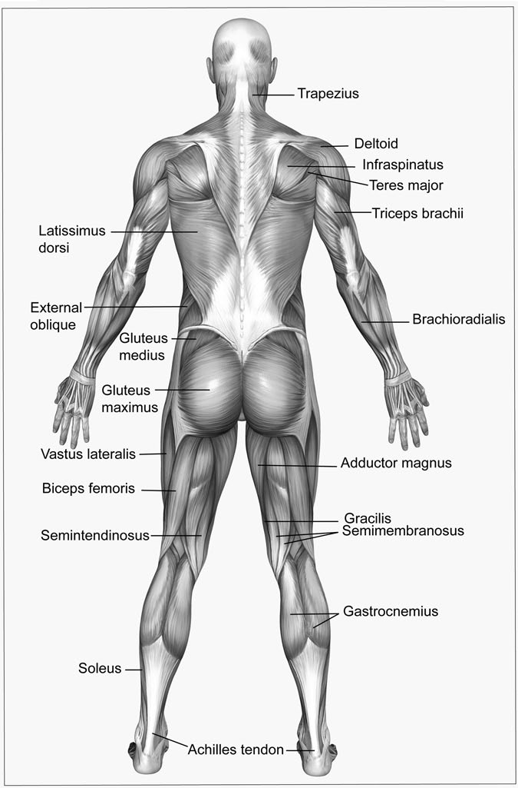

Figure 7.1 Posterior view of the body’s muscular system. (Linda Bucklin/Dreamstime.com)

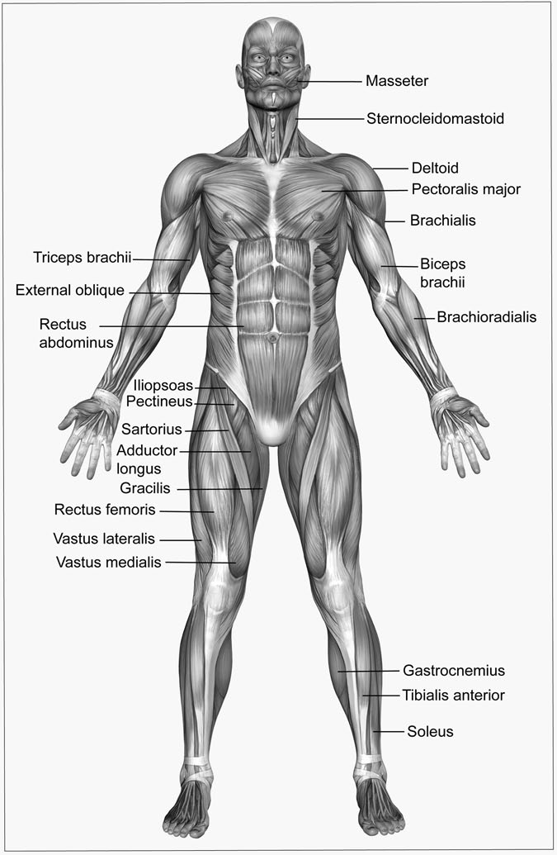

Figure 7.2 Anterior view of the body’s muscular system. (Linda Bucklin/ Dreamstime.com)

TABLE 7.2

Major Muscle Groups

*Name Function*

Major muscles of the head and neck

Orbicularis oris Gathers and puckers lips

Orbicularis oculi Closes lid over eye

Masseter Shuts jaw

Buccinator Moves corners of mouth

Sternocleidomastoic Flexes head and neck muscles to turn head towards opposite side

Semispinalis capitis Extends head and neck muscles to turn head to the same side

Trunk muscles

Trapezius Raises and lowers shoulders

External intercostals Allows inhalation by pulling ribs up and out

Internal intercostals Forces exhalation by pulling ribs down and in

Diaphragm Prepares chest cavity for inhalation by pulling down and ﬂattening, which enlarges the cavity

Rectus abdominus Constricts abdomen

Sacrospinalis muscles Group of deep muscles that extends the vertebral column

Shoulder and arm muscle group

Deltoid Helps to abduct the muscles in the lower posterior neck, back of the lower shoulder region

Pectoralis major Abducts the muscles in the upper anterior of the chest

Latissimus dorsi Abducts and extend the muscles in the lower posterior of the back

Teres major Abducts and extends the muscles in the upper posterior of the back

Triceps brachii Extends the muscles of the forearm Biceps brachii, brachioradialis Extends and ﬂexes the muscles of the

forearm

Hip and leg muscle group

Iliopsoas Flexes the muscles of the femoris (femur), the long bone located in the thigh

TABLE 7.2 (*Continued*)

*Name Function*

Gluteus maximus Extends the muscles of the femur or thigh

Gluteus medius Abducts the femur muscles

Quadriceps femoris group (rectus femoris, vastus lateralis, vastus medialis, vastus intermedius)

Hamstring muscle group (biceps femoris, semimembranosus, semitendinosus)

Flexes femur muscles and extends muscles of the lower leg

Extends femur muscles and ﬂexes muscles of the lower leg

Adductor muscle group Adducts femur muscles

Sartorius Flexes lower leg muscles and femur

Gastrocnemius, Soleus Plantar ﬂexion of the foot (lowering movement)

Tibialis anterior Dorsiﬂexion of the foot (elevating movement)

#### Anatomy of the Muscular System

Three basic types of muscles carry out all movement within the body: smooth muscle, cardiac (heart) muscle, and skeletal muscle. Although each of these three types of muscles shares the ability to contract, they are located in different places in the body, contract at different strengths, and look different under a microscope.

#### Types of Muscles

##### Smooth Muscle

Smooth muscle lines many of the internal organs. They cause contractions that move food through the intestines, expand and contract the blood ves- sels to regulate blood supply, and contract to push the baby out of a wom- an’s uterus. Smooth muscles also control the size of the pupil and are found at the base of hair follicles, where they produce goose bumps when it is cold. Ideally, these goose bumps would raise the hair to trap an insu- lating layer of air around the body, although few humans have enough hair for goose bumps to serve a practical purpose.

Smooth muscles are also called involuntary muscles because they cannot be controlled voluntarily; one cannot decide to relax the pupil to let in more light any more than a person can stop the spread of a blush across the face. Instead, smooth muscles contract in response to biological conditions such as food passing through the intestine, bright light shining on the eye, cold temperatures, or embarrassment.

Smooth muscles contract slowly but with great force, and can hold a contraction without growing tired. They also shorten more when they con- tract than other muscles do. Whereas most muscles are designed for quick, precise motions, smooth muscles are designed for long-term squeezing.

Smooth muscles earned their name by being smooth in appearance under the microscope. The individual cells are long and tapered and tend to form into sheets, such as in the lining of the digestive system. As with most cells in the body, each smooth muscle cell has its own nucleus.

##### Cardiac Muscle

Cardiac muscle is the muscle that makes up the heart. It is similar to smooth muscle in that (1) each cardiac muscle cell has its own nucleus and (2) the heart muscle cannot be controlled voluntarily. Instead, a region of the brain monitors how much oxygen is in the blood and adjusts how quickly the heart beats accordingly. A runner cannot decide to slow the heart rate, nor can a resting person voluntarily speed up how quickly the heart beats.

The cardiac muscle is extremely strong and is unique in that the entire muscle contracts at the same time. Whereas smooth muscles squeeze con- sistently, the cardiac muscle is unable to sustain a contraction. Instead, the entire muscle contracts forcefully, then relaxes. The cardiac muscle also looks different under the microscope than smooth muscle. Each individual muscle cell is cylindrical in shape and can have many branches. The cells join together to form long, branched tubes, with each cell separated by a disk of cell membrane called the intercalated disk.

##### Skeletal Muscle

The skeletal muscles are all the muscles that attach to the skeleton and help the body move. These are the 600 or so muscles that you might exer- cise at the gym and that you use to move around or pick up a book.

They are also the muscles that get strained from exercise and that become diseased in muscular dystrophy. Most of the muscles in the body are skeletal muscles. For that reason, throughout this chapter, the term muscles will refer speciﬁcally to skeletal muscles unless stated otherwise. Skeletal muscles generally have both ends anchored to the skeleton with a thick, rope-like tissue called a tendon. When the muscle contracts, it pulls on the tendons, which then pull two skeletal regions closer together. Usually, two ends of the muscles are on either side of a joint. For example, the biceps muscle on the inside of the upper arm is attached to the shoulder at one end and to the forearm at the other end. The muscles on the inside of the joint, such as the biceps, pull two sides of the joint together, causing the joint to bend, while muscles on the outside of a joint

contract to pull the joint straight.

Most muscles are organized into pairs located on either side of a joint. These two muscles work against each other and are thus called antagonis- tic pairs. One antagonistic pair might be the biceps muscle that bends the arm and the triceps muscle that straightens it back out. A similar pair is the quadriceps muscle on the front of the thigh that straightens the leg, and the hamstring on the back of the thigh that bends it. In each case, the two muscles have opposing actions and help keep the joint stable and control movement. Another type of muscle helps ﬁne-tune direction of the movement caused by the antagonistic pair. This type of muscle works in synergy with a larger, stronger muscle and is called a synergist. For example, the strong bicep muscle bends the arm at the elbow, but synergist muscles control whether the hand moves directly toward the shoulder, or veers right or left.

To understand how agonists and antagonists work, imagine lifting a weight. As one lifts the weight, the biceps contracts, causing the arm to bend, and the triceps relaxes to allow the bend. The triceps does stay somewhat contracted to help control how quickly the arm moves. When one lowers the weight, the triceps contracts to pull the arm straight and the biceps slowly relaxes, allowing the weight to lower (Sidebar 7.1).

Skeletal muscle has things in common with both smooth and cardiac muscle, but is unique in that it is the only muscle group that a person can move voluntarily. Like the cardiac muscle, each ﬁber can only con- tract once in response to a signal from a nerve. This single contraction is

SIDEBAR 7.1

#### Therapy for Your Muscles?

Many people rely on massage therapy to ease pain and soreness related to sports injuries, as well as to increase relaxion and reduce stress, anxiety, and depression. In fact, an estimated 18 million adults in the United States are believed to receive massage therapy every year. People use massage for a variety of health-related purposes, such as to relieve pain or rehabili- tate sports injuries, as well as to reduce stress, increase relaxation, address anxiety and depression, and aid general wellness. However, the National Institutes of Health’s National Center for Complementary and Alternative Medicine emphasizes that there is limited scientiﬁc evidence on massage therapy; therefore, it is not clear what impact massage therapy has on muscles, if it impacts health, and if so, how it inﬂuences health.

There are various types of massage. Some examples include Swedish, deep tissue, and trigger point massage. In a Swedish massage, the masseuse uses long stroke and deep circular movements, as well as kneading, vibra- tion, and tapping on the muscles. Deep tissue and trigger massage focuses on knots in the muscles that can become painful when pressure is applied, although the massaging works to ease these knots.

called a simple twitch. However, most movements like walking or playing basketball involve smooth, sustained motion that could hardly be achieved by simple twitches. Instead, signals from the nerves come in extremely quick pulses. Rather than resulting in a series of simple twitches, these signals cause a sustained contraction called a tetanus contraction. (The disease tetanus—which is also called lockjaw—causes muscles of the body to contract).

##### Anatomy of a Skeletal Muscle

Most muscles connect to a bone at either end. The tendons that attach muscles to bones are also part of the bone’s outer coating and part of the muscle’s coating, making the connection extremely strong. One end of the muscle is generally considered to be the origin, while the other end

is the insertion. The origin of the muscle is usually closer to the center of the body and is connected to a bone that does not move much when the muscle contracts. The insertion is usually the end of the muscle that is far- ther from the middle of the body and is connected to the bone that moves when the muscle contracts. For example, when the biceps muscle ﬂexes, the forearm moves closer to the shoulder. With that in mind, the end that connects to the shoulder is the origin, while the end that connects to the forearm is the insertion.

Although most muscles are attached at both ends to a bone, a few muscles are not. These include the facial muscles that allow a person to smile or frown and the many muscles that make up the tongue. These muscles have complex origins and insertions that allow the tongue to do everything from pick food out of the teeth to control whistling and speech. Another group of muscles, such as those in the abdomen, connect to bands of tendons that cross the stomach rather than to any bone. When the muscles contract, they pull those tendons toward each other to bend the stomach.

There are also circular bands of muscles called sphincters that help control the ﬂow of food through the digestive system. These sphincters do not connect to muscles, tendons, or skin, but instead form a continuous, circular band of muscles that surround the mouth, the ends of the stomach, and the anus. Puckering the lips for a kiss involves contracting a sphincter muscle. These muscles are especially good at constricting passages, such as at either end of the stomach where they prevent food from leaving until it is fully digested.

#### Layers of the Muscle

Although a muscle looks like a single, solid mass, it is actually made up of many smaller ﬁbers all bundled together to form one functioning unit. The entire muscle is wrapped in a connective tissue called the fascia, or the epi- mysium, that holds the muscle together. It is this fascia that forms into ten- dons and is fused to the bone to make a strong muscle-bone connection. Held within this outer covering are many smaller bundles of ﬁbers called the fascicles. These bundles are also held together with connective tissue called the perimysium. These fascicles cause the stringiness one may notice when eating meat (see Figure 7.3 for an illustration of muscle anatomy).

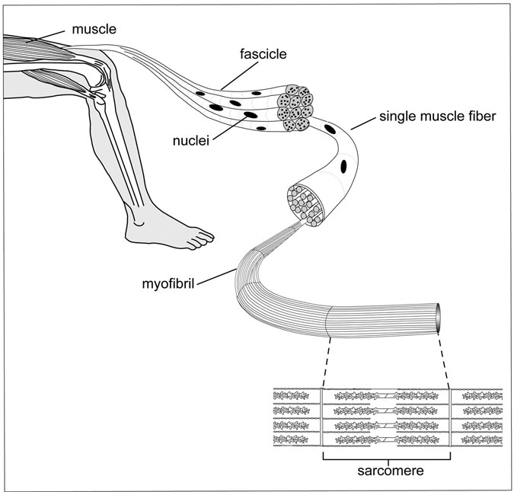

Figure 7.3 Anatomy of a muscle. (Sandy Windelspecht/Ricochet Productions)

Within the fascicles are the muscle ﬁbers themselves. These ﬁbers are actually very long cells—each less than the width of a hair—with many nuclei. Most cells only have one nucleus. Muscle cells are a conglomera- tion of many cells that fuse during development into one long ﬁber with several nuclei per ﬁber. The longest single-muscle ﬁbers in humans tend to be about 4.7 inches (12 centimeters). The number of individual ﬁbers in each muscle can range from 10,000 ﬁbers to more than a million ﬁbers, with each ﬁber spanning only a portion of the muscle’s full length in some long muscles.

Finally, each muscle ﬁber contains thousands of long units called myoﬁbrils. These myoﬁbrils are what actually contract when the cell receives a contraction signal from a nerve.

Running through the muscle between fascicles are nerves and blood vessels. The nerves relay signals that run from the brain, down the spinal column, and through nerve cells to the muscle. When a person decides to move, these nerves relay that signal to the muscle ﬁbers that carry out that decision. The blood vessels deliver food, nutrients, and oxygen to the muscles to help the muscles contract. They also pick up carbon dioxide from the muscle and deliver it to the lungs where it is breathed out in exchange for more oxygen.

#### Muscle Fiber Anatomy

The individual muscle ﬁbers are surrounded by a cell membrane called the sarcolemma. The sarcolemma both encircles the muscle ﬁber and sends hollow projections across the ﬁber. These channels, called T tubules, help the muscle transmit the signal to contract.

Just underneath the sarcolemma are granules of a type of sugar called glycogen. This glycogen serves as a food reservoir for the muscle to feed on when it is in heavy use. Along with the glycogen, cellular units called mitochondria also inhabit the space just under the sarcolemma. These mitochondria are referred to as the “powerhouse of the cell.” They convert food from the bloodstream, glycogen, and other sources into energy that the muscle uses in order to contract.

Under the mitochondria is a network of hollow tubules called the sarcoplasmic reticulum. The sarcoplasmic reticulum is a repository for calcium, which the muscle uses in the process of contraction. It closely follows the T tubules that cross the ﬁber and winds throughout the muscle ﬁber, providing a quick source of calcium.

#### Ultrastructure of a Muscle Fiber

Skeletal muscle is also called striated muscle, because under a micro- scope, the myoﬁbrils contain many tiny stripes, or striations. The stripes that can be seen under the microscope are the individual units of the

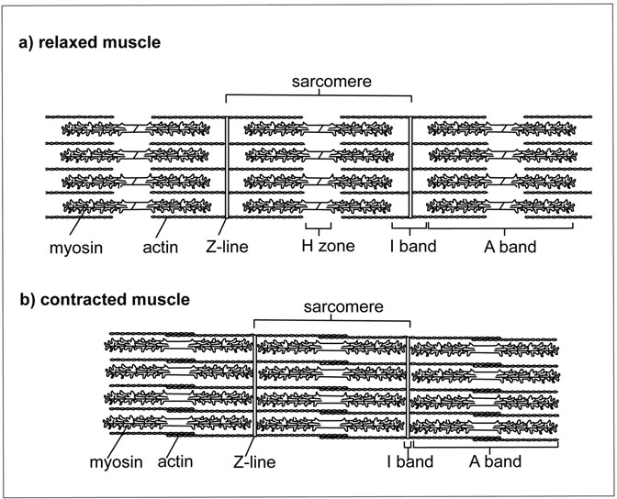

Figure 7.4 Sarcomere Structure. The structure, when relaxed and contracted. (Sandy Windelspecht/Ricochet Productions)

muscle ﬁber, which are called sarcomeres (Figure 7.4). Cardiac muscle also has these striations, though smooth muscle does not.

It is bounded on both ends by a vertical band of tissue called a Z band. Looking closely at the sarcomere under a microscope, there are several horizontal stripes of protein ﬁlaments. These are made up of the two primary types of protein ﬁlaments in a muscle: actin and myosin. There are roughly 1,500 myosin ﬁlaments and 3,000 actin ﬁlaments per muscle ﬁber.

Emanating from both Z bands are the long, thin ﬁlaments of actin. These stick out into the center of the sarcomere like posts, with one end embedded in the Z band. When a muscle is at rest, these two sets of actin ﬁlaments do not overlap, leaving a gap in the center of the sarcomere.

Myosin ﬁlaments lie parallel to the actin in the center of the sarcomere and overlap with the actin on both ends. These myosin ﬁlaments are teth- ered in place to either Z band by a ﬁne, thread-like ﬁlament called titin.

The bands of actin and myosin within the sarcomere account for the striations that can be seen under the microscope. The region next to the Z band that contains only actin ﬁlaments is called the I band. The region between actin ﬁlaments in the center of the sarcomere is called the H zone. The entire span of the myosin is called the A band.

The actin ﬁlaments are actually made up of three proteins. The globu- lar actin proteins form into two chains that wrap around each other like two strands of twisted pearls. Winding around the actin are long, narrow ﬁlaments of a protein called tropomyosin. Tropomyosin ﬁts into the groove between the two actin strands. At intervals, a smaller protein called troponin dots the outside of the actin/tropomyosin complex.

Myosin is much thicker than actin and thus is sometimes referred to as the “thick ﬁlament.” It looks like a chain of golf clubs twisted around each other. Each golf club represents a single myosin molecule that doubles back on itself at the tip to form the head.

#### Anatomy of a Contraction

##### Skeletal Muscle

Each contraction results when a nerve delivers a message to the muscle. The smooth and cardiac muscles respond to nerves that are controlled by automatic reactions in the brain. Skeletal muscles move in response to nerves controlled by a person’s decisions.

When a muscle gets a signal to contract, the globular myosin heads attach to the actin and pull, much like a team of people playing tug-of- war. The heads ﬂex, release, and reattach farther up the actin ﬁlament, then ﬂex again. This action works like a ratchet pulling the myosin along the actin ﬁlament. Because the actin ﬁlaments are attached to the Z bands at both ends of the sarcomere, this action pulls the actin ﬁlaments toward each other and pulls the Z bands closer together to shorten the sarcomere. This mechanism is called the sliding ﬁlament model for muscle con- traction. One result of the ﬁlaments sliding past each other is that the actin

ﬁlaments overlap in the center of the sarcomere, causing the sarcomere to grow thicker. This overlap is what accounts for the muscle’s bulge when ﬂexed. Although each individual sarcomere contracts only a small amount, when many sarcomeres contract at once, the muscle gets consid- erably shorter.

When a sarcomere contracts, the A band (or myosin) remains the same size in the center of the sarcomere because the myosin does not change length. The H band, which is the gap between the actin ﬁlaments in the center of the sarcomere, disappears as the actin ﬁlaments are pulled toward the center of the sarcomere. Likewise, the I band disappears during a con- traction because the space between the Z band and the myosin ﬁlaments grows shorter. Notice that as the sarcomere contracts, the ﬁlaments stay the same length, although the distance between the Z bands decreases.

The strength of a contraction depends in part on how many muscle ﬁbers (and their associated myoﬁbrils) receive the signal to contract. When only a few ﬁbers receive a signal, the contraction is relatively weak. When many ﬁbers receive a signal, many more sarcomeres will contract, making for a much stronger contraction.

##### Cardiac Muscle

Cardiac muscle has actin and myosin arranged into striated sarcomeres, much like skeletal muscle, and it has a well-developed sarcoplasmic reticulum. Unlike skeletal muscle, which contains single long ﬁbers, car- diac muscle ﬁbers have many branch points and appear like a complex web. When this muscle contracts, the irregular shape of the branching ﬁbers causes the heart muscle to twist and essentially wring blood out of the heart.

##### Smooth Muscle

Smooth muscles lack the orderly striations of skeletal and cardiac muscles. Instead, the actin ﬁlaments are arranged in a roughly parallel way and are attached to the ends of the cell. Myosin ﬁlaments slide the actin past each other and pull the ends of the cell closer together. In smooth muscle, this action causes the entire muscle sheet to contract.

Unlike either skeletal or heart muscle, smooth muscle does not have a well-developed sarcoplasmic reticulum. When a signal from a nerve arrives at the muscle, calcium seeps in from outside the cell. This process is much slower than in the other types of muscles and does not allow as much calcium into the cell. Overall, the contraction takes longer to start and does not pull as hard as the other muscle types.

##### Contraction Strength

When a nerve sends to a skeletal muscle ﬁber the signal to contract, that ﬁber contracts with an all-or-none response. It cannot contract partway. This seems to contradict day-to-day experience, in which the strength of a contraction can be adjusted for the relatively little strength required to pick up a pencil or the large amount of strength needed to pick up a large weight. If each contraction used the muscle’s complete strength, then it would be nearly impossible to pick up a pencil in a controlled manner.

It turns out that the amount the muscle contracts has to do with how many ﬁbers receive a signal. One single muscle ﬁber cannot produce a con- traction that is strong enough to do any signiﬁcant work. For this reason, most single nerves have connections with about 150 ﬁbers, each of which contracts when the nerve sends a signal. These groups of muscle ﬁbers are called motor units. In areas like the hands, where ﬁne control is needed for activities such as writing or playing a musical instrument, the motor units are composed of fewer ﬁbers. Each nerve controls only a few ﬁbers, provid- ing the ability to make miniscule changes in how the muscle contracts. In muscles such as the hamstring, which provides the strength to bend the leg, the motor unit may be composed of a much larger number of ﬁbers.

Stimulation from nerves also controls how long a contraction lasts. When a doctor taps the knee to test a person’s reﬂexes, the leg twitches but does not stay contracted. That is because the muscle receives only a brief stimulation from the nerve. In order to keep the muscle contracted, the nerve sends a rapid volley of signals in quick succession. Although each signal stimulates only a single contraction, they add up so that the muscle can stay ﬂexed to hold a paintbrush steady or hold a dance pose.

Some muscles, such as those that help a person stand upright, always have some muscle ﬁbers contracting in order to maintain posture. In order

to prevent one group of muscle ﬁbers from getting tired, the brain sends signals to different motor units so that the groups of ﬁbers share respon- sibility for holding a person upright. This same rotation takes place if one holds a heavy object for a long time. At ﬁrst, a few groups of muscle ﬁbers will all get the signal to contract. But over time, if those ﬁbers become tired, the brain recruits a new group of ﬁbers to take over respon- sibility for contracting. After a long time of standing upright or holding a heavy book, the muscle will become tired, but no one group of muscle ﬁbers is damaged because the motor units shared the load.

One ﬁnal factor that controls the strength of a contraction is the width of a single muscle ﬁber. Anyone who has been to a gym knows that the more a muscle gets used, the larger it is. This change has to do, in part, with the size of the individual muscle ﬁber, and therefore how many myoﬁbrils are within the muscle cell. A thick muscle ﬁber with many myoﬁbrils will respond with more strength in response to a signal from a nerve. In essence, that muscle cell has more myosin heads playing tug-of-war on the actin ﬁlaments, allowing that ﬁber to pull harder. Although the nerve will contact the same number of muscle ﬁbers in a motor unit, the overall contraction will be stronger.

#### The Nerve/Muscle Connection

##### Skeletal Muscle

The signal to contract a muscle ﬁber comes from nerves. Each nerve starts at the spinal column, travels through the body, and then branches out so that the single nerve controls several muscle ﬁbers in a motor unit. When the nerve is stimulated by the brain, an electrical signal travels the length of the nerve and reaches each of the many branched tips. At the tip, the electrical signal causes the nerve to release a chemical called acetylcholine into a gap between the nerve cell and the muscle ﬁber. The acetylcholine is also called a neurotransmitter because it transmits a signal from the nerve to the muscle. Acetylcholine travels across the space between the nerve and muscle and binds to a protein (called a receptor) located on the muscle cell membrane. The bound acetylcholine triggers a series of reactions to occur that propagate the electrical signal down the muscle ﬁber in a wave, transmitting the signal throughout the muscle ﬁber and across the

T tubules almost instantaneously. Where the T tubules and sarcoplasmic reticulum come in close contact, the signal from the T tubules transfers to the sarcoplasmic reticulum. In response, the sarcoplasmic reticulum releases calcium into the muscle ﬁber. Keep in mind that because the nerve connects to many different muscle ﬁbers, this same reaction takes place in each ﬁber at exactly the same time.

##### Heart Muscle

The same general principles hold true between skeletal muscle and heart muscle; however, there are some notable differences. In skeletal muscle, groups of ﬁbers within the muscle contract as they are needed—the entire muscle rarely contracts at once. In the heart, on the other hand, the entire muscle contracts with each heartbeat. For this reason, the heart muscle does not have the web of nerves branching out to connect with each individual muscle ﬁber.

A signal to contract reaches the heart at a specialized group of muscle cells located near the top back side of the heart. This group of cells is called the pacemaker. When a nerve delivers its neurotransmitter to the pacemaker region, these cells spread the signal across muscle cells in the top half of the heart. Unlike skeletal muscle ﬁbers, where the signal stays within the single ﬁber, heart muscle ﬁbers are connected with an intercalated disk that allows a signal to move easily from one muscle ﬁber to the next. Because the signal can spread so quickly, all of the ﬁbers in this top region contract at the same time. This ﬁrst phase of the heartbeat pushes the blood down into the lower portion of the heart, while the upper region reﬁlls with blood. When the pacemaker receives a signal to contract, it delivers the message to all the upper muscles and also sends the signal to a group of cells in the lower portion of the heart. This message is delayed slightly to give the upper muscles time to contract. When the lower region receives the message to contract, it spreads the signal to all the muscle ﬁbers of the lower part of the heart. This contraction ﬁnishes the heartbeat and pushes blood out to the body. Chapter 2 on the circulatory system has more information about

how the heart relays the signal to contract.

Unlike the skeletal muscle, heart muscles can beat without a signal from the brain and can continue beating even outside of the body.

Although the pacemaker cells generally relay a signal from a set of nerves, if the heart is disconnected from those nerves or if the nerves fail to ﬁre, the pacemaker will continue sending a signal to contract at a regular rhythm. Mechanical pacemakers can back up the heart’s pacemaker to ensure that the heart continues to beat at a regular rhythm, even if the heart’s natural pacemaker fails to maintain the heartbeat.

#### Sliding Filament Model of Muscle Contraction

##### Skeletal and Heart Muscle

Researchers knew as early as 1883 that calcium was required in order for a muscle to contract. However, not until the 1960s did researchers understand what role calcium played when it was released from the sarcoplasmic reticulum.

It turns out that when either the skeletal or heart muscle is relaxed, the globular myosin heads cannot attach to the actin ﬁlaments. The troponin/ tropomyosin complex blocks access to areas of the actin ﬁlament where the myosin head would normally bind. This physical block ensures that the muscle stays relaxed when there is no nerve signal. To prevent the muscle from contracting inappropriately, the muscle ﬁbers actively move calcium from the cell into the sarcoplasmic reticulum, which winds throughout the cell.

When a nerve signal sweeps across the muscle ﬁber and through the T tubules, it is translated to the sacroplasmic reticulum, which responds by releasing the stored calcium. Once in the muscle ﬁber, calcium binds to the troponin and causes the troponin to change shape. In this new shape, the troponin/tropomyosin complex shifts and reveals the site on the actin ﬁlament where myosin binds.

Although the myosin can now bind to actin, it takes energy in order for the actin and myosin to pull past each other. This energy comes from a molecule called adenosine triphosphate (ATP) that is normally bound to myosin when the muscle is in a relaxed state. ATP is the form of energy that is produced primarily by the mitochondria. Although ATP itself can do no work, other proteins within the cell can break the ATP into a related molecule called adenosine diphosphate (ADP), and in the process

release some energy. ATP is like a match: it does not release any energy when it sits in a box, but if someone strikes the match, it releases enough energy to burn ﬁngers, melt wax, or heat a small drop of water. When the match is burned out, like ATP, it can no longer be used.

In a relaxed muscle, myosin is bound to a molecule of ATP. When cal- cium enters the cell and troponin changes conﬁguration, the myosin breaks the ATP into two units and in the process releases a small amount of energy. Myosin uses that energy to change shape and stretch out far up the actin molecule. The myosin then binds to the newly revealed binding site on actin and releases the ATP. Without ATP, the myosin relaxes back into a less energetic conﬁguration while still bound to actin. This change in shape pulls the actin past the myosin. A new molecule of ATP then binds myosin, allowing myosin to break its bond with actin and resume its stretched-out shape, reaching farther up the actin ﬁlament (Figure 7.5).

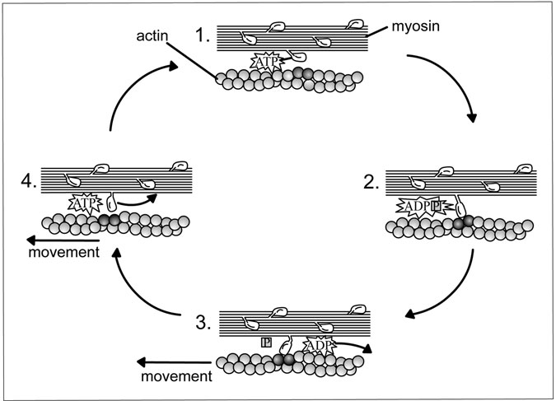

Figure 7.5 Myosin-Actin Filament. Myosin slides along the actin ﬁlament using ATP. (Sandy Windelspecht/Ricochet Productions)

The entire process repeats itself when myosin reattaches to the actin, relaxes, pulls the actin farther along, and binds a new molecule of ATP. With many myosin heads all attaching and ﬂexing at different times, the process results in a slow, controlled contraction that lasts as long as ATP and calcium are present in the cell.

When a nerve stops ﬁring, calcium stops being released from the sar- coplasmic reticulum, and calcium that is in the muscle ﬁber is actively transported back into storage. The troponin/tropomycin/actin complex then reverts back to a shape that prohibits myosin attachment. The myosin then cannot reattach, and the contraction ends. The actin ﬁlaments slide past the myosin and come back to rest with the Z bands farther apart.

One side effect of churning through ATP when a muscle contracts is that the process produces heat. People generally get hot when they exer- cise or use their muscles heavily; that is because each time myosin breaks ATP, a small amount of heat is released. When a person stops exercising and myosin no longer requires ATP, they eventually cool off. The body takes advantage of this phenomenon by shivering when a person gets cold. Using the muscles in this way acts as an internal heater to help warm the body. However, even with active shivering, the body cannot make enough heat to warm a person when he or she is very cold. Shivering is not consid- ered to be a useful response, because it requires quite a bit of energy to shiver with very little actual heat being produced.

Another example of the contraction process comes when an organism dies. After death, the body no longer makes ATP. Remember that ATP is needed in order for myosin to release from the actin ﬁlament after it relaxes. Once a muscle has used up its store of ATP, the myosin heads can no longer release from the actin, locking the muscles into a rigid state that is also known as rigor mortis. In this condition, all of the muscles are tightly contracted, and the body is very difﬁcult to bend.

##### Smooth Muscle

Smooth muscle does not contain the regular sarcomeres of skeletal and heart muscles. Instead, the actin ﬁlaments span the length of the entire muscle cell. Myosin pulls on those actin ﬁlaments to pull the cell shorter. This alternate form of contraction is also regulated in a different way.

In smooth muscle, the actin ﬁlament does not have a troponin/tropomysin complex preventing myosin from binding. Instead, calcium enters the cell and activates a set of enzymes. Those enzymes add a phosphate to myosin, changing its shape and allowing it to bind actin. These intermediary steps slow the time it takes for a smooth muscle to contract. Whereas heart and skeletal muscles contract immediately when calcium enters the muscle ﬁber, smooth muscle cells can take as long as a second to contract after calcium levels go up in the cell.

#### Types of Muscle Fibers

##### Fast-Twitch and Slow-Twitch Fibers

All skeletal muscle ﬁbers have the same basic structure, but they do vary in subtle ways that can dramatically affect the performance of the muscle. Muscles contain two general types of ﬁbers: slow-twitch (type I) and fast- twitch (type II). As their names imply, slow-twitch ﬁbers contract slowly whereas fast-twitch muscles contract quickly after they receive a signal from a nerve. On average, slow-twitch ﬁbers take about one-tenth of a sec- ond to reach their peak contraction, while fast-twitch muscles take about half that time.

The difference between slow-twitch and fast-twitch muscle ﬁbers lies in how quickly the myosin can cycle through ATP. The more quickly the myosin can use the ATP, the more quickly it can ﬁnish one stroke and attach to myosin for another pull.

It turns out that myosin itself is basically the same in both types of ﬁbers. The difference between the myosins lies in their ability to break ATP—an enzyme function called an ATPase. Slow-twitch and fast- twitch ﬁbers have myosins with different ATPase activity. As one would imagine, slow-twitch ﬁber myosins have an ATPase that breaks ATP slowly, while fast-twitch ﬁber myosins have an ATPase that breaks ATP quickly.

The two types of muscle ﬁbers also differ in how quickly the contrac- tion begins. Fast-twitch ﬁbers have a much more extensive sarcoplasmic reticulum network than slow-twitch ﬁbers, allowing these ﬁbers to receive calcium more quickly after a nerve signal than slow-twitch muscles. In the

time it takes a fast-twitch muscle to ﬂood with calcium and begin a con- traction, a slow-twitch muscle is still only slowly ﬁlling with calcium, and few troponin molecules have changed shape.

Sometimes the difference between fast- and slow-twitch ﬁbers is not absolute. Fast-twitch ﬁbers can be classiﬁed as type IIa or type IIb. The type IIa ﬁbers have fast myosin ATPase and can contract faster than slow-twitch ﬁbers, but they also have more endurance than fast-twitch ﬁbers. The type IIb ﬁbers are the pure fast-twitch ﬁbers.

On average, fast-twitch ﬁbers begin contracting ﬁve to six times faster than slow-twitch ﬁbers. With their quick response and fast contractions, it is no surprise that sprinters have a higher percentage of fast-twitch muscle ﬁbers than distance athletes

##### Roles for Slow-Twitch and Fast-Twitch Muscles

Slow-twitch and fast-twitch ﬁbers play distinctly different roles in a muscle. In an average muscle, slow-twitch ﬁbers make up about half the muscle, while fast-twitch ﬁbers make up the other half. The photo shows a muscle section composed of both slow-twitch ﬁbers (stained dark) and fast-twitch ﬁbers. Keep in mind that people differ dramatically in their muscle composition and that ﬁber composition can differ even between muscles in a single person. For example, the solius muscle, which is deep inside the calf, is made up of almost exclusively slow-twitch ﬁbers in everyone. Although the ﬁber composition does vary among individuals, a person who has predominantly fast- or slow-twitch muscles in the legs will have a similar composition in the arms and other muscles. This means that a person who is a particularly good sprinter when running is likely to be a sprinter rather than a distance athlete at swimming and biking as well. When a muscle ﬁrst starts being used—for example, when a person begins walking—the slow-twitch muscles are the ﬁrst to be called upon to contract. When these muscles fatigue, or when the contraction needs to be more powerful, the muscle will recruit a subset of the fast-twitch type Ia ﬁbers. Only when both of these types of ﬁbers grow tired or when great strength is needed does the muscle call upon the fast-twitch type IIb ﬁbers. In order to control which type of muscle ﬁber contracts, each nerve connects to either all fast-twitch or all slow-twitch muscle ﬁbers.

The nerves themselves also differ. Nerves that connect to slow-twitch ﬁbers are smaller and connect to about 10 to 180 ﬁbers in a motor unit. A nerve for fast-twitch ﬁbers is much larger and connects to as many as 300 to 800 ﬁbers in a motor unit. With this arrangement, the muscle can recruit a very small number of slow-twitch muscles at a time, but can sig- nal many more fast-twitch muscle ﬁbers with a single nerve impulse. Because of this, a single fast-twitch motor unit contraction is much stronger than the contraction of a single slow twitch motor unit.

#### Types of Contractions

In general, when a muscle receives a signal to contract, the muscle grows shorter and causes a joint to either straighten or bend. Although this basic principle holds true, there are other types of muscle contraction. In most activities such as running and jumping, these different types of contraction work smoothly together to create the motion. However, it is worth discussing these actions separately to point out different mechanisms of moving the muscle.

##### Concentric Action

A concentric contraction is the motion that a person generally associates with muscle contraction. In a concentric action, the muscle contracts and pulls two bones closer together, causing the joint to open or close. Con- centric action would occur if one holds a weight in the hand and bends the elbow to ﬂex the biceps.

The myosin heads can be thought of as a team of tug-of-war players and actin as their rope. Concentric action would occur when the team pulls and the rope moves toward them.

##### Isometric (Static) Action

Although people usually think about contracting a muscle to move a joint, there are other types of contractions. Imagine holding a weight that is too heavy to lift. Flexing the biceps muscle, the arm will remain straight even though the muscle is trying to contract. This is an isometric contraction. In an isometric contraction, the nerve sends a signal for the muscle to contract.

The muscle ﬁber ﬂoods with calcium, and the myosin pulls on the actin ﬁlaments, but the ﬁber does not generate enough force to bend the arm. This type of contraction also occurs when holding a weight in a stationary position. The muscle is ﬂexing even though the weight is not moving. Only enough muscle ﬁbers are activated to hold the weight steady. Pushing on a wall is also an isometric action.

In the same example, if a person grows tired of holding the weight and decides to lift the weight to a new position, the muscle will recruit extra muscle ﬁbers to help lift the load. These extra ﬁbers then provide enough strength to lift the weight, and the isometric action becomes a concentric action. Isometric action has to do with the weight of the object and the number of muscle ﬁbers recruited to do the work. Going back to that same team of tug-of-war players, an isometric action would occur when the players pull with all their strength, but the rope does not budge.

The word isometric is also used to describe a type of exercise. Isomet- ric exercises involve ﬂexing a muscle without moving the joint. Isometric exercises were made popular in the 1950s as part of the Charles Atlas pro- gram. Although people did become stronger using this program, their muscles were particularly stronger only when they were bent at the same angle as was used in the isometric exercises. Although isometric exercise is far from perfect, it has the advantage of requiring little equipment or room. For this reason, it is used by astronauts trying to maintain muscle strength in the weightlessness of space.

##### Eccentric Action

After bending the arm to lift a heavy weight (a concentric action), the arm must then straighten to let the weight down. Straightening the arm requires the biceps to maintain some contraction to control how quickly the arm straightens. This contraction that occurs as the muscle lengthens is called an eccentric contraction. Even though the myosin heads are pulling on the actin ﬁlaments, those actin ﬁlaments are moving farther away from each other within the sarcomere. In tug-of-war terms, an eccentric action would occur when the players pull with all their strength, but the rope moves away from them and toward the other team.

Eccentric actions tend to damage the muscle ﬁbers. Although this sounds like a bad thing, it can actually have positive results. After a ses- sion of exercise with eccentric action, the muscle ﬁbers will become dam- aged and very sore. But they will adapt to just one session of eccentric exercise by increasing the number of sarcomeres per muscle ﬁber (essen- tially making each sarcomere shorter). With more sarcomeres per ﬁber, each sarcomere has to stretch less for the eccentric action, so the muscle sustains less damage. The other advantage to this is that the muscle will become quicker to respond to a signal because many more sarcomeres are doing the same work. This change lasts about 10 weeks—after that time, the muscle loses the adaptation and will once again be damaged by eccentric action.

Most people have experienced pain associated with eccentric action when they run or walk downhill. When a person walks downhill, the thigh muscle contracts as the leg extends in front. Transferring weight onto the other leg, the knee lowers slightly to absorb the shock and in the process stretches the thigh muscle. Stretching the thigh muscle while the muscle contracts is a form of eccentric action that damages the muscle and can lead to pain and weakness over the next two to three days. Walking or run- ning downhill in the next few weeks will cause much less pain in the fol- lowing days because the muscles have adjusted to the eccentric action.

#### Energy Use by Muscles

Muscles require energy in the form of adenosine triphosphate (ATP) in order to contract. This ATP is used as an energy source for all the reactions that take place in the body—it is required to conduct signals along the nerves, to translate genes into proteins, to move molecules into and out of a cell, and to contract muscles, among other things.

Each cell is self-sufﬁcient when it comes to making ATP. A person cannot eat ATP and have the molecule transported to cells, nor can energy-starved cells take ATP from the bloodstream. Instead, each cell generates its own ATP from sugar, fat, or protein that comes either from the bloodstream or from the cell’s internal stores. For this reason, cells that require large amounts of energy, such as muscle cells, have to be extremely efﬁcient at making ATP and at storing the starting materials.

Chapter 10 on the respiratory system provides detailed information about the process of how cells convert food into ATP. This section focuses on those details of respiration that are important in order to understand how muscles get the energy to contract and what happens as muscle cells use up their energy stores.

##### Getting Energy from ATP

ATP belongs to a class of molecules called nucleotides—the same mole- cules that make up DNA. Like other nucleotides, ATP is made up of three parts: a sugar called ribose, a double ring of carbon atoms called adenine, and three phosphates attached like a tail. These phosphates are linked by high-energy bonds. When a cell needs energy, it breaks off one of the phosphates from the ATP to form adenosine diphosphate (ADP) and one free phosphate. Removing that phosphate releases enough energy to drive a cellular reaction such as ﬂexing the myosin head. Because the remaining ADP is not a source of energy, a cell needs to constantly convert ADP back into ATP by adding a phosphate back to the tail—particularly if that cell requires a large amount of ATP to do its job, such as a muscle cell (Figure 7.6).

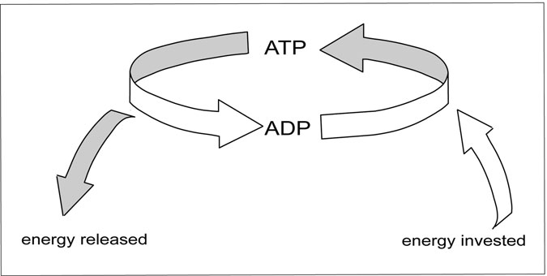

Figure 7.6 ATP and ADP. Conversion between ATP and ADP. (Sandy Windelspecht/Ricochet Productions)

It may seem surprising that breaking off a piece of a molecule can result in usable energy. However, the process is similar to how cars get energy out of burning gasoline or how ﬁres produce heat. In each case, breaking the bonds between two atoms releases energy. In a car engine, breaking the bonds of atoms in gasoline makes energy to drive the pistons that turns the motor. In a ﬁre, that energy takes the form of heat; and in ATP, the energy is used for cellular reactions. In each of these examples, oxygen is needed in order to break the bonds in the molecule, and carbon dioxide is released.

##### Creating ATP

Generating ATP is a several-step process. The ﬁrst phase takes place in the main cavity of the cell, whereas the second—and most ATP-producing— step takes place in a cellular component called the mitochondria.

A mitochondrion is a small, bacteria-shaped component of the cell. Each cell has from one to many mitochondria, depending on how much energy it needs in order to survive. It is no accident that the mitochondria resemble bacteria—researchers think that hundreds of millions of years ago, free-living bacteria entered larger cells. These bacteria received food from the cell, and in return, they provided ATP. Over time, the bacteria lost their ability to exist without their host cell and became the mitochon- dria that cells have today. Mitochondria still have some remnants of their free-living bacterial ancestors, such as some DNA and genes that make bacterial proteins. The process mitochondria use to make ATP is similar to how free-living bacteria still function.

##### Glycolysis

The ﬁrst step of producing ATP—called glycolysis—takes place outside of the mitochondria in the main compartment of the cell. This process requires a sugar called glucose as a starting material. The glucose mol- ecule is a chain of six carbon atoms with some hydrogen and oxygen (C6H12O6). It can either come from the bloodstream, where glucose con- stantly circulates to feed cells, or from the muscle cell’s internal stores.

During the glycolysis process, a series of reactions splits glucose into two halves, each of which is called pyruvate (in fact, the name glycolysis means “sugar splitting”). For each sugar that enters glycolysis, the process

makes two molecules of pyruvate and two molecules of ATP. Although this is a net gain in ATP, two ATP molecules are not enough to fuel exten- sive exercise.

##### Citric Acid Cycle

The next step in the ATP-producing pathway takes place within the mito- chondria. Because of their critical importance in creating energy for the muscle, mitochondria are located underneath the sarcoplasmic reticulum, overlaying the muscle ﬁbers themselves. In this position, the mitochondria are poised to receive fat or sugar from the blood and convert that into ATP. In most cells, mitochondria exist as individual units that dot the interior of the cell. They are so important to a muscle cell, however, that they fuse to form a single large entity that spans the entire muscle cell.

The process that takes place within the mitochondria is called the citric acid cycle—also called the Krebs cycle after Sir Hans Krebs (1900–1981), who ﬁrst discovered the cycle in the 1930s. The cycle is also sometimes called the tricarboxylic acid (TCA) cycle because of the three- carbon molecule that continually moves through the cycle. The citric acid cycle begins when pyruvate from glycolysis loses one carbon atom, to become a two-carbon molecule called acetyl coenzyme A (acetyl CoA). This acetyl CoA then enters the mitochondria, where it goes through eight individual steps, producing carbon dioxide that gets breathed out, one more molecule of ATP, and two high-energy molecules called NADH and FADH2. These molecules have the most potential to generate ATP.

Although each acetyl CoA that enters the citric acid cycle produces one ATP, every glucose produces two molecules of acetyl CoA. This means that the citric acid cycle produces two molecules of ATP per glu- cose, bringing the total up to four molecules of ATP for each glucose that goes through glycolysis and then into the citric acid cycle. Again, having four molecules of ATP is better than no ATP at all, but it is not enough to sustain long-term exercise such as jogging or swimming.

Sugar is the most common fuel for making ATP, but cells can also get energy from fat in the form of free fatty acid in the blood. A fat molecule is a very long chain of carbon atoms. One common fat that is found in the cell is called palmitate, which is a chain of 16 carbons. When a fat

molecule enters the cell, it is broken down in two-carbon units into acetyl CoA—the same molecule that sugar is converted into after glycolysis. This acetyl CoA then goes through the citric acid cycle and produces car- bon dioxide, one ATP, and NADH and FADH2.

With sugar, scientists can calculate how many ATPs come from each molecule. That is because each sugar has six carbons and sends two acetyl CoA molecules through the pathway. Fat molecules can be different lengths, so it is harder to calculate how many acetyl CoA molecules will be made from one fat molecule and therefore calculate how much ATP will be produced. Regardless, a fat molecule will produce the same amount of ATP, carbon dioxide, NADH, and FADH2 per acetyl CoA as each acetyl CoA from sugar—it is just a matter of how many acetyl CoA molecules can be generated from each fat molecule.

The difference in how fat and sugar molecules enter the citric acid cycle helps explain why a gram of fat has so many more calories than a gram of sugar. A calorie is essentially a measure of how much energy that food contains. From each six-carbon sugar, only four carbons go through the Krebs cycle (two molecules of two-carbon acetyl CoA). The remain- ing two carbons are breathed out as carbon dioxide. With fat, the entire molecule is broken down in two carbon chunks, so the entire molecule is used to create ATP. Because the entire weight of the fat molecule goes to making energy, it can provide more energy per weight than sugar. This translates into more calories per gram on a food label. The beneﬁts of burning fat over burning sugar for energy is not lost on muscle cells. As muscles become highly trained, they also become better at using fat for energy.

#### Electron Transport

The ﬁnal phase of ATP production involves the NADH and FADH2 that were made during both the citric acid cycle and glycolysis. These mole- cules both carry extra electrons that are in a high-energy state. They trans- fer their electrons to a series of proteins that are lodged in the membrane of the mitochondria. Together, these proteins are called the electron trans- port chain. They form a continuous path for electrons, picking up the elec- trons from NADH and FADH2, and transferring them down the chain.

This step leaves the NADH and FADH2 short on electrons. The depleted molecules go back to the citric acid cycle, where they pick up new high- energy electrons that can once again be donated to the electron transport chain.

In the ﬁnal step of the electron transport chain, the electrons combine with oxygen in the mitochondria to form water. Oxygen is essential to this step. Without oxygen, electrons pile up in the electron transport chain, and transport stops. When this happens, the citric acid cycle also grinds to a halt, pyruvate stops being imported into the mitochondria, and all the ATP must be made by glycolysis.

The point of moving electrons along the mitochondrial membrane is not simply to convert an oxygen into water—at each step of the chain, the same reaction that transfers the electron to the next protein also trans- ports hydrogen ions from inside the mitochondrial membrane to the out- side of the membrane. These hydrogens build up on the outside of the membrane like water behind a dam. When the mitochondria releases the hydrogen ions back inside (through a molecule called the ATP synthe- tase), those hydrogens do the equivalent of the spinning wheels inside a dam. In dams, the spinning wheels make electricity that powers homes. In a cell, unleashing the dam produces about thirty-two molecules of ATP per sugar molecule. The process of producing ATP through the elec- tron transport chain is called oxidative phosphorylation.

The entire process of breaking down sugar in glycolysis, sending pyr- uvate into the mitochondria, and transporting electrons down the electron transport chain is shown in Figure 7.5.

#### The Importance of Oxygen

Only 4 of 36 total molecules of ATP come from glycolysis and the citric acid cycle, while the remaining 32 molecules come from oxidative phos- phorylation. Oxidative phosphorylation is a rich source of ATP, as long as the mitochondria receive a steady supply of oxygen.

The oxygen used in the electron transport chain accounts for why a person’s breathing and pulse increase when they exercise. If a person can- not deliver enough oxygen to the muscles, then the electron transport chain shuts down, and the muscle receives only the paltry amount of

ATP made by glycolysis. For low-level exercise such as gardening, a per- son will breathe slightly harder than usual in order to provide the muscle cells with enough oxygen for their slightly increased ATP demands. A person in a swimming race, on the other hand, must breathe very hard and pump new oxygen-containing blood to the muscles very quickly to keep up with the muscle’s high demand for ATP (Figure 7.7).

Exercise that takes place through ATP made by oxidative phosphoryla- tion is called aerobic exercise (aerobic means “with oxygen”). Exercise that takes place when oxygen is limited and all ATP comes from glycolysis is called anaerobic exercise (anaerobic means “without oxygen”).

Once a person is done exercising, his or her breathing and heart rate stay elevated for several minutes even though the muscles are no longer using ATP. This happens because the muscle cells need to replenish their supply of stored-up ATP. A person will continue breathing faster than

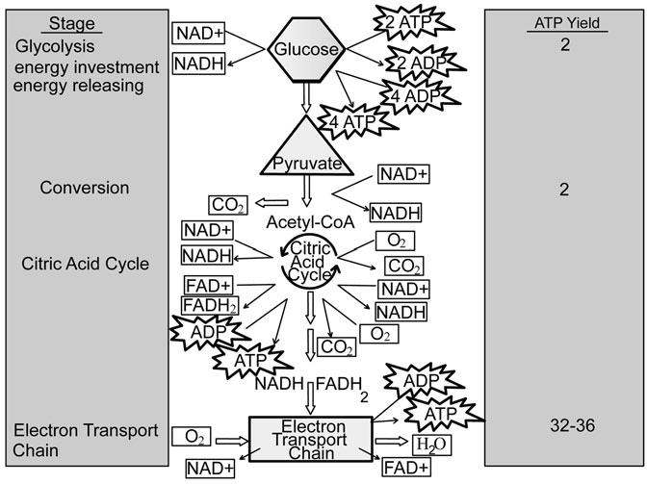

Figure 7.7 Overview of energy production from glucose. (Sandy Windelspecht/Ricochet Productions)

usual until the muscle has enough ATP stored up to act as a buffer against future bursts of exercise.

#### Sources of Energy

Cells in the body can convert sugars, fat, or protein from the bloodstream into ATP. Although the bloodstream provides a continuous source of fuel, muscles also store their own fuel in the form of molecules called creatine phosphate and glycogen (Figure 7.8).

##### Creatine Phosphate

Researchers knew from early experiments that a backup energy source must exist in muscles. In these experiments, Eggleton and Eggleton removed a piece of muscle but kept the nerve intact so that it could still stimulate the muscle to contract. When they gave that muscle chemicals

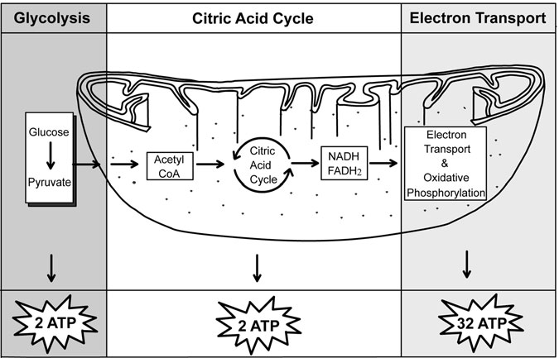

Figure 7.8 ATP Production. ATP produced from glycolysis, the citric acid cycle, and electron transport. (Sandy Windelspecht/Ricochet Productions)

to prevent either glycolysis or oxidative phosphorylation, and then stimu- lated the nerve, the muscle could still contract. This result told the researchers that the muscle must have some way to regenerate ATP that did not include either glycolysis or oxidative phosphorylation.

In 1927 the researchers identiﬁed this short-term energy store as a molecule called creatine phosphate. Creatine phosphate serves as a reser- voir for phosphates that can be added to ADP to regenerate ATP. When the cell is at rest and making excess ATP, then the ATP will transfer one phosphate to creatine to make creatine phosphate, converting the ATP to ADP. (The ADP receives a new phosphate through glycolysis or oxidative phosphorylation and is converted back into ATP.)

When a person begins exercising—for example, by suddenly standing up and beginning to walk briskly—the muscles do not have enough time to ramp up ATP production. These muscles will use up all the available stored ATP in about two seconds. That is less time than is needed for the muscle to begin producing energy through glycolysis and oxidative phos- phorylation. During the lag time between when muscles use up stored ATP and when new ATP can be created, the creatine phosphate donates phosphate back to ADP to regenerate ATP and maintain energy for a con- traction. By the time the cell depletes its store of creatine phosphate, the mitochondria have begun churning out a fresh supply of ATP.

When the exercise ends, the muscles reﬁll the bank of creatine phos- phate to be used at a later time. This refueling can happen on the order of a few minutes, which is why a sprinter or weight lifter can do several repetitions of creatine phosphate–depleting exercise with only a few minutes to recover.

##### Glycogen

After eating a meal, digestive enzymes in the stomach and small intestine break down food into sugars, protein, and other nutrients that are absorbed into the blood from the small intestine. For about an hour after eating a meal, the blood has a lot of sugar in the form of glucose, which the cells of the body take up and use to produce ATP or store for later use. How- ever, the body eventually uses up all that sugar and must turn to another source of energy.

Cells of the liver and muscle save sugar to use when supplies are lim- ited between meals. They both take up excess sugar when it is plentiful and convert it into chains of six-glucose molecules called glycogen. In the muscle, the sarcoplasmic reticulum serves as a reservoir for this glyco- gen. When the muscles need energy, they can convert the glycogen back into sugar and feed that sugar into the energy-producing pathway to pro- duce ATP. The liver releases its glycogen as sugar into the blood to keep a steady supply of sugar available to other cells in the body, including the brain.

Where creatine phosphate provides a short burst of energy for cells, it is quickly depleted. After the creatine phosphate is used up, the muscles turn to glycogen stores to create new ATP. In most cases, this stored glyco- gen will provide enough energy for any activity the muscle needs to accomplish, such as walking, running, or housecleaning.

##### Fat

When blood sugar levels are high after a meal, liver and muscle cells are not the only ones planning ahead. Fat cells take up sugar and convert it into a form of fat called a triglyceride, which the cell stores as a single, large droplet for later use. This fat is a reserve against the future when the body needs fuel and all the creatine phosphate and glycogen are used up. The fat cells then release the stored fat into the blood in a form called a fatty acid, which the mitochondria can convert into ATP. In addition to fatty acids in the blood, muscles cells store tiny droplets of fat that they can use during exercise.

Although the muscles use creatine phosphate, glycogen, and fat more or less in sequence, it is important to note that the body almost always has some sugar and some fatty acid present in the blood at any time. Muscles will also use these fuel sources in different quantities under some condi- tions. As an example, highly trained endurance athletes rely more heavily on fat for energy—an adaptation that makes the muscle far more efﬁcient at getting the most energy out of the lowest-weight fuel source. Moreover, the brain can only survive on sugar, so for normal brain function, there must always be some sugar in the blood.

##### Protein

Most food is made up of sugars (carbohydrates), fat, and protein. Although the body stores sugar and fat for later use, it does not store excess protein. Instead, the protein subunits (called amino acids) are taken up from the bloodstream and used to build new proteins in cells. Some of that protein can also be taken up by liver cells and converted into sugar that then fuels ATP production in cells or is converted into fat by fat cells. Protein in the bloodstream is very rarely used as an energy source.

During starvation, the body may break down existing proteins and use that to fuel the production of ATP. But in a normal situation, protein contrib- utes only about 5 percent of the fuel to make ATP. Some protein subunits can be broken down into acetyl CoA and fed directly into the citric acid cycle. Other subunits feed in partway through the cycle and only produce some of the ATP, NADH, and FADH2 that are normally made in the process.

#### Regulating the Fuel Source

Which source of energy the muscle cell uses depends on both what type of work the muscle is performing and what energy source is available. For short, intense work, the muscle will rely on creatine phosphate and muscle glycogen. But for longer work, it may rely on a combination of muscle glycogen, sugar and fatty acids from the blood, and even protein. A num- ber of factors determine what energy source a muscle uses, including diet, caffeine, hormones, and the environment.

##### Sugar Availability

After exercise that uses up all of the stored glycogen—such as running a 10-kilometer race—it takes about 24 hours before the muscles can reﬁll their glycogen supplies. If the person uses the muscles before they have replenished the glycogen supplies, the muscle will have to rely more heavily on fat for energy. People who eat a high-fat diet will have more fat than sugar available in the blood and will likely use fat more exten- sively to generate ATP.

##### Caffeine

One of caffeine’s many side effects is that it causes fat cells to release fatty acids into the blood. With higher blood concentrations of fatty acids, the muscles will rely more on fat and less on stored glycogen for energy. The effect is particularly relevant in the ﬁrst 20 or so minutes of exercise, when muscles usually use very little fat. By drinking caffeine before an event, athletes can increase their endurance by using fat for energy early on and sparing the muscle glycogen for later.

##### Hormones

A combination of hormones in the body regulates the sugar and fat sup- plies to ensure that the muscles have a steady supply of fuel. Hormones such as adrenaline—which the body secretes under times of stress and during exercise—cause the body to release more fatty acids and therefore to use fatty acids for energy in the muscles. Adrenaline also causes the liver to break stored glycogen into glucose and release that into the blood. Two other key hormones regulate how sugar is used by the body. The pan- creas releases insulin after a meal when sugar levels are high. During this time, muscles take up sugar to store as glycogen and are more likely to use sugar to make energy. When sugar levels fall, the pancreas stops making insulin and instead makes glucagon. Glucagon causes the fat cells to release fatty acids and the liver cells to release glucose. During exercise, the body produces additional glucagon, which further increases the amounts of fat and sugar that are available to the muscles. For more infor- mation about how insulin and glucagon regulate blood sugar levels, see Chapter 4 on the endocrine system. (See also Sidebar 7.2.)

With so many hormones all telling the liver to release glucose during exercise, blood glucose levels can be as much as 50 percent higher after a short period of exercise. This phenomenon is in part responsible for why people often do not feel hungry immediately after exercising. For most athletic events, the liver releases glucose at about the same rate that the muscles take it up. But for very long events, the liver may run out of glycogen and not be able to keep pace with the muscle’s glucose demands. At this time, the muscles rely entirely on fat or on food such as energy bars or gels.

SIDEBAR 7.2

#### Exercise Improves Type 2 Diabetes

To take advantage of the glucose in the bloodstream, muscles that are exercised regularly become better able to take up glucose from the blood. This effect is also why people with type 2 diabetes are encouraged to exer- cise regularly. In type 2 diabetes, people become increasingly resistant to insulin, which is the hormone that helps cells of the body take up sugar. With the cells not able to take up sugar, blood sugar levels increase and cause damage to the eyes, kidneys, nerves, and blood vessels. Through regular exercise, muscles in people with type 2 diabetes take up more sugar from the blood, lowering blood sugar levels and helping to prevent long-term damage to the organs. Exercise can also cause a person to lose weight, which also helps control type 2 diabetes.

##### Environment

Heat and altitude can both cause the body to use carbohydrates for energy and to rely more on glycolysis for ATP. At higher altitudes, the air con- tains less oxygen, and therefore less oxygen is present in a person’s blood- stream. With limited oxygen, the muscles cannot generate enough ATP through oxidative phosphorylation and must instead use glycolysis for the remaining ATP. This effect can leave a person winded and unable to keep exercising as long as would be possible at lower altitudes.

A similar phenomenon happens in the heat. The body diverts blood to the skin where it can radiate heat, but this takes blood volume away from the muscles. With less oxygen, fatty acid, and sugar being delivered, the muscles must use stored glycogen to make energy through glycolysis. As with exercise at a high altitude, a person exercising in the heat will have less endurance than on a cooler day when the muscles generate ATP though oxidative phosphorylation.

##### Energy Use during Sprint and Endurance Exercise

During long-distance events such as a 10-kilometer running race, the muscles receive enough oxygen from the blood and generate ATP through

oxidative phosphorylation. In one study, researchers found that marathon runners rely 99 percent on aerobic forms of generating ATP, whereas in a 100-meter sprint, 90 percent of the energy comes from anaerobic processes. An 800-meter sprint lies between these two extremes, with 60 percent of energy coming from anaerobic means.

#### Generating Energy in Different Muscle Types

As mentioned earlier, there are two general types of muscle ﬁbers—slow twitch and fast twitch. The slow-twitch ﬁbers are specialized for endur- ance use, while fast-twitch muscles excel at short, intense bursts of strength. With their respective specialization, the two muscle types differ in how they generate energy and how effectively they use oxygen. (See the previous section, “Energy Use during Sprint and Endurance Exercise.”)

##### Energy in Slow-Twitch Muscles

Muscles use slow-twitch ﬁbers for sustained exercise such as walking, dancing, or even running a marathon. These activities rarely involve large amounts of strength but do require the muscle to contract repeatedly over a long time. In order to generate enough energy to contract over such a long time period, slow-twitch muscles must be very effective at delivering oxygen so the muscles can maintain oxidative phosphorylation. As men- tioned earlier, any type of endurance exercise that requires large amounts of oxygen is called aerobic exercise.

Blood vessels threading throughout the slow-twitch muscle ﬁbers ensure that the muscle gets enough oxygen to make ATP effectively. These blood vessels bring oxygen from the lungs and return carbon diox- ide created through the citric acid cycle. Blood vessels also take up water that is made in the ﬁnal step of the electron transport chain. In addition to having blood vessels bring in plenty of oxygen, slow-twitch muscles contain a protein called myoglobin that is extremely effective at removing oxygen from the blood. This myoglobin gives the ﬁber a red color, which was originally used by physiologists to distinguish between fast- and slow-twitch muscle ﬁbers.

To make the best use of all the oxygen coming in from the blood ves- sels, slow-twitch muscles contain many more mitochondria than fast- twitch muscles. In fact, in some muscle ﬁbers, these mitochondria make up 20 percent of the muscle ﬁber volume.

##### Energy in Fast-Twitch Muscles

Fast-twitch muscles are used for bursts of speed—exercise that ends before the heart can begin beating faster to deliver more oxygen to the muscles. In order to generate enough ATP for the contraction without being able to rely on the electron transport chain, fast-twitch muscle ﬁbers are adapted to be extremely efﬁcient at glycolysis. They have fewer blood vessels and mitochondria than slow-twitch muscles and store more crea- tine phosphate in order to replenish the ATP supplies. Fast-twitch muscles also contain more of the molecules that carry out the process of glycolysis and store far more glycogen than slow-twitch muscles to ensure a continu- ous supply of sugar to feed into glycolysis.

As discussed earlier, there are two types of fast-twitch muscles—type IIa and type IIb. Type IIb ﬁbers are the ones that are most specialized for fast, sprint-type work. They have the fewest mitochondria, least myoglo- bin, and most glycolysis enzymes of any muscle ﬁber.

The type IIa ﬁbers are somewhere between the slow-twitch ﬁbers and type IIb ﬁbers. Their myosin heads pull and release the actin ﬁlaments quickly, like the IIb ﬁbers, and they are used for sprinting rather than endurance exercise. They have more mitochondria than IIb ﬁbers, how- ever, and are also darker in color because they contain some myoglobin. These ﬁbers often serve as a backup when the slow-twitch muscles become fatigued. Table 7.3 shows the differences between the different muscle types. (See also Sidebar 7.3.)

#### Energy Use in Cardiac Muscle

The previous material has dealt primarily with how skeletal muscles gen- erate and use energy. However, cardiac and smooth muscles also have characteristic ways of generating ATP. Cardiac muscles resemble slow- twitch skeletal muscles in that they must continuously perform a

TABLE 7.3

Differences between Muscle Fiber Types

|  |  |  |  |
| --- | --- | --- | --- |
|  | *Slow-twitch* | *Fast-twitch IIa* | *Fast-twitch IIb* |
| Contraction speed | Slow | Fast | High |
| Number of mitochondria | High | Medium | Low |
| Glycolysis enzymes | Low | High | High |
| Citric acid cycle enzymes | High | Medium | Low |
| Creative phosphate levels | Low | High | High |
| Motor unit strength | Low | High | High |
| Endurance | High | Moderate | Low |

low-intensity contraction. Each cardiac muscle cell has mitochondria packed between the muscle ﬁbers where they can provide a steady supply of energy. Near the mitochondria, the heart cells also have droplets of fat that the cell uses almost exclusively for energy.

SIDEBAR 7.3

#### Light and Dark Meat Represent Fast- and Slow-Twitch Muscles

The differences between fast- and slow-twitch muscles are noticeable by the naked eye as light and dark meat in chicken or turkey. The dark meat on the thighs is juicier because of all the fatty membranes around the blood vessels and mitochondria. The difference in color comes from a protein called myoglobin that helps the muscle extract oxygen from the blood. In poultry, the thighs are used all day long for walking and standing, so these muscles have a large number of slow-twitch ﬁbers and are dark in color. The lighter muscle that makes up the breast meat is used for short bursts of ﬂying—exercise that takes a lot of strength but does not last long. This muscle is dryer because it has less fatty cell membranes sur- rounding the blood vessels and mitochondria and is lighter in color because it has less myoglobin.

The heart absolutely relies on having a steady blood supply to pro- vide oxygen. During a heart attack, one or more of the blood vessels that bring blood to the heart muscles gets blocked. Even a temporary loss of oxygen can prevent the heart from making enough ATP and con- tracting normally, cutting off the blood supply to other parts of the body including the brain. The heart is unable to compensate for the lack of oxygen by calling on creatine phosphate stores or by making ATP through glycolysis.

#### Energy Use in Smooth Muscle

Smooth muscle has a different way of contracting than either skeletal or heart muscle. In these cells, the myosin heads cycle through ATP about 10 times more slowly than the myosin in heart and skeletal muscle. This makes the smooth muscle very slow to contract, but once it is contracted, the muscle burns through ATP very slowly and can sustain the contraction for a long time. This quality makes smooth muscle particularly good at squeezing, such as squeezing food through the digestive system or main- taining a blood vessel’s diameter.

With its limited ATP needs, smooth muscle has few special adapta- tions for generating ATP. Like all the cells of the body, smooth muscle cells contain mitochondria that generate ATP from the sugar or fat circu- lating in the blood. Smooth muscle cells do not store their own energy supplies, nor do they have excess mitochondria. In smooth muscle cells, as in most cells of the body, the mitochondria do tend to congregate near the actin and myosin ﬁbers where the ATP is most needed.

#### Muscular Adaptation to Exercise

It does not take an exercise physiologist to tell the difference between a person who works out and a person who does not. Those who get regular exercise tend to be leaner and have better-deﬁned muscles than those who do not exercise. The lower weight is a function of burning calories while exercising. But other differences, such as stronger, better-deﬁned muscles, are a result of molecular changes that take place within the

muscle. Some of these changes are visible, but others are invisible adaptations that make the muscles and heart better able to run, bike, row, or lift weights. The muscle ﬁber type can change, ﬁbers themselves grow larger, muscles contain more ATP-producing enzymes, and the muscles become better able to use oxygen. Remember that there are two types of exercise: anaerobic and aerobic. In aerobic exercise, such as biking, most of the energy comes from oxidative phosphorylation. In anaerobic exercise, such as weight lifting or sprinting, a person cannot deliver enough oxygen to the muscle and so the muscle relies primarily on glycolysis for ATP. Whether a person does aerobic or anaerobic train- ing controls what types of changes take place in the muscle.

#### Muscle Adaptations to Anaerobic Exercise

##### Gains in Muscle Strength

Regular anaerobic exercise causes muscles to grow larger and more deﬁned. In the past, researchers thought that the increase in muscle size led directly to an increase in strength. Keep in mind that during this time, most athletes were men who did indeed develop bulky muscles as they gained strength, and weight-lifting champions do have larger muscles than ordinary people. Together, these factors build a compelling case that muscle strength and size are related.

To some extent, these observations do hold true—the men’s and women’s weight-lifting champions do all have extremely large muscles. However, studies in women and children show that more is going on than just an increase in muscle size.

Even in the ﬁrst eight weeks of training, when untrained men and women ﬁrst begin lifting weights, the muscles become much stronger. However, during this time, their muscles do not increase noticeably in size. This is especially true of women and children, who can increase their strength the same percentage as men without showing the same increase in muscle girth. From this, it appears that muscle size does contribute to muscle strength, but that other factors also play a role in determining a muscle’s strength.

##### Hypertrophy

When a muscle grows large in response to weight training, that gain in size is called hypertrophy. Immediately after exercising, a muscle is ﬁlled with ﬂuid and feels pumped up. This hypertrophy lasts only a few hours after exercise. True muscle hypertrophy lasts as long as the muscle is in regular use, but decreases if the muscle is not used regularly.

##### Increases in Muscle Fiber Size

For a long time, scientists thought that people were born with a certain number of muscle ﬁbers in each muscle and that this number could not change. If that were the case, then all muscle hypertrophy would be due to increases in ﬁber size, because no new ﬁbers could be formed. One compelling reason to believe this is that scientists can look under a micro- scope and see larger individual muscle ﬁbers in a person who has trained on weights for many weeks compared to that same person before they began training. The individual ﬁbers grew larger, leading to an overall larger muscle.

The addition of new actin and myosin ﬁlaments within a muscle ﬁber happens because the muscles produce new protein. At any given time, a muscle is both building new protein and breaking down old protein. The balance between these processes keeps a muscle at a certain size. Regular strength training increases the amount of new protein that muscles make and decreases the amount of protein that is broken down, leading to a net gain in muscle mass.

This balance between protein being made and being broken down is also altered by the hormone testosterone, of which men have much more than women. Testosterone increases the amount of protein that muscles make. This accounts, in part, for why men develop larger muscles than women do. Some experiments lead scientists to think that endurance ath- letes rely exclusively on increases in muscle ﬁber size to gain their increases in strength, while sprint athletes rely very little on increases in ﬁber size. When researchers train animals to press a lever several times to receive food, those animals have the same number of muscle ﬁbers before and after training, but those ﬁbers grew larger. However, they

mainly see this effect in animals who are trained to press light weights and must repeat the movement many times throughout the day—much like endurance training.

##### Increases in Muscle Fiber Number

Increases in muscle ﬁber number seem to happen mainly in athletes who train on heavy weights. When cats were trained to press a very heavy lever to get their food, researchers saw muscle ﬁbers in the process of splitting in two, generating new ﬁbers. They also counted the muscle ﬁbers and found more individual ﬁbers after training than before, probably as a result of ﬁbers splitting to create additional ﬁbers.

Although it is hard to count the exact number of ﬁbers in a person’s muscle, researchers can look at the overall size of muscle ﬁbers. When they compare muscle ﬁbers in bodybuilders and people who are ﬁt but have done no weight training, they ﬁnd that the muscle ﬁbers are about the same size. Because the bodybuilder’s overall muscles are much larger, the researchers conclude that the bodybuilders must have more ﬁbers in total.

One reason that strength training increases the number of muscle ﬁbers may have to do with how the muscles respond to lifting heavy weights. After a heavy weight-lifting session, muscle ﬁbers have some damage due to the stress of lifting heavy weights. In the process of repair- ing those damaged cells, new ﬁbers can be formed.

##### Strength Increases Due to Exercise

Scientists are not precisely sure how muscles become stronger without becoming bigger, such as in the case of women or children or during the early weeks of training in men. Several studies have led exercise physiol- ogists to believe that changes in the nervous system may explain these increases in strength. In one study, participants did strength-training exer- cises with one arm for eight weeks. At the end of the study, the partici- pants had grown 25 percent stronger in the trained arm, as expected. But these people were also about 15 percent stronger in the untrained arm. This result tells researchers that factors in addition to muscle strength must have changed in response to exercise.

One explanation is that when the muscle of a trained person contracts, more motor units contribute to the contraction. Because a person is using the entire muscle, he or she can lift a heavier weight. This could also explain how people pull off remarkable feats of strength when they are under pressure, such as lifting people out from under cars or freeing them- selves when pinned under heavy objects. The muscle may contract all motor units at one time, making the muscle signiﬁcantly stronger than when only a few motor units contribute to a contraction.

Another explanation could be that when a trained muscle ﬂexes, the opposite muscle does not resist as much. For example, when a trained per- son does an arm curl using the biceps muscle, the opposing triceps muscle relaxes and allows the biceps to ﬂex (see the earlier discussion in this chapter of how muscles work in antagonistic pairs). According to this theory, the triceps muscle in an untrained person does not relax as much, so it takes more strength on the part of the biceps to overcome the resis- tance. If this explanation were true, then training with one arm causes the brain to alter how it instructs the triceps of both arms.

Scientists have also seen changes in the junction between the nerves and the muscle in people who are highly trained. Although they still do not know how those changes relate to muscle strength, it is possible that these changes allow the muscle to contract more strongly in response to a given nerve signal.

At this time, scientists do not have enough evidence to ﬁgure out which explanation is right. It could be that all of these changes take place to some extent, each contributing to the overall gain in strength.

#### Muscle Adaptations to Aerobic Exercise

##### Increased Ability to Use Oxygen

Whereas anaerobic exercise such as weight lifting or sprinting causes the muscles to grow larger, aerobic exercise causes changes in the way the muscle uses energy. Keep in mind that aerobic exercise such as swimming or rowing does not use a muscle’s full strength, but that muscle must be able to contract repeatedly over a long time. The muscles will become

stronger and larger than in a person who does not work out at all, but they never achieve the size or strength of a weight lifter’s muscles. The hurdle for endurance athletes is delivering enough oxygen to the muscles so the muscles can make ATP for contraction. Sidebar 7.4 takes a closer look at when exercise-related muscular injuries.

SIDEBAR 7.4

#### When Exercising Hurts

With obesity-related diseases on the increase in the United States, more people are staying active and exercising regularly. But according to the National Institute of Arthritis and Musculoskeletal and Skin Diseases, more people are now suffering sports injuries. Those people who overdo a certain exercise or who do not train or warm up properly are particu- larly vulnerable to sports injuries.

Most of these injuries can be treated effectively, and physical activity can resume with proper rest and recovery. In fact, many sports injuries can be avoided with the proper prevention measures.

Common sports injuries related to the muscular system often involve sprains and strains, as well as compartment syndrome and Achilles’ tendon injuries. Here are some details on each of these injuries:

*Sprain*: This injury occurs when there is a stretch or tear in a ligament— a band of connective tissues that connect the ends of bones. Sprains can range in severity. Ligaments can be simply stretched, resulting in inflammation, tenderness, and/or pain. In severe cases, ligaments can be torn, which can make it difficult to move the affected limb or joint. The most areas of the body most vulnerable to sprains are the ankles, knees, and wrists.

*Strain*: This injury involves a muscle or tendon—the connective tissue joining muscles to bones. Strains occur when the muscle or tendon is pulled, twisted, or torn as a result of overstretching or overcontraction. Symptoms of this injury include pain, muscle spasm, and loss of strength.

*Compartment Syndrome*: A compartment is composed of tough membranes located throughout the body. Within these compart- ments are muscles, nerves, and blood vessels. When a muscle is injured and becomes inflamed, the swollen muscles can expand, filling the compartment. This swelling can cause interference with the nerves and blood vessels in the compartment, resulting in a painful condition known as compartment syndrome. This can be caused by an acute hit to certain parts of the body, or ongoing overuse injuries that can occur in sports such as long-distance running.

*Achilles Tendon Injuries*: The Achilles tendon connects the calf muscle to the back of the heel. Injuries in this area can occur when the tendon is stretched too far, torn, or irritated in some manner. Achilles tendon injuries can cause severe and sudden pain. These injuries often occur among people who do not warm up properly prior to exercising. There have also been studies linking Achilles tendon injuries to professional athletes who are required to quickly accelerate and jump, such as in football and basketball.

##### Blood Supply

Capillaries run throughout the muscle ﬁbers, delivering oxygen and nutrients to the muscles. As people train for endurance events, their muscles accumulate more capillaries to meet the energy needs. Over time, trained people can have as many as 15 percent more capillaries in their muscles than untrained people.

##### Myoglobin

Remember that myoglobin in the muscle takes oxygen from the blood and delivers it to the mitochondria. An increase in capillaries will not do the muscle any good unless that muscle contains enough myoglobin to carry the increase in oxygen. The slow-twitch ﬁbers that are most commonly used for endurance activities already contain more myoglobin than fast- twitch muscles. With training, slow-twitch ﬁbers will contain as much as 75 percent more myoglobin than untrained ﬁbers.

##### Mitochondria

The mitochondria produce ATP for the cell, using oxygen to manufacture ATP and water. The amount of ATP that can be made in a muscle cell depends, in part, on how many mitochondria that cell contains. As people do aerobic training, both the number of mitochondria within their slow- twitch muscle ﬁbers and the size of those mitochondria increase.

Fast-twitch type IIa ﬁbers normally contain some mitochondria, though not as many as in slow-twitch ﬁbers. With aerobic exercise, these type IIa muscle ﬁbers also accumulate more, larger mitochondria. This increase helps those fast-twitch type IIa ﬁbers contribute to the aerobic exercise.

##### Enzymes

Within the muscle cells, sugars go through glycolysis, which produces pyruvate. This pyruvate is converted into acetyl CoA, which then enters the mitochondria where the citric acid cycle uses that acetyl CoA to gen- erate NADH and FADH2, which eventually leads to ATP production. The end result—producing ATP—relies on the citric acid cycle working at optimal speed. To make sure the cycle can produce enough NADH and FADH2 to meet a muscle ﬁber’s energy needs, muscles in trained ath- letes contain more of the enzymes that are used during the citric acid cycle. The activity of these enzymes increases throughout aerobic train- ing. People who get even a small amount of aerobic exercise have much more enzyme activity in their muscles than in people who do not train. Highly trained people can have as much as double the citric acid cycle enzyme activity of untrained people.

#### Changes to the Heart Muscle during Exercise

With all the changes that take place to skeletal muscle as a result of training, it is easy to overlook the heart muscle. However, the heart plays a key role in a person’s exercise performance and also undergoes some changes through exercise. These changes help the heart pump more blood to the muscles. The regular blood supply is critical—the blood brings oxygen and fuel to the muscle and clears waste and lactic acid. Without sufﬁcient blood ﬂow, the muscles would not be able to maintain their peak contraction.

##### Heart Size

Through regular training, the heart muscle becomes larger, as do skeletal muscles. The heart is divided into four chambers, of which one (called the left ventricle) is primarily responsible for pumping blood containing oxygen out to the body. The muscles surrounding the left ventricle grow larger in endurance-trained athletes, and the chamber cavity grows larger to accommodate more blood. Resistance-trained athletes also have some increase in left-ventricle muscle thickness, though the chamber size remains about the same as in untrained people. The thickness of a person’s heart muscle directly correlates to their VO2max—endurance-trained ath- letes with a high VO2max also have thicker heart muscle walls, whereas sedentary people with a low VO2max have thinner heart muscles.

A thicker heart muscle means a stronger contraction, pushing blood out to the muscles where it is needed. Many athletes notice this change in heart muscle strength by a lower resting heart rate. Because the heart muscle is stronger, it pumps more blood with each contraction. At rest, the heart can beat fewer times per minute and still distribute the same amount of blood as a weaker heart pumping at a fast rate. Untrained peo- ple often have a resting heart rate of between 65 to 80 beats per minute, though extremely sedentary people can have heart rates as high as 100 beats per minute. Trained athletes have been known to have resting heart rates as low as 28 to 40 beats per minute.

The larger chamber size also contributes to an athlete’s lower heart rate. Trained athletes have more blood volume than sedentary people, so the chamber ﬁlls fuller per beat than in untrained people. The chamber also has more time to ﬁll between the slower beats, further increasing the blood volume in the heart chamber. With these factors combined, ath- letes force much more blood out to the body with each beat than untrained people. In one study, the total volume of blood forced out by each heart- beat went up by almost 50 percent after a six-month training regime.

##### Heart Rate during Exercise

During exercise, the heart rate increases to send more blood to the muscles. When an athlete reaches a steady pace, such as the pace for a two-hour bike ride, the heart rate levels off and will stay about the same

for the given amount of exercise. This heart rate is called the steady-state heart rate. If the athlete increases or decreases the pace, the steady-state heart rate will also increase or decrease.

People who are in good physical condition will generally have a lower steady-state heart rate for the same amount of exercise as a person who is untrained. This lower heart rate is a result of the heart squeezing out more blood volume per heartbeat in trained people.

For all-out exertion, that steady-state heart rate will reach a maximum that the heart cannot exceed. A person can reach the highest maximum heart rate at about age 10 to 15, and that maximum decreases by about one beat per minute per year. A person’s maximum heart rate can be approximated with the formula 220 − age (in years). So, a 40-year-old per- son would have a maximum heart rate of 220 − 40 = 180, or 180 beats per minute. This formula is simply an estimate—many people have heart rates that fall outside the calculated maximum.

The decrease in maximum heart rate seems to happen as a result of how the signal to contract spreads across the heart. Even with regular exercise, which causes the muscle to contract with more force, a person’s maximum heart rate will decrease with age. This does not generally affect a person’s athletic performance for endurance-type events, because in these events, the heart rate rarely reaches its maximum. However, as peo- ple age, they may notice their sprint performance declining. People reach their maximum heart rate when sprinting—if the maximum heart rate is lower, a person will tire faster when sprinting.

#### Changes to Smooth Muscle during Exercise

When a person is resting in a chair, the muscles receive about 20 percent of the total blood ﬂow, with the liver, kidney, and brain making up about 60 percent of the blood ﬂow and the remaining blood distributed through the heart muscle, skin, and other tissues. During heavy exercise, the heart muscle continues to receive about 5 percent of the blood ﬂow, while the skeletal muscle receives 80 to 85 percent of the total blood ﬂow and the other organs receive severely restricted blood ﬂow. This massive redistrib- ution of blood arises due to changes in the smooth muscle lining that sur- rounds blood vessels.

Blood leaves the heart through large vessels called arteries. These arteries branch out, sending offshoots to all regions of the body. When the blood reaches a tissue, such as a muscle or the kidneys, the arteries branch into a network of tiny vessels called capillaries. These capillaries then feed into veins that return blood from the organs back to the heart. All of these vessels are surrounded by sheets of smooth muscle that regu- late the size of the vessel. When the smooth muscles contract, the vessels become narrow and carry less blood.

Several signals direct when muscles surrounding blood vessels should contract. One of these is the level of oxygen in the surrounding tissue. Remember that muscles use up more oxygen as they increase their demand for ATP. Where oxygen levels are low, blood vessels open up to allow more blood into the region to supply fresh oxygen and fuel.

At the beginning of exercise, signals throughout the body cause smooth muscle surrounding capillaries in the digestive system and other organs to constrict, reducing blood ﬂow. At the same time, signals such as lower oxy- gen levels instruct capillaries in the muscle to expand, allowing more blood to the region. As exercise continues, more and more blood is redirected to the muscles. The redistribution of blood to the muscles is dependent, in part, on the blood supply needs of other tissues. For example, exercise too soon after a meal can result in not enough blood being directed to the muscles. In studies in both humans and other animals, eating a meal directly before exercise caused a 15–20 percent drop in blood ﬂow to the muscles. This blood was redirected to the intestinal tract, where it was needed to help digest food. Many athletes avoid eating soon before exercise in order to have as much blood ﬂow as possible available to the muscles.

#### Summary

There are three types of muscles in the human body. The ﬁrst, the skeletal muscle, helps the body move, as they are attached to the skeleton; the sec- ond, smooth muscle, is an integral part of the internal muscles. The third type of muscle, cardiac, works to help the heart to function. Each of these muscles contract differently, and based on messages from different areas of the body. The smooth and cardiac muscles are directed by the

autonomic nervous system, while the skeletal muscles respond to the cen- tral nervous system.

Muscles require energy to function, and interacts with nerves to con- tract. Speciﬁcally, two types of muscular nerve ﬁbers determine how muscles perform—fast-twitch and slow-twitch ﬁbers. Muscles produce energy and take energy from various sources, including foods and drinks. Muscles also help us to maintain a healthy body through regular exercise. However, muscles adapt differently to anaerobic and aerobic exercising.

# 8

### The Nervous System

*Julie McDowell*

Interesting Facts

• The average weight of an adult human brain is between 2.8 and 3.1 pounds (1,300 and 1,400 grams).

• The average weight of an elephant’s brain is 17.2 pounds (7,800 grams).

• The average number of neurons in the brain is 100 billion.

• The length of myelinated nerve ﬁbers in the brain is between 93,200 and 112,000 miles (150,000 and 180,000 kilometers).

• The difference in the number of neurons in the brain’s left and right hemispheres: 186 million more neurons in the left hemisphere in comparison to the right hemisphere.

• Total surface area of the human brain’s cerebral cortex: 2.5 square feet (2,500 square centimeters).

• Total surface area of an elephant’s cerebral cortex: 6.8 square feet (6,300 square centimeters).

• Total number of neurons in the cerebral cortex: 10 billion.

379

• Total volume of cerebrospinal ﬂuid in the human body: 4.2–5.1 ﬂuid ounces (125–150 milliliters).

• Half life of cerebrospinal ﬂuid: 3 hours.

• Nerve impulses can travel from the brain at speeds up to 170 miles (274 kilometers) per hour.

Chapter Highlights

• Central nervous system

• Nerve cells

• Cells and energy production

• Synapses

• Neurotransmitters

• Nerve impulses

• Spinal cord and spinal nerves

• The brain: lobes and the cerebral cortex

• Peripheral and autonomic nervous system

• Sympathetic nervous system

• The senses

#### Words to Watch For

Acetycholine Adaptation Adenosine

diphosphate (ADP)

Adenosine triphosphate (ATP)

Adrenaline

Aerobic cell respiration

Afferent nerves Autonomic nervous

system

Brain Brain stem

Cell body Central nervous

system

Cerebellum Cerebral aqueduct Cerebral cortex Cerebrospinal fluid

Cerebrum Choroid plexus Chromosomes Circadian rhythm Convergence Corpus callosum Cranial nerves

Craniosacral division Cranium

Cutaneous senses Cytoplasm Depolarization Divergence

DNA

Dopamine Dorsal root

Dorsal root ganglion Effector

Efferent nerve Efferent neuron Endocrine system Equilibrium Excitatory nerve Excitatory synapse Extracellular fluid Glucose

Gray matter Growth hormone-

releasing hormone

Gyri Hypothalamus

Hypoxia Inhibitory nerve Inhibitory synapse

Intermediolateral cell column

Intracellular fluid Medulla Meninges Mitochondria Muscle spindle Myelin sheath Nerve

Nerve fiber Nerve plexus Nerve tracts Neuroglia Neurolemma Neurons Neutrotransmitter Node of Ranvier Noradrenalin Norepinephrine Nucleus Occipital lobes Oligodendrocytes Organelles Parasympathetic

division

Peptides Peripheral nervous

system

Polarization Pons Postganglionic

neuron

Postsynaptic process Preganglionic neuron Presynaptic process Projection

Reflex Repolarization Sarcolemma Schwann cells Sensory nerve Sensory neuron Serotonin Somatic neuron Spinal nerves Spinal reflex Stimulus Stretch flex Sulci

Sympathetic division Synapatic gap Synapse

Thalamus Threshold level Ventral root Visceral neuron Visceral organs White matter

#### Introduction

The human body’s nervous system is divided into two parts: the central nervous system (CNS) and the peripheral nervous system (PNS). The CNS consists of the brain and the spinal cord, and the PNS consists of the cranial nerves (the brain’s 12 pairs of nerves) and the spinal nerves (31 pairs of nerves associated with the spinal cord). Also included in the PNS is the autonomic nervous system (ANS), which controls the “automatic” or involuntary movements of the body’s smooth muscles (found in the walls of tubes and hollow organs), cardiac muscles, and glands (see Figures 8.1 and 8.2

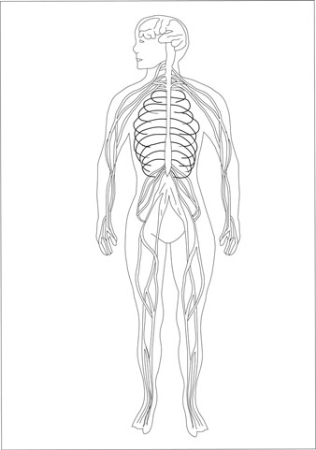for a general overview of the organization of the nervous system and the somatic nervous system that controls voluntary movement). The two divisions of the ANS are the parasympathetic division, which dominates and controls the body during nonstress- ful situations, and the sympa- thetic division, which dominates and controls the body during stressful situations.

Information is sent from the PNS to the brain, which serves as the activity headquarters of the CNS. Through the ﬁve senses (sight, smell, touch, hearing, and

taste), the CNS detects a stimulus,

which is a change that prompts a response in a living organism. The brain then processes the transmit- ted information and initiates the appropriate response or responses in the effector. An effector is an organ, such as a muscle or gland,

Figure 8.1 The Nervous System.

The brain and nerve systems, including the spinal cord, make up the nervous system. While regulating movements, the nervous system also works to interpret sensory information. (Sandy Windelspecht/ Ricochet Productions)

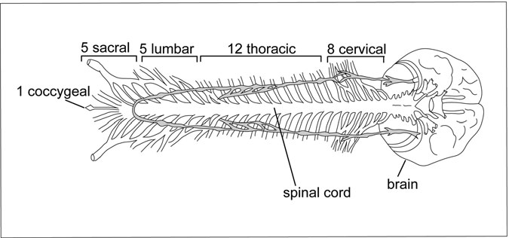

Figure 8.2 The Spinal Cord. There are ﬁve categories of spinal nerves noted on top of the ﬁgure: the coccygeal, sacral, lumbar, thoracic, and cervical, which total 31 pairs of nerves. (Sandy Windelspecht/ Ricochet Productions)

that responds through some kind of reaction (usually movement) when receiving a stimulus.

A nerve is deﬁned as a group of nerve ﬁbers located outside the CNS, and bundles of nerve ﬁbers located within the CNS are called nerve tracts. Nerve ﬁbers make up nerve cells, also known as neurons, which are the building blocks of the entire nervous system. Neurons are the essential conducting unit of the entire nervous system.

Before looking at the details of the neuron, it’s important to under- stand some other important elements that enable the CNS to operate smoothly. Taking a close look at a slice of the spinal cord, one sees that most of it is composed of white material and some of it is composed of a gray substance. These two parts are simply called white matter and gray matter. Whereas the gray matter consists mostly of nerve cell bodies, the white matter is composed mostly of nerve ﬁbers.

#### Nerve Cells: Foundation of the Nervous System

During the initial stages of growth, nerves develop in the embryo’s CNS and then grow out and spread through the body like tentacles. There are thousands of nerve ﬁbers grouped in large bundles that run to and from the CNS. Afferent

nerves are those ﬁbers coming to the CNS from the muscles, joints, skin, or internal organs, whereas those leaving the CNS to travel to these areas are known as efferent nerves. The spinal cord has two types of afferent nerves: those coming in at the back are called posterior or sensory; those leaving the spinal cord come out the front and are called anterior or motor. When these afferent nerves reach the spinal cord’s white matter, they divide and branch out to bring their messages to various different areas of the cord (Figure 8.3).

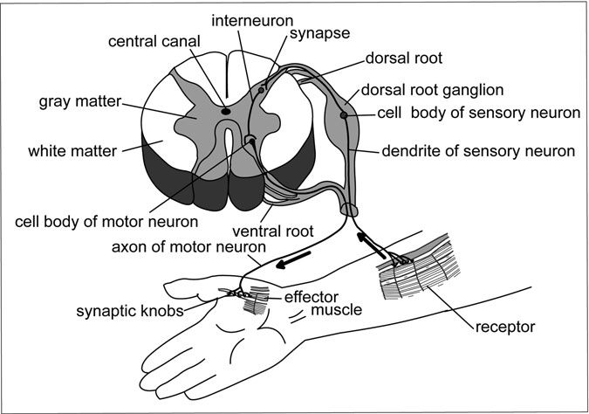

Figure 8.3 Another View of the Spinal Cord. A cross section of the spinal cord displays the white matter, which is the nerve tissue that contains myelinated axons and interneurons, and the gray matter, which is the nerve tissue that contains the neurons’ cell bodies. The spinal roots—the dorsal and ventral roots—are just shown on the right side of the spinal section, although these roots and the corresponding nerve tracts are actually present on both sides of the spinal cord. This ﬁgure also shows the path of a reﬂex arch, with the receptor muscles receiving the impulse, which is processed by the sensory neuron and then transmitted to the motor neuron at the synapse in the spinal cord. (Sandy Windelspecht/Ricochet Productions)

Most of the branches connect with neurons near the entry region of the nerve ﬁber and intermediate neurons. These intermediate neurons then connect with the motor neurons, which control muscle movement.

Although neurons vary in size, shape, and functions, they all consist of the following four distinct parts:

1. *Cell body*. This is the main mass of the cell and contains the nucleus and other organelles. The nucleus is the cell’s largest organ- elle, which contains chromosomes. In these chromosomes, genes carry the body’s hereditary information in the DNA, which allows the cell to reproduce. Neuron cell bodies are found in the CNS or close to it in the trunk of the body so they are protected by bone. The cell body also contains cytoplasm, and an abundance of mitochondria, which are organelles responsible for energy produc- tion in the cell.
2. *Dendrites*. This group of branching nerve ﬁbers carries impulses to the cell body. Small black spots also appear on the dendrites: these represent the nerve endings of other neurons, which pass messages from other neurons.
3. *Axon*. This single nerve ﬁber carries impulses away from the cell body and the dendrites. In humans, some axons can be around one meter long, but in larger mammals such as whales and giraffes, these would be much longer. A nerve ﬁber is the neuron including the axon and the surrounding cells. These ﬁbers branch out at the neuron’s ending (also known as arborization) and can be classiﬁed as either excitatory or inhibitory.
4. *Transmitting region*. The axon carries the impulses to the trans- mitting region, and from there it leaves the cell body and travels to the CNS.

In addition to these four parts, neurons are composed of layers of mem- branes and microtubules that produce hormones, neurotransmitters, and substances such as peptides and proteins, which will be discussed in detail further in this chapter.

##### How Cells Produce Energy

Cells produce energy through aerobic cell respiration. The following equation provides a simple explanation:

Glucose (C6H12O6) + 6O2 ! 6CO2 + 6H2O + ATP + heat

Each product of cell respiration is vital to the body’s function. The heat regulates body temperature, the water feeds the cells, and the CO2 is the waste that is exhaled through breathing.

An important product of cell respiration is ATP (adenosine triphos- phate), a neurotransmitter that is the muscle’s direct source of energy for movement. Basically, ATP captures energy from food, breaks it down, and then releases it into cells. Some of this energy resulting from respiration is used by the cell’s mitochondria to produce ATP. Therefore, cellular respi- ration is a constant, continuing cycle. All cells contain molecules of ADP (adenosine diphosphate) and phosphate. When the body digests food, it breaks down various chemical components to use in cell processes. A form of sugar known as glucose (C6H12O6) is one such substance, and is a neces- sary component (along with oxygen) in aerobic respiration. Glucose breaks down into CO2 and H2O (water), along with a release of energy. This energy then bonds with the ADP and a third phosphate to form ATP. Energy for cell processes is released and available for use when the bond holding this third phosphate is once again broken down.

##### Neurons

As mentioned earlier, neurons are nerve cells that are composed of nerve ﬁbers. Neurons are the foundation of the entire nervous system, and are responsible for transmitting messages throughout the body. In the PNS, the neurons are constantly carrying information to and from the CNS. How- ever, neurons can only carry electrical impulses in one direction, making it impossible for impulses to run into each other and cancel each other out.

The nervous system is made up of millions of neurons, in addition to the other cells that help support the functions of the spinal cord and brain. Neurons are classiﬁed into three groups: sensory, motor, and interneurons. Sensory and motor neurons make up the PNS, and interneurons are found in the CNS.

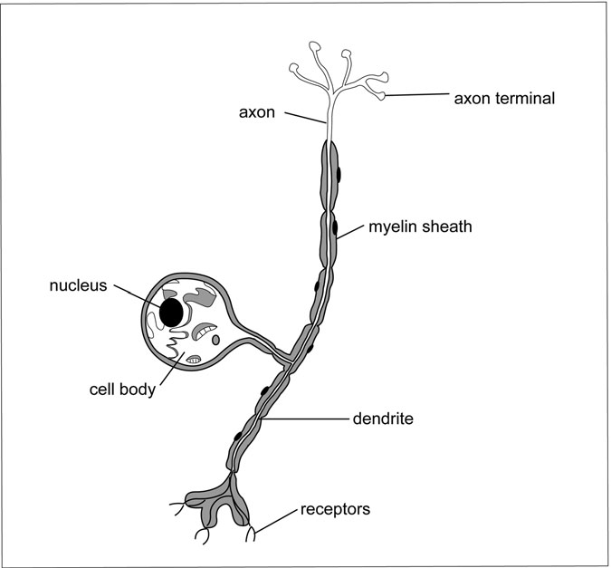

Figure 8.4 The Sensory Neuron. This neuron structure details a sensory neuron, which carries impulses and messages to the spinal cord and brain. These sensory neurons, which have cell bodies, are located in the CNS and close to the body so they are protected from damage. The axon moves these messages away from the nucleus and cell body, and the dendrites work in reverse to bring the impulses into the cell body. The myelin sheath works as an insulator to protect the neurons from short- circuiting with each other. (Sandy Windelspecht/Ricochet Productions)

The sensory or afferent neuron mainly functions in the CNS, and the motor or efferent neuron mainly functions in the PNS. Although both these neurons contain the same physical parts (the cell body, dendrites, axon, and transmitting region), there are some important differences in their composition (Figures 8.4 and 8.5).

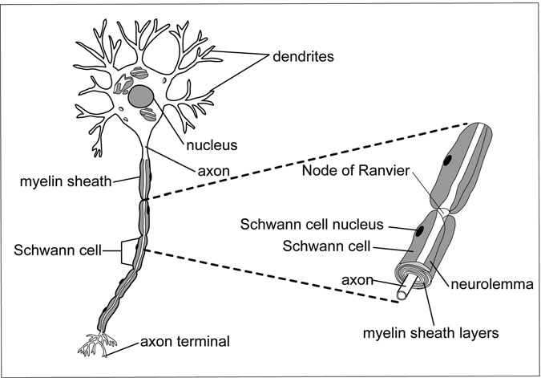

Figure 8.5 The Motor Neuron. This neuron structure details a motor neuron, which carries the impulses from the central nervous system to muscles and glands. Compared to the sensory neuron, this structure features the cell body at the top (rather than the side) and does contain receptors. (Sandy Windelspecht/Ricochet Productions)

The sensory or afferent neuron carries impulses and messages to the spinal cord and brain. In these neurons, the dendrites act as receptors— they detect external or internal changes, and transmit this information to the CNS. The sensory neuron dendrites may be short or long (sometimes as long as one meter), but they are single and are not branchlike in appear- ance like in the motor neuron.

Once the information is transmitted to the brain and spinal cord, the impulse is interpreted and the CNS stimulates a sensation. Sensory neu- rons located in the skin, skeletal muscle, and joints are known as somatic, and those in the internal organs are called visceral.

The motor (or efferent) neuron carries the impulses from the CNS to muscles and glands, also known as effectors. After the CNS processes an

impulse, the motor neuron will tell muscles to contract or relax and tell glands to secrete. Those motor neurons associated with the skeletal muscle are called somatic, and those associated with the smooth muscle, cardiac muscle, and glands are called visceral.

Some axons in both in both the CNS and PNS are layered with a cov- ering called the myelin sheath. Composed of fatty material, the myelin sheath electronically insulates neurons from one another. Without the pro- tection of the myelin sheath, the neurons would short-circuit and thus be unable to transmit electronic impulses.

In the motor neurons, the axons and dendrites are wrapped in special- ized cells called Schwann cells, which create their myelin sheath. The nucleus and cytoplasm in the Schwann cells are collectively called the neurolemma and are located outside the myelin sheath, physically cover- ing the nerve cell. Schwann cells are located in the PNS. The specialized cells in the CNS are called neuroglia. The node of Ranvier is the space that separates the Schwann cells. These nodes are responsible for depola- rizing electrical impulses, which will be explained in greater detail later in this chapter.

The neurolemma is important for nerve regeneration. If a nerve or nerves in the PNS is damaged or severed (for example, if a limb is dam- aged or severed) and then reattached through surgery, the neurolemma allows the axons and dendrites to regenerate and reattach to their proper connections. In addition, the Schwann cells are believed to produce a chemical substance that stimulates regeneration. This regeneration may be a slow process (it could take months or years), but eventually the nerve ﬁbers may restore their functions, therefore reinstating feeling and move- ment to the limb.

Regeneration, however, is not possible in sensory neurons of the spi- nal cord because there are no Schwann cells. In these neurons, the myelin sheath is formed by the oligodendrocytes, the specialized cells found only in the brain and spinal cord. Because there are no Schwann cells, there is no neurolemma, and thus cell regeneration is impossible. This is why spinal cord damage or severing results in permanent loss of function. The ﬁnal classiﬁcation of neurons is called interneurons. These are located entirely within the CNS and combine or integrate the sensory and motor impulses. Some of their functions include thinking, memory,

and learning. For instance, interneurons might receive impulses from the brain and transmit them to the somatic nervous system that determines movement in voluntary muscles, such as ﬁngers and toes.

Cranial nerves, or the nerves located in the brain, contain sensory, motor, and mixed nerve ﬁbers. The sensory nerves carry impulses toward the brain, and the motor nerves carry impulses away from the brain. But most of the cranial nerves and all of the spinal nerves are made up of both sensory and motor ﬁbers, and these are called mixed nerves.

##### Synapses

Every neuron has dendrites that connect with other neurons. In the CNS, neurons communicate with each other when the axon of one neuron comes into contact with the cell body or dendrite of another neuron. The space or junction between the axon and dendrite of these two neurons is known as a synapse, which comes from the Greek word meaning “to clasp.” This is where the message carried by the neuron is passed on. The synapse is often called a relay because it is here where the information is relayed to the next neuron. More speciﬁcally, the actual area (which is between 10 and 50 nm in width) between the axon and dendrite is known as the synaptic gap or cleft. Like a blueprint showing the ﬂoor plan and layout of a house, the location and pattern of connections between neurons determine the struc- ture and organization of the CNS. The position of the synapses dictates the route that impulses will follow within and between the brain and spinal cord. The impulse pathways determine what sensations are experienced

and how an effector responds to these sensations.

Events related to the synaptic process are classiﬁed as either presy- naptic (before transmission) or postsynaptic (following transmission). It is important to note that neurons conduct impulses in only one direction, depending on if they are afferent or efferent.

The synapse transmissions in the CNS are extremely complicated, but Figure 8.6 describes their role in transporting information throughout the CNS at the most basic level. In this illustration are four neurons—A, B, C, and D. A and B are the presynaptic neurons that are carrying informa- tion to C and D, the postsynaptic neurons. The A and B axons will make contact with the C and D dendrites, thus creating four synapses.

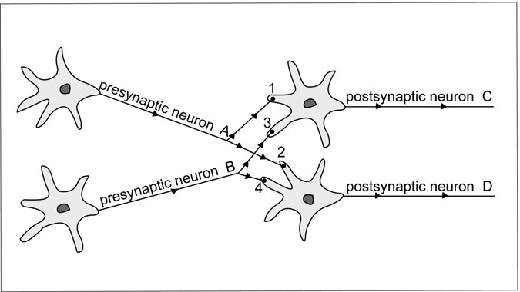

Figure 8.6 Synaptic Connections. The synapse transmission between the neurons of the CNS. The two presynaptic neurons, A and B, carry impulses and messages to the postsynaptic neurons, C and D. The locations where A and B make contact with C and D are known as synapses, which are numbered 1–4. (Sandy Windelspecht/Ricochet Productions)

Neurons connect with each other in two ways: (1) a neuron receives impulses from a few other neurons and relays these impulses on to thousands of other neurons—divergence; and (2) a neuron receive impulses from the nerve endings of thousands of other neurons and transmits its message to only a few other neurons—convergence. Convergence and divergence are two types of pathways that impulses can take when traveling from the presy- naptic neuron to the postsynaptic neuron, as shown in Figure 8.6. An impulse can travel across synapse 1 to C, or it can go across synapse 2 to D.

However, the impulse can also travel along A and cross synapses 1 and 2 to C and D, which is divergence. Convergence is when the impulse travels along to presynaptic neurons to one postsynaptic neuron; for exam- ple, if A and B impulses would travel through synapse 1 and converge to postsynaptic neuron C. Of course, in the complex body, any postsynaptic neuron can expect to have hundreds of axons from presynaptic neurons attach to its dendrites.

A nerve impulse enters the cell body by ﬁrst attaching itself to that cell’s dendrites. This then alters the neuron’s excitability. The excitatory nerve ﬁber ampliﬁes the energy from the impulse, but the inhibitory nerve ﬁber reduces this energy. Although the arrival of the impulse alters the excitability of the neuron, it does not necessarily result in a postsynaptic neuron reaction or ﬁring. A reaction occurs only when the nerve ﬁber’s axon has reached its threshold level. The value of this threshold varies with each nerve ﬁber and depends on the composition of the cellular ﬂuid and the number of impulses recently received and conducted.

For example, when one touches a warm stove with his or her ﬁngers, the nerve impulse translating the corresponding sensation of warmth attaches itself to the dendrites of the neurons located in the ﬁngertips, thus stimulating the neuron’s excitability. The excitatory and inhibitory nerve ﬁbers process this sensation through amplifying but also inhibiting the energy from the impulse. When the sensation (or warmth) increases beyond the threshold level of the nerve ﬁber’s axon, a reaction occurs. So if the heat on the stove increases beyond a certain level, the nerve ﬁbers will stimulate a chain of events that produce a reaction, such as pulling the ﬁngers away from the stove.

Both excitatory and inhibitory neurons are managed by excitatory and inhibitory nerve ﬁbers. Some postsynaptic neurons ﬁre off most of the time, whereas others ﬁre off less frequently. For example, neurons that work the muscles in the brain and spinal cord are in a constant state of excitability. Because the body’s muscles must always be ready for action, there must be a constant ﬂow of impulses between the brain and spinal cord. But neurons that control breathing are not constantly ﬁring—they operate at a more rhythmic pace.

The respiratory and muscular responses are examples of postsynaptic excitation or inhibition because they take place immediately after an impulse transmission at the synaptic gap. Presynaptic excitation or inhib- ition occurs before the impulse reaches the synaptic gap. If an impulse is transmitted along an inhibitory nerve ﬁber, it will not deliver its full load of excitability at the synapse. In fact, this nerve ﬁber can completely block all nerve impulses from reaching the synapse.

Synapses can deliver messages either to thousands of neurons or to only a few. The more synaptic exchanges there are in a transmission, the

more opportunities there are for changes or modiﬁcations that can be made to that resulting reaction. For example, suppose there are two ways to get from Anytown, USA, to Nowhere, USA. The ﬁrst route is a straight road with no turnoffs, but the second route has numerous crossings and connects with secondary roads that ultimately lead to Nowhere. Although the ﬁrst route is faster, there is no chance for changes or modiﬁcations. One cannot change the route—it is a straight shot. But the second route, even though it might be slower, has numerous opportunities for change with all its turnoffs and back roads.

When a nerve impulse crosses the synaptic gap, each synapse contains substances to create adhesion between the presynaptic and postsynaptic membranes. When contacted by the impulse, the synaptic gap constricts as the width decreases and the concentration of the transmitter increases. Synapses that are not used often tend to cease functioning, but synapses that are used frequently tend to transmit impulses quickly.

##### Neurotransmitters

In the latter part of the nineteenth century, there was a controversy over whether the vertebrates had a nervous system composed of a continuous net- work of neurons or of separate neurons. When it was eventually proven that the vertebrate’s body is made up of separate neurons connected with synap- ses, the question remained about how the neurons related to each other.

Because nerve ﬁbers are minute and cover only a small portion of the postsynaptic neuron’s cell body, the amount of impulse and energy it can deliver is diminutive. This might be adequate for organisms such as ﬁsh or crustaceans—enough current is delivered to inhibit or excite a postsy- naptic neuron in these animals. However, in reptiles and mammals, another mechanism is used to transmit impulses. In the early 1900s, scien- tists and physiologists had concluded that the endings of nerve ﬁbers emit chemical substances that inﬂuence the behavior of postsynaptic neurons.

Researchers noticed that by injecting certain nerve tissue with a sub- stance called adrenaline, the sympathetic system (the motor nerve net- work that operates the blood vessels and sweat glands, along with some of the internal organs) was stimulated. They believed that the body was constantly tapped into a natural supply of adrenaline.

These landmark discoveries veriﬁed that chemical substances are emitted through nerve endings to help transmit messages. These chemi- cals are called neurotransmitters, or simply transmitters. In the human body, there are about 80 different neurotransmitters.

Neurotransmitters are classiﬁed into four groups:

• *Amines*: acetylcholine, noradrenalin, serotonin, dopamine

• *Amino acids*: glutamic acids, gamma aminobutyric acid (GABA)

• *Purines*: adenosine triphosphate (ATP)

• *Peptides*: enkephalins, dynorphin, endorphin

Some important neurotransmitters in our body include acetylcholine, dopamine, norepinephrine, and serotonin. Many neurotransmitters have a particularly wide distribution and vital roles. Noradrenalin, for exam- ple, transmits neurons from various regions in the brain, such as the cer- ebral hemispheres, the cerebellum, and the spinal cord. Noradrenalin increases the reaction excitability in the CNS and the sympathetic neurons in the spinal cord.

Another major transmitter is serotonin, which is an important dis- tributor for the sensory channels in the CNS and in the expressions of emotion. Medications that alter mood or behavior, such as antidepres- sants, will be targeted at serotonin and norepinephrine and will affect synapse transmission.

Dopamine is an important transmitter in the motor system, limbic sys- tem, and the hypothalamus. Parkinson’s disease kills the cells that produce these transmitters, therefore impeding mobility and other motor functions. These transmitters are supplemented using a drug called L-dopa, which improves posture and motility, although it cannot stop the tremors that accompany Parkinson’s disease.

In simplistic terms, when a presynaptic neuron receives an electrical impulse, its axon releases a neurotransmitter, which then diffuses across the synapse and combines with the dendrites of the postsynaptic neuron. This generates an electrical impulse, which is then carried to the postsy- naptic neuron’s axon to the next synapse and so on. A chemical inactivator

is located at the dendrite of this postsynaptic neuron to counteract the impulse generated by the neurotransmitter. Each neurotransmitter has a speciﬁc inactivator. For example, cholinesterase is the inactivator for acetylcholine, a neurotransmitter found in many of the body’s muscular junctions. The inactivator stops the continuous transmission of the impulse unless a new impulse is generated by a neurotransmitter at the ﬁrst neuron. But let us look at this process more closely to further under- stand the transmission of a nerve impulse.

Neurons produce transmitters either in their nerve endings or in their cell bodies. In the case of peptides, they are made in the cell bodies, and then transported to the nerve endings where they are then converted into transmitters. Some unmyelinated nerves, such as those in the sympathetic system, emit transmitters along the course of the nerve rather than the nerve ending. Transmitters pass through little bulges called varicosities located along the nerve ﬁber. These varicosities move along the nerve ﬁber, similar to when a ball moves through a stocking.

In other cases, transmitters are stored in tiny vesicles of the nerve end- ings. When an impulse or action potential affects these endings, calcium (Ca+) ions pass into the endings from the extracellular ﬂuid from the neighboring neutron. This connects the vesicle with the membrane of the nerve ending, and then the transmitter connects with the synaptic cleft. The upper layer of this four-layered membrane is presynaptic membrane, and the synaptic cleft is between this layer and the second layer. After the transmitter leaves the vesicle, it crosses the synaptic cleft and connects with the membrane or receptor site of the postsynaptic neuron. This recep- tor site is made up of various proteins, and those proteins that are speciﬁ- cally affected by a transmitter are known as receptors or targets of the transmitter. It is important to note that one transmitter can have different effects on different neurons. Acetylcholine can excite one neuron while inhibiting another. However, in vertebrates, GABA is always inhibitory, and glutamate is always excitatory (Figure 8.7).

Transmitters must be controlled. If their secretion was not stopped at some points, then rapid changes in excitation and inhibition would not occur, and all activity would be slowed down. Some synapses block impulse transmission rather than pass the impulse on to other synapses (known as an excitatory synapse). A synapse that inhibits impulse

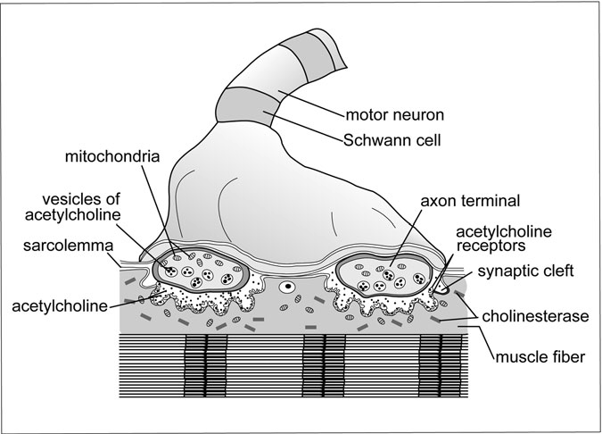

Figure 8.7 The Neuromuscular System. When the muscle ﬁber meets the motor neuron at the axon terminals, a movement or reaction results with the aid of neurotransmitters, including acetylcholine and its inactivator, cholinesterase. The sarcolemma contains receptors for the acetylcholine, and the mitochondria are where cell respiration takes place and energy is produced. Muscle contraction begins when the axon terminal receives a nerve impulse, which stimulates the release of acetylcholine. This release causes electrical changes—because of the movement of ions—at the sarcolemma. (Sandy Windelspecht/Ricochet Productions)

transmission is known as an inhibitory synapse. In this situation, a chemical inactivator located at the dendrite of the postsynaptic neuron inactivates the neuron, which ceases any impulse unless a new impulse from the ﬁrst neuron releases more of the neurotransmitter.

Peptides have been discovered to be transmitters only in the past 20 to 30 years. One example is the parasympathetic nerves that control the salivary glands, which release a transmitter called VIP, also known as

vasointestinal peptide. VIP increases the amount of acetylcholine released by nerve endings and also dilates blood vessels, which brings more blood to the glands so more saliva can be secreted. In addition, because of its abil- ity to dilate blood vessels, it is used in the penis to achieve an erection. Often someone who is impotent has a deﬁciency of VIP in his genital organs.

##### Nerve Impulse

The body’s nerve ﬁbers system can be compared to a telegraph wire. Both are electric conduction systems designed to relay messages quickly over long dis- tances. Both transmit messages in the form of pulses that are of a constant size and speed. Both the nerve ﬁber and the telegraph wire must be insulated for protection. If the wires or the ﬁbers are damaged in any way, they cannot carry the impulses. But the nerve ﬁber is signiﬁcantly more complicated than a telegraph wire. The nerve ﬁber generates the message itself along with trans- mitting it, whereas the telegraph wire is simply involved in the transmitting.

The body is composed of two kinds of ﬂuid: intracellular (ICF) and extracellular (ECF). ICF, the ﬂuid within the cells, contains 65 percent of the body’s total water. ECF, the ﬂuid outside the cells, contains the remaining 35 percent. Both ICF and ECF contain electrolytes—chemicals that dissolve in water to become positive and negative ions. Positive ions are known as cat- ions, while negative ions are called anions. ECF is comprised of a salt and chloride solution—NaCl—that breaks down to become sodium cations (Na+) and chloride anions (Cl−). ICF is composed of potassium cations (K+). Both Na+ and K+ are essential for neurons to conduct impulses throughout the body. In order to understand the electrical changes, look at Figure 8.8.

When a neuron is not carrying an impulse, it is considered in a state of polarization (A). This means that Na+ is more abundant outside the cell, and K+ is more abundant inside the cell. In this state, the neuron has a pos- itive charge on the outside of the cell membrane and a negative charge inside. When an axon receives a nerve impulse, it releases the neurotrans- mitter acetylcholine (ACh). ACh diffuses across the synapse and bonds to the ACh receptors, located on the sarcolemma. The ACh makes the sarco- lemma permeable to the Na+ ions. These Na+ ions then rush into the cell membrane and the K+ ions rush out of the cell. The neuron is then in a state of depolarization (B), and the charges acting on the membrane are

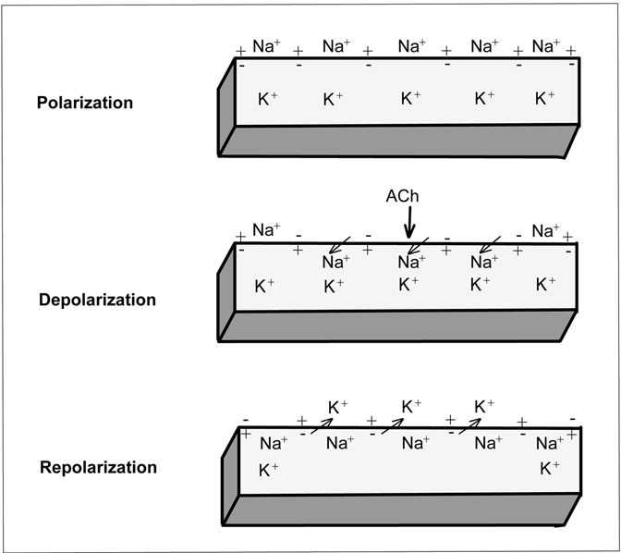

Figure 8.8 Muscular Electrical Charges. Muscle contractions are caused by electrical charges and the ion chemistry at the sarcolemma.

Polarization is when the muscle is relaxed, depolarization is when the muscle is responding to the inﬂuence of acetylcholine, and repolarization is the process of the ion concentration returning to the polarization state. See also Table 1.1. (Sandy Windelspecht/Ricochet Productions)

reversed. Therefore, the inside of the cell has a positive charge whereas the outside has a negative charge. In addition, the cholinesterase inacti- vates the ACh. This is when the impulse is generated and transmitted through the body to prompt a reaction.

In order for the neuron to receive another impulse, it must be repolar- ized (C) and returned to the state it was in before it received the stimulus. Repolarization happens when the body’s sodium pumps return the Na+

TABLE 8.1

Electrical Charges

*Polarization (resting potential)*

* A positive (+) charge is outside the sarcolemma and a negative (−) charge is inside.
* Na+ ions are more abundant outside the cell. They diffuse inward until the sodium pump pushes them back outside the cell.
* K+ ions are more abundant inside the cell. They diffuse outward until the potassium pump pushes them back inside the cell.

*Depolarization (action potential)*

* ACh is released by the neuron when a nerve impulse is received at the axon terminal.
* ACh makes the sarcolemma permeable to Na+ ions.
* Na+ ions rush into the cell, causing a reversal of charges on the sarcolemma—now the outside is (−) and the inside is (+).
* The ACh is then deactivated by cholinesterase.

*Repolarization*

* Cell becomes permeable to K+ ions, which rush out of the cell.
* Charge restoration takes place—the outside is (+) and the inside is (−).
* The Na+ ions return outside via the sodium pumps, and the K+ ions return inside via the potassium pumps.
* Muscle ﬁbers now are ready to respond to another nerve impulse received by the axon.

ions outside the cell membrane, and the potassium pumps return the K+ ions inside the membrane. The neuron is then once again in a state of polarization—the Na+ ions are more populous outside and the K+ ions are dominant inside. The neuron is now ready to respond to a stimulus and generate an impulse. Take a look at Table 8.1 for a recap of these processes. The polarization, depolarization, and repolarization cycle is similar to when a crowd of cheering fans at a stadium sporting event begin a “wave.” One section will get up and throw their hands in the air, fol- lowed by the neighboring section, and so on, and a wave motion reverber- ates around the stadium. Just like the neuron’s polarization behavior, the activity of each section inﬂuences the activity of the next section.

A neuron responds to a stimulus or action potential very quickly—in fact, it is measured in milliseconds. Each neuron has the ability to respond to hundreds of stimuli each second and to generate an electrical impulse.

Motor neurons are especially efﬁcient because only their nodes of Ranvier depolarize, which is known as salutatory conduction. In these neurons, impulses travel extremely rapidly along the nodes of Ranvier. The neuron’s myelin sheath also increases the rate at which impulses are generated.

Once the impulse is generated, neurons are able to transmit the infor- mation within milliseconds, even over great distances. For example, when a barefooted man or woman over six feet tall steps on a sharp tack, they will feel pain just as quickly as someone who is only ﬁve feet tall. The body can transmit these sensory impulses from the sole of a foot to the brain in under a second.

The nerve ﬁbers that actually transmit information to the spinal cord and brain are called primary afferent axons. The speed at which these ﬁbers can transmit messages depends on their thickness—the thicker the ﬁber, the faster information can travel. These axons are classiﬁed into four different groups (in order of decreasing size—thickest to thinnest):

* *A-alpha* carries information related to muscles
* *A-beta* carries information related to touch
* *A-delta* carries information related to pain and temperature
* *C* carries information related to pain, temperature, and itch

For example, if someone stubs her toe on a table, she initially feels the touch sensation when her toe collides with the table. The thick (and there- fore fastest) A-beta nerve ﬁber carries this sensation from her toe to the brain. Because of the speed of this ﬁber, this sensation reaches the brain ﬁrst. But shortly after, she feels pain. This is because the information related to pain is carried by the slower and thinner A-delta and C-nerve ﬁber.

#### The Spinal Cord

The central nervous system (CNS) is made up of two major organs: the brain and the spinal cord. The spinal cord connects the brain to the peripheral nervous system (PNS)—the nerves associated with the brain and spine. In order for information to travel between the brain and PNS, it must pass through the spinal cord.

Protected by a bony canal, the spinal cord extends down to the end of a column, which is made up of bones called vertebrae. This vertebral col- umn grows at a faster rate than the nerve tissue of the spinal cord, so even- tually the lower part of the canal grows longer than the cord. In an adult body, the spinal cord ends a short distance from the lowest rib (between the ﬁrst and second vertebrae). An adult male’s spinal cord will measure about 45 cm long, and an adult woman’s will grow to about 43 cm long. The nerves that are below the spinal cord run in the vertebral canal—they are known as the cauda equina, which is Latin for “horse tail.”

##### Function

The spinal cord has three main functions:

* *Direct reﬂexes*: Examples of a reﬂex are a knee jerk or pulling one’s hand away from a hot surface. A spinal reﬂex only passes through the spinal cord and doesn’t involve the brain.
* *Conduct sensory impulses*: Transmit sensory information from the afferent neurons to the brain through ascending nerve tracts.
* *Conduct motor impulses*: Transmit impulses from the brain through descending nerve tracts to the efferent neurons that communicate with the body’s glands and muscles.

The stretch reﬂex—when a muscle is stretched and responds by contracting—is the most basic reﬂex arc in humans. This is basically a syn- apse between a sensory or afferent neuron and a motor or efferent neuron. Stretch reﬂexes can be induced by tapping many of the body’s larger muscles, such as the triceps in the arm or the calf muscle in the leg. But most reﬂexes involve at least three neurons and numerous synapses. Reﬂex path- ways or arcs will be examined more thoroughly later in this chapter.

##### Structure

Spinal Cord

The center of the spinal cord contains H-shaped material—this is the gray matter, which is made up of the cell bodies of the motor neurons and inter- neurons (Figure 8.9). Surrounding this gray matter and ﬁlling out the

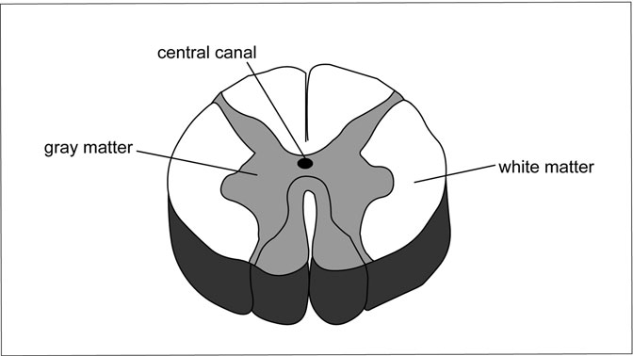

Figure 8.9 Another Cross-Section View of the Spinal Cord. This cross section of the spinal cord shows the gray matter, which con- tains the cell bodies of the motor neurons and interneurons, and the white matter, which contains the interneurons’ myelinated axons and dendrites. The central canal contains the cerebrospinal ﬂuid. The gray matter coming out the top of the ﬁgure is the dorsal root, and the gray matter coming out the bottom is the ventral root. (Sandy Windelspecht/Ricochet Productions)

remainder of the spinal cord is the white matter—consisting of the inter- neurons’ myelinated axons and dendrites. These are known as nerve ﬁbers, which are bundled into nerve tracts based on what function they perform. The descending tracts carry motor impulses away from the brain, and the ascending tracts carry impulses to the brain. Also note the central canal—this contains the cerebrospinal ﬂuid (CSF), which circulates in and around the brain and spinal cord.

Spinal Nerves

The spinal cord contains 31 pairs of spinal nerves (Figure 8.10). Because they are in pairs, they are bilateral, which means the nerves and nerve tracts occupy both sides of the spinal cord. Whereas the spinal cord is con- sidered part of the central nervous system (CNS), the spinal nerves and nerve tracts are part of the peripheral nervous system (PNS).

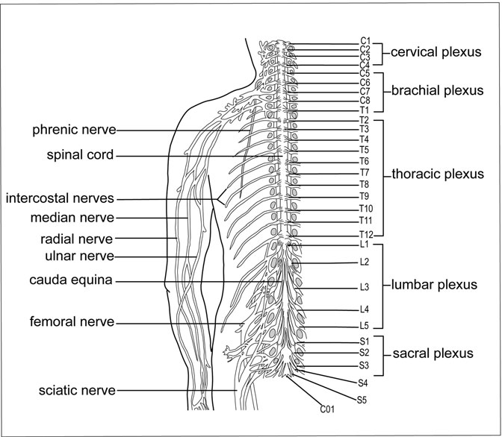

Figure 8.10 Nerves and Spinal Cord. The CNS’s spinal cord consists of spinal nerves (on the left of the ﬁgure) and the spinal nerve plexus network (located on the right of the ﬁgure). The purpose of the nerve plexus is to combine neuron networks from various parts of the spinal cord to form nerve systems speciﬁc to parts of the body. For example, the arms’ radial and ulnar nerves are part of the brachial plexus. (Sandy Windelspecht/Ricochet Productions)

As noted in Table 8.2, each pair of spinal nerves is numbered corre- sponding to the level of the cord and area of the vertebrae where it is attached. In addition, each pair is deﬁned by a letter. For more information on spinal cord-related injuries, read Sidebar 8.1.

There are eight cervical pairs, 12 thoracic pairs, ﬁve lumbar pairs, ﬁve sacral pairs, and one tiny coccygeal pair (see Table 8.2). The ﬁrst cer- vical vertebra is called the atlas, inspired by one of the heroes in Greek mythology. After losing an important battle, Atlas was turned to stone

|  |  |  |
| --- | --- | --- |
| TABLE 8.2 |  | |
| Spinal Nerves |
| *Nerve group* | *Name* | *Corresponding location* |
| C1–C8 | Cervical pairs | Neck |
| T1–T12 | Thoracic pairs | Ribs |
| L1–L5 | Lumbar pairs | Large vertebrae in the small of the back |
| S1–S5 | Sacral pairs | Base of the spine |
| CO1 | Coccygeal pair | Pelvic ﬂoor |

and forced to carry the Earth and heavens on his shoulders. Therefore, this vertebra is called atlas because it carries the weight of the head.

Receptors located on the skin send information to the spinal cord through the spinal nerve. In referring to Figure 8.11, notice the dorsal and ventral roots protruding from the spinal cord. These roots attach the nerves to the cord. Dorsal refers to the back or posterior of the body, and ventral refers to the front of the body. The dorsal horns are the gray matter in the dorsal area—this is where sensory information is received through the dor- sal root. The ventral horns are the gray matter in the ventral region, and they contain the motor neurons. The axons of these motor neurons leave the spi- nal cord, travel along the ventral roots, and head directly to the muscles.

Each dorsal root contains an enlarged area of gray matter, called the dorsal root ganglion. Because ganglion refers to any collection of nerve cell bodies outside the CNS, the dorsal root ganglion contains the cell bodies of the peripheral sensory neurons, such as the receptors on the skin. All the nerve ﬁbers from all the sensory receptors throughout the body converge in the dorsal root ganglia.

The ventral roots contain motor nerve ﬁbers, which connect to volun- tary muscles, involuntary muscles, and glands. Cell bodies from these neurons are housed in the gray matter of the spinal cord. Both the dorsal and ventral roots meet in the spinal nerve—therefore creating a network of both sensory and motor nerves.

The groupings of nerves on the right side of the body are called nerve plexuses. A nerve plexus is a combination of neurons from various sections of the spinal cord that serve speciﬁc areas of the body (see Table 8.2).

SIDEBAR 8.1

#### Making Advances in Spinal Cord Injury Research

Treating spinal cord injuries and paralysis has presented some of the great- est challenges to medical researchers throughout history. Even as we understand more about the nervous system and how neurons behave, researchers could not uncover a way to re-grow injured nerves in the brain and spinal cord.

That was until two important scientiﬁc breakthroughs in the 1980s. First, experiments in rats showed that under certain laboratory condi- tions, many types of injured neurons in the central nervous system could be regenerated. Then, in the late 1980s, as scientists were focused on ﬁg- uring out what was keeping axons from regrowing in people, they discov- ered important proteins that were inhibiting this growth. These proteins were produced by the oligodendrocytes. These are the cells that create the myelin sheath that covers nerves.

Both of these discoveries reinvigorated an area of research that had been considered beyond hope. Below are three areas where research is currently focused in treating spinal cord injuries:

*Promoting Axon Growth*: Researchers now know that it is not enough just to regrow a damaged axon. The axon needs to be positioned in the proper area of the spinal cord that will promote its growth and support its function. Even more challenging is that many regions of the adult spinal cord contain chemicals that inhibit the growth of a damaged axon, prompting it to retreat. Scientists are working on changing this environment in order to make it more hospitable to growing axons.

*Enhancing Compensatory Growth of Uninjured Axons*: Studies have shown that when damaged axons undergo treatment, the healthy neurons that surround the damage site begin to grow and support the recovering cells. Scientists are now using this knowledge to try to repair damaged nerve networks, particularly in patients who still have uninjured nerve networks. The hope is that these healthy nerves might be manipulated into taking over the function of the damaged nerves.

*Preventing Scar Formation*: Scar tissue that forms over the site of the injury can hamper repair. Scientists have discovered some molecular signals that scar tissue gives off that tries to block growth. Research is now focused on analyzing enzymes that will block these molecules and allow nerves to grow amidst scar tissue.

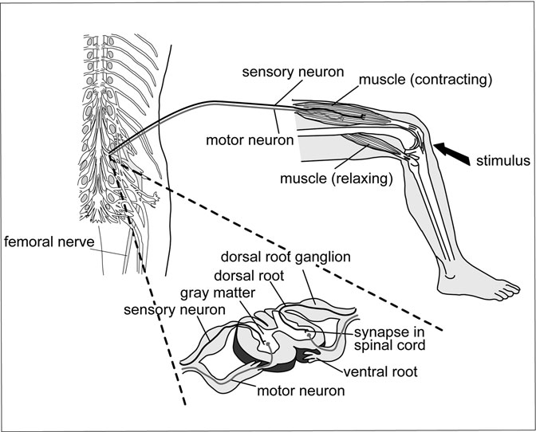

Figure 8.11 Spinal Roots of the Reﬂex Arc. A stimulus is applied to the knee, causing the sensory neuron to transmit the impulse to the spinal cord. The impulse is processed, and the instructions for a reaction are carried by the motor neuron, telling the relaxing muscle to contract. This reaction then causes the contracted muscle to relax. (Sandy Windelspecht/Ricochet Productions)

##### Differences among Spinal Cord Segments

All the pictures in Figure 8.11 represent a different segment of the spinal cord. Each picture is slightly different. The darker areas in each picture re- present the gray matter, which is where the cell bodies of the nerve ﬁbers are located, and the white matter is represented by the lighter areas that sur- round the gray matter. This is where the spinal cord’s axons are located. In the cervical segment picture, there is a large amount of white matter. The cervical vertebrae fall right below the skull, at the top of the spinal cord.

Because of their location, there are many axons traveling up to the brain from all levels of the spinal cord. In addition, there are many axons traveling from the brain to the various segments on the spinal cord. In contrast, the sacral segment (which is the lowest, except for the coccygeal pair) has much less white matter. This is because fewer axons are traveling to and from the brain through this spinal cord segment. To summarize, the amount of white matter in relation to gray matter decreases as one moves down the spinal cord. In addition to the differences in the amount of white matter, there are also differences in the size of the ventral horn, depending on the level of the spinal cord. Motor neurons are abundant and large in the segments controlling limbs, which are the lower cervical (C5–C8), lumbar, and sacral sections. In addition, the thoracic level features an extra cell column called the intermediate or intermediolateral cell column. This cell col-

umn is the location of all presynaptic sympathetic nerve cell bodies.

##### Reﬂexes

As mentioned earlier in this chapter, a reﬂex refers to when an incoming signal is processed by the CNS and then reﬂected to the motor nerve ﬁbers, which then generate movement. But the action is generated from the spinal cord, and the brain is not directly involved.

The path that a nerve impulse follows after a signal is processed

is known as the reﬂex arc. Five essential elements are involved in the reﬂex arc:

* Receptors detect the incoming stimulus and generate an impulse.
* Impulses are transmitted from receptors to the CNS through sensory neurons.
* The CNS houses the synapses where the impulse travels through.
* Impulses are transmitted from the CNS to the effector by motor neurons.
* The effector performs its distinctive action.

An appropriate example of a reﬂex arc is the patellar reﬂex, also known as the knee-jerk reﬂex. This is often an initial clinical test to determine if there is any neurological damage in the CNS. Doctors will hit the patellar tendon (right below the knee) with a rubber mallet to ensure a patient’s nervous system is working correctly. If the knee quickly rises in response to the stimulus, then the CNS is functioning properly. Any problems with this response might indicate trouble in the thigh muscle or spinal cord. When the leg is raised, the muscle stretches and contracts; this is known as the stretch reﬂex.

In order to understand the patellar reﬂex, it is helpful to look at the different elements, which collectively happen in under one second. When the stimulus, or rubber mallet, hits the patellar tendon, the stretch recep- tors detect that the tendon is stretching. These receptors produce impulses that are carried along sensory neurons to the spinal cord. In the spinal cord, the sensory neurons synapse with the motor neurons, which transmit an impulse to the motor neurons in the femoral nerve. These neurons in the femoral nerve then transport impulses back to the quadriceps femoris (known as the effector), which contracts and then causes the lower leg to extend.

A closer look at a reﬂex, such as the patellar or stretch reﬂex, reveals the important role of the muscle spindle, which is a small group of muscle ﬁbers wrapped in connective tissue that separates it from the rest of the muscle. Connected to an afferent neuron, the muscle spindle actually detects the stretch in the muscle.

Another important spinal cord reﬂex is the ﬂexor, or withdrawal reﬂex. Once again, the ﬂex reﬂex is automatic, and the brain is not directly involved in any decision making. This is when the stimulus is potentially harmful, such as touching a hot cooking pan or a sharp needle. The response is to pull one’s hand or ﬁnger away. Similar to the patellar reﬂex, the sensory neurons transmit information to the spinal cord, and then the motor neurons tell the speciﬁc muscle to contract.

#### The Brain

Along with the spinal cord, the brain is the other major organ that makes up the central nervous system (CNS). Weighing approximately 3 pounds, or a little over 1 kilogram, in an average adult, the brain consists of over 100 billion neurons and trillions of glia, or support cells. The brain is covered by ﬂuid, membranes, and bones. Housed in the skull, the brain is enclosed by a total of 14 bones, eight of which make up the cranium (the remaining six bones enclose various other parts of the brain). The skull is important because it protects the brain, and it will be explained more thoroughly later on in this chapter.

The brain is made up of many major parts that function as an integrated unit (Figure 8.12). The brain stem is the ﬁrst major part. This consists of the medulla, pons, and midbrain, which is located just above the medulla. The remaining major parts are the cerebellum, the hypothalamus, the thalamus, and the cerebrum. Although each part is explored individually in the

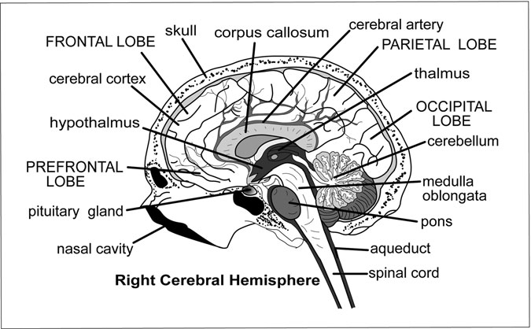

Figure 8.12 The Right Hemisphere of the Brain, including the Lobes. This hemisphere of the brain is associated with space-related perceptions, facial recognition, visual images, and music. (Sandy Windelspecht/ Ricochet Productions)

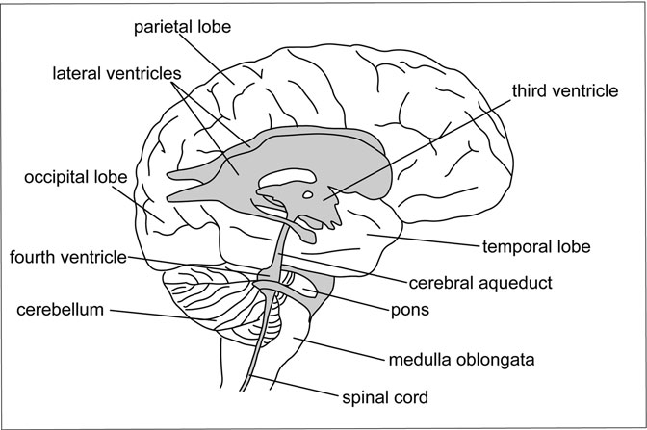

Figure 8.13 The Ventricles in the Brain. The brain’s four ventricles are cavities that contain the choroids plexus, which is important in forming the CNS’s tissue ﬂuid (called the cerebrospinal ﬂuid). (Sandy Windelspecht/Ricochet Productions)

following sections, it is important to remember that each part is intercon- nected and works with each other.

In addition to these major parts, the brain consists of four cavities, or ventricles (Figure 8.13). There are two lateral ventricles, as well as a third and fourth ventricle. Within each ventricle is a choroid plexus, a capillary network that forms cerebrospinal ﬂuid (CSF) using blood plasma. This tissue ﬂuid circulates in and around the brain and spinal cord, and will be covered in more detail later in the section about blood circulation in the brain.

##### Medulla

The medulla is anterior to the cerebellum, and extends between the spinal cord and the pons. Because the medulla contains myelinated nerve ﬁbers and gray matter (or collections of cell bodies), this part of the brain is active in regulating the respiratory and cardiac activities of the body. This means

regulating the body’s heart rate, regulating the blood pressure by controlling the diameters (or width) of the blood vessels, and maintaining respiratory centers that control breathing. In addition, the medulla contains reﬂex functions that control coughing, sneezing, swallowing, and vomiting.

##### Pons

Also anterior to the cerebellum, the pons bulge out from the top of the medulla. The pons are also composed mainly of myelinated nerve ﬁbers, which connect the two halves of the cerebellum with the brain stem in addition to the cerebrum above and the spinal cord below. This area of the brain is a vital link between the cerebellum and the rest of the nervous system. Nerve ﬁbers in the pons carry messages to and from areas below it and above it. The pons contain two respiratory centers that work with the medulla to establish a normal breathing rhythm.

##### Midbrain

The midbrain extends from the pons and encloses the cerebral aqueduct, which is a tunnel that joins the third and fourth ventricles. The upper part of the midbrain is composed of four rounded masses of gray matter. Visual and auditory reﬂexes—or eye and ear reﬂexes—are housed in these masses. For example, when a bee comes buzzing toward someone’s nose, he moves his head away. This is a visual reﬂex, because it involves the coordinated efforts of his eyeballs. When someone whispers near a person’s ear, her ﬁrst instinct will probably be to move closer to that whisper in order to hear better, which is an example of an auditory reﬂex. Righting reﬂexes— which ensure the head is upright and balanced—are also contained in the midbrain.

##### Cerebellum

The cerebellum is separated from the medulla by the fourth ventricle and cerebral aqueduct and is located below the occipital lobes of the cerebrum. As stated earlier, the cerebellum is connected to the brain stem, cerebrum, and spinal cord by the pons. This part of the brain controls movement, which includes coordination, regulation of muscle tone, and

maintaining posture and equilibrium in the body. Equilibrium is actually controlled by receptors located in the inner ear. It is important to note that these are all involuntary functions. Because the cerebellum works below conscious thought, the conscious brain is able to function without being overwhelmed. For example, if someone drops a pen while writing, the cer- ebellum coordinates the impulses that tell her arm, hand, and ﬁngers to pick up that pen. This all happens unconsciously so the brain can focus on tasks that need conscious effort, such as reading or writing.

##### Hypothalamus

Located at the base of the brain (above the pituitary gland and below the thalamus), the hypothalamus acts as the junction between the nervous sys- tem and the endocrine system. The hypothalamus is extremely small—it comprises approximately only 1/300 of the total brain weight. One of its most important jobs is to integrate all the various functions of the autonomic nervous system, which maintains the behavior of organs such as the heart, blood vessels, and intestines. But the hypothalamus has many other impor- tant and diverse jobs:

* *The body’s thermostat*: The hypothalamus senses changes in body temperature and then transmits information so the body can adjust accordingly. For example, the hypothalamus will detect an increase in body temperature, which means the body is too hot. A signal will be sent to the skin’s capillaries, telling them to expand to allow the blood to cool faster. Responses such as shivering or sweating are also prompted by the hypothalamus.
* *Oxytocin and antidiuretic hormone (ADH) production*: ADH helps to maintain the body’s blood volume by enabling the kidneys to reabsorb water back to the blood. Oxytocin is important for women when they are in labor—it causes contractions that bring about delivery.
* *Stimulating the anterior pituitary gland*: The hypothalamus produces growth hormone-releasing hormone (GHRH), which stimulates the anterior pituitary gland to secrete growth hormone (GH). GH helps to encourage body growth throughout childhood—especially in bone and muscle development. But GH is also important in adults

because it processes fats for energy production, increases the rate of cell division and protein synthesis, and speeds up the transportation of amino acids to cells, which enables protein production in the body.

* *Producing hunger sensations*: One of the hypothalamus’s important jobs is to sense changes in blood nutrient levels. When these levels are low, this means that a person needs to eat to replenish nutritional resources. The hypothalamus activates this hunger sensation, so people eat, and blood nutrient levels are raised. This creates the sensation of fullness, so that a person stops eating.
* *Stimulating visceral reactions in emotional situations*: When one is feeling intense emotions, such as anger or embarrassment, the hypothalamus detects a change in the emotional state and prompts a response by the autonomic nervous system. People cannot control these visceral responses, and scientiﬁc experts still do not fully understand the biological and neurological bases for emotional reactions.
* *Maintaining circadian rhythms*: The hypothalamus regulates body rhythms, sleep cycles, and accompanying changes in mood and mental alertness. Our circadian rhythm and biological clock ensure that people are awake and alert during the day and tired at night. When people sleep, the hypothalamic biological clock is reset, and they are able to be awake for the day. If someone gets too little sleep, his clock might not be completely reset, and he will feel tired the next day.

##### Thalamus

The third ventricle passes through both the hypothalamus and thalamus. Located above the hypothalamus, the thalamus focuses on sensations. Almost all sensory impulses travel through the thalamus. With the excep- tion of smell, the sensory impulses initially enter the brain through neu- rons in the thalamus. Eventually, these impulses are transmitted to the cerebrum, where they are processed (which eventually leads to perception), but initially, the thalamus categorizes and integrates these impulses. For example, when someone holds a glass of ice water, her body feels impulses related to coolness and the feel of the glass, including its texture and shape, which is perceived by sensory receptors in her muscles. She does not feel

these sensations separately because the thalamus integrates them before sending them to the cerebrum, where they are interpreted and felt.

The thalamus can also block minor sensations, causing one not to be distracted while intensely focused on a particular task. For example, when someone is engrossed in a good book or television program, he might not notice someone coming into the room or speaking to him. The thalamus allows the cerebrum to focus on that book or television program by sup- pressing these distracting sensations.

##### Cerebrum

The largest part of the brain, the cerebrum is divided into two halves called hemispheres, which are separated by a deep groove or longitudinal ﬁssure. The hemispheres are also connected by a bundle of nerves called the corpus callosum, found at the base of the longitudinal ﬁssure. A band of 200 million neurons, the corpus callosum allows the right and left hemispheres to communicate with each other. The brain stem connects the cerebrum with the spinal cord. As stated earlier, it is also the general term for the area between the thalamus and the spinal cord, which includes the medulla and pons.

The outer layer of the cerebrum is called the cerebral cortex, which is a sheet of gray matter tissue, about 2 to 6 mm in thickness. The word “cortex” comes from the Latin word for “bark.” The cerebral cortex is similar to the bark of a tree—it serves the same protective function. The gray matter is composed of the cell bodies of neurons, which carry out the many functions of the cerebrum. White matter is also located inside of the gray matter. Consisting of myelinated axons and dendrites, the white matter connects the cerebrum’s lobes to one another and to other parts of the brain (the brain’s lobes will be discussed shortly).

The cerebral cortex is folded many, many times in the brain. In humans, the cerebral cortex looks like it has many bumps and grooves. These folds or bumps are known as convolutions or gyri (plural of gyrus), and the grooves between them are called ﬁssures or sulci (plural of sulcus). Because of this extensive folding, millions and millions of neurons are located on the cer- ebral cortex. The degree or extent of folding corresponds with the brain’s capabilities. In an animal such as a cat or a dog, the cerebral cortex does

not have nearly the amount of folding as in a human; therefore, animals cannot do many things that humans do—such as read, speak, or talk.

##### Lobes

Certain areas of the brain are associated with speciﬁc functions. In addition, the cerebral cortex is divided into lobes, which are also associated with certain brain activities. Each hemisphere is separated into a frontal lobe, parietal lobe, temporal lobe, and occipital lobe (Figure 8.14). Table 8.3 shows a summary of each lobe’s functions.

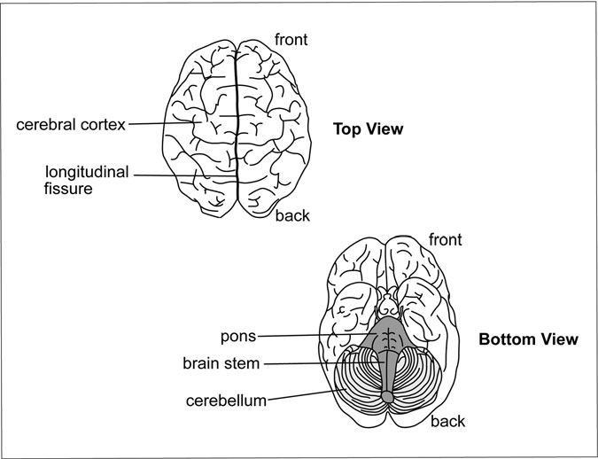

Figure 8.14 Views of the Brain. The longitudinal ﬁssure separates the brain’s left and right hemispheres. The pons, which are visible in the bottom view, help to regulate breathing, and the cerebellum regulates movement. The brain stem contains the pons, along with the medulla and midbrain. (Sandy Windelspecht/Ricochet Productions)

TABLE 8.3

Lobes of the Brain

Frontal lobe Motor areas: Control movement

Parietal lobe Sensory areas: Perceive touch, pressure, temperature, and pain Temporal lobe Auditory and olfactory areas: Hearing and smelling; speech areas

and hippocampus

Occipital lobe Visual areas: Vision, spatial distances

The frontal lobes contain the motor areas of the brain—here, impulses are generated for voluntary motor activity and movement. The left motor area (in the left brain hemisphere) controls movement on the right side of the body, and the right motor area (on the right brain hemisphere) controls movement on the left side of the body (Figure 8.15). When someone has a

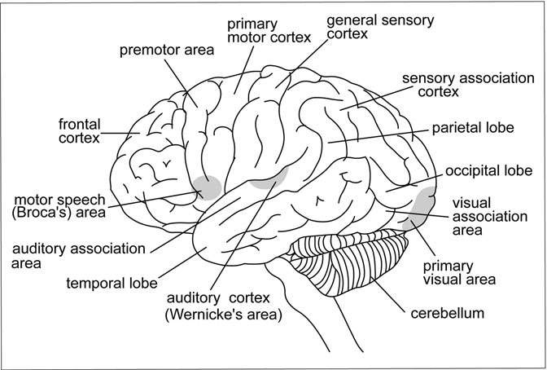

Figure 8.15 Functional Areas of the Brain. These areas work to regulate speech, cognition, sensory association, motor abilities, and visual processes, among others. (Sandy Windelspecht/Ricochet Productions)

stroke, also known as a cerebrovascular accident, either (or both) of their motor areas might be damaged, causing muscular paralysis. If the right motor area is damaged, then the left side of the body might be paralyzed. In addition to movement, the frontal lobe is involved in reasoning, planning, emotions, and problem solving. The frontal lobe in the human brain is relatively larger than in any other organism.

General sensory areas are located in the parietal lobes. This area focuses on receiving impulses relating to touch, pressure, temperature, and pain. Like the motor areas, the left area of the brain works with the right area of the body and vice versa. Skin receptors transmit impulses to the parietal lobes, where they are felt and interpreted. This area of the brain is also involved with stretch receptors in muscles and with taste— taste receptors, or taste buds, send their impulses to the taste areas of the parietal lobes. Taste areas overlap the parietal and temporal lobes.

Auditory (hearing) areas and olfactory (smelling) areas are located in the temporal lobes. Receptors for hearing are located in the inner ear, and olfactory receptors are located in the nasal cavity. In addition, temporal and parietal lobes in the left hemisphere contain speech areas that are involved with the actual thinking that precedes speech. Many people explain away an embarrassing slip of the tongue by exclaiming, “I spoke without thinking,” but in reality, this is impossible.

The hippocampus, located in the temporal lobe and on the ﬂoor of the lateral ventricle, is involved with memory. Although little is known about how the brain actually stores and processes memories, it is believed that the hippocampus will collect information from many areas of the cerebral cortex, such as people’s names or places where one has visited. If some- one’s hippocampus is damaged, they can only form memories that last a few seconds. This is evident in someone who suffers from Alzheimer’s disease. Brain neurons are destroyed with this disease, followed by a loss of memory and the individual’s personality. In addition to the memory functions, the hippocampus is also part of a group of structures known as the limbic system, which is important for controlling emotional responses, such as laughing and crying.

The last lobe area of the brain, the occipital lobe, is where the visual centers are located. Visual impulses received by the retinas in the eyes travel along the optic nerves to this area of the brain, where the brain

processes and interprets what has been seen. Spatial relationships—such as judging distance and viewing in three dimensions—are processed in the occipital lobe.

Many areas in the cerebral cortex are not involved with movement or sensations. These are called association areas, and are believed to give people individuality and personality, including a sense of humor and the ability to learn and use reason and logic. See Table 8.4 for more details on the association areas of the cerebral cortex.

Two remaining important parts of the brain are the basal ganglia and the corpus callosum, which was mentioned earlier in this chapter. Grouped masses of gray matter within the white matter of the cerebral hemispheres, the basal ganglia regulate certain subconscious aspects of voluntary move- ment. Examples include movements such as hand gestures while talking or arm movements from front to back when walking. Parkinson’s disease involves an impairment of the basal ganglia.

TABLE 8.4

The Cerebral Cortex

*Cortex area Function*

Prefrontal Emotion, problem solving, complex thought

Motor association Complex movement

Primary motor Stimulates voluntary movement

Primary somatosensory Receives tactile (touch) sensory information

Sensory association Processes multisensory information

Visual association Processes complex visual information

Visual Receives simple visual information

Wernicke’s area Comprehends language

Auditory association Processes complex auditory information

Auditory Processes sound qualities, such as loudness or softness

Speech center, or Broca’s area Produces and articulates speech

This part of the cerebrum is in charge of many high-level functions, including language and learning, although language is managed in the left cerebral hemisphere.

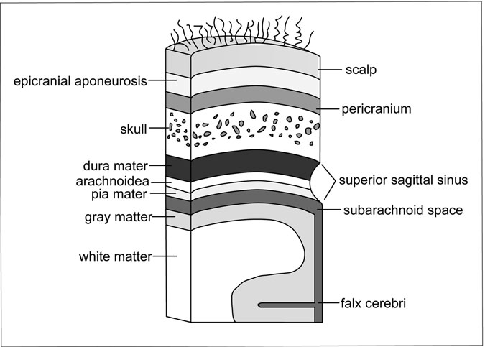

Figure 8.16 Cross-Section of the Skull and Brain. The scalp, pericranium, and skull all form the brain’s coverings. (Sandy Windelspecht/ Ricochet Productions)

The corpus callosum is a band of nerve ﬁbers that connects the left and right hemispheres of the brain and allows them to communicate and know each other’s behavior (Figure 8.16). This creates a sort of “division of labor” in the brain, because each hemisphere performs functions the other does not. For example, the left hemisphere contains the body’s speech centers. Because the right hemisphere does not, it has to be able to communicate with the left hemisphere through the corpus callosum to know what these centers are “talking about.” See Table 8.5 for a summary of each hemisphere’s functions.

##### Meninges

Because the brain is such an important organ, it needs a lot of protection. The initial layer of protection is the scalp, or skin layer, which contains the hair follicles. Right beneath the scalp is the skull, which is followed by

TABLE 8.5

Hemispheres of the Brain

*Left hemisphere Right hemisphere*

Language Spatial abilities and perceptions

Math Facial recognition

Logic Visual imagery, music

In general, each hemisphere of the brain is dominant for certain behaviors, although the information is shared through the corpus callosum.

three layers of connective tissues call meninges. Meningitis—a nervous system disease involving the brain—is an infection of the meninges.

The outermost layer of the meninges is made up of thick ﬁbrous tissue called the dura mater, which lines the skull. Because of its thickness, the dura mater keeps the brain from moving too much in the skull, which could cause blood vessels to stretch and tear. The next layer is the arach- noid membrane. Arachnids are spiders, so arachnoid is an appropriate name for this layer because it is made up of web-like strands of connective tissue. Finally, the innermost layer is called the pia mater, which is clos- est to the brain and spinal cord. An easy way to remember these layers is, “The meninges PAD the brain”—“P,” pia mater; “A,” arachnoid mem- brane; and “D,” dura mater.

Between the arachnoid and the pia mater is the subarachnoid space, which contains the clear, colorless liquid called cerebrospinal ﬂuid, or CSF.

##### CSF and the Ventricular System

Remember that the brain contains four ventricles, or cavities—the two lat- eral ventricles, and a third and fourth ventricle. Within each ventricle, there is a choroid plexus, a capillary network where CSF is formed from cellular secretions and ﬁltration of the blood, also known as blood plasma. CSF ﬂows from the lateral and third ventricles through the fourth ven- tricle. Then it continues to the central canal of the spinal cord, then to the

cranial and spinal subarachnoid spaces.

CSF is reabsorbed into the blood as more is produced. It is through this continuous process that it ﬂows in and around the CNS. When CSF is in the

cranial subarachnoid spaces, it is reabsorbed through the arachnoid villi into large veins within the dura mater called cranial venous sinuses. After this reabsorption, the CSF becomes blood plasma again. The rate of reabsorption usually equals the rate of production. Total daily production of CSF is normally about 13.53–16.91 ﬂuid ounces (400–500 milliliters) and the total volume of CSF remains around 4.28–5.07 ﬂuid ounces (125– 150 milliliters).

The CSF is vital to the brain and spinal cord, and has many functions:

* *Protection*: CSF cushions the brain, especially if the brain is impacted by a blow to the head. However, the CSF can only provide so much protection—sharp or heavy blows will injure the brain.
* *Buoyancy*: Pressure at the brain’s base is reduced because it is immersed in CSF, reducing the net weight of the brain from about

52.91 ounces to 1.76 ounces (1,500 grams to 50 grams).

* *Waste product elimination*: The CSF takes harmful substances and toxins away from the brain.
* *Hormone transportation*: The CSF transports hormones to all areas of the brain.

##### Blood Supply

Blood brings necessities such as oxygen, carbohydrates, amino acids, fats, hormones, and vitamins to the brain. In addition, blood removes carbon dioxide, ammonia, and lactate from the brain (Figure 8.17). The brain occu- pies about 2 percent of the total body weight in humans, but it receives about 15 percent of the blood supply. The brain has priority over all other organs in the human body for blood, because it needs blood to survive. Cells in the brain will die without oxygen, and it is the blood vessels within and on the surface of the brain that transport food and oxygen. Blood vessels bring their goods to the brain holes in the skull called foramina.

##### Memory and Learning

Memory is the mental ability to remember ideas and experiences. As stated earlier, scientists believe the hippocampus is responsible for

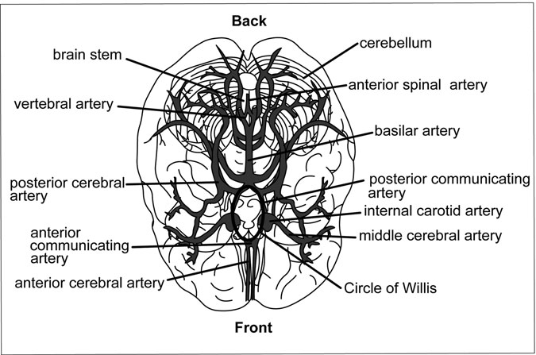

Figure 8.17 Arterial Networks of the Brian. The posterior communicating artery, internal carotid artery, and middle cerebral artery form the circle of Willis, which provides the brain with blood if one of the internal carotid arteries or one of the vertebral arteries gets blocked. (Sandy Windelspecht/Ricochet Productions)

forming, sorting, and then storing memories. The hippocampus is also responsible for connecting new memories with related ones, thus giving them meaning. For example, one might remember the ﬁrst baseball game she played by associating it with the smell of the grass on the ﬁeld, the feel of the uniform she was wearing, and the sound of the crowd cheering for her. Each of these is an individual memory that relates to an overall recol- lection of that particular experience.

The initial stage of memory processing involves recognizing visual and auditory (sights and sounds) sensory signals that are stored for only a minute or fractions of a second. This short-term memory retains these bits of information only for a short time, and they are lost if not reinforced or repeated. When stored information is recalled at a later time, this is called long-term memory. Memories become more ingrained in the mind

the more often they are repeated. Therefore, a short-term memory can become a long-term memory. In addition, the memory becomes stronger and more impressed in the brain the more often it is recalled—this is referred to as memorization.

For example, say someone is studying a history book on the Revolutionary War for an upcoming test. The more times he reads this book and processes the information, the easier it will be for him to recall what he reads when it comes time to take the test. Certain facts, such as dates of battles, will be imprinted on his memory; the deeper that imprint, the easier and quicker it will be for him to remember these facts. Studies have shown that someone who is wide awake and mentally alert memo- rizes far better than someone who is tired.

Additional studies have shown that the brain is able to organize new information where similar information is stored. If, next month, that same person reads a book about George Washington becoming the ﬁrst president of the United States, his memory will sort and ﬁle these new facts in the same area where it stored what he learned about the Revolutionary War. The memory will relate the new information on George Washington to what he learned about him during the Revolutionary War.

##### Peripheral and Autonomic Nervous System

As mentioned earlier, the human body’s nervous system is separated into two divisions: the central nervous system (CNS) and the peripheral nerv- ous system (PNS). The previous sections of this chapter explored the brain and spinal cord, the two primary components of the CNS. Through cranial and spinal nerves, the PNS transmits information to the CNS, where the brain processes it and responses are initiated.

The internal or visceral organs in the body, such as the heart and lungs, have nerve ﬁbers and nerve endings that conduct messages to the brain and spinal cord. However, people are not aware that many of these messages reach their brain, although they do know that they happen or they would not be functioning. In other words, these impulses never reach their consciousness. These impulses are processed or translated into reﬂex responses without ever reaching the conscious areas of the brain. For

example, people do not notice when their blood vessels expand or their heart rates increase; they happen involuntarily.

These efferent or visceral neurons are grouped together in the autonomic nervous system (ANS), which falls under the direction of the PNS. This is where visceral neurons, which are neurons associated with the body’s internal organs, relay information to the glands in addition to the smooth and cardiac muscles. Through nerve networks, the ANS facilitates commu- nication between sensory impulses from the blood vessels, heart, and organs located in the chest, abdomen, and pelvis to various parts of the brain (espe- cially the medulla, pons, and hypothalamus). Bypassing the consciousness, these impulses elicit mostly automatic reﬂex responses in the heart, vascular system, and bodily organs that control temperature, posture, food intake, and reactions to stressful feelings (such as anger or fear), among other processes.

##### Cranial Nerves

The ANS consists of 12 pairs of cranial nerves, which originate in the midbrain, the pons, and the medulla of the brain stem (Figure 8.18). The pairs are numbered using Roman numerals—beginning in the front and ending in the back—that are based on the nerves’ connection with the brain. These cranial nerves are divided into sensory, motor, or mixed nerves depending on their function. Some of these nerves transport information from the sensory organs to the brain, and other cranial nerves work to con- trol muscles. Some other cranial nerves control glands and internal organs, such as the ear and lung. Mixed nerves, which contain at least one sensory (or afferent) and one motor (or efferent) nerve, originate in more than one nucleus. In some cases, a single nucleus can produce more than one nerve.

One example is the sense of taste, which comes from one nucleus even though its function is spread across two nerves.

Based on the sensory or motor functions of the cranial nerves, each pair is further deﬁned by one of the following four categories:

1. *Special sensory impulses*: Senses relating to smelling, tasting, seeing, and hearing.
2. *General sensory impulses*: Senses relating to pain, touch, temperature, deep muscle sense, pressure, and vibrations.

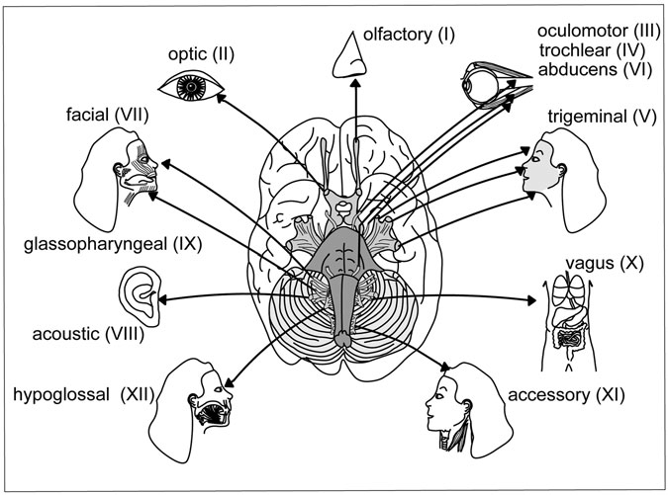

Figure 8.18 The Cranial Nerve Network. The distribution of the brain’s cranial nerve network. (Sandy Windelspecht/Ricochet Productions)

1. *Somatic motor impulses*: These relate to voluntary control of the skel- etal muscles.
2. *Visceral motor impulses*: These relate to involuntary reactions of glands and involuntary muscles such as the cardiac muscle.

Nerve pairs I, II, and VIII contain only sensory ﬁbers, whereas III, IV, VI, XI, and XII contain mostly motor ﬁbers. Pairs numbered V, VII, IX, and X contain mixed nerves. Following is an examination of the cranial nerves based on their functions.

Optical Sensations and Eye Muscles

Nerves III, IV, and VI are motor nerves that help the external eye muscles to operate. The oculomotor nerve, or Nerve III, controls blinking and pupil dilation. When one’s pupils are dilated at the optometrist’s ofﬁce, the person

receives eye drops, which are actually an acetylcholine blocker that inhibits the body’s parasympathetic system, which will be explained later in this chapter. Once this happens, the pupils dilate, or expand, and the doctor can look inside the eye lens. However, the patient will not be able to read or focus on close objects because the parasympathetic system is being restrained.

The sensory aspect of this category involves Nerve II, the optic nerve, which transmits visual impulses from the eye to the brain. The other two cranial nerves in this category are motor nerves—the trochlear (Nerve IV) and the abducens (Nerve VI) control eyeball movement.

Face and Mouth Sensations

Nerve V is a mixed nerve that controls all sensations and movements from the face and mouth. For example, this nerve, also called the trigeminal nerve, controls chewing by carrying motor ﬁbers from the face and mouth to the mastication muscles. Another example is getting a hard knot in the cheek when clenching the teeth. This happens when the trigeminal nerve stimulates the masseter muscle.

The sensory functions of this nerve include carrying impulses such as pain, touch, and temperature to the brain. For example, when someone is hit in the face, this nerve senses the onset of pain and changes in touch and transmits these impulses to the brain.

Another nerve in this category, Nerve VII, is simply known as the facial nerve. All of the muscles involved with facial expression are con- trolled by this nerve. However, the facial nerve is mixed because it also carries sensory impulses for taste from the tongue to the brain. Taste ﬁbers, which originate from the taste buds, are predominantly located on the anterior two-thirds of the tongue. However, the touch and pain sensa- tions related to the tongue come from Nerve V.

Also classiﬁed in this category is the olfactory nerve, or Nerve I. This sensory nerve gathers sensations relating to smell from the nasal mucosa (the membrane located in the nose’s interior that produces mucus) to the brain.

Hearing and Balance

The vestibulocochlear nerve, or Nerve VIII, carries auditory or acoustic information relating to sound from the ear to the brain. In addition to hear- ing, this sensory nerve controls balance.

Throat and Salivary Glands

Nerve IX, or the glossopharyngeal nerve, is a mixed nerve that contains sensory ﬁbers for the throat and for taste from the posterior one-third of the tongue. The tongue’s movement is controlled by the hypoglossal nerve, or Nerve XII. Also located in this category are the motor nerves that control swallowing in the throat. In addition, this nerve contains sensory ﬁbers that control secretions from the salivary gland in the throat. The spinal accessory nerve, or Nerve XI, also controls the throat muscles, in addition to the two major neck muscles.

Thoracic Nerve

Thoracic refers to the rib area of the spinal cord. Nerve X is the longest cranial nerve. Also known as the vagus nerve, it is a mixed nerve that con- trols most of the thoracic and abdominal organs, such as the glands, digestion (including the production of digestive juices), and the body’s heart rate. In addition, the vagus nerve contains motor ﬁbers that control the voicebox.

#### Autonomic Nervous System

An important part of the PNS, the ANS is made up of the motor elements of the cranial and spinal nerves. The ANS consists of visceral motor neu- rons that connect with smooth muscle, cardiac muscle, and glands. These areas are known as visceral effectors; they receive the impulses from the neurons through the nerve pathways and produce involuntary responses. For example, upon receiving impulses, the heart beats, muscles contract or relax, and glands secrete.

There are two divisions in the ANS: sympathetic and parasympathetic (Figure 8.19). In most cases, one will function in opposition to the other. The afferent nerves working for both divisions transmit impulses from sen- sory organs, smooth muscles, and the circulatory system, in addition to all the body’s organs, to the vital centers of the brain. Then efferent impulses are conveyed from these centers to all parts of the body by way of the para- sympathetic and sympathetic nerves, which will be discussed shortly.

Basically, the sympathetic division operates in stressful situations, and the parasympathetic controls the body in non-stressful situations. However, both divisions operate under the direction of the hypothalamus. As

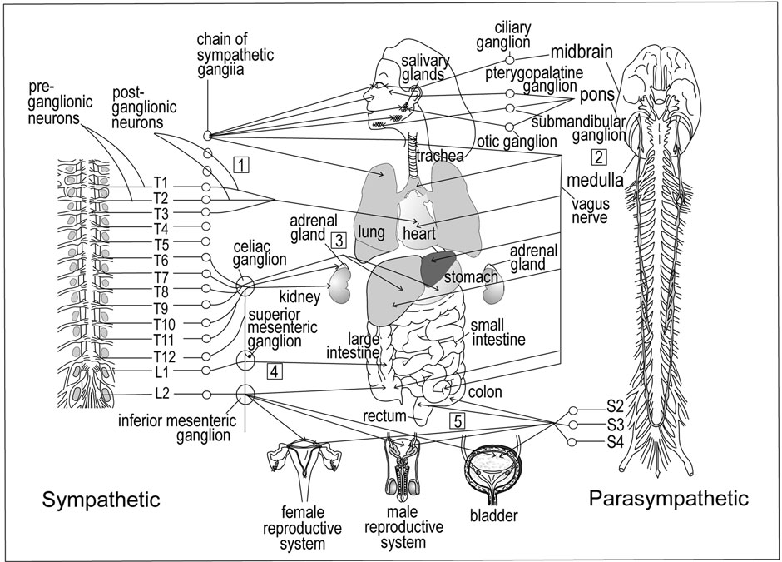

428 Julie McDowell

Figure 8.19 Sympathetic and Parasympathetic Nervous System. The left side of the ﬁgure details the sympathetic system, along with the preganglionic and postganglionic neurons and the chain of sympathetic ganglia that connects the nerves to their effectors. On the right side is the parasympathetic system, which has various ganglia that connect the nerves to effectors. (Sandy Windelspecht/Ricochet Productions)

mentioned earlier, the hypothalamus is the part of the brain located right below the thalamus and above the pituitary gland. The hypothalamus has many functions, including regulating body temperature and ensuring that the visceral effectors (smooth muscle, cardiac muscle, and glands) respond appropriately to the impulses transmitted by the visceral motor neurons.

It is important to point out the role of autonomic pathways in the PNS. Impulses travel from the CNS along the autonomic nerve pathway to vis- ceral effectors. Along this nerve pathway are located two motor neurons that synapse outside the CNS in a ganglion, which is a group of neuron cell bodies. The ﬁrst motor neuron is called the preganglionic neuron, which connects the CNS to the ganglion, and the second neuron is called the postganglionic neuron, which connects the ganglion to the visceral effector. The ganglion is made of cell bodies of the postganglionic neuron. Fibers of the preganglionic neuron are short and myelinated, which means parts are covered with a myelin sheath that provides electrical insulation and increases the speed at which an impulse is transmitted. In contrast, ﬁbers of the postganglionic neuron are long and unmyelinated.

These ganglia are like relay stations in the body. An impulse or message is transferred at the synapse (located in the ganglion) from the preganglionic neuron to the postganglionic neuron and then to the muscle or gland. This is in contrast to the voluntary nervous system, where the motor nerve ﬁber functions by beginning at the spinal cord and extending to the skeletal muscle without a synapse. Through these processes of the autonomic path- ways, stimuli is transmitted through the body, eliciting unconscious, auto- matic reﬂex responses such as the stomach and intestinal digestion, respiration rate and depth, pupil dilation, and blood rate regulation through the expansion or contraction of blood vessels.

##### Sympathetic Nervous System

The cell bodies of the sympathetic division’s preganglionic neurons originate in the thoracic and some of the lumbar segments of the spinal cord, which are located at the small (or lower area) of the back. Because of this, the sympa- thetic division is often called the thoracolumbar division. The ganglia of this division are located in two chains right outside of the spinal column. The sympathetic ganglia connect with them on these two chains. The ganglia

are home to the synapses between the preganglionic and postganglionic neurons. After receiving an impulse, a preganglionic neuron synapses with a postganglionic neuron to initiate a response in an effector. It is important to note, however, that one preganglionic neuron often synapses with many postganglionic neurons, and thus many effectors. This allows the simultane- ous responses among many effectors—a vital function of the ANS.

When a person becomes angry or afraid, or falls under any kind of stress, the sympathetic division of the ANS becomes dominant in the body (this also includes during exercise). This was essential for the survival of humans’ ancient or prehistoric ancestors. Their lifestyle included hunting live animals for food and protecting themselves and their families from enemies such as animals and other humans. This demanded intense physi- cal activity and endurance. This division of the ANS is often referred to as the “ﬁght-or-ﬂight response,” which was obviously an important inner navigating tool for avoiding danger and defending family and property.

Even thousands and thousands of years later, the human nervous sys- tem is not much different than that of its prehistoric forefathers. The ﬁght-or-ﬂight response still helps the body to determine the appropriate behavior when it feels afraid or anxious. Table 8.6 shows how some of the body’s organs respond when in a stressful situation. The heart rate increases, and breathing becomes heavier because the bronchial muscles are contracting and the bronchioles are dilating, allowing for increased air intake. In other words, the breathing rate increases. A person might feel more powerful because the liver is changing glycogen to glucose, which supplies the body with more energy. Blood vessels associated with the visceral organs and the skin constrict, thus forcing more blood to vital organs such as the heart, muscles, and brain. But not all organs move at a faster rate. Stomach digestion is not important in stressful situations; therefore, secretion of digestive juices decreases along with peristalsis, the waves of muscle contractions that move food through the stomach muscle. All of these responses enabled prehistoric ancestors to stay and ﬁght or run away from potential danger. People often ﬁnd themselves in stressful situations that are not life-threatening, such as when they are studying for an important history exam or interviewing for a new job. But the body is prepared to react appropriately when circumstances escalate from everyday stress to life-threatening danger. See Sidebar 8.2

TABLE 8.6

Autonomic Nervous System: Visceral Effectors

*Effector*

*What happens when the sympathetic division is activated?*

*What happens when the parasympathetic division is activated?*

Eye muscle (also known as an iris)

Pupils dilate Pupils contract

Salivary glands Saliva production decreases Saliva production increases

Nasal and oral mucus (mucosa)

Mucus production decreases Mucus production increases

Heart Heart rate increases Heart rate decreases Lungs Bronchial muscle relaxes Bronchial muscle contracts

Stomach Peristalsis reduces Peristalsis increases, gastric (or digestive) juices are secreted

Small intestine Digestion processes slow down Digestion processes increase

Large intestine Movement and contractions slow down

Secretions increase, along with movement and contractions

Kidney Urine secretion decreases Urine secretion increases

Bladder Organ wall relaxes and sphincter closes

Organ wall contracts and sphincter relaxes or opens

Liver Glycogen changes to glucose None Sweat glands Production of sweat increases None

Skin and viscera blood vessels

Skeletal muscle blood vessels

Constrict None

Dilate None

Adrenal glands Secretion of epinephrine and

norepinephrine increases

None

to read how hormones enable the body to react appropriately in these situations.

An example of an everyday stress relieved by the sympathetic division is when the body temperature rises when one is sitting by the pool or on the beach. When someone is in a warm environment, this external stimuli can drain the body’s heat reserves. Within the sympathetic division, ther- mal receptors send messages to the brain through the sympathetic nerve systems. One result of these messages is the expansion of cutaneous blood

SIDEBAR 8.2

#### How the Adrenal Medulla Helps Us Fight

The body’s endocrine system controls glands that produce or secrete chemical messengers, known as hormones, into the bloodstream. One of these glands, which is stimulated by the ANS, is the adrenals. The adrenals are located right above the kidneys, and each is made of two small glands that operate independently. The inner area is called the medulla, and the outer area is called the cortex. The two main hormones released by the adrenal medulla, epinephrine (also known as adrenaline) and norepineph- rine, are related to reactions to stressful situations also known as the “ﬁght-or-ﬂight response.” Once these hormones are released, some of the effects include an increase in the heart rate, rate at which the body cells metabolize; dilation of the lungs’ bronchioles, so the breathing rate can increase; and the conversion of glycogen (which is stored in the liver) to glucose. Through the blood, this glucose is sent to the voluntary muscles, enabling them to handle an increased workload.

vessels, which reside right below the skin’s surface. The expansion or dilation of these blood vessels enables more blood to ﬂow to the body’s surface, where heat has been lost. This dilation also may cause oozing of certain ﬂuids from the capillaries, causing dependent limbs to swell, which is why people sometimes swell in the heat. This increase in blood ﬂow ensures that all necessary organs are receiving the proper amount of blood. Otherwise, the blood might concentrate in the lower limbs and not get to the brain, which leads to fainting spells.

If an organ receives both sympathetic and parasympathetic impulses, the responses are opposite. Note that some effectors can only receive sym- pathetic impulses (liver, sweat glands, many blood vessels, and adrenal glands). In these cases, an opposite response happens when there is a decrease in the sympathetic impulse.

Another important way the sympathetic division responds to exces- sive heat is by forcing the body to sweat. The brain’s hypothalamus senses a great increase in temperature and conveys this information to the sweat

glands via the sympathetic nerves, which causes one to sweat. Through the evaporation of sweat (sometimes aided by a cool breeze), the body cools down. Once again, this is all involuntary. However, one can cool the body by jumping in a pool or cool shower or even sitting in an air- conditioned room, which lowers the environmental temperature.

##### Parasympathetic Division

Another name for the parasympathetic division is the craniosacral divi- sion. In this division, the cell bodies of preganglionic neurons are located in the brain stem and sacral segments of the spinal cord. The axons of these preganglionic neurons are contained in cranial nerve pairs III, VII, and IX in addition to some sacral nerves. These axons extend to the para- sympathetic ganglia, which are located in or extremely close to the vis- ceral effector. The postganglionic cell bodies are actually located in the effector, and their very short axons connect with the cells of the effector. Unlike in the sympathetic division, one preganglionic neuron synap-

ses with only a few postganglionic neurons and then to only one effector. This aspect of the parasympathetic division enables single-organ responses, or very localized responses.

As stated earlier, this division dominates the body during non- stressful and relaxed situations, allowing several organ systems to func- tion at a normal level and rate. For example, digestion is efﬁcient through increased secretions and peristalsis. Urination and defecation occurs, and the heart rate will be at the normal resting rate.

##### Neurotransmitters in the ANS

As mentioned, there are two kinds of synapses in the ANS that bring about a reaction in a visceral effector: one between preganglionic and postgan- glionic neurons, and another between postganglionic neurons and the effectors. In order for nerve impulses to cross synapses, they need the help of neurotransmitters.

Acetylcholine is the neurotransmitter released by all preganglionic neu- rons in both the sympathetic and parasympathetic divisions. A chemical inactivator is located at the dendrite of each postsynaptic neuron to defuse

the impulse generated by the neurotransmitter. This is because transmitters must be controlled and inactivated—if their secretion was not stopped at some point, then rapid changes in excitation and inhibition would not occur, and all activity would be slowed down. Acetylcholine’s inactivator is cholin- testerase, which is located in postganglionic neurons. However, in the parasympathetic division, postganglionic neurons also release acetylcholine right before they connect with their visceral effectors. In addition, most postganglionic neurons in the sympathetic division also release the neurotransmitter norepinephrine when they synapse with effector cells. Norepinephrine’s inactivator is catechol-O-methyl transferase, or COMT.

#### The Senses

The central nervous system’s ﬁve senses—seeing, hearing, touching, tast- ing, and smelling—allow the body to maintain homeostasis, which is when the internal environment is stabilized despite what constant changes are occurring in the external environment. The senses also protect people by providing information about what is going on inside and outside the body. For example, smelling and tasting might tell someone that something she is about to eat could be dangerous. Our touch sensation tells someone that a stove is too hot and will burn his skin on contact.

The information collected by the senses is transmitted through path- ways and stimulates electrical nerve impulses. There are four important components of these sensory pathways:

* *Receptors*: Changes, or stimuli, are detected by receptors. All receptors respond to stimuli by generating electrical nerve impulses. However, depending on location, each receptor only responds to certain sensory changes. For example, receptors in the retina detect light rays, while nasal cavity receptors detect airborne chemicals. When the speciﬁc stimuli is detected, an impulse is generated.
* *Sensory neurons*: These neurons take the impulses produced by the receptors and transmit them to the central nervous system. Although the sensory neurons are located in the spinal and cranial nerves, each carries impulses from only one type of receptor. For example, separate networks of these neurons serve the eyes, nose, ears, skin, and mouth.
* *Sensory tracts*: Impulses are transmitted to a speciﬁc part in the brain through sensory tracts in white matter located in the brain or spinal cord. White matter is deﬁned as nerve tissue composed of myelinated axons and dendrites.
* *Sensory area*: This is where the impulses, or sensations, are felt or perceived and interpreted. Located in the cerebral cortex, this area functions without a person’s conscious awareness.

##### Breakdown of Sensations

Sensations have several important characteristics that enable people to feel, see, hear, smell, and taste. The ﬁrst characteristic is projection. When a hand pets a furry cat, it seems like the sensation is located in the hand. However, receptors located in the hand collect information associ- ated with the cat’s fur and transmit it to the cerebral cortex or the brain, where it is interpreted as soft and ﬂuffy. The brain projects what it feels to the hand. This aspect is evident in patients who have had a limb amputated. Often, patients say that even though their hand has been removed, they feel as if that hand is still there. Even though the hand’s receptors have been removed with the severed limb, the nerve endings associated with those receptors still continue to generate impulses. The brain continues to behave as it did when the hand was still present. When the impulses from these severed nerve endings travel through sensory pathways to the brain, these impulses are interpreted and projected. The brain projects the sensation or feeling of the hand as still present. This feeling is known as phantom pain, and generally diminishes as the severed nerve endings heal.

Another important sensory characteristic is intensity, which is how strongly sensations are felt. A weak stimulus, such as a soft hum or dim light, will affect only a small number of receptors. However, a strong stimulus, such as a loud bang or bright light, will affect many more recep- tors, causing an increased amount of impulses to travel to the brain’s sen- sory area. Based on the number of impulses received, the brain will respond accordingly. The more impulses received, the more intense the brain’s sensory projection.

The brain’s interpretations also allow it to contrast previous and cur- rent stimulations and allow for inﬂated or diminished sensations. For example, when someone takes a hot shower, the brain will compare the water temperature to those previously experienced. If the water is hotter than experienced before, the brain will most likely cause one to jump away from the water. But if the water is cooler than usual, the brain will tell one to make it hotter.

A third characteristic of the senses is adaptation, or when the body adjusts to a continuing stimulus. Receptors are always ready to detect changes to the body’s external environment, but if the stimulus continues, it becomes less of a change. Therefore, the receptors will generate fewer impulses to the brain, which adapts itself to the stimulus. For example, many people wear jewelry on hands and arms, such as rings or watches. The pres- ence of a ring is a continuous stimulus from the moment it is put on in the morning until it is taken off before bed. However, because it is on all day, the cutaneous or skin senses adapt to the presence of the ring, and the wearer becomes unaware that it is on his ﬁnger. Only when there is a change, such as when the ring comes off before bedtime, do the receptors detect a change. After-image is the ﬁnal characteristic of the senses. This is when a sen- sation remains in the conscious memory even after the stimulus has ceased. One example is a ﬂashbulb from a camera, which often stays in the memory for a few minutes after a picture is taken. Because the ﬂashbulb produces such a bright light, the receptors in the retina generate many impulses that are interpreted by the brain as an intense sensation. The sensation is so strong

that it lasts a bit longer than the stimulus from which it was generated.

##### Cutaneous Senses

As mentioned earlier, cutaneous senses are those related to the skin (Figure 8.20). The cutaneous senses tell what is happening in and to the immediate external environment, including what is happening to the skin. For instance, an annoying mosquito bite on the knee often produces an itch- ing sensation. This is actually a mild form of the pain sensation. The brain interprets sensory impulses in the parietal lobes. The largest part of this sen- sory area is reserved for the parts of the skin with the most receptors, which are the hands and face.

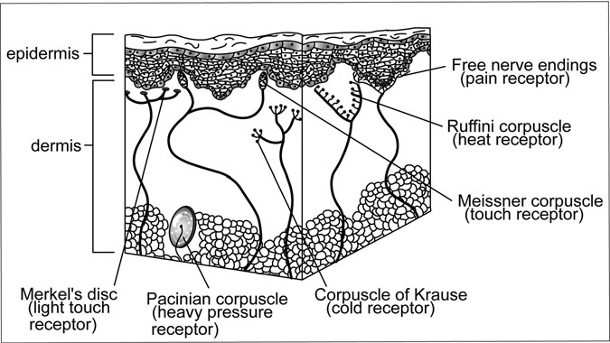

Figure 8.20 The Cutaneous Senses. The cutaneous receptors of the skin include the Merkel’s disc, the Pacinian corpuscle, the Rufﬁni corpuscle, and the free nerve endings. (Sandy Windelspecht/Ricochet Productions)

Sensations related to touch, pressure, pain, and temperature (heat and cold) are produced by receptors located in the skin’s inner layer, or der- mis. Pain receptors, also called free nerve endings, react to any intense stimulus. This means intense extremes of temperature applied to the skin, whether cold or hot, will be felt as pain. Encapsulated nerve endings are the receptors for the other cutaneous senses. This means that these nerve endings are surrounded by a cellular structure.

##### Taste and Smell Senses

Taste-speciﬁc receptors are located in taste buds, which are found in the papillae area of the tongue (Figure 8.21). In general, experts believe there are four types of taste receptors: sweet, sour, salty, and bitter. The papil- lae’s taste receptors (or chemoreceptors) decipher chemicals from food that have dissolved in the mouth’s solution, also known as saliva. A moist mouth full of saliva is necessary for taste distinction—if the mouth is dry, even the most ﬂavorful food, such as a grilled steak, will have little taste.

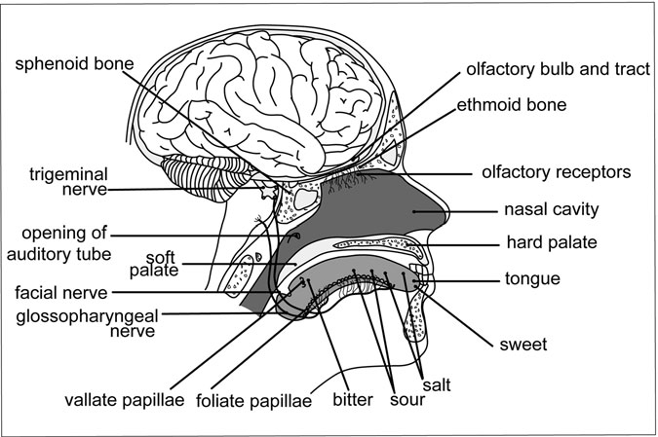

Figure 8.21 Smell and Taste Senses. This midsagittal section of the brain shows the smell and taste nerves and sensory components. (Sandy Windelspecht/Ricochet Productions)

Most foods contain a variety of the four general ﬂavors and stimulate dif- ferent combinations of receptors. For example, one bite of a peanut butter and jelly sandwich will stimulate both sweet (from the jelly) and salty (from the peanut butter) taste combinations. The smell of food also con- tributes to food perception.

Impulses relating to taste sensations are transmitted through the facial and glossopharyngeal nerves, which are the seventh and ninth cranial nerves, to the parietal-temporal cortex of the brain where the taste areas are located. Food scientists have found evidence of a genetic link in some taste preferences. For example, people who have an above-average num- ber of taste buds tend to ﬁnd broccoli bitter and unpleasant, whereas those with an average number of taste buds might like this vegetable’s taste.

Olfaction, or the sense of smell, functions through chemoreceptors located in the upper nasal cavities. These receptors detect vaporized chemicals and then generate impulses that travel through the ﬁrst cranial

or olfactory nerves on the ethmoid bone. From there, these impulses move on to olfactory bulbs and then on to the olfactory areas of the brain’s temporal lobes. Scientists believe there are at least 1,000 different smells.

In comparison to other animals, humans have a poor sense of smell. For instance, dogs have a far greater sense of smell—they are believed to smell 200 times better than humans. The olfactory sense has a rapid adaptation rate, which is why pleasant smells tend to be acute and sharp at ﬁrst but then quickly fade away. As mentioned above, the taste sense is greatly inﬂuenced by smell, which is why food can lose its taste when someone has a cold and the nasal cavities are clogged.

##### Visceral Sensations

Visceral refers to anything that involves the body’s internal organs, such as the glands and the smooth and cardiac muscle. Visceral sensations are the result of internal changes. Two important visceral sensations are hunger and thirst. The receptors that detect hunger and thirst are believed to be specialized cells located in the brain’s hypothalamus. Hunger recep- tors function by detecting deﬁciencies in blood nutrient levels, and thirst receptors look for deﬁciencies in the body’s water content, or the body ﬂuid’s water-salt proportion.

People are not conscious of the hypothalamus detecting hunger and thirst because the brain projects these sensations. Thirst is projected to the mouth and throat, which will feel dry because less saliva is produced. Hunger is projected to the stomach, which contracts and feels empty. Usually people satisfy both sensations by eating and drinking. However, if hunger is not addressed with food, eventually the brain adapts and the hunger gradually decreases in intensity. This is because even though blood nutrient levels will decrease and prompt the hunger sensation, these levels eventually stabilize as fat from certain body tissues is converted to energy. Once this stabilization occurs, there are few changes for the receptors to detect, and hunger dimin- ishes. However, the brain does not adapt if the thirst sensation is ignored. The body has no ability to stabilize as the water content decreases. Without stabilization, changes and ﬂuctuations continue, which receptors continue to detect. The thirst sensation increases, and dehydration may result.

##### Vision

Vision receptors are located in the eye, along with a refracting system that directs light rays to the vision receptors located in the retina.

The eyeball is protected by eyelids and lashes. Eyelids are able to open and close over the eye because they are made of skeletal muscle. Eyelashes border the eyelids and keep dust and other debris from the eyelids. In addition, there is a thin membrane called the conjunctiva that lines the interior of each eyelid. Many eye infections are forms of conjunctivitis, in which the conjunctiva becomes infected and inﬂamed, making the eyes red and itchy.

Located on the upper outer corner of the eyeball are the lacrimal glands, which produce tears that cleanse the eyes and keep them moist (Figure 8.22). Tears are taken to the eye’s anterior region through small ducts.

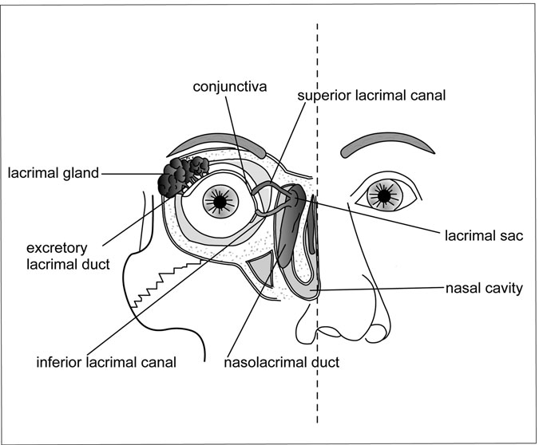

Figure 8.22 The Lacrimal Apparatus. The lacrimal apparatus is an important protection for the eye. (Sandy Windelspecht/Ricochet Productions)

Blinking spreads the tears and allows them to wash the eye. Composed mostly of water, tears also contain an enzyme called lysozyme, which pre- vents bacteria from producing on the eye’s surface. In the outer portion of the middle of the eye are the superior and inferior lacrimal canals, which are ducts that transport tears to the lacrimal sac. Located in the lacrimal bone, the lacrimal sac leads to the nasolacrimal duct, which empties tears into the nasal cavity. This is what causes a runny nose when someone cries. The orbit is a cavity in the skull that protects and surrounds the eyeball.

There are six muscles that extend from the socket to the surface of the eye- ball. These six muscles include four rectus muscles, which move the eyeball up and down and side to side. The remaining two oblique muscles allow the eye to rotate (Figure 8.23). These muscles function through the third, fourth, and sixth cranial nerves (oculomotor, trochlear, and abducens).

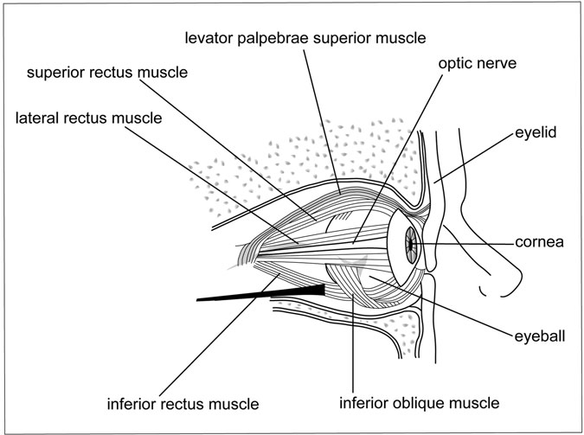

Figure 8.23 The Eye Muscle. This view of the eye displays vital muscles, in addition to the optic nerve. (Sandy Windelspecht/Ricochet Productions)

When examining the eyeball’s anatomy, it is important to note the eyeball’s three layers—the outer sclera, the middle choroid layer, and the inner retina. Composed of ﬁbrous tissue known as the white of the eye, the sclera is the thickest layer. The cornea is located on the anterior of the sclera, and is unique from the rest of this layer because it is transpar- ent and has no capillaries. This allows it to be the ﬁrst part of the eye to bend (or refract) light rays.

The second layer of the eyeball, the choroid layer, is made up of blood vessels. In addition, this layer prevents glare by absorbing a certain amount of light within the eyeball. The outer portion of this layer contains the iris and the ciliary body, a circular muscle that is connected to the lens’s edge by suspensory ligaments. Similar to the cornea, the lens is transparent and has no capillaries. The ciliary muscle allows the eye to focus light from objects near and far by changing the shape of the lens.

At the front of the lens is located the circular iris, which is known as the colored portion of the eye. The iris’s opening is called the pupil. The pupil’s diameter is controlled by two sets of muscle ﬁbers. When the radial ﬁbers contract, the pupil dilates or expands, which is a sympathetic response. The pupil constricts or reduces in size when the circular ﬁbers contract, which is a parasympathetic response of the oculomotor nerves. This automatic or reﬂexive response is a protective mechanism because it prevents too much intense light from entering the retina. It also allows more precise near vision, which allows people to read books and other materials that are close to their eyes.

Another important part of the eye’s anatomy is the retina, which is located on the interior of the choroid level (although it covers only two- thirds of the eye). The retina houses the visual receptors, called the rods and cones (Figure 8.24). Whereas rods only detect light, cones detect col- ors, which are actually made up of varying wavelengths of visible light. The macula lutea is abundant with cones and is located in the center of the retina behind the lens. The area known for the best color vision is the fovea, a small depression located in the macula lutea that contains only cones. Towards the edge of the retina is where the most rods reside. When light is dim, such as in a dark room or at night, we can best see through the periphery or sides of our visual ﬁelds, because this is where most of the rods are located.

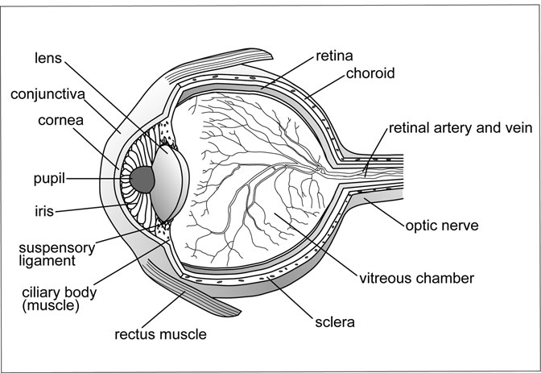

Figure 8.24 The anatomical elements of the eye. (Sandy Windelspecht/ Ricochet Productions)

Inside the eyeball are two cavities. Located between the lens and the retina, the larger posterior cavity contains a semisolid substance called vitreous humor. The retina is kept in place by the vitreous humor. How- ever, if the eyeball is injured and the vitreous humor is lost, the retina can become detached. The second cavity, the anterior cavity, is between the front of the lens and the cornea. This cavity contains the aqueous humor, the eyeball’s tissue ﬂuid formed by capillaries in the ciliary body. Aqueous humor ﬂows through the eye’s pupil and is absorbed by small veins called the canal of Schlemm, located where the iris and cornea join together. Because the lens and cornea have no capillaries, they need the nourishment from the aqueous humor.

##### How the Eye Perceives Light

The vision process begins when the eye’s receptors—the rods and cones— detect light and generate impulses. These impulses are then transported to

the brain’s cerebral cortex, where they are processed. An important part of the vision process is the refraction of light, which is when a light ray is bent or deﬂected as it passes from one object into another of greater or smaller density (Sidebar 8.3). In the eye, the refraction of light begins with the cornea, then the aqueous humor, the lens, and ﬁnally the vitreous humor. Adjustments can only be made in the lens and depend on the ciliary muscle. When the eye is trying to focus on a distant object, the ciliary muscle will be relaxed, making the lens thin out. But when trying to focus on closer objects, the ciliary muscle contracts, causing the lens to recoil and bulge in the middle, which gives the lens greater refractive abilities. Problems with the lens and ciliary muscle can be addressed with corrective lenses or glasses. The next step in the vision process happens when light hits the retina, causing chemical reactions to occur in the rods and cones. The rods con- tain a chemical called rhodopsin. During a chemical reaction, rhodopsin breaks down into scotopsin and retinal, a derivative form of vitamin A. An electrical impulse is generated as a result of this chemical reaction. The chemical reactions in the cones also involve retinal and generate an electrical impulse. However, cones are also absorbing various wave- lengths of light during this time. There are three types of cones: red absorbing, blue absorbing, and green absorbing. Every ray of light is taken in by one of these types of cones. Dysfunctions of the cones and rods can

lead to night and color blindness.

The impulses from the rods and cones are carried by ganglion neurons to the optic disc, where they converge to become the optic nerve and exit the eyeball. Because the optic disc contains no rods or cones, it is sometimes called the eye’s “blind spot.” However, the eye is constantly moving and rotating to compensate for this blind spot. The optic nerves from the left and right eye join together at the optic chiasma, located right in front of the pituitary gland.

Fibers from each eye’s optic nerve cross to the other side, allowing each side to capture visual impulses from both eyes. In the brain, the vis- ual areas are located in the occipital lobes of the cerebral cortex. These visual areas integrate the slightly different picture transmitted by each eye into a single picture, which is called binocular vision. In addition, the image on the retina is actually upside down, but these visual areas cor- rect this so people see the image right side up.

SIDEBAR 8.3

#### Correcting Vision Problems through Refractive Surgery

Vision problems are caused by errors of refraction. Normal vision is referred to as 20/20, which means that the eye can clearly see an object 20 feet away. If someone is nearsighted, or has myopia, the eyes can see near objects but not distant ones. For example, if someone has 20/80 vision, this means that the normal eye can see objects clearly at 80 feet away, but the nearsighted eye can only see that object if it is brought within 20 feet. Focusing of images by the nearsighted eye is done in front of the retina because the eyeball is too long or the lens is too thick. This can be corrected with glasses with concave lenses that spread out the light before it hits the eye.

When an eye sees distant objects well, it is farsighted, or hyperopic. For instance, vision might be 20/10, which means that it can see at 20 feet what a normal eye can see at 10 feet. This eye will focus images behind the retina due to a short eyeball or too thin lens. To correct hyperopia, glasses with convex lenses are used to unite light rays before they hit the eye. Contact lenses are also used to correct vision problems.

In addition to glasses and contact lenses, there are surgical procedures that improve the focusing power of the eye. These are a more permanent approach to vision correction. Here are some details on a few of these surgeries:

*LASIK (Laser-assisted* In Situ *Keratomileusis)*: Using a laser, this procedure permanently changes the shape of the cornea. The initial step is to cut a flap in the cornea using a blade or laser. This flap is folded back, exposing the midsection of the cornea known as the stroma. Then the laser is focused on the cornea, vaporizing part of the stroma. The flap is then replaced over the cornea.

*Radial Keratotomy (RK) or Photorefractive Keratectomy (PK)*: Both of these procedures also reshape the cornea. RK uses a knife to cut slits in the cornea. Like LASIK, PRK uses a laser (the procedure was developed prior to LASIK). While a flap is cut to expose the stromal layer in the LASIK procedure, the PRK exposes this layer

through the epithelium, which is the top layer of the cornea. The epithelium is actually scraped away to completely expose the stroma.

*Thermokeratoplasty*: This type of refractive surgery uses heat to reshape the cornea. While the source of heat can be a laser, the laser used is different from that used in LASIK and PRK. Another type of refractive surgery is in which heat is used to reshape the cornea.

##### Hearing

There are three main areas in the ear: the outer ear, the middle ear, and the inner ear (Figure 8.25). Receptors for hearing and equilibrium, or bal- ance, are both found in the inner ear.

The auricle (or pinna) and ear canal make up the outer ear. Composed of skin-covered cartilage, the auricle is not important to humans, although it acts as a sound funnel for many animals, such as dogs and cats. Wearing glasses would be uncomfortable without an auricle, but it has no impact on hearing. The second part of the outer ear, the ear canal, acts as a tunnel into the temporal bone and middle ear. The eardrum, also called the tympanic membrane, stretches across the end of the ear canal and produces vibrations when hit with sound waves. These vibrations are transmitted to the three auditory bones called the malleus, incus, and stapes. This last bone, the stapes, transports vibration to the oval window through the inner ear.

Air enters and leaves the middle ear through the eustachian tube, also called the auditory tube, which extends from the middle ear to the nasophar- ynx. In order for the eardrum to function and vibrate, the air pressure in the middle ear must be equal to the pressure outside the ear. Ears often tend to “pop” when the air pressure is unequal, such as when in an airplane or when driving to a different elevation. The “popping” is caused when the eusta- chian tubes are trying to expand in order to equalize the pressure.

The inner ear is located within the temporal bone and encases a bone cavity known as the bony labyrinth. Lined with a membrane called the membranous labyrinth, this cavity contains ﬂuid called perilymph, which is found between the temporal bone and the membrane.

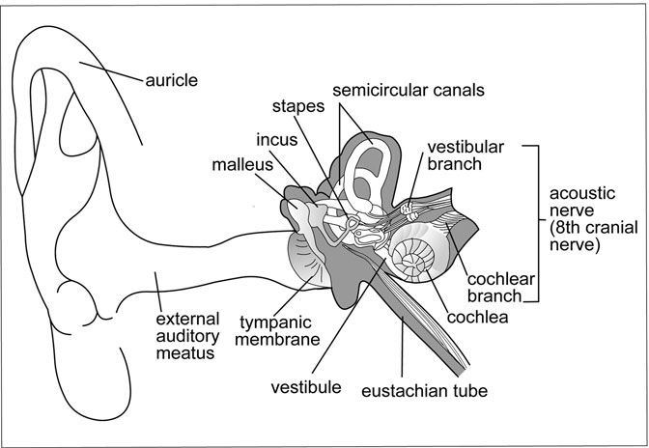

Figure 8.25 The inner, middle, and outer ear structures. (Sandy Windelspecht/Ricochet Productions)

Endolymph is the ﬂuid found within the inner ear structures—the cochlea (important in hearing) and the utricle, saccule, and semicircular canals (all important in equilibrium).

The cochlea looks like a snail shell and is made up of two and a half turns that give it a coiled appearance. The cochlea is divided into three canals ﬁlled with ﬂuid. The medial canal is known as the cochlear duct and encases the hearing receptors in the spiral organ, or organ of Corti. These receptors are known as hair cells, although they are not hair at all. These cells contain nerve endings from the cochlear branch of the eighth cranial nerve.

Hearing involves the reception of vibrations, the transmission of vibrations, and then the generation of nerve impulses (Figure 8.26). After sound waves enter the ear canal, they are transmitted to the ear structures according to the following sequence: eardrum, malleus, incus, stapes, the inner ear’s oval window, the cochlea’s perilymph and endolymph, and ﬁnally the organ of Corti’s hair cells. Vibrations reach these hair cells,

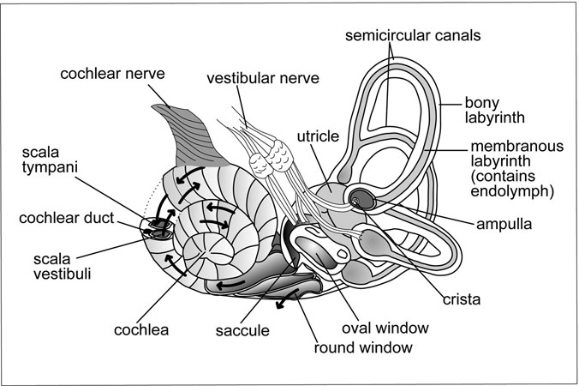

Figure 8.26 Inner Ear Structures. The inner ear structures are shown with details indicating the direction in which vibrations move during hearing. (Sandy Windelspecht/Ricochet Productions)

which bend and then generate impulses that travel to the brain through the eighth cranial nerve. Sounds are heard and processed in the auditory areas of the brain, which are located in the temporal lobes of the cerebral cortex. The hair cells are protected by the round window, which is found just below the oval window. The structure pushes out when the stapes pushes in through the oval window, thus relieving pressure and preventing dam- age to the hair cells. (Sidebar 8.4 contains an explanation of hearing loss.)

Two other inner ear structures, the utricle and saccule, are located in the vestibule between the cochlea and semicircular canals. These struc- tures are actually hair cells surrounded in a gelatinous membrane with oto- liths, which are tiny crystals of calcium carbonate. When the head changes position, gravity pulls down on these otoliths and bends the hair cells, thus generating impulses. The vestibular portion of the eighth cranial nerve then transmits these impulses to the cerebellum, midbrain, and temporal lobes of the cerebrum. At the subconscious level, the cerebellum and

SIDEBAR 8.4

#### Deafness

There are three different types of deafness (the inability to hear properly): conduction deafness, nerve deafness, and central deafness. Conduction deafness is when one of the ear’s structures cannot transmit vibrations properly. This can be caused by a punctured eardrum, an audi- tory bone arthritis, or a middle ear infection in which an excess amount of ﬂuid ﬁlls the middle ear cavity.

Nerve deafness occurs when there is damage to the eighth cranial nerve or the hearing receptors located in the cochlea. Some antibiotics can damage this cranial nerve. In addition, some viral infections, such as mumps or rubella, can also cause nerve damage. Nerve deafness often occurs in the elderly when hair cells in the cochlea become damaged from years and years of exposure to noise; this hair cell damage is accelerated by chronic exposure to loud noise.

Central deafness is when the auditory areas of the brain’s temporal lobes become damaged. This can be caused by a brain tumor or other nervous system disorder.

midbrain interpret and process these impulses to maintain equilibrium. The cerebrum informs us of the head’s position.

The last inner ear structure consists of three semicircular canals, which are also involved in stabilizing equilibrium. Each of these mem- branes is oriented in a separate plane and ﬁlled with ﬂuid. At the bottom of each structure is the ampulla, an enlarged portion that contains hair cells sensitive to movement. When the body moves forward, the hair cells are initially bent backward and then straighten. Impulses are generated when these cells bend, and are also transmitted to the cerebellum, mid- brain, and temporal lobes of the cerebrum via the vestibular branch of the eighth cranial nerve. The interpretation of these impulses is associated with stopping or starting, accelerating or decelerating, and changing direc- tions. In general, the semicircular canals provide information while the body is in motion, and the utricle and saccule provide information while

the body is at rest. The brain synthesizes all this information to create a uniﬁed sense of body position.

##### Receptors in the Bloodstream

Two of the heart’s arteries, the aorta and carotid, have receptors to detect changes in the bloodstream. Blood pumped by the left ventricle is fed through the aortic arch, which works its way over the top of the heart. The carotid arteries are the left and right branches of the aortic arch that transport blood through the neck and then on to the brain (Figure 8.27).

Both of these blood vessel systems contain receptors. The pressore- ceptors are located in the carotid and aortic sinuses and detect changes in blood pressure; the chemoreceptors are located in the carotid and aortic bodies and detect changes in the oxygen and carbon dioxide content of blood. Rather than stimulate sensations, these receptors generate impulses that regulate breathing and circulation. For example, if there is a sudden decrease in the blood’s oxygen content (known as hypoxia), this

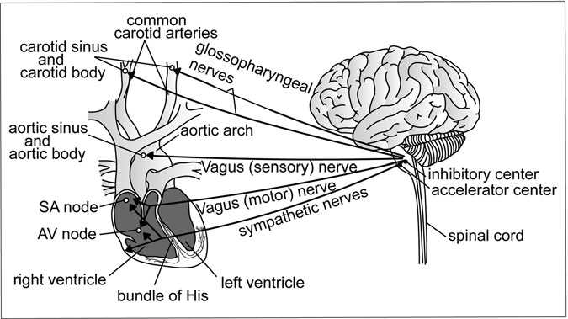

Figure 8.27 Regulation of the Heart by the Brain and Spinal Cord. The brain and spinal cord work to regulate various elements of the heart. (Sandy Windelspecht/Ricochet Productions)

change will be detected by the carotid and aortic chemoreceptors. These impulses are then transmitted through the ninth and 10th cranial nerves (glossopharyngeal and vagus) to the medulla. As a result of the sensory interpretation in the medulla, the respiratory rate and the heart rate will increase to collect and circulate more oxygen. This allows the body to maintain stable levels of oxygen and carbon dioxide in the bloodstream and maintain normal blood pressure.

#### Summary

The human body’s nervous system has two divisions, the central nervous system (CNS) and the peripheral nervous system (PNS). The brain and the spinal cord make up the CNS, which is where the ﬁve senses are proc- essed. The CNS detects a stimulus and facilitates the appropriate response in the effector organ or muscle. The PNS includes the cranial and spinal nerves, as well as the autonomic nervous system (ANS). The ANS has two divisions, the parasympathetic and the sympathetic divisions. Invol- untary movements of the body’s smooth muscle system are controlled by the ANS.

The foundations of the nervous system are the nerves and nerve ﬁbers, which make up neurons. Neurons are the true activity hub of the nervous system—through the neurons, impulses and related messages are commu- nicated throughout the entire nervous system.

*This page intentionally left blank*

9

The Reproductive System

*Kathryn H. Hollen*

Interesting Facts

* The proportions of a developing fetus change dramatically as it grows. The size of its head at the ninth week of development is almost one- half the total length of its body; an adult’s, in comparison, is only about one-eighth the total length of its body.
* Increased age in women increases their likelihood of having twins because the zona pellucida tends to be harder in older women and causes the inner cell mass to break into clumps as it “hatches.”
* About 50 percent of conceptions fail between fertilization and implantation due to abnormalities in the specialized cells required for implantation.
* A fetus can detect light coming from outside the mother’s body; it will turn to follow a light moving outside and across the abdomen.
* The ﬁrst successful vaginal hysterectomy for the cure of uterine prolapse was self-performed by a peasant woman in the seventeenth century. She slashed off the prolapse with a sharp knife, surviving the hemorrhage to live out the rest of her life.
* The brain of a child malnourished in the womb and in infancy may be 60 percent smaller than that of a normal child.

453

• Babies in the womb dream, which contributes to brain development.

• Several theories surround the discrepancy in size between the sperm and the egg. One is that the egg is larger because it contributes most of the bulk to the embryo while the small sperm must be an agile, mobile hunter of the ovum. Another suggests that sperm have to be tiny to be produced in quantity; the more produced, the greater the likelihood that only superior sperm will reach the egg.

#### Chapter Highlights

• Sex and reproduction

• Genetics

• Cell division

• Reproductive organs: female and male

• Endocrine system and sex differentiation

• Pregnancy: what happens in each trimester

• Prenatal Care: testing and pregnancy-related complications

• Preventing pregnancy

#### Words to Watch For

Alleles

Asexual reproduction Blastocyst

Chromatin Circumcision Colostrum Complementary base

pairs

Contraceptives Daughter cells

Down syndrome Embryogenesis Epiblast Gametes

Gene expression Genetic imprinting Genetic sex Glucose tolerance

test

Graft rejection

Histones Homologous Huntington’s chorea Hypoblast

In vitro In vivo Meiosis Mitosis

Monozygotic Morula

Multiple marker test Oocytes

Oogonia Phosphates Polyspermy

Sex-linked inherited characteristics

Sickle cell anemia Spermatogonia Ultrasound scan

Ureters Vestibule Vestigial

Zona pellucida Zygote

#### Introduction

The systems that animate the human body do not operate independently of one another. They are united by a network of blood, nerves, and tissues that give them substance and function, and, in this respect, the reproduc- tive system is no different from its counterparts. But in another respect, it is unique, for it is the only system in the body dedicated exclusively to the continuation of the species. This single fact dictates a dual direction for the material in this chapter. On the one hand, it must address the biology of the reproductive system that keeps the human race going. On the other, it must also consider, albeit much more brieﬂy, how tapping into human DNA can so transform genetic identity that the deﬁnition of what it means to be human may unravel.

#### Sex and Reproduction

Human beings have sex to reproduce, but there is another reason that is critical to the vitality of the species—and to that of other species as well. In fact, sex is a fundamental feature of the reproductive life of most ani- mals, although some of them engage in it differently from humans. The frog, for example, lays her eggs near a river or stream for later fertilization by any compatible male frog that happens by, while humans customarily have reproductive sex together, at the same time. People are very different from frogs in another way, too, in that human sex can result in serious con- sequences such as unwanted pregnancy, disease, social disgrace, moral or religious disapproval, or legal difﬁculties. Asexual reproduction or clon- ing would likely be easier; hydra and sponges are able to grow buds genet- ically identical to themselves with far fewer consequences. Flatworms and sea stars reproduce by generating new organisms from their own detached parts. Why do people complicate their lives with sex and all that it entails?

The answer is simple: genetic diversity, the mingling of genes from two different parents to create genetically unique offspring. This is the very deﬁnition of sexual reproduction, a means of propagation that, unlike the asexual method, reduces the chance that harmful mutations will be passed on because the normal gene from one parent can dominate the defective gene from the other parent. Since not all mutations are bad, how- ever, sexual reproduction is also an avenue for passing on beneﬁcial traits, such as genetic adaptations that might, for example, improve one’s resis- tance to environmental pathogens. And just in case the species neglects to engage in the reproductive activity that biology has so thoughtfully designed for it, renewed motivation arises from the persistent nudging of the libido—that compelling drive that, some would argue, is second only to the need for food and water in the urgency of its demand.

In a strictly biological sense, sex is fundamental to reproduction in humans, as in many other species, because the offspring gain genetic re- sistance to disease and threatening mutations are minimized or purged.

##### Genes

Genes, the human genome, genetic engineering, sequencing the genome— most people have heard and read a great deal about these subjects in recent years. Genes determine the characteristics that deﬁne the species as human: creatures who walk erect, who are born with two legs and arms and hands, and who are capable of learning to read and write.

Genes also determine if a person’s legs will be short or long, his nose large or small, his hair blond or black; each of these traits makes every person unique, even though 99.999 percent of nearly all humans’ genes are same. (Identical siblings like twins, however, start out in life with 100 percent of the same genes.) When deoxyribonucleic acid (DNA) rep- licates and accidentally drops a critical molecule from the gene during transcription, or when environmental assaults such as exposure to ciga- rette smoke accumulate in the cells’ DNA, the damage can be serious enough that, later in life, the affected twin might develop a genetically related disease while the other does not.

Although it is generally understood that every person is the product of unique combinations of parental genes, not everyone understands the

intricate details: what genes are made of, where they reside in the cell, and how cell division ensures genetic diversity in the species.

Like all living things, the human body is made up of chemicals, tiny molecules such as the four amino acids comprising genes. Called bases, these amino acids (adenine, cytosine, guanine, thymine) reside in the cell as part of the coiling DNA that forms diffuse nuclear matter known as chromatin. Two bases, adenine and thymine (A and T), always form one pair, and cytosine and guanine (C and G) always form the other. These are complementary base pairs that, held loosely together by hydrogen bonds, construct the “rungs” of DNA’s familiar ladder or spiraling double helix. When a cell begins to divide, DNA twists and condenses out of chromatin to organize into chromosomes and to replicate. This is how the cell’s copy will receive the same DNA—that is, the same chromo- somes and genes. In turn, as these daughter cells divide, they produce exact replicas of themselves. Thus, all the genetic information of the ﬁrst cell is transferred to every descendant.

Although the word “gene” is a singular noun, a gene actually repre- sents the components of a given piece of DNA that act as a single unit to direct an activity. The genes utilize 20 different amino acids that, in turn, can construct about 250,000 different proteins. This is known as encoding; that is, the gene encodes for a protein, an enzyme perhaps, which in turn unleashes a cascade of chemical reactions triggering cellular activity. The gene that initiated this activity is said to have been expressed—that it has been “switched on.”

Recent research indicates that proteins called histones embedded within DNA represent epigenetic information that tells genes when to turn on or off. In embryogenesis, the early stages of human development in the womb, they are switched on to tell the cells what kind of tissue to become—transforming a cell into a muscle cell, for instance, and instructing the new cell how to do its job. Every muscle cell division thereafter will produce a muscle cell, but it was a series of genes that told the ﬁrst cell what to become (Figure 9.1). Cells in muscle tissue look different from those in epithelial tissue, just as both of these look very different from a neuron, a type of brain.

How the cells are instructed to become different kinds of cells and thus to take on different functions is a subject of intense interest, not just within the research community, but among the lay public, politicians,

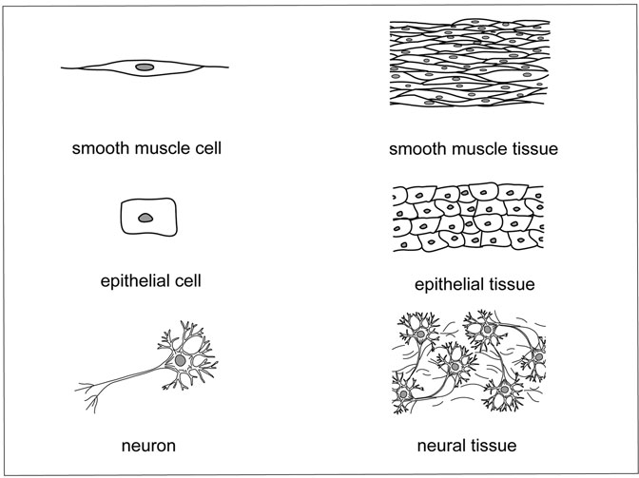

Figure 9.1 Cells and Tissues. Epithelial cells give rise to epithelial tissue, which forms the inside and outside surfaces of many organs; the muscle cell depicted here produces smooth muscle tissue, which comprises involuntary muscles like those of the intestines; and neurons (nerve cells) like these feature dendrites, branching arms reaching out from the body of the neuron to receive impulses from the nervous system. (Sandy Windelspecht/Ricochet Productions)

bioethicists, and the medical establishment. Because that ﬁrst cell, called a stem cell, has the ability to differentiate into any other kind of cell the genes so order, its therapeutic promise is tantalizing. Researchers are developing techniques to cultivate the cells in the laboratory and to manipulate their dif- ferentiation with the goal of growing human organs—in vivo or in vitro—to replace diseased ones. But before therapeutic breakthroughs of this kind are likely to be commonplace, a signiﬁcant ethical hurdle must be addressed: the stem cells with the greatest potential for differentiation are generally obtained from human embryos, although current research is looking into

the exciting possibilities of “reverse programming” differentiated cells back into stem cells. Adult stem cells can be harvested for therapeutic purposes from certain portions of the body, but most scientists ﬁnd them of limited value.

Sequencing the human genome simply means mapping all the genes— each speciﬁc group of bases that, once switched on, directs the manufacture of the proteins that drive cellular functions. While it is tempting to assign one function to one gene, it is usually not that simple, although there are instances, such as in Huntington’s chorea or sickle cell anemia, in which one causative gene can be identiﬁed. Usually, however, it appears that differ- ent genes may interact with external features in the environment, or may combine to predispose someone to a disease, or, conversely, to confer resis- tance to it. Nevertheless, links can be made between the inﬂuence of speciﬁc genes on speciﬁc characteristics or diseases, and some of these will be dis- cussed later in this chapter.

Interestingly, although the human genome contains roughly three bil- lion base pairs, scientists disagree about how many of these are genes. Researcher believes that there is a great deal of excess DNA, called introns or “junk DNA,” whose role puzzles scientists. Many believe that these non-coding sequences, probably enough in each person’s 100 trillion cells to reach the sun and back, are made up of meaningless pieces of viruses and other genetic debris whose sole value lies in providing an evo- lutionary fossil record of human ancestry. Others maintain that they may represent crucial coding sequences that control other genes in as-yet- undetermined ways and thus multiply the effect of all.

##### Chromosomes

The DNA “ladder” has two spiraling “uprights” made up of phosphates, sugars, and bases. One phosphate, sugar, and base form a nucleotide that matches up to its complement, another group of three molecules; if one piece of the DNA is made of phosphate, sugar, and adenine (one of the four bases), its counterpart would be attached at the rung to thymine, sugar, and phosphate. In every cell (except mature red blood cells, which discard their nuclei during human development to carry more oxygen throughout the blood), about six feet (180 centimeters) of DNA resolve

out of chromatin into 46 coiled chromosomes that form 23 pairs. Each pair is comprised of two homologous chromosomes—that is, they carry essen- tially the same genes, but one chromosome is from the mother and one chromosome is from the father. An example is the gene for eye color. Sup- pose a person inherited a gene for blue eyes from her mother and a gene for brown eyes from her father. The genes for eye color in this case are called alleles because, while they are essentially the same gene—they both transmit eye color characteristics—one encodes for one color on the mother’s chromosome and the other for a different color on the father’s. Thus alleles are different expressions of the same gene on homologous chromosomes.

So, 23 chromosomes from one parent pair up with their homologs from the other parent. Each chromosome pair, however, is different from every other pair. Twenty-two of these pairs are called autosomes; the 23rd pair comprises the sex chromosomes, so called because they deter- mine the sex of the offspring and carry the genes for sex-linked inherited characteristics like color-blindness. In women, the sex chromosome is called an X chromosome; in men, it is a Y chromosome.

##### Cell Division: Meiosis and Mitosis

Humans have two kinds of cells: body (somatic) cells, which form all of their tissues, and sex (germ) cells, which in women are eggs and in men are sperm. Although a human being’s body cells are building and repair- ing tissues like heart muscle or bones throughout that person’s life, sex cells have prepared themselves for one thing only—reproduction. The decision about which cells became body cells and which became sex cells was a differentiation decision made early in embryogenesis. While it is true that all but the red blood cells contain exactly the same 46 chromo- somes, there comes a time when the sex cells must decrease their number to 23, or a haploid (n) number, so that, once male and female sex cells unite in fertilization, the original diploid number of chromosomes, 46 (or 2n), will be restored in the new organism.

Sex cells divest themselves of half of their chromosomes, and chromo- somes mix up their genes to impart diversity to new cells, during a special type of cell division called meiosis, or meiotic division. Like regular cell

division, meiosis relies partially on ribonucleic acid (RNA), a chemical closely related to DNA that might be, some suggest, DNA’s evolutionary precursor. In humans, RNA carries out essential missions such as relaying messages from the genes to the cells and replicating DNA so there is a copy available for the new cell.

The function of meiosis is to mix both parents’ genes and to reduce the number of chromosomes in the resulting cells by half; whereas, in mitosis (mitotic division), the full complement of chromosomes from the parent cell is passed on to the daughter cell with no change in genetic material. Thus, meiosis ensures the progeny will receive a diverse set of genes and, at the end of meiotic division, the germ cells will have become gametes, reproductive cells containing only 23 chromosomes. When meiosis is completed, the zygote will inherit traits from both mother and father because the nucleus of its father’s sperm contained 23 chromo- somes that were comprised of genes the father received from his mother and father, and the nucleus of its mother’s egg also contained, at fertiliza- tion, 23 chromosomes that carry genes she received from her mother and father. In this way, the zygote received 46 chromosomes’ worth of its parents’ (and their parents’, and so on) genetic material. Someday, as a sexually mature adult, what is now the zygote may contribute 23 of its chromosomes to its own child.

In the male, there is always a sufﬁcient supply of sperm maturing in the testes, because meiotic division has already been completed and four hap- loid sperm cells from each germ cell reside there. In the female, however, a speciﬁc number of egg cells are produced only by mitotic division early in the development of the female embryo, and it is not until the maturing female reaches puberty that, at ovulation, one egg a month will complete its ﬁrst meiotic division and discharge excess chromosomes not into a second egg, but into a polar body, a poor cousin to the ovum. Meiosis is arrested at that point, and not until fertilization will the ovum complete its second meiotic division, retaining most of the original cellular cytoplasm for itself while the extra chromosomes and remaining cellular material are consigned to another polar body or two, all of which are nonfunctional and will simply degenerate. Immediately after fertilization, the pronuclei of the sperm and egg cells merge and become the nucleus—now with 46 chromosomes—of the newly conceived organism, the zygote.

#### The Reproductive Organs

The last section brieﬂy discussed differentiation—how certain cells become nerve cells, others become muscle cells, and still others become sex cells. In the early embryo, the latter are called primordial germ cells. They migrate to an undifferentiated area of tissue called the genital ridge where they multiply, becoming oogonia in the female embryo’s develop- ing ovaries or spermatogonia in the male’s developing testes, or testicles. The essence of human life, they are poised to complete their development whenever the body summons them.

##### Female Reproductive Organs

Although several million primordial germ cells are produced during the embryo’s development in the womb, hundreds of thousands die en route to the ovary and afterwards, during a girl’s growth. This is due to apopto- sis, or cell suicide, the body’s normal biological response to excessive cell proliferation. A female born with about 2 million eggs in her ovaries is left at puberty with 300,000 to 500,000. Of these, she will use only 400 to 500 throughout her reproductive life. Until recently, scientists believed that women cease egg production forever at menopause. Intriguing new ﬁnd- ings in mice, however, suggest that ovarian stem cells continue to produce eggs throughout the animals’ lives. If the same is true in humans, it could have profound implications for infertility and aging in women.

The ovaries housing the eggs are two almond-shaped organs, one on either side of the pelvis in the lower abdomen, attached to the uterus by ligaments (Figure 9.2). At any one time, oocytes may be maturing in the ovaries in preparation for eventual fertilization. Regulated by hormones, follicles form around each of the oocytes, one of which matures into a Graaﬁan follicle containing what is by then a secondary oocyte.

At ovulation, the mature ovum bursts from the ovary and the next fol- licle begins to mature (Figure 9.3). Once the egg is released, it is drawn into the Fallopian tube, or oviduct, that leads into the uterus. Each oviduct, about 5 inches (12.7 centimeters) long, has fringelike projections called ﬁmbria that help direct the egg. New studies suggest that the egg’s loca- tion in the Fallopian tube is a slightly warmer area than surrounding tissue, and that sperm have heat sensors to guide them to the site. If the

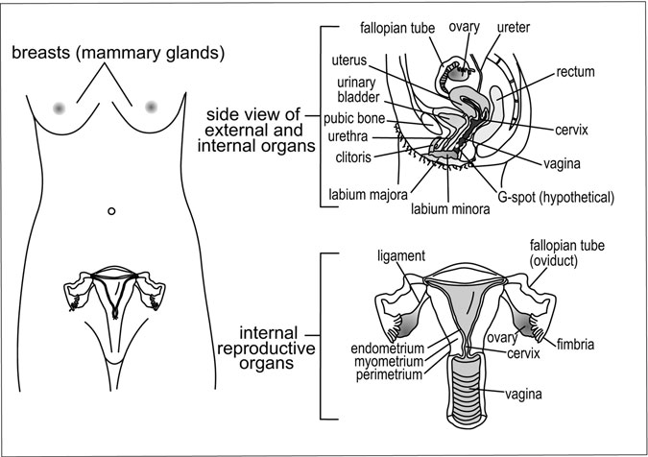

Figure 9.2 Female internal reproductive organs. (Sandy Windelspecht/ Ricochet Productions)

egg is fertilized, it completes the meiotic division that was arrested at ovu- lation. Fine hairs called cilia coordinate with the contractions of the ovi- duct to propel the egg down to the uterus, or womb, the upside-down pear-shaped organ that will house the developing fetus.

If the egg is not fertilized, the uterus sheds its endometrium, a special lining that thickens in preparation for the fertilized ovum, and expels it during menstruation along with the egg. Powerfully muscular, the uterus is capable of expanding to the size of a basketball during pregnancy. Its wall has three principal layers: the endometrium; the myometrium, the complex of muscles that surrounds the uterus to contract in childbirth and to help reduce uterine size afterwards; and the perimetrium, the outer layer of connective tissue.

The lower third of the uterus narrows into the cervix and the vagina. An organ about one inch in circumference, the cervix protrudes into the upper cavity of the vagina and dilates during childbirth to permit the infant’s head to emerge. Its opening into the vagina, the external os, is

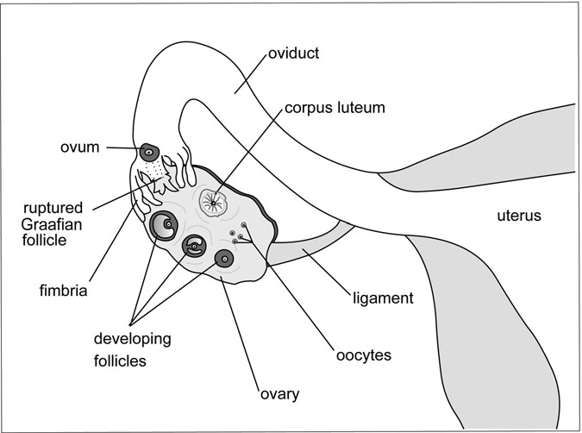

Figure 9.3 Ovulation. (Sandy Windelspecht/Ricochet Productions)

covered with cervical mucus that changes with the cycling of the men- strual cycle. During pregnancy, it thickens, forming a plug to keep out threatening pathogens. Also known as the birth canal, the vagina is a mus- cular cavity 3 to 5 inches (7.6 to 12.7 centimeters) long that is ordinarily narrow and collapsed on itself, but it expands and lubricates to admit the erect penis during intercourse. If pregnancy occurs, it stretches much more to accommodate the fetus during childbirth.

While it is not technically part of the genitalia, the urethra is so inti- mately associated with both the female and the male reproductive tracts that it merits a brief description here. In the female, urine produced by the kidneys ﬂows down the ureters into the bladder, which stores and then releases it through the urethra to exit the body at the vestibule.

There are hidden but important glands on either side of the vagina called the lesser and greater vestibular glands (Bartholin’s glands) that secrete ﬂuids into the labia to help lubricate them during sexual arousal. There are

two pairs of labia; the labia majora, or larger lips, are the ﬂeshy outer lips that cover the more sensitive, hairless labia minora, or smaller lips.

Just behind the urethra, tucked within the labia, is the vaginal opening, which in young girls is partially covered by a thin membrane called the hymen. Although this tissue is usually present in those who have never had intercourse, some girls are born without it or unknowingly tear it during physical activity or with the repeated use of tampons. The small expanse of skin between the vaginal opening and anus is called the perineum. Each female is born with an organ devoted entirely to sexual pleasure, the clitoris. Comparable to the penis in terms of sensation, the exquisitely sensitive clitoris is hooded by a prepuce (a membranous, protective tissue capable of sliding back, or retracting). The glans is the tip of the clitoris that can be seen at the upper junction of the labia minora. The rest of its body is the shaft, which disappears into the pelvis and consists of two cavities that ﬁll with blood during sexual excitement. Some insist there is a knot of tissue within the vagina known as the Gra¨fenberg spot or “G spot,” a controversial subject because recent evidence suggests it does not exist. But others believe it to be a sensitive site of female pleasure located an inch or so into the vagina on the front wall, adjacent to the urethra and bladder and behind the pubic bone. The external female genitals are referred to collectively as either the vulva or the pudendum. Both terms include the mons veneris or mons pubis, the mound of tissue lying over the pubic bone that in sexually mature women is covered with pubic hair.

The breasts are mammary glands that, despite their undeniable sexual signiﬁcance, evolved primarily to feed the young. The nipples’ so-called erectile tissue—although susceptible to stimulation—is altogether different from that of the penis or clitoris. Smooth muscles within the areola, the dif- ferently colored tissue surrounding the nipples, are responsible for the erec- tility, which probably helps infants ﬁnd and grasp the nipples more easily.

When she enters puberty, a young girl’s breasts begin to accumulate fat and grow. A radiating series of lobes in each breast that reduces to smaller lobules and ends in tiny sacs called alveoli drain into lactiferous ducts carry- ing milk to the nipples. During pregnancy, high levels of estrogen and pro- gesterone cause the alveoli to ﬁll with proteins and other ﬂuids. When the infant is born, the breasts release these nutrients, or colostrum, which impart the mother’s immunities to the newborn. Within just a few more days, the

breasts begin to lactate (produce milk). Nursing not only feeds the child; it also triggers powerful contractions in the mother’s uterus that help it revert to its normal size.

When ovulation occurs, the Graaﬁan follicle from which the secondary oocyte erupts is transformed into a corpus luteum, a body that produces the hormones estrogen and progesterone to prepare the uterus for implantation of the fertilized egg. These hormones, under the direction of the pituitary gland, orchestrate the phases of a woman’s monthly menstrual cycle, 28 days long on average. At mid-cycle, ovulation, the lining of the uterus thickens and new blood vessels grow. Ten to fourteen days afterwards, if the egg is not fertilized, the corpus luteum ceases hormone production and degenerates; in response, the endometrium breaks down and is expelled from the body in the form of menstrual blood and tissue. The monthly menstrual cycle begins anew with the maturation of another primary oocyte in one of the ovaries. Although nature’s choice of which ovary is released from the ovum each month is entirely random, evidence indicates an equal distribution of labor—each ovary seems to contribute about half of the total eggs ovulated during a woman’s reproductive life.

##### Male Reproductive Organs

Spermatogonia, or immature sperm, also undergo changes before they are capable of fertilizing an egg (Figure 9.4). They reside in some 800 feet (24,000 centimeters) of seminiferous tubules, subsequently dividing by meiosis to become spermatids. Then, under the direction of specialized Sertoli cells, they differentiate and mature into spermatozoa, or sperm, sev- eral hundred million of which will be made in the testes daily from puberty onward. Since sperm must be kept at the right temperature to remain alive and healthy, the testes are nestled within a pouch of skin, the scrotum, sus- pended outside the body. In cold weather, the scrotum contracts to pull the testicles closer to the body for warmth. Too much heat can also damage sperm; tight clothing that restricts air circulation or regular bathing in water that is too hot can kill enough sperm to imperil fertilization.

At ejaculation, mature sperm stored in testicular ducts called the epidi- dymides enter the vasa deferentia (singular form: vas deferens) that extend up into the body and behind the bladder. There they meet the seminal vesicles,

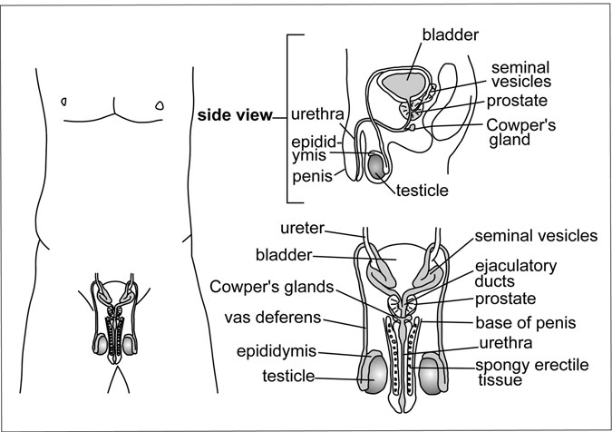

Figure 9.4 Male external and internal reproductive organs. (Sandy Windelspecht/Ricochet Productions)

glandular structures that narrow with the vasa deferentia into ureters, and form ejaculatory ducts. Sitting just below the bladder and surrounding the ureters is the prostate, a gland that contracts during ejaculation and secretes ﬂuids into the urethra. This ﬂuid combines with sperm and the secretions of the seminal vesicles and the bulbourethral, or Cowper’s, glands to make semen, the whitish ﬂuid ejaculated through the urethra at the end of the penis.

Like the clitoris, the penis contains spongy tissue whose vessels become engorged with blood during sexual arousal; this causes an erection that allows the penis to penetrate the vagina and deposit semen during ejaculation. Semen protects sperm in several ways: it provides a safe and ﬂuid environment, it helps neutralize harmful acids in the male urethra and female vagina, and it supplies sperm with needed energy to swim up and into the uterus, a journey that must be completed within 12 to 72 hours before they die. Although millions of sperm are contained in a teaspoon or two of semen (the average amount in each ejaculate), fewer than 1,000 will reach the Fallopian tubes.

##### Circumcision

Males and females alike are born with a prepuce that covers the glans of the penis and clitoris, respectively. In males, the prepuce is also called the fore- skin. It is attached to the glans but usually, by the time boys are of school age, the foreskin has naturally separated from the penis except for one anchoring point at the frenulum from which it can retract. Many males undergo a procedure to remove the foreskin surgically at birth; this is known as circumcision. Within certain societies around the world, girls and women are circumcised too, in what is usually an excruciatingly painful and mutilat- ing process carried out to allow males lifetime power over female sexuality.

Male Circumcision

Male circumcision was ﬁrst performed centuries before the beginning of the common era (BCE), and many cultures since have continued the practice for hygienic, cultural, or religious reasons. Although the procedure is performed nowadays in a clean environment by a trained person, there is a great deal of controversy surrounding it. Because circumcision usually takes place with no anesthesia when one is an infant and has no say in the matter, and because the absence of a foreskin may deprive men of signiﬁcant sexual pleasure, many regard it as an unnecessarily cruel procedure akin to mutilation. On the other hand, there is evidence that uncircumcised men are more vulnerable to urinary tract infections and sexually transmitted diseases (STDs) than their circumcised counterparts, and they bear a slightly increased risk of penile cancer as well.

##### The Nervous System

The Brain and Spinal Cord

The brain is the most important sexual organ in the human body. Partnered with the spinal cord to make up the central nervous system, it not only super- vises the nervous and the hormonal, or endocrine, systems that regulate the physiology of sexual response (what happens chemically and physically in the body), it is also the repository of the images, thoughts, and feelings that humans associate with sex.

The oldest neural tissue in the human brain, the reptilian brain is medi- ated by the inﬂuence of mankind’s thinking brain, or neocortex. A third area, the limbic brain, may be thought of as a bridge between the two, and the

place where emotions and sexual impulses reign. The brain is much more complicated than this; brain structures are coordinated in unaccountably complex ways to balance human instincts and emotions with appropriate behavior. There is nevertheless compelling evidence that some aspects of sexuality are “wired” into the brain. Evolution has etched into humans’ unconscious many of the characteristics that are desirable in a mate, and these traits subtly inﬂuence how they choose one another. Men may look for the “right” proportions in women, a certain waist-to-hip ratio that sug- gests a suitable physique for pregnancy and sufﬁcient fat deposits to nourish the young. Women, on the other hand, may tend to seek men who are tall, perhaps because their increased height once conferred hunting advantages and thus meant they would be better providers for the family. In most cases, men and women are not consciously aware of making these choices; they know only that they ﬁnd someone sexually attractive.

The Peripheral Nervous System and Neurotransmitters

The ﬁrst arm of the nervous system, the brain and spinal cord combination, works in concert with a second arm, the peripheral nervous system, made up of neural networks that thread throughout the body. It is divided into two parts, the somatic and the autonomic. The somatic sends sensory signals to the brain and activates certain kinds of motor activity, but in human repro- duction, the autonomic nervous system (ANS) is the main player. It is always working, orchestrating involuntary functions outside of one’s control. Very simply put, its sympathetic system makes preparations for the body to go into action, and its parasympathetic system reverses the preparations. (A third part of the ANS is the enteric system, which inﬂuences certain functions such as digestion.) When sexual arousal occurs, the sympathetic system increases pulse rate and saliva production, quickens breathing, and raises blood pres- sure; as excitement ebbs, the parasympathetic system slows pulse rate and breathing, lowers blood pressure, and decreases glandular secretions.

But this is by no means the whole story. Communication among the cells of the body is an extraordinarily complex process that relies on chemical messengers. Some of these are neurotransmitters, made by nerve cells to carry messages in the form of impulses across the synapses, or gaps, that separate them. They convey emotions, thoughts, ideas—all the neural

processing that animates humans—and help regulate the secretion of hor- mones. Some are called the “feel-good” neurotransmitters: dopamine, acetyl- choline, and the endorphins, known as natural painkillers. These, along with other biochemicals like norepinephrine and serotonin that act as neurotrans- mitters in the brain, seem to have major roles in sexuality and reproductive functions, probably due to their regulatory effects on mood. An imbalance or deﬁciency in any one of these neurotransmitters can result in depression, lethargy, insomnia, anxiety, or difﬁculty with concentration. The body care- fully governs this delicate mix primarily through the hypothalamus. The hypothalamus is a regulatory organ in the brain that maintains conditions in the body like temperature, metabolism, and blood pressure, and oversees the limbic system, where emotions such as aggression and rage reside. It also issues critical instructions to the pituitary, the master gland that, directly or indirectly, dispenses the body’s hormones.

##### Hormones

Hormones are another kind of biochemical messenger. There are two types, steroid and nonsteroid, that are secreted by glands throughout the body that comprise the endocrine and exocrine systems (Figures 9.5 and 9.6). By means of a biofeedback mechanism, the hypothalamus is alerted to abnormal biochemical levels; in response, it secretes neurohormones to tell the anterior and posterior lobes of the pituitary to increase or decrease the relevant hormones (Sidebar 9.1). For example, when the hypothalamus releases the neurohormone gonadotropin-releasing hormone (GnRH) to the anterior pituitary, it is telling the gland to produce both follicle- stimulating hormone (FSH) and luteinizing hormone (LH), chemicals that the ovaries and the testes require to support egg and sperm development. Once the pituitary delivers the message, the ovaries and testes begin to do the work to which they have been hormonally assigned. An example of a hormone produced by the posterior pituitary is oxytocin, related to uterine contractions, milk production, and emotional bonding.

Steroid hormones are made by the adrenal glands in both males and females. These chemicals are converted primarily to estrogen in women and, to a lesser degree, to testosterone; in men, they are converted primarily to testosterone and, to a lesser degree, to estrogen. These, along with

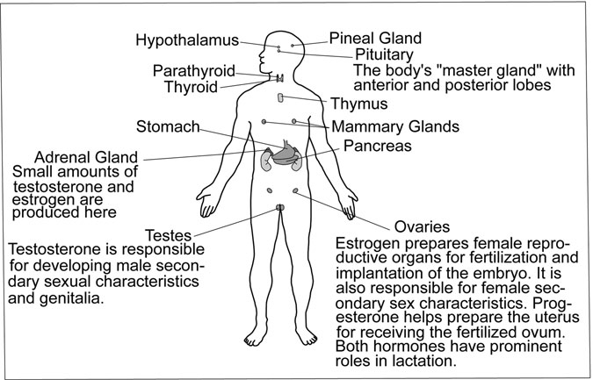

Figure 9.5 Glands of the human body. (Sandy Windelspecht/Ricochet Productions)

progesterone, are called the sex hormones because they are also produced in the ovaries and testes and are fundamental to reproductive biology.

The Role of Hormones in Embryonic Sex Differentiation

When fertilization occurs, the chromosomal arrangement of the merged gametes determines the genetic sex of the child. An X ovum fusing with a Y sperm yields an XY embryo, or a male. An X ovum fusing with an X sperm yields a girl. But the “default” embryo—the newly conceived embryo that has not yet developed sexual organs or produced hormones—is generally considered female until other steps involved in sex differentiation take place. It is critical that each step occurs at the right time, or normal development will go awry.

A seven-week-old XY embryo already has testicular tissue identifying him, at the level of his gonads, as male, just as an XX embryo has ovarian tissue identifying her as female. Both embryos have two ducts, the Wolfﬁan and the Mu¨llerian, that will be transformed into the reproductive structures

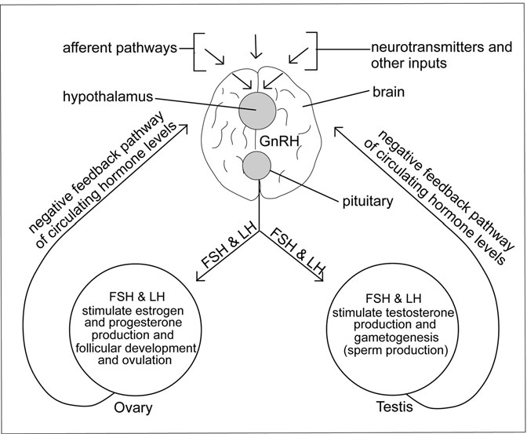

Figure 9.6 Biomechanical pathways. (Sandy Windelspecht/Ricochet Productions)

of either the male or the female, respectively. Scientists believe that a gene expressed only in the embryonic male brain triggers the development of testes; the early testicular tissue secretes testosterone, the transforming agent that causes the Mu¨llerian duct to degenerate and prompts the male genito- urinary tract to develop. In contrast, without that testosterone acting on the XX embryo, the Wolfﬁan duct degenerates, leaving the Mu¨llerian to give rise to the female’s reproductive organs.

Just as hormones are associated with the differentiation of the gonads and external reproductive organs, so are they associated with sex differentia- tion in the brain. Once again, testosterone plays an especially critical role.

Remember that the brain of the embryo is still that of the “default” gender, even though male sexual organs may have begun development.

SIDEBAR 9.1

#### The Hypothalamus and Mechanisms of Feedback

Also known as the body’s “guardian,” the hypothalamus ensures homeo- stasis, or equilibrium, within the body. It provides a link between the nerv- ous and endocrine systems to regulate temperature; maintain appropriate hormone levels; signal sensations of hunger, fullness, and thirst; juggle aggression, fear, and rage; and set circadian (sleeping versus waking) rhythms. In reproduction, it triggers the pituitary to prompt sex hormone production by the ovaries and testes.

While it is not completely understood how the hypothalamus receives all of its input, it is known that several afferent pathways carry neurotrans- mitters and biochemicals into the organ from the brain and body. To help regulate reproductive functions, it relies on a feedback system; negative feedback is a function of hormone levels. For example, reduced blood con- centrations of estrogen and progesterone that result from the degener- ation of the corpus luteum after ovulation alert the hypothalamus to a low level of these essential hormones. The hypothalamus releases GnRH that instructs the pituitary to secrete FSH and LH to stimulate ovarian production. As blood levels of the newly produced hormones then rise, the hypothalamus stops triggering their secretion. This mechanism is illus- trated in Figure 9.6.

To masculinize the brain, a certain amount of estrogen (testosterone that has been converted in the male’s body) must pass through the brain barrier. It is not entirely clear why it is the primarily “female” hormone estrogen that is required, but one thing is very clear—estrogen must not be permitted to penetrate the female’s brain barrier at this stage. A protein the female embryo produces, called alpha-fetoprotein, erects a barrier of its own that successfully blocks the estrogen’s entry.

This process does not mean that estrogen is responsible for every “male” thought a man possesses. While it seems likely that hormones regulating sex differentiation are responsible for some of the structural differences between the male and female brain, it is also clear that social

or cultural factors affect its fundamental development as well. During their youth, boys and girls are bombarded with input that will shape their individual sexual identities. General attitudes as well as individual experi- ences can inﬂuence them; today’s “ideal” woman is thin, for instance, but before World War I, with a few exceptions, the plumper, rounded female ﬁgure was widely favored. However, there is consensus that even if a given input has no intrinsic sexual content, it could be integrated differ- ently by a male brain than by a female brain, simply because their neuro- logical networks are different. Analyzing what this means in terms of human behavior is not the focus of this chapter, but the implications offer a tantalizing glimpse into how profoundly the brain affects human sexual- ity and how differently it shapes male and female perceptions.

##### The Libido and the Physiology of Sexual Response

The sex drive, or libido, is one of the most compelling drives in human expe- rience, in part because it ensures continuation of the species. It is a source of great pleasure and fulﬁllment, but it can also be responsible for great heart- break and loss—even, in extreme cases, violence. People under its inﬂuence have jeopardized marriages, parental rights, job security, economic status, national or international prestige, and countless other symbols of stability and respectability for what is sometimes only a “one-night ﬂing.”

The ﬁrst phase, excitement, is the period when sexual stimulation activates the sympathetic nervous system to increase heart rate, produce hormonal secretions, and develop tissue swelling and erection. When someone responds to stimuli, the sympathetic arm of the ANS instructs the Cowper’s glands in the male to secrete ﬂuid; it tells the arterioles, the blood vessels that carry blood from the heart, to dilate, opening them wider to allow greater blood ﬂow. At the same time, it orders the venules, small veins carrying blood back to the heart, to constrict and thus prevent too much blood from returning; in this way, blood accumulates in the genitals and, in the male, engorges spongy tissue in his penis to cause an erection. Similarly, in the female, engorgement causes her clitoris to become erect while her vestibular glands secrete lubricating ﬂuid and her pulse rate and blood pressure rise. In addition, her breasts and the outer portion of her vagina may swell as her labia become darker in color.

The second phase, plateau, is an intensiﬁcation of excitement; vascular congestion in the genitals is at its peak, ﬂushing of the skin might occur, and muscles of the thighs and buttocks tighten. Interestingly, the clitoris retracts under its prepuce in this phase and shortens by up to 50 percent, a phenomenon that seems to signal the onset of female orgasm.

The third phase is orgasm, or climax. The male reaches ejaculatory inevitability, or “the point of no return” at which he can no longer delay powerful spasms that originate in the epididymides and pulse through the vasa deferentia and prostate. The entire nervous system becomes involved; this is the height of his pleasure, and the moment that sexual tension is discharged amid strong contractions that ordinarily lead to ejaculation. But not always. Men may also have a “dry orgasm,” an orgasm with no expulsion of seminal ﬂuid. This syndrome can accompany certain neurological condi- tions or diabetes, it can occur in perfectly healthy males who have ejaculated frequently over a recent period of time, and, most commonly, it happens to young boys nearing puberty when they are experiencing sexual pleasure but their semen-producing organs have not fully matured. Retrograde ejacu- lation, when semen backs up into the bladder, is another reason for dry orgasm. In the absence of disease, this is a normal phenomenon following several episodes of arousal that do not result in orgasm; ﬂuids quite literally back up into the bladder and subsequently must be released during urination.

Physiologically, the female’s orgasm is similar to the male’s in terms of buildup and the point at which contractions begin. These are over- whelmingly pleasurable, pulsing through her uterus and vagina in wave- like patterns. Although her orgasm is not necessary for fertilization, uterine spasms in the outer third of the vagina can dip the cervix into contact with sperm and may even help draw sperm up into the cervix, increasing the chance of fertilization. Because she produces no sperm, however, her pleasure and orgasm are almost incidental to the biology of human reproduction; if her menstrual cycle deems her ready for fertiliza- tion, there is every possibility she will be impregnated even as a result of rape, no matter how brutal her experience.

Some schools of thought hold that there are two types of female orgasm, vaginal and clitoral, the latter, according to Freudian psychoanalytic theory, being the more “immature,” and that an individual woman is capable of experiencing only one kind. Others maintain that the same woman,

depending in part on how and where she is stimulated, can experience both. Some women report that an orgasm felt deeply in the vagina is the more intense of the two, triggering stronger uterine and vaginal contractions, while other women say that sensations arising from clitoral stimulation are more pleasurable. All must agree, however, that it is actually the brain that reigns supreme in the sexual response department, for only the brain can trigger a spontaneous orgasm. A sleeping person receiving none of the physical or external stimulation on which arousal normally relies can have an orgasm simply because his or her brain created some exciting imagery. In fact, so complete is the brain’s mastery over arousal that some women can fantasize to orgasm while fully conscious, using nothing for stimulation but the rich material her neural activity evokes.

The ﬁnal period of a sexual encounter is called resolution, when the par- asympathetic system begins to reverse the excitement that its counterpart ignited and allows blood from engorged genitals to ebb. Norepinephrine, one of the feel-good hormones, is released, adding to the overall sense of well-being and relaxation that the participants enjoy.

#### From Sex to Pregnancy—or Not

Despite scientists’ sophisticated understanding of human reproductive biology, conception, the beginning of life, cannot be deﬁned. Just because a sperm has penetrated an ovum does not mean fertilization has taken place; that occurs only when the pronuclei of the sperm and egg (two gametes, each with 23 chromosomes) fuse to create a zygote, whose nucleus will then contain 46 chromosomes.

Some view fertilization as the moment of conception. Others feel that fertilization merely launches cell division, producing a nondescript cluster of cells that is not alive until it implants in the womb, establishes a nour- ishing blood supply, and begins to differentiate into human tissue; these events, they believe, represent conception. So to avoid any misunderstand- ing, fertilization, rather than conception, is used here to describe the beginning stages of embryogenesis.

Most biological processes build on one another and balance complex cellular and hormonal activity with split-second timing. Nowhere is this more evident than in a human being’s ﬁrst three months in the womb.

Developments during the last six months are much less dramatic but are equally important, because they represent organ maturation and growth necessary for life outside the mother’s body.

Every parent hopes for a normal pregnancy that ends with the birth of a healthy child, and the following describes how such a pregnancy might unfold in the context of a hospital or home delivery attended by physicians or midwives. In addition, prenatal care, fetal and maternal screening, and frequent medical issues pregnant women encounter are discussed.

Many women choose not to have children. In recent decades, thanks to dependable contraceptives and safe, legal abortion, a decision to post- pone or avoid parenthood entirely can easily be made. This section con- cludes with a description of the methods used to prevent or terminate unwanted pregnancies.

##### The First Trimester

Fertilization

Given the long and dangerous journey each sperm makes, from the upper vault of the vagina through the cervix and uterus and into the Fallopian tubes where it encounters the ovum, it is surprising that fertilization occurs at all. But out of the millions of sperm ejaculated during inter- course, a few hundred or so do indeed survive the journey and, in as little as 15 minutes or as much as 72 hours, reach the upper Fallopian tubes where the ovum awaits, abundantly covered with sperm receptors. Normally, only one sperm can penetrate the ovum; the moment its surface enzymes digest a path through the ovum’s outer layer, the zona pellucida, the ovum dispenses enzymes of its own that break down its receptors and harden its outer layer to make it impenetrable. In a rare event known as polyspermy, more than one sperm breaks through. Because this leads to altered chromosome numbers that would result in abnormal development, the ovum fails to develop and is expelled (see Sidebar 9.2).

Although fertilization occurs just after ovulation, the medical commu- nity usually calculates pregnancy, or gestation, to begin at the start of a woman’s most recent period and to last 280 days (rather than the 266 days elapsing between fertilization and childbirth). The 280 days or 40 weeks are divided into three trimesters, the ﬁrst spanning the weeks between

SIDEBAR 9.2

#### The Question of Twins

Polyspermy raises the question of twins: if only one sperm can fertilize an egg, how do twins develop? The twofold answer lies in the difference between fraternal and identical twins.

Fraternal Twins

These children are not identical and may be male and female; they result from two different eggs being fertilized by two different sperm. In a given month, a female may ovulate from both ovaries; each of her two Fallopian tubes contains a mature ovum awaiting fertilization. After intercourse, a different sperm fertilizes each. So two genetically distinct siblings— brother-brother, sister-sister, or brother-sister—will become embryos. They are no different from any other sibling combination except that they were nurtured in the womb at the same time rather than, typically, a few years apart. Fraternal twins are often referred to as double-egg twins, and these are the types of twins that tend to run in families.

Identical Twins

These two, on the other hand, developed from the same egg and the same sperm and therefore have the same genetic makeup. How do two (or, in the case of triplets or quadruplets, three or four) identical children emerge from one egg? It is because a single fertilized egg, when it begins to divide by mitosis and grow, produces daughter cells identical to itself; rather than staying attached to one another in a single ball, they may split into two (or more) groups. Each group has the same genetic makeup, and each begins to grow at the same rate. Two groups of daughter cells produce identical twins, three groups produce identical triplets, and so on. Many mistakenly believe that identical twins can be male and female. Their identical genes clearly make this impossible. Moreover, this so- called “single-egg” twinning does not appear to run in families.

What many may not realize is that twins are not truly identical, even

though they have just been described as such. If the twins implant in the uterus at different places, they will receive substances from the mother’s

bloodstream differently; one twin may be exposed to a greater concentra- tion of certain bacteria than the other. Their genetic makeup can change slightly after the blastocyst splits into two groups, because a few of one twin’s genes may be damaged during subsequent cell division while the other’s are not. After birth, they are exposed to environmental inﬂuences that will affect the genetic makeup of each twin differently. Then there is genetic imprinting, the process by which certain genes are turned “on” or “off” based on which parent they came from; because this somewhat ran- dom gene activation will occur differently in each twin, their tissues—some imprinted, some not—will develop somewhat differently.

For this reason, many scientists prefer “monozygotic” to “identical,” and nowhere is the reason for this preference better illustrated than in forensic investigation. If a monozygotic twin is suspected of a crime, DNA evidence cannot identify which twin is the culprit because current analytic techniques cannot discern the tiny mutations and variations that differentiate the two. So for now, investigators must hope the guilty twin left some ﬁngerprints behind because, surprisingly, the ﬁngertips of mono- zygotic twins are not the same. In an excellent example of how environ- ment literally shapes development, the different whorl patterns of identical twins’ ﬁngerprints arise in part from the amniotic ﬂuid surround- ing them as well as their contact with each other, themselves, and the walls of the uterus.

the last menstrual period through the end of the 12th week. The second tri- mester is almost four months, covering the 13th week through the 27th; and the third occurs between the 28th week and the 40th. Another system for marking pregnancy’s passage, used during the 10-week-long ﬁrst tri- mester, pinpoints 23 stages of embryogenesis beginning with fertilization at Stage 1, quickly followed by cleavage at Stage 2.

Cleavage

Fertilized at the upper end of the Fallopian tube, the zygote must make its way to the uterus, implant, and begin developmental growth. As it migrates, it undergoes cleavage, or cell division. The resulting daughter cells divide

every few hours, creating a cluster that is the multicelled embryo. The cells then ﬂatten to form tighter junctions, compacting into a rounded morula that enters the uterus about the ﬁfth day after fertilization.

At Stage 3, the morula develops ﬂuid at the center and becomes a blastocyst. As ﬂuid accumulates, the blastocyst for the ﬁrst time begins to display signs of cell differentiation. There is an inner cell mass that represents the embryo-to-be; a discernible outermost collection of tropho- blast cells that later contributes to the placenta, an organ that supplies nutrients to the fetus and removes waste products such as carbon dioxide; and the umbilical cord, a network of blood vessels that connects the embryo to the placenta. The ﬂuid-ﬁlled center is contained by the amnion, a membrane surrounding the embryo that suspends it in amniotic ﬂuid.

Identical twins can result from cleavage if daughter cells split and implant at different sites in the uterus, each developing its own amnion and placenta. These cases account for about 10 percent of identical twins. Another 70 percent or more are formed when the inner cell mass splits, forming two embryos and two amniotic sacs. Or, both may share an amniotic sac; if the cells fail to separate completely, the embryos will be conjoined (or Siamese) twins. Twins sharing an amniotic sac and placenta are at high risk. Nearly a week after fertilization, the zygote is ready to implant in a uterus already prepped by the pituitary’s hormonal directives. At Stage 4, the cluster of cells erupts from the still-intact zona pellucida to land on the blood-rich endometrium of the uterus, where it burrows aggressively and initiates physiological changes in its maternal host that she will soon be

unable to ignore.

The Primitive Streak and Gastrulation

About this time, Stages 5 through 8, a placenta forms and becomes anch- ored to the uterine wall by means of chorionic villi, or “ﬁngers,” that inﬁl- trate the endometrium. The blastocyst’s inner cell mass divides into an epiblast that forms the embryo and a hypoblast that forms the yoke sac, a structure that supplies early nutrients in other animal embryos but may be vestigial in humans. A groove called the primitive streak forms along the back of the inner cell mass. Cells along this groove migrate inward in a process called gastrulation, during which they differentiate into three rudimentary tissues (embryonic germ layers) that in turn give rise to

different organs and body systems: the outer ectoderm, cells that will form the nervous system, outer tissues like skin, hair, mouth, and anus, and the lenses of the eyes; the endoderm (sometimes called the gastroderm), an innermost layer that will become the linings of glands and internal organs comprising the digestive, respiratory, and endocrine systems; and the middle layer known as the mesoderm that will develop into the reproduc- tive system, heart, lungs, and blood, and whose cells will develop seg- mented tissues called somites to become muscles and bones. The notocord, a rodlike structure that orients the organism to top and bottom, front and back, left and right, and forms the basis of the backbone, will also emerge from the mesoderm, followed by primitive development of the nervous system in Stage 8.

Occurring close to the third week of embryogenesis, gastrulation is a pivotal point of development in the ﬁrst trimester because it marks the beginning of organ formation. This is a critical time for the embryo, since certain viruses or drugs or inadequate nutrition can gravely imperil its development and is one of the many reasons prenatal care is so important early in pregnancy.

The Embryo

The embryo’s ﬁrst three months of life are characterized by the most dramatic changes a human organism ever experiences. With a developing notochord serving as an axis, the three cellular layers curl under them- selves to form a tube with a hollow “gut” through the middle. The body plan is taking shape, and primitive blood vessel networks are developing. Already elongating, the embryo’s lumpy body indicates accelerating tissue differentiation. Thickened circles along its upper sides suggest the eyes that are to come and, nearby, puckered areas reveal the sites of future ears. By Stage 9, its primitive heart begins to beat and blood vessels grow, even as a large forebrain starts to dominate the embryonic structure.

In Stages 10 through 12 (weeks 3 and 4), changes become more marked. The embryo curls into a “C” shape, displaying budlike limbs. Digestive organs and glands start to develop, and the early division of the heart into distinct sections begins when blood circulation is established and heart valves are more deﬁned. Extensive groundwork for central nervous system

development occurs during these stages. A thin layer of skin forms over facial features that are beginning to distinguish themselves; nasal pits are visible, and the depression that will become the mouth appears.

Stages 13 through 18, during weeks 5 through 7, are characterized by the appearance of a fully developed umbilical cord, lengthening appen- dages, and a lobed heart. Digestive organs can be seen now, especially the intestines, which have grown so quickly they temporarily reside out- side the abdominal cavity. The esophagus develops out of the trachea, and the lungs form. The embryo’s trunk straightens to hold its head more erect, and its bones become harder. Fingers and toes are becoming more distinguishable, and genital membranes primed for male or female devel- opment reveal the inﬂuence of the Wolfﬁan and Mu¨llerian ducts described earlier in this chapter.

An increase in brain size, the growth of vocal cords, and progression of organ development characterize the next three weeks of the ﬁrst trimes- ter, Stages 19 through 23. Male or female genitalia become distinct as the testes begin their slow descent into the scrotum or the ovaries relocate to the pelvic region. The embryo’s chin sharpens. The pancreas begins to secrete insulin, hands display dexterity, and both body hair and ﬁngernails grow. By the end of the eighth week, when its facial features are recogniz- ably human, the embryo becomes a fetus (Figure 9.7). Only one inch (2.54 centimeters) long, it appears to swallow, even hiccup, and in its tiny mouth are 32 buds that will become permanent teeth. The muscles function more smoothly and the fetus makes random movements, although its mother cannot yet detect them.

The Mother

It is very unlikely the mother is having any symptoms of her pregnancy this early, but already her body is undergoing radical changes to accom- modate a bundle of cells that her body regards as foreign—in this case, the embryo, whose genetic material is different from hers. Human immune systems do not accept alien invasions gracefully; they make very sharp distinctions between “self” and “nonself,” and the mother’s system would immediately identify this stranger as “nonself.”

But just as her system poses a problem, it provides a solution. First, before the fertilized ovum descends all the way down the Fallopian tube,

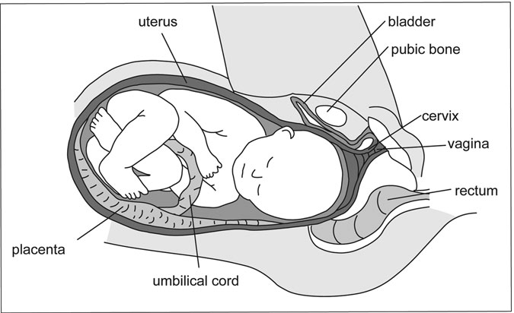

Figure 9.7 Full-term fetus. (Sandy Windelspecht/Ricochet Productions)

the mother’s uterine mucus lining forms a membrane called the decidua so that, when the embryo implants, the decidua wraps over the organism to separate it from the inner wall of the uterus. This prevents the mother’s immune system from “seeing” the embryo. Second, because there must be some kind of connection between her uterus and her child if the embryo is to survive, a placenta begins to develop from both the decidua and the fetal chorion, a layer of tissue that lies between the embryo and the decidua. This becomes the critical passageway for the transfer of nutrients and wastes between mother and child. Life-sustaining chemicals pass back and forth between the two: from the embryo to and from the placenta via the umbilical cord, and from the mother to and from the placenta via its attachment to her uterine wall. This vital activity escapes the surveil- lance of the immune system because the blood systems of mother and embryo do not touch. How, then, do they make the exchange? There are complex theories that genetic imprinting and graft rejection molecules are involved, but to what degree is not known. What is known is that the biochemicals exchanged by mother and fetus rely on the placenta, where osmosis and diffusion make the transfer.

The placenta also produces hormones, initially just enough to prevent the degeneration of the ovary’s corpus luteum that is keeping the endo- metrial lining richly supplied with blood. When the placenta is capable of producing enough hormones on its own, usually after the ﬁrst three months, the corpus luteum begins to disintegrate. The yolk sac usually dis- appears by the seventh or eighth week.

Much of the embryo’s very early development occurs before the mother even realizes she is pregnant. If she becomes aware of anything unusual, it might be that her menstrual period is a day or two late, but even in this she could be misled by the light vaginal bleeding or “spotting” that many preg- nant women experience during embryonic implantation. (To add to the con- fusion, some women actually continue to have periods throughout their pregnancy, but this is rare.) Her breasts may be sore too, the kind of tender- ness that just precedes her period. So, unless she is consciously awaiting conﬁrmation that she is pregnant, she is oblivious to her condition.

That will change by the time her period is four weeks late. The embryo’s primitive heart has been beating for two weeks, and the mother will have developed symptoms such as fatigue, lightheadedness verging on fainting, and “morning sickness.” The latter is a misnomer; the syndrome is more properly known as “pregnancy sickness,” or the “nausea and vomiting of pregnancy” (NVP) because the nausea can occur anytime, even in the middle of the night, and may range from slight queasiness to persistent vom- iting and dehydration. If the nausea is severe (hyperemesis gravidarum), medical intervention is required, but for the usually mild-to-moderate sick- ness associated with the ﬁrst trimester of normal pregnancy, small but fre- quent meals, avoidance of certain foods, and plenty of ﬂuids will often alleviate symptoms. Although the causes of NVP are not fully understood, the most common hypothesis points to elevated hormones. The reasoning is that higher hormone levels seem to support a healthier pregnancy; women with healthier pregnancies—those who miscarry less frequently—have more NVP. Others believe that NVP is an evolutionary adaptation to prevent mothers from eating foods that are potentially toxic to the embryo.

The high levels of hormones a pregnant woman produces are due in part to the corpus luteum producing more estrogen and progesterone by order of the beta human chorionic gonadotropin (ß-hCG or hCG) hormone. The placenta produces hCG once the embryo embeds in the uterine wall, and

the hormone’s increased level is one measure by which pregnancy is conﬁrmed. The additional estrogen, which incidentally causes the mother’s breasts to become sore, is needed in the development of the embryo’s pla- centa, bones, and sexual characteristics. Progesterone, initially produced by the corpus luteum to build up the endometrial lining before ovulation, normally decreases after ovulation, so the lining will disintegrate and be expelled in menstrual ﬂuid. In pregnancy, however, the uterine lining must be sustained, so the progesterone released by the stimulus of the corpus luteum, which in turn is nudged by hCG, ensures that the hormone levels remain high. The woman continues to produce hCG throughout her pregnancy at sufﬁcient levels to prevent uterine contractions, to stimulate breast tissue growth, and to help support the placenta. She also produces human placental lactogen (hPL), both to help her breasts prepare for nursing and to regulate her insulin levels to compensate for some of the nutritional demands the baby is making. As the mother approaches her second trimes- ter, the fetus, whose basic organs systems are now in place, will begin to make rapid gains in size and weight.

##### The Second and Third Trimesters

The Fetus

As the fetus lengthens through the torso, its physical features are melding into position; its eyes are moving forward, and its ears are close to their permanent location. It can hear, and its reﬂexes have matured. As the weeks pass and it continues to strengthen, its limbs and torso grow larger to achieve proportion with its head. It is covered in a downy coating called lanugo that it will shed before birth. Its heart is pumping more blood, and its limbs move rapidly.

Between the sixth and seventh months, the fetus has immature lungs, and only with very sophisticated support could it survive outside the womb, but as it develops the capacity to breathe on its own, its rapidly growing brain takes over many of its body’s functions. Its testes, if it is male, or ovaries if female, are fully formed, and hair is growing on its head. It is so large now it must bring its knees up into the fetal position to have room in its mother’s uterus. By the ninth month, the fetal lungs have matured and it has built up sig- niﬁcant body fat under its skin, which has thickened. Its gastrointestinal

system, though immature, is fully functioning, and its nervous system reacts reﬂexively. Toward the end of the month, when it weighs between 6 and 9 pounds (4.1 and 5.7 kilograms) and is about 20 inches (50.8 centimeters) long, it is ready to be born.

The Mother

A pregnant woman usually feels better during the second trimester than during the ﬁrst. Nausea and fatigue often vanish early in the fourth month, and she may be suffused with a sense of contentment and well-being. But she may also begin to feel clumsy and overweight.

Growing pressure compresses her bladder, making her urinate fre- quently; she sometimes has backaches; hormonal changes and the pres- sure from the baby’s growth may have made her constipated and given her hemorrhoids. She might have noticed swollen veins in her legs and stretch marks over her abdomen and breasts.

Colostrum, the nutrient her breasts produce for the child’s ﬁrst post- natal day or two, leaks from her breasts, which are sore and tender. Unlike the nausea of the ﬁrst trimester, she might have food cravings that she is compelled to satisfy even though she knows she must not gain too much more weight. Headaches are sometimes a problem, as is indigestion (acid reﬂux) due to the pressure of the baby pushing against the valve that sepa- rates her stomach and esophagus. Her uterus is so large now it displaces her diaphragm, making her short of breath, and she has frequent pelvic pain as her bones and joints withstand the growing baby’s activity in her womb.

All of these symptoms are normal, although not everyone experiences them. But there are other, more serious, conditions that can arise during pregnancy that require careful medical attention, and this is why prenatal care to help avert them is so important.

##### Medical Issues Surrounding Pregnancy

Prenatal Care

Any woman contemplating pregnancy should be sure she is in good health, both for her own well-being and for that of the child. She should quit smok- ing, drinking alcohol, and taking illegal or prescription drugs (unless the latter are approved by her physician) for at least three months before she conceives.

If the father is a smoker, he should quit smoking as well to prevent second- hand smoke from endangering the infant.

Once she knows she is pregnant, a woman should see her physician or arrange an appointment at a clinic where health care personnel will take her medical history, perform a physical examination, and analyze her urine and blood to determine the state of her overall health. Speciﬁc infor- mation they seek includes her blood type, Rhesus factor (see “Complica- tions of Pregnancy” below), the presence of infection, anemia, or sexually transmitted diseases, and whether she is immune to the German measles (rubella) virus that endangers normal fetal development. Other risks to the fetus about which pregnant women should be informed include

• The dangers of smoking

• Fetal alcohol syndrome

• Parasitic, bacterial, and viral infections, such as toxoplasmosis, puerperal fever, or chickenpox

• Dietary insufﬁciencies

The physician or midwife who oversees the pregnancy will set up regular appointments in which to check the mother’s weight, blood pressure, and urine, and to feel her abdomen to evaluate the progression of the preg- nancy. Under normal conditions, only one or two visits are required during the ﬁrst trimester. They increase to one visit every four weeks in the sec- ond trimester and to one visit every two weeks in the third. From the 14th week on, the baby’s heartbeat will be monitored as well, and its size checked from about the 20th week on.

Maternal and Fetal Testing

Several screening and diagnostic procedures are recommended at various stages throughout pregnancy to evaluate the progress of mother and child. Some are routine, and others are repeated or introduced when there is rea- son for concern.

• The ultrasound scan is routine and is normally done around 12 weeks to screen for Down syndrome and again at 18 to 20 weeks to verify

fetal growth is occurring normally. If the scan captures a view of the external genitalia, it reveals the child’s gender.

• A multiple marker test done at 15 to 18 weeks consists of blood analysis. Additional screening tests are performed in the ﬁrst and second trimesters if speciﬁc complications or disorders are suspected based on the mother’s history, symptoms, or the results of the ultrasound; these also detect chromosomal abnormalities and alpha-fetoprotein levels, which can be implicated in Down syndrome or neurological disorders.

• A glucose tolerance test will probably be administered to check for gestational diabetes.

• Amniocentesis is a diagnostic procedure usually performed only on mothers age 37 or older because of the small risk of miscarriage it poses. A sample of amniotic ﬂuid is removed from the uterus and examined for fetal cells. These can yield valuable information like the sex of the fetus, its metabolic health, and whether there are chromosomal irregularities indicative of Down syndrome or other disabilities.

• Chorionic villus sampling is a less common diagnostic procedure than amniocentesis but can be done at an earlier stage of fetal development to detect genetic problems or blood abnormalities. This test is normally performed only if speciﬁc disorders are suspected.

• Umbilical vein sampling or cordocentesis elicits a great deal of information from fetal blood such as biochemical imbalances that may lead to slowed or retarded development, the presence of infection, and the Rhesus factor. If necessary, the umbilical cord can serve as the route of intrauterine blood transfusion.

Complications of Pregnancy

Despite early detection capabilities and the remarkable sophistication of today’s screening and diagnostic tools, not all the complications associ- ated with pregnancy can be avoided, nor can they be successfully treated once they pose a threat.

• Miscarriage and stillbirth are the death of the fetus. Miscarriages usually occur in the ﬁrst trimester, often because of embryonic abnormalities too severe to allow survival. Stillbirth refers to death of the fetus after 24 weeks. Sometimes hormones fail to support the pregnancy, sometimes infections or illnesses compromise it, and sometimes the mother’s uterus or cervix have impairments or irregularities that do not allow pregnancy to continue. Although nearly 25 percent of women experience some vaginal bleeding early in pregnancy, only half of those are likely to miscarry. Bleeding in the second and third trimesters, however, can be very serious and may indicate the placenta is involved.

• Placental separation occurs when the placenta becomes detached from the uterine wall, and the condition can have very severe consequences. In the ﬁrst or second trimester, it means almost certain death of the fetus; in the third trimester, if the extent of the separation is not so great as to place the mother’s life in danger from excessive bleeding, a Caesarean section can usually rescue the fetus.

• Placenta previa is a life-threatening development for the fetus because the placenta lies in the path of the baby through the birth canal, and if it is dislodged during the child’s passage, it will cease to provide needed oxygen. Fortunately, the condition can be diagnosed early and, if the mother receives proper bed rest and specialized medical supervision up to her 37th week, she could deliver a healthy baby by Caesarean section.

• Placental insufﬁciency is just that; for unknown reasons, the placenta is occasionally unable to transfer nutrients and waste products with enough efﬁciency to sustain the fetus. Ultrasound imaging and detecting less-than-normal maternal weight gain can lead to a diagno- sis of this condition, which may require the induction of labor or a Caesarean section.

• Preeclampsia and eclampsia are very serious conditions with unknown causes. They arise from the placenta and are somehow related to an inadequate blood supply. Preeclampsia, which is symptomless, is detected with blood pressure readings and urine

tests during prenatal checkups. It rarely occurs before the 20th week, but when it does, the only treatment beyond stabilizing the mother is delivery of the fetus and placenta. If preeclampsia develops near term and the mother receives expert medical attention, she may be able to deliver her baby normally. In any event, the condition must be monitored constantly because it could suddenly lead to eclampsia, a worsening of the condition that results in seizures, kidney failure, coma, and, if not treated immediately as the medical emergency it is, death of the baby.

• An ectopic pregnancy means the embryo has implanted in a Fallopian tube where it promptly begins to grow. The discomfort and pain this causes usually alerts the mother by the 6th to 10th week of her pregnancy that something is very wrong. This is the subacute form of ectopic pregnancy in which the Fallopian tube is still intact and the embryo can be destroyed by an injection. The acute form, by contrast, comes on suddenly and is an extreme emergency. The tube ruptures and severe pain, shock, and falling blood pressure imperil the life of the mother. Immediate surgery to remove the tube and the fetus can save her life, but she may have difﬁculty conceiving again or may even be left infertile.

• Gestational diabetes is diabetes that begins in pregnancy and, in many cases, disappears after the baby is born. Diabetic mothers require careful monitoring, because maintaining proper blood sugar levels is critical to fetal health. Often they must deliver by Caesarean section because their children tend to be large; this is due to the increased sugar in the mother’s system that crosses the placental barrier and becomes converted in the fetus into larger organs. With careful management, mothers who develop the disease during pregnancy should expect to deliver healthy children.

• The Rhesus factor (Rh factor) is simply an antigen or protein-like sub- stance that appears in the red blood cells of about 85 percent of people; this makes them Rh positive. The other 15 percent of people are missing the antigen and are Rh negative. It becomes important when the blood of an Rh-negative mother mixes with that of her Rh-positive baby

during delivery. No harm is done at that time except that the mother’s immune system reacts to the presence of the baby’s Rh-positive blood by producing anti-Rh-positive antibodies. If she gets pregnant again with an Rh-positive baby, the antibodies her system has produced will seek out and begin to destroy the baby’s red blood cells. Monitoring the mother’s blood for antibodies during the pregnancy allows physi- cians to evaluate the fetus and, if it is in distress, transfuse it through the umbilical cord.

• A Group B strep test is usually administered at the 35th to 37th week to determine whether the mother is carrying an infection that could be transmitted to her baby. She will also be examined to determine whether the baby is in the normal (head down) or breech (buttocks down) position for delivery, and may have her cervix checked to see if it has dilated in preparation for childbirth.

##### Preventing and Terminating Pregnancy

Since humans ﬁrst made the connection between sex and pregnancy, they have sought ways to have the pleasure of the former without the conse- quence of the latter. They have often succeeded, although there were mil- lions of unplanned pregnancies along the way. That does not have to be the case now, because there are several birth control methods that, if used properly, are nearly 100 percent effective in preventing pregnancy. Dis- ease is another matter, however. Only condoms can help prevent sexually transmitted diseases.

Given the differing viewpoints about when life begins, it is important to distinguish between contraceptives and abortifacients. Contraceptives are agents that prevent ovulation, kill sperm, or block it from reaching the ovum. Abortifacients are agents that intervene after fertilization to pre- vent implantation of the blastocyst in the uterus and cause the embryo to be aborted. For this reason, contraceptives and combinations of contracep- tives and abortifacients are discussed separately in the following sections. If an unwanted pregnancy does occur, millions of women turn to abor- tion. The U.S. Supreme Court has ruled that abortion is legal up to the 24th week of pregnancy, but many states have imposed limits on the pro- cedure. Some require parental notiﬁcation or consent for minors, others

require waiting periods, and still others have pushed the date of fetal viability to earlier than 24 weeks. New laws restricting abortion and court challenges to that legislation are pending in many states. Because abortion is deﬁned as the premature delivery of a human embryo or fetus that can- not survive outside the womb, the use of abortifacients is sometimes referred to as abortion.

Contraceptives

The famous—or infamous—withdrawal method, or coitus interruptus, is hardly a birth control method at all because it fails so frequently. It amounts to the male withdrawing from the vagina immediately before he ejaculates. But even if he does, the lubricating ﬂuids his glands produce during sex can be loaded with sperm well before he ejaculates.

The rhythm method is a natural birth control measure endorsed by the Catholic Church. (Other natural contraceptive practices like the body tem- perature method, described in the following paragraph, are presumably allowed as well, but the Catholic Church speciﬁcally bans any artiﬁcial means of contraception.) The rhythm method relies on the partners’ avoid- ance of intercourse at exactly the time of month the ovum would be poised for fertilization in the Fallopian tube. Its effectiveness, if very carefully timed, approaches 80 percent. Like Catholicism, many religions, such as Orthodox Judaism and very traditional factions within Hinduism, Islam, and Christianity, impose restrictions on birth control except in certain cases, while some modern branches of these religions favor a more liberal approach to contraceptive use. In many cultures, opponents of contracep- tion view it as a license for immorality, while proponents view it as essen- tial to worldwide health and avoidance of many threats posed by overpopulation.

The Billings method and body temperature method are techniques in which a woman relies on her body to tell her when she is most fertile. In the Billings method, she carefully observes her vaginal discharge for a few critical days, watching for sticky, opaque cervical mucus that tells her she is ovulating. Some women may need informal training to be sure they can recognize the characteristic discharge. In the body temperature method, she simply takes her temperature during those same critical days

to discern the slight elevation that occurs right after ovulation. These methods at best are 80 percent effective.

The cervical cap and diaphragm are “barrier” methods in that they block the entry of sperm into the uterus. The cap ﬁts snugly over the cer- vix itself; the diaphragm is larger and is placed in the upper vagina in front of the cervix. Both devices must be ﬁtted by a doctor, and both should be used with an over-the-counter spermicide to improve their effectiveness. They must be kept in place for several hours after intercourse, then removed and cleaned for reuse before having intercourse again. They are inexpensive and safe to use, although some spermicides irritate genital tis- sue, and the ﬂexible ring surrounding the diaphragm can put enough pres- sure on the bladder to cause a uterine infection. Even with proper use, these are only about 80 percent effective, although that rate rises a few points if spermicides are conscientiously used as well.

A new contraceptive technique now on the market is a tiny springlike device implanted into the Fallopian tube near its entrance into the uterus. This blocks sperm from reaching the ovum where fertilization can occur. Considered permanent contraception, it cannot be reversed, so it is pri- marily aimed at older women who have had their families and want no more children. One advantage is that, unlike tubal ligation, the device is inserted vaginally through the uterus in a physician’s ofﬁce under local anesthesia. It requires no surgery, and recovery from the procedure is almost immediate.

Condoms are thin, ﬂexible sheaths that ﬁt over the erect penis and catch the sperm during ejaculation, blocking it from reaching the cervix. Condoms are effective only if they do not leak and should be checked carefully for cracks or holes before use. They are available in pharmacies and grocery stores everywhere and are often manufactured with a spermi- cide lubricant or packaged with a printed recommendation to use a spermicide for greater effectiveness.

So far, there are no other male contraceptives on the market except the condom, but research trials are underway to develop a hormone-based agent that suppresses sperm production.

There is also a female condom, a pouch that ﬁts inside the vagina and performs the same function as the male condom. Male condoms are

slightly more effective than female, 85 percent versus about 80 percent, respectively.

The spermicidal sponge, foam, cream, jelly, and suppositories are differ- ent products with the same mode of action. Any one of them can be inserted into the vagina before intercourse. They are safe and comfortable to use unless either partner is allergic to an ingredient in the spermicide. The sponge must be removed and disposed of after intercourse. Effectiveness can range from 80 percent to 85 percent, but if a woman has been pregnant before, the effectiveness of the sponge is reduced to about 60 percent.

Contraceptive-Abortifacient Combinations

The contraceptive pill, or “the pill” as it is generally known, created a revo- lution in birth control in the 1960s. It gave women complete control over their reproductive destiny for the ﬁrst time and, many believe, spawned the sexual revolution of the 1960s by freeing women to explore their sexuality exempt from pregnancy. In the 45-plus years since, the pill’s estrogen and progestin levels have been decreased to deliver effective contraception with minimal hormones. It works by suppressing ovulation, but it has a backup mechanism, in case the ﬁrst fails, that irritates the uterine lining to prevent implantation of the embryo. Taken cyclically, it is fairly safe, but risks increase greatly for older women and those who smoke. It is about 95 percent effective.

While the pill must be taken daily, implants are small rods or capsules placed underneath the skin of the upper arm that are fully effective 24 hours after insertion. Like the pill, they deliver estrogen and progester- one to suppress oocyte development, prevent implantation, and thicken cervical mucus to interfere with the penetration of sperm. The implants, 95 percent to 99 percent effective in preventing pregnancy, can remain in place for three to ﬁve years, at which time they must be replaced.

In recent years, a new birth control pill was introduced that reduces a woman’s menstrual period from once a month to once every three months. Although its mode of action is similar to that of the original pill, the active ingredient in the new product is taken for 84 days rather than 20.

Injections given periodically at a doctor’s ofﬁce are convenient, but can cause irritation at the site of injection. Depending on their formulation, they give one to three months’ protection that is 99 percent effective.

Abortifacients

The “mini-pill” is another kind of birth control pill, but has only one hormone, progesterone, which inﬂames the uterine lining and makes it inhospitable to the fertilized ovum. It is about 88 percent to 99 percent effective.

The intrauterine device (IUD) or intrauterine system (IUS) is a small device that a doctor inserts into the uterus. Although some IUDs are treated with a spermicide, their primary mode of action is to irritate the uterine lin- ing. They last for up to ﬁve years, are very affordable, and are effective up to 99 percent, but they can cause cramping and heavy bleeding.

The vaginal ring, inserted by the user into the vagina for three weeks, releases hormones that confer 95 percent to 99 percent effectiveness. The ring can be awkward to remove.

The patch, which may cause skin irritation where it is applied on the body, is a hormonal delivery system changed weekly, with three weeks on and one off. It is 95 percent to 99 percent effective.

Signiﬁcant research is underway to develop a contraceptive vaccine, renewable with “boosters,” that harnesses the immune system. Studies are particularly focused on producing antibodies that block the hormones supporting pregnancy or that make sperm and eggs resistant to fusing at fertilization. Much more research is needed to establish the efﬁcacy of these agents and to conﬁrm that normal fertility returns after the antibod- ies diminish in the body.

##### Surgical Abortions

In the ﬁrst trimester, the most frequent procedure is vacuum abortion per- formed in a doctor’s ofﬁce or clinic in a single visit. The doctor widens the cervix by inserting a series of tapered rods, then suctions out the contents of the uterus. To prevent damaging the uterus, this procedure should not be performed before the sixth week of pregnancy.

In the second trimester, pregnancy may be terminated by inducing labor. Known as the induction or instillation method, an injection is given in a hospital setting that will cause the pregnant woman to go into labor and expel the fetus a few hours later. Another procedure, usually done with anesthesia on an outpatient basis, is a dilation and evacuation (D&E). This is similar to the aspiration method except that the cervical dilation must be

greater and the contents of the uterus, which are larger, must not only be suctioned but scraped out with a curette as well. A similar procedure is dilation and curettage (D&C), which may or may not involve suctioning.

Abortion is rarely performed in the third trimester, and then only when the mother has a severe medical problem that prevents her from carrying the child to term, or when there is a gross fetal abnormality that would not permit the child to live. When an abortion must be performed at this stage, it is one of two kinds: dilation and extraction (D&X) or hysterotomy. The former is a partial-birth abortion, so called because the dead fetus is delivered vaginally. Hysterotomy, the alternative procedure, is very similar to a Caesarean section.

Although there are a few mild side effects associated with the contra- ceptives listed here, the contraceptive-abortifacients and the abortifacients, because they are formulated with hormones, can have side effects ranging from mild to serious and can pose signiﬁcant risk to certain women. The IUDs and IUSs, because they involve devices that are placed inside the ute- rus, can cause infection and, if they perforate other organs, serious bleeding and damage. Anyone considering these birth control measures should edu- cate herself about these side effects and risks and discuss her concerns with her healthcare professionals.

#### Summary

Throughout this encyclopedia, the interaction of all the systems has been emphasized. Each of the systems cannot function properly with the other. While the reproductive system is no different, it is the only system whose primary purpose is the continuation of the species. Sexual reproduction represents not only mixing the gene pool to pass along the genetic material that determines characteristics, but also imparting resistance to mutations that can threaten the species.

Females and males each have a distinct set of reproduction organs—an internal and external set. The female organs produce an egg, which results in pregnancy if successfully fertilized by the sperm produced by the male reproductive organs. However, there are methods to avoid pregnancy—some more successful than others. Currently, the most reliable forms of birth con- trol are contraceptives, which include the birth control pill for women and condoms for men.

# 10

### The Respiratory System

*David Petechuk*

Interesting Facts

• At rest, we breathe 15 to 20 times a minute and exchange nearly 17 ﬂuid ounces (about 500 milliliters) of air with each complete breath in and out.

• Approximately 5 ﬂuid ounces (about 150 milliliters) of the air we breathe in with each breath ﬁlls the passageways of the trachea, bronchi, and bronchioles.

• We breathe over 5,000 times a day, taking in enough air throughout a lifetime to ﬁll 10 million balloons.

• The average set of human lungs has approximately 600 million alveoli (300 million per lung), creating a respiratory surface about the size of a singles tennis court or a square about 27 to 28 feet long on each side.

• At birth, an infant’s lung is estimated to have approximately 20 to 30 million alveoli and 1,500 miles of airway passages.

• The right lung is slightly larger than the left.

• The capillaries in the lungs would extend 1,600 meters, or about one mile, if placed end to end.

497

* Every minute, 1.3 gallons (5 liters) of blood is pumped through the pulmonary capillaries and around the alveoli.
* Overall, blood takes approximately one second to pass through the lung capillaries, during which time it becomes nearly 100 percent saturated with oxygen, while losing all of its excess carbon dioxide.
* As a result of goblet cells and ﬁne hair-like structures called cilia that help to ﬁlter foreign particles out of the air before they can enter the lungs, air breathed in through the nose is cleaner than air entering through the mouth.

Chapter Highlights

* Basics of the respiratory system, including major cells and components: nose and nasal cavity, pharynx, larynx, trachea, bronchi, alveoli, and lungs
* Development of respiratory system
* Respiration process
* How gases are transported
* Cellular respiration
* Respiratory diseases and disorders

#### Words to Watch For

Aerobic Allergies Alveoli Antibodies Aorta

Aortic bodies Bohr effect Bronchi Bronchioles

Capillaries Carbamino

compounds

Carotid arteries Carotid bodies Chemoreceptors Chloride shift Cilia

Conchae

Cytochromes Cytoplasm Electron transport

system

Epidemics Erythrocytes Flavoproteins Gas exchange Glycolysis

Goblet cells Haldane effect Hemes Hyperventilation Immune system

response

Inflammatory mediators

Intercostal muscles

Macrophages Mucociliary Oxaloacetic acid Oxidation-reduction

reaction

Oxidization

Oxygen dissociation curve

Pandemics

Pathogens Plasma Pleura Porphyrin Respiration Septum Surfactant Vagus nerve

#### Introduction

When the aging vaudeville entertainer Sophie Tucker was asked what the key to long life was, she replied, “Keep breathing.” Although Tucker was making a joke, her answer was also correct in the most fundamental bio- logical way. Although all of the human body’s various systems are integral to life, none of them—from the cardiovascular to the nervous systems— would be able to function without the respiratory system. It is the respira- tory system that garners the body’s most basic fuel in the form of oxygen that we breathe in from the air. Every cell in our body uses oxygen to pro- duce energy from food and drink. In fact, every chemical process through- out the body ultimately needs oxygen to take place. It is also through the respiratory system that the body eliminates carbon dioxide waste from cell metabolism. If the respiratory system ceases to function, death occurs within minutes as carbon dioxide rapidly reaches toxic levels in the blood.

When most people think of the respiratory system, they generally think of the relatively simple concept of breathing in and out, which is called respiration. But the respiratory system is a complex assemblage of organs and tissues that are integral to three different types of respiration. Breathing begins with nerve impulses that stimulate the breathing process, moving air into and out of the lungs through a series of passages from the nose down through the throat and into the lungs. Once the oxygen-rich air reaches the lungs, gas exchange (oxygen for carbon dioxide) occurs between the lungs and the blood. This process is called external respiration. Then, working in concert with the circulatory system, the now oxygen-rich blood

is transported to all of the body’s tissues where the gas exchange process occurs once again, this time between the blood and cells, with the blood passing oxygen into the cells and carrying away carbon dioxide to be eliminated via the lungs and expiration. This respiratory process is called internal respiration. Once the oxygen reaches the cells, it is used for a variety of speciﬁc energy-producing activities within the cells. This third form of respiration is called cellular respiration.

The respiratory system, especially the lungs, is unique from other sys- tems in that it is in close and constant contact with the outside environ- ment via the air we breathe. As a result, it is exposed to a wide variety of potentially harmful substances, from naturally occurring bacteria and viruses to pollutants produced by humans and modern society. Largely because of these exposures, respiratory diseases and illnesses—from the common cold to asthma to lung cancer—are among the most prevalent forms of sickness and disease in human beings.

This chapter provides an overview of the respiratory system, from the basic anatomy and functioning of the system, as well as touching brieﬂy on related diseases and treatments. Breathing is an amazing and intricate process, and the respiratory system is the very foundation of life.

#### Components and Development

From the day we are born and take our ﬁrst breath, we have set into motion the continuous and essential process of acquiring oxygen (O2) from the air and eliminating carbon dioxide (CO2) from the blood. This exchange of gases is called respiration. The spontaneous and rhythmic process of breathing is made possible by a complex, ﬁnely tuned system of organs, tissues, and passages called the respiratory system. Working in conjunction with the cardiovascular system, which pumps 1.3 gallons (5 liters) of blood through the lungs every minute, the respiratory system provides oxygen for the body’s cells to produce energy and removes the carbon dioxide waste by-product created by cellular metabolism.

In addition to gas exchange, the respiratory system has other functions. For example, the respiratory tract is lined from the nasal cavities to its smallest branches within the lung with sticky, mucous-secreting cells. These cells help defend the body from environmental pollutants by trapping

and eliminating dust, allergy-causing pollens, and other airborne particles. The respiratory system also helps to maintain the body’s temperature from 97° to 100°F by releasing warm, moist air during exhalation, and it plays a part in balancing the blood’s acid-base alkaline composition. Never- theless, the system’s primary function is respiration for gas exchange. There are two distinct modes of respiration: organismal (sometimes referred to as external) respiration (involving the lungs) and cellular respiration (involv- ing chemical reactions within the cells). All of the respiratory system’s functions begin with a specialized system of structures and organs.

##### The Components

The respiratory system can be broken down into two portions, each of which performs distinct functions. The conductive portions are composed of structures that act as ducts and pathways connecting the lungs to the outside environment. These include the nasal cavity, pharynx, and other structures. The respiratory portion, which includes the lung and lung structures, facilitates the gas exchange process. In addition, the respiratory system includes ventilating mechanisms, which are the various chest structures and muscles that help to move air in and out of the lungs. The entire respiratory system can also be broken down into two sections: the upper and lower respiratory tracts.

The primary components of the upper respiratory tract are:

* Nose and nasal cavity (passage)
* Pharynx (throat)
* Larynx (voice box)

The primary components of the lower respiratory tract are the:

* Trachea (windpipe)
* Bronchi
* Alveoli
* Lungs

##### The Nose and Nasal Passages

Although we sometimes breathe through our mouths (for example, when we run or do strenuous work, or when we have a sinus infection), human inspiration (taking in air) and expiration (expelling air) usually takes place through the nose and nasal cavity, which joins the nose and the pharynx. The nasal wall, or septum, divides the nasal cavity into two sides. The bottom portion of the nasal cavity is called the hard palate, and three bony ridges or projections, called nasal conchae, are on the surface of the cavity sides. The nasal structure also includes the paranasal sinuses. These hol- low cavities in the bones of the head connect to the nasal airways via a small passageway in the conchae called a meatus. It is unclear what func- tion the paranasal sinuses perform. They may help provide resonance for vocal sounds and lighten the skull. Another theory is that the sinuses may have once aided humans in the ability to smell, as they still do for some lower animals. However, since they no longer perform this function in humans, the paranasal sinuses may be a leftover component that no longer serves an important functional purpose.

Air enters through the external openings of the nose, called the nostrils or external nares. It then passes into the pharynx or throat through interior openings called the internal nares. The nasal passages and sinuses between the external and internal nares are lined with mucus-secreting epithelial cells called goblet cells and ﬁne hair-like structures called cilia (see Sidebar 10.1). Together, these components help to ﬁlter foreign par- ticles out of the air before these particles can enter the lungs. This ﬁltering process is achieved when the sticky mucous membrane traps foreign par- ticles, which are then swept by the waving microscopic cilia into the back of the throat, or pharynx, much like seaweed or sea grass buffeted back and forth by the waves. These particles are swallowed and eventually bro- ken down by hydrochloric acid in the stomach and eliminated by the digestive system. The cough reﬂex can also expel them into the air. As a result of this process, air entering through the nose is cleaner than air entering through the mouth.

The nose and nasal cavities also serve as the body’s air conditioner. The nasal passages and mucous membrane warm and humidify air before it enters the lower part of the respiratory system; this function is essential

SIDEBAR 10.1

#### Major Cells of the Respiratory System

Epithelial cells typically form sheets covering the surface of the body and lining cavities, tubular organs, and blood vessels. They play a major role in the respiratory system. Pseudostratiﬁed columnar epithelium cells line the conducting portion of the respiratory tract, from the trachea to the mid-size bronchioles. They are called pseudostratiﬁed columnar because this sheet of columnar cells (cells that are taller than they are wide) look like they are stratiﬁed in layers. However, the “pseudo” preﬁx means “fake,” and these cells are not actually multilayered. Cells making up the pseudostratiﬁed columnar epithelium include:

* Ciliated cells that have moving cilia to “sweep up” particulate matter
* Goblet cells that produce and secrete mucous coverings (primarily in the trachea and bronchi), help humidify the air, and trap foreign particles
* Basal cells in the bronchi and bronchioles that may serve as stem, or progenitor, cells to create other cell types, including ciliated and goblet cells
* Clara cells that secrete extracellular lining ﬂuid and surfactant proteins In addition, two essential types of epithelial cells are found in the alveoli:
* Type I pneumocyte (Alveolar type I) cells are very thin, ﬂat squamous cells that cover about 95 percent of the alveolar surface and form part of the blood-gas barrier for gas exchange in the alveoli.
* Type II pneumocyte (Alveolar type II) cells are situated at the junctions between alveoli and synthesize and secrete phospholipid- rich surfactant; they also proliferate in response to lung injury acting as a progenitor, or precursor, for the type I cells.

to help prevent harm to other, more fragile linings within the system, such as the lining of the lungs. Several features facilitate this process. Humidiﬁ- cation takes place partially because of moisture secreted by the mucous membrane. The nose is also partitioned into two halves by the nasal septum, which is supported by bone and cartilage, thus providing a greater surface area for warming air. Capillaries (small blood vessels) that line the nose and cavities also give off heat, and the nasal conchae folds increase surface area and create turbulence that further “conditions” the air.

##### Pharynx

The pharynx, commonly referred to as the throat, is the funnel-shaped opening leading from the nose and mouth to both the lower respiratory tract and the digestive system. While food passes through the pharynx into the esophagus and stomach for digestion, air passes through the nose and pharynx and on into the larynx and trachea, which leads directly into the lungs. The pharynx, which is about ﬁve inches long, is typically divided into three segments, called the nasopharynx (upper), oropharynx (middle), and laryngopharynx (lower). (The nasopharynx serves exclusively as part of the respiratory tract. The oropharynx and laryngopharynx also help guide food into the alimentary tract. On swallowing, a muscular ﬂap called the soft palate closes the nasopharynx off from the oropharynx. The laryngopharynx connects the oropharynx with the esophagus.) Lined with mucous secreting epithelial cells to help remove foreign particles, the pharynx also helps to warm and humidify air before it reaches the lungs.

##### Larynx

Composed of bone, cartilage, and muscle, the larynx is a valve-like struc- ture that separates the trachea from the upper respiratory tract and con- nects the pharynx and trachea. It includes the large thyroid cartilage that can protrude from the front of the neck, commonly called the “Adam’s apple.” Although often referred to as the “voice box” because it contains the vestibular (vocal) folds and chords needed for human speech, the larynx serves important regulating functions during respiration. Both the vestibular folds and the epiglottis, a ﬂap-like tissue composed of elastic

cartilage that sits above the larynx, act similar to trap doors that open to allow air to enter and close to prevent aspiration (food from entering the lower respiratory tract). The larynx, which is also lined with mucosal epithelium, also helps the respiratory system rid itself of impurities through the coughing mechanism activated by nerves that are extremely sensitive to touch. Laryngitis develops when mucosal epithelium on the vocal chords become inﬂamed.

##### Trachea

The trachea, commonly referred to as the windpipe, is a tube-like structure stabilized by 15 to 20 C-shaped pieces of cartilage (Figure 10.1). It is typ- ically 4 to 5 inches (10 to 12 centimeters) long and around one inch

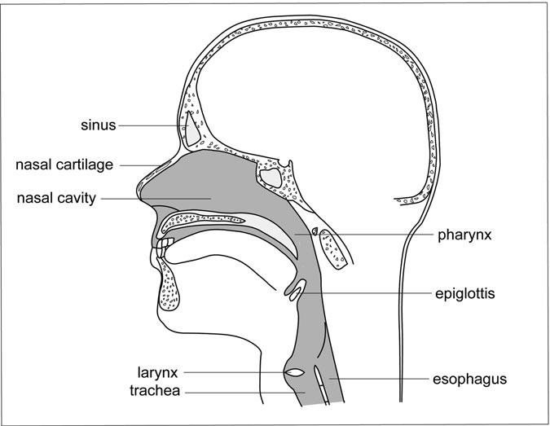

Figure 10.1 Upper Respiratory Tract. The upper respiratory tract, with the upper portion of the trachea and esophagus included. (Sandy Windelspecht/Ricochet Productions)

(2.5 centimeters) in diameter. In addition to serving as the primary passage- way of air into the lungs, the trachea contains mucus-producing epithelium to trap foreign particles. Cilia are also present to propel these particles upward toward the larynx for swallowing or expiration. As the lower end of the trachea enters the lungs, it branches off behind the sternum (breast- bone) into the left and right primary bronchi, which enter the left and right lung. Because the right bronchus is shorter, wider, and more vertical than the left bronchus, food usually enters the lower respiratory tract via the right bronchus when it bypasses the esophagus and “goes down the wrong pipe.”

##### Bronchi and Bronchioles

The primary bronchi are similar to the trachea in that they also have an epithelium lining and are supported by C-shaped cartilage. The ﬁnal por- tion of the respiratory system’s conductive segment, the primary right and left bronchi branch off further into increasingly smaller bronchi down to approximately 0.04 inches (1 millimeter) in diameter. These differ in construction from the primary bronchi in that their support comes from smaller cartilage plates embedded in the walls.

The complex system of bronchi that branches throughout the lungs is called the bronchial tree, which extends further and further into ﬁner “branches” that have less cartilage for support and more smooth muscle. These ultimately become bronchioles, which are approximately 0.02 inches (0.5 millimeters) in diameter. The division leads to terminal bron- chioles and then respiratory bronchioles. These tiny tubes, which further divide to form alveolar ducts that will end in air sacs called alveoli, are considered the ﬁrst structures that belong to the respiratory portion rather than the conductive portion of the respiratory system.

##### Alveoli

The respiratory bronchioles end in small grape-like clusters of alveoli (individually called alveolus), where the gas exchange between oxygen and carbon dioxide takes place (Figure 10.2). As bronchioles continue to divide, the number of alveoli increases. The average set of human lungs has approximately 600 million alveoli (300 million per lung), creating a respiratory surface in the vicinity of 750 square feet (about 70 square

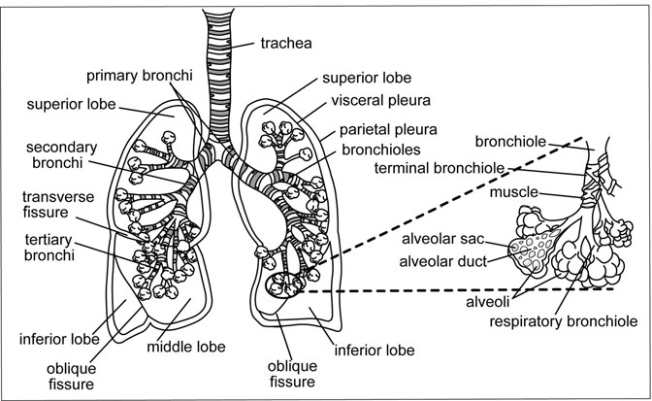

Figure 10.2 Lower Respiratory Tract. The major passages and structures of the lower respiratory tract. (Sandy Windelspecht/Ricochet Productions)

meters, which is about the size of a singles tennis court or a square about 27 to 28 feet long on each side).

Each individual alveolus is approximately 0.004 to 0.007 inches (0.1 to 0.2 millimeters) in diameter. Like tiny balloons, the alveoli inﬂate and deﬂate. Alveoli have thin, one-celled walls made of squamous epithelial cells (epithelial cells with a scaly outer layer) that are covered by an exten- sive network of ﬁne capillaries. Each single alveolus is surrounded by about 2,000 segments of capillaries, which have single-layered endothelial cell walls. Gas exchange occurs via diffusion (net movement of particles from a region of higher concentration to a region of lower concentration) between the thin walls of the alveoli and the capillaries. The blood-gas barrier, or respiratory membrane, has a thickness of approximately one- half of one micrometer (a micrometer is 1/1000 the thickness of a dime). The process involves oxygen passing from alveoli into capillaries for dis- tribution throughout the body, and carbon dioxide diffusing from the capil- laries into alveoli where the gas is eliminated through expiration.

A ﬂuid called a surfactant is produced by type II pneumocytes (spe- cialized cells that line the alveoli) and secreted in the alveoli to coat the walls and reduce surface tension or stiffness. Reduction of surface tension results in less pressure being needed to inﬂate the alveoli, which is espe- cially important at birth. Surfactant lining the alveoli also provides the moist surface necessary for gas exchange, because gas must dissolve in liquid before moving through cells. As a substance, surfactant has a half- life of 14 to 28 hours, meaning that it degrades very quickly and must be continually produced by the pneumocytes.

##### Lungs

The bronchial tree and alveoli course throughout the conical-shaped left and right lungs. In terms of volume, the lungs are one of the largest organs of the body, and the two lungs together weigh a total of approximately between 1.7 and 2.2 pounds (800 and 1,000 grams). They take up the majority of chest space (thorax), which comprises the space from the base of the neck to the diaphragm, upon which the lungs sit. The slightly larger right lung has three lobes (the superior, middle, and inferior lobes), and the left lung has two (the superior and inferior lobes). Deep ﬁssures, or crevices, on the lung’s surface deﬁne the separate lobes.

Each lung is enveloped by a transparent membrane called the pleura, which has an outer membrane (parietal pleura) attached to and lining the thoracic, or chest, wall and an inner membrane (visceral pleura) that tightly covers the lungs. Between the outer and inner pleural membranes, which are actually one continuous membrane that doubles back to cover both the chest and lungs, is a space called the pleural cavity. Inside this cavity is the pleural ﬂuid, which helps to reduce friction between the membranes during breathing when the lungs expand and contract and also helps hold both pleural layers in place, much like two microscopic slides that are wet and stuck together. The lungs are also encased by the rib cage, which provides protection from outside trauma. Between the right and left lungs is an area called the mediastinum, which contains the heart, trachea, esophagus, thymus, and lymph nodes. The heart separates the right and left lung, and the left lung’s smaller size includes a “cardiac notch” to pro- vide space for the heart to extend into.

##### Diaphragm and Intercostal Muscles

The diaphragm and the intercostal muscles are the ventilating mecha- nisms, or muscles, that allow the lungs to bring in and expel large volumes of air. At rest, we breathe 15 to 20 times a minute and exchange nearly 17 ﬂuid ounces (about 500 milliliters) of air with each complete breath in and out. The dome-shaped diaphragm is attached to the lower six ribs via a central tendon. The intercostal muscles line the rib cage, with the external intercostals running forward and downwards and the internal intercostals running upwards and back. Together, they form sheets that stretch between successive ribs. The diaphragm and intercostal muscles help the chest area and the lungs to expand and contract. During inspiration, the external intercostal muscles contract and lift the ribs up and out, and the diaphragm contracts. This process increases the size of the chest cavity and reduces air pressure inside the lungs compared to the air outside,

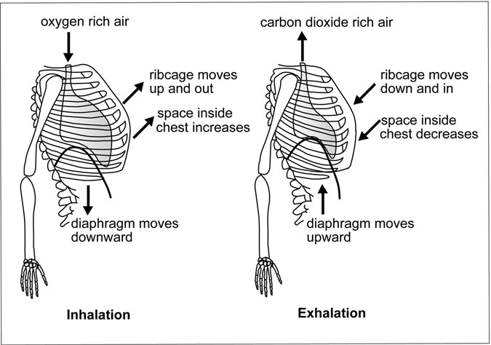

Figure 10.3 Inhalation and Exhalation. The movement of the diaphragm and rib cage during inhalation and exhalation. (Sandy Windelspecht/Ricochet Productions)

creating a vacuum that inﬂates and draws air (via the trachea) into the lungs. During expiration, the process is reversed, with the intercostal muscles moving the ribs downward and the diaphragm moving up creat- ing a smaller chest cavity that increases lung pressure and forces air out. The natural elasticity of the lungs helps return them to their normal vol- ume (Figure 10.3).

#### Development

The respiratory system begins to develop in the embryonic stage of life as cells start to divide. It continues postnatally (after birth) for at least two years and possibly for as long as 10 years. This multi-event process involves more than 40 different cell types that differentiate (specialize in structure and function) and proliferate.

Differentiated tissue for all the body systems and components develop from three primordial germ cell layers formed in the embryo during its early development. These are the ectoderm (outermost layer), mesoderm (middle layer), and endoderm (innermost layer) of the forming embryo. The respiratory system develops primarily from the mesoderm and endo- derm. The endoderm germ layer differentiates into the larynx, trachea, and lung, and ultimately the lining of the respiratory tract. The mesoderm gives rise to the vascular system necessary for transportation of oxygen, as well as to other connective tissues, lymphatics, bone, and cartilage throughout the body.

#### Respiration

We are taught at an early age that eating the proper foods is essential for good health. But without the respiratory system, the food we eat could not sustain us. The oxygen (O2) supplied by the respiratory system plays a fundamental role in enabling the body’s cells to turn food into life- producing energy.

Beginning with nearly 2 gallons (approximately 6 to 7 liters) of fresh air we breathe in every minute, the respiratory system inhales close to 3,000 gallons of air each day to acquire the oxygen necessary to fuel the metabolic processes that create energy from the carbohydrates found

in food. This energy enables the body’s cells to multiply and function. The process also results in the generation of the waste product carbon dioxide (CO2), which the respiratory system helps to eliminate. If we did not breathe in fresh oxygen, carbon dioxide would rapidly accumulate to toxic levels within the blood and result in death. As discussed earlier in this chapter, the process of bringing in oxygen from the atmosphere and eliminating carbon dioxide is called gas exchange.

Although the word respiration comes from Latin meaning “to breathe again,” respiration is much more than merely “breathing” air in and out. In the human body, respiration encompasses many processes, from the readily perceptible act of breathing to the hidden, complex metabolic machinery that continuously works within the body’s trillions of individ- ual cells. In terms of human biology, respiration operates on two basic levels. The ﬁrst is called organismal respiration and refers to the entire human body, or “organism,” taking in oxygen from the environment and returning carbon dioxide to it. The second is called cellular respiration and encompasses the metabolic activities that occur when the body’s cells use oxygen and food to generate energy and produce carbon dioxide.

##### Organismal Respiration

Organismal respiration involves four stages:

* *Pulmonary ventilation*: Movement of air in and out of the lungs
* *External respiration*: Gas exchange between the lungs and the blood
* *Internal respiration*: Gas exchange between the blood and the body’s cells (tissues)
* *Transportation*: Movement of oxygen and carbon dioxide through the body via the blood

Pulmonary Ventilation and the Mechanics of Breathing

The respiratory system’s function begins with the exchange of large volumes of air between the environment and the lungs via inspiration and expiration. This process is referred to as pulmonary ventilation. Although pulmonary ventilation primarily serves to bring oxygen into

the body from the atmosphere and as the ﬁnal stage of expelling carbon dioxide waste from the body, it is during this initial process that the respi- ratory system performs many of its functions secondary to gas exchange. Air is warmed and moistened as it enters the nose, which helps to maintain our body temperature. The respiratory system also ﬁlters out environ- mental pollutants, such as dust. For example, mucus secreted by goblet cells lining the airways and lungs traps particles, and then cilia sweep the mucus upwards from the throat for swallowing or expulsion via coughing. The respiratory system also helps to balance our body’s acid, or pH, levels through its role in regulating the elimination of carbon dioxide. Control of pH is essential for the proper functioning of enzymes, proteins, and other biological processes.

As with all the major systems of the human body, the respiratory sys- tem works in conjunction with other major systems. In the case of pulmo- nary ventilation, the nervous system exerts initial control over the breathing process, including the rhythm, rate, and depth of breathing. The message centers in the brain that control rhythmic respiration of breathing in and out are located in the brain stem and are called the pons and the medulla oblongata. These autonomic (or automatic) brain centers are more primitive than parts of the brain located in the cortex, which give us control over our movements and thoughts.

Whether we think about it or not, the pons and the upper portion of the medulla automatically regulate our breathing, which is why we can still breathe while we sleep. However, we can exert voluntary control over our breathing when needed. For example, we can hold our breaths for a certain length of time under water, or consciously make ourselves breathe faster or slower. The part of the brain that allows conscious control of breathing is located in the cerebral cortex.

During automatic respiration, speciﬁc neurons in the medulla and pons send signals to motor neurons in the spinal cord, approximately 10 to 12 times each minute (Figure 10.4). These nerve cells, in turn, signal the diaphragm and intercostal muscles surrounding the thoracic cage to contract, thus expanding the rib cage and lungs within it. When the lungs expand, pressure within the lungs becomes lower than the pressure in the atmosphere, causing air to rush in through the conductive portion of the respiratory system (nose, pharynx, larynx, trachea, and bronchi) until full

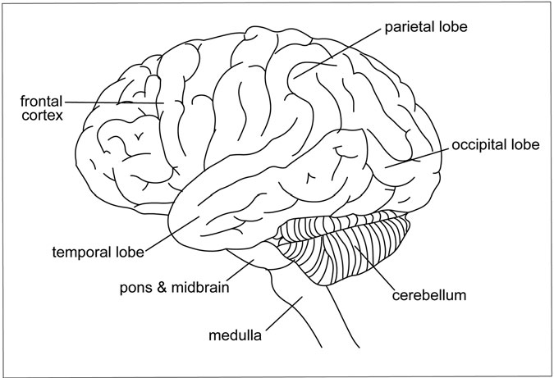

Figure 10.4 Respiratory Functions of the Brain. The location of the pons and the medulla, which are the parts of the brain that automatically control our rhythmic breathing. (Sandy Windelspecht/ Ricochet Productions)

expansion is reached. The air we inhale contains approximately 21 percent fresh oxygen and little or no carbon dioxide.

When the lungs are fully expanded, the vagus nerve tells the brain to “turn off” its signals for inspiration. As a result, the muscles surrounding the thoracic cage relax, moving the ribs back to their resting state. At this point, expiration is passive in that the brain and the muscles surrounding the lungs do not directly regulate it. The resulting decrease in chest cavity size contracts the lungs, causing us to exhale because the space available for air in the lungs is reduced. In other words, the air pressure in the lungs becomes higher than the pressure in the atmosphere. The resulting exhaled “stale” air is made up of about 16 percent oxygen and 6 percent carbon dioxide.

Although pulmonary ventilation is primarily automatic because we do not consciously control our breathing most of the time, the brain is

actually hard at work interpreting neurochemical information to control breathing, including monitoring respiratory volume and blood gas levels. Surprisingly, the primary stimulus for the brain to control breathing is not the amount of oxygen in the blood, but rather the amount of carbon dioxide. Chemical receptors, or chemoreceptors, in the medulla, in col- laboration with chemoreceptors in the carotid arteries and the aorta, respond to carbon dioxide levels in the blood. High carbon dioxide con- centrations result in deeper and faster breathing designed to bring in higher levels of oxygen and reduce harmful carbon dioxide levels. In turn, our respiration rates slow down when carbon dioxide levels are lower. However, oxygen levels can also affect respiration. When the aortic bodies and carotid bodies detect low levels of oxygen, they send signals to the brain stem to make breathing more rapid and deeper.

Other factors affect the brain’s regulatory function of respiration:

* An increase in blood pressure slows respiration.
* A sudden decrease in blood pressure increases respiration.
* A decrease in blood acidity (higher pH levels) increases respiration. (This state usually results from oxygen debt, or a lack of oxygen reaching the muscles, which produces lactic acid and lowers the pH level.)

Although some diseases can affect the body’s oxygen and carbon dioxide levels, these levels are most commonly affected by physical activ- ity. For example, hard work or exercise, especially when aerobic in nature, causes the body’s cells to metabolize faster to create more energy. More carbon dioxide is produced in the process and eliminated into the blood, thus lowering the blood’s pH level. As a result, during physical exertion, the body can increase oxygen consumption up to 25 to 30 times more than when the body is at rest.

External Respiration

External respiration is the exchange of oxygen and carbon dioxide between the lungs and circulating blood. Just as the respiratory system works in conjunction with the nervous system during pulmonary

ventilation, it also works with the heart and circulatory system to pump blood to the lungs during external respiration. This process is called pul- monary circulation. The movement of blood away from the lungs and heart to other parts of the body is called systemic circulation.

The amount of air we breathe in and out of the lungs during pulmonary ventilation is called tidal volume. Although we breathe in about one pint (around 500 milliliters) of air with each breath, approximately .32 pints (150 milliliters) of this air ﬁlls the passageways of the trachea, bronchi, and bronchioles. When ﬁlled with tidal volume air, these conductive portions of the respiratory system are referred to as anatomical dead space, meaning that the air remaining in this space is not involved in the external respiration process. The air that passes through the last conductive portions of the respiratory system enters the millions of alveoli in the lungs. It is here that external respiration takes place when oxygen and carbon dioxide are exchanged between air in the alveoli and the minute blood vessels called pulmonary capillaries that surround each individual alveolar sac like a net.

Every minute, 1.3 gallons (5 liters) of blood is pumped through the pulmonary capillaries and around the approximately 600 million alveoli in the lungs. The air-ﬁlled alveoli contain more oxygen compared to the blood in the capillaries. Conversely, blood in the capillaries contains more carbon dioxide than air in the alveoli. As a result, the exchange of oxygen and carbon dioxide between the capillaries and the alveoli occurs via dif- fusion across the microthin membrane walls separating the two.

The diffusion of all gases primarily depends on their solubility in water and their partial pressure, which expresses the concentration of a gas. The concentration, or diffusion gradient, of the gas is expressed in millimeters of mercury (mmHg). (For example, the partial pressure of oxygen would be expressed as pO2 # mmHg.) Because the random movement of oxygen and carbon dioxide molecules results in their net movement from a region of higher concentration to a region of lower concentration, the concentration or partial pressure of oxygen in the alveoli must be kept at a higher level than in the blood. Likewise, the concentration of carbon dioxide in the alveoli must be kept at a lower level than in the blood. These different levels are maintained because the continuous inspiration of fresh air supplies an abundance of oxygen

to the lungs and alveoli, while expiration eliminates carbon dioxide from the body into the air.

The blood carrying the carbon dioxide travels from all parts of the body into the heart’s right atrium and then into the right ventricle, where it is pumped into the pulmonary artery. This artery, which is the only artery in the body that carries deoxygenated blood, branches into the right and left lung, ultimately feeding blood into the pulmonary capillaries. Blood entering the capillaries surrounding the alveoli has a pCO2 of 45 mmHg and a pO2 of 40 mmHg. Conversely, the environmental air that has entered the alveoli during inspiration has a pCO2 of 40 mmHg and a pO2 of 100 mmHg. As a result, oxygen diffuses across microthin mem- branes into the blood from the alveoli, and carbon dioxide diffuses into the alveoli from the blood.

When a person exhales, the air in the alveoli is breathed out into the atmosphere along with the abundance of carbon dioxide that it now con- tains. Conversely, the oxygen-rich blood is pumped throughout the body via the systemic capillaries to the cells that make up various tissues. Overall, blood takes approximately one second to pass through the lung capillaries, during which time it becomes nearly 100 percent saturated with oxygen while losing all of its excess carbon dioxide.

Internal Respiration

Although internal respiration is sometimes used in the same sense as cellular respiration to refer to the metabolic process within the cells, it is most often used to designate the gas exchange process between blood in the capillaries and the body’s cells. Once the external respiration process is completed, the oxygenated blood travels from the alveoli to the heart’s left atrium. The blood moves to the heart’s left ventricle, then is pumped throughout the body via a network of arteries that feed the capillaries surrounding the body’s various tissues. As mentioned earlier, this is known as systemic circulation.

When the blood returning from the lungs reaches the tissues, it has a pO2 of 95–100 mmHg and a pCO2 of 40 mmHg. Conversely, the cells that make up our tissues have a pO2 of 30–40 mmHg and a pCO2 of approxi- mately 45 mmHg, depending on the metabolic activity within the cell. Again, since the diffusion of gases occurs from an area of higher

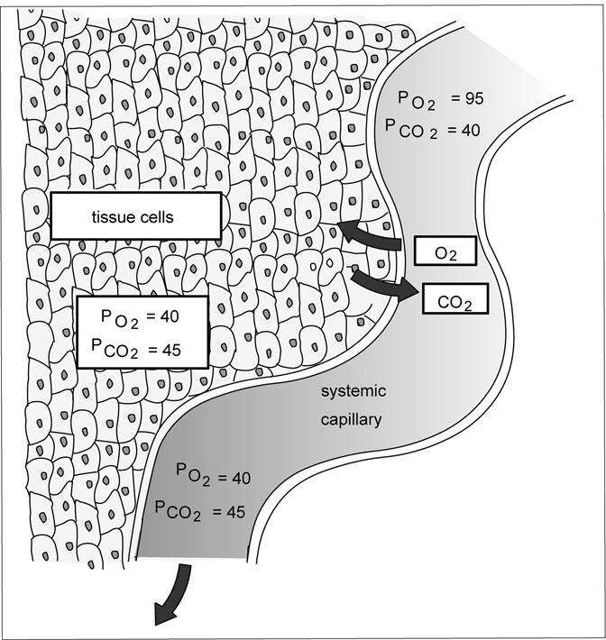

Figure 10.5 Gas Diffusion in Tissues. Oxygen-enriched blood (carried from the alveoli and the pulmonary capillary via the systemic capillaries) diffuses into tissue cells, which have a lower concentration of oxygen. At the same time, the higher concentration of carbon dioxide in the tissues diffuses into the systemic capillary for eventual transport to the alveoli. (Sandy Windelspecht/Ricochet Productions)

concentration to lesser concentration, oxygen from the blood diffuses across the interstitial ﬂuid (liquid found between the cells of the body) and into the cells, or tissues. Conversely, the carbon dioxide from the cells and tissues diffuses into the blood (Figure 10.5).

#### Transporting the Gases

The gas exchange process necessary for cells to function properly could not occur without the blood transporting oxygen and carbon dioxide throughout the body. This transportation depends on the gases’ distinct properties and on a blood component called hemoglobin, an oxygen carry- ing protein found in red blood cells called erythrocytes.

##### O2 Transport

Compared to carbon dioxide, oxygen is not very soluble. As a result, only about 0.01 ﬂuid ounces (0.3 milliliters) of oxygen will dissolve in every

3.4 ﬂuid ounces (100 milliliters) of blood plasma, which is not enough to carry sufﬁcient oxygen to the body’s tissues and cells. The majority of oxygen in the human body is carried via hemoglobin, which is the respira- tory pigment in humans and also gives blood its red color. Because of the afﬁnity of oxygen to hemoglobin, the oxygen-carrying capacity of blood is boosted nearly 70-fold to about 0.7 ﬂuid ounces (20.8 milliliters) per

3.4 ﬂuid ounces (100 milliliters) of blood.

Hemoglobin’s unique molecular characteristics make it an excellent transport molecule for oxygen. Each hemoglobin molecule includes four hemes, which are iron-containing porphyrin compounds, combined with the protein globin. Porphyrins are a group of organic pigments character- ized by a ringed group of four linked nitrogen-containing molecular rings (called a tetrapyrrole nucleus). In a heme, each porphyrin ring has an atom of iron (Fe) at its center. Each iron atom can unite with one molecule of oxygen. As a result, each hemoglobin molecule can carry four oxygen molecules. Furthermore, when one oxygen molecule binds to one of the four heme groups, the other heme groups change shape ever so slightly so that their afﬁnity increases for the binding of each subsequent oxygen molecule. In other words, after the ﬁrst oxygen molecule is attached, the next three oxygen molecules attach even more rapidly to form oxyhemo- globin (the bright red hemoglobin that is a combination of hemoglobin and oxygen from the lungs), thus providing rapid transfer of oxygen throughout the blood. Conversely, when it comes time for hemoglobin to “unload” its oxygen content into cells and tissues, once one heme group releases its oxygen, the other three rapidly follow.

Oxygen’s afﬁnity for hemoglobin is also affected by the partial pres- sure of carbon dioxide and the blood’s pH level. This is known as the Bohr effect, named after its discoverer Christian Bohr (1855–1911). A high concentration, or partial pressure, of carbon dioxide makes the blood more acidic, which causes hemoglobin to have less afﬁnity for oxygen. As a result, in tissues in which the concentration of carbon dioxide in the blood is high because of its release as a waste product from cells, hemo- globin easily releases oxygen. In the lungs, where blood carbon dioxide levels are low because of its diffusion into the alveoli, hemoglobin readily accepts oxygen.

The Bohr effect or shift, which relates to a mathematically plotted curve called the oxygen dissociation curve, serves an extremely useful purpose. During exercise, cells are working harder—more actively respiring—to produce more energy. As a result, they release much higher levels of carbon dioxide into the blood than when the body is at rest. The higher carbon diox- ide levels, in turn, reduce the blood’s pH level, thus acidifying the blood and signaling hemoglobin to release more rapidly the oxygen needed to replen- ish cells and tissues. In other words, the Bohr effect informs the body that its metabolism has increased due to exercise and that it must compensate for the increased need to absorb oxygen and release carbon dioxide.

##### CO2 Transport

Carbon dioxide enters the blood as a waste product of cell metabolism and cellular respiration. Unlike oxygen, carbon dioxide readily dissolves in blood. Carbon dioxide is transported by the blood to the alveoli in three ways:

1. As soluble CO2 in blood (5–10 percent)
2. Bound by hemoglobin (20–30 percent)
3. As a bicarbonate (60–70 percent)

Although carbon dioxide is more soluble than oxygen and dissolves directly into the blood after it diffuses out of cells, the amount that dis- solves is not enough to perform the essential function of ridding the body of carbon dioxide. In the second mode of transport, approximately a

quarter of the carbon dioxide eliminated from cells reacts with hemoglo- bin. In essence, carbon dioxide is able to hitch a ride with hemoglobin because, at this point, hemoglobin is not carrying much oxygen and has an increased afﬁnity for carbon dioxide. This is known as the Haldane effect and occurs as blood passes through the lungs. Blood proteins that bind to carbon dioxide are called carbamino compounds. When carbon dioxide binds to the hemoglobin’s protein, the combination is called car- baminohemoglobin.

The ﬁrst two methods of transporting carbon dioxide are relatively slow and inefﬁcient compared to the third method of transporting the gas. Because carbon dioxide is highly soluble, it reacts readily with water (H2O) molecules to form carbonic acid (H2CO3) in red blood cells. This reaction would also be too slow for efﬁcient carbon dioxide transport if not for an enzyme called carbonic anhydrase (CA), which is highly con- centrated in red blood cells and acts as a catalyst to help produce carbonic acid. The carbonic acid then ionizes (or disassociates) to form a positively charged hydrogen ion (H+) and a negatively charged bicarbonate ion (HCO3−). The chemical process can be viewed as follows:

+

CO2 + H2O

! H2CO3

! H + HCO3

Because the concentration of the negatively charged bicarbonate ions in the red blood cells is at a higher level than outside of these cells, these ions readily diffuse into the surrounding blood plasma for transport to the alveoli. To compensate for the negatively charged bicarbonate ions moving out of a red blood cell, a negatively charge chloride (Cl) ion enters the cell from the plasma to maintain the electrical balance in both the erythrocyte and the plasma. This exchange is called a chloride shift.

##### Cellular Respiration

Cellular respiration is the process by which cells use the oxygen delivered by the respiratory and circulatory systems to manufacture and release the chemical energy stored in food, primarily in the form of carbohydrates. As such, it is called an exergonic reaction, meaning that it produces energy. Cellular respiration produces energy via a catabolic process, that is, by making smaller things out of larger things. In cellular respiration,

it refers to the breaking down of polymers (large molecules formed by the chemical linking of many smaller molecules) into smaller and more man- ageable molecules.

The catabolic process within cells involves breaking down glucose, a simple sugar in carbohydrates that stores energy, into smaller molecules called pyruvic acid. These smaller molecules are ultimately used to produce adenosine triphosphate (ATP). ATP is the primary “energy currency” of the cell, the human body, and nearly all forms of life. Energy via ATP in cells is used to:

* Manufacture proteins
* Construct new organelles (subcellular structures that perform a role within each cell)
* Replicate DNA
* Synthesize fats and polysaccharides
* Pump water through cell membranes
* Contract muscles
* Conduct nerve impulses

Cellular respiration is the most efﬁcient catabolic process known to exist in nature. Although it occurs in every cell in the body, cellular respi- ration does not take place simultaneously in the exact same phases throughout all the cells. If the energy produced though cellular respiration was released simultaneously, the body would not be able to process all the energy efﬁciently, which would result in wasted energy. In addition, the impact of such a large amount of energy being released all at once could overload and damage cells. As a result, cellular respiration occurs at dif- ferent stages in the body’s various cells, even in cells that are close neigh- bors or side by side. ATP molecules act like time-release capsules; they release small amounts of energy to fuel various functions within the body at different times.

Overall, two primary processes occur in cellular respiration. The ﬁrst is the breakdown of glucose into carbon dioxide and hydrogen, known as

the carbon pathway. The second is the transfer of hydrogen from sugar molecules to oxygen, resulting in the creation of water and energy. The entire process of cellular respiration occurs in three primary stages:

1. Glycolysis
2. Krebs cycle (citric acid cycle)
3. Electron transport system

##### Glycolysis

Glycolysis, which comes from the Greek words glykos (“sugar” or “sweet”) and lysis (“splitting”), is the initial harvester of chemical energy within the body. It occurs in the cell’s cytoplasm and converts glucose molecules into molecules of pyruvate, or pyruvic acid. Unlike the other processes in cellular respiration, glycolysis does not require oxygen and is the only metabolic pathway shared by all living organisms. Scientists believe that this biological approach to producing life-giving energy existed before oxygen developed in the Earth’s atmosphere. It is the ﬁrst step in both aerobic (oxygen) and anaerobic (oxygen-free) energy- producing processes (see Sidebar 10.2).

Glycolysis is a multistep process, with each step being catalyzed by a speciﬁc enzyme dissolved in the ﬂuid portion of the cytoplasm called the cytosol. As with all biological processes, energy is needed to begin the process, and two ATP energy molecules initiate the reactions. This initial input of energy is called the energy investment phase, and occurs when ATP is used to phosphorylate, or add a phosphate to, the six-carbon glu- cose molecule. However, the process also yields energy in that further breaking down the six-carbon glucose molecule into two three-carbon pyruvic acid molecules ultimately results in a net gain of ATP molecules, as well as other energy molecules such as reduced nicotinamide adenine dinucleotide (NADH). However, glycolysis is extremely inefﬁcient. The entire process captures only about 2 percent of the energy that is available in glucose for use by the body. Much more energy is available in the two molecules of pyruvic acid and NADH produced during glycolysis. It is this potential energy that goes on to the next step, called the Krebs cycle.

SIDEBAR 10.2

#### Anaerobic Respiration

When we exercise, our bodies produce more energy and require more oxygen. However, our blood cannot always supply enough of the oxygen via respiration that the cells in our muscles need. Under these circum- stances, our muscle cells can respire anaerobically, that is, without oxygen, like some fungi and bacteria are able to do. Anaerobic respiration is also referred to as fermentation. However, cells in the human body can only respire without oxygen for a short period of time.

Like normal aerobic cellular respiration, anaerobic respiration begins with glucose in the cell, but takes place completely in the cell’s cytoplasm. Although ATP energy molecules are also produced this way, the process is extremely inefﬁcient compared to aerobic respiration. In the human body, the anaerobic process results in pyruvic acid being turned into the waste product lactic acid, as opposed to entering the mitochondria for further oxidation as it does in aerobic cellular respiration. It is the lactic acid in muscles that makes them stiff and sore after intense aerobic exercise, such as running.

##### The Krebs Cycle (Citric Acid Cycle)

Discovered by Hans Krebs (1900–1981), the Krebs cycle, also known as the citric acid cycle, is a cyclic series of molecular reactions that require oxygen to function. The cycle is mediated by enzymes that help create the molecules for the ﬁnal harvesting of cellular energy in the third and ﬁnal phase of the cellular respiration process. The Krebs cycle occurs in the matrix of the mitochondria, which are the powerhouses of cells. Although the mitochondrion is the second largest organelle in a cell after the nucleus, some cells may contain thousands of mitochondria from 0.5 to 1 micrometer in diameter. Unlike the energy-harvesting process of gly- colysis in the cytoplasm, mitochondria are extremely efﬁcient in taking energy from sugar (and other nutrients) and converting it into ATP. In fact, compared to the typical automobile engine, which only harvests about

25 percent of the energy available in gasoline to propel a car, the mito- chondrion is more than twice as efﬁcient—it converts 54 percent of the energy available in sugar into ATP.

After glycolysis is completed, the two pyruvate molecules that were formed enter the mitochondria for complete oxidization by a series of reactions mediated by various enzymes. As the pyruvate leaves the cyto- plasm and enters a mitochondrion, acetyl coenzyme A (CoA) is produced when an enzyme removes carbon and oxygen molecules from each pyr- uvate molecule. This step is known as the transition reaction.

The Krebs cycle begins as oxygen within the cells is used to com- pletely oxidize the acetyl CoA molecules. The process is initiated when each of the acetyl CoA molecules combines with oxaloacetic acid to produce a six-carbon citric acid molecule. Further oxidation eventually produces a four-carbon compound and carbon dioxide. The four-carbon compound is ultimately transformed back in oxaloacetic acid so that the cycle can begin again. Because two pyruvate molecules are transferred into the mitochondria for each glucose molecule, the cycle must be com- pleted twice, once for each pyruvate molecule. Each cycle results in one molecule of ATP, two molecules of carbon dioxide, and eight hydrogen molecules. The ATP molecules produced during this cycle can be used as energy. But it is through the cycle’s creation of the electron “carrier” coenzyme molecules NADH and reduced ﬂavin adenine dinucleotide (FADH2)—which are created when the coenzymes nicotine adenine dinu- cleotide (NAD) and ﬂavin adenine dinucleotide (FAD) “pick up” the hydrogen molecules—that the abundance of ATP is produced in the next stage of cellular respiration, the electron transport system.

##### Electron Transport System

Overall, the ﬁrst two processes in cellular respiration, glycolysis and the Krebs cycle, have produced relatively little energy for the body’s cells to use. Although both of these processes produce some ATP directly, the energy currency of ATP is created and cashed in for the big payoff during the electron transport system, also known as the electron transport chain. This process takes place across the inner membrane of the mitochondria called the cristae. A chain of electron receptors are embedded in the

cristae, which are folded to create numerous inward, parallel, regularly spaced projections or ridges. This design results in an extremely high den- sity of receptors, thus increasing the electron transport chain’s efﬁciency. The receptors are actually a network of proteins that can carry elec- trons and transfer them on down a protein chain. The process works like a snowball gaining speed as it rolls down a hill. As the NADH and FADH2 molecules produced during glycolysis and the Krebs cycle pass down the chain, they release electrons to the ﬁrst molecule in the chain and so on. Because each successive carrier in the chain is higher in electronegativity (that is, has a higher tendency to attract electrons) than the previous car- rier, the electrons are “pulled downhill.” During the process, hydrogen protons (H+) or ions from NADH and FADH2 are transferred along a group of closely related protein receptors that include ﬂavoproteins, iron-sulfur proteins, quinones, and a group of proteins called cyto- chromes. The cytochrome proteins in the electron transport system will only accept the electron from each hydrogen and not the entire atom. The ﬁnal cytochrome carrier in the chain transfers the electrons, which by this time have lost all their energy, to oxygen in the matrix to create the hydrogen-oxygen bond of water. This bond is another reason why oxy- gen is so important to the life of the cell. Without it, the molecules in the chain would remain stuck with electrons, and ATP would not be produced. Because of the second law of thermodynamics, the electrons passed down the chain lose some of their energy with every transfer from cyto- chrome to cytochrome. Some of the energy lost helps to “pump” hydrogen ions out of the mitochondria’s matrix into a conﬁned intermembrane space between the mitochondria’s inner and outer membranes. This energy for pumping the hydrogen ions is a result of a process called the oxidation- reduction reaction, or redox reaction. The reaction results in the mole- cules within the electron transport system alternately being reduced (gain- ing an electron) and then oxidized (losing an electron). The entire process establishes a buildup of hydrogen ions, resulting in a concentration, or dif- fusion, gradient—more hydrogen ions are pumped inside the conﬁned space between the mitochondria’s membranes than exist in the mitochon- dria’s matrix. As the concentration gradient increases, the ions begin to diffuse back through the membrane into the matrix to equalize the hyrdogen

ion gradient.

Hydrogen ion diffusion occurs through ATP synthase, an enzyme within the inner membrane of the mitochondrion. ATP synthase uses the potential energy of the proton gradient to synthesize the abundance of ATP out of the adenosine diphosphate (ADP) molecule and phosphate. This process is referred to as chemiosmosis. The formation of ATP is an energy storage process, and the energy is released when ATP is converted via the ATPase enzyme back into ADP (adenose bound to two phosphate groups) or to adenosine monophosphate (AMP—adenose bound to one phosphate group). All of these conversions are known as ATP phospho- rylation. ADP and the separate phosphates produced by the breakdown are then recycled into cellular respiration for the recreation of ATP. At the same time, the waste products carbon dioxide and water are eliminated via diffusion from the cell into the bloodstream and on through the organ- ismal respiratory process (Figure 10.6).

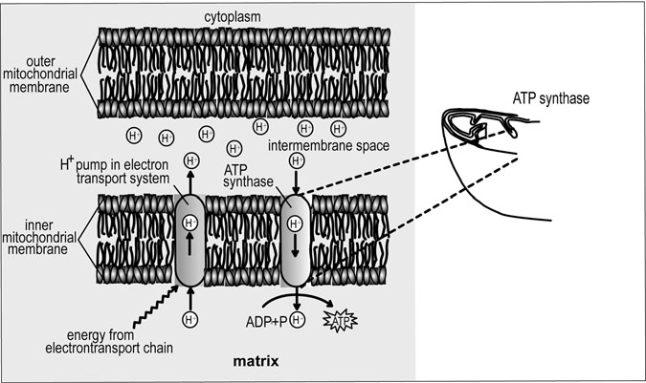

Figure 10.6 Synthesis of ATP. The buildup of hydrogen ions into the mitochondria’s intermembrane space via electron transport and the eventual transport of these ions back through the membrane, where they are used by ATP synthase to make ATP (the major source of energy for cellular reactions) out of ADP and phosphate. (Sandy Windelspecht/ Ricochet Productions)

#### Respiratory Problems and Diseases

Few people have gone through life without experiencing an acute (short but severe) upper respiratory infection, more commonly known as the common cold. Not only are colds the most prevalent infectious disease known, respiratory ailments and diseases as a group are more common than any other medical problem in humans.

Numerous factors can adversely affect respiratory functioning, from genetic inﬂuences and medical problems during infancy to overall health as we grow older. Even psychological well-being may impact respiratory health. For example, some cases of bronchial asthma have been linked to anxiety, and a sudden anxiety attack can lead to hyperventilation. Never- theless, environmental factors are by far the most common cause of respi- ratory ailments and diseases.

Because we breathe in approximately 16,000 quarts (over 15,000 liters) of air each day, our respiratory system is exposed to a continuous barrage of substances in the air that can affect the system’s functioning, from bacteria and viruses to pollutants caused by industry and automobiles. According to some estimates, a person inhales and ingests approximately 10,000 microorganisms per day. Although the respiratory system is designed to protect our bodies against this environmental onslaught, it is not always successful, especially in cases of overexposure to pollutants. Cigarette smoking, for example, is directly responsible for the over- whelming majority of lung cancer and emphysema cases.

##### Respiratory System Defense Mechanisms

The respiratory system has several features that help protect it from the pos- sible harmful effects of environmental particles and pathogens (viruses, bacteria, etc.) that can enter the system when we breathe. In the upper respi- ratory tract, the mucociliary (mucus and ciliary) lining of the nasal cavity is the respiratory system’s ﬁrst line of defense. Composed of tiny hairs lining the nose, this defense mechanism ﬁlters out the particles inhaled from the environment. The second line of defense is the mucus that lines the turbi- nate bones (scrolled spongy bones of the nasal passages) in the sinuses and collects particles that get past the nose. These defense mechanisms together trap larger particles from 5 to 10 micrometers in diameter.

As the air we breathe passes through the nose and nasal cavity, it enters the pharynx, where many particles also stick to the mucus on the back of the throat and tonsils. These captured particles can then be elimi- nated via coughing and sneezing. In addition, the adenoids and tonsils in the back of the throat help trap pathogens for elimination. These lymphoid tissues (tissue from the lymphatic system) also play an important role in developing an immune system response, such as the production of anti- bodies to ﬁght off germs.

The lower portion of the respiratory tract also has ciliated cells and mucus-secreting cells that cover it with a layer of mucus. These features work together with the mucus-trapping particles and pathogens, which are then driven upwards by the sweeping ciliary action to the back of the throat where they can be expelled.

Most of the upper respiratory tract surfaces (including the nasal and oral passages, the pharynx, and the trachea) are colonized by a variety of naturally occurring organisms called ﬂora. These organisms (primarily of the staphylococcus group) can help to combat infections and maintain a healthy respiratory system by preventing infectious microorganisms or pathogens from getting a foothold. This phenomenon is known as coloni- zation resistance or inhibition, and occurs because the normal ﬂora com- pete for space and nutrients in the body. Some ﬂora also produce toxins that are harmful to other pathogenic microorganisms. In rare instances, normal ﬂora can help cause disease if outside factors cause them to become pathogenic or they are introduced into normally sterile sites in the body.

Despite these defense mechanisms, pathogens and particles from 2 to

0.2 micrometers often make their way to the lungs and the alveoli. For exam- ple, most bacteria and all viruses are 2 micrometers or smaller. The alveoli, however, also have defense mechanisms to protect against microscopic invaders. In the case of the lungs, these mechanisms are primarily cellular in nature. For example, alveolar macrophages are a type of leukocyte that ingest and destroy invading organisms as part of the immune system’s response to infection (Figure 10.7). The ﬂuid lining the alveoli contains many components, such as surfactant, phospholipids, and other unidentiﬁed agents, that may be important in activating alveolar macrophages. Lymphoid tissue associated with the lungs also plays a role in defending against

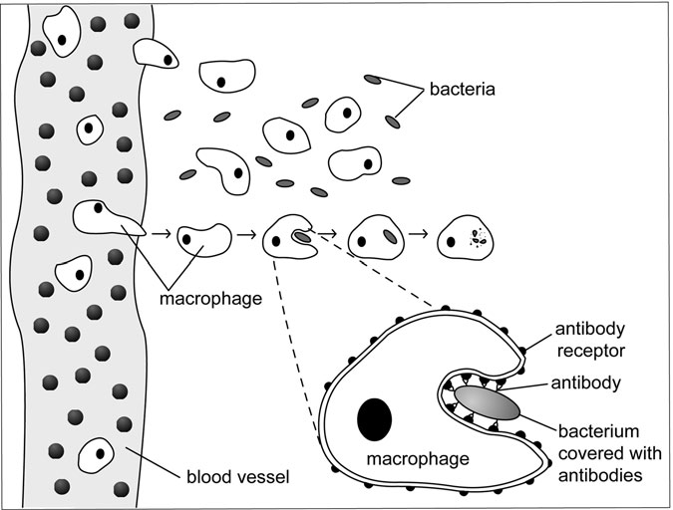

Figure 10.7 Macrophage. A macrophage, which means “big eater,” engulfs, or ingests, bacteria and other microbes. It does this by surrounding the particle to be eaten; then the macrophage’s membrane ﬂows together and the particle ends up inside. (Sandy Windelspecht/ Ricochet Productions)

infections by initiating immune responses. For example, immune system cells, such as B and T cells, represent a local immune response to ﬁght off infections by producing antibodies or activating macrophages.

##### Disorders and Diseases

While the respiratory system’s defense mechanisms are largely effective in battling infections, environmental pathogens can still cause problems when a sufﬁcient “dose” of an infectious agent is inhaled. For example, during cold and ﬂu seasons, a larger quantity of viruses and bacteria are alive and circulating in the air (see Sidebar 10.3). If they enter the

SIDEBAR 10.3

#### Viruses and Bacteria

Because bacteria and viruses cause many familiar diseases, especially in the respiratory system, people often get them confused or think that they are the same type of microbes. In fact, viruses are as different from bacteria as plants are from animals.

Bacteria have a rigid cell wall and a rubbery cell membrane that surround the cytoplasm inside the cell. Within the cytoplasm is all the genetic information that a bacterium needs to grow and to duplicate or reproduce, such as deoxyribonucleic acid (DNA), ribonucleic acid (RNA), and ribosomes. A bacterium also has ﬂagella so that it can move (see Figure 10.8).

Despite the minute size of bacteria, viruses are much smaller. Viruses are surrounded by a spiky layer called the envelope and a protein coat. They also have a core of genetic material, either in the form of DNA or RNA. Unlike bacteria, viruses do not have all the materials needed to reproduce on their own. As a result, they invade cells, either by attaching to a cell and injecting their genes or by being enveloped by the cell. Once inside the cell, they harness the host cell’s machinery to reproduce. Viruses eventually multiply and cause the cell to burst, releasing more of the virus to invade other cells.

respiratory tract and gain a foothold so that they overcome the body’s defense mechanisms and colonize respiratory tract surfaces, the individual will “catch” a cold or the ﬂu (Figures 10.8 and 10.9).

Not all respiratory system problems are caused by infections or envi- ronmental assault, such as pollution and cigarette smoke. For example, cystic ﬁbrosis is a genetic disease that can affect the respiratory system by producing an overabundance of thick mucus that can eventually close the respiratory system airways.

Respiratory problems and diseases, some of which are discussed in this chapter, focus on general respiratory ailments that primarily affect the upper respiratory tract. These include epistaxis (bloody nose),

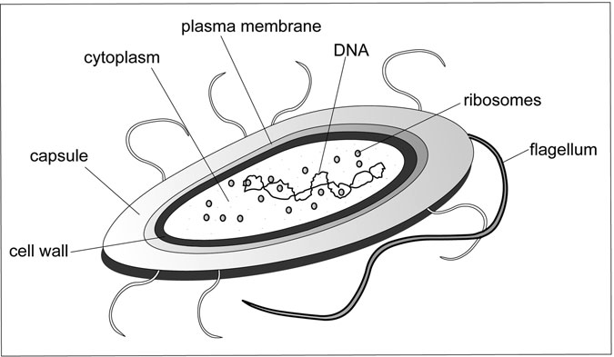

Figure 10.8 Bacterium. (Sandy Windelspecht/Ricochet Productions)

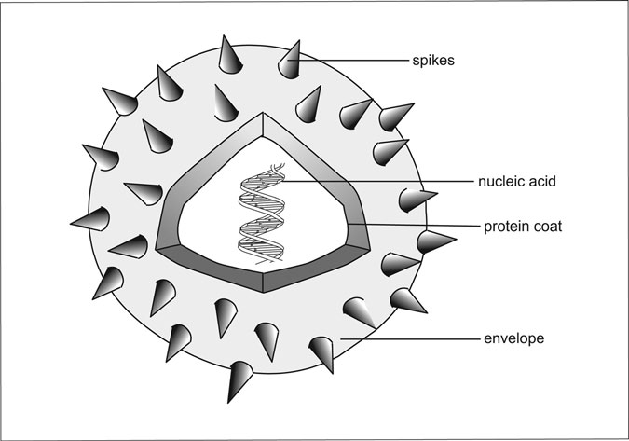

Figure 10.9 Virus. (Sandy Windelspecht/Ricochet Productions)

laryngitis, pharyngitis, rhinitis (also known as hay fever), sinusitis (sinus infection), sleep apnea, strep throat, tonsillitis, and upper respiratory infections (common cold).

Laryngitis

Inﬂammation of the larynx, or laryngitis, occurs when the vocal cords in the larynx become swollen or scarred. The vocal cords include a central bundle of muscles and various layers of connective tissue covered with mucosa. Any change in these layers can cause hoarseness, low voice, and scratchy throat.

Laryngitis results most often from a viral or bacterial upper respira- tory infection. It may also occur when the voice is strained or misused. For example, many people such as auctioneers and singers can develop laryngitis, and overenthusiastic yelling can strain the larynx. Cigarette smoke, dust, or other airborne pollutants are also causes of laryngitis. In rare cases, laryngitis may be linked to a more serious illness such as growths on the vocal chords, allergies, and Horner syndrome, which leads to laryngeal paralysis.

For the most part, laryngitis is temporary in nature, especially if the source is viral, and will heal within a week or so. Most chronic (long- term or frequently recurring) cases are due to continuous voice strain or exposure to environmental pollutants. However, severe cases can result in fever and other respiratory problems.

Rhinitis

Rhinitis is an inﬂammation of the mucous membrane lining the nose and the sinuses. The primary symptoms include a runny nose, sneezing, and nasal congestion, and may include itchy nose, throat, and eyes. Although rhinitis usually is not a serious problem in terms of impacting a person’s overall health, it is an irritating and uncomfortable ailment. However, many cases of allergic rhinitis, particularly when it occurs in children, can lead to various other complications, including chronic otitis media (ear infection), rhinosinusitis, conjunctivitis (eye infection), and sinusitis. Although there are many types of rhinitis, they are broken down into two main categories: allergic rhinitis (more commonly known as hay fever) and nonallergic rhinitis.

Although allergies come in many forms, allergic rhinitis is the most common allergic disorder known to medicine. It affects approximately 40 million people in the United States and results in an estimated 10 million lost days of school or work each year. For the most part, it occurs in people who are sensitive to airborne irritants called allergens, including pollen, dust, animal dander, fungus, molds, and grasses. However, allergic rhinitis can also result from allergic reactions to other substances.

In allergic rhinitis, allergens trigger the release of antibodies against the various allergens. These antibodies attach themselves to mast cells, a type of leukocyte or white blood cell that contains various inﬂammatory mediators, including histamines, prostaglandins, and leukotrienes. The mediators cause inﬂammation and ﬂuid production in the linings of the nasal passages and sinuses.

Although the symptoms of allergic rhinitis are identical to those of the nonallergic form, nonallergic rhinitis does not result from hypersensi- tivity to allergens. The many types of nonallergic rhinitis include infec- tious rhinitis, which is caused by an upper respiratory viral or bacterial infection; and eosinophilic rhinitis, which accounts for 20 percent of all rhinitis cases and produces elevated eosinophil (a type of leukocyte) counts in nasal samples, or smears. Scientists have not completely deter- mined its causes.

Sinusitis (Sinus Infection)

Sinusitis, or the common sinus infection, shares a strong resemblance to rhinitis in that it includes inﬂammation of the membranes that line the nasal passages. However, most sinusitis cases are due to an upper respira- tory infection and include inﬂammation of the paranasal sinuses. In acute cases of sinusitis, the most common causes are viral infections. Fungal infections can cause sinusitis as well, especially in people who have aller- gies to fungi. In fact, people who suffer from allergies and allergic rhinitis often develop chronic sinusitis. Growths called polyps may block the sinus passages and result in sinusitis in some individuals.

Approximately 37 million Americans each year suffer at least one epi- sode of sinusitis. The most common symptoms in sinusitis are a feeling of throbbing pressure and pain in the sinus areas as well as tenderness in the upper face caused by swelling in the nasal passages. This swelling results

in air and mucus getting trapped behind the sinuses, resulting in nasal con- gestion and blockage and sometimes by a mild fever. A runny nose, head- ache, and fatigue are also common symptoms.

Sleep Apnea

Apnea comes from the Greek word meaning “without breath.” Sleep apnea is characterized by a brief stoppage in breathing during sleep that can last from 10 seconds to over a minute and occurs as many as hundreds of times during the night. First described in 1965, sleep apnea is a common disorder that affects more than 12 million Americans.

The most common type of sleep apnea is obstructive sleep apnea, which occurs when the upper airways become blocked. This blockage usually results from the soft palate at the base of the tongue and the uvula (the small, ﬂeshy tissue that hangs from the center of the back of the throat) collapsing or sagging and partially or completely blocking the air- way during sleep. Overweight people often have this type of sleep apnea because of excess tissue in the airway. The other type of sleep apnea is central sleep apnea; it occurs because the brain fails to send signals to the breathing muscles (chest muscles and diaphragm) to make them work. People with sleep apnea begin breathing again because the brain senses lowered levels of oxygen and increased levels of carbon dioxide in the blood and alerts the body to arousal, that is, to wake up and start breathing again. As a result, people with sleep apnea do not get the same prolonged, restorative sleep as other people. People with sleep apnea will often snore or make choking sounds during the night and repeatedly wake up. This cycle may repeat during the day because the person is often tired from lack of sleep. However, not everybody with sleep apnea snores, espe-

cially those with the rare form of central sleep apnea.

Sleep apnea has many serious implications and consequences. One of the most common is increased sleepiness during the day, which hinders concentration and performance in such areas as work and driving a car. Untreated sleep apnea can also cause headaches and serious physical problems, including high blood pressure resulting from the heart pumping harder to make up for oxygen drops in the blood. Eventually, sleep apnea can lead to other cardiovascular diseases and increase risk for heart attack and stroke. A person’s memory and sexual functioning may also be

affected. Although sleep apnea can occur in anyone, it is most common in men. Overweight people and people who snore often are more likely to develop sleep apnea. Other risk factors include high blood pressure and physical abnormalities in the upper airways. Smoking and alcohol also increase the risk. Because sleep apnea sometimes occurs repeatedly in families, some cases may have a genetic cause.

Upper Respiratory Infections (Common Cold)

According to the National Institute of Allergy and Infectious Diseases, as many as 1 billion upper respiratory infections may occur each year in the United States. More widely known as the common cold, these infections can be caused by more than 200 different viruses. The primary viruses responsible for the common cold are called rhinoviruses (from the Greek word rhin, for nose), which cause an estimated 25 to 35 percent of all colds. (Rhinoviruses may be the main cause of colds because they grow best at 91.4°F or 33°C, which is the temperature of human nasal mucosa.) Other viruses that can cause colds include the myxoviruses (such as the inﬂuenza and parainﬂuenza viruses), coronaviruses, and adenoviruses. Bacterial agents cause approximately 10 percent of colds.

Viruses are transmitted or spread from person to person in several ways. Studies have shown that cold viruses reach their highest concentra- tion in the nasal secretions three to four days after infection, which means this is when the infected person is most contagious and likely to pass on the virus. One common way of catching a cold, or most viral or bacterial infections, is to touch almost anything that an infected person has also touched, sneezed on, or coughed on, from a doorknob to a telephone to their hands. (Some viruses, such as the human immunodeﬁciency virus, or HIV, cannot be caught in this manner.) After touching the surface, the virus can be transmitted to the body when the person then touches their nose or eyes, which have ducts that drain into the nasal cavity. Inhaling droplets in the air resulting from someone sneezing or coughing close to you is also a common way to catch a cold.

Viruses cause colds when they penetrate the nasal mucosa, after which they enter cells lining the nasal region and the pharynx. Rhinoviruses, for example, bind to a molecule much like a docking system in a space station. Speciﬁcally, they contain depressions on their protein shell, sometimes

referred to as “canyons,” that ﬁt onto surface protein receptors on the nasal cells known as the intercellular adhesion molecules, or ICAMs. This provides the portal for the virus to enter into the cell and begin replicating. It ultimately reproduces thousands of copies of itself, leading to cell disruption and release into the nose, where the infection is further spread to nearby nasal epithelial cells.

##### Lung Disorders and Diseases

The lungs are unique among internal organs because they are continu- ously exposed to the external environment. This direct interface with the outside world results in the lungs being assaulted by numerous sub- stances. As a consequence, the lungs are often the most likely organs to be affected by viruses and bacteria, allergy-causing pollen and dust, cigarette smoke, car fumes, and toxic chemicals from factories. Even a naturally occurring substance, like radon gas found in the soil and rocks, can harm the lungs.

Numerous diseases and conditions affect the lungs and impair their ability to provide the body with life-giving oxygen and rid it of carbon dioxide waste. Lung problems and diseases are usually classiﬁed accord- ing to three major categories, although many lung diseases, such as emphysema, often involve all three. They are:

• Obstructive lung diseases are those diseases in which the airways are narrowed or obstructed, thus decreasing the airﬂow.

• Restrictive lung diseases occur when the total volume of air that the lungs are able to hold decreases, usually as a result of a lost of elasticity in lung tissue or inability to expand the chest wall during inhalation.

• Diseases that affect the alveoli reduce their ability to diffuse oxygen into the blood.

According to the American Lung Association, lung diseases as a whole are the third-most prevalant killer in America and are responsible for one in seven deaths. Each year, approximately 335,000 Americans die of lung disease. Although lung diseases affect all kinds of people, minority

populations, especially African Americans, suffer from a disproportionate share of lung diseases, largely due to increased rates of cigarette smoking. Ironically, despite the toll that lung diseases take on a person’s health and the many deaths caused by them, a large majority of lung diseases could be prevented. For example, the number one cause of lung ailments

is smoking cigarettes, a decision that is up to each individual.

Asthma

According to some estimates, some 10–14 million Americans may suffer from asthma, with more than half of the cases occurring in children and teenagers. In fact, asthma is the most common chronic illness in child- hood. Asthma is sometimes referred to as “bronchial asthma” because it affects the bronchi, the small air tubes that branch off of the main bronchi and course throughout the lungs. The bronchi are surrounded by bronchial smooth muscle, which contracts or “twitches” as a defense mechanism in reaction to inhaled pollutants, irritants, and other factors. In the case of an asthma attack, these muscles essentially overreact to certain “triggers.” The combination of muscle contraction, or spasms, along with bronchial inﬂammation, swelling, and excess mucus production make the bronchial airways so narrow that the individual ﬁnds it hard to breathe, especially to exhale air. Asthma symptoms vary but usually include coughing or wheezing, shortness of breath, and a tightening in the chest.

Asthma is a serious condition and can be a medical emergency in cases of sudden, severe, and prolonged attacks. If the airways become totally blocked, respiratory failure, or suffocation, occurs because the body cannot get enough oxygen.

The triggers for asthma attacks vary from individual to individual. The most common causes are infections (primarily viral) and severe aller- gies to a wide variety of substances, from pollen and molds to house-dust mites and certain foods. Various irritants, like tobacco smoke and chemi- cal fumes and even cold air or exercise, can cause an asthma attack. In the case of exercise, rapid breathing through the mouth results in air bypassing the nose, which warms air entering the body. As a result, the air reaching the bronchial tubes is cold and triggers an attack in people who are overly sensitive to air temperature. Scientists have also shown that emotional factors like stress can trigger an attack or make it worse.

Chronic Obstructive Pulmonary Disease (COPD)

According to some estimates, approximately 16 million Americans suffer from chronic obstructive pulmonary disease (COPD). The disease, which is characterized by reduced airﬂow through the respiratory system, is the fourth-leading cause of death in the United States. By far, the primary cause of COPD is smoking tobacco. Other risk factors include exposure to dust and fumes (especially in the workplace such as mines), outdoor air pollution (associated primarily with people who smoke), repeated childhood respiratory tract infections, exposure to secondhand cigarette smoke, and some genetic deﬁciencies.

Although people with COPD often lead relatively normal lives for many years, COPD is a disease that progressively worsens over time. It is characterized by a chronic cough, spitting or coughing mucus, a loss of breath during exertion or exercise, and a growing inability to exhale air. COPD can encompass many conditions, including chronic asthma; the most common diseases associated with COPD are emphysema and chronic bronchitis.

Emphysema

Like chronic bronchitis, smoking is the overwhelmingly primary cause of emphysema. A deﬁciency of a protein known as alpha-I antitrypsin (AAT) can also lead to an inherited form of emphysema. Emphysema is the fourth- leading cause of death in the United States and has risen by 40 percent since 1982.

Emphysema does not affect the bronchial tree, but rather causes irre- versible damage to the alveoli that cluster in sacs at the ends of the bron- chial tree. Among the damages to alveoli are overinﬂated alveoli, which can fuse with other alveoli to form enlarged alveoli. As a result, the walls between alveoli are reduced in number, and so are the blood vessels that course throughout these walls. This reduction of alveoli walls and sur- rounding blood vessels results in less surface area to provide for proper gas exchange and oxygenation of the blood. In addition, the surfactant that lines the alveoli within the lungs is damaged, leading to a loss of elasticity so that “stale” air left in the lung is never completely replaced by fresh air. The alveoli can eventually collapse, which causes air to become trapped and results in a greater difﬁculty in expelling air.

Unfortunately, most people do not pay attention to their symptoms of breathlessness until they lose 50 to 70 percent of their functional lung tis- sue. In addition to the common symptoms of COPD, other symptoms associated particularly with emphysema include weight loss and an increase in chest size called barrel chest.

Cystic Fibrosis

Cystic ﬁbrosis (CF) is an inherited disease that affects the body’s exocrine glands, which produce mucus, tears, sweat, saliva, and digestive juices. Caused by a defective gene, CF changes the chemical composition of these secretions, transforming them from thin and slippery to thick and sticky. Speciﬁcally, the gene changes a protein that regulates salt (sodium chloride) movement in and out of cells.

Although CF can affect the liver, pancreas, and the reproductive sys- tem, the disease mostly affects the respiratory and digestive systems. In the digestive system, the abnormal mucus can impede the digestive process. However, the disease’s effect on the respiratory system is its most danger- ous manifestation. The abnormal accumulation of thick mucus in the lungs sets up a breeding ground for bacteria, leading to many respiratory infec- tions. It can also block the airways, and lung disease and respiratory failure are the usual cause of death. People with CF can also develop a collapsed lung, in which air leaks in to the pneumothorax (chest cavity).

Approximately 30,000 people in the United States have CF, which pri- marily occurs in white people of northern European ancestry. Between 2,500 and 3,200 babies are born with cystic ﬁbrosis each year in the United States. The CF gene is a recessive gene, meaning that two copies of the gene must be inherited, one from each parent. As a result, someone who inherits only one copy of the gene will not develop CF or any symptoms of the disease. However, they do carry the gene and can possibly pass it on, but the disease will manifest itself only if the gene-carrier has a child with someone who also carries the gene. One in 29 people in the United States is a carrier of the CF gene. If two “carriers” have a baby, the child has a 25 percent chance of getting CF and a 50 percent chance of being a carrier. There is also a 25 percent chance that the child will neither get the disease nor become a carrier.

The signs and symptoms of CF may vary, depending on what part of the body is most affected. In infants and young children, the most

common signs and symptoms include foul-smelling and greasy stools or bowel movements, weight loss, breathlessness, wheezing, a persistent cough with a thick mucus, and numerous respiratory infections. In infants, older children, and adults, the most common symptom is salty sweat. As a result, a standard test for determining whether someone has CF is the sweat test, which measures the amount of sodium and chloride in a per- son’s sweat. Most people with CF are diagnosed when they are infants or children. Other problems associated with CF include polyps (growths) in the nose, clubbing (enlargement and rounding) of the ﬁngertips and toes, cirrhosis of the liver, and delayed growth.

Inﬂuenza (“The Flu”)

Inﬂuenza, more commonly known as “the ﬂu,” is a contagious disease caused by the inﬂuenza viruses. Much like the common cold, inﬂuenza spreads from person to person in several ways. The primary mode of infection is when a person is near an infected person who coughs and sneezes, or the uninfected person touches something that an infected per- son has coughed on or touched.

Unlike the common cold, however, the ﬂu often causes severe and even life-threatening illnesses, including bacterial pneumonia. It also can exacerbate other medical conditions, such as asthma, diabetes, and con- gestive heart failure. Flu epidemics and pandemics have killed hundreds of thousands of people (see Sidebar 10.4). Even people with the ﬂu who do not suffer serious medical complications are much sicker than the common cold sufferer. In addition to the stuffy nose, sore throat, and dry cough that usually accompany a cold and the ﬂu, people with the ﬂu also suffer from fevers, headaches, body aches, and extreme tiredness.

Each year, approximately 10 to 20 percent of the people in the United States catch the ﬂu. The inﬂuenza viruses also kill an average of 36,000 Americans each year and hospitalize another 114,000. Inﬂuenza, aided by its major complication of bacterial pneumonia, is the sixth-most common cause of death in the United States.

The inﬂuenza viruses are broken down into three major categories: type A, B, and C. The type A viruses are the most common and found in both people and many animals, including birds, pigs, ducks, and horses. Although people can catch the virus from animals, the virus is rarely

SIDEBAR 10.4

#### The Flu Threat: Now and Then

In the summer of 2009, the World Health Organization (WHO) declared that a global pandemic of the H1N1 ﬂu (also known as the swine ﬂu) was underway. A pandemic occurs when there is an outbreak of a new inﬂu- enza A virus; there is little to no immunity to this virus in the human pop- ulation. This H1N1 outbreak is in addition to the seasonal ﬂu outbreak that typically affects approximately 10 to 20 percent of the population, according to the Centers for Disease Control and Prevention (CDC). The CDC estimates that there are approximately 36,000 ﬂu-reported deaths reported in the United States every ﬂu season, which is typically late fall to early spring. In addition, there were also conﬁrmed cases of H5N1 ﬂu (also known as bird ﬂu) outside of the United States—primarily in Asia, Africa, the Paciﬁc, Europe, and the Near East.

Flu refers to illnesses caused by a number of different inﬂuenza

viruses, and can have a wide range of symptoms and effects, from mild to lethal. This latest pandemic does not appear to have the impact of history’s other signiﬁcant inﬂuenza pandemic that occurred in 1918. That pandemic, called the “Spanish ﬂu,” resulted in an estimated 20 to 50 million deaths. In the United States alone, the Spanish ﬂu epidemic killed more than 500,000 people, including more U.S. soldiers than died in all of World War I. The ﬂu was so pervasive that it reached all areas of the world, including remote northern frozen tundra where it wiped out entire Eskimo villages.

The Spanish ﬂu had the ability to kill young and healthy adults, who in a matter of hours could develop fevers of 105°F and become so weak they could not walk. As the virus swept throughout the United States, fear became pervasive. Doctors were shocked when they performed autopsies on those who died and found a bloody and foamy liquid that entered the lungs in such quantities that it caused people to drown, or suffocate, in the mucus-like ﬂuid. Another ﬂu epidemic comparable to the Spanish ﬂu has not occurred since 1918. If such an epidemic occurred today, an esti- mated 1.5 million Americans would die.

In addition to the 2009 and 1918 pandemics, other pandemics have occurred. The “Asian ﬂu” pandemic of 1957–1958 caused 70,000 deaths

in the United States, and the “Hong Kong ﬂu” killed approximately 34,000 Americans in 1968–1969. Potential pandemics that never developed include the “Swine ﬂu” outbreak of 1976 and the “avian ﬂu” outbreak of 1997, in which 19 people in Hong Kong came down with a type of inﬂu- enza infection that was thought to occur only in birds.

The potential for a new ﬂu virus to emerge and result in a deadly epi- demic that can quickly become a pandemic is very real, especially because of the growing number of people who travel worldwide in a matter of hours. Scientists are constantly researching inﬂuenza viruses in an effort to develop better vaccines. In the United States, the CDC and local public health agencies also maintain surveillance systems that monitor such factors as weekly pneumonia and inﬂuenza deaths and overall inﬂuenza activity.

spread this way. Type A viruses are the causes of the most serious epidem- ics and pandemics. The inﬂuenza B virus is also very contagious and causes large epidemics, but the disease and its complications are much milder than those caused by type A viruses. The inﬂuenza C viruses are much more mild than either A or B viruses and are not believed to cause epidemics.

By far, the best approach is to avoid the ﬂu by getting a ﬂu vaccina- tion. Because ﬂu viruses change over time, different vaccines are devel- oped each year based on the viruses circulating at the time. Vaccines are made from killed, or deactivated, ﬂu viruses grown in chicken eggs. How- ever, even if a person receives a ﬂu shot, they can still catch the ﬂu because new strains of the virus may appear during the course of the ﬂu season, which is when most ﬂu cases occur because, it is believed, people are indoors more where they are in closer contact with other infected indi- viduals and breathing recirculated air. Nevertheless, the ﬂu vaccine usu- ally leads to milder symptoms and complications even when it encounters a new viral strain. The ﬂu vaccine can have side effects. Even though most of them are mild, certain people should consult their doctors and avoid vaccination, especially if they are allergic to chicken eggs, have previously had a serious reaction to a ﬂu shot, have a paralytic disorder such as Guillain-Barre´ Syndrome, or are currently sick with a fever.

Lung Cancer

Although lung cancer was a rare and virtually unknown disease in the United States prior to 1900, the incidence of lung cancer has been steadily rising in correlation with the growing popularity of cigarette smoking since the 1930s. Not only is lung cancer one of the most common cancers in the United States, it is the leading cause of death due to cancer in American men and women. In 2002, about 150,000 people died from lung cancer, and approximately 170,000 new cases of lung cancer are diag- nosed each year.

Lung cancer occurs when cells in the lungs begin to divide and grow abnormally. Once this process gets out of control, abnormal tissues called tumors are formed. Tumors can be either benign, meaning that they do not spread and are noncancerous, or malignant, meaning that they are cancer- ous and will continue to spread, often throughout the body.

Although many types of lung cancer occur, they are grouped into two primary categories called non–small cell lung cancer and small cell lung cancer. This division is based on how the cancer looks under a microscope,

SIDEBAR 10.5

#### Did You Know? Cigarette Smoking

Cigarette smoking is the single most preventable cause of premature death in the United States and accounts for one out of every ﬁve deaths, killing more than 430,000 people in the United States each year. Compared to people who do not smoke, men who smoke increase their risk of dying from lung cancer by more than 22 times and from chronic bronchitis and emphysema by nearly 10 times. Women, in whom lung cancer increased dramatically between 1960 and 1990, have a 12-times-increased risk of dying from lung cancer and a 10-times-increased risk of dying from chronic bronchitis and emphysema. Exposure to secondhand, or environmental, tobacco smoke also causes an estimated 3,000 deaths from lung cancer in American adults who do not smoke. Maternal smoking has also been strongly associated with adverse respiratory effects in children, and there is evidence that it even affects the child while it is in the womb.

and not because of the tumor size. Non–small cell cancer is the most common form of lung cancer and includes squamous cell lung cancer, adenocarcinoma, and large cell carcinoma. These cancers usually spread more slowly than small cell lung cancer, which is also more likely to spread to other parts of the body.

Smoking cigarettes causes most cases of lung cancer (see Sidebar 10.5). Cigar smoking also causes lung cancer, but not as often because people usually smoke fewer cigars and do not inhale cigar smoke as deeply. More than 90 percent of all lung cancer deaths are related to smoking tobacco and inhaling the more than 4,000 chemicals that tobacco contains, many of which are carcinogens. In addition, many lung cancer deaths are due to people being exposed to secondhand environmental smoke—that is, the smoke blown into the air by smokers. Not everyone who smokes gets lung cancer, and some people develop the disease because of other rea- sons, including exposure to radon, asbestos, and certain air pollutants and other substances. Lung diseases such as tuberculosis also increase the risk for developing lung cancer.

#### Summary

The respiratory system’s complex system of organs and tissues in the upper and lower respiratory tracts regulate the respiration process. The organs of the upper respiratory tract are the nose and nasal cavity or passage, the pharynx or throat, and the larynx or voice box. Located in the lower respiratory tract are the trachea or windpipe, the bronchi, the alveoli, and the lungs.

The breathing process starts when nerve impulses stimulate the breath- ing process, prompting air to move into and out of the lungs through nasal passage, down through the throat, and into the lungs. This air is ﬁlled with oxygen, and when it reaches the lungs, gas exchange occurs—oxygen is exchanged for carbon dioxide. Known as external respiration, this exchange occurs between the lungs and the blood. Now the blood is rich with oxygen, and the circulatory system transports this blood throughout the body’s tissues, where the exchange process repeats itself. This time, however, the exchange occurs between the blood and the cells, with the blood passing oxygen into the cells and carrying away carbon dioxide,

which will be pushed out of the body through the lungs. This is called inter- nal respiration. The third type of respiration is called cellular respiration, and is when oxygen is exchanged throughout the cells to perform varies functions.

One of the distinct characteristics of the respiratory system is that it is in constant contact with the outside environment, particularly the air. Because of this, it is exposed to substances such as bacteria, virus, and chemical pollutants. Therefore, a signiﬁcant number of diseases and disor- ders are associated with this system of the body, including inﬂuenza, asthma, and even lung cancer.

*This page intentionally left blank*

11

The Skeletal System

*Evelyn Kelly*

Interesting Facts

• Eighty bones protect the vital organs of heart, lungs, spinal cord, and brain.

• Children with broken bones heal much faster than adults. A bone that requires three to ﬁve months for healing in an adult will mend in four to six weeks in a child.

• The spinal column consists of a series of 26 individual bones, or vertebrae.

• Motorcycle accidents account for one injury to the skeletal and muscular systems in every 7,000 hours of biking; horseback-riding accidents account for one injury in every 2,000 hours of riding—three and one-half times more than motorcycling.

• About 6.8 million people seek medical attention each year for injuries involving the skeletal system.

• Throughout the day, the discs in the spine are squashed, making people shorter when they go to bed than when they wake up.

• Osteoclasts consume old and worn bone matter; osteoblasts manufacture new bone tissue. Both are important to good bone health.

547

• Sports medicine has been around since ancient times. To stay alive to ﬁght, warriors had to keep in top physical condition.

• Nearly 40 million Americans—or 1 in 7—have arthritis, including 285,000 children.

• The average person will walk about 115,000 miles during a lifetime; that accounts for more than four jaunts around the equator on the feet.

#### Chapter Highlights

• Skeleton system’s primary functions

• Different types of bones

• How bones move

• Protective functions of bones

• The axial system

• The appendicular system

• How joints, ligaments, tendons, and cartilage are vital to the skeletal system

#### Words to Watch For

Abduction Adduction Adipocytes Amphiarthroses Anterior Appendicular system Arthritis

Axial system Bipedal Bursa

Cancellous bone Collagen Compression Coronal plane Cortical bone Cuboid bones Diaphysis Diarthroses Dislocation Distal

Epiphysis Equilibrium Extension Flexion Fossa

Hematopoiesis Intracapsular

ligaments

Joints Lateral

Ligaments Medial Midsaggital plane Opposable thumb Osteology

Palmar Pituitary gland

Plantar Posterior Proximal Rotation Sagittal plane Sesamoid bone Superior

Symphysis Synarthroses Synolvial fluid Trabeculae Trabecular bone Transverse plane

#### Introduction

From ancient times, bones have fascinated human beings. In fact, bones are an integral part of ancient documents, literature, and art. The Hebrew Old Testament tells how God caused a deep sleep to come over Adam so that He could take one of Adam’s ribs to make woman. Adam recognized, “This is now bone of my bone” (Genesis 1:28).

In the second century, the Greco-Roman physician Galen (129–216?) told medical students in his book *On Bones* the importance of studying osteology. However, Galen was able to study only the bones of animals and criminals who had not been buried. Human dissection was not permit- ted at that time.

Bones have often appeared as a symbol of danger or death. In the 1500s, pirates who plundered and terrorized ships and coastal towns hoisted ﬂags bearing a skull and crossbones. The same symbol was at one time printed on labels of poisonous materials or used to mark hazard- ous places.

Throughout history, bones were associated with death because bone was considered to be dead. In fact, the word skeleton comes from the Greek word skeletos, meaning “dried up.” It was not until the awakening of scientiﬁc investigation in the eighteenth century that an English sur- geon, John Hunter (1728–1793), discovered that bone is living, dynamic, and changing.

This chapter will explore this living and dynamic system, from its function to its anatomy.

##### Functions of the Skeletal System

A formless jellyﬁsh ﬂoats on the water, wafting back and forth with the wind and waves. Without bones, human beings would be just like this creature—gigantic, massive blobs that would move only by inching along the ground. Without bones, we would not be able to stand up straight, run, do handsprings, or even hear.

The skeleton provides shape and support to all the other body systems. In addition, it allows movement, protects body tissues and organs, stores important materials, produces valuable blood cells, and holds a record of our past development, diet, illnesses, and injuries.

Providing Shape and Support

In the human body, 206 bones are intricately arranged to keep the body upright. The skeleton is both rigid and ﬂexible, enabling internal organs to defy the forces of gravity. The unique architectural plan makes the scaffold on which other body parts are hung and supported. One could even say the human being is a model of architecture and design. In fact, Marcus Vitruvius (ﬁrst century BCE), an ancient Roman architect and engineer, advised his students who were designing symmetrical temples to study the human body because when a person’s arms and legs are extended, he or she can touch a square with four corners and form a perfectly circular arc.

##### Body Plan

Compared with the nearest related primate, the gorilla, Homo sapiens is completely erect. Although the skull is at one end of the body, it functions as the center and main point of reference. As with any well-designed structure, form follows function. The classical anatomical form of Homo sapiens is standing erect, head straight, facing the observer, with arms at the side and palms facing forward. A midline perpendicular to the ground divides the body into left and right halves. This line represents the sagittal plane. A transverse plane runs parallel to the ground or ﬂoor.

To understand and read anatomy, one must be familiar with words that describe the positions of the body plan (Figure 11.1). The following terms

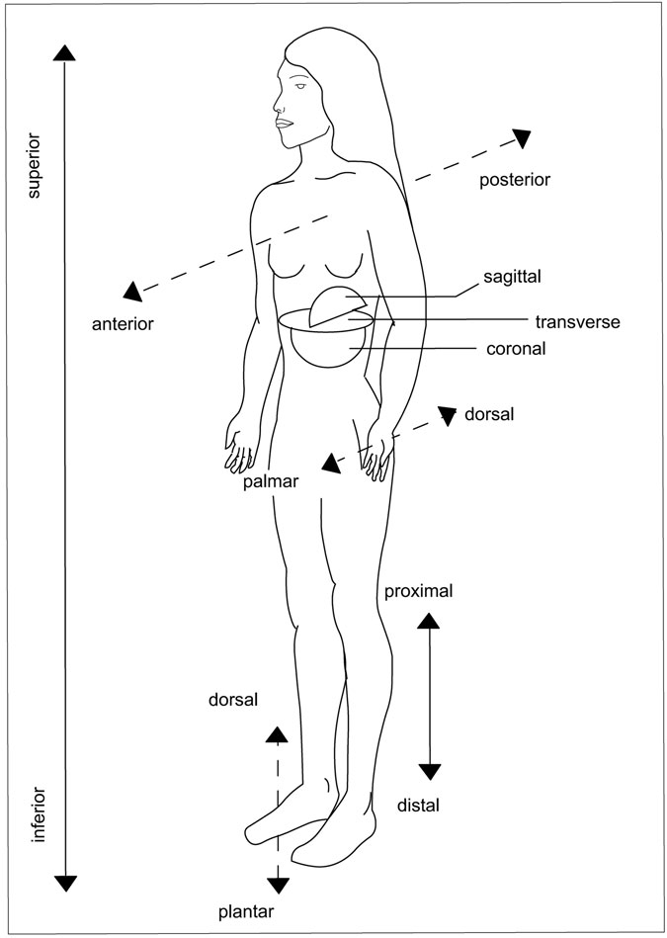

Figure 11.1 Planes. (Sandy Windelspecht/Ricochet Productions)

deﬁne the relationship of shape and support that create the framework of Homo sapiens:

• Superior indicates toward the head; inferior indicates away from the head.

• Anterior refers to the front part of the body or body part; posterior

refers to the back of the body or body part.

• Medial indicates toward the midline; lateral indicates to the side away from the middle.

• Proximal indicates closer to the torso; distal indicates farther away from the torso. For example, the hand is distal to the forearm because it is farther away from the torso than the arm.

• Palmar indicates the palm of the hand; dorsal indicates the back of the hand.

• Plantar indicates the sole of the foot.

• Coronal plane divides the body into front and back portions.

The entire skeletal structure works together to manage the forces created by the upright position. When prehistoric animals walked on all fours, their back legs formed a right angle with the spine. The dog and cat reﬂect this general design. In the chimpanzee, which walks in a semi-upright position, the legs form less than a right angle. The upright position of the human causes the legs to form a straight line that runs through the backbone, the pelvis, and down each leg. When walking, as a leg on one side swings back, the arm on the same side swings forward. When taking a step, the opposite happens. The alternating movement keeps the body weight right in the center. When a person uses two feet, the stresses of walking, running, and jumping are calculated with precision. For example, when a person stands up, the hip takes half of the body weight, and the pull of stabilizing muscles can multiply this weight six times. When a person runs or walks, each hip alternates carrying the full body weight. Bones are extra strong at

joints where large compression forces are generated.

The cranium and vertebrae support the brain and spinal cord. Whereas the cranium, or skull, shapes and supports delicate brain structures, the spine is the literal “backbone” of the human body. It forms a supporting rod for the head, arms, and legs. In other mammals, the spine is a horizon- tal girder taking the weight off the chest and abdomen of animals that move on all fours. When the human spine is viewed from the side, an S-shaped curve is visible; this curve aids in balancing parts of the body over the legs and feet when standing. The chain-link arrangement of the vertebrae allows only a small amount of movement for each link; but when all the individual movements are added up, the spine is capable of making large, complex shapes and contortions. The S-shape helps bring the centers of gravity of the head, arms, chest, and abdomen above the legs. Thus, the body as a whole is well balanced.

##### A Framework of Different Shapes

Each bone is designed to support, protect, and shape the body. For exam- ple, relative to body size, the human skull protects one of the biggest brains in the animal world. The features of different bones allow for efﬁ- cient form and function. Bones may be classiﬁed by shape.

Long Bones

Like tubular furniture, the tubular structure of long bones makes them both strong and light. The outer shell of bone is made of compact corti- cal bone. The spongy center has little trabeculae, or beams, that act as strengthening girders of cancellous bone. The inner casing of trabecular bone is arranged along lines of force with calciﬁed ﬁbers as they transmit the force into tendons, the ﬁbrous bands that join muscles to bones. Bones are thickest in the middle to support areas where forces are strongest. Weight for weight, bone structure is stronger than that of a solid rod. The lower extremities of bones are longer and stronger than the upper extrem- ities. The purpose of the long bone of each leg, the femur, is to provide form and support and create an interconnected set of levers and linkages that allow movement.

Short Bones

Found in the wrist and ankle, these spongy, cuboid bones (shaped like cubes) are covered with a thin layer of compact bone. This arrangement permits shock absorption, movement, elasticity, and ﬂexibility.

Flat Bones

These bones in the ribs, the crest of the hip, the breastbone, and the shoulder blade are sandwiches of spongy bone between two layers of compact bone. They protect and provide attachment sites for muscles.

Irregular Bones

Bones of the skull, face, vertebrae, and pelvis, as well as others that do not ﬁt into another category, are referred to as irregular. Usually consisting of spongy bone with a thin compact bone exterior, they support weight and dissipate loads.

Sesamoid Bones

These are short bones embedded within a tendon or joint capsule. An example is the patella (kneecap), which allows the angle of insertion of a muscle to be altered.

The type of support provided by the bones reﬂects gender differences. Although men and women have the same number of bones, women’s skel- etons are lighter and smaller. Women’s shoulders are narrow whereas their hips are broad and boat-shaped to accommodate a growing fetus. In men, proportions are reversed: broad shoulders and slim hips.

Allowing Movement

The skeletal system is an engineer’s dream of a moving machine. “Mechanical science is of all the noblest and most useful, seeing that by means of this all animate bodies which have movement perform all these actions,” said Leonardo da Vinci (1452–1519). Combining art and anatomy, he was one of the ﬁrst to study how the interaction of the skeletal and muscular systems allows bodily movement.

Many parts of the skeletal system help the body to move. Tendons con- nect muscle to bone; ligaments connect bone to bone. Bones meet each other at joints. Muscles cause movement at joints by working in pairs.

When one muscle contracts, the other extends. For example, the contrac- tion of the biceps muscle in the front of the upper limb (humerus) and the relaxation of the triceps muscle behind this bone cause the elbow to bend. When the triceps contracts and the biceps relaxes, the arm straightens.

Rigidity of the bones allows for movement. The attached muscles at the joint permit freedom of movement in a variety of planes and in almost any direction.

Scientists are slowly learning more about how the human machine works. The ﬁeld of bioengineering combines engineering principles with the anatomy of the living body to understand how movement occurs. For example, in a procedure called gait analysis, subjects are ﬁtted with diodes, or electronic sensors, that send out pulses of infrared rays of light as the subjects walk a prescribed route in the laboratory. Cameras sensitive to the emitted light follow the walkers’ trails and record the positions relative to a ﬁxed background. The cameras shoot as many as 315 frames per second. When this information is analyzed on a computer, a three- dimensional picture reveals if the person has problems with walking that arise from a skeletal deformity.

##### Bones as Levers

The science of physics is very important to human anatomy. Each time a person moves, the laws of physics come into play. The mechanics of movement integrates the laws of physics into biology. The skeleton is ﬁrst and foremost a mechanical organ because one of its primary functions is to transmit forces from one part of the body to another. The tissues must bear loads without being damaged, and the skeleton must withstand very high forces because muscles can contract only a small percentage of their length. With the help of muscles, the bones pull and push, creating the action of a lever (Figure 11.2). The term fulcrum refers to the point of support at which a lever turns in raising or moving something. This is the pivot point of the lever.

The underlying principle of physics that every machine reﬂects is the conservation of energy. Thus, to simplify movements, levers save rather than spend forces. Moreover, the lever is one of the simplest machines. At the same time work (force) is exerted on one end of the lever, the other

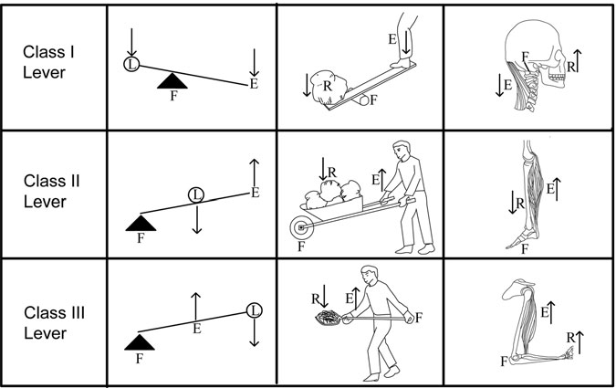

Figure 11.2 Levers. (Sandy Windelspecht/Ricochet Productions)

end moves the load. In the human body, muscles and bones function as one of three types of levers.

Class 1 Lever

In this class, the fulcrum is between the force and the load. A seesaw on a playground is an example. When force is exerted at one end, the load (the child) at the other end is lifted. In the human body, an example of a class 1 lever is the arm bending at the elbow. The elbow is the fulcrum. Contrac- tion of the biceps muscle exerts force; the mass of the forearm bone is the resistance force. Another example is the head raising to look up. Muscles in back of the neck contract; bones of the face resist.

Class 2 Lever

In this class, the load is between the effort force and the fulcrum. For exam- ple, exerting force on a long steel bar placed under an automobile frame lifts the car. Raising the foot to stand on tiptoe is an illustration in the human body. Gliding joints at the ankles, or tarsals, provide the fulcrum.

Pushing down on the shin bone, or tibia, and the other leg bone, the ﬁbula, provides resistance, while contracting the soleus muscle in the calf of the leg provides the effort force.

Class 3 Lever

In this class, the fulcrum is at one end and the load is at the other end, with the effort force applied between. In the human body, the fulcrum is the elbow and the load is the hand. When the biceps move the hand, they func- tion as a class 3 lever. This type of lever increases distance at the expense of force. When the biceps muscle moves a short distance, the hand moves a greater distance. The input and output forces are on the same side of the fulcrum and have the same direction.

##### Motion through Levers

How all these parts work together is demonstrated by a biomechanical mar- vel, the knee. The knee bone, or patella, hangs free from the center of the body and bends, glides, and rotates with the stresses that motion puts on it. Although 4 major ligaments and 13 muscles support it, the knee is the most vulnerable of all joints because outside forces may displace these structures. When a person takes a step, the ligaments and muscles contract, relax, twist, and turn. Two long bones, the thigh and shin, sit between a piece of shock-resistant cartilage called meniscus. The crescent-shaped meniscus

cushions and absorbs the shock of movement when walking or running.

To understand this function of movement, one must know several terms related to the action of bones and joints:

• Flexion involves bending or decreasing the angle at the joints. When the calf bends back toward the thigh, ﬂexion occurs. When a bodybuilder ﬂexes his muscles, he changes the angle of his bones at the joints.

• Extension is the opposite of ﬂexion, with bones straightened to a 180- degree angle—a straight line.

• Rotation involves turning a body part on an axis. Just as the earth turns, the entire body may turn. However, a single body part (such as an arm or leg) cannot turn in a complete circle of 360 degrees because doing so would tear tissues such as blood vessels and nerves.

• Abduction involves drawing away from the midline of the body. Lifting up the arm at the shoulder joint moves it away from the body.

• Adduction involves moving toward the midline or trunk. Dropping the arm at the shoulder joint moves it back toward the body.

##### Protecting Tissues and Organs

The skeletal system protects the tissues and organs from the hard knocks of life. Although tremendous forces are constantly bombarding human bodies, bone is one of the strongest materials that nature has devised. One cubic inch can withstand loads of up to 20,000 pounds, which is about four times the strength of concrete.

The cranium, or skull, protects the soft, delicate brain, which has the consistency of custard. The strong cranial case, which has an internal volume of about 2.5 pints, contains the organ that acts as “chief executive ofﬁcer” of the body by controlling information from the outside world and responding to this information. Also protected are the organs of sight, hearing, smell, and taste. Eyes are set in sockets in the skull to stabilize the delicate structures. The delicate middle and inner ear not only are sur- rounded by bone, but have three tiny bones that transmit sound. Through the bony recesses of the nose, air with vital oxygen passes on the way to the lungs. The jaws and teeth crush nourishing food on the way to the digestive system.

Attached to the cranium is the vertebral column, which consists of a series of small bones, stacked on top of each other like a tower of spools. Large holes in the vertebrae line up to form a bony tunnel or canal. Nerves enter and leave the tunnel through gaps between neighboring vertebrae. Together, the vertebrae protect the delicate spinal cord, the important message cable between the brain and the other body parts. In front of the spinal cord, the rib cage and breastbone protect the heart, lungs, and part of the digestive system.

##### Producing Blood Cells

When a person gets a cut, a red ﬂuid comes through the wound in the skin that contains red blood cells manufactured in the bones. Whenever there is

a risk of infection or even a common cold, the body’s defenders—white blood cells—are also made by the bones.

Indeed, an important function of the skeletal system is the production of blood cells. Marrow is a Latin word that means “middle”; hence, bone marrow is located in the middle, spongy part of bone. There are two types of marrow: Red marrow produces red blood cells, or erythrocytes and white blood cells or leukocytes; yellow marrow produces fat cells, or adipoctyes. Red bone marrow is the site of hematopoiesis, or blood cell forma- tion. In the adult human, this production takes place in bones such as the vertebrae, sternum, ribs, and pelvis and also at the ends of the upper arm (humerus) and the upper leg (femur). Red cells in the marrow make a substance called heme, which is an iron-containing nonprotein portion of hemoglobin, the red part of the erythrocyte. Hemoglobin contains iron and carries oxygen from the lungs to tissues. About 175 billion red cells per day are made and released according to the demands of the body. The red marrow also produces white blood cells. About 70 billion per day of these important cells are needed for the body’s defense. Also, about 175 million platelets per day are produced. These blood cells are impor- tant for clotting. According to demand, the system may increase produc-

tion ﬁve- to tenfold.

In newborns, red bone marrow ﬁlls in most marrow cavities. In older adults, much of the red marrow has been converted to yellow marrow. Long bones are ﬁlled with yellow marrow, which is mostly fat. In certain conditions like anemia, which occurs when there is a shortage of oxygen-carrying red blood cells, yellow marrow can be converted to red marrow for the manufacture of more red blood cells.

##### Storing Materials

The bones are keepers of the minerals calcium and phosphorus. Deposited minerals account for about 50 percent of a bone’s volume and 75 percent of its weight. In fact, 97 percent of the body’s calcium is stored in bone.

Not only does the skeletal system store minerals, but it acts as a reser- voir that maintains the equilibrium, or balance, of calcium and phosphorus in the bloodstream. Calcium homeostasis is very important for bodily func- tions. For example, too many calcium ions, or charged particles of calcium

atoms, in the bloodstream can cause heart attacks; too few can cause respi- ratory problems. In the bones, these substances are available for rapid turn- over when needed. For example, in pregnancy, a growing fetus has a high demand for calcium. Storage in the bones makes available an extra supply. Likewise, after menopause, when menstrual activity ceases, changes in hormones may impair a woman’s calcium and phosphorus levels, causing the minerals to leach out and leaving brittle, osteoporotic bones.

Many hormones play a role in this storage system. These include estrogen, testosterone, thyroid hormone, adrenal gland hormones, insulin, and growth hormone.

##### Giving Clues to the Past

The skeleton’s durability is staggering. Even after death, it has many uses. Archaeologists, anthropologists, and forensic scientists can glean valuable information from bones as to what happened in the past. For example, fossils (bones that have turned to stone) offer a broad outline of how the human face evolved. Fossils of Australopithecus, the Southern Ape that existed 2 to 3 million years ago, can be compared to those of Homo sapiens neandertha- lensis, or Neanderthal Man, of 100,000 years ago. Both of these can be com- pared to the ﬁrst Homo sapiens, or Thinking Man, who lived 40,000 years ago. Gradually, the face became ﬂatter, the teeth smaller, the chin less pro- truding, and the forehead more domed to house a larger brain.

Bones also tell the story of humans’ adaptive mechanisms to the envi- ronment over time. Bones often survive the process of decay and are important in the following ways:

• They provide evidence of fossil man.

• They form the basis of racial classiﬁcation in prehistory.

• They give information about culture and people’s worldview.

• They are major sources of information about ancient disease and causes of death.

• They help solve forensic crimes by providing evidence to detectives.

The human skeletal system is a marvel of mechanical and architec- tural design. It is intricately structured to keep the body straight and upright, but ﬂexible enough to permit great freedom of movement. It is strong enough to protect vital organs while also producing blood cells and storing and regulating minerals. As a source of data, bones have made possible the study of the evolution, history, and culture of Homo sapiens.

#### Bones of the Central Skeleton: The Axial System

Osteology—the study of bones—is important to many scientiﬁc disciplines, including archaeology, physical anthropology, geology, paleontology, anatomy, medicine, and forensics. In fact, knowledge of the framework of the skeleton is essential not only for scientists, but also for lay people. How the body’s framework functions is essential to developing good health habits and care of the skeletal system.

The sturdy scaffold of the human body is made up of 206 bones. Softer tissues and organs are attached to this structure. Actually, the skel- eton, directly or indirectly, supports or connects to all body parts. Bones are grouped into two categories: the axial skeleton and the appendicular skeleton. This section discusses the axial skeleton; bones of the skull, vertebral column, ribs, and breastbone.

##### Special Bone Structures

Some structures are important in understanding both the axial and the appendicular skeletons. These structures include sutures and processes.

Sutures

During birth, a baby’s head is squeezed as it passes through the birth canal. In order for the baby to be born safely, its skull is not solid bone. A membrane covers the areas where the skull bones have not yet grown together. The structures known as fontanels, or soft spots, allow the bones of the skull to mold, slide, and overlap to minimize danger to the delicate brain during birth. These soft areas disappear completely by age 2, closed by structures called sutures.

Sutures could be referred to as bone zippers as they occur where the bones of the skull come together along serrated and interlocking joints. The areas appear as irregular gaps before the age of 17 but grow together as the person gets older. By age 30 or 40, the sutures gradually fade away. Looking at these sutures is one way of telling the approximate age of a skull (Figure 11.3).

As the sutures turn into bone, the process (the outgrowth of bone) begins inside the skull and then knits together toward the outside. Most sutures are named from the bones that grow together to form them. For example, the ethmoidofrontal suture joins the ethmoid and frontal bones. Other special names for sutures follow:

*Coronal:* Between the frontal and parietal bones

*Sagittal:* Between the two parietal bones

*Basilar:* Between the occipital and the sphenoid bone

*Squamosal:* Between temporal and parietal bones

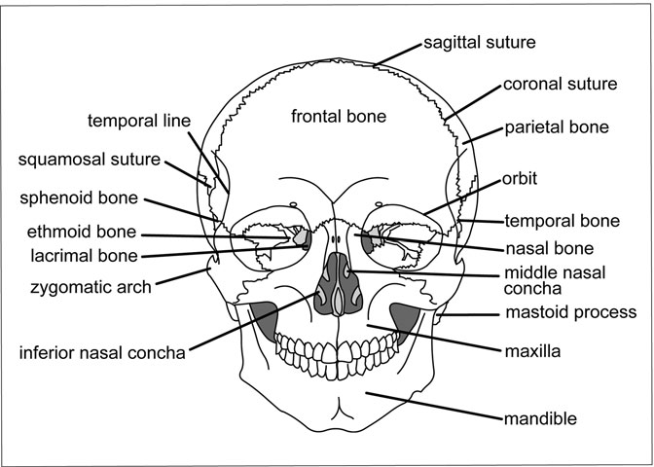

Figure 11.3 Skull, anterior. (Sandy Windelspecht/Ricochet Productions)

Processes

A process is a projection or outgrowth of bone or tissue. On any given bone, depressions and holes may also be present. These structures provide for the attachment of muscles, help form joints, and act as passageways for blood vessels and nerves.

Bone processes include the following structures:

• *Head*—a large round part that joins with another bone; the term articulation refers to the joining of one bone to another

• *Shaft*—the principal part of a long bone

• *Neck*—the narrow part of a bone between the head and shaft

• *Spine*—a sharp slender process, as seen on the back of the shoulder blade (scapula)

• *Condyle*—a rounded, knuckle-like process located where one bone articulates with another

• *Crest*—a very narrow ridge of bone

• *Trochanter*—a large projection for the attachment of muscles

• *Depression, or fossa*—a shallow hole in the surface of the bone

##### The Axial Skeleton

The axial skeleton—the central supporting portion of the body—is com- posed of the skull, vertebral column, ribs, and breastbone. The term axial is derived from the word axis, a real or imaginary straight line that runs through the center of a body. Axis may also refer to a structure around which other objects rotate. The axial skeleton has 80 bones.

The Skull

The skull is divided into the cranium and facial bones. Oval in shape and wider behind than in front, the skull rests on the top of the vertebral column. The human skull starts life as a “jigsaw puzzle” of about 30 pieces held in cartilage and membranes. During embryonic development, these pieces gradually grow together to form a solid case. There are six fontanels

at birth; the pulsing of the baby’s blood system can be seen in the upper- most fontanel. The cranium, which lodges and protects the brain, consists of eight bones. The names of these eight bones, along with their common names or locations, follow:

• *Frontal*—the forehead

• *Occipital*—lower back of the skull

• *Sphenoid*—large bone between the occipital and ethmoid in front and temporal bones at the side

• *Ethmoid*—inner part of the eye socket and back of the nose

• Two sets of *parietal*—top and side of the skull

• Two sets of *temporal*—temple areas on the side of the skull

These ﬂattened or irregular bones do not move—with one exception, the mandible (jaw). They are joined at points called sutures.

Frontal Bone The frontal bone forms the forehead and the upper portion called the squama in the forehead region, and a horizontal portion that forms the roofs of the orbital and nasal cavities (Figure 11.4)

The outer surface of the squama is convex and usually shows the remains of the frontal, or metopic, suture that divides the bone in two. On each side of this suture, located about 3 centimeters above the eye socket, is a rounded elevated area called the frontal eminence. These protrusions vary in size and are usually larger in men than in women. Sometimes they are referred to as supraorbital ridges. The frontal bone articulates with 12 other bones.

Occipital Bone The occipital bone forms the posterior, or back, surface of the skull. It is shaped like a trapezoid—a four-sided ﬁgure with two par- allel sides and two nonparallel sides. The structure seems to curve in on itself. A large oval hole, or aperture, called the foramen magnum pierces the bone. This hole, the largest foramen, allows the spinal cord to pass through the bone.

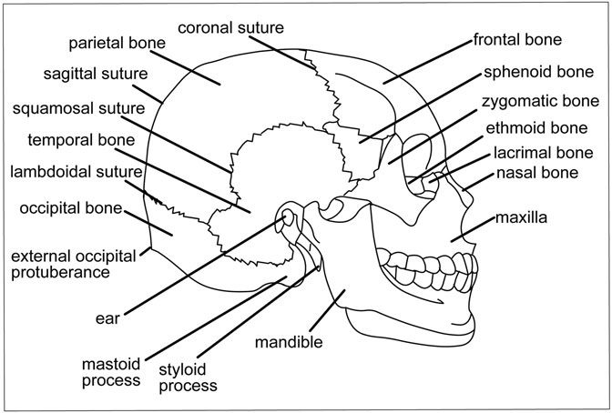

Figure 11.4 Skull, lateral. (Sandy Windelspecht/Ricochet Productions)

The external surface of the occipital bone curves out in a convex area, producing a protrusion on either side to which ligaments are attached. The lateral, or side, parts of the occipital bone rest at the side of the foramen magnum (Figure 11.5).

Sphenoid Bone One of the most difﬁcult bones to describe is the sphenoid. A number of features and projections enable it to be viewed from various points. A single bone, it runs through the midsagittal plane and connects the cranium to the facial bones.

The sphenoid bone is a hollow body that contains the sphenoid sinus and three pairs of projections. On the inside of the sphenoid is a small, saddle- shaped shelf where the pituitary gland rests. One section of the sphenoid bone called the smaller lesser wings has a hole that allows the optic, or second cranial, nerve to pass through. Other processes run along the back portion of the nasal passages toward the palate, or roof of the mouth. Muscles run from these attachments to the internal, or medial, surface of the mandible, or jawbone. These muscles provide the grinding motion of chewing.

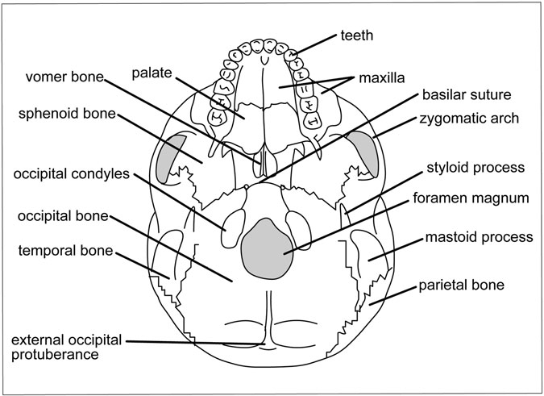

Figure 11.5 Skull, interior. (Sandy Windelspecht/Ricochet Productions)

Ethmoid Bone The ethmoid bone is a light and somewhat spongy bone that is cubical. A single bone, it runs through the midsagittal plane that connects the cranium to the facial skeleton. Unlike the sphenoid, one can- not see it from various views.

The bone has paired projections called the Crista Galli, or Cock’s Comb. Several plates make up this single bone, which cradles the nerve of smell, separates the nasal passage, and forms part of the eye socket.

Ethmoid Notch The ethmoid notch separates two orbital plates. In front of the notch are the openings to the frontal air sinuses. A sinus is a cavity within a bone or organ. In the interior of the cranium, these cavities are vein channels that move blood from the brain. External sinuses—such as those found in the frontal, sphenoidal, ethmoid, and maxillary (upper jaw) areas—are hollow spaces in the bone. They are connected to the nasal cavities that contain air.

Parietal Bones Between the frontal and occipital bones are two parietal bones. As the two bones unite, they form the sides and roof of the cranium. Each bone is roughly quadrilateral and has two surfaces, four borders, and four angles.

Temporal Bones The temporal bones are paired cranial bones situated at the side and base of the skull. They are located below the parietal bones and form part of the sides of the base of the cranium. Each tem- poral bone contains the middle and upper portion of the hearing mecha- nism. One area of the temporal bone forms the mastoid process, a conical projection. The mastoid can be felt by placing the hand behind the ear. The mastoid process is larger in men than in women. Part of the temporal bone extends out to form the zygomatic arch (see the next section) of the facial bones.

Facial Bones

All bones of the face are paired except the vomer, mandible, and hyoid. The paired bones are the following:

• Zygomatic

• Maxillae

• Nasal

• Lacrimal

• Palatines

Zygomatic The cheekbone is made up of two bones; the zygomatic, and a ﬁngerlike projection from the temporal bone. This joining is called the zygomatic arch. Also called malar or jugal, each zygomatic bone articu- lates (joins) with surrounding bones, one on each side.

Maxillae The maxillae, or upper jawbone, are paired facial bones that join to form the hard palate in the roof of the mouth. They also contain the upper teeth.

Nasal Some facial features are composed of both bone and cartilage. The nasal bones are small rectangular bones that form the upper part of the bridge of the nose. Cartilage forms the lower part of the nasal frame. Cartilage deteriorates after death. This is why one never sees a skeleton with a nose.

Lacrimal The lacrimal bones are located behind and lateral to the nasal bones. These small and fragile bones help form the eye orbit and part of the nasal passage. They also contain the fossae, or holes, housing the lacrimal duct that connects the medial corner of the eye to the nasal passage. This duct enables tears from the eye to enter the nasal passage.

Ossicles The human body’s tiniest bones are in the ear. Three little bones called ossicles are located in each middle ear. The bones are named for their appearance:

• The malleus, or hammer, is about 0.32 inch long.

• The incus, or anvil, looks like a small version of the metal table used by blacksmiths to hammer iron tools.

• The stapes, or stirrups, appear as a saddle about 1.2 inches long.

The mallet-shaped handle of the malleus attaches to the inner surface of the eardrum. The head of the hammer ﬁts into a tiny socket at the base of the anvil. Small ligaments between these two bones bind them ﬁrmly together. A long process of the anvil joins with the head of the stirrup. Hearing occurs when sound waves strike the eardrum and set the ossicles in motion. Moving through the bones, the waves result in a rocking motion of the stir- rups that oscillates against the membrane covering the opening (called the oval window) in the inner wall of the middle ear. At birth, the ossicles are completely developed. They do not change in size as a person grows.

Vomer The vomer is a thin, ﬂat bone that looks like a plowshare. Joining with the ethmoid bone, it becomes the partition between the two nasal cavities, or septum. The lateral walls of the nasal cavity have two scroll- shaped bones called inferior nasal conchae. These thin, porous paired

bones are elongated and curl upon themselves. Attached to the wall of the nasal cavity, the bones increase the amount of mucus membrane and olfactory nerve endings that contribute to the sense of smell.

Mandible, or Jawbone The largest and strongest bone of the face is the mandible. This horseshoe-shaped bone holds the lower teeth. Its parts include a curved, horizontal body and two perpendicular portions, the rami, that join the ends at right angles.

In adults, portions of the base are of equal depth and the rami are almost vertical, measuring from 110 to 120 degrees. However, in old age, the bone is greatly reduced in size. With the loss of teeth, some bone is absorbed and each ramus becomes oblique, with an angle that measures about 140 degrees.

Hyoid The U-shaped hyoid bone is unique in that it does not attach to any other bone. Located in the neck above the larynx, or voice box, it serves as the attachment for the muscles of the tongue.

The Vertebral Column, or Spine

The vertebral column is the backbone of the body, forming a supporting rod for the head, arms, and legs. The vertebral column is made up of a series of 26 bones called vertebrae (singular, vertebra). Cartilage and liga- ments link the vertebrae together, allowing ﬂexibility and giving support to the trunk. The column protects the spinal cord.

Vertebrae are grouped according to the region they occupy (Figure 11.6):

• Cervical, or neck—7 vertebrae

• Thoracic, or chest—12

• Lumbar—5

• Sacral—5 fused bones between the hip bones

• Coccygeal—tailbone region

In the embryo, 33 separate vertebrae exist. Before birth, the ﬁve sacral vertebrae and four coccygeal vertebrae fuse, forming a single bone at birth.

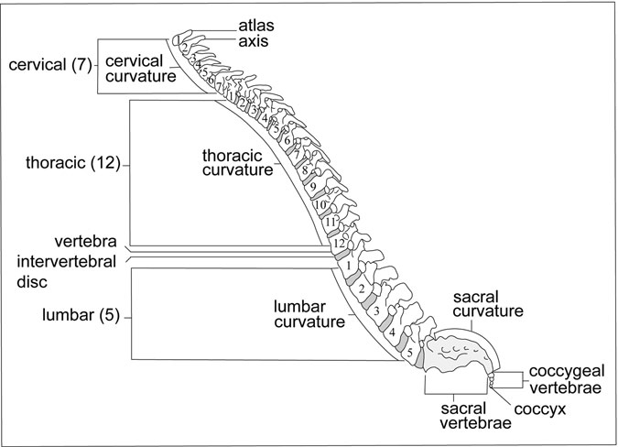

Figure 11.6 Spine. (Sandy Windelspecht/Ricochet Productions)

Seen from the side, the spinal column does not form a straight line. Several curves correspond to the sacral curves that appear before birth, and others develop later. The cervical curve in the neck appears when an infant begins to sit up and hold its head erect. Another forms in the lumbar region when the baby begins to walk. Changes in the curvature of the column result in shifts in the body’s center of gravity. The average length of the spinal column in men is 28 inches (71 centimeters); in women, 24 inches (61 centimeters).

A Typical Vertebra A typical vertebra has two parts (Figure 11.7):

• Body—the largest part, which is shaped like a short cylinder; this is the forward, or anterior, part

• Vertebral arch—a ring of bone formed by paired pedicles, or short, strong processes

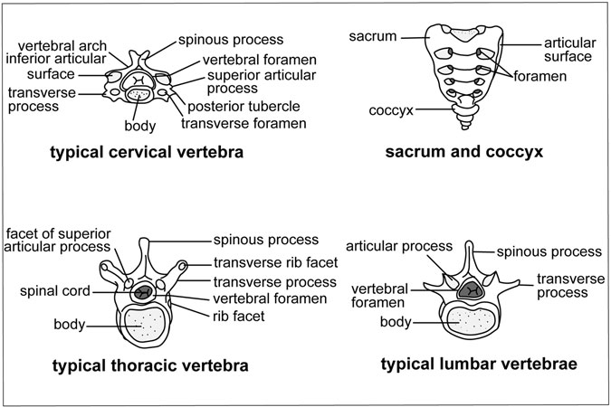

Figure 11.7 Typical vertebrae. (Sandy Windelspecht/Ricochet Productions)

Parts of the vertebral arch roof over an opening called the vertebral foramen, through which the spinal cord passes. Each vertebra has a spinous process for the attachment of ligaments and muscles of the back. Other processes permit the attachment of muscles and joints that connect individual vertebrae.

The following processes are on the vertebrae:

• *Pedicles*—short thick processes that project backwards, one on each side; vertebral notches are located above and below the pedicles

• *Laminae*—two broad plates directed backward and toward the middle

• *Spinous processes*—bony areas directed downward and backward from the junction of the laminae that serve as attachment sites for muscles and ligaments

• *Articular processes*—springing from the junction of the pedicles and laminae, their surfaces are coated with hyaline cartilage, or true cartilage that has a smooth and pearly appearance

• *Transverse processes*—located at each side of the joint where the lamina joins the pedicle; sometimes called wings, they also serve as attachments for muscles and ligaments

Because the vertebrae differ in subtle ways in their makeup, they are identiﬁed in the following ways:

• The letter C is for cervical; T for thoracic; L for lumbar.

• The vertebrae are numbered from top to bottom. For example, C2 is the second cervical vertebra; T3 is the third thoracic vertebra. Each number begins with the location in the new section.

Cervical Vertebrae The seven cervical vertebrae in the neck are the smallest of the vertebrae. These vertebrae enable the head to turn in roughly three-quarters of a circle without moving the shoulder. Moving the eyes in conjunction with the neck generates almost a full circle of vision. Muscles run from the wings, or transverse processes, on the sides and to the rear of the vertebrae to the skull, shoulder blades, and lower vertebrae. These structures also steady the head on the neck.

Cervical vertebrae are different from thoracic or lumbar vertebrae in that they have a foramen, or hole, in each transverse process. There are also other differences:

• C1 is named for Atlas, the Greek mythological Titan who bore the weight of the world on his neck and shoulders. The atlas, or C1, allows the nodding movement. This bone has no vertebral body, only anterior and posterior arches. It joins with the odontoid process of C2, or axis.

• C2 is the second cervical vertebra, called axis. The axis allows movement from side to side. The odontoid process projects above the body and joins the anterior arch of the atlas. The dens is a process that forms a pivot around which the atlas rotates to allow head movement.

• C3–6 are vertebrae that are alike but without the special features of C1, 2, and 7.

• C7, called vertebra prominens, has the distinctive feature of a long spinal process that is thick and nearly horizontal.

Thoracic (Chest) Vertebrae The thoracic vertebrae become larger from top to bottom to carry additional weight. These 12 vertebrae are inter- mediate in size between the cervical and lumbar vertebrae. They have the features of a typical vertebra, plus long slender spines that project downward. The 12 vertebrae join with the 12 pairs of ribs. The ribs join to shallow cups, or costal pits, on the body of the vertebrae. Ten thoracic vertebrae have two costal pits, or facets, on each side—one above and one below—to join the head of the same rib. This gives extra stability. The two sets move with every breath.

Lumbar (Lower Back) Vertebrae These ﬁve vertebrae are the strongest and the largest because they support the weight of the body. The trans- verse processes and neural spine are thicker because they anchor the muscles that twist and level the lower back. Between the vertebrae is a cushion-like disk of cartilage. Although the lumbar vertebrae have fea- tures of a typical vertebra, they also have short, blunt spines that project to the rear. The lumbar spines do not overlap, so the area is a good place for a spinal tap—a drawing of spinal ﬂuid for the diagnosis of certain con- ditions, such as meningitis, an inﬂammation of the covering of the brain called the meninges.

Acrum The sacrum is a triangular bone formed by ﬁve fused vertebrae. The sacrum makes up part of the pelvis. The fused vertebrae sit like a wedge between other parts of the pelvis.

Coccyx The end of the vertebral column is the coccyx, or tailbone. It results from the fusion of four coccygeal vertebrae, which are not as complex as the others in that they have no pedicles, laminae, or spine. The coccyx is made from four centers, one for each segment. The forming of the bone occurs in the following order during a person’s lifetime:

• Between ages 1 and 4, the ﬁrst segments ossify, or form bone.

• Between ages 5 and 10, the second unit forms bone.

• Between ages 10 and 15, the third unit forms bone.

• Between ages 14 and 20, the fourth unit ossiﬁes.

• As people advance in age, the segments unite with one another.

• Later in life, especially in women, the coccyx often fuses with the sacrum.

Gymnasts demonstrate the amazing agility of the spine, which is most ﬂexible during the younger years. As people age, knobs of bone grow on the vertebrae and cartilage disks between them become hardened.

Thorax, or Rib Cage

Because the lungs inhale and exhale, they need protection from being damaged. A solid case like the skull would not enable a person to breathe in and out; a better means of protection would be a group of moveable bars forming a ﬂexible cage—just like the ribs. In fact, the ribs are closely spaced with ligaments and muscles in between. They move at the joints, with the spine and breastbone, making it possible for them to lift upward during inhaling and to move back down during exhaling.

The thorax, or rib cage, is made of bones and cartilage that protect the important organs of respiration and circulation. Its shape is like an inverted cone, with the narrow part above and the broad part below. From the back, the 12 thoracic vertebrae and the posterior part of the ribs form the cage. The sternum and costal cartilages form the front surface. The sternum is slightly convex and tilts downward and forward. The ribs form its side surface. Eleven intercostal spaces separate the ribs. The term costal means “pertaining to the ribs.” The intercostal muscles and membranes are also found in this area.

A woman’s thorax differs from a man’s in the following ways:

• The woman’s capacity is less.

• Her sternum is shorter.

• The upper level of her sternum is on a level with the lower part of her body.

• Her upper ribs are movable, allowing for a greater enlargement of the upper part of the thorax to accommodate expansion of the uterus during pregnancy.

Ribs Twelve pairs of ribs are classiﬁed as typical, or true, ribs; false ribs; and ﬂoating ribs. All three types of ribs have the following structures:

• *Head*—the back and middle ends that join with demifacets, or cup-like structures, of two adjacent vertebral bodies

• *Neck*—a constricted region about 4 inches (2 centimeters) long that is beside the head

• *Tubercle*—next to the neck of the rib, this part joins to the transverse process of a vertebra

• *Body*—the shaft of the rib, the longest part of a typical rib The ribs are described as follows:

• Ribs 1–7 are true ribs that attach directly to the sternum by means of costal cartilage and a true synovial joint (this joint has a clear lubricating ﬂuid secreted by the synovial membrane, which will be detailed later in this chapter).

• Ribs 8–10 are false ribs joined via the costal cartilage of rib 7.

• Ribs 11–12 are ﬂoating ribs that do not articulate with the sternum or costal cartilage of the rib above (see photo).

Most men and women have 12 complete pairs of ribs. Sometimes a man or a woman will have 11 or 13 pairs, but this is unusual.

Sternum, or Breastbone

The sternum is a broad, ﬂat bone forming the anterior wall of the thorax. Three parts make up its structure:

• *Manubrium*—the top part of the sternum means “handle,” such as that of the handle of a sword.

• *Body*—the middle part articulates with the costal cartilages and ribs 2–7.

• *Xiphoid process*—the lower, or inferior, part of the bone varies in size and joins the bottom of the sternum; its name means “sword shaped.”

Ligaments form the alignments to the clavicles, or collarbones, at each side of the top of the sternum. Costal cartilages are bars of true hyaline cartilage made of smooth, tough material that contribute to the elasticity of the rib cage.

The axial skeleton—composed of skull, vertebral column, ribs, breastbone, and pelvic and pectoral girdles—is the main part of the skel- eton making up the head and trunk. These 80 bones protect the vital organs of heart, lungs, spinal cord, and brain. They form the foundation for the attachments of the appendicular skeleton.

#### Bones of the Limbs: The Appendicular System

Whereas the bones of the limbs had a mystical past, they serve today as the creative tools of modern existence Bones of the limbs and structures relating to them make up the appendicular skeleton. The word appendicu- lar comes from the Latin, meaning “to hang from.” Actually, the limbs do hang from the body as appendages.

The axial skeleton of skull, vertebral column, ribs, and sternum becomes the form to which the appendages are hung. Most bones do not lie in the body’s central axis but in the extremities. The appendicular skel- eton has 126 bones and includes the bones of the arms and legs and those of the shoulder and pelvic girdle.

Mammals, including humans, generally have legs longer than the torso. These bones account for great variation in height. For example, the length of the human spine varies little from woman to woman or from man to man. The woman’s spine is basically 24 inches in length, and the man’s is 28 inches. Differences in height result from the length of the leg bones. When a group of men are seated, they look the same height; but when they stand up, great differences in height are visible. Arm and leg, hand and foot—these appendages are similar, with the arrangement and number of bones being somewhat alike.

The importance of the human appendages is underlined by speciali- zation. Quadripeds—animals that walk on all fours—have similar struc- tures in all limbs. Apes and monkeys have hind feet that are very much like hands. In addition to opposable thumbs, these animals have oppos- able big toes that enable them to grasp. In humans, the limbs have more

specialized jobs. The hands function to create and to work; the feet support.

The appendicular skeleton has 126 bones and includes the bones of the arms and legs, as well as those of the pectoral and pelvic girdles. The structures of the muscles, tendons, ligaments, and cartilage surround the bones at the joints and enable movement.

##### The Pectoral Girdle

The pectoral, or shoulder, girdle is composed of four bones: two scapulae and two clavicles. Usually a girdle is something that encircles as a complete ring. Looking down at the pectoral girdle from above, one can see a double crescent that encircles the upper part of the body. However, this girdle is incomplete, with the clavicles, or collarbones, being separated by the ster- num in the front and a gap between two scapulae, or shoulder blades, in the back. In the back, the scapulae are connected only to the trunk by muscles. The bones allow for the attachment of muscles that ﬁrmly bind the arm to the trunk. These muscles also permit free movement of the arms.

Scapulae, or Shoulder Blades

Two pairs of bones in the upper torso connect to the bones of the arm. Located one in front and one in back, the shoulder blades literally ﬂoat in a sea of muscles. The name scapula comes from a Greek word meaning “to dig.” The shape is like a shovel or spade. Early humans used the scapu- lae of some animals as primitive digging tools. Shoulder blades are difﬁcult to fracture and articulate with the clavicles.

The scapula—a ﬂat, triangular bone that has two surfaces—forms the back part of the shoulder girdle. A spiny, prominent, shelf-like ridge extends obliquely across the blade. It supports the acromonium process. This is where the shoulder blade connects with the head of the humerus.

The scapula has two surfaces, three borders, and three angles. One angle, called the subscapular angle, appears to be bent in on itself along a line at right angles. This arched form strengthens the body of the bone while the summit of the arch supports the spine and the acromonium. Underneath the clavicle, the coracoid process of the scapula projects for- ward and serves as an attachment site for several muscles.

Clavicle, or Collarbone

The clavicles are located in front, ventral to the rib cage and just above the ﬁrst rib. One can feel them at the base of the neck where the collar is located. The name clavicle is a Latin word that means “little key.” To some people’s imaginations, it looks like an old-fashioned key. The clavicle of birds is very important in folklore. It forms the familiar V-shaped wishbone: Break the long end, and your wish will come true.

The clavicle forms the anterior, or front, portion of the shoulder girdle. Some people describe this long, thin, curved bone as shaped like an S. Others say it is like the italicized lowercase f. Placed horizontally at the upper and anterior part of the thorax, it is immediately above the ﬁrst rib. The upper surface is ﬂat and rough and has impressions for attachments of the deltoid muscle that covers the shoulder prominence in front and the triangular-shaped trapezius muscle covering the back part of the neck and shoulders behind. In fact, the clavicle acts like a fulcrum that enables the muscles to give lateral motion to the arm. The part of the clavicle that joins the scapula is triangular. The other end joins a ﬂattened projection of the scapula called the acromonium process. This process can be felt as the slight bony projection on the upper surface of the shoulder.

Women have shorter, thinner, less curved, and smoother clavicles than men. In people who perform manual labor, the clavicles are thicker, are more curved, and have prominently marked ridges for muscular attach- ments. The clavicle is the most commonly broken bone in the body because it transmits forces from the arm to the trunk.

The Arm

Hooked onto the pectoral girdle are the bones of the arm. Each arm con- sists of three principal bones: the humerus, ulna, and radius. Because of the joints in the bones, the arm is able to move. Also, arms are divided into three segments: upper arm, lower arm, and hand.

Humerus The longest and largest bone of the upper arm is divided into a body and two extremities, or ends. This long bone of the upper arm extends from the shoulder to the elbow. The word humerus comes from

the Greek word meaning “shoulder.” Sometimes the humerus is called the brachium. However, it should not be confused with the word humorous, which means “comical” or “funny.” The common term funny bone comes not from a bone, but from a nerve—the ulnar nerve—that passes over the elbow and creates a tingling sensation when hit.

The humerus has a smooth, rounded head that articulates with the scapula. On the lateral, or side, surface is a roughened area. Muscles and ligaments attach here. There are also several sites along the shaft of the bone where other muscles are attached. The bones of the forearm articu- late on smooth surfaces at the lower end of the humerus.

Two knob-like projections—one on the lateral side and one in the middle—are attachment sites for the common extensor and the common ﬂexor tendons that help move the forearm. Inﬂammation of the extensors causes the condition known as “tennis elbow.” The distal end of the medial condyle of the humerus is called the trochlea, meaning “pulley.” It articu- lates with the troclear notch of the ulna, which limits side movement and guarantees a hinge action.

Ulna The ulna is the longer bone along the back of the forearm. The word comes from the Latin term that means “elbow.” The end of the ulna is the bony portion of the elbow. At the upper end of the ulna is the olecranon process, a projection that ﬁts into the olecranon fossa of the humerus when the arm is extended. These two bones form the joint at the elbow. On the lateral side of the ulna is a shallow notch for the head of the radius. The head of the ulna joins with the radius at the lower ends of the individual bones. The ﬂattened surface at the lower end of the radius enables it to rotate around the ulna.

Radius The word radius comes from the Latin word that means “ray,” something that radiates outward from a center (originally, the word applied to the spokes of a wheel). Whoever named this bone thought this section of the lower arm seemed straight enough to be a spoke in a wheel.

The radius pivots on its long axis and crosses the ulna. Its proximal end has a smooth, rounded surface that articulates with the ulna. Next to the head is the neck; then comes the body, the long slender mid-portion

also known as the shaft, or diaphysis. The bone ends with the styloid process, a projection that joins with the carpal bones of the wrist.

The radius and ulna form the forearm. When viewed from the correct anatomical position, the radius is on the side away from the body (lateral side), and the ulna is on the side toward the body (medial side). The ulna is longer than the radius and connects more ﬁrmly to the humerus. How- ever, the radius is more involved in movement of the hand. A broken arm usually involves this bone.

The Hand

The hand has three parts: the wrist, palm, and ﬁngers. Twenty-seven bones form this distal end of the limb. The large number of bones allows for the hand’s versatility. A single bone would create a ﬂipper-like, inefﬁcient oar; a single line of bones would lead to bending as a unit, as in the spinal column. But the number of hand bones that spread out in two planes— length and width—introduce two-dimensional ﬂexibility that permits delicate maneuvering. Thus the hand is a superb manipulative organ with four limber ﬁngers and an opposable thumb that can act as pincer, grasper, twister, bender, puller, pusher—and manipulator of piano and computer keys.

Carpals The wrist, or carpus, has eight small bones. The Latin word carpus means “wrist.” Ligaments hold these bones tightly together. To allow ﬂexion, or movement, of the wrist, the carpal bones are arranged roughly in two rows. On their inner, or palmar, surface are attached some of the short muscles that move the thumb and little ﬁngers.

Together, the bones of the wrist form a box-like structure. Each of the bones of the wrist has a special appearance and function. Early anatomists named them according to objects that were familiar at the time. The bones in the ﬁrst, or proximal, row from side to middle are as follows:

• *Scaphoid*—sometimes called navicular, from the Latin word that means “boat shaped.” This bone is located on the ﬂoor of the anatomical wrist box. Hyperextension, or excess bending, of the wrist may fracture this bone.

• *Lunate*—from the Latin word meaning “moon shaped” or “crescent shaped”; the second carpal bone in the proximal row.

• *Triquetrum*—from the Latin word meaning “three cornered.” The bone is the most medial in the row.

• *Pisiform*—from the Latin word meaning “pea shaped.” This sesamoid bone is in a tendon and articulates with the triquetrum.

Bones in the second, or distal, row are as follows:

• *Trapezium*—from the Latin word that means “saddle” or “swing.” This bone forms a saddle joint with the metacarpal bone of the thumb. Literally, the thumb swings on the trapezium.

• *Capitate*—from the Latin word meaning “head.” This largest carpal bone is named for its rounded head. A punching blow with the ﬁst generates forces that are transmitted through the third metacarpal bone to the capitate to the radius.

• *Hamate*—from the Latin word meaning “hooked.” This describes the shape of the bone.

Metacarpals The ﬁve metacarpal bones articulate with the bones of the wrist. The word metacarpal is from the Latin word that means “after the wrist.” The other ends of the metacarpals are rounded and connect with the bones of the ﬁngers. They are embedded in soft tissue and form the palms of the hand. The metacarpals are visible in the back of the hand. They are numbered 1 through 5 beginning with the thumb. Numbers 2 to 5 are almost parallel and do not move, whereas number 1 is set at an angle and has limited mobility.

The metacarpals are described as follows:

• Metacarpal 1—shorter and stouter than the others; diverges to a greater degree from the carpus; its surface is directed toward the palm

• Metacarpal 2—longest of the ﬁve bones; forms a prominent ridge

• Metacarpal 3—a little smaller than number 2

• Metacarpal 4—shorter and smaller than number 2

• Metacarpal 5—has only one facet on its base

The metacarpals articulate with the carpals and phalanges of the ﬁngers.

Phalanges The 14 bones of the ﬁngers are called phalanges. One of these bones is called a phalanx. In Greek history, the phalanx was a close formation of soldiers marching side by side and front to back. Fingers 2 to 5 have three phalanges decreasing in size from proximal to distal. The thumb has two phalanges.

Each ﬁnger has a formal name. The thumb is called pollex, from the Latin term meaning “strong.” It is stronger than the others. (For example, people push a tack into a board with the thumb—hence the term thumb- tack.) The second ﬁnger is the index ﬁnger, from the Latin word meaning “pointer.” The middle ﬁnger is called medius, from the Latin for “middle.” The fourth ﬁnger is the ring ﬁnger, or annularis, from the Latin for “ring.” Last, as well as least, is the minimus, which means “least.”

Fingers 2 to 5 have three phalanges, whereas the thumb has only two. The ﬁngers move in and out or up and down. As each phalanx meets, it forms a hinge joint that enables part of the ﬁnger to bend. The thumb is more ﬂexible than the other four ﬁngers, with the distal end of its corre- sponding metacarpal bone being more rounded. Thus the thumb may cross the palm of the hand. This is why it is called an opposable thumb. Occasionally, small sesamoid bones are found within the tendons of the hand.

##### The Pelvic Girdle

Just as the pectoral girdle anchors the arms and hands, the heavier and stronger lower hip girdle supports the structures of the legs and feet. The word pelvis comes from the Latin word that means “basin.” The pelvic girdle has two large hipbones attached to each other. In the back, these connect with the sacrum to make a bowl-shaped circle of bone. An oddity in the animal kingdom, humans’ rounded pelvis is quite different from the elongated pelvis of other animals.

Hip Bone

It is a common mistake to think that the hipbone is the large ridge just below the waist. Actually, the hip is at the top of the thighbone and is hid- den beneath heavy layers of muscle.

The hipbone is a large, ﬂattened, irregular-shaped bone constricted in the center and expanded above and below. The prominent bones of the hip are called coxals or ossa coxae, from the Latin words meaning “hip bone.” Sometimes the name is innominata, from the Latin word meaning “no name.” The bones meet in the middle line in front and form the sides and anterior walls of the pelvic cavity.

Each hip bone is composed of three pairs of bones: the ilium, from the Latin for “groin”; the ischium, from the Greek word for “hip”; and the pubis, from the Greek word meaning “adult.” The midline divides the bones, with one on each side. Together, they constitute the bony struc- ture known as the hips.

Ilium This fan-shaped bone forms the lateral, or side, prominence of the pelvis. Divided into two parts, the body of the ilium forms two-ﬁfths of the acetabulum, the socket that ﬁts the ball-shaped top of the thigh. The crest of the ilium can be felt on each side of the body just below the waistline. This is the bone most people mistake for the hip bone.

Ischium This V-shaped bone forms the lower and back part of the hip bone. The body of this bone forms another two-ﬁfths of the acetabulum. It is the site of attachments of many membranes and ligaments, including the hamstring, a major muscle in the groin. The muscles that enable one to sit are also attached to the ischium.

Pubis This angulated bone forms the front part of the pelvis and makes up one-ﬁfth of the acetabulum. It joins the ischium to form a pair of large holes. The holes, which are prominent in pictures of the skeleton, are called obturator foramina, Latin for “stopped-up holes.” In reality, a mem- brane covers this area.

The term pubis is derived from the same root as the word puberty, describing sexual maturity. One of the signs of such sexual change is the

growth of adult hair, or pubic hair. The bones located just under this region share this name.

In the front, the pubic bones are joined by cartilage similar to that in the vertebrae. This linkage is called the pubis symphysis, Greek for “growing together.” In the back, the two bones that form the ilium do not meet but join the sacrum to form the sacroiliac joint, the articulation of the hip bones with the sacrum. Five sacral vertebrae form the sacrum, a connection so ﬁrm that sometimes the area is considered one bone—the sacroiliac. This area sometimes becomes a problem for human beings because of the stress of standing upright on two feet.

The sacrum and the two bones known as os coxae form the complete bony structure called the pelvis. The rounded, basin-like structure is found only in human beings. However, this arrangement is not perfect, as the pelvic basin tips forward and is not entirely upright.

During birth and early childhood, each coxal bone has the three separate parts of ilium, ischium, and pubis. But by age 20, these bones are ﬁrmly fused. The fusion takes place at the large cup-shaped cavity called the acetabulum, located near the middle of the outer surface of the bone. The acetabulum forms a socket, or depression, that gives it this name. The structure looked like a round cup the Romans used for vinegar, or acetum. Forensic scientists and anthropologists who examine skeletal remains use the hip for distinguishing between man and woman. In the woman, the bony ring of the pelvic girdle must be large enough for an infant to pass through during childbirth. The average lighter and thinner female girdle is two inches wider than that of the male. However, the rest of the woman’s skeleton is much smaller and lighter. In the man, the bones are more massive, and the iliac crests are much closer.

Where the pubis bones meet at the symphysis, a disk of cartilage, in the woman, the bones form a right angle of 90 degrees, whereas the man’s has an angle of 70 degrees. During childbirth, the fetus must pass through the pubic area. If the opening is too small, a problem may occur with birth. By looking at skeletal bones, scientists can determine the number of children a woman has had because a record of the births is evident in the pelvis. Parturition (meaning “childbirth”) scars begin to be deposited at about the fourth month of pregnancy when a hormone is released that

softens the tendons that hold the pelvic bone together. These scars appear on the back side of the pubis symphysis.

The pelvic girdle, along with the sacrum, is a massive and rigid ring that is very different from the light and mobile shoulder girdle. But the pelvis, while sacriﬁcing mobility, does provide strength and stability. The pelvic girdle supports the weight of the body from the vertebral column. It also protects the lower organs—including the bladder and the reproductive organs—and the developing fetus during pregnancy.

Thigh and Leg

Simply standing on a corner waiting for a bus is in fact an intricate balancing act. Some animals, such as bears, can stand on their back legs for a short period but will soon topple over. Humans, however, can stand upright for hours, leaving their hands free for other things.

The lower extremity is composed of the bones of the thigh, leg, foot, and patella, commonly known as the kneecap. Bones in the legs reﬂect a compromise with the upper part of the body: They are much stronger than the bones of the arm but are able to move less.

Femur Between the hip and knee is a single bone called the thigh, or femur. It is the longest and strongest bone in the human skeleton, making up about two-sevenths of the person’s height. Femur is from the Latin word meaning “thigh” (Figure 11.8).

The parts of this bone include the head, neck, trochanter, body, and patellar surface. The head of the femur, the proximal end, is rounded with ridges that anchor powerful leg muscles. It joins the ilium at an indented surface called the acetabulum, ﬁtting into this rounded socket as a ball and socket. Below the head of the femur is the neck, a constricted area that is next to the head. Most of the blood supply to the head streams along this surface. The main shaft of the thighbone forms a wide angle. The neck region tends to become porous over time, especially in older persons, and therefore is a common site of fracture.

The lower end of the femur expands into a large ﬂattened area with two bony processes on each side. Jutting out from the junction of the neck of the shaft is the trochanter. The greater trochanter is the insertion point

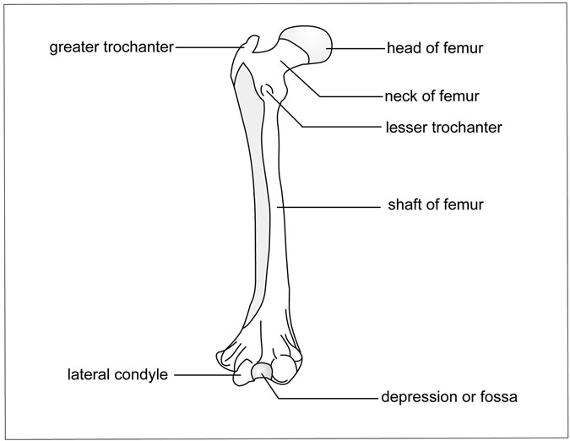

Figure 11.8 Femur. (Sandy Windelspecht/Ricochet Productions)

for several muscles, including the gluteus minimus. The lesser trochanter projects from the back middle surface and is an insertion point for major tendons and the muscles that form the posterior of an individual. The body is the long slender shaft that ends in the condyles, three rounded inferior ends that terminate at the kneecap.

Patella, or Kneecap Differing from a similar structure in the arm—the elbow—the knee has a separate bone: the kneecap, or patella. The name of this small, ﬂat, triangular bone comes from the Latin, meaning “small pan.” The larger bone of the lower leg, the tibia, joins with both processes on each side. The larger bone of the lower leg joins with the tibia to form the knee joint. The kneecap protects this important joint, which is con- stantly pushed out ahead of the body as one walks or runs. Like the hyoid bone, the patella is a ﬂat sesamoid bone located just in front of this joint.

It is not directly connected to any other bone. The patella develops in the tendon of the front thigh muscle. A ligament attaches the patella to the tibia. When leg muscles are relaxed, the patella is not held in place by these muscles. The patella moves. Lodged in the tendon, it straightens the leg at

the knee and increases the muscle’s leverage while protecting the knee.

Tibia, or Shinbone Like the middle part of the arm, the leg has two bones. Whereas the bones in the arm are nearly equal in length, those in the leg are unequal. On the side nearest the body (medial side) is the larger of the two bones—the shinbone, or tibia. It is the second-longest bone in the body. The word tibia comes from the Latin word meaning “ﬂute,” which its length and shape resemble. The shinbone is long and skinny; it is slim where the stresses are least.

The tibia is the weight-bearing bone of the leg. It possesses heavy prominences, or condyles, that articulate with the femur to form the knee joint. In the front of the lower leg, the tibia can be felt as not very smoothly rounded and with a protruding ridge. At the distal end at the ankle, the heavy bony protuberance it forms at the inside of the ankle can be felt.

Fibula, or Calfbone This bone is much thinner than its partner, the tibia, and does not carry the body weight. It mostly anchors muscles that move the foot. The name comes from the Latin word meaning “pin.” Its relation- ship to the tibia resembles the pin on the back of a brooch: well hidden. The ﬁbula cannot be felt, as it is securely embedded in muscles. Some- times it is called the splinter bone, as it resembles the splinter off the shinbone. The end of the ﬁbula can be felt as the bony prominence on the outside of the ankle.

The Foot

The foot, or pes, consists of the ankle, instep, and ﬁve toes. Twenty-six bones make up the distal limb (Figure 11.9).

Tarsus or Ankle The ankle has a series of seven irregular bones, one less than the eight of the wrist. The word tarsus is from the Greek term meaning “wicker basket,” apparently suggesting that the separate bones

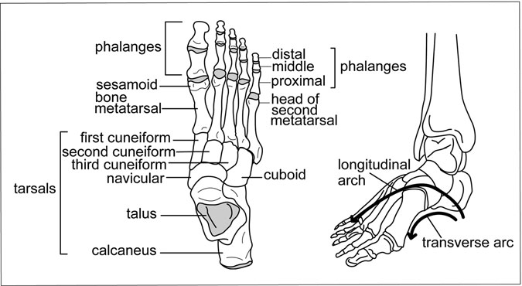

Figure 11.9 Foot. (Sandy Windelspecht/Ricochet Productions)

resembled the interwoven wicker strands of a basket. Bones of the tarsus are as follows:

• Calcaneus—from the Latin word meaning “heel.” This largest tarsal, the strongest bone in the foot, extends back to form the heel. By extending backward, the two heels along with the two soles of the feet give humans bipedal support.

• Talus—from the Latin term meaning “ankle.” This ankle bone articulates with the tibia, ﬁbula, calcaneus, and navicular bones.

• Navicular—from the Latin word meaning “boat shaped.” This bone articulates with the head of the talus and all three cuneiform bones.

• Cuboid—from the Latin word meaning “cube shaped.” Soldiers in Rome used these bones, usually from horses, as dice for gambling.

• Cuneiform—from the Latin word meaning “wedge shaped.” There are three of these bones.

As in the wrist, the bone structure enables the foot to move up and down in a single plane. The calcaneus helps support the weight of the body

and serves as an attachment site for muscles of the calf of the leg. In fact, when standing, the body weight presses down through the talus and is divided evenly: Half travels to the heel bone, and the other half goes to the ﬁve remaining bones and the arch. Wearing high-heeled shoes upsets this balance, throwing the body weight to the balls of the foot.

Metatarsals The foot contains ﬁve metatarsals that join ﬁve sets of phalanges. The ﬁve metatarsals are similar to the metacarpal bones of the hand. Each of the metatarsals articulates with at least one of the tarsal bones, and sometimes with other metatarsals. The foot is shaped to form two main arches where the metatarsals join with the tarsal bones. One of the arches is longitudinal, lying perpendicular to the transverse arch. Together, they strengthen the foot and act as a spring to cushion certain movements. From any of a variety of conditions—including poor prenatal nutrition, excessive weight, fatigue, or incorrectly ﬁtted shoes—lowered arches, or ﬂat feet, can result. This problem causes unnatural stress and strain on the muscles of the foot and may lead to fatigue and pain while walking.

Phalanges The bones of the toes are similar in number to those of the ﬁngers. Four of the toes have three phalanges, and the great, or ﬁrst, toe has only two. Just like the ﬁngers, the ﬁrst digit of the big toe has two bones. The name for this bone is hallus, from the Latin word meaning “big toe.” However, unlike the ﬁngers, the toes have a sturdy, stout shape that bears weight. The bones help the foot push off, aiding in balance as they ﬁrmly grip the ground.

#### Joints, Ligaments, Tendons, and Cartilage

Not only is the skeleton a framework for the body, but it also constitutes a movable machine. Bones themselves are rigid, so the only possible motion occurs where two bones come together.

Indeed, the entire body is a complex interaction of matter and motion. A new ﬁeld, biomechanics, merges the human machine and mechanics. Replacing joints diseased from arthritis, regrowing bone, and bone tissue engineering are hot research topics. These are only some of the current and future efforts to fathom the complex engineering of the human machine.

The sophisticated name for joint is articulation, from the Latin word meaning “to join.” The study of the joints is known as arthrology, from the Greek word arthro, meaning “joint.” The same root word is found in arthritis, meaning “inﬂammation of the joint.”

Just because a joint is present does not imply mobility. Some joints allow no movement, some permit minor movement, and some allow free movement. The joints may or may not have ligaments that attach bone to bone or bone to cartilage.

Custom-designed according to the body part, joints are divided into three classes that describe the amount of movement between bones:

• Synarthroses, or immovable joints, permit no movement.

• Amphiarthroses permit only slight movement.

• Diarthroses are freely movable joints.

Tough collagen ﬁbers called ligaments (from the Latin word that means “to tie”) bind joints together and link bone to bone. Many are named from the two bones they attach. For example, the sphenomandibu- lar ligament attaches the spine of the sphenoid bone and the mandible; the stylohyoid ligament connects the styloid process with the horn of the hyoid bone.

Ligaments and tendons are like rubber bands that hold the musculo- skeletal system together. The material is very strong in resisting heavy loads. Although tendons and ligaments are made of dense, ﬁbrous con- nective tissue, they differ in makeup and function. Ligaments bind one bone to another; tendons bind muscle to bone. Ligaments are 55 to 65 percent water. A special type of protein called collagen makes up 70 to 80 percent, with the protein elastin making up 10 to 15 percent of the dry weight (minus water). Tendons have 75 to 85 percent collagen and less than 5 percent elastin. Generally, tendons have fewer cells than ligaments do, and they are very sturdy. For example, the tendon of the foreleg of a horse can support the weight of two large automobiles. Sometimes a tendon is called by the Anglo-Saxon word sinew, which means “tough.”

##### Immovable, or Fibrous, Joints

Immovable joints are called synarthroses, from two Greek words: syn, meaning “together,” and arthro, meaning “joint.” These joints are ﬁrm in their positions to prevent gliding or sliding. Examples are sutures in the skull.

Sutures are limited to the skull. Instead of cartilage between bones, ﬁbrous tissue is located there. Necessary for skull growth, the joints are well marked in the young skull and barely visible in the aging skull. The only movement in the area is at birth, when cranial bones overlap to allow the baby to pass through the birth canal. Serrated little teeth that ﬁt together join the suture. Later in life when growth is complete, they fuse. Suture joints in the skull are the following:

• Coronal sutures—the articulation between the frontal bone and the two parietal bones

• Intermaxillary suture—the midline of the hard palate that marks the line of the two palatine shelves

• Lambdoidal suture—the joint between the occipital and parietal bones that resemble the Greek letter lambda

• Metopic suture—a midline suture forming the articulation between two centers of the frontal bone

• Pterion suture—joins four bones: the greater wing of the sphenoid, the frontal, the parietal, and the squamous part of the temporal bone; this area is easily fractured with a blow to the side of the head

• Sagittal suture—joins the parietal and squamous portions of the temporal bone

##### Cartilage, or Amphiarthroses, Joints

These ﬁbrous and cartilagenous joints occur where two bones are sepa- rated by a material that gives a little. Three such joints are synchondrosis, gomphosis, and syndesmosis.

Synchondrosis

This common type of joint is named from two Greek words meaning “join together with cartilage.” The structure is a cartilage “sandwich,” with bone as the “bread” on each side. The bone and cartilage ﬁt together perfectly, and the whole joint is shaped like a cup. If movement occurs, the growing bone will be damaged, causing a condition known as a slipped epiphysis. (The epiphysis is the portion of a bone that is attached to another bone by a layer of cartilage.) A long pin can be inserted to hold the joint in place.

Gomphosis

These peg-and-socket joints occur between the teeth and jaws. The perio- dontal ligament holds this joint, which gives only a little. When the teeth bite down on a hard piece of candy, this joint absorbs the shock.

Syndesmosis

This type of joint is commonly known as a tight joint. In fact, tight ligaments limit many joints. An example is the inferior tibio-ﬁbular joint between the two lower leg joints. A tight ligament limits the movement of this joint.

Symphysis is a word that describes two bones united by cartilage but designed to give a bit. For example, the symphysis pubis with ligaments and cartilage is normally closed, but female hormones signal it to open for childbirth.

The disks between the vertebrae are made up of ﬁbrous cartilage and form a symphysis. These disks, which give just a little, are important shock absorbers between vertebrae. Joints between the disks of cartilage and other tissues permit some movement.

What Is Cartilage?

Cartilage comes in different types, each suited to a particular use:

1. Hyaline cartilage is the most prevalent type. It is found at the ventral ends of ribs, in the rings of the windpipe, and covering the joint surfa- ces of bones. The covering at the joint surfaces of bones is called articular cartilage.
2. Elastic cartilage is found in the external ear, the Eustachian tubes in the middle ear, and the epiglottis—the ﬂap that covers the windpipe

during swallowing. Compared to hyaline cartilage, it is more opaque, ﬂexible, and elastic. It is yellow and very dense.

1. Fibrocartilage occurs in the disks between vertebrae, in the pubis symphysis in the pelvis, and in the bony attachments of certain ten- dons. It may also form when hyaline cartilage is damaged.

Cartilage is mainly collagen embedded in a ﬁrm gel. Collagen is an albumin-like protein in connective tissue, cartilage, and bone. The material is more ﬂexible than bone and lacks blood vessels. Cartilage cells receive nutrients from the diffusion of ﬂuids from nearby capillaries (minute blood vessels that connect the smallest arteries and veins). Nose and ears are examples of cartilage that deteriorate at death. This is why a skeleton never has a nose or ears.

##### Synovial, or Diarthroses, Joints

Synovial joints are very different from ﬁbrous joints in that they are con- structed to allow a range of motion. Yet they are sturdy enough to hold the skeleton together. Cartilage covers bones near synovial joints so that ligaments may attach.

Constructed to give power and motion, the ends at the synovial joints have a thin but tough layer of articular cartilage. This clear material less- ens friction and cushions joints from jolts. If the coating is destroyed, the bones grind against one another, producing a creaking sound. Between the bones and at the center of a synovial joint is the joint cavity that gives bones some freedom of movement. Synovial joints occur in a range of sizes and shapes (Figure 11.10).

Ball-and-Socket Joint

These joints are in the shoulder and hip. They allow for the freest move- ment. The surface of the epiphysis, or rounded head, of one bone ﬁts in the cup-shaped socket of the other. For example, the ball of the femur ﬁts tightly into the acetabulum of the hip bone. A rim of cartilage lines the socket and aids the ﬁrm grip on the femur. Some of the strongest liga- ments in the body reinforce this joint. Because of the ball-and-socket joint, a person may move the leg in almost any position. Dislocation

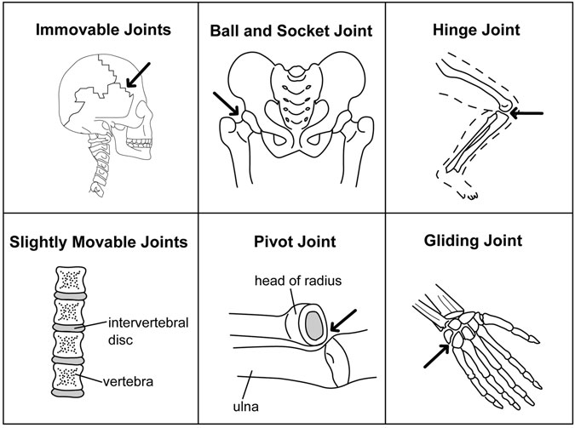

Figure 11.10 Joints. (Sandy Windelspecht/Ricochet Productions)

injuries are most common when the knee is ﬂexed, as when sitting in a car and the impact from a collision causes the knee to strike the dashboard.

A similar ball-and-socket joint located between the humerus and scapula permits an even greater degree of freedom. The socket here is shallower than the one at the hip joint, enabling a person to turn the arm in a complete circle at the shoulder. For example, baseball pitchers doing a complex windup can move their arms in a full circle.

Hinge Joints

As a door swings back and forth on hinges in one plane only, so do bones connected at hinge joints. There are 40 hinge joints in the human body, including the elbow and knee.

The elbow allows motion in one plane only. This complex synovial joint consists of humerus and radius, humerus and ulna, and radius and ulna

articulations—all within a common articular capsule. The proximal epiphy- sis of the ulna just ﬁts between the two epiphyses of the distal end of the humerus, allowing movement back and forth but not from side to side.

More complex is the body’s largest joint, the knee. This joint links the two rounded bulbs of the femur with the condyles of the tibia. The patella, or kneecap, covers this joint. In the act of walking, the knee is constantly rolling, gliding, and shifting orientation. To bear these enormous loads, a host of ligaments and tendons go into action. Two ligaments on each side of the joint prevent it from moving too far to one side. When torn, these ligaments usually repair themselves.

Not so with a second group of ligaments strapped across the joint, the cruciate ligaments. These intracapsular ligaments are the anterior and posterior cruciate ligaments. The anterior cruciate ligament, or ACL, is infamous in sports medicine. The role of these ligaments is to stop the joint from moving too far backward or forward. When the ACL is dam- aged, the knee is in great peril because it is extremely difﬁcult to repair. Damage to the ACL has put many athletes out of their game.

The joint capsule of the knee has ligaments as well as menisci to add to stability. The medial and lateral menisci are crescent-shaped wedges of cartilage with a smooth, slippery surface. Menisci enable the joint to glide easily and to absorb the shock of daily activity. Menisci are the knees’ weakest link, accounting for 90 percent of all knee surgeries. Muscles, such as the vastus medialis that hold the knee in place, also add to the sta- bility of the region.

Other hinge joints occur between the ﬁrst and second phalanges of the ﬁngers and thumbs and between the second and third phalanges of the ﬁngers. The same is true for joints in the toes. The lower jaw, or man- dible, is mostly a hinge joint, but it can move from side to side in a rotary motion.

Pivot Joints

These joints provide rotary movement in which a bone rotates on a ring or a ring of bone rotates around a central area. In shaking the head “no,” the movement between the ﬁrst two vertebrae allows the turning of the skull on the spine.

Gliding Joints

These joints are found between the carpals of the hand and the tarsals of the feet. The joining parts slide over each other with angular or rotary motion. Similar joints are in the ribs and vertebrae.

Angular Joints

Where a football-shaped bone ﬁts into a concave cavity, an angular joint occurs. This is found in the wrist, and it permits movement in two direc- tions. Sometimes these are called condyloid or ellipsoid joints.

Saddle Joints

Similar to an angular joint in its range of movement, this joint is found only in the thumb. Each bone that forms a saddle joint has a concave and convex articular surface.

Plane Joints

These joints occur between two ﬂat bones, where one moves horizontally over the other in both directions. They are found in the hand.

##### Synovial Fluid

When the bones move against each other, friction must be reduced. Several features work together to accomplish this. Portions of the bone are lined with a smooth layer of cartilage, and a capsule called the syno- vial capsule holds the bones together. This joint capsule permits move- ment and has great strength to prevent dislocation. Lining the joint is a membrane that secretes a lubricant called synovial ﬂuid. Like egg white in texture, the ﬂuid contains a substance called hyaluronic acid that helps to ease friction.

In these joints, there is also a membrane sac called a bursa. Bursae produce synovial ﬂuid that bathes the end of the bone, allowing ﬂuid movement. If the bursae become inﬂamed, a condition called bursitis causes severe pain.

Because bones are rigid, the only motion occurs where two bones come together as joints. Ligaments bind one bone to another; tendons bind

muscle to bone. Although not all joints move, these structures at the joint allow the human being to move.

#### Summary

The human body’s skeletal system is vital because it provides support to all of the other systems. Similar to the integumentary system, it also plays an important protective role. It protects the body’s tissues and organs, as well as storing blood cells and other important nutrients. There are 206 bones in the skeletal system that are at once rigid to provide support and ﬂexible to allow movement. One way of classifying bones is by shape. There are long bones, located in the body’s lower extremities that are strong and light, and short bones that are located in the wrist and ankle. Flat bones are located in the ribs and the hip, while irregular bones make up the skull, face, vertebrae, and pelvis, and help to support weight. Sesamoid bones are short bones located within a tendon or joint capsule. Tendons, ligaments, and joints allow muscles and bones to move, working according to a lever system.

Another way that bones can be classiﬁed is through two systems: the axial skeleton and the appendicular skeleton. The axial skeleton includes the bones of the skull, vertebral column, ribs, and breastbone. The appen- dicular skeleton refers to the bones that hang from the axial skeleton, such as the collarbone, shoulder blades, arms, hands, thighs, and legs.

*This page intentionally left blank*

12

The Urinary System

*Stephanie Watson*

Interesting Facts

• About 25 percent of the total volume of blood in the body is pumped through the kidneys every minute.

• A normal, healthy adult kidney is about the size of a human ﬁst and weighs about 5 ounces. But when cysts develop, as in polycystic kidney disease, the kidneys can grow to the size of a football and weigh upwards of 38 pounds.

• At birth, each kidney weighs about half an ounce. The kidneys do not reach their ﬁnal weight until adolescence.

• The male urethra measures about 8 inches, compared with the female urethra, which may only be 1.5 inches long.

• A healthy adult bladder can comfortably hold 14–20 ounces (400–600 milliliters) of urine.

• The average adult ingests about 2.5 quarts of ﬂuid per day and urinates between 1.5 and 2 quarts of urine each day.

• The average person urinates about 4–6 times per day. People who have severe cases of the chronic disorder interstitial cystitis may need to urinate up to 60 times a day.

599

* The average prostate weighs about an ounce and is about the same size and shape as a walnut. But in men who develop benign prostatic hyperplasia (BPH) as they age, the prostate can swell to the size of an orange.
* Each ureter stretches about 12 inches and, at its widest portion, measures about 0.5 inches around.

#### Chapter Highlights

* How the urinary system functions
* Components of the urinary system: kidneys, ureters, urinary bladder, urethra, prostate (men), and urinary sphincter muscles
* How the kidneys function
* How urine is formed

#### Words to Watch For

Acidosis Adipose capsule Aldosterone Antidiuretic

hormone

Bladder Bowman’s capsule Calcitrol Collecting duct Cortex

Creatinine Detrusor muscle Distal convoluted

tubule

Diuretic

External urethral sphincter

Glomerular capsule Glomerular filtrate Glomerulus Hematuria

Hilius Hypernatremia Hyponatremia Internal urethral

sphincter

Ketone bodies Kidneys

Loop of Henle Major calyces

Micturition Minor calyces Mucosa Papillary duct Prostate

Proximal convoluted tubule

Renal capsule Renal fascia Renal pelvis Renal pyramid Renin Semipermeable

membrane

Serosa

The Urinary System 601

Sodium/potassium pump

Sphincters Trigone

Urea Ureter

Ureteral orifices Urethra

Uric acid Urochrome

#### Introduction

The human body is a sophisticated piece of machinery; its organs, nerves, muscles, and tissues are designed to perform one or more of the functions necessary to keep us alive and healthy. Within the body are several com- plex systems, each one specialized—each one crucial in its own way. The respiratory system supplies oxygen to the blood; the circulatory system transports that oxygenated blood throughout the body; the lymphatic system protects against infection; the endocrine system produces the hormones that direct bodily functions; the nervous system gathers, stores, and transmits sensory information; the skeletal and muscular systems maintain an upright posture and mobility; the reproductive system enables procreation; and the digestive system transforms food into energy.

Once the digestive system has completed its job and the body has taken the nutrients it needs, waste products are left behind in the blood. If allowed to build up, these poisonous wastes would eventually destroy cells, tissues, and organs, causing the body to simply shut down. Fortu- nately, humans have a built-in mechanism, called the urinary system, to rid the body of wastes. The urinary system turns toxic materials into urine, stores and carries that urine, and removes it safely from the body.

Waste removal is the urinary system’s primary responsibility, but it has other important functions as well. For example, the system must main- tain the proper balance of water and chemicals—ensuring that the body is hydrated but not drowning in ﬂuid. It does this, in part, by controlling the amounts of electrolytes—inorganic compounds such as sodium, potas- sium, magnesium, and calcium—that conduct electric currents and regu- late the ﬂow of water molecules across cell membranes. Finally, the urinary system continuously monitors and regulates the acidity of body ﬂuids.

The ﬁrst section of this chapter delves into the inner workings of the urinary system. Included are detailed descriptions of each organ—kidneys,

ureters, bladder, urethra—and their collective role in urine production, storage, and elimination. This includes the urine pathway from kidney ﬁltration to bladder storage and ﬁnally to removal via the urethra. This section also describes in detail the process by which the kidneys ﬁlter waste products out of the blood and return necessary electrolytes and nutrients to the body, how the ﬁltered urine travels to the bladder for stor- age, and how a combination of voluntary and involuntary nerves work together to release the urine from the body.

#### Parts of the Urinary System

To perform all of these sophisticated functions requires a collaboration of organs, tubes, muscles, and nerves. The primary components of the uri- nary system are the kidneys, ureters, urinary bladder, urethra, and urinary sphincter muscles.

##### The Kidneys

The two bean-shaped kidneys are the functional core of the urinary sys- tem (see Figure 12.1). They keep the body free from impurities, maintain a healthy water and chemical balance, oversee the composition of electro- lytes, regulate blood pressure, and secrete several important hormones.

The kidneys are located on either side of the spine toward the back, just underneath the rib cage (Figure 12.2). The right kidney is slightly lower than the left to make room for the liver. In an average adult, each kidney measures about 5 inches long, 3 inches wide, and 1 inch thick, and weighs about 5 ounces. Three layers of tissue encase and protect each kidney: The renal (renal is another word for kidney) capsule, a smooth ﬁbrous membrane, forms the innermost layer. It is surrounded by the adipose capsule, a layer of fatty tissue. Finally, the outermost layer, the renal fascia, is composed of connective tissue that holds the kidney to the abdominal wall.

The outer portion of the kidney is called the cortex. In the center of the kidney is the medulla, which contains 10–15 cone-shaped collecting ducts called renal pyramids. The renal pyramids drain urine into cup- shaped receptacles called minor calyces. From here, the urine ﬂows into

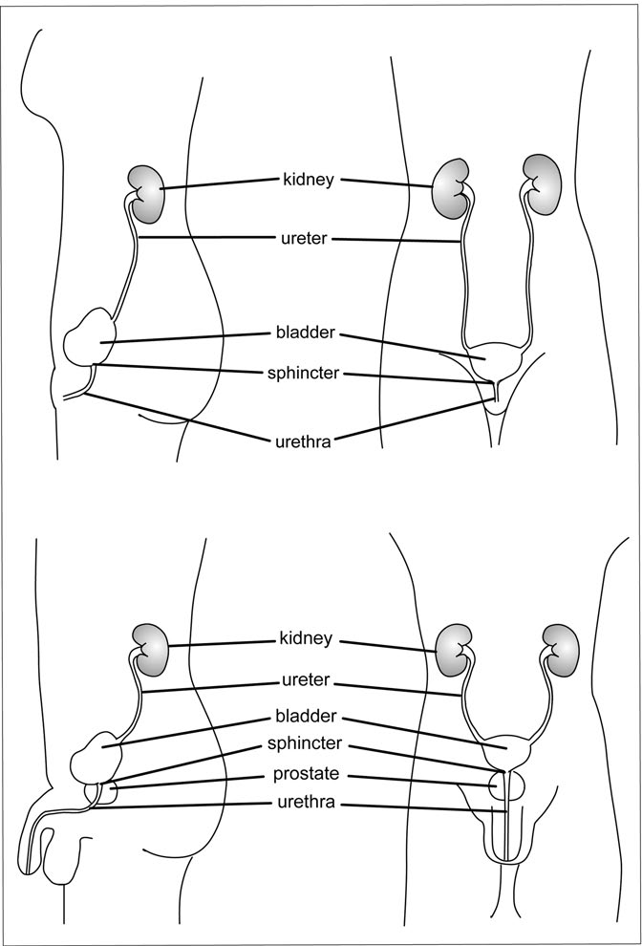

Figure 12.1 The Female and Male Urinary Systems. The two ureters lead from the kidneys to the bladder. The female urethra is shorter (1½ inches) than the male urethra (8 inches). In the male, the walnut-shaped prostate encircles the urethra. (Sandy Windelspecht/ Ricochet Productions)

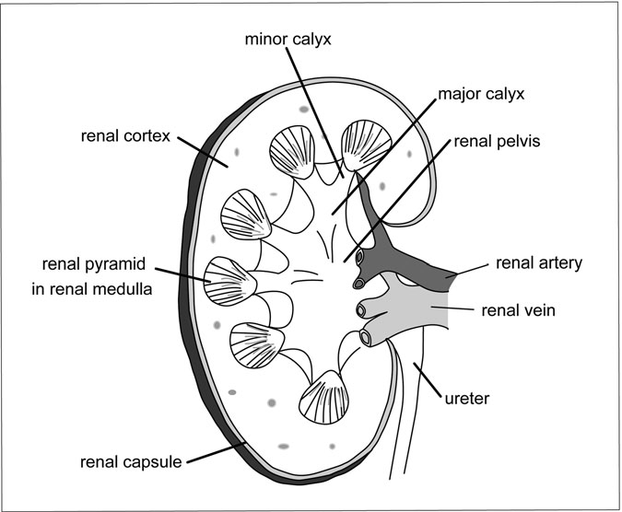

Figure 12.2 The Kidney. Filtered urine drains from the renal pyramids into the minor calyces, through the major calyces, and on into the renal pelvis. From there, it ﬂows down through the ureter to the bladder. (Sandy Windelspecht/Ricochet Productions)

larger openings called major calyces, through the funnel-shaped renal pelvis, and on to the ureter and bladder.

Most kidney function actually takes place in microscopic cup- shaped capsules called nephrons. Each kidney contains about one million nephrons, and it is here that the blood is ﬁltered. Toxic wastes are removed while water and necessary nutrients are reabsorbed into the system. Nephrons also control the blood pH level—in other words, they make sure that the blood is neither too acidic nor too alkaline. Inside each nephron is the glomerulus, a network of tiny blood vessels or capillaries, which are contained in a thin sac called the glomerular capsule (also

called the Bowman’s capsule). About 25 percent of the total blood pumped by the heart passes through the kidneys every minute. The blood enters each kidney via the renal artery in the hilius (the curved notch near the center on the side of each kidney), then branches off into the capilla- ries of the glomerulus. As the blood ﬂows out of the glomerulus, it passes through a three-layered membrane, beginning the ﬁltration process. The membrane stops blood cells and large protein molecules from passing through, but allows water, electrolytes, sugars, and amino acids to con- tinue into the glomerular capsule.

When the ﬁltered ﬂuid, called glomerular ﬁltrate, reaches the glomerular capsule, it moves through a small coiled tube—the proximal convoluted tubule (PCT). It is in this tubule that the real recycling work begins. Water, sodium, sugar, calcium, proteins, and other substances the body needs are reabsorbed into the bloodstream through tiny capillaries. The remainder of the ﬂuid, containing substances not reabsorbed by the blood—such as water, urea (a waste product created by the breakdown of proteins), and excess salts—is carried through the U-shaped loop of Henle, to the distal convoluted tubule (DCT). Several distal tubules empty the waste, called urine, into a single collecting duct. The collecting duct in turn empties urine into larger papillary ducts. As it moves down the path from proximal convoluted tubule to papillary duct, the solution is continually being ﬁltered, so that by the time it reaches the ureters, about 99 percent of the origi- nal glomerular ﬁltrate has been reabsorbed into the bloodstream. The cleansed blood makes its way back to the heart through the renal vein, while the urine ﬂows into the calyces of the renal pelvis on its way to the ureters.

Kidney Functions

The kidneys have three main functions: homeostasis, waste removal, and hormone secretion.

*Homeostasis*: The primary function of the kidneys is homeostasis— maintaining a balance of ﬂuids within the body. The body contains more than 40 quarts (37 liters) of ﬂuid, which is found in and around the cells. About two-thirds is intracellular ﬂuid, located within the cells themselves. About 75 percent of the remaining extracellular ﬂuid is found in the tissue outside of the cells (called interstitial ﬂuid), and the other 25 percent is contained in plasma, the ﬂuid portion of blood.

Water passes in and out of these three ﬂuid areas via a process known as osmosis. Surrounding each cell is a semipermeable (or selectively permeable) membrane, which separates ﬂuids of different concentrations. The semipermeable membrane allows certain molecules to pass through while restricting the movement of other molecules. In osmosis, water moves across this membrane via a passive process called diffusion, from an area of higher concentration to an area of lower concentration until the two volumes are equal. The process is called passive because ﬂuid is not pushed across the membrane by any outside force, but simply ﬂows from higher to lower concentration.

The body takes in about 2.5 quarts (2,500 millimeters) of water every day through food and beverages. What goes in must equal what goes out, and the body has several routes by which ﬂuid can exit the body: the kidneys (urine), skin (perspiration), lungs (breath), and intestines (feces). When a malfunction in the water removal process occurs, the body becomes overly saturated or parched. Too much water in the blood can force the heart to work harder and dilute essential chemicals in the system. Dehydration, or too little water, can lead to low blood pressure or shock and is potentially fatal. The kidneys help to balance the ﬂuid in the body by reabsorbing liquid into the bloodstream when levels get too low, or by eliminating excess ﬂuids when levels rise too high. These processes are overseen by the hypothalamus, the part of the brain that also regulates metabolism, body temperature, blood pressure, and hormone secretion.

If the concentration of water drops too low (because not enough liquid was ingested or because ﬂuid was lost through sweating, vomiting, or diar- rhea), neurons called osmoreceptors send a message to the hypothalamus, which in turn tells the pituitary gland to secrete antidiuretic hormone (ADH; also known as vasopressin) into the bloodstream. This hormone increases the permeability of the distal convoluted tubules and the collecting ducts in the nephrons of the kidneys, thus returning more ﬂuid to the blood- stream. When more water is reabsorbed, the urine becomes more highly concentrated and is excreted in smaller volume. When the ﬂuid concentra- tion in the body is too high, ADH is not released. The distal convoluted tubules and collecting ducts are less permeable to water, and the kidneys ﬁlter out excess ﬂuid, producing a larger volume of more dilute urine.

The kidneys must also maintain a balance of sodium, potassium, and other electrolytes in body ﬂuids. To do this, they separate ions from the blood during ﬁltration, returning what is needed to the bloodstream and sending any excess to the urine for excretion. Electrolyte levels are directed by the endocrine system, a collection of hormone-releasing glands. Hormones are chemical signals that travel through the blood- stream, triggering cells to complete a particular job.

Sodium and potassium are two of the most important electrolytes, because without them, ﬂuids would not be able to properly move between the intracellular and extracellular spaces. Sodium is the most abundant electrolyte in the extracellular ﬂuid, and it also plays an important role in nerve and muscle function. The presence of too much sodium (a condi- tion called hypernatremia) will cause water from inside the cells to cross over into the extracellular region to restore balance, causing the cells to shrink. If nerve cells are affected, the result can be seizures, and in rare cases, coma. Too little sodium (called hyponatremia)—lost from exces- sive diarrhea, vomiting, or sweating—can send water into the cells, caus- ing them to swell. This can lead to weakness, abdominal cramps, nausea, vomiting, or diarrhea. The swelling is even more dangerous if it occurs in the brain, where it can lead to disorientation, convulsions, or coma.

Potassium assists in protein synthesis and is crucial for nerve and muscle function. Too little potassium can lead to a buildup of toxic sub- stances in the cells that would normally pass into the extracellular ﬂuid. To prevent a sodium-potassium imbalance, the cells use a mechanism called the sodium/potassium pump. This pump is a form of active trans- port (as opposed to the passive transport used in osmosis), which means that ﬂuid can pass from one side of a semipermeable membrane to another, even if the concentration is already high on that side. But active transport requires energy to push molecules across the membrane. That energy is derived from adenosine triphosphate (ATP), a byproduct of cellular respiration. Once activated by ATP, the sodium/potassium pump pushes potassium ions into the cell while pumping sodium ions out of the cell until a balance is reached.

Endocrine hormones regulate the amount of sodium and potassium in the bloodstream. In the case of a sodium imbalance, an enzyme secreted

by the kidneys, called renin, stimulates the production of the hormone aldosterone by the adrenal glands located just above the kidneys. Aldosterone forces the distal convoluted tubules and collecting ducts in the nephrons to reabsorb more sodium into the blood. It also maintains potassium homeostasis by stimulating the secretion of potassium by the distal convoluted tubule and collecting ducts when levels in the blood- stream get too high. Aldosterone also indirectly regulates the balance of chloride. As sodium is reabsorbed, chloride is present and is passively reabsorbed into the bloodstream.

Parathyroid hormone (PTH), produced by the four parathyroid glands in the neck, regulates levels of bone-building calcium and phos- phate. When calcium concentrations in the body drop, PTH pulls calcium from the bones, triggers the renal tubules to release more calcium into the bloodstream, and increases the absorption of dietary calcium from the small intestine. When too much calcium circulates in the blood, the thyroid gland stimulates the production of another hormone, calcitonin, which causes bone cells to pull more calcium from the blood and increases calcium excretion by the kidneys. PTH decreases phosphate levels in the blood by inhibiting reabsorption in the kidney tubules, and calcitonin stim- ulates the bones to absorb more phosphate.

In addition to ﬂuid and electrolyte balance, the kidneys play a crucial role in regulating the acidity, or pH, of ﬂuids in the body. Water in the body is composed of hydrogen and oxygen molecules, which are held together by a chemical bond. Often the hydrogen and oxygen molecules separate into the positively charged H+ ions and the negatively charged OH− ions. An excess of H+ will make the solution acidic, and too much OH− produces an alkaline solution. Acidity is generally measured on a scale of 0 to 14. A neutral solution measures 7, right at the center of the scale. The higher the pH, the more alkaline the solution; the lower the pH, the more acidic the solution. The body pH must remain within a very narrow range, between 7.35 and 7.45, in order to survive. Fortunately, when the body ﬂuids become too acidic or too alkaline, the kidneys either eliminate or reabsorb hydrogen ions until the pH returns to within its normal range.

*Waste Removal:* As food moves through the stomach and intestines, digestive enzymes break the nutrients into smaller particles to be used

by the body. This breakdown process releases several toxic waste products into the bloodstream. These include:

* *Urea*: Amino acids, derived from protein metabolism, are broken down in the liver to form ammonia. Because ammonia is too poisonous for the body to process, the liver converts it into the less toxic urea for removal.
* *Uric acid*: This is formed by the breakdown of purines (components of foods) in the tissues.
* *Ketone bodies*: These are produced by the breakdown of excess fatty acids in the liver.
* *Creatinine*: This is a by-product of muscle metabolism.

If any of these wastes were allowed to build up in the blood, they would eventually poison the blood and cells. The kidneys ﬁlter out dissolved wastes from the bloodstream to form urine, which is eventually removed from the body. More on urine formation will be detailed later in this chapter.

*Hormone Secretion*: The kidneys either secrete or activate three essen- tial hormones:

* *Erythropoietin*: This stimulates the production of red blood cells in bone marrow.
* *Calcitrol*: This promotes bone growth by increasing the levels of calcium and phosphorous in the blood.
* *Aldosterone*: This regulates blood pressure and sodium balance by increasing the ﬁltration of blood in the kidneys, increasing water reab- sorption, and decreasing the amount of sodium that is lost. The kidneys do not actually produce aldosterone, but they do control its production by secreting renin, an enzyme that converts a protein in the blood called angiotensin to angiotensin I. As it passes through the lungs, angiotensin I is converted into angiotensin II. Angiotensin II stimulates the release of the hormone aldosterone from the adrenal cortex.

##### The Ureters

Out of each kidney extends a ureter, a thin, hollow tube that reaches down into the bladder. Each ureter stretches about 12 inches and, at its widest portion, measures about 0.5 inches around. The ureters pierce the bladder walls from either side, forming a U shape. At the bottom of the U, the ureters connect to the triangular-shaped area on the bladder ﬂoor called the trigone. As the kidneys turn waste into urine, muscles lining the ureter walls help to push the urine down into the bladder for storage. Urine enters the bladder through openings called ureteral oriﬁces. Valve-like mucous mem- branes inside the ureters keep the urine inside the bladder and prevent it from traveling back up toward the kidneys where it could cause an infection.

##### The Bladder

The hollow, muscular bladder stores urine until it is time for elimination (Figure 12.3). The bladder is located in the abdomen, just behind the pubic bone. As mentioned in the previous section, the ureters pierce the top of the bladder at a diagonal angle, forming a U shape where they intersect with the trigone. At the bottom of the trigone, in the neck of the bladder, is the opening to the urethra through which urine exits the body.

The inside of the bladder is composed of three layers: the mucosa, detrusor muscle, and serosa. The serosa, or outer coat, is made up of ﬁbrous tissue. The detrusor muscle is actually a collective term for three layers of smooth muscle. This muscle is involuntary, meaning that it is not consciously controlled but is under the direction of the autonomic nervous system (see the section on urine removal later in this chapter for a description of the autonomic nervous system’s role in bladder contrac- tions during urination; for more information on the autonomic nervous system, see Chapter 8 in this encyclopedia). Finally, the mucosa, or inner lining, protects the bladder from infection.

As the bladder ﬁlls with urine, it stretches like a balloon. A healthy adult bladder can comfortably hold 14–20 ounces (400–600 milliliters) of urine. When the bladder ﬁlls up, a message is sent to the spinal cord indicating the need to urinate. The bladder muscles are relaxed during ﬁlling, but they contract during urination to push the urine down the urethra and out of the body. As the bladder contracts, its walls compress, preventing urine from

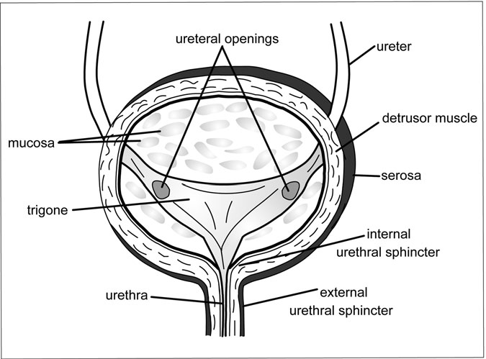

Figure 12.3 The Bladder. The ureters pierce the bladder on either side, reaching down into the organ to form a triangular shape, called the trigone. As urine funnels down the ureters and into the bladder, the detrusor muscle in the bladder wall is relaxed. When the bladder empties, the detrusor muscle contracts, and the internal and external urethral sphincters relax. (Sandy Windelspecht/Ricochet Productions)

backing up into the ureters and kidneys. The angle of the bladder also shifts during urination. While it is ﬁlling, the bladder is tilted at the point where it attaches to the urethra to prevent leakage. But during urination, the angle shifts to allow urine to ﬂow down the urethra and out of the body.

##### The Prostate

Only men have a prostate, the doughnut-shaped gland that surrounds the urethra at the point where it connects to the bladder (Figure 12.4). In young men, the prostate is about the size and shape of a walnut, but with increasing age it can enlarge to about the size of an orange.

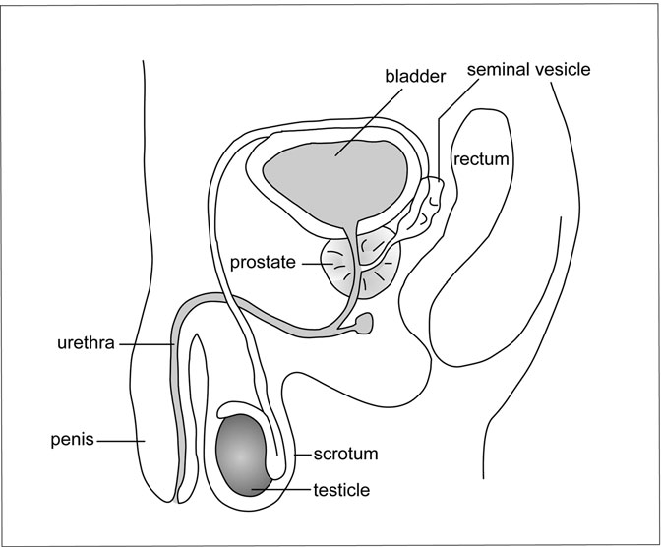

Figure 12.4 The Prostate Gland. Close-up of the prostate gland

from the point at which it connects to the bladder. (Sandy Windelspecht/ Ricochet Productions)

The primary function of the prostate is to add nutrients and liquid volume to the sperm. Thousands of tiny glands inside the prostate produce a ﬂuid that is mixed with sperm in the urethra during orgasm. The combined ﬂuids, called semen, are released through the penis during ejaculation (the repro- ductive functions of the prostate are discussed in greater depth in Chapter 8 of this encyclopedia). The prostate also protects the bladder from infection. Its muscular ﬁbers squeeze to help control the ﬂow of urine into the urethra.

##### The Urethra

The thin, muscular tube of the urethra connects the bladder to the exterior and provides a passageway for urine to leave the body. The wall of the

urethra is made up of a mucous membrane, as well as a layer of smooth muscle tissue. The length, path, and function of the urethra differ in men and women.

In men, the urethra is about 8 inches long and is connected from the bladder to the tip of the penis. It not only carries urine, but it also serves as the duct through which semen is released during ejaculation. In women, the urethra only measures about 1.5 inches in length, which is why women are much more likely to suffer a urinary tract infection than men. This short length makes it easier for urine to slip back up into the bladder and cause infection. The urethra connects to the top of a woman’s vagina, just beneath the clitoris, and its sole function is to carry urine out of the body.

##### The Urinary Sphincter

Two groups of muscles, called sphincters, control the ﬂow of urine out of the bladder. Where the bladder and urethra meet is a ring of smooth muscle called the internal urethral sphincter. These involuntary muscles stop urine from ﬂowing back up the urethra to the bladder. At the end of the urethra is the external urethral sphincter, voluntary muscles that release and tighten to start and stop urine ﬂow. When open, the internal and external sphincter muscles allow urine to exit the body. When closed, they prevent the urine from escaping.

The sphincter muscles are designed to work in conjunction with the bladder. When the bladder relaxes to allow urine to enter, the sphincter muscles remain closed to prevent leakage. As the bladder contracts during urination, the sphincter muscles relax, allowing urine to ﬂow out of the body. If they fail to work together, urine may leak from the bladder, lead- ing to incontinence.

#### What Is Urine and How Is It Formed?

Every day, about 190 quarts (180 liters) of blood plasma pass through the nephrons of the kidneys. Most of that liquid—about 188 quarts—is cleansed and returned to the bloodstream. The remainder is removed from the body as urine.

Urine formation involves three processes:

1. *Filtration*: Blood from the renal artery enters the nephrons of each kidney and passes through the tiny ﬁltering units of the glomeruli. Blood pressure inside the capillaries of each glomerulus pushes water, small molecules (such as glucose, amino acids, and waste products like urea), and electrolytes into the Bowman’s capsule, while leaving the larger blood cells and proteins in the bloodstream. The ﬁltered ﬂu- ids are called the glomerular ﬁltrate. The amount of ﬁltrate that forms in the glomerular capsule of both kidneys every minute is called the glomerular ﬁltration rate (GFR). In a healthy adult, the normal GFR is about 4.2 ounces (125 milliliters) per minute.
2. *Reabsorption*: When the glomerular ﬁltrate exits the glomerular capsule, it enters the proximal convoluted tubules. Nearly all of the water, sodium, and nutrients such as glucose, potassium, and protein are reabsorbed from the ﬁltrate into the bloodstream. About half of the urea is also reabsorbed; the rest is excreted in the urine. The move- ment of these substances occurs through active and passive transport. Glucose, amino acids, sodium, and potassium are carried across the cells of the tubules via active transport. Water is reabsorbed passively via osmosis.
3. *Secretion*: As the ﬁltrate enters the loop of Henle and moves up the distal convoluted tubule, wastes from the blood are added. Secretion is essentially reabsorption in reverse—rather than substances moving from the ﬁltrate into the blood, they move from the blood into the ﬁltrate. Substances added to the ﬁltrate may include excess hydrogen, potassium, nitrogenous wastes (urea, creatinine, and uric acid), and certain drugs (such as penicillin). After rising up the ascending limb of the loop of Henle, the ﬁltrate moves through the distal convoluted tubule and into the collecting duct, where it is referred to as urine.

##### What Makes Up Urine?

Because the human body is composed of about 50 to 70 percent water, it makes sense that the urine is made up primarily of water. In fact,

about 95 percent of urine is water. The remainder is made up of dis- solved wastes, including urea, creatinine, uric acid, and ketone bodies. The urine may also contain small amounts of substances the body nor- mally uses, like sodium, potassium, and calcium. If the bloodstream contains excessive amounts of these nutrients, the kidneys will excrete the leftover portion into the urine. Other substances may end up in the urine that signal a problem within the body. The presence of protein or white blood cells during a urinalysis may indicate an infection or inﬂammation of the kidneys. Glucose in the urine may signal diabetes.

The volume and concentration of water in the urine are determined by how much water is reabsorbed as the ﬁltrate passes through the end of the distal convoluted tubules and collecting ducts on the ﬁnal leg of the urine production process, as controlled by the antidiuretic hormone (ADH) (see the section “How Is Urine Removed from the Body?” later in this chap- ter). If the body is dehydrated, more ADH is produced, making the cells more permeable to water. As more water is reabsorbed by the kidneys, the urine becomes more concentrated. If there is too much water in the body, less ADH will be produced, and water will not be reabsorbed in the distal convoluted tubules and collecting ducts, making the urine more dilute.

##### What Are the Characteristics of Urine?

Urine is typically yellow or amber in color. The yellow color is created by urochrome, a pigment produced from the breakdown of bile (the yellow- ish ﬂuid secreted by the liver to digest fats). The color of urine may change depending on ﬂuid levels in the body and on the types of foods ingested. A deﬁciency of ﬂuid in the body forces the kidneys to absorb more water, creating a more concentrated, darker-colored urine. Too much ﬂuid in the body results in a more dilute, lighter-colored urine. If the urine turns green or red, it may simply be because a person’s diet included asparagus, beets, foods containing dyes, or certain medications. A change in color alone is usually no cause for concern, but the presence of pinkish or red blood in the urine (hematuria) can be a sign of disease (like kidney stones) or infection.

Normal, healthy urine is clear immediately after urination, but becomes cloudy when left standing. Likewise, urine does not have a

strong smell as it leaves the body, but when left outside for any length of time, it develops an ammonia-like odor. This occurs because of the process in which the liver breaks down proteins. Referring back to the dis- cussion on waste removal in the kidney function section of this chapter, the breakdown of proteins releases ammonia, which is too toxic for the body to handle. Ammonia is converted into the less toxic urea before it is sent to the kidneys for ﬁltration. But when urea in the urine is exposed to oxygen in the air, it converts back to ammonia, which explains the strong odor. If the urine has a strong, foul smell immediately after leaving the body, it may be the result of bacteria from a urinary tract infection. In diabetics, urine will have a sweet, fruity smell because it contains excess ketone bodies.

The normal pH of urine ranges from 4.5 to 8.0, averaging around 6.0. The more acid the body retains, the more acidic the urine. Certain condi- tions may lead to overly acidic urine, including uncontrolled diabetes, diarrhea, dehydration, and acidosis (an abnormal increase in acidity when blood pH drops below 7.35). Urine tends to be more alkaline when an individual suffers from urinary tract obstruction or chronic kidney failure. A vegetarian diet can also make the urine more alkaline.

How Is Urine Removed from the Body? The average person drinks between 1.5 and 2 quarts (1,500–2,000 milliliters) of ﬂuid per day, and voids between 1 and 2.5 quarts (1,000–2,500 milliliters).

Obviously, the more liquids that are ingested, the more urine the kidneys

produce and eliminate. How much urine is produced also depends on the types of liquids ingested. For example, soda and coffee contain caffeine, which is a diuretic. A diuretic increases urine production and leads to more frequent urination than a nondiuretic like water.

If an individual urinates more than the volume of liquids ingested, the body becomes dehydrated. Prolonged dehydration can be caused by excessive sweating, vomiting, diarrhea, or extremely rare conditions like diabetes insipidus. If the ﬂuid level in the body drops too low, serious illness may occur. Extreme dehydration can eventually result in death. Thankfully, the body has a built-in regulating system to prevent dehydra- tion. When the level of ﬂuid in the extracellular spaces drops, receptors

in the hypothalamus of the brain release the antidiuretic hormone (ADH) into the bloodstream. ADH increases the reabsorbtion of water in the dis- tal convoluted tubules and collecting ducts of the kidneys, creating a more concentrated urine. It also triggers that dry-mouthed feeling of thirst.

The average person urinates every 3–5 hours throughout the day and can sleep through the night without having to use the bathroom. Of course, what is normal varies from person to person. Some people may drink more, and therefore ﬁnd it perfectly normal to urinate every 1–2 hours, while others drink less or have more accommodating bladders, and may only have to go every 5–6 hours. The volume of each urination can vary from about 4 ounces to 34 ounces, depending upon how much the kidneys are producing and how much the bladder can comfortably hold.

The process by which urine is released from the bladder, through the urethra, and out of the body is called micturition, or urination, and it occurs continuously. Every 10–15 seconds, small amounts of urine are forced down the thin tubes of the ureters and into the bladder. The bladder stores urine until an appropriate time—that is, until the person has reached a bathroom. As mentioned earlier, when the bladder ﬁlls, its muscles relax, but the muscles of the sphincters that surround the bladder opening tighten to prevent leakage. The process leading up to urination is con- trolled by the central nervous system and involves a combination of invol- untary and voluntary nerve impulses. The bladder is controlled by the autonomic nervous system, which oversees other involuntary actions such as breathing. The voluntary muscles of the urethra are controlled by the somatic nervous system. As the amount of urine rises and the bladder stretches, receptors in its walls send a message to the spinal cord via sensory neurons that it is getting full. The spinal cord passes the message along to the brain in the form of impulses, and the result is that feeling of pressure in the lower abdomen that signals the need to urinate.

When it is time to urinate, parasympathetic nerves release the neuro- transmitter acetylcholine, which causes the detrusor muscle in the wall of the bladder to contract and the internal urethral sphincter to relax. At the same time, the brain tells the sphincter muscles, which until now have been tightly holding the bladder and urethra shut, to relax. As the muscles relax, the urethra opens, and urine is allowed to exit the body.

##### When the Urination Process Fails

Losing voluntary control over the micturition, or urination, process is called incontinence. Babies naturally wet themselves because their brains and spinal cords have not matured enough to control the sphincter muscle. But if incontinence occurs in adults, it is usually the result of disease or injury to the nerves controlling the bladder, damage to the external sphinc- ter, or infection.

The opposite problem, retention, is the inability to urinate. This may be caused by a blockage in the urethra or bladder neck, an uncontrolled contraction in the urethra, or the lack of an urge to urinate.

#### Summary

Each of the human body’s systems performs a signiﬁcant job that keeps it functioning and healthy. As emphasized throughout this encyclopedia, each system depends on the other systems to perform its duties. The urinary system’s primary responsibility is to remove waste from the body. However, this system has other important jobs also, including ensuring that the body is properly hydrated and the body ﬂuids are in proper balance. The organs or components of the urinary system that are integral to its function are the kidneys, ureters, bladder, urethra, and in men, the prostate. These organs play the key roles in urine production, storage, and elimination as well as the other processes of the urinary system.

Glossary

Abduction Withdrawal of a part of the body from the body’s axis.

ABO group The name of the genetic system that determines human blood groups. Named for the presence of A and B carbohydrates on the surface of the cell, or the absence of the carbohydrates in the case of the O group. This system uses four possible combinations: A, B, AB, or O.

Acetylcholine (ACh) A neurotransmitter released in the central and peripheral nervous system, speciﬁcally at neuromuscular joints.

Acetyl Coenzyme A (acetyl CoA) A molecule that enters the citric acid cycle to produce energy. The acetyl CoA can come from sugars that have gone through glycolysis, or it can come directly from fats or proteins in the cell.

Acidosis An abnormal increase in the acidity of the body’s ﬂuids.

Acquired Immunity A type of immunity that is not the result of genetic inheritance, but rather due to the exposure to some antigen and the result- ing response by the immune system.

Actin One of the major proteins involved in muscle contraction. Actin proteins form a long ﬁber within the muscle contractile unit. Myosin, the other major protein involved in muscle contraction, attaches to the actin ﬁlaments and pulls the muscle shorter.

Action Potential A change in the electrical charge of a nerve cell follow- ing the transmission of a nerve impulse.

Adaptation The state of sensory acclimation in which the sensory aware- ness diminishes despite the continuation of the stimulus.

Adduction Movement of a limb toward the median line of the body.

619

Adenosine Diphosphate (ADP) A chemical substance produced through digestion and used in cell respiration and energy production.

Adenosine Triphosphate (ATP) A chemical substance produced from aerobic cell respiration that is the muscle’s direct source of energy for movement.

Adipocytes Cells that have large holes ﬁlled with fat.

Adipose Capsule The central layer surrounding the kidney, composed of fatty tissue.

Adrenal Glands The hormone-releasing glands located above the kidneys.

Adrenaline Also known as epinephrine, a hormone produced by the adre- nal glands that helps regulate the sympathetic division of the autonomic nervous system. During times of stress or fear, the body produces addi- tional amounts of adrenaline into the bloodstream, causing an increase in blood pressure and cardiac activity.

Adrenocorticotropic Hormone (ACTH) Hormone produced by the pituitary gland, which stimulates the release of hormones from the adrenal cortex. Also called corticotropin.

Aerobic Anything having to do with acquiring oxygen from the air.

Aerobic Cell Respiration A chemical process that allows the cell to pro- duce energy from glucose and oxygen.

Aerobic Exercise Exercise in which energy is made by processes invol- ving oxygen. Types of aerobic exercise include swimming, biking, and jogging.

Afferent Nerves Fibers coming to the central nervous system from the muscles, joints, skin, or internal organs.

Afferent Vessels A form of vessel that brings ﬂuid towards an organ or lymph node.

After-image An image of a visual nature that exists even after the visual stimulus has ceased.

Agglutination The clumping of blood. This can occur if a patient with a certain blood type is given blood of another type.

Agonists Hormones that bind to their receptor and elicit a speciﬁc biologi- cal response.

Albumin The most abundant plasma protein. It makes up 55 percent of the total protein content of plasma. It is involved in maintaining blood vol- ume and water concentration.

Aldosterone A hormone secreted by the adrenal glands in the kidneys that increases sodium reabsorption.

Alkaline A term used to indicate a pH of 7 or greater. Sometimes also called basic.

Allele A variation of a gene that encodes for a speciﬁc trait. It is usually due to minor variations in the DNA at the molecular level.

Allergies Hypersensitive reaction to a particular substance or allergen; symptoms vary in intensity.

Alveoli Tiny air sacs in the lungs. They exchange oxygen and carbon dioxide between the lungs and the blood.

Amino Acids The building blocks of proteins.

Amphiarthrosis Joint that permits only slight movement.

Amphiphatic Molecules A term given to a molecule that has both hydro- philic and hydrophobic properties.

Anaerobic Exercise Exercise in which energy is made by processes that do not involve oxygen. Types of anaerobic exercise include weight lifting and sprinting.

Androgens Male sex hormones produced by the gonads and adrenal cortex.

Anemia A reduction in the number of red blood cells in the body, result- ing in an insufﬁcient number of hemoglobin molecules to carry oxygen to the tissues of the body. This may result in tissue color changes, weak- ness, and increased susceptibility to disease.

Anions Negatively charged particles.

Annulus Fibrosus A ring of ﬁbrous connective tissue that serves as an anchor for the heart muscle and as an almost continuous electrical barrier between the atria and ventricles.

Antagonistic Muscle Pair Two muscles that have an opposite action, such as the muscle that bends the arm and the muscle that straightens the arm. The antagonistic pair controls and stabilizes the elbow as it bends and straightens.

Antagonists Hormones that bind to the receptor but do not trigger a bio- logical response. By occupying the receptor, an antagonist blocks an ago- nist from binding and thus prevents the triggering of the desired effect within the cell.

Anterior Situated in front; at or toward the head end of a person or animal.

Anterior Pituitary The lobe of the pituitary that secretes hormones that stimulate the adrenal glands, thyroid gland, ovaries, and testes.

Antibody Proteins that attack antigens.

Antidiuretic Hormone (ADH) Hormone produced by the pituitary gland that increases the permeability of the kidney ducts to return more ﬂuid to the bloodstream. Also called vasopressin.

Antigens Invading organisms and materials that enter the human body. The body may mount a defense with antibodies.

Antioxidants Compounds that prevent oxidative damage to organic mole- cules. Vitamins C and E are examples of antioxidant nutrients, as is the min- eral selenium.

Aorta The largest artery in the human body. It supplies oxygenated blood from the left ventricle of the heart to the branching arteries, which in turn supply oxygen to all parts of the body.

Aortic Arch A large, rounded section of the aorta that occurs above the heart, just after the aorta leaves the right ventricle.

Aortic Bodies Chemoreceptors found in the aortic arch, the curved por- tion between the ascending and descending parts of the aorta.

Appendectomy The surgical procedure that is used to remove an inﬂamed,

diseased, or ruptured appendix.

Appendicitis An inﬂammation of the appendix. This is usually caused by an infection of the appendix and results in fever, pain, and loss of appetite.

Appendicular Skeleton The skeletal structures composing and support- ing the appendages; these include the bones of the shoulder and hip girdles as well as those of the arms and legs.

Arterial Baroreceptor Reﬂex The mechanism that provides oversight and maintenance of the blood ﬂow by responding to slight changes in blood pressure.

Arterial System The portion of the circulatory system that delivers oxygen-rich blood to the body tissues.

Arteries Larger blood vessels that deliver oxygen-rich blood to the body tissues.

Arterioles Smaller blood vessels that deliver oxygen-rich blood to the body tissues.

Arteriovenous Anastomoses Blood vessels that directly connect arte- rioles to venules. Commonly, blood travels from arterioles to capillaries to venules. Arteriovenous anastomoses are typically found in only a few tissues.

Arthritis An inﬂammation of the joints.

Asexual Reproduction Reproduction in which genetically identical off- spring are produced from a single parent.

Atherosclerosis Also known as hardening of the arteries. It is a narrowing of arterial walls caused by deposits, collectively called plaque, that create rough, irregular surfaces prone to blood clots.

Atria Plural of atrium.

Atrium In the human heart, it is one of the heart’s two upper chambers. The plural form is atria.

Autocatalytic Process A chemical reaction in which the products of the reaction are responsible for initiating the start of the reaction.

Autocrine The action of a hormone on the cells that produced it.

Autoimmune A term used to describe an immune response to the patient’s own body. An autoimmune disease is therefore one that attacks part of the patient’s body.

Autoimmune Disease This occurs when the immune system incorrectly identiﬁes the tissues of the body as foreign material, and begins an immune response against the cells or tissue. Lupus and forms of diabetes may be caused by an autoimmune response.

Autonomic Nervous System The part of the nervous system that controls involuntary actions and rules the variations of the heart rate.

Axial Skeleton The central supporting portion of the skeleton, composed of the skull, vertebral column, ribs, and breastbone.

Axon A single nerve ﬁber that carries impulses away from the cell body and the dendrites.

B Cells Also known as B lymphocytes. They are one of two main types of lymphocyte, and participate in the body’s immune response.

B Lymphocytes *See* B Cells.

Baroreceptors Pressure detectors located in the major arteries. Part of the arterial baroreceptor reﬂex, they sense a dip or spike in blood pressure.

Basilar Artery A blood vessel that arises from the vertebral arteries and joins with other cerebral arteries to form the circle of Willis.

Basophil A type of granulocyte that appears to be active in the inﬂammatory process.

Bayliss Myogenic Response The mechanism by which smooth muscle cells impart muscle tone to the blood vessels.

Bilirubin A waste product produced by the liver that is the result of the breakdown of red blood cells. It is released into the small intestine, but some is reabsorbed back into the blood and excreted with the urine.

Binucleate Cell A cell that contains two nuclei.

Bioavailability A term of nutritional analysis that indicates how much of a nutrient in a food is actually available to the body for absorption by the gastrointestinal tract.

Biomarker A molecular clue indicating the presence of disease or the genetic predisposition for disease.

Biomolecule A general classiﬁcation for any of the four groups of organic molecules that are used in the building of cells—proteins, carbohydrates, lipids, and nucleic acids.

Bipedal An animal that walks on two feet.

Bladder A hollow, muscular organ that stores urine for elimination.

Blastocyst An embryonic stage following the morula stage characterized by outer trophoblast cells, an inner cell mass, and a central, ﬂuid-ﬁlled cavity.

Blood The ﬂuid that contains the plasma, blood cells, and proteins and carries oxygen, carbon dioxide, nutrients, waste products, and other mole- cules throughout the body.

Blood Cells Cells contained in the plasma of the blood. *See also* Red Blood Cells and White Blood Cells.

Blood Pressure The force of the blood against the walls of the blood vessels.

Blood Sugar Level The amount of glucose in the blood.

Blood Type A form of blood, determined by the presence or absence of chemical molecules on red blood cells. A person may have type A, B, O, or AB blood.

Blood Vessels Also known as the vasculature. These are the tubes of the circulatory system that transport the blood throughout the body.

Bohr Effect High concentrations of carbon dioxide and hydrogen ions in the capillaries in metabolically active tissue that decrease the afﬁnity of hemoglobin for oxygen and leads to a shift to the right in the oxygen dis- sociation curve.

Bolus The name given to the mass of food that accumulates at the rear of the oral cavity for swallowing.

Bone Marrow The site in the body where the cells of the lymphatic system originate.

Bowman’s Capsule The bulb surrounding the glomeruli. It provides an efﬁcient transfer site for water and waste products to move from the blood to the urinary system.

Brachial Artery The blood vessel in the upper arm that accepts blood from the subclavian artery by way of the axillary artery, and travels down the arm to supply the ulnar, radial, and other arteries of the forearm.

Brachial Vein The blood vessel that collects blood from the ulnar vein and empties into the axillary vein.

Brachiocephalic Artery Also known as the innominate artery. This short blood vessel arises from the aortic arch, and branches into the right common carotid artery and the right subclavian artery.

Brachiocephalic Veins Also known as the innominate veins. This pair of veins arises from the convergence of the internal jugular and subclavian veins and ﬂows into the superior vena cava.

Brain Other than the spinal cord, the primary organ in the nervous system.

Brain Stem This area of the brain connects the cerebrum with the spinal cord and is also the general term for the area between the thalamus and the spinal cord, which includes the medulla and pons.

Bronchi The two large air tubes leading from the trachea to the lungs that convey air to and from the lungs.

Bronchial Vein One of two main blood vessels that collect newly oxygen- ated blood from the bronchi and a portion of the lungs, and deliver it through one or more smaller veins to the superior vena cava.

Bronchiole Any of the smallest bronchial tubes that end in alveoli.

Buccal Cavity Another term commonly used to describe the oral cavity. It technically represents the space between the back of the teeth and gums to the rear of the mouth.

Bundle of His A thick, conductive tract located in the heart that transmits the electrical signal from the AV node to the Purkinje ﬁbers in the base of the ventricle wall.

Bursa A sac of ﬂuid within a joint.

Calcitonin Hormone produced by the thyroid gland that inﬂuences cal- cium and phosphorous levels in the blood.

Calcitrol A hormone secreted by the kidneys that increases the levels of calcium and phosphorous in the blood.

Calorie A measure of how much energy food contains.

Cancellous Bone Bone that has a latticework structure, such as the spongy tissue in the trabecular bone.

Capillaries The tiniest blood vessels. They are the sites of exchange: At body tissues, blood in the capillaries delivers oxygen and nutrients, and

picks up carbon dioxide and waste products; and at the lungs, blood in the capillaries drops off carbon dioxide and picks up oxygen.

Carbon Monoxide Poisoning A medical condition arising when a person is exposed to carbon monoxide gas. Prolonged exposure can be fatal.

Cardiac (Heart) Muscle The type of muscle found in the heart.

Catecholamines A class of hormone (including epinephrine and norepi- nephrine) synthesized in the adrenal medulla that is involved in the body’s stress response.

Cation A positively charged particle.

Cell Body Main mass of the neuron that contains the nucleus and organelles.

Central Nervous System Division of the nervous system that contains the brain and the spinal cord.

Cerebellum Located towards the back of the medulla and pons, this por- tion of the brain is in charge of many subconscious aspects of skeletal muscle functioning, such as coordination and muscle tone.

Cerebral Aqueduct The tunnel that runs through the midbrain, allowing cerebrospinal ﬂuid to travel from the third to the fourth ventricle.

Cerebral Cortex This area of the brain is the gray matter located on the surface of the cerebral hemispheres. The cerebral cortex includes the brain’s motor, sensory, auditory, visual, taste, olfactory, speech, and associ- ation areas.

Cerebrospinal Fluid (CSF) The ﬂuid in the spinal cord’s central canal that serves as the ﬂuid for the central nervous system. This tissue ﬂuid cir- culates in and around the brain.

Cerebrum This is the largest portion of the brain and consists of the left and right cerebral hemispheres. The cerebrum controls movement, sensa- tion, learning, and memory.

Chemoreceptors Cells that respond to changes in their chemical environ- ment by creating nerve impulses. Some chemoreceptors in the brain respond to carbon dioxide levels in the blood to help regulate breathing.

Chemotaxis The reaction of mobile cells to a chemical gradient; the cells may move either towards or away from the gradient depending on the nature of the chemical being used.

Chloride Shift Describes the exchange of negatively charged chloride ions for negatively charged bicarbonate ions across an erythrocyte’s cell membrane.

Cholesterol A fatlike substance that occurs naturally in the body. Two types exist: high-density lipoprotein (HDL) and low-density lipoprotein (LDL).

Chondrocytes Cartilage cells.

Chordae Tendineae Tiny tendinous cords located at each of the heart valves. They attach to nearby muscles and prevent blood backﬂow through the valves.

Choroid Plexus This capillary network helps form the cerebrospinal ﬂuid in the brain.

Chromatin A diffuse mixture of DNA and proteins that condenses into chromosomes prior to cell division.

Chromosomes Cellular structures composed of proteins and DNA that carry the body’s hereditary information.

Cilia Hairlike projections from the surface of a cell. In the respiratory sys- tem, cilia help ﬁlter out foreign particles from the air before they reach the lungs.

Circadian Rhythm The body’s 24-hour biological cycle that regulates certain activities, such as sleep, regardless of environmental conditions, including lightness and darkness.

Circle of Willis A vascular structure that supplies blood to the brain. It arises from the basilar, internal carotid, and other arteries.

Circulatory System The heart, blood vessels, and blood.

Circumcision The surgical removal of the foreskin. The term is also sometimes used with reference to females to describe a controversial and excruciating practice of genital mutilation that is common in certain soci- eties around the world.

Citric Acid Cycle A chemical reaction that takes place in the mitochon- dria. The cycle produces some energy for the cell and produces products that can be used to produce large amounts of energy through oxidative phosphorylation.

Colic Arteries Divided into right, left, and middle colic arteries, all of which branch from either the inferior or superior mesenteric arteries, and feed the colon.

Collagen The albumin-like substance in connective tissue, cartilage, and bone.

Collecting Duct Where ﬂuid is carried from the distal convoluted tubule (DCT) in the nephron of the kidneys on its way to the minor calyx.

Colostrum Nutritious ﬂuids secreted by the breasts shortly before and after a woman gives birth; precedes the production of breast milk.

Common Carotid Arteries One of two major blood vessels that supply the head. The left carotid splits directly from the aortic arch between the bases of the two coronary arteries. The right carotid indirectly branches from the aorta via the brachiocephalic artery.

Complement The collective term for a variety of beta globulins. *See also*

Globulins.

Complement Fixation The process by which complement factors bind to either antibodies or cell surfaces during the immune response.

Complementary Base Pair Nucleotide bases (adenine and thymine or guanine and cytosine) that pair up via hydrogen bonds in DNA.

Compression Forces Forces that squeeze items together; blows that press against the body.

Computed Tomography (CT) Scan A commonly used tool for determin- ing the nature of a stroke.

Concentration Gradient The change in solute concentration from one location to another. Unless restricted, solutes will move from a site of higher solute

concentration to one of lower solute concentration, leading to an equi- librium between the two sites.

Concentric Contraction The type of contraction that occurs when a muscle contracts and grows shorter, such as the biceps muscle when bend- ing the elbow.

Conchae Structures or parts that resemble a seashell in shape with three bony ridges or projections—the superior, middle, and inferior conchae— on the surface of the nasal cavity sides.

Contraceptive An agent that prevents ovulation, kills sperm, or blocks sperm from reaching the ovum for fertilization.

Convergence An impulse pathway where a neuron receives impulses from the nerve endings of thousands of other neurons but transmits its message to only a few other neurons.

Coronal Plane Divides the body into front and back portions.

Coronary Arteries Arising from the base of the aorta, these are the two major arteries that feed the heart muscle. The right coronary artery remains a single, large vessel, but the left coronary artery almost immedi- ately splits into transverse and descending branches.

Coronary Circulation The circulatory system of the heart.

Corpus callosum A band of white matter connecting the cerebral hemispheres.

Corpus luteum Progesterone-secreting tissue that forms from a rup- tured Graaﬁan follicle in the mammalian ovary after the egg has been released.

Cortex The tissue layer that covers the brain.

Cortical Bone The hard, dense bone that forms the outer shell of all bones.

Corticotroph Cell in the anterior pituitary gland that secretes corticotropin (ACTH).

Cortisol A steroid hormone produced by the adrenal cortex that inﬂuences the body’s stress response.

Cranial Nerves The brain’s 12 pairs of nerves located in the peripheral nervous system.

Craniosacral Division Another name for the parasympathetic division of the autonomic nervous system. In this division, all the cell bodies of pre- ganglionic neurons are located in the brain stem and sacral segments of the spinal cord.

Cranium The bones of the skull that house the brain.

Creatinine Waste produced by the breakdown of creatine phosphate in muscles.

Creatine Phosphate A molecule stored in the muscle that can quickly replenish ATP during a sudden burst of exercise.

CT Scan *See* Computed Tomography (CT) Scan.

Cuboid Bones Bones in the wrist that are shaped like cubes.

Cutaneous Senses The skin’s sensory mechanisms whose receptors are located in the dermis.

Cytochromes A class of membrane-bound intracellular hemoprotein res- piratory pigments. These enzymes function in electron transport as car- riers of electrons.

Cytokines Signaling peptides secreted by immune cells and other types of cells in response to infection or other stimuli.

Cytoplasm Cellular material located between the nucleus and cell membrane.

Daughter Cells Cells arising from mitotic division that are identical to the parent cell.

Deglutition Another term used for the act of swallowing.

Dehydration Synthesis A form of chemical reaction that involves the removal of water to form a chemical bond. Also called a condensation reaction.

Dentin A tissue that is the majority of the mass of a tooth. It consists pri- marily of minerals (70 percent), with the remainder being water and organic material.

Depolarization When the electrical charges in a nerve cell reverse due to a stimulus. The rapid infusion of sodium ions causes a negative charge outside and a positive charge inside the cell membrane.

Detrusor Muscle Three layers of smooth muscle surrounding the mucosa of the bladder.

Diaphragm A muscle that aids in respiration. It separates the thoracic cavity from the abdominal cavity.

Diaphysis The central shaft of a bone.

Diastole The heart’s resting period.

Diathroses Joints allowing free movement.

Diffusion The passive ﬂow of molecules from one location to another.

Diploid Cells Any organism whose cells contain two copies of each chromosome. The majority of human cells, except sex cells and some liver cells, are diploid.

Dislocation Condition when a bone is moved out of a joint.

Distal Indicates direction away from the torso.

Distal Convoluted Tubule (DCT) Located between the loop of Henle and the collecting duct inside the nephron of the kidney.

Diuretic A substance (i.e., caffeine) that increases urine production.

Divergence An impulse pathway where a neuron receives impulses from a few other neurons and relays these impulses to thousands of other neurons.

DNA A nucleic acid that contains a cell’s genetic or hereditary information.

Dopamine A neurotransmitter found in the motor system, limbic system, and the hypothalamus.

Dorsal Root The sensory root of a spinal nerve that attaches the nerve to the posterior part of the spinal cord.

Dorsal Root Ganglion An enlarged portion of the spinal nerve’s dorsal root that contains the sensory neuron’s cell bodies.

Down Syndrome Mental retardation associated with speciﬁc chromoso- mal abnormalities.

Dura Mater This ﬁbrous connective tissue is the outermost layer of the brain’s meninges.

Eccentric Contraction The type of contraction that occurs when a muscle contracts but the overall muscle grows longer rather than shorter; an eccentric contraction occurs in the biceps which contracts to control the arm as it extends, but the muscle grows longer rather than shorter.

Effector A muscle, gland, or other organ that responds after receiving an impulse.

Efferent Nerves Fibers leaving the central nervous system carrying mes- sages to the muscles, joints, skin, or internal organs.

Efferent Neuron Nerve cells that carry impulses and messages away from the spinal cord and brain to the muscles and glands.

Efferent Vessels A vessel of the lymphatic or circulatory systems that car- ries ﬂuid away from an organ or lymph node.

Eicosanoids Compounds derived from fatty acids that act like hormones to inﬂuence physiologic functions.

Elastin A protein of blood vessels that imparts elasticity.

Electrocardiogram (ECG or EKG) The product of an electrocardio- graph, it is a printout depicting the heart’s electrical activity. An ECG has ﬁve parts, each signiﬁed with the letter P, Q, R, S, or T, that reﬂect dif- ferent phases in the heart activity.

Electrocardiograph (ECG or EKG) A device that records the heart’s electrical activity as a jagged line on a sheet of paper, which is called an electrocardiogram.

Electrolyte A charged particle like calcium (Ca2+) or magnesium (Mg2+) that may have a number of functions in cells.

Electron Transport System A complex sequence found in the mitochon- drial membrane that accepts electrons from electron donors and then passes them across the mitochondrial membrane creating an electrical and chemical gradient.

Embryogenesis The entire process of cell division and differentiation leading to the formation of an embryo.

End-diastolic Volume The amount of blood in a completely ﬁlled ven- tricle. In an adult, this is typically about 0.12 quarts (120 ml).

Endocardium The membrane lining the heart.

Endocrine System The body’s organ system that controls hormone secretion.

Endothelium In blood vessels, it is also known as the tunica intima. The tunica intima forms the innermost layer of blood vessels.

Eosinophil A type of granulocyte that appears to be active in the modera- tion of allergic responses and the destruction of parasites.

Epiblast The outer layer of a blastocyst before differentiation into the ectoderm, mesoderm, or endoderm.

Epidemic A widespread outbreak of an infectious disease that affects a disproportionately large number of people within a given population.

Epinephrine *See* Adrenaline.

Epiphysis The portion of bone attached to another bone by a layer of cartilage.

Epithelial Cell A type of cell that lines organs and tissues of the body. It specializes in the exchange of materials with the external environment, such as the lumen of the gastrointestinal tract.

Epitope The speciﬁc area of an antigen to which the B cell receptor binds. Equilibrium Balance mechanisms that are regulated by inner ear structures. Erythroblast An early stage in red blood cell development.

Erythrocytes Red blood cells.

Erythropoietin A protein hormone produced by the kidneys that stimu- lates red blood cell production.

Estrogen Any of a family of hormones produced by the female ovaries that determine female sexual characteristics and inﬂuence reproductive development.

Excitatory Nerve/Fiber A nerve ﬁber that passes impulses on to other ﬁbers.

Excitatory Synapse The passing of an impulse transmission to other synapses.

Exocrine Glands Glands that utilize ducts to release their secretions to the outside environment.

Extension A stretching out, as in straightening a limb.

External Urethral Sphincter Ring of voluntary muscle surrounding the end of the urethra, which regulates urine ﬂow out of the body.

Extracellular Fluid The water found outside a cell that contains plasma and other tissue ﬂuids.

Extrinsic Factors Another term used for vitamin B12 in the diet.

Facilitated Diffusion A passive process that utilizes a membrane-bound protein to move a compound across a membrane down its concentration gradient.

Fascia The connective tissue surrounding an entire muscle. The fascia becomes part of the tendon at either end of the muscle, connecting the muscle to the bone.

Fascicle A bundle of muscle ﬁbers within the muscle surrounded by a tis- sue called the perimysium. Each muscle is made up of many fascicles.

Fast-twitch Muscle A type of muscle ﬁber that is able to contract very quickly. These ﬁbers are predominantly found in muscles that must con- tract quickly and with great strength but do not need to contract over a long period of time.

Femoral Artery Arising from one of the two external iliac arteries, the femoral artery traverses the thigh to the popliteal artery.

Femoral Vein A large blood vessel in the thigh that collects blood from the popliteal vein and great saphenous vein and delivers it to the external iliac vein.

Fibrinogen A protein in plasma. It functions in blood clotting.

Fibular Vein *See* Peroneal Veins.

Flavoproteins The enzymes that contain ﬂavin bound to a protein. Flavo- proteins play a major role in biological oxidations.

Flexion The bending of a joint or of body parts having joints.

Follicle-stimulating Hormone (FSH) A hormone produced by the ante- rior pituitary gland that triggers sperm production in the testes and stimu- lates the development of follicles in the ovaries.

Fossa A hole or indentation.

Fossae The plural form of fossa.

Gametes Reproductive cells that, before fusing at fertilization, are haploid—they contain 23 instead of 46 chromosomes.

Gas Exchange In the respiratory system, gas exchange refers to the pro- cess of acquiring oxygen from the air and eliminating carbon dioxide from the blood.

Gastric Arteries Blood vessels of the digestive system. The left gastric artery stems from the celiac artery and supplies the stomach and lower part of the esophagus. The right gastric artery stems from the common hepatic artery and eventually connects with the left gastric artery.

Gastric Inhibitory Peptide (GIP) The gastrointestinal hormone whose main action is to block the secretion of gastric acid.

Gastric Veins Blood vessels of the digestive system. Blood from the stom- ach exits into the gastric veins, which then empty into a number of other veins that ultimately enter the portal vein (in the case of the left and right gastric veins) or the splenic vein (in the case of the short gastric vein).

Gastrin Hormone produced by the gastrointestinal system that regulates stomach acid secretion.

Gastroepiploic Arteries Blood vessels of the digestive system. The right gastroepiploic artery branches from the gastroduodenal artery. The left gastroepiploic artery branches from the splenic artery. Both provide blood to the stomach and duodenum.

Gene Expression In genetics, a term describing the results of activating of a gene.

Gene Transcription The process by which a strand of DNA is copied to form a complementary RNA strand.

Genetic Immunity A form of immunity to a pathogen that is inherited.

Genetic Imprinting Refers to differences in the way maternal or paternal genes are expressed in the offspring.

Genetic Sex Gender determination based on an XX or an XY chromo- some conﬁguration.

Glia Support cells in the brain.

Globulins Plasma proteins that function as transportation vehicles for a variety of molecules, in blood clotting and/or in the body’s immune responses. They are

divided into three types alpha, beta, and gamma globulins.

Glomerular Capsule A cup-shaped sac that surrounds glomeruli of the nephrons.

Glomerular Filtrate The product of blood ﬁltration in the nephrons of the kidneys.

Glomeruli Clusters of capillaries in the kidneys.

Glomerulus The singular form of glomeruli.

Glossopharyngeal Nerve The mixed nerve in the throat and salivary glands that contains sensory ﬁbers for the throat and taste from the pos- terior one-third of the tongue.

Glucose A form of sugar that is a necessary component (along with oxy- gen) in cell respiration.

Glucose Tolerance Test A test measuring blood sugar levels that is often used to diagnose diabetes.

Glutamate A neurotransmitter associated with pain-related impulses.

Glycogen A storage form of carbohydrate. The liver converts fats, amino acids, and sugars to glycogen, which functions as a reserve energy supply for the body.

Glycogenolysis The breakdown of glycogen in the liver and in muscle tissue.

Glycolysis The process of breaking down glucose into two molecules of pyruvate. Glycolysis produces some energy for the cell and is the primary way of producing energy during anaerobic exercise.

Glycoprotein An organic compound composed of a joined protein and carbohydrate.

Goblet Cell An epithelial cell that secretes mucus.

Gonadotroph A cell in the anterior pituitary gland that secretes luteiniz- ing hormone and follicle-stimulating hormone.

Gonadotropins Hormones (luteinizing hormone and follicle-stimulating hormone) released by the anterior pituitary gland that stimulate the ovaries and testes.

Graft Rejection The tendency of the immune system to reject trans- planted tissue as foreign.

Granulocyte The most abundant type of white blood cell. *See also*

Basophil, Eosinophil, and Neutrophil.

Gray Matter Nerve tissue located in the central nervous system contain- ing cell bodies of neurons.

Growth Factors Proteins that act on cells to stimulate differentiation and proliferation.

Growth Hormone Hormone secreted by the anterior pituitary gland that promotes bone and muscle growth and metabolism.

Growth Hormone-Releasing Hormone (GHRH) A hormone that stimu- lates the anterior pituitary gland to secrete the growth hormone (GH).

Gyri Folds or ridges in the cerebral cortex.

H Zone The space between the two sets of actin ﬁlaments in the center of the sarcomere. The H zone grows smaller when the sarcomere contracts, and the actin ﬁlaments slide toward each other in the center of the sarcomere.

Haldane Effect A high concentration of oxygen, such as occurs in the alveolar capillaries of the lungs, that promotes the dissociation of carbon dioxide and hydrogen ions from hemoglobin.

HDL *See* High-density Lipoprotein (HDL).

Heart The muscular pump that powers the circulatory system.

Heart Attack Also known as a myocardial infarction, this condition hap- pens when the supply of oxygen to a portion of the heart muscle is cur- tailed to such a degree that the tissue dies or sustains permanent damage.

Heart Failure A condition in which the heart can no longer carry out its pumping function adequately, resulting in slow blood circulation, poorly oxygenated cells, and veins that hold more blood.

Hematopoeisis The formation and maturation of blood cells.

Hematuria Blood in the urine.

Heme Group A ringlike chemical structure that is part of hemoglobin.

Hemes The deep-red organic pigment that contains iron and other atoms to which oxygen binds in blood hemoglobin. Hemes are found in most oxygen-carrying proteins.

Hemoglobin A large chemical compound in red blood cells that imparts their red color and also participates in transporting oxygen and carbon dioxide.

Hemolysis The rupture and destruction of red blood cells.

Hepatic Arteries The blood vessels supplying the liver and other organs. The common hepatic artery arises from the celiac trunk and supplies the right gastric, gastroduodenal, and proper hepatic arte- ries. The proper hepatic artery supplies the liver by way of the cystic artery.

Hepatic Portal System The name given to the portion of the circulatory system that connects the stomach and both intestines to the liver.

Hepatic Vein The blood vessel that collects blood from the liver and delivers it to the inferior vena cava.

High Blood Pressure A medical condition that arises when the pressure of the blood against the blood vessel walls exceeds normal limits. It results from a narrowing of the arterioles.

High-Density Lipoprotein (HDL) Often called the type of chole- sterol curtails the accumulation of low-density lipoprotein in blood vessels.

Hilius The curved notch on the side of each kidney near the center where blood vessels enter and exit the kidney.

Histones Proteins associated with gene expression.

Homeostasis The regulation of the body’s internal environment to main- tain balance.

Homologous In genetics, chromosomes (one from the male parent, one from the female parent) carrying alleles for similar traits, such as eye color, that pair up during meiosis.

Hormone A chemical compound, often called a chemical messenger, that the brain and other organs use to communicate with the cells.

Huntington’s Chorea A progressive and fatal disease affecting the nerv- ous system.

Hydrolysis In chemistry, the breaking of a chemical bond by the addition of water.

Hydrophilic A water-loving compound, meaning that it is soluble in water. An example is glucose.

Hydrophobic A water-fearing compound, meaning that is it generally insoluble in water. Most lipids are hydrophobic, as are some amino acids.

Hypernatremia Too much sodium in the extracellular ﬂuid.

Hypertension *See* High Blood Pressure.

Hypertrophy The process in which muscles grow larger in response to exercise.

Hyperventilation An increased and excessive depth and rate of breathing greater than demanded by the body’s needs; can lead to abnormal loss of carbon dioxide from the blood, dizziness, tingling of the ﬁngers and toes, and chest pain.

Hypoblast The inner layer of tissue in a developing embryo that will eventually become the digestive tract and respiratory tract.

Hypocalcemia A deﬁciency of calcium in the blood. Hyponatremia Too little sodium in the extracellular ﬂuid. Hypophysis The pituitary gland.

Hypothalamic-Hypophyseal Portal System The circulation sys- tem through which neurohormones from the hypothalamus travel directly to the anterior pituitary gland without ever entering the general circulation.

Hypothalamic-Pituitary-Target Organ Axis A multiloop feedback sys- tem that coordinates the efforts of the hypothalamus, the pituitary gland, and the target gland.

Hypothalamus This part of the brain regulates body temperature and pituitary gland secretions. The hypothalamus is located superior to the pituitary gland and inferior to the thalamus.

Hypoxia A sudden decrease in the blood’s oxygen content.

I Band The region between the Z band at the outside of the sarcomere and the end of the myosin chain that spans the center of the sarcomere.

Iliac Arteries These arise at the end of the abdominal artery. The abdomi- nal artery bifurcates into two common iliac arteries, each of which soon divides again into internal and external iliac arteries.

Iliac Veins Blood from the femoral vein collects in the external iliac vein, which joins the internal iliac vein and carries blood from the pelvis to form the common iliac vein.

Immune System A body system that includes the thymus and bone mar- row and lymphoid tissues. The immune system protects the body from for- eign substances and pathogenic organisms in the form of specialized cellular responses.

Immunity The ability of an organism not to be affected by a given disease or pathogen.

Immunoglobulins (Ig) Plasma proteins that act as antibodies. The ﬁve main types are IgA, IgD, IgE, IgG, and IgM.

Inﬂammatory Mediators Soluble, diffusible molecules that act locally at the site of tissue damage and infection.

Inhibin Hormone secreted by the ovaries and testes that inhibits the release of follicle-stimulating hormone (FSH) by the pituitary.

Inhibitory Nerve A type of nerve ﬁber that obstructs impulse transmis- sion to another ﬁber.

Inhibitory Synapse An impulse transmission obstruction due to a chemi- cal inactivator located at the dendrite of the postsynaptic neuron.

In-series Blood Circulation Also known as portal circulation. It is blood ﬂow that travels from one organ to another in series.

Insertion The end of the muscle that is usually farthest from the center of the body and usually the one that moves when the muscle contracts.

Insulin A hormone secreted by the pancreas. It allows the body cells to use energy, speciﬁcally glucose.

Insulin-like Growth Factors Substances produced in the liver and other tissues that act much like growth hormone, stimulating bone, cartilage, and muscle cell growth and differentiation.

Intercalated Disk A disk that separates two muscle ﬁbers in the heart muscle. This disk can conduct the signal to contract from one muscle ﬁber to the next. With this connection, the entire heart muscle can contract in unison.

Intercostal Muscles Found under the ribs, these muscles play a role in res- piration.

Interferons A family of drugs used to regulate the body’s immune sys- tem. They may be used for such diseases as multiple sclerosis or cirrhosis of the liver.

Interlobar Arteries Blood vessels that branch from the renal artery to disperse blood throughout the kidney and to glomeruli.

Intermediate Pituitary A lobe of the pituitary of which only vestiges remain in humans.

Intermediolateral Cell Column Located on the thoracic level of the spi- nal cord, this is an extra cell column where all presynaptic sympathetic nerve cell bodies are located.

Internal Urethral Sphincter Ring of involuntary muscle that surrounds the urethra where it meets the bladder and that controls the ﬂow of urine.

Intestinal Villi Tiny projections that line the inside wall of the small intes- tine and the uptake of nutrients by capillaries.

Intracapsular Ligaments Ligaments within the capsule at the joint.

Intracellular Fluid The water found within a cell.

Intrinsic Factors A protein released by the gastrointestinal tract that aids in the absorption of vitamin B12.

In Vitro Occurring outside the body, often used to refer to laboratory pro- cedures such as fertilization of ova within a laboratory dish.

In Vivo Occurring inside the body.

Involuntary Muscle *See* Smooth Muscle.

Ions Any element or compound that loses or gains electrons and in the process changes its net electric charge.

Islets of Langerhans Endocrine cells located in the pancreas in which the hormones insulin and glucagon are produced.

Isometric Contraction The type of contraction that occurs when a muscle contracts but the joint does not open or close, such as when pushing against a wall or pushing down on a table.

Joint The union between two bones.

Jugular Veins Blood vessels of the head and/or neck. The anterior jug- ular vein collects blood from veins of the lower face, traverses the front of the neck, and delivers the blood to the external jugular vein. The external jugular vein is a large vein that also receives blood from within the face and around the outside of the cranium, and empties into one of several veins, including the internal jugular. The internal jugular vein is the largest vein of the head and neck, and also drains blood from the brain and neck. It joins the subclavian vein to form the brachiocephalic vein.

Ketone Bodies Substances produced from fats when not enough glucose is present, which provide an alternate energy source for the brain and other tissues.

Kidneys The two bean-shaped organs that ﬁlter wastes, regulate electro- lyte balance, and secrete hormones.

Kilocalorie The amount of energy required to raise 1,000 grams of water from 14.5° to 15.5° Celsius at standard atmospheric pressure.

Lacteals The portion of the lymphatic system that is associated with the gastrointestinal system, speciﬁcally the intestines.

Lactotroph A cell in the anterior pituitary gland that secretes prolactin.

Lateral Situated on a side.

LDL *See* Low-density Lipoprotein (LDL).

Leptin A protein hormone that inﬂuences metabolism and regulates body fat.

Ligament A tough band of connective tissue that connects bones to each other.

Lipoproteins Proteins that are connected chemically to lipids and used by the digestive system to transport hydrophobic fats and lipids in the hydro- philic bloodstream.

Loop of Henle The U-shaped section between the proximal convoluted tubule and the distal convoluted tubule in the nephron of the kidney.

Low-density Lipoprotein (LDL) Often called the “bad” cholesterol. This type of cholesterol can build up on blood-vessel walls and cause health problems.

Lumbar Veins Blood vessels of the digestive system. Lumbar veins collect blood from the abdominal walls and deliver it to other veins, including the inferior vena cava.

Lumen The internal diameter of a blood vessel. It represents the open space in the vessel through which the blood ﬂows.

Luteinizing Hormone (LH) A hormone produced and secreted by the anterior pituitary gland that stimulates ovulation and menstruation in women and androgen synthesis by the testes in men.

Luteolysis The process by which the corpus luteum in the ovary degener- ates when an egg is not fertilized.

Lymph Fluid in the vessels of the lymphatic system. It is the interstitial ﬂuid that exits the capillaries and enters surrounding cells during the capillaries’ exchange function.

Lymphatic System A series of vessels that shunts excess tissue ﬂuid into the veins.

Lymph Node Filters that separate from lymph any invading organisms and other foreign materials.

Lymphocyte A type of leucocyte that detects antigens and serves in the body’s immune response. The two main types are B cells and T cells.

Macrophage White blood cells that ingest and digest bacteria, other for- eign organisms, platelets, and old or deformed red blood cells.

Magnetic Resonance Imaging (MRI) A diagnostic tool for viewing blood ﬂow and locating sites of blood-ﬂow blockage.

Major Calyx Openings in the center of the kidneys through which urine ﬂows into the renal pelvis.

Malignant A condition that becomes progressively worse or more pro- nounced over time, and which may lead to death.

Medial Toward the midline of the body.

Medulla Located above the spinal cord, this part of the brain controls vital functions such as heart rate, respiration, and blood pressure.

Medullary Cords Within a lymph node, these are areas of dense lym- phatic tissue.

Meiosis A process of cell division resulting in daughter cells containing half the number of chromosomes contained in the parent cell. In humans, this process is responsible for the generation of the sex cells, oocytes and sperm.

Meninges The membrane is composed of connective tissue that covers the brain and spinal cord and lines the dorsal cavity.

Mesenteric Arteries Blood vessels of the digestive system. The inferior and superior mesenteric arteries arise from the abdominal aorta and ﬂow into numerous arteries of the large and small intestines, and the rectum.

Mesenteric Veins Blood vessels of the digestive system. The superior mesenteric vein drains the small intestine, and the inferior mesenteric col- lects blood from the colon and rectum. Both deliver their blood to the splenic vein.

Mesentery A tissue that suspends the digestive glands within the abdomi- nal cavity. The mesentery connects to the outer layer of the gastrointesti- nal tract.

Metabolism The sum of all of the chemical reactions in a cell, tissue, organ, or organism. In nutritional terms, it frequently applies to the processing of the energy nutrients and generation of energy.

Microvilli Small outgrowths covering the intestinal villi. They increase the surface area of the villi, aiding in nutrient uptake by capillaries.

Micturition The process in which urine is released from the bladder; urination.

Midsagittal plane An imaginary line that passes through the skull and spinal cord, dividing the body into equal halves.

Mineralocorticoids A class of hormones produced by the adrenal cortex that regulate mineral metabolism.

Minor Calyx A cup-like receptacle attached to each renal pyramid in the kidney.

Mitochondria Located in the cell’s cytoplasm, these are organelles where cell respiration takes place and energy is produced.

Mitosis A process of cell division resulting in daughter cells containing the same number of chromosomes as the parent cell.

Monocyte A type of white blood cell. They become macrophages, large cells that engage in phagocytosis.

Monozygotic Refers to twins arising from one ovum.

Morula A compacted group of embryonic cells at a level of development between the zygote and blastocyst stages.

Motilin A gastrointestinal hormone that stimulates intestinal muscle con- tractions to clean undigested materials from the small intestine.

Mucociliary Pertaining to mucus and to the cilia of the epithelial cells in the respiratory system.

Mucosa A mucous membrane that lines a body cavity.

Multiple Marker Test Testing to screen for various biomarkers of dis- ease. *See also* Biomarker.

Muscle Fiber A muscle unit made up of many muscle cells that have fused together and received the signal to contract from a single nerve.

Muscle Spindle Related to the stretch reﬂex, this receptor responds to the muscle’s passive stretch and contraction. The muscle spindles are parallel with the muscle ﬁbers.

Myelin Sheath A substance composed of fatty material that covers most axons and dendrites in the central and peripheral nervous systems in order to electronically insulate neurons from one another.

Myoﬁbril The contractile unit within a muscle ﬁber that is made up of a series of contractile units called sarcomeres. Each muscle ﬁber contains many myoﬁbrils, all of which contract when the muscle ﬁber receives a signal from a nerve.

Myoglobin A molecule in the muscle that collects oxygen from the blood and delivers it to mitochondria in the muscle ﬁber.

Myosin One of the major contractile proteins making up a muscle ﬁber. Myosin proteins form chains that pull on actin ﬁlaments, causing the muscle ﬁber to contract.

Nephron The ﬁltering unit of the kidney.

Nerve A system of neurons with blood vessels and other connective tissue.

Nerve Fiber The neuron including the axon and the surrounding cells. These ﬁbers branch out at the neuron’s ending, which is known as arborization.

Nerve Plexus A combination of neurons from various sections of the spi- nal cord that serve speciﬁc areas of the body.

Nerve Tracts A neuron group that performs a common function in the central nervous system. This grouping can be ascending (sensory) or descending (motor).

Neurohormone A chemical messenger released by the hypothalamus that signals the pituitary gland to release or inhibit release of its hormones.

Neurolemma Essential to the regeneration of damaged neurons in the peripheral nervous system, this is a sheath surrounding peripheral axons and dendrites and is formed by cytoplasm and the nuclei of Schwann cells.

Neuron A nerve cell that consists of a cell body, in addition to an axon and dendrites.

Neurosecretory Cells Specialized nerve cells that transmit chemical impulses, release hormones, and serve as a link between the endocrine and nervous systems.

Neurotransmitter Chemical substances that are emitted through nerve endings to help transmit messages. In the human body, there are about 80 different neurotransmitters.

Neutrophil The most common type of granulocyte. Neutrophils are a main bodily defense mechanism against infection, and are particularly suited to engulﬁng and destroying bacteria, although they can also combat other small invading organisms and materials.

Node of Ranvier The cell region located on or between the Schwann cells.

Noradrenalin A type of neurotransmitter that transports neurons through- out the various regions in the brain and spinal cord, in addition to increas- ing the reaction excitability in the CNS and the sympathetic neurons in the spinal cord.

Norepinephrine A hormone that causes blood pressure to rise in stressful situations.

Normoblast The cells of the bone marrow that are responsible for the for- mation of the red blood cells.

Nucleus The cell’s largest organelle that contains chromosomes and hereditary material.

Occipital Lobes The most posterior part of the brain, containing the vis- ual areas.

Oligodendrocytes A type of neuroglia that forms the neuron’s myelin sheath.

Oocytes Ova that have not yet matured in the ovary; they arise from pri- mordial oogonia that develop in the fetus.

Oogenesis The formation and development of an egg in the ovary.

Oogonia Cells that arise from primordial germ cells and differentiate into oocytes in the ovary.

Opposable Thumb In primates including humans, the ability to use the thumb to touch each ﬁnger.

Opsonization The modiﬁcation of a bacterium so that it is more easily rec- ognized by the immune system, resulting in an increase in phagocytosis by macrophages.

Organelles Primary components in a cell, including the nucleus, chromo- somes, cytoplasm, and mitochondria.

Organic Molecules Molecules that contain carbon-carbon or carbon- hydrogen bonds.

Origin The end of the muscle closest to the body.

Osmoreceptors Neurons that sense ﬂuid concentrations and send a mes- sage to the hypothalamus.

Osmosis A process that seeks to equalize the water-to-solute ratio on each side of a water-permeable membrane.

Osteology The study of bones, from the Greek word osteon, meaning “bone” and the sufﬁx -ology, meaning “study of.”

Ovarian Vein One of a pair of veins serving the female reproductive system.

Oxaloacetic acid An acid formed by oxidation of maleic acid, as in metabolism of fats and carbohydrates in the Krebs cycle.

Oxidation-reduction Reaction A reaction in which there is transfer of electrons from an electron donor (the reducing agent) to an electron acceptor (the oxidizing agent). Also called the redox reaction. In the elec- tron transport system, this reaction results in molecules alternately losing and gaining an electron.

Oxidative Phosphorylation The process of combining electrons with oxygen to create water. This process also produces energy for the cell when enough oxygen is present.

Oxidization Add oxygen to or combine with oxygen, usually in chemical processes.

Oxygen Dissociation Curve A graph that shows the percent saturation of hemoglobin at various partial pressures of oxygen. The curve shifts to the right (the Bohr effect) when less than a normal amount of oxygen is taken up by the blood and shifts to the left (the Haldane effect) when more than a normal amount is taken up.

Pacemaker *See* SA Node.

Palmar Indicates the palms of the hands.

Pancreatic Polypeptide Hormone secreted by the F cells of the endocrine pancreas that inhibits gallbladder contraction and halts enzyme secretion by exocrine cells in the pancreas.

Pandemic An epidemic that occurs over a large geographic area, some- times throughout the world.

Papillary Duct A tube that drains urine from collecting ducts in the neph- ron and empties it into the minor calyx.

Paracrine The action of a hormone on neighboring cells.

Parasympathetic Nervous System Also known as the vagal system. It is one of two major divisions of the autonomic nervous system. It functions to inhibit the pacemaker and lower the heart rate. *See also* Sympathetic Nervous System.

Parathyroid Hormone (PTH) A hormone secreted by the parathyroid gland that helps maintain calcium and phosphorous levels in the body. PTH controls the release of calcium from bone, the absorption of calcium in the intestine, and the excretion of calcium in the urine. Also called parathormone.

Partial Pressure Within the circulatory system, it is a term used to describe the relative oxygen concentration in tissues. For example, hemo- globin has a differential ability to bind oxygen: It picks up oxygen when the partial pressure in surrounding tissues is high, as it is in the lungs, and drops off oxygen when the partial pressure in the surrounding tissues is low, as it is in the tissues.

Pathogens Disease-producing agents such as virus, bacterium, or other microorganisms.

Peptides A chemical that helps to join amino acids in a protein molecule.

Pericardium The two-layered membranous sac around the heart.

Perimysium Connective tissue that surrounds the bundle of muscle ﬁbers making up a fascicle.

Peripheral Nervous System Division of the nervous system that consists of the spinal and cranial nerves.

Peristaltic Action A rhythmic contraction of the muscles of the gastro- intestinal tract, most notably in the small intestine, that is responsible for moving nutrients and undigested material through the lumen towards the anus.

Peroneal Veins Also known as ﬁbular veins. They drain the lower leg and ankle, and deliver the blood to the posterior tibial vein.

pH The acidity of a solution. It is formally the measure of the hydrogen ion concentration of a solution.

Phagocytic Cell A type of cell that engulfs external particles, food, or organ- isms into its cytoplasm; the enclosed material may then be destroyed by digestive enzymes.

Phagocytosis The process of engulﬁng and destroying bacteria and other antigens.

Pharynx The rear area of the oral cavity. This area connects the respira- tory and digestive systems of the body.

Phosphate A chemical related to energy usage and transmission of genetic information in the cell.

Phospholipids A class of organic molecules that resemble triglycerides but have one fatty acid chain replaced by a phosphate group.

Pia Mater The meninges’ innermost layer, made of thin connective tissue located on the surface of the brain and spinal cord.

Pituitary Gland An endocrine gland at the base of the brain that sends out growth hormones.

Plantar Indicates the soles of the feet.

Plasma The liquid portion of blood in which red and white blood cells, platelets, and other blood contents ﬂoat.

Plasminogen A beta globulin that participates in blood clotting.

Plasticity The reorganization of the nervous system following an injury or a tissue-damaging disease.

Platelets Also known as thrombocytes. They are round or oblong disks in the blood that participate in blood clotting.

Pleura A membrane that envelops the lung and attaches the lung to the thorax. There are two pleurae, right and left, that are entirely distinct from each other, and each pleura is made of two layers. The parietal pleura lines the chest cage walls and covers the upper surface of the diaphragm, and the visceral pleura tightly covers the exterior of the lungs. The two layers are actually one continuous sheet of tissue that lines the chest wall and doubles back to cover the lungs. The pleura is moistened with a thin, serous secre- tion that helps the lungs to expand and contract in the chest.

Polarization A chemically charged state when the neuron’s membrane has a positive charge outside and a negative charge inside.

Polyploid Cells In humans, each cell has two copies of each chromosome, one maternal and one paternal. Polyploid indicates more than two chromo- somes in a cell.

Polyspermy The entrance of several sperm into an ovum.

Polyunsaturated Fatty Acids Components of dietary fats that contain at least two double bonds.

Pons The parts of the brain that are anterior and superior to the medulla. The pons regulate respiration.

Popliteal Artery A blood vessel that arises from the femoral artery and traverses the knee before dividing into the posterior and anterior tibial arteries.

Popliteal Vein A blood vessel that collects blood from the anterior and posterior tibial veins, and empties into the femoral vein.

Porphyrin A complex, nitrogen-containing compound that makes up the various pigments found in living tissues. Iron-containing porphyrins are called hemes.

Portal Circulation *See* In-series Blood Circulation.

Portal Vein A blood vessel that arises from the splenic vein and superior mesenteric vein. It empties into the liver.

Positron Emission Tomography (PET) Scan A type of brain imaging technique that shows the brain in action. In order to obtain this image, a radioactive substance (such as glucose) is injected into the brain and then followed as it moves throughout the brain.

Posterior Indicates the back of a person or mammal.

Posterior Pituitary Lobe of the pituitary gland that is an extension of the nervous system.

Postganglionic Neuron A neuron located in the autonomic nervous sys- tem that extends from a ganglion to the visceral effector.

Postsynaptic Any impulse event following transmission at the synapse.

Preganglionic Neuron A neuron located in the autonomic nervous sys- tem that extends from the central nervous system to a ganglion and then synapses with a postganglionic neuron.

Pregnenolone A steroid hormone precursor produced from cholesterol.

Preprohormone/Prohormone An inactive sequence of amino acids from which an active hormone is released.

Progesterone Steroid hormone produced in the adrenal gland, placenta, and corpus luteum that inﬂuences sexual development and reproduction.

Progestin Female hormone produced by the ovaries that inﬂuences sexual development and pregnancy.

Proglucagon Precursor molecule from which the hormone glucagon is produced.

Proinsulin The inactive precursor molecule from which insulin is formed.

Projection A sensory occurrence when the sensation is felt in the receptor area.

Prolactin A protein hormone secreted by the anterior pituitary that stimu- lates mammary gland development and milk production.

Prostaglandin Fatty acid derivatives that act much like hormones to inﬂu- ence a number of physiological processes throughout the body.

Prostate The gland surrounding the top of the urethra in men that contrib- utes nutrients to the seminal ﬂuid.

Protease A class of enzyme that is involved in the breakdown of proteins into amino acids.

Protein Complex chemical compounds that are essential to life. Prothrombin A beta globulin that participates in blood clotting. Protozoa Single-celled, eukaryotic organisms, including many parasites. Proximal Indicates direction closer to the torso.

Proximal Convoluted Tubule (PCT) Tiny tubes in the nephrons of the kidneys through which glomerular ﬁltrate passes and substances necessary to the body (i.e., water, sodium, and calcium) are reabsorbed into the bloodstream.

Pulmonary Artery The blood vessel that originates at the right ventricle, then splits into two branches. The left and right pulmonary arteries lead to the left and right lung, respectively.

Pulmonary Circulation The transit of blood from the heart to the lungs and back to the heart. Blood picks up oxygen and drops off carbon dioxide in this circulatory route.

Pulmonary Semilunar Valve The three-cusped heart valve located between the right ventricle and pulmonary artery.

Pulmonary Veins Four blood vessels that ﬂow from the lungs to the left atrium.

Purkinje Fibers A mesh of modiﬁed muscle ﬁbers located in the base of the ventricle wall. The ﬁbers receive the electrical impulse from the bun- dle of His and deliver it to the ventricle, which then contracts.

Pyruvate The end product of glycolysis.

Radial Artery A blood vessel in each lower arm that receives blood from the brachial artery and delivers it to numerous arteries of the forearm, wrist, and hand.

Radial Vein A blood vessel in each arm that collects blood from veins in the hand. It eventually merges with the ulnar vein into the brachial vein.

Receptors Proteins on the surface of cells or within cells that bind to par- ticular hormones.

Rectal Vein Blood vessels in the digestive system that drain parts of the rectum. The inferior rectal vein joins the internal pudendal vein, which ﬂows into the internal iliac vein, while the middle rectal vein connects directly to the internal iliac vein. The superior rectal vein ﬂows directly into the inferior mesenteric vein.

Red Blood Cells Also known as erythrocytes. These are the cells in the blood that are responsible for gathering and delivering oxygen and nutrients to the body tissues, and for disposing of the tissue’s waste products.

Reﬂex An automatic or involuntary response to a stimulus.

Renal Artery A pair of blood vessels that arise from the abdominal aorta. Each feeds a kidney and adrenal gland, and the ureter.

Renal Fascia The outermost layer of the kidney, composed of connective tissue that holds the kidney to the abdominal wall.

Renal Pelvis A funnel-shaped cavity that collects urine and sends it into the ureter.

Renal Pyramids Cone-shaped receptacles inside the medulla of the kidney.

Renal Veins A pair of blood vessels that drain the two kidneys. They empty into the inferior vena cava.

Renin An enzyme secreted by the kidneys that leads to the production of the hormone aldosterone.

Repolarization A chemically charged state following a neuron’s depo- larization, when the membrane has a positive charge outside and a nega- tive charge inside due to the outﬂow of potassium ions.

Respiration In the respiratory system, the movement of respiratory gases, such as oxygen and carbon dioxide, into and out of the lungs.

Reticulocyte Immature red blood cells; these are usually found in the bone marrow.

Rh Factor An antigen that is found on the surface of blood cells; it is an independent factor of the ABO group.

Rotation Involves turning a body part on an axis.

Saggital Plane An imaginary vertical line that divides the body into right and left segments.

SA Node Also known as the sinoatrial node, or pacemaker. This is a group of small and weakly contractile modiﬁed muscle cells that spontaneously deliver the electrical pulses that trigger the heart’s contraction.

Sarcolemma The cell membrane of a muscle ﬁber.

Sarcomere An individual contractile unit within the myoﬁbril that con- tains actin ﬁlaments attached to either end. Myosin chains pull the actin ﬁlaments closer together, making the sarcomere grow shorter.

Sarcoplasmic Reticulum A network of tubules that runs throughout the muscle ﬁber. The sarcoplasmic reticulum stores calcium when the ﬁber is not contracted and releases calcium when the ﬁber receives a signal to contract.

Schwann Cells Located in the peripheral nervous system, these cells form the myelin sheath and neurolemma of the peripheral axons and dendrites.

Semilunar Valves Valves, shaped like half-moons, that ensure blood movement in only one direction. They are found in the heart and in large blood vessels.

Seminiferous Tubules Tubes in the testes in which sperm are produced.

Semipermeable (or Selectively Permeable) Membrane A membrane that allows certain molecules to pass through while restricting others.

Sensory Nerves A type of afferent nerve coming in at the back of the spi- nal cord; also called posterior nerves.

Sensory Neurons Also known as afferent neurons, they carry impulses and messages to the spinal cord and brain.

Septum A partition, dividing wall, or membrane that separates bodily spaces or masses of tissue. In the respiratory system, septum most often refers to the cartilage separating the two nostrils.

Serosa The outer layer of the bladder wall.

Serotonin A neurotransmitter present throughout the central nervous system.

Sertoli Cells Cells in the testes in which sperm is produced.

Sesamoid Bone Short bones embedded within a tendon or joint capsule.

Sex-linked Inherited Characteristics Traits, such as color-blindness, that are linked to genes on the sex chromosomes, especially the X chromosome.

Sickle Cell Anemia A serious autosomal recessive disease characterized by abnormal red blood cells.

Sigmoidal Artery A blood vessel that arises from the inferior mesenteric artery and supplies blood to the lower abdominal region.

Skeletal Muscle Muscles that are attached to the skeleton and allow the body to move. This is also called voluntary muscle because these are the muscles that move voluntarily.

Slow-twitch Muscles A type of muscle ﬁber that is able to contract very quickly. These are predominantly found in muscles that must contract repeatedly but without much strength.

Smooth Muscle Also known as an involuntary muscle. It is a type of muscle that is controlled by the autonomic nervous system, rather than by willful command, as is the striated muscle.

Sodium/Potassium Pump A form of active transport that regulates the amount of sodium and potassium in and around the cells.

Somatic Neuron A type of sensory neuron located in the skeletal muscle and joints.

Somatostatin A hormone produced by the endocrine pancreas and hypo- thalamus that regulates insulin and glucagon release, and inhibits growth hormone release from the pituitary gland.

Somatotroph A cell in the anterior pituitary gland that secretes growth hormone.

Spermatogonia Primordial sperm cells that develop in the male fetus.

Sphincter A skeletal muscle that forms a circular band and that usually controls the size of an opening, such as the mouth or the entrance to the stomach. The muscle contracts to close the opening or relaxes to open it.

Spinal Nerves The spine’s 31 pairs of nerves located in the peripheral nervous system.

Spinal Reﬂex An automatic or involuntary reﬂex related to the spinal cord and in which the brain is not directly involved.

Splenic Artery Blood vessel that arises from the celiac trunk and branches into numerous arteries that feed the stomach and peritoneum, pancreas, and spleen.

Splenic Vein A large blood vessel that collects blood from the spleen. It joins the superior mesenteric vein to create the portal vein.

Stem Cells Undifferentiated cells. They have the genetic potential to mature into speciﬁc cell types. Some stems are only able to become one type of cell, while others have the ability to become any number of differ- ent cells.

Stimulus Any sort of change in a living organism that causes a response or affects a sensory receptor.

Stretch Reﬂex A reﬂex from the spinal cord in which a muscle will respond to a stretch by contracting.

Striated Muscle Also known as voluntary muscle. A person can con- sciously control the action of striated muscle.

Subclavian Arteries Blood vessels that supply the arms, much of the upper body, and the spinal cord. The right subclavian artery branches from the brachiocephalic artery, while the left divides off of the aortic arch. Numerous arteries arise from each.

Subclavian Veins Primary blood vessels draining the arms. They collect blood from the axillary vein and later merge with the internal jugular vein to produce the brachiocephalic vein.

Substance P Neuropeptide found in the gut and brain that stimulates smooth muscle contraction and epithelial cell growth and that plays a role in both the pain and pleasure responses.

Sulci Grooves between the gyri of the cerebellum.

Superior Direction given to a body part that indicates toward the head.

Surfactant A substance that acts on the surface of objects. In the respira- tory system, surfactants are secreted by pneumocyte cells into the alveoli and respiratory air passages, helping to make pulmonary tissue elastic in nature.

Sympathetic Nervous System One of two major divisions of the auto- nomic nervous system. It functions to stimulate the pacemaker and boost the heart rate. *See also* Parasympathetic Nervous System.

Symphysis A disk of cartilage where two bones meet ﬁber that attaches a muscle to a bone.

Synapse The junction between two neurons where the axon passes on information to the dendrite. This area is often called a relay because it is here where the information is relayed to the next neuron.

Synaptic Gap or Cleft The actual area (which is approximately 10–50 nanometers in width) between the axon and dendrite where the neurons communicate with each other.

Synarthroses Nonmoveable joints.

Synergist A muscle that works in conjunction with an antagonistic pair to control the movement of a joint. The synergist usually runs beside a joint or diagonally across a joint.

Synovial Fluid The clear ﬂuid that is normally present in joint cavities.

Systemic Circulation The transit of blood from the heart to the body (except the lungs) and back to the heart. *See also* Coronary Circulation and Pulmonary Circulation.

T Cells Also known as T lymphocytes. They are one of two main types of lymphocyte, and participate in the body’s immune response.

T Tubule Tubules that run through muscle ﬁbers carrying the signal to contract. The signal passes from the T tubule to the sarcoplasmic reticu- lum, which releases calcium and causes the contraction to take place.

Target Cells Cells that are responsive to a particular hormone.

Tendon A band of connective tissue that connects the muscle to the bone.

Terminal Arterioles Arterioles that feed capillaries.

Testosterone A hormone that produces male characteristics including large muscles.

Tetanus Contraction A sustained contraction as a result of many inde- pendent signals from a nerve.

Thalamus The portion of the brain located superior to the hypothalamus that controls the elements of subconscious sensation.

Threshold Level This value in a nerve ﬁber depends on the composition of the cellular ﬂuid and the number of impulses recently received and con- ducted. When this level is reached in the nerve ﬁber’s axon, a reaction results.

Thrombocytes *See* Platelets

Thromboplastin A substance released by damaged tissue and platelets. With calcium, it promotes the formation of blood clots.

Thyroid-stimulating Hormone (TSH) Hormone produced by the pitui- tary gland that stimulates the thyroid gland to secrete its hormones, thy- roxine (T4) and triiodothyronine (T3). Also called thyrotropin.

Thyrotroph Cell in the anterior pituitary gland that secretes thyroid- stimulating hormone.

Thyrotropin-releasing Hormone (TRH) Hypothalamic neurohormone that triggers the release of thyroid-stimulating hormone (TSH) and prolac- tin (PRL) from the pituitary gland.

Thyroxine (T4) Thyroid hormone that inﬂuences metabolism and growth.

Tibial Arteries Blood vessels of the lower leg. The posterior and anterior tibial arteries arise from the popliteal artery and supply blood to arteries feeding the lower leg, ankle, and foot.

Tibial Veins Blood vessels of the lower leg. The anterior and posterior tibial veins drain the leg, then join together to form the popliteal vein.

Tonsils The name given to the lymphatic tissue found at the back of the oral cavity.

Toxoid The toxin produced by a bacterium that has been detoxiﬁed, but still retains its antigen characteristics. Toxoids are useful in the genera- tion of immunizations.

Trabeculae Beams that act as strengthening girders of cancellous bone.

Trabecular Bone The porous, spongy bone that lines the bone marrow cavity and is surrounded by cortical bone.

Transverse Plane An imaginary line passing at right angles to both the front and midsection; a cross section.

Trigone A triangular-shaped region located in the bladder ﬂoor.

Triiodothyronine (T3) The more potent of the two thyroid hormones.

Tropomyosin A protein that forms long ﬁlaments wrapping around actin within the muscle ﬁber.

Troponin A protein that is associated with actin and tropomyosin within the muscle ﬁber.

Tunica Adventitia Fibrous connective tissue forming the outer of the three layers comprising arteries, arterioles, veins, and venules. *See also* Tunica Intima and Tunica Media.

Tunica Intima Also known as endothelium. It forms the innermost of the three layers comprising arteries, arterioles, veins, and venules. Capillaries are composed of only a single layer of endothelial cells. *See also* Tunica Adventitia and Tunica Media.

Tunica Media Muscular and elastic tissue forming the middle of the three layers comprising arteries, arterioles, veins, and venules. *See also* Tunica Adventitia and Tunica Intima.

Type A Blood Blood containing a certain antigen called “A.” Due to potential antigen reactions, a person with type A blood can receive blood donations of type A and type O, but not type B or type AB.

Type AB Blood Blood containing anti-lymphocytes. *See also* T Cells.

Type B Blood Blood containing a certain antigen called “B.” Due to potential antigen reactions, a person with type B blood can receive blood donations of type B and type O, but not type A or type AB.

Type O Blood Blood containing neither of the antigens called “A” and “B.” Due to potential antigen reactions, a person with type O blood can receive blood donations of type O, but not type A, type B, or type AB.

Tyrosine An amino acid component of protein.

Ultrasound Scan An imaging method using high-frequency sound waves to form images inside the body. Also called ultrasonography.

Urea Waste produced by the breakdown of proteins.

Ureter A long tube that delivers urine from the kidney to the bladder.

Ureteral Oriﬁces Two holes where the ureters pierce the bladder.

Urethra A muscular tube that connects the bladder with the exterior of the body.

Uric Acid Waste produced by the breakdown of nucleic acids (DNA and RNA).

Urochrome Pigment produced by the breakdown of bile that gives urine its yellow or amber color.

Vagus Nerve The 10th of 12 cranial nerves, which originates somewhere in the medulla oblongata in the brainstem and extends down to the abdomen.

Vasoconstrictor Nerves Nerves that signal the veins to constrict.

Vasodilation The relaxation of the muscles surrounding the vascular tis- sue; this increases the diameter of the vessel and reduces pressure.

Vasopressin A hormone produced by the pituitary gland that increases the permeability of the kidney ducts to return more ﬂuid to the bloodstream. Also called antidiuretic hormone (ADH).

Vena Cava One of two large veins, the superior and inferior venae cavae, bringing blood from the body back to the heart.

Ventral Root The motor root of a spinal nerve that attaches the nerve to the anterior part of the spinal cord.

Ventricle In the human heart, it is one of the heart’s two lower chambers.

Vertebral arteries A pair of blood vessels on each side of the neck that arise from the subclavian arteries. They unite at the basilar artery.

Vestibule The opening or entrance to a passage, such as the vestibule of the vagina.

Vestigial A term for nonfunctional remnants of organs.

Virus A nonliving infectious agent that is characterized as having a pro- tein covering and either DNA or RNA as its genetic material; some viruses

may also have a lipid covering. Viruses are completely dependent on cells for reproduction.

Visceral Neuron A type of sensory neuron located in the body’s internal organs.

Visceral Organs The body’s internal organs, such as the heart and lungs, that have nerve ﬁbers and nerve endings that conduct messages to the brain and spinal cord.

White Blood Cells Also known as leukocytes. These are the cells in the blood that function in the body’s defense mechanism to detect, attack, and eliminate foreign organisms and materials.

White Matter The nerve tissue located within the central nervous system that contains myelinated axons and interneurons.

Z Band A dense area that separates the sarcomeres. The actin ﬁlaments are embedded in the Z band, extending inward into each sarcomere.

Zona Fasciculate The middle layer of the adrenal cortex, in which the glucocorticoids (cortisol) are produced.

Zona Glomerulosa The outermost layer of the adrenal cortex, in which the mineralocorticoids (aldosterone) are produced.

Zona Pellucid The outer covering of an ovum.

Zona Reticularis The innermost layer of the adrenal cortex, in which the gonadocorticoids (sex hormones) are produced.

Zygote A diploid cell resulting from fertilization of an egg by a sperm cell.

## Select Bibliography

Aaronson, Philip I., and Jeremy P. T. Ward, with Charles M. Wiener, Steven P. Schulman, and Jaswinder S. Gill. *The Cardiovascular System at a Glance*. Oxford: Blackwell Science Limited, 1999.

Abrahams, Peter, ed. *How the Body Works*, London: Amber Books, 2009.

“Acne.” National Institute of Arthritis and Musculoskeletal and Skin Diseases. <http://www.niams.nih.gov/Health_Info/Acne/default.asp> (accessed June 20, 2010).

Adams, Amy. *The Muscular System*. Westport, CT: Greenwood Publish- ing, 2004.

“Alcohol-Induced Liver Disease.” American Liver Foundation, http:// [www.liverfoundation.org/abouttheliver/info/alcohol/](http://www.liverfoundation.org/abouttheliver/info/alcohol/) (accessed June 20, 2010).

American Academy of Allergy, Asthma and Immunology. http:// [www.aaaai.org](http://www.aaaai.org/) (accessed June 20, 2010).

American Academy of Family Physicians. [http://www.familydoctor.org](http://www.familydoctor.org/) (accessed June 20, 2010).

American Academy of Otolaryngology. [http://www.entnet.org](http://www.entnet.org/) (accessed June 20, 2010).

Asimov, Isaac. *The Human Body: Its Structure and Operation*. Rev. ed.

New York: Mentor, 1992.

Bainbridge, David. *Making Babies: The Science of Pregnancy*. Cambridge, MA: Harvard University Press, 2001.

663

“Bariatric Surgery for Severe Obesity.” National Institute of Diabetes and Digestive and Kidney Diseases, Weight-Control Information Network. <http://win.niddk.nih.gov/publications/gastric.htm>(accessed June 20, 2010).

Bastian, Glenn F. *An Illustrated Review of the Urinary System*. New York: HarperCollins College Publishers, 1994.

Berne, Robert M., and Matthew N. Levy. *Cardiovascular Physiology*.

6th ed. St. Louis, MO: C. V. Mosby-Year Book, 1992.

Charlton, C. A. C. *The Urological System*. Harmondsworth, UK: Penguin Books, 1973.

Cornett, Frederick D., and Pauline Gratz. *Modern Human Physiology*.

New York: Holt, Rinehart, and Winston, 1982.

“Did You Know .. . Facts about the Human Body.” Health News. http:// [www.healthnews.com](http://www.healthnews.com/) (accessed June 20, 2010).

“Drinking Water.” Centers for Disease Control and Prevention. http:// [www.cdc.gov/healthywater/drinking/travel/index.html](http://www.cdc.gov/healthywater/drinking/travel/index.html) (accessed June 20, 2010).

“Flu.” Centers for Disease Control and Prevention. [http://www.ﬂu.gov](http://www.ﬂu.gov/) (accessed June 20, 2010).

“Fun Science Facts.” High Tech Science. <http://www.hightechscience.org/> funfacts.htm (accessed June 20, 2010).

Gilbert, S. F., M. S. Tyler, and R. N. Kozlowski. *Developmental Biology*, 6th ed. Sunderland, MA: Sinauer Associates, 2000.

“Global Water, Sanitation, and Hygiene (WASH).” Centers for Disease Control and Prevention. <http://www.cdc.gov/healthywater/global/> index.html (accessed June 20, 2010).

Greenspan, Francis S., and David G. Gardner. *Basic and Clinical Endocri- nology*. 6th ed. New York: Lange Medical Books/McGraw-Hill, 2001.

“The Heart: An Online Exploration.” <http://sln.ﬁ.edu/biosci/heart.html> (accessed June 20, 2010).

Hess, Dean, and Robert M. Kacmarek. *Essentials of Mechanical Ventila- tion*. 2nd ed. New York: McGraw-Hill, Health Professions Division, 2002.

Hlastala, Michael P., and Albert J. Berger. *Physiology of Respiration*.

2nd ed. New York: Oxford University Press, 2001.

Hollen, Kathryn. *The Reproductive System*. Westport, CT: Greenwood Publishing, 2004.

Holmes, Oliver. *Human Neurophysiology: A Student Text*. 2nd ed.

London: Chapman & Hall Medical, 1993.

“How Does Smoking Affect the Heart and Blood Vessels?” National Heart and Lung Institute. <http://www.nhlbi.nih.gov/health/dci/> Diseases/smo/smo_how.html (accessed June 20, 2010).

“The Human Body.” Teachnology. <http://www.teach-nology.com/themes/> science/humanb/ (accessed June 20, 2010).

“Interesting Facts about the Human Body.” Random Facts. http:// facts.randomhistory.com/2009/03/02_human-body.html (accessed June 20, 2010).

Kelly, Evelyn. *The Skeletal System*. Westport, CT: Greenwood Publishing, 2004.

Knight, Bernard. *Discovering the Human Body*. New York: Lippincott & Crowell, 1980.

“LASIK.” Food and Drug Administration. <http://www.fda.gov/Medical> Devices/ProductsandMedicalProcedures/SurgeryandLifeSupport/ LASIK/default.htm (accessed June 20, 2010).

Lyman, Dale. *Anatomy DeMystiﬁed*. New York: McGraw-Hill, 2004. “Massage Therapy: An Introduction.” National Center for Complemen-

tary and Alternative Medicine. <http://nccam.nih.gov/health/massage/>

(accessed June 20, 2010).

McDowell, Julie. *The Nervous System and Sensory Organs*. Westport, CT: Greenwood Publishing, 2004.

McDowell, Julie, and Michael Windelspecht. *The Lymphatic System*.

Westport, CT: Greenwood Publishing, 2004.

“Medical References.” University of Maryland Medical Center. http:// [www.umm.edu/medref/](http://www.umm.edu/medref/) (accessed June 20, 2010).

Mertz, Leslie. *The Circulatory System*. Westport, CT: Greenwood Pub- lishing, 2004.

“National Cholesterol Education Program.” National Heart Lung and Blood Institute. <http://www.nhlbi.nih.gov/chd/>(accessed June 20, 2010).

“National Diabetes Statistics, 2007.” National Institute of Diabetes and Digestive and Kidney Diseases. <http://diabetes.niddk.nih.gov/dm/> pubs/statistics/index.htm#what (accessed June 20, 2010).

National Institute of Allergy and Infectious Diseases. [http://www](http://www/)

.niaid.nih.gov (accessed June 20, 2010).

Northwestern University Medical School, Department of Neurology. <http://www.neurology.northwestern.edu/>(accessed June 20, 2010).

Petechuk, David. *The Respiratory System*. Westport, CT: Greenwood Pub- lishing, 2004.

Phillips, Chandler A., and Jarold S. Petrofsky. *Mechanics of Skeletal and Cardiac Muscle*. Springﬁeld, IL: Thomas, 1983.

Sanders, Tina, and Valerie C. Scanlon. *Essentials of Anatomy and Physiol- ogy*. 3rd ed. Philadelphia: F. A. Davis Company, 1999.

Sherwood, Lauralee. *Human Physiology: From Cells to Systems*. 4th ed.

Paciﬁc Grove, CA: Brooks/Cole, 2001.

Soloman, Eldra P., Linda R. Berg, Diana W. Martin, et al. *Biology*. 4th ed.

Orlando, FL: Harcourt Brace & Company, 1997.

“Spinal Cord Research.” Christopher and Dana Reeve Foundation. http:// [www.christopherreeve.org/site/c.ddJFKRNoFiG/b.4343879/k.D323/](http://www.christopherreeve.org/site/c.ddJFKRNoFiG/b.4343879/k.D323/) Research.htm (accessed June 20, 2010).

“Sports Injuries.” National Institute of Arthritis and Musculoskeletal and Skin Diseases. <http://www.niams.nih.gov/Health_Info/Sports_Injuries/> default.asp (accessed June 20, 2010).

Steele, D. Gentry, and Claude A. Bramblett. *The Anatomy and Biology of the Human Skeleton*. College Station: Texas A&M University Press, 1988.

Takahashi, Takeo. Atlas of the Human Body. New York: HarperCollins Publishers, 1989.

Watson, Stephanie. *The Endocrine System*. Westport, CT: Greenwood Publishing, 2004.

Watson, Stephanie. *The Urinary System*. Westport, CT: Greenwood Pub- lishing, 2004.

“What Is Coronary Disease?” National Heart and Lung Institute. http:// [www.nhlbi.nih.gov/health/dci/Diseases/Cad/CAD_WhatIs.html](http://www.nhlbi.nih.gov/health/dci/Diseases/Cad/CAD_WhatIs.html) (accessed June 20, 2010).

Windelspecht, Michael. *The Digestive System*. Westport, CT: Greenwood Publishing, 2004.

*This page intentionally left blank*

Index

A bands, 339–40

Abdomen, 20–21, 335

Abdominal aorta, 47

Abdominal cavity, 17

Abduction, 557–58 ABO blood type group,

252–54

Abortion, 495–96

Acetabulum, 584–85

Acetylcholine, 195, 342, 394–95,

433–34

Acetyl coenzyme A (acetyl CoA), 354–55, 361, 374, 524

Acetylsalicylic acid, 118

Acidosis, 616

Acinar cells, 148

ACL (anterior cruciate ligament), 595

Acne, 219–20

Acquired immunity, 267–71 ACTH. *See* Adrenocorticotropic

hormone

Actin, 338–40, 344–47,

349–50, 369

Action potential, 395, 399

Active immunity, 267–69

Adaptation, 436

Adaptive responses, 258–59

Adduction, 558

Adenine, 9–11, 457

Adenoid, 257

Adenosine diphosphate (ADP), 344, 352, 359, 386, 526

Adenosine monophosphate (AMP), 526

Adenosine triphosphate (ATP) cell respiration and, 6, 386,

521–26

muscle contraction and, 344–48, 351–61, 363–65,

367–68, 374

neurotransmitters, 394, 521 sodium/potassium pump

and, 607

ADH. *See* Antidiuretic hormone Adipocytes, 559

Adipose capsule, 602

Adipose tissue, 7, 14

ADP. *See* Adenosine diphosphate Adrenal cortex, 188–90

Adrenal glands, 151–52,

185–90, 432

Adrenaline, 393

Adrenal medulla, 185–88

I-1

I-2 Index

Adrenocorticotropic hormone (ACTH), 162, 173, 174,

176, 188

Aerobic exercise, 357–58,

371–77, 514

Aerobic respiration, 89–90, 386 Afferent/efferent nerves/neurons,

383–85, 388–90, 400, 424

Afferent vessels, 248

After-image, 436

Agglutination, 40, 254

Agonists, 161, 333

Albumins, 35, 36

Alcoholic hepatitis, 126

Alcoholism, 126

Aldosterone, 151, 189, 609

Alkaline pH, 110

Alleles, 242, 260

Allergies, 533

Alveoli, 503, 506–8, 515–16,

528, 538

Amines, 394

Amino acid derivatives, 158, 159 Amino acids, 29, 94, 129, 394, 457 Aminopeptidases, 129

Ammonia, 616

Amniocentesis, 488 AMP. *See* Adenosine

monophosphate (AMP) Amphiarthroses, 590–93

Amphipathic molecules, 130–31

Ampulla, 449

Anaerobic cells, 89–90

Anaerobic exercise, 357–58,

368–71, 523

Anaerobic respiration, 523

Anatomy terms, 18

Androgens, 158, 199, 214

Anemia, 251, 559

Angiotensin, 189

Angular joints, 596

Anions, 35

Ankle, 587–89

Annulus ﬁbrosus, 68

ANS. *See* Autonomic nervous system

Antagonists, 161, 333 Anterior cruciate ligament

(ACL), 595

Anterior pituitary, 160, 173–78

Anterior/posterior, 552

Antibodies, 233–38, 253–54,

260–61, 261–65, 267–69, 528

Antidiuretic hormone (ADH), 168, 173, 176, 178–79, 412, 606,

615, 617

Antigen-presenting cells (APC), 240, 242

Antigens, 32, 34, 233–34, 236–38,

254, 261–65

Antimicrobial proteins, 229–30

Antioxidants, 96

Antrum, 109, 111, 115–16

Anus, 135, 138

Aorta, 45–47, 66, 68–70, 72,

75–77, 79, 81, 450, 514

Aortic arch, 46, 450

Aortic bodies, 514

APC. *See* Antigen-presenting cells Appendectomy, 258

Appendicitis, 258

Appendicular skeleton, 576–89

Index I-3

Appendix, 136, 258

Aquaporins, 132

Aqueous humor, 5, 443

Arachnoid membrane, 420

Arachnoid villi, 421

Arbortifacients, 494–95

Arm, 578–80

Arrector pili, 214–15

Arterial anastomoses, 65 Arterial baroreceptor reﬂex, 64

Arterial system, 41–49, 52, 61–62, 422–23. *See also speciﬁc arteries, such as* Carotid

Arterioles, 42, 44, 46, 48,

52–53, 65

Arteriovenous anastomoses, 48

Arthritis, 590

Articular processes, 571

Articulation, 590

Asexual reproduction, 455

Asian ﬂu, 541

Association areas, 418

Asthma, 527, 537–38

Atoms, 4

ATP. *See* Adenosine triphosphate Atria (atrium), 46, 66, 68, 70,

72–73, 516

Atrioventricular node (AV node), 73

Auditory bones, 446

Auricle, 446

Autocatalytic process, 112

Autocrine action, 155

Autoimmune diseases, 234 Autonomic nervous system (ANS),

75, 382, 423–24, 427–34

Avian ﬂu, 542

AV node, 73

Axial skeleton, 561–76

Axons, 385, 387, 389–92, 394,

396–97, 400, 402, 405–6

Bacteria, 139, 530–31

Balance, 446, 449–50

Baldness, 217

Ball-and-socket joints, 593–94

Bariatric surgery, 114–15

Baroreceptors, 64, 75–76

Basal cells, 503

Basal ganglia, 418

Base pairs, 1, 9–11, 457

Basilar artery, 81–82

Basophils, 32–33, 238–39,

241, 244

Bayliss myogenic response, 64 B cells/lymphocytes, 34, 81,

233–34, 236–38, 260–61,

263, 529

Beta globulins, 36–37 Beta human chorionic

gonadotropin (hCG), 484–85

Bicarbonate ions, 30, 520

Bile, 123–24, 130–31, 144

Bile canaliculi, 146

Bilirubin, 124, 138–39, 147

Binocular vision, 444

Binucleate cells, 144

Bioavailability, 97, 133

Biomolecules, 241–42

Bipedal support, 588

Birth control. *See* Contraceptives Bladder, 610–11

I-4 Index

Blastocyst, 479–80

Blisters, 209–10 Blood

arterial system, 41–49, 52,

61–62, 422–23

blood-brain barrier, 82–84

brain and, 421

capillaries, 41, 53–54, 56–60,

63–64, 230–31, 373, 504, 516

cells, 2

cerebral circulation, 81–82

digestive system, 76–78

ﬂow, 60–65, 65–67, 69–72

kidneys and renal system, 79–80

liver and hepatic circulation, 78, 146

overview, 27–28

plasma, 34–37

platelets and blood coagulation, 37–38

pressure, 50, 61–64, 69–70,

75–76, 189, 514

receptors in, 450–51

red blood cells, 27–31, 250–54, 558–59

spleen circulation, 80–81

transfusions, 254

types, 38–40, 252–54

valves, 60, 63, 68–74

venous system, 49–56, 61–63

vessels, 40–41

white blood cells, 27–28, 31–34, 238–41, 250, 558–59

*See also* Circulatory system; Heart

Blood-brain barrier, 82–84

Blood-sugar levels, 79, 360,

362–63

Body cavities, 16–17 Body heat. *See* Heat Body parts, 18

Bohr effect, 519

Bolus, 103, 106–8, 111, 113, 115

Bone marrow, 244, 250–52, 559 Bones

appendicular system, 576–89

axial skeleton, 561–76

classiﬁcation of, 553–55

functions of, 550, 558–61

as levers, 555–58

overview, 549

parathyroid hormones and, 184 processes, 563

*See also* Skeletal system Bony labyrinth, 446

Bound versus free hormones, 159–60

Bowman’s capsule, 80, 605

Brachial pulse, 46

Brachiocephalic artery, 47 Brain

anatomy, 409–10

blood-brain barrier, 82–84 blood ﬂow in, 64–65 blood supply, 421–22

cell life of, 2

central nervous system, 382 cerebellum, 411–12

cerebral circulation, 81–82

cerebrospinal ﬂuid, 5, 402,

420–21

Index I-5

cerebrum, 414–15

cranial nerves, 385, 390,

424–27

hypothalamus, 160, 166,

170–72, 412–13, 429,

439, 473

lobes, 415–19

medulla, 106, 117, 410–11,

512–13, 602

memory and learning, 421–23 meninges, 419–20

midbrain, 411

oxygen and, 2 peripheral/autonomic nervous

system, 75, 382, 386, 400,

423–24, 427–34, 469–70

pons, 411

senses, 434–51

sex and, 468–69

thalamus, 413–14

Brain stem, 409

Breastbone, 575–76

Breasts, 465–66

Bronchi/bronchioles, 506, 537

Bronchitis, 538

Bruises, 38

Brush border, 122, 127, 129

Buccal cavity, 99–100 Bundle of His, 73 Burns, 212

Bursa, 596

CAD (coronary artery disease), 43, 71

Caffeine, 362

Calcitonin, 169, 181, 608

Calcitrol, 609

Calcium, 3, 133–34, 169, 184–85,

344–48, 350, 559–60, 608

Calfbone, 587

Calluses, 209–10

Calories, 355

Canal of Schlemm, 443 Cancellous bone, 553

Cannon, Walter, 186

Capillaries, 41, 53–54, 56–60,

63–64, 230–31, 373, 504, 516

Carbamino compounds, 520

Carbohydrates, 6–7, 89–91,

125, 127

Carbon, 2, 4 Carbon dioxide

in aerobic respiration, 89 in the body, 3–4, 6

capillary movement, 58–60

gas exchange process, 500, 507,

511, 518–26

in red blood cells, 29–30 respiration and, 510–11 Carbonic anhydrase (CA), 520

Carbon monoxide, 30–31

Carbon pathway, 522

Cardiac muscles, 44, 67–69, 332,

340, 343–46, 365–67, 374–76

Cardiac output, 47, 74–75, 80, 82,

376–77

Cardiac sphincter, 108

Carotid arteries, 47, 450, 514

Carotid bodies, 514

Carotid pulse, 46

Carpals, 580–81

Cartilage, 591–93

I-6 Index

Catecholamines, 159, 162,

185–87, 196

Catechol-O-methyl transferase (COMT), 434

Cations, 35

CCK. *See* Cholecystokinin Cecum, 135–36

Celiac artery, 76

Cell body, 385, 429

Cell-mediated immunity, 261–65

Cell membranes, 11–13, 241–42

Cell organelles, 11–14 Cells

anaerobic/aerobic, 89

DNA in, 1

number of, 1

reproduction and, 457–61 types and structures, 11–14

Cellular respiration, 6, 7, 386, 500, 511, 520–22

Central nervous system (CNS),

382. *See also* Brain; Spinal cord

Centrioles, 14

Cerebellum, 411–12

Cerebral aqueduct, 411

Cerebral cortex, 414, 418, 512

Cerebrospinal ﬂuid, 5, 402,

420–21

Cerebrum, 414–15

Ceruminous glands, 220

Cervical nerves, 403–4

Cervical vertebrae, 569–72

Cervix, 463–64

Chemiosmosis, 526

Chemoreceptors, 76, 450, 514

Chemotaxis, 264

Chewing, 102

Chief cells, 110

Chloride shift, 520

Cholecystokinin (CCK), 117–18,

121, 124, 144, 195–97

Cholesterol, 8, 12, 43, 92–93, 123,

158–59, 188

Cholinesterase, 395, 434

Chordae tendineae, 69

Chorionic villus, 488

Choroid layer, 442

Choroid plexus, 410

Chromatin, 457

Chromosomes, 13, 385, 459–60

Chrondrocytes, 177

Chronic obstructive pulmonary disease (COPD), 538

Chylomicrons, 131, 133, 229

Chyme, 115–16, 118, 122–23, 130

Cicadian rhythms, 180

Cigarette smoking, 71, 527,

543–44

Cilia, 14, 502–3

Ciliary body, 442

Ciliary muscle, 444

Circadian rhythms, 413 Circle of Willis, 81 Circulatory system

arterial system, 41–49, 52,

61–62, 422–23

blood-brain barrier, 82–84

blood ﬂow, 60–65, 65–67,

69–72

blood type, 38–40

blood vessels, 40–41

Index I-7

capillaries, 41, 53–54, 56–60,

63–64, 230–31, 373, 504, 516

cerebral circulation, 81–82 cigarette smoking and, 71 digestive system, 76–78

facts about, 23–24 kidneys and renal system,

79–80

liver and hepatic system, 78 lymphatic system and, 225, 230

overview, 26–27

plasma, 34–37

platelets and blood coagulation, 37–38

red blood cells, 28–31 spleen, 80–81

venous system, 49–56, 61–63 white blood cells, 27–28,

31–34, 238–41, 250, 558–59

*See also* Heart Circumcision, 468

Cirrhosis, 126

Citric acid cycle, 89, 354–55, 366,

374, 523–24

Clara cells, 503

Clavicles, 577–78

Cleavage, 479–80

Clitoris, 465

Cloning, 455

Clotting, 37–38

CNS. *See* Central nervous system Cobalamin, 133

Coccygeal nerves, 403–4

Coccyx, 569–71, 573–74

Cochlea, 447

Coenzyme molecules, 524

Colds, 535–36

Colic artery, 47

Collagen, 44, 213, 590

Collarbones, 577–78

Collateral arteries, 72

Collecting duct, 605

Colon, 135–36, 138–39

Colony stimulating factors, 156 Colostrum, 486

Common carotid arteries, 47 Common cold, 535–36

Communication systems, 154

Complement, 36–37

Complement ﬁxation, 263–64

Complement proteins, 227–28

Compression forces, 552 COMT. *See* Catechol-O-methyl

transferase Concentration gradient, 59–60

Concentric contractions, 349

Conchae, 502, 504 Cones and rods, 442–44 Conjunctiva, 440

Connective tissues, 14

Constant regions. *See* C regions Continuous capillaries, 57–58

Contraceptives, 494–95

Convergence, 391

COPD. *See* Chronic obstructive pulmonary disease

Cordocentesis, 488

Cornea, 442

Coronal plane, 552

Coronary arteries, 46

Coronary artery disease (CAD), 43, 71

I-8 Index

Coronary circulations, 72

Corpus callosum, 414, 418–19

Corpus luteum, 175, 202, 203–4,

466, 484–85

Cortex, 602

Cortical bone, 553

Corticosteroids, 188–90

Corticotroph, 174

Corticotrophins, 174, 176

Cortisol, 151, 157, 159,

188–90

Cowper’s glands, 467, 474

Coxal bone, 584

Cranial cavity, 17

Cranial nerves, 385, 390,

424–27

Cranial venous sinuses, 421 Cranium, 409, 558, 563–67

Creatine phosphate, 358–61,

366–67

Creatinine, 609

C regions, 234–38

Cristae, 14

Cuboid bones, 554

Cutaneous senses, 436–37

Cystic ﬁbrosis, 539–40

Cytochromes, 525

Cytokines, 156, 242, 262–63

Cytoplasm, 11–14, 385, 522

Cytosine, 9–11, 457 Cytotoxic T cells, 232–33

Daughter cells, 457, 461 DCT (distal convoluted

tubule), 605

Deafness, 449

Decidua, 483

Defecation, 138

Deglutition, 105–6

Dehydration, 616

Dehydration synthesis, 90, 94, 98 Dehydroepiandrosterone sulfate

(DHEA-S), 176

Dendrites, 385, 387–92,

394–96, 402

Dentin, 103

Deoxyribonucleic acid. *See* DNA Deoxyribose, 9–11

Depolarization, 397–99

Dermis, 213–20

Detrusor muscle, 610

Dextrin, 127

D genes, 235–36

DHEA-S (dehydroepiandrosterone sulfate), 176

Diabetes, 193–94, 363

Diaphragm, 108, 509–10

Diaphysis, 580

Diarthroses, 590, 593–96

Diastole, 70

Diffusion, 58–60, 507, 606

Diffusion gradient, 515 Digestion

enzymatic, 105, 111–12, 138

mechanical, 102–5, 111–13,

115–16

*See also* Digestive system Digestive system

accessory organs, 140–50

cellular/molecular level, 88

circulation, 76–78

energy nutrients, 89–95, 118

Index I-9

facts about, 85–86

lower gastrointestinal tract, 118–39

minerals, 97, 133–35

overview, 87–88

upper gastrointestinal tract, 98–118

vitamins, 96–97, 132–33

water, 97–98, 132

Diglycerides, 9

Dipeptidase, 129

Diploid cells, 144

Disaccharides, 6–7, 91

Discontinuous capillaries, 58

Dislocation, 593–94 Distal convoluted tubule

(DCT), 605

Diuretics, 616

Divergence, 391

DNA (deoxyribonucleic acid) gene transcription, 161

in the nucleolus, 13 overview, 9–11

reproduction and, 456–61

in a single cell, 1, 385

Dopamine, 156, 186, 187, 394

Dorsal cavity, 16–17 Dorsal pedal pulse, 46 Dorsal root ganglion, 404 Dorsal roots, 404

Double helix, 11. *See also* DNA Down syndrome, 487–88

Duct cells, 148

Duodenal glands, 122 Duodenum, 115–18, 120, 122–23,

129, 148

Dura matter, 420

Dynorphin, 394

Ear canal, 446

Eardrum, 446, 568

Eccentric contractions, 350–51 ECF. *See* Extracellular ﬂuid Eclampsia, 489–90

Ectoderm, 510

Ectopic pacemakers, 73

Ectopic pregnancy, 490

Effectors, 382, 388 Efferent/afferent nerves/neurons,

383–85, 388–90, 424

Efferent vessels, 248

Ehrlich, Paul, 82

Eicosanoids, 156–57

Elastin, 44, 51–52, 213 Electrical activity of the heart,

72–74

Electrolytes, 97, 167–68, 601, 607

Electrons, 4

Electron transport chain (ETC), 89, 355–56, 364–65, 524–25

Elements, 4

Embryo, 481–82

Embryogenesis, 457, 460

Emotions, 413

Emphysema, 538–39 Encapsulated nail endings, 218 Encoding, 457

End-diastolic volume, 70

Endocardium, 45, 68 Endocrine glands

adrenal, 151–52, 185–90, 432

anatomy and function, 166–70

I-10 Index

hypothalamus, 160, 166,

170–72, 412–13, 429,

439, 473

pancreas, 123–24, 131–32, 148,

151, 190–92, 195–99

parathyroid, 183–85

pineal, 151, 179–80

pituitary, 160, 170, 172–80, 565

sex glands, 199–206

thyroid, 180–83

*See also* Endocrine system Endocrine system

endocrine disruptors, 151

facts about, 151–52

hormones, 155–66 hypothalamic-pituitary-target

organ axis, 156

overview, 154–55

*See also* Endocrine glands Endoderm, 510

Endolymph, 447

Endometrium, 463

Endorphin, 394

Endothelium, 45, 230

Energy nutrients, 89–95

Enkephalins, 394

Enteroendocrine cells, 120

Enterohepatic circulation, 131

Enterokinase, 129

Enzymatic digestion, 105,

111–12, 138

Enzymes, 9, 94–95, 128–29,

148–49, 229–30, 374, 520

Eosinophils, 32–33, 238–40, 533

Epiblast, 480

Epidemics, 540

Epidermis, 209–12

Epimysium, 335

Epinephrine, 156, 159, 186, 195

Epiphysis, 592

Epistaxis, 530

Epithelial tissues/cells, 14, 107,

121, 209, 503

Epitopes, 34

Eponychium, 218

Equilibrium, 446, 449–50, 559

Erythrocytes, 28, 518, 520, 559.

*See also* Red blood cells Erythropoietin, 156, 251, 609

Esophagus, 107–8

Estrogen, 157, 158, 199, 201–4,

472–73, 484

ETC. *See* Electron transport chain Ethmoid bone, 566

Ethmoid notch, 566

Ethyl alcohol, 118, 126

Eustacian tubes, 446 Excitatory/inhibitory nerve ﬁbers,

385, 392

Excitatory/inhibitory synapse, 395–96

Exercise, 357–58, 361–64,

367–77, 514, 523

Exhalation/inhalation, 509 Exocrine glands, 148, 166–67, 190 Extension, 557

External respiration, 499, 514–16 External urethral sphincter, 613 Extracellular ﬂuid (ECF), 5,

155, 397

Extrinsic factor, 251

Eye, 440–46

Index I-11

Facial bones, 567–69

Facial nerve, 426

Facial pulse, 45

Facilitated diffusion, 127

FADH2, 354–56, 361, 374, 525

Fallopian tubes, 462–63

Fascia, 335

Fascicles, 335

Fast-twitch muscle ﬁbers, 347–49, 365–67

Fats, 7–9, 89–93, 360–62

Fatty acids, 156

Fatty liver disease, 126

Feedback loops, 163–66, 177, 473 Female reproductive organs,

462–66

Femoral arteries, 48

Femoral pulse, 46

Femoral veins, 54

Femur, 585–86

Fenestrated capillaries, 58

Fertilization, 477, 479

Fetus, 485–86

Fiber, 91

Fibrinogen, 35–37

Fibula, 587

Fibular veins, 54

Fight-or-ﬂight response, 185–88, 430

Flagella, 14

Flat bones, 554

Flavin adenine dinucleotide (FAD), 524

Flavoproteins, 525

Flexion, 557

Flexor, 407

Folate, 133

Follicle-stimulating hormone (FSH), 158, 173, 174–76,

199, 201–3, 470, 473

Foot, 587–89

Foramen magnum, 564–65

Fossa, 563

Fossils, 560–61

Fovea, 442

Free nerve endings, 218

Free versus bound hormones, 159–60

Frontal bone, 564

Frontal lobes, 416–17

Frontal plane, 19–20, 551

Fructose, 127

FSH. *See* Follicle-stimulating hormone

Fundus, 109, 111, 115

Gait analysis, 555

Galactose, 127

Gall bladder, 123–24, 141, 144

Gametes, 461

Gamma aminobutyric acid (GABA), 394–95

Gamma globulins. *See*

Immunoglobulins (Ig) Ganglia, 404, 418, 428–30, 429, 433

Gas exchange process, 500, 507,

511, 518–26

Gastric inhibitory peptide (GIP), 117–18, 121, 195, 198

Gastric juices, 109–11

Gastric lipase, 111, 117

Gastric pits, 109–11

I-12 Index

Gastrin, 111, 117, 123, 156,

195–97

Gastroduodenal artery, 77

Gastroepiploic artery, 47

Gastroepiploic vein, 55 Gastroesophageal sphincter,

108, 111

Gastrointestinal hormones, 196–99

Gastrulation, 481

G cells, 111, 117

Genes, 11, 161, 235–36, 458–59

Genetic immunity, 267–69

Genetic imprinting, 479, 483

Genetic sex, 471

Genome, 1, 459 Gestation. *See* Pregnancy

Gestational diabetes, 488, 490

Ghrelin, 198

GHRH. *See* Growth hormone- releasing hormone

Gingivae, 103

GIP. *See* Gastric inhibitory peptide Glans, 465

Glia, 409

Gliding joints, 596

Globin proteins, 29–30, 518

Globulins, 35–37

Glomerular capsule, 604–5

Glomerular ﬁltrate, 605, 614 Glomerular ﬁltration rate

(GFR), 614

Glomerulus, 47, 604–5, 614

Glossopharyngeal nerve, 427

Glucagon, 162, 191–92,

195–96, 362

Glucocorticoids, 159, 188–90, 196

Glucose, 7, 90–91, 127, 190,

192–96, 362–63, 386, 521

Glucose tolerance test, 488 Glutamic acids, 394

Glycerol, 7–9, 190

Glycogen, 337, 359–61, 432

Glycogenolysis, 187, 192, 195

Glycolysis, 89, 353–59, 363,

365–67, 522–24

Glycoproteins, 158, 237, 241–42

Goblet cells, 121, 502–3

Goiter, 182

Goldman, Edwin, 82

Golgi apparatus, 13

Gomphosis, 592

Gonadotroph, 174

Gonadotropin-releasing hormone (GnRH), 470, 473

Gonadotropins, 175–76, 201, 203

G proteins, 163

Graft rejection, 483

Granulocytes, 31–34

Gray matter, 383–84, 401–2,

405–6, 410

Growth factors, 156 Growth hormone-releasing

hormone (GHRH), 412

Growth hormones, 156, 171–74,

176–77, 412–13

G spot, 465

Guanine, 9–11, 457

Gyri, 414

H1N1 ﬂu, 541–42

Hair/hair follicles, 214–16

Haldane effect, 520

Index I-13

Hand, 580–82

Haustra, 137

Haustral contractions, 137, 139 hCG. *See* Beta human chorionic

gonadotropin HDL. *See* High-density

lipoproteins Hearing sense, 446–50 Heart

anatomy and blood ﬂow, 65–67 blood ﬂow, 69–72

cardiac muscle, 44, 67–69, 332,

340, 343–46, 365–67, 374–76

cardiac output, 47, 74–75,

376–77

coronary circulation, 72

electrical activity, 72–74

rate, 375–76

receptors, 75–76

*See also* Circulatory system Heat, 1, 346, 363

Hematopoiesis, 559 Hematopoietic stem cells,

232–34, 238

Hematuria, 615

Heme group, 29–30

Hemes, 518

Hemoglobin, 29–30, 88,

518–20, 559

Hemolysis, 40, 254

Hepatic portal system, 129, 147

Hepatic system, 78

Hepatocytes, 144, 146–47

Heterotrophic organisms, 87 High-density lipoproteins (HDL),

93, 158

Hilius, 605

Hinge joints, 594–95

Hipbone, 583

Hippocampus, 417, 421–22

Histamines, 32, 241, 244, 533

Histones, 457

Homeostasis, 11, 148, 167, 473,

559, 605

Homologous chromosomes, 460 Hormones

adrenocorticotropic, 162, 173,

174, 176, 188

amino acid derivatives, 158, 159 antidiuretic, 168, 173, 176,

178–79, 412, 606, 615, 617

bound versus free, 159–60 follicle-stimulating, 158, 173,

174–76, 199, 201–3, 470, 473

gastrointestinal, 196–99 gonadotropin-releasing

hormone (GnRH), 470, 473

growth, 156, 171–74, 176–77,

412–13

kidneys and, 609

luteinizing, 158, 162, 173–76,

199, 201–3, 205

muscles and, 362

neurohormones, 171–72, 174

overview, 155–57

parathyroid, 162, 169,

184–85, 608

peptide, 158–59

preprohormones, 158

prohormones, 158, 174 protein and peptide hormones,

158–59

I-14 Index

regulation and secretion, 163–66

reproductive, 470–74

steroids, 7–9, 157–59 target cells and receptors,

160–63

thyroid-stimulating, 158, 162,

173–75, 182

thyrotropin-releasing, 158, 175,

182–83

transport, 159–60

tropic, 164

*See also* Endocrine glands; Prohormones; *speciﬁc hormones such as* Gastrin

Humerus, 578–79

Humoral immunity, 261, 263–65

Hunger sensations, 413, 439

Huntington’s chorea, 459

Hydrochloric acid, 111–12, 122

Hydrocortisone, 188–90

Hydrogen, 2, 4, 522, 525–26

Hydrolysis, 90, 94

Hydrophilic molecules, 125, 130,

133, 241–42

Hydrophobic molecules, 92–93,

130–31, 228, 241–42

Hymen, 465

Hyoid bone, 569

Hypernatremia, 607

Hypertension, 64

Hypertrophy, 369

Hyperventilation, 527

Hypoblast, 480

Hypocalcemia, 184–85

Hypoglossal nerve, 427

Hyponatremia, 607

Hyponchium, 218

Hypophsis, 172 Hypothalamichypophyseal portal

system, 160, 171 Hypothalamic-pituitary-target

organ axis, 156 Hypothalamus gland, 160, 166,

170–72, 412–13, 429, 439, 473

Hypoxia, 82, 251, 450

H zone, 339–40

I bands, 339

ICAMs. *See* Intercellular adhesion molecules

ICF. *See* Intracellular ﬂuid Ileocecal valve, 122–23

Ileum, 120, 123, 129

Ilium, 583 Immune response

antibodies, 260–61

cell-mediated versus humoral, 261–65

complement proteins, 227–28 genetic versus acquired, 267–69 innate, 265–67

lymphatic cells and, 231–32 nonspeciﬁc versus speciﬁc,

258–59

respiratory system and, 528 thymus gland, 237, 255, 259

vaccines, 269–71

*See also* Lymphatic system; Lymphocytes

Immune system. *See* Immune response; Lymphatic system

Index I-15

Immunoglobulins (Ig), 37,

260–61, 268

Incontinence, 618

Incus, 446, 568

Inferior/superior, 552

Inﬂammation response, 265–66

Inﬂammatory mediators, 533

Inﬂuenza, 540–42

Inhalation/exhalation, 509

Inhibin, 176, 202 Inhibitory/excitatory nerve ﬁbers,

385, 392

Inhibitory/excitatory synapse, 395–96

Innate immunity, 265–67

Innate responses, 258–59

Inorganic chemicals, 3–6

In-series blood circulation, 79 Insertion (of muscles), 335 Insoluble ﬁber, 91

Insulin, 158, 190–95, 362

Insulin-like growth factor, 177 Integumentary system

dermis, 213–20

epidermis, 209–12

facts about, 207–8

overview, 208

Intensity, 435

Intercalated disk, 343 Intercellular adhesion molecules

(ICAMs), 536

Intercostal muscles, 509–10

Interferons, 156, 242–44, 265–67

Interleukins, 156, 242–44

Interlobar arteries, 80

Intermediate pituitary, 173

Intermediolateral cell column, 407 Internal respiration, 500, 516–17 Internal urethral sphincter, 613 Interneurons, 386, 389–90

Interstitial ﬂuid, 5, 230–31,

244, 605

Interstitial space, 59

Intestinal glands, 120

Intestinal villi, 77

Intracapsular ligaments, 595

Intracellular ﬂuid (ICF), 5, 168,

397, 605

Intrinsic factor, 251

In vivo/vitro, 458

Involuntary muscles, 67, 332.

*See also* Smooth muscles Iodine, 181–82

Ions, 101, 520

Iris, 442

Iron, 3, 134–35

Irregular bones, 554

Ischium, 583

Islets of Langerhans, 151, 191

Isometric contractions, 349–50

Jawbone, 569

Jejunum, 120, 123, 129

Jenner, Edward, 270

J genes, 235–36

Joints, 554, 589–96

Keratin, 210

Keratinocytes, 209

Ketone bodies, 191–92, 609

Kidneys, 79–80, 168, 184, 602–10

Kilocalories, 89

I-16 Index

Kneecap, 586–87

Krebs cycle, 89, 354–55, 366, 374, 523–25

Kupffer’s cells, 145–46

Labia, 464–65

Lacrimal bones, 568

Lacrimal glands, 440–41

Lacteals, 120, 229

Lactic acid, 523

Lactose, 91, 127

Lactotroph, 176

Laminae, 571

Langerhans cells, 211

Large intestine, 135–39

Laryngitis, 505, 532

Larynx, 504–5

Lateral/medial, 552

LDL (low-density lipoproteins), 93 Leg, 585–87

Leptin, 195

Leukocytes, 31–34, 559. *See also*

White blood cells Leukotrienes, 533

Levers, 555–58

Leydig cells, 205

LH. *See* Luteinizing hormones Libido, 474–76

Lifespan, 1

Ligaments, 554, 590

Limbic system, 417

Lingual lipase, 105, 111, 117, 130

Lipids, 7–9, 89–93, 129–31,

241–42. *See also* Fats Lipoproteins, 92–93, 225, 228–29

Liver, 78, 123–24, 126, 144–47

Lobes, 415–19

Long bones, 553

Loop of Henle, 605, 614

Low-density lipoproteins (LDL), 93, 188

Lower gastrointestinal tract, 118–39

Lower respiratory tract, 507–10, 528

Lubricants, 5

Lumbar nerves, 403–4

Lumbar vertebrae, 569–71, 573

Lumen, 57, 62, 65, 112

Lung cancer, 543–44

Lungs, 508, 536–44

Lunula, 218

Luteinizing hormones (LH), 158, 162, 173–76, 199, 201–3,

205, 470, 473

Luteolysis, 202 Lymphatic system

appendix, 136, 258

blood types, 252–54

bone marrow, 250–52

cell types, 231–32

cellular markers, 241–42

chemical signals, 242–44

facts, 223

functions, 226–27

lymph, 5, 34, 246–50

lymphatic ﬂuid, 230–31

lymphatic vessels, 244–46

lymph nodes, 246–50

lymph nodules, 250, 257

lymphocytes, 31, 34, 232–38,

242–43, 248, 255, 260–65, 529

Index I-17

natural killer cells, 232–33, 242

organs, 226

overview, 225–26

spleen, 255–56

subcellular components, 227–30 thymus, 223, 237, 254–55, 259

tonsils, adenoid, Peyer’s patches, 250, 256–57

white blood cells, 27–28, 31–34, 238–41, 250, 558–59

*See also* Immune response Lymphocytes, 31, 34, 232–38,

242–43, 248, 255,

260–65, 529

Lysosomes, 32, 239

Lysozyme, 101, 120, 141,

229, 441

Macrophages, 32, 223, 238–40,

242–44, 248–49, 252,

262–65, 528

Macula lutea, 442

Major calyces, 604 Major histocompatibility

complexes (MCH) markers, 241–42

Male reproductive organs, 466–68 Malignant cells, 259

Malleus, 446, 568

Maltose, 91, 127

Mandible, 569

Massage, 334

Masseter muscle, 426

Mass movement, 137

Mast cells, 241, 244, 533

Mastication, 102

Mastication muscles, 426

Maxillae, 567

MCH markers. *See* Major histocompatibility complexes (MCH) markers

Mechanical digestion, 102–5,

111–13, 115–16

Medial/lateral, 552

Median sagittal plane, 19–20, 551

Medulla oblongata, 106, 117,

410–11, 512–13, 602

Medullary cords, 248–49

Megakaryocytes, 38

Meiosis, 460–61

Melanin, 211–12

Melanoctyes, 211

Melatonin, 179–80

Membranes, 561

Membranous labyrinth, 446 Memory and learning, 421–23 Meninges, 17, 419–20

Menstruation, 202, 463, 466

Mesentery membranes, 17, 106

Mesoderm, 510

Messenger ribonucleic acid (mRNA), 158

Metabolism, 87, 191–92

Metacarpals, 581–82

Metatarsals, 589

Micelles, 130–31

Microvilli, 77, 121–22

Micturition, 617

Midbrain, 411

Midsagittal plane, 565 Millimeters of mercury, 515 Mineralocorticoids, 159, 188–89

I-18 Index

Minerals, 97, 133–35

Minor calyces, 602

Miscarriage, 489 Mitochondria

aerobic respiration and, 89

in ATP production, 353–56, 374

as a cell organelle, 13–14, 385 creatine phosphate and, 359–60 Krebs cycle and, 523–24

in muscle ﬁbers, 337, 365–67

Mitosis, 460–61

Mixed agonist-antagonist, 161

Molecules, 4

Monocytes, 31, 34, 239

Monomers, 90, 105

Monosaccharides, 6–7, 90–91,

105, 127

Monozygotic twins, 479

Morula, 480

Motilin, 198

Motility, 116–18

Motor nerves/neurons, 384,

386–90, 400, 404, 424–27

Mouth. *See* Oral cavity

mRNA (messenger ribonucleic acid), 158

Mucociliary lining, 527

Mucosa, 107–10, 120, 250, 610

Mucus, 5, 101

Multiple marker test, 488 Muscles

action and organization of, 327–31

cardiac, 44, 67–69, 332, 340,

343–46, 365–67, 374–76

contractions, 339–47, 349–51

electron transport, 89, 355–56,

364–65

energy and, 351–55, 358–67

exercise and, 361–64, 367–77,

514, 523

facts about, 323–24

ﬁbers, 336–39, 342, 347–49,

366, 369–70

intercostal, 509–10

layers, 335–37

massage, 334

mastication, 426

overview, 325–27

oxygen and, 356–58

skeletal, 67, 332–35, 339–40,

342–46

smooth, 44–45, 64, 67–69,

331–32, 340–41, 346–47,

367, 376–77

striated, 44, 67, 337

types, 44–45, 326, 331–34

voluntary versus involuntary, 67 Muscle spindles, 407

Muscle tissues, 14

Muscularis externa, 107

Myelin sheath, 389

Myenteric plexus, 107

Myoﬁbrils, 337

Myoglobin, 364–66, 373

Myosin, 338–40, 344–50, 352,

367, 369

NADH, 354–56, 361, 374, 522,

524–25

Nail follicles, 216–18

Nasal bones, 568

Index I-19

Nasal passages, 502, 504

Nasolacrimal duct, 441 Natural killer (NK) cells,

232–33, 242

Nausea and vomiting of pregnancy (NVP), 484

Nephrons, 80, 604

Nerve ﬁbers, 385, 402

Nerve plexusus, 404 Nerves

afferent/efferent, 383–85,

388–90, 400

cranial, 385, 390, 424–27

deﬁnitions, 383

energy production, 386

glossopharyngeal, 427

hypoglossal, 427

motor, 384, 386–90, 400,

404, 424–27

nerve impulse, 397–400

neurons, 383, 385–90

oculomotor, 425–26

olfactory, 426

sensory, 384, 386–90, 424–27

spinal, 382–83, 402–4

spinal accessory, 427

synapses, 390–93

thoracic, 403–4, 427

trigeminal, 426

vestivulocochlear, 426

*See also* Nervous system; Neurotransmitters

Nerve tissues, 14, 383

Nerve tracts, 383 Nervous system

energy production, 386

facts, 379–80

muscles and, 341–43

nerve cells, 383–85

nerve impulses, 397–400

neurons, 386–90

overview, 382–83

peripheral/autonomic, 75, 382,

386, 400, 423–24, 427–34,

469–70

reproductive system and, 468–70 spinal cord, 400–408

synapses, 390–93

*See also* Brain; Nerves; Neurotransmitters; Spinal cord

Neurochemical information, 514

Neuroglia, 389

Neurohormones, 171–72, 174

Neurolemma, 389

Neurons, 383, 385–90, 512.

*See also* Nervous system Neurosecretory cells, 170

Neurotransmitters, 155–56,

170–71, 386, 393–97,

433–34, 469–70

Neutrons, 4

Neutrophils, 32–33, 238–40 Nicotinamide adenine

dinucleotide. *See* NADH Nitrogen, 2, 4

NK cells. *See* Natural killer (NK) cells

Node of Ranvier, 389, 400

Noradrenaline, 394

Norepinephrine, 156, 159, 186,

394, 434

I-20 Index

Normoblasts, 251

Nose/nasal passages, 502, 504

Nuclei, 4, 11–13, 385

Nucleic acids, 9–11, 131–32

Nucleoli, 13

Nucleotides, 352. *See also*

Adenosine triphosphate Nutrients

absorption of, 118

carbohydrates, 6–7, 89–91

fats/lipids, 7–9, 89–93

in small intestine, 122–23, 125,

127–35

*See also* Proteins

NVP. *See* Nausea and vomiting of pregnancy

Occipital bone, 564–65

Occipital lobes, 411, 416–18

Oculomotor nerve, 425–26

Olfaction, 438–39

Olfactory nerve, 426

Oligodendrocytes, 389

Oligosaccharides, 6–7

Oocytes, 462

Oogenesis, 200–201

Oogonia, 462

Opposable thumb, 580

Opsonization, 263

Optic chiasma, 444

Optic nerve, 426

Oral cavity, 99–100, 140–41

Orbit, 441

Organelles, 385, 521

Organic chemicals/molecules, 3–4, 6–11, 89

Organismal respiration, 511–17.

*See also* Gas exchange process

Organ or Corti, 447 Organs, 14–15

Organ system, 15–16

Orgasm, 475–76

Origin (of muscles), 334–35 Os coxae, 584

Osmoreceptors, 151, 168, 178, 606 Osmosis, 35–36, 132, 246, 606

Ossicles, 568

Osteology, 561

Ovaries, 199–204, 462

Ovulation, 201, 462, 466

Oxaloacetic acid, 524

Oxidation, 524

Oxidation-reduction reaction, 525 Oxidative phosphorylation,

356–59, 364, 368

Oxygen

in the body, 2, 4, 6

capillary movement, 58–60

gas exchange process, 500, 507,

511, 518–26

muscles and, 356–58, 371–72

in red blood cells, 29–30, 251

respiration and, 510–11 Oxygen dissociation curve, 519 Oxytocin, 172, 179, 412

Pacemaker, 73, 343–44

Palmar/dorsal, 552

Pancreas, 123–24, 131–32,

148–50, 151, 190–92, 195–99

Pancreatic amylase, 127, 148–49

Index I-21

Pancreatic lipase, 148–49

Pancreatic polypeptide, 191

Pandemics, 540

Paneth cells, 120, 229–30

Papillae, 104–5, 437

Papillary ducts, 605

Papillary layer, 213

Paracrine action, 155 Parasympathetic division of the

autonomic nervous system, 382, 428, 433

Parathyroid glands, 183–85 Parathyroid hormone (PTH), 162,

169, 184–85, 608

Parietal bones, 567

Parietal cells, 110–11

Parietal lobes, 416–17

Parietal membranes, 17 Partial agonist–partial

antagonist, 161

Partial pressure, 30, 515

Passive immunity, 267–69

Patella, 586–87

Pathogens, 527

PCT. *See* Proximal convoluted tubule

Pectoral girdle, 577–78

Pedicles, 571

Pelvic cavity, 17

Pelvic girdle, 582–85

Penis, 467

Pepsin, 112, 128

Pepsinogen, 110, 112

Peptide bonds, 94, 128–29

Peptide hormones, 158–59

Peptides, 385, 394, 395–96

Pericardial membranes, 17

Pericardium, 68

Perilymph, 446

Perimysium, 335

Perineum, 465

Peripheral nervous system (PNS), 75, 382, 386, 400, 423–24,

427–34, 469–70

Peristaltic action, 107–8, 115,

122–23

Peritoneum, 17

Pes, 587–89

Peyer’s patches, 250, 257

pH, 110

Phagocytic cells, 211, 228, 239

Phagocytosis, 32–34, 120

Phalanges, 582, 589

Phantom pain, 435

Pharyngoesophageal sphincter, 108

Pharynx, 103, 504

pH levels, 512, 514, 604, 608, 616

Phosphate, 169, 386, 459, 522, 526

Phospholipids, 7–9, 12, 92, 93,

124, 241–42

Phosphorus, 559–60

Pia matter, 420

Pineal gland, 151, 179–80

Pinna, 446

Pituitary gland, 160, 170,

172–80, 565

Pivot joints, 595

Placenta, 480, 483–84

Placental insufﬁciency, 489

Placental separation, 489

Placenta previa, 489

Plane joints, 596

I-22 Index

Planes, 17, 19–20, 550–53

Plantar, 552

Plaque, 43

Plasma, 5, 27–28, 34–37, 246

Plasma cells, 223

Plasminogen, 37

Platelets, 27–28, 37–38, 250

Pleural membranes, 17, 508 PNS. *See* Peripheral nervous

system Polarization, 397, 399

Polymers, 90

Polyploid cells, 144

Polyps, 533

Polysaccharides, 6–7, 91

Polyspermy, 477 Polyunsaturated fatty acids,

156–57

Pons, 106, 411, 512–13

Popliteal pulse, 46

Pores, 220

Porphyrin, 518

Portal circulation, 79 Posterial tibial pulse, 46 Posterior/anterior, 552

Posterior pituitary, 173, 178–79

Postganglionic neurons, 429,

433–34

Postsynaptic neurons, 390–96

Potassium, 168–69, 189, 607

Preeclampsia, 489–90

Preganglionic neurons, 429,

433–34

Pregnancy abortion, 495–96

arbortifacients, 494–95

breasts during, 465–66

complications, 488–91

contraceptives, 491–94

fertilization, 477, 479

ﬁrst trimester, 478–85

maternal and fetal testing, 487–88 nausea and vomiting of, 484 prenatal care, 486–87

progestins and, 203–4 second and third trimesters,

485–86

twins, 478–79

Pregnenolone, 159

Prenatal care, 486–87

Preprohormones, 158

Pressoreceptors, 450

Presynaptic neurons, 390–95, 407

Primitive streak, 480–81 Primordial germ cells, 462 Processes, 563, 571–72

Progenitor cells, 232–33 Progesterone, 158, 199, 202–4, 484 Progestins, 203–4

Proglucagon, 195

Prohormones, 158, 174

Proinsulin, 192

Projection, 435

Prolactin, 158, 172, 173, 176

Prostacyclines, 156

Prostaglandins, 156, 533

Prostate, 467, 611–12

Proteases, 112, 128–29, 229–30

Protein hormones, 158–59 Proteins

antimicrobial, 229–30

in the body, 4, 9

Index I-23

in cell membranes, 12–13, 241–42

complement, 227–28 digestive system and, 89–90,

93–94, 112, 128–29

in DNA/RNA, 11

as energy sources, 361 globin, 29–30

G proteins, 163

growth factors, 156

Proteolytic enzymes, 148–49

Prothrombin, 37

Protons, 4

Protozoa, 34

Proximal convoluted tubule (PCT), 605

Proximal/distal, 552

PTH. *See* Parathyroid hormone Pubis, 583–84

Pudendum, 465

Pulmonary artery, 516

Pulmonary circulation, 41, 48–49, 56, 61, 515

Pulmonary ventilation, 511–15.

*See also* Gas exchange process; Respiration

Pulses, 45–46

Pupil, 442

Purines, 394

Purkinje ﬁbers, 73

Pyloric sphincter, 115–16, 120, 122 Pyruvate, 353–54, 356, 524

Pyruvic acid, 521–22

Radius, 579–80

Receptive relaxation, 115

Receptors

in the bloodstream, 450–51 in the heart, 75–76

of the heart, 64 osmoreceptors, 151, 168,

178, 606

sensory pathways and, 434 in the skin, 218, 436–37

stretch, 407

target cells and, 160–63 Rectum, 135–36

Red blood cells, 27–31, 250–54,

558–59. *See also*

Erythrocytes Redox reaction, 525

Reﬂexes, 401, 406, 407–8, 411

Reﬂux, 108

Refraction, 444

Refractive surgery, 445–46

Renal capsule, 602

Renal fascia, 602

Renal pyramids, 602

Renal system circulation, 79–80 Renin, 169, 189, 608

Repolarization, 398–99 Reproductive system

cell division, 460–61

chromosomes, 459–60

facts about, 453–54

female organs, 462–66

genes, 11, 161, 235–36, 456–59

hormones, 470–74

libido, 474–76

male organs, 466–68 nervous system and, 468–70 sex and, 455–56, 474–76

I-24 Index

sex glands, 199–206

*See also* Pregnancy Respiration, 500, 510–17, 511–17,

520–22. *See also* Gas exchange process

Respiratory system alveoli, 506–8

asthma, 537–38

bronchi/bronchioles, 506 chronic obstructive pulmonary

disease, 538

common cold, 535–36

cystic ﬁbrosis, 539–40

defense mechanisms, 527–29

development, 510

diaphragm, 509–10

emphysema, 538–39

epithelium, 503

facts about, 497–98

functions, 500–501

gas exchange process, 500, 507,

511, 518–26

inﬂuenza, 540–42

laryngitis, 532

larynx, 504–5

lung cancer, 543–44

lungs, 508

muscle contractions and, 352–55 nose and nasal passages,

502, 504

overview, 499–500

pharynx, 504

respiration, 500, 510–17,

511–17, 520–22

rhinitis, 532–33

sinusitis, 533–34

sleep apnea, 534–35

smoking and, 527, 543–44

trachea, 505–6

viruses and bacteria, 529–32 Reticulocytes, 251

Retina, 442

Rh factor, 252–54, 490–91

Rhinitis, 532–33

Rhinoviruses, 535–36

Rhodopsin, 444

Rib cage, 574

Ribonucleic acid. *See* RNA Ribose, 10–11

Ribosomes, 13

Ribs, 575

Rigor mortis, 346

RNA (ribonucleic acid), 9–11, 13,

161, 461

Rods and cones, 442–44 Rotation, 557

Rugae, 115–17

Saccharides, 6–7

Saccule, 447–48

Sacral nerves, 403–4

Sacromeres, 338, 340

Sacroplasmic reticulum, 337,

340–41, 344

Sacrum, 569–71, 573, 584–85

Saddle joints, 596

Sagittal plane, 550

Saliva, 1

Salivary amylase, 101, 105, 111,

117, 125, 141

Salivary glands, 100–101, 105,

140–41

Index I-25

SA node, 73

Sarcolemma, 337, 397–99

Saturated fats, 7–9

Scabs, 38

Scapulae, 577–78

Schwann cells, 389

Sclera, 442

Sebaceous glands, 214

Second messenger system, 162–63 Secretin, 117–18, 195, 197–98

Segmentation, 122

Self-tolerance/identiﬁcation, 234,

241–42

Semen, 467

Semicircular canals, 447

Seminiferous tubules, 205

Semipermeable membranes, 606

Sensations, 413–14, 425–27, 435–36. *See also* Senses

Senses

in the bloodstream, 450–51 cutaneous, 436–37

hearing, 446–50

olfaction, 438–39

overview, 434–36

taste, 104–5, 437–38

visceral, 439

vision, 440–46

*See also* Sensations Sensory nerves/neurons, 384,

386–90, 424–27

Septum, 46, 502

Serosa, 106–7, 610

Serotonin, 32, 394

Serous membranes, 17

Sertoli cells, 175–76, 205

Sesamoid bones, 554, 581 Sex and reproduction, 455–56 Sex glands, 199–206

Sex-linked inherited characteristics, 460

Shinbone, 587

Short bones, 554

Shoulder blades, 577–78 Sickle cell anemia, 459 Sinoatrial node (SA node), 73 Sinusitis, 533–34

Sinusoidal capillaries, 58

Sinusoids, 146

Size, 1

Skeletal muscles, 67, 332–35,

339–40, 342–46, 561–76.

*See also* Smooth muscles Skeletal system

appendicular, 576–89

body planes, 550–53

bone classiﬁcations, 553–55 bones as levers, 555–58 facts about, 547–48

functions, 550, 558–61

joints, 554, 589–96

ligaments, 554, 590

overview, 549

synovial ﬂuid, 596–97

tendons, 553, 554, 590

*See also* Bones Skin

acne, 219–20

burns, 212

dermis, 213

epidermis, 208–12

glands, 218, 220

I-26 Index

hair/hair follicles, 214–16

nail follicles, 216–18

sensory receptors, 218, 436–37

Skin grafts, 213

Skull, 409, 561–69

Sleep apnea, 534–35

Sliding ﬁlament model, 339–40 Slow-twitch muscle ﬁbers,

347–49, 364–67, 373

Small intestine

accessory glands, 123–24

digestive compounds, 125 functions and structure, 119–22 nutrient movement, 122–23

nutrient processing, 125,

127–35

pancreatic enzymes and, 148–50

parathyroid hormones and, 184

*See also* Duodenum Smoking, 71, 527, 543–44

Smooth muscles, 44–45, 64,

67–69, 331–32, 340–41,

346–47, 367, 376–77

Sodium, 3, 168–69, 189, 607

Sodium bicarbonate, 35, 124, 148

Sodium chloride, 35

Sodium/potassium pump, 607

Soluble ﬁber, 91

Solutes, 35–36

Solvents, 5

Somatic sensory neurons, 388 Somatostatin, 156, 191, 195–96

Somatotroph, 174

Somatotropin, 176–77

Spanish ﬂu, 541

Specialized ﬂuid, 5

Sperm, 205, 466

Sphenoid bone, 565

Sphincter of Oddi, 124, 144, 146 Sphincters

cardiac, 108, 111

digestive system, 335

gastroesophageal, 111

Oddi, 124, 144, 146

pyloric, 115–16, 120, 122

urinary, 613

Spinal accessory nerve, 427 Spinal cavity, 17

Spinal cord, 382–84, 400–408,

569–74

Spinal nerves, 382–83, 402–4

Spinal reﬂexes, 401

Spinous processes, 571

Spleen, 80–81, 255–56

Stapes, 446, 448, 568

Stem cells, 232–33, 251,

457–59, 462

Sternum, 575–76

Steroids, 7–9, 157–59, 470–71

Sterols, 92–93

Stillbirth, 489

Stimuli, 382

Stomach, 108–18

Stratum corneum, 210–11

Stratum germinativum, 210

Strength, 370–71

Stretch receptors, 407

Stretch reﬂex, 401

Striated muscles, 44, 67, 337.

*See also* Skeletal muscles Strokes, 38

Index I-27

Stroke volume, 46

Subclavian arteries, 47

Submucosa, 107

Substance P, 199

Sucrose, 91, 127

Sulci, 414

Superior/inferior, 552

Surfactant, 507

Sutures, 561–62, 591

Swallowing reﬂex, 105–6

Sweat glands, 151, 220

Swine ﬂu, 541–42 Sympathetic division of the

autonomic nervous system, 75–76, 116,

382, 428–33

Symphysis, 584, 592

Synapses, 390–93, 433–34

Synaptic gap, 390

Synarthroses, 590–91

Synchondrosis, 592

Syndemosis, 592

Synergist muscles, 333

Synovial ﬂuid, 596–97

Synovial joints, 593–96, 594–95

Systemic capillaries, 516

Systemic circulation, 41, 45–48,

53–56, 61

Systole, 70

Taeniae coli, 137

Target cells, 160–63

Tarsus, 587–89

Taste buds, 104–5, 437–38 TCA cycle. *See* Tricarboxylic

acid (TCA) cycle

T cells/lymphocytes, 34, 81,

232–33, 237–38, 242–43,

255, 260–65, 529

Teeth, 102–3

Temperature, 5, 412

Temporal bones, 567

Temporal lobes, 416–17

Temporal pulse, 45

Tendons, 333, 335, 553, 554, 590

Terminal aterioles, 65

Testes, 199–200, 204–6, 466–67

Testosterone, 157, 158, 199,

205–6, 369, 472

Tetanus contractions, 334

Thalamus, 413–14

Thigh, 585–86

Thirst sensations, 439

Thoracic aorta, 47

Thoracic cavity, 17

Thoracic nerves, 403–4, 427

Thoracic vertebrae, 569–71, 573

Thorax, 574

Threshold level, 392 Throat. *See* Pharynx Thrombocytes, 37–38.

*See also* Platelets Thromboplastin, 38

Thromboxanes, 156

Thymine, 9–11, 457

Thymus gland, 223, 237,

254–55, 259

Thyroid gland, 180–83

Thyroid hormones, 159, 180–83 Thyroid-stimulating hormone

(TSH), 158, 162, 173–75, 182

Thyrotroph, 174

I-28 Index

Thyrotropin, 174

Thyrotropin-releasing hormone (TRH), 158, 175, 182–83

Thyroxine (T4), 159, 174, 180,

182–83

Tibia, 587

Tidal volume, 515

Tissue ﬂuid, 5

Tissues, 14, 550

Titin, 339

TNF (tumor necrosis factors), 156 Tongue, 103–5, 106

Tonsils, 250, 256–57 Total cardiac output.

*See* Cardiac output Touch, sense of, 436–37 Toxoids, 271

Trabeculae, 553

Trachea, 505–6

Transferrin, 135

Transverse plane, 19–20, 550, 551

Transverse processes, 572

TRH. *See* Thyrotropin-releasing hormone

Tricarboxylic acid (TCA) cycle, 354–55

Trigeminal nerve, 426

Triglycerides, 7–9, 92, 111–12,

130–31, 228

Triiodothyronine (T3), 159, 174,

181–83

Trochanter, 585–86

Tropic hormones, 164

Tropomyosin, 339, 344–48

Troponin, 339, 344–48

True fats, 7–9

Trypsin, 129, 149–50

Trypsinogen, 128–29, 149

Tryptophan, 180

TSH. *See* Thyroid-stimulating hormone

T tubules, 337, 343

Tumor necrosis factors (TNF), 156 Tunica adventitia, 42, 44, 51–52

Tunica intima, 42, 45, 51–52

Tunica media, 42, 44, 51–52

Twins, 478–79, 480

Tyrosine, 159

Ulna, 579

Ultrasound, 487–88

Unsaturated fats, 7–9 Upper gastrointestinal tract,

98–118

Upper respiratory tract, 500–507, 528

Uracil, 10–11

Urea, 605, 609

Ureter, 80, 466–67

Ureteral oriﬁces, 610

Urethra, 464, 612–13

Uric acid, 609

Urinary sphincter, 613 Urinary system

bladder, 610–11

facts about, 599–600

kidneys, 602–10

overview, 601–2

prostate, 611–12

urethra, 612–13

urinary sphincter, 613

urine, 605, 610–11, 613–18

Index I-29

Urine, 605, 610–11, 613–18

Urochrome, 615

Uterus, 463–64

Utricle, 447–48

Vaccines, 269–71, 374

Vagina, 463–65

Vagus nerve, 427, 513

Valves, 60, 63, 68–74

Vas deferens, 466–67 Vasoactive intestinal

polypeptide, 198

Vasoconstrictor nerves, 49–50

Vasodilation, 265

Vasointestinal peptide, 397

Vasopressin, 168, 176, 178–79

Vaso vasorum, 44

Velocity of blood ﬂow, 61–64 Vena cavae, 49–50, 54–56, 66, 69

Venous system, 49–56, 61–63

Ventral cavity, 16–17

Ventral roots, 404

Ventricles, 46, 48–49, 66–70,

72–74, 410, 420–21, 516

Venules, 51–53, 56, 61–62, 65

Vertebrae, 401, 569–74.

*See also* Spinal cord Vertebral arteries, 81–82

Vestibular glands, 464

Vestivulocochlear nerve, 426

V genes, 236

Villi, 58, 77–78, 120–21, 421

Viruses, 232, 530–31, 535–36,

540–42

Visceral membranes, 17

Visceral neurons, 424

Visceral sensations, 439 Visceral sensory neurons,

388–89

Viscosity, 27

Vision, 440–46

Vitamin D, 96, 132, 134, 210

Vitamin K, 37, 96–97, 132

Vitamins, 96–97, 132–33

Vitreous humor, 443

VO2max, 375

Voluntary muscles, 67.

*See also* Skeletal muscles; Striated muscles

Vomer, 568–69

Vulva, 465

Water

antidiuretic hormones, 168, 173, 176, 178–79

in the blood, 35–36 in the body, 3–6

in cell respiration, 7

in the digestive system, 97–98, 132

endrocrine system and, 167–69 hydrolysis, 90, 94

importance of, 142–43

kidney functions, 79–80, 168 as a nutrient, 97–98 osmoreceptors, 151, 168, 178

urine and, 614–15

Waxes, 93

White blood cells, 27–28, 31–34,

238–41, 250, 558–59

White matter, 383–84, 402,

405–6

I-30 Index

Z bands, 338–40

Zona fasciculata, 188

Zona glomerulosa, 188

Zona pellucida, 477

Zona reticularis, 188

Zygomatic bone, 567

Zygote, 461, 479–80

Zymogens, 227